LCHS4003 Christian Dave Galvan 2430423 Lecturer: Mrs Ping Wu
TASK:1
A brief history of the Pharmacy service in the UK
Pharmacy services in the UK began with apothecaries in medieval times. They made herbal medicines and gave simple health advice. By the 1600s, they were seen as trained professionals. In 1841, the Pharmaceutical Society was created to improve training and make medicines safer. In the early 1900s, pharmacists mainly prepared and dispensed medicines prescribed by doctors. When the NHS started in 1948, community pharmacies became a key place for people to get their medicines. Over time, their role has grown. Today, pharmacies also give health advice, help with minor illnesses, offer vaccinations, and support people who take long-term medication (Royal Pharmaceutical Society, n.d.; Webster, 2002).
Medieval times | 1600’s | 1700s-1800s | 1868 | 20th Century | 21st Century
Apothecaries made herbal remedies  and gave basic health advice | Apothecaries recognized as professional  pharmacists | Expansion of medicines and pharmacy trade | Pharmacy Act: formal training and registration required | 20th Century  Community pharmacies provide prescriptionsand health advice | Modern pharmacies: vaccinations, health checks,  medication safety monitoring

Pharmacy services and statistics
Pharmacy services play a key role in helping people stay healthy in the community. They give us easy access to medicines and clear advice on how to use them safely. Pharmacists make sure our medication is right for us and explain how to take it so we can get the best results.
Community pharmacies also support people with everyday health needs. They can help with common problems like coughs, colds, rashes, and stomach issues. Many pharmacies now offer vaccinations, blood pressure checks, help to quit smoking, contraception advice, and repeat prescriptions. This means people can get quick and convenient care without always needing to see a GP.
Pharmacy staff also work with doctors to make sure our medicines are safe and well monitored. Overall, pharmacy services make healthcare easier to access and more supportive for everyone (Royal Pharmaceutical Society, n.d.; NHS, 2023).
- There are 12,009 “active” pharmacies in 2023/24, partly because some changed owners, even if the shop didn’t move.
- Prescriptions are going up—3% more this year—so people are using more medicines.
- Most pharmacies now use the Electronic Prescription Service (EPS), so e-prescriptions are the norm.
- Pharmacies were paid £10 billion for medicines and supplies, showing both high demand and rising costs.
- There are around 90,000 pharmacy staff, including pharmacists and technicians, so the sector has plenty of people working in it.

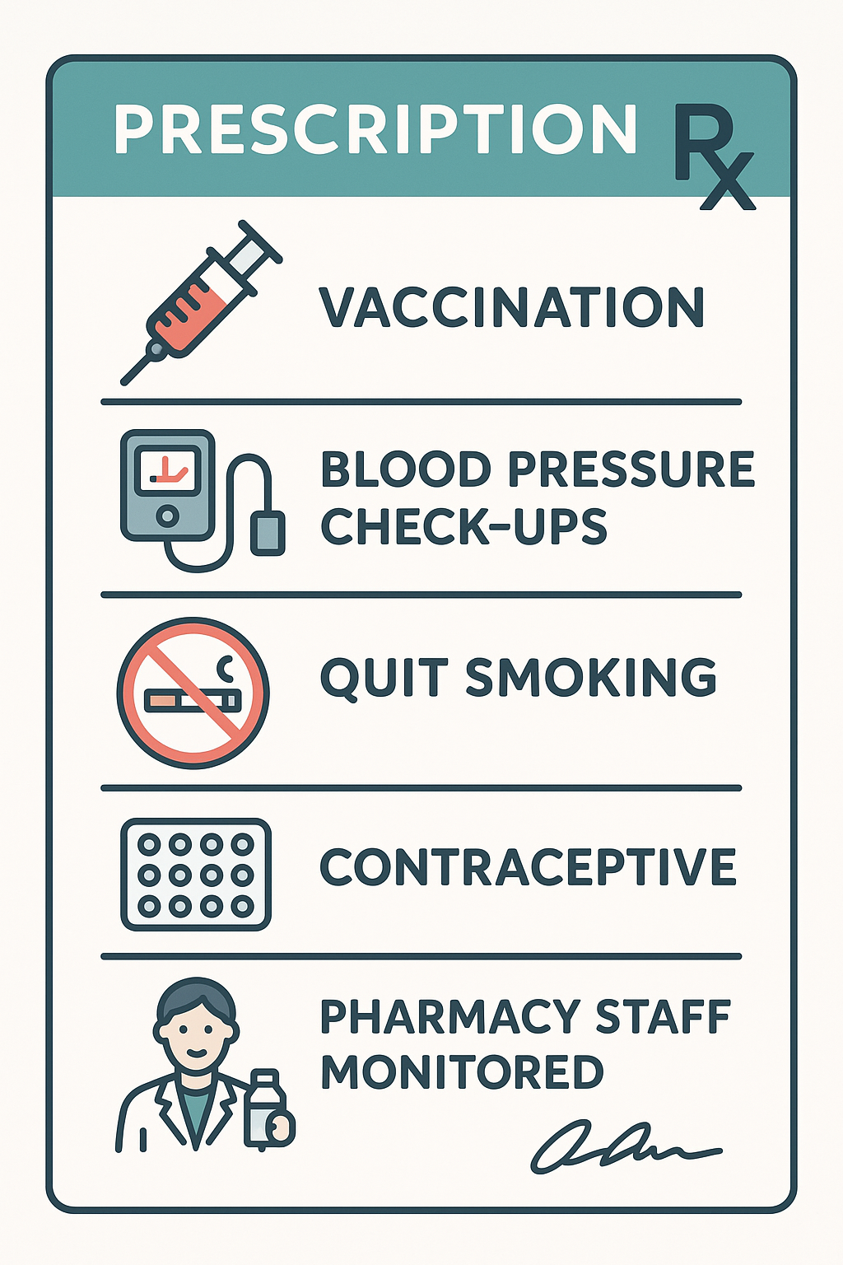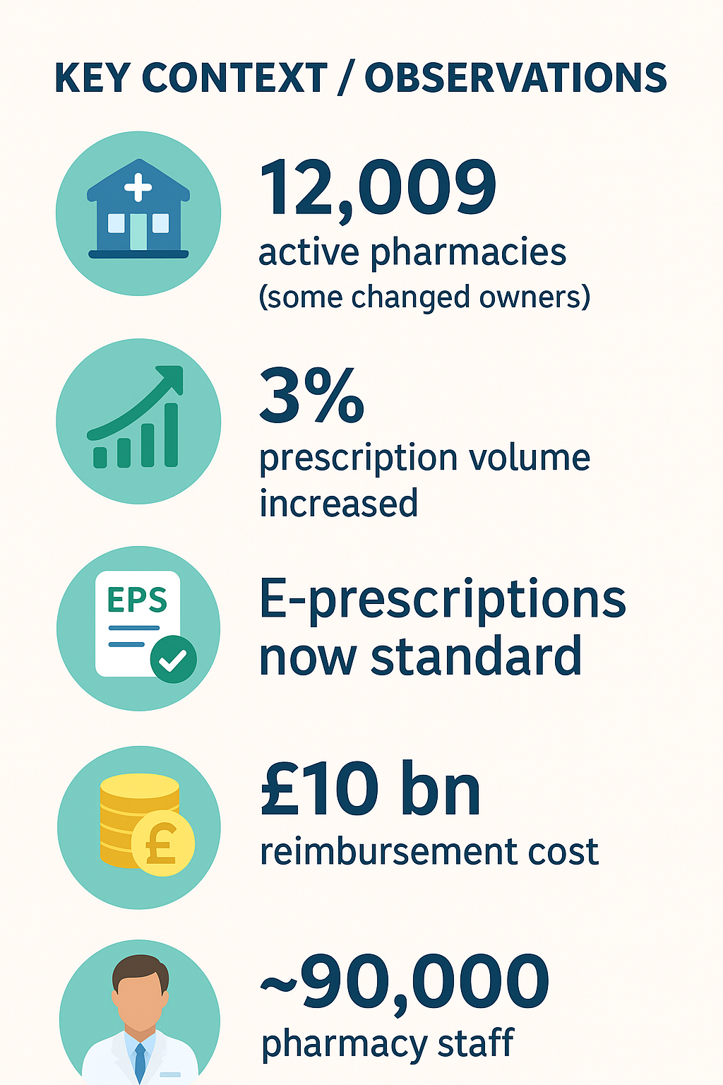
Current functioning of the Pharmacy Services
Pharmacies are regulated to make sure they provide safe and high-quality care. The General Pharmaceutical Council (GPhC) oversees registration, standards, and inspections of pharmacists and pharmacies. Pharmacists must follow strict rules on medicine safety, record-keeping, and patient confidentiality. Through these services and regulations, pharmacies help people manage their health safely and make healthcare more accessible in the community (General Pharmaceutical Council, 2023; NHS, 2023).


Clinical and Consultation Services
Pharmacists offer more than just medicines—they provide advice and support to keep patients healthy. Through Pharmacy First, they can treat seven common conditions, like sore throats, sinus infections, earaches, shingles, and uncomplicated UTIs, without needing a GP. Minor Ailments Support helps with everyday health issues like coughs and colds. New Medicine Service (NMS) and Medicines Use Reviews (MURs) guide safe medicine use, while Discharge Medicines Service helps patients manage medications after leaving hospital (NHS England, 2023; Royal Pharmaceutical Society, n.d.).
Core and Operational Services
Pharmacies handle key everyday tasks to support patient care. Dispensing and Repeat Prescriptions make sure medicines are given accurately, including electronically. Medicine Disposal safely removes expired or unwanted medicines. Signposting guides patients to other healthcare professionals or support services when needed. Technology like automated dispensing, electronic health records, and telepharmacy helps improve efficiency, reduce errors, and provide care to people in remote areas.

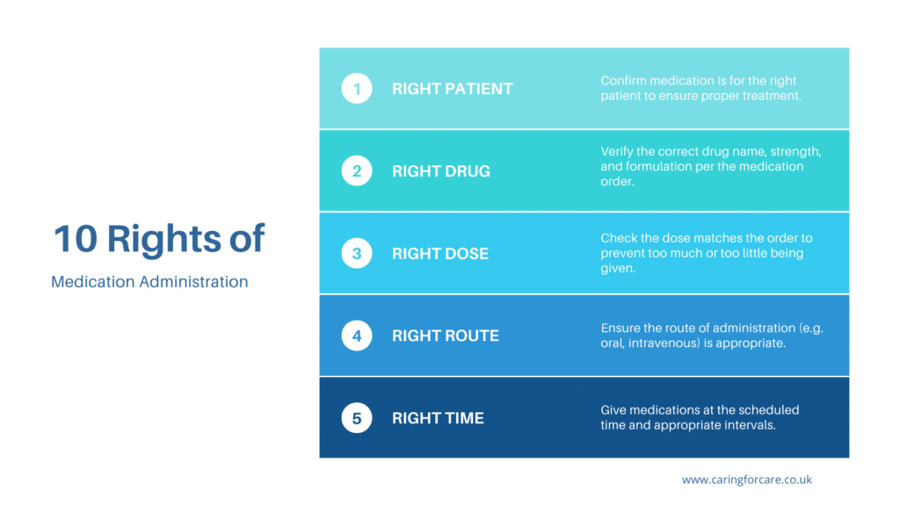
Two Challenges Faced by Pharmacy Services
Pharmacies often don’t have enough staff because there is a high demand for prescriptions, advice, and extra services like vaccinations. Finding qualified pharmacists and support staff can be difficult, and busy schedules make it hard to keep up with patient needs. Funding can also be limited because some pharmacies, especially smaller or community ones, rely on government budgets or local support, which may not cover all costs. With less money, pharmacies struggle to offer extra services, buy medicines, or hire enough staff. Together, these issues make it harder for pharmacies to give fast and high-quality care.
- Busy Workload & Not Enough Staff – Hard to give each patient enough time.
- Limited Funding & Resources – Fewer medicines and services available.
These challenges can slow down care for the community (NHS England, 2023; Pharmaceutical Journal, 2023).

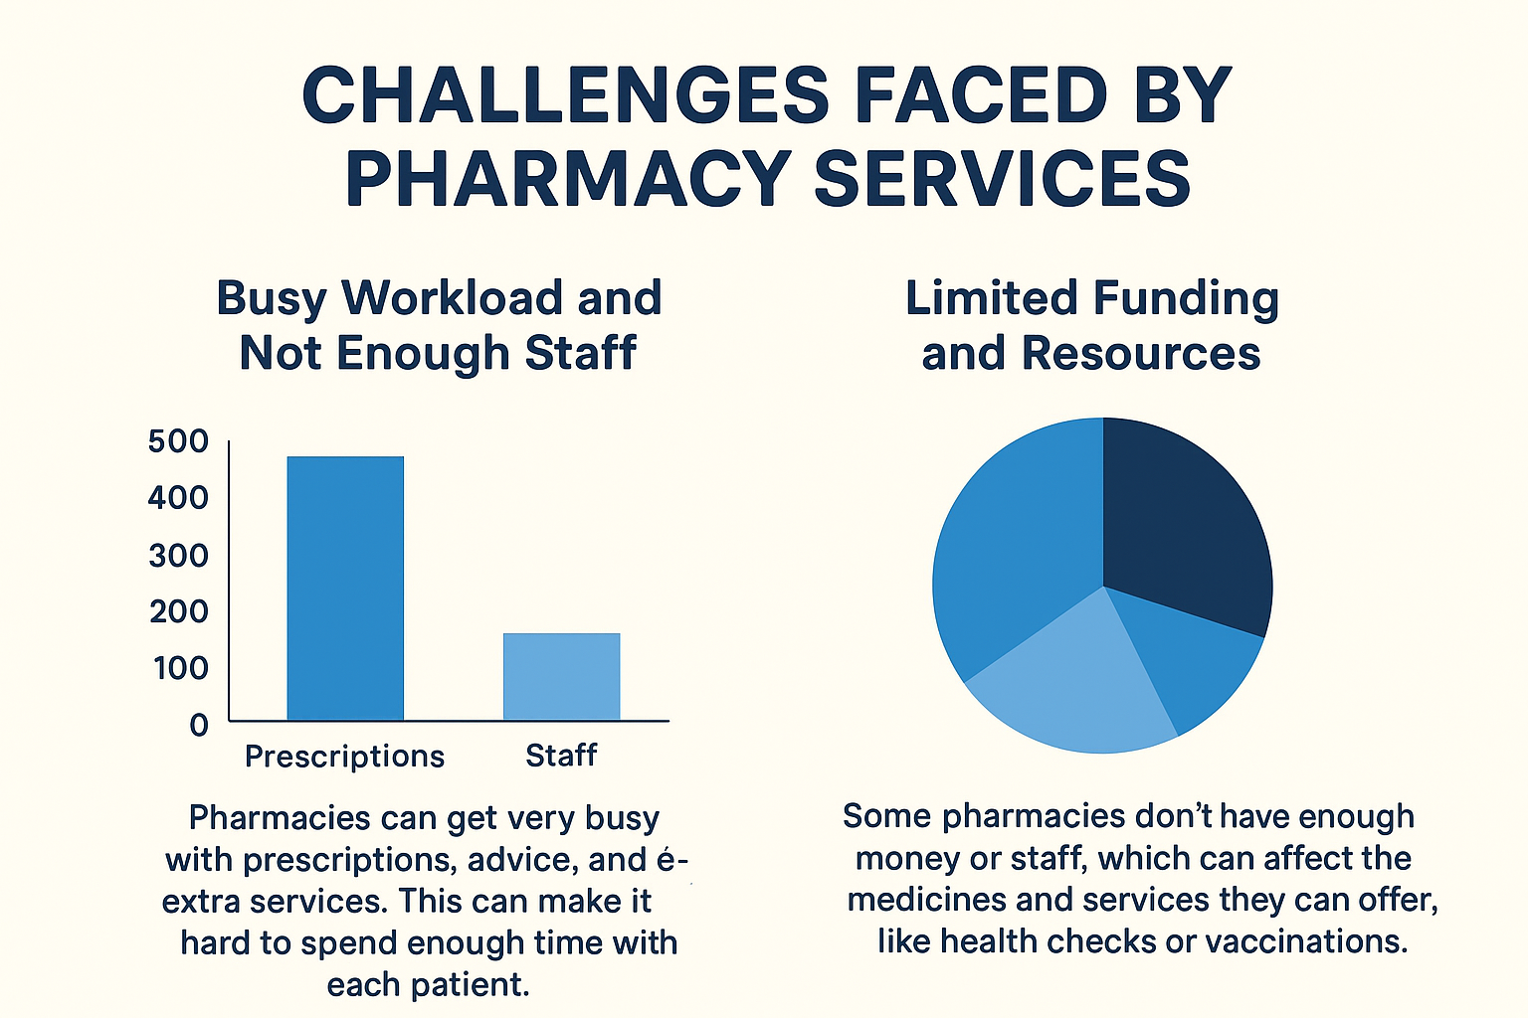

Pharmacy actions with the challenges
Pharmacies face challenges like staff shortages, heavy workloads, and limited funding, but they focus on what’s most important. They prioritise tasks, ensuring urgent prescriptions and patient safety are handled first. They make use of technology, including automated dispensing systems and electronic prescriptions, to speed up work and reduce mistakes. Collaboration is essential, with staff working with other healthcare providers to share responsibilities and support patients. Careful resource management helps pharmacies maintain medicine supplies and funding to keep essential services running smoothly.

TASK:2
The National Health Service (NHS) was established in 1948 in the United Kingdom, soon after World War II. Its creation was influenced by historical, social, and political factors and reflected the country’s commitment to social welfare and public health (Timmins, 2001). Before the NHS, healthcare in the UK was inconsistent and often depended on wealth, employment, or charity. Many working-class families could not afford medical care, and poor housing, malnutrition, and disease affected vulnerable communities the most (Webster, 2002).
A major step towards the NHS was the Beveridge Report of 1942, led by Sir William Beveridge. The report recommended reforms across health, education, and welfare and promoted services available to everyone “from cradle to grave” (Beveridge, 1942). After the war, the Labour government under Clement Attlee focused on social welfare and national rebuilding, establishing a healthcare system that would be accessible to all, regardless of income (Klein, 2013).
The NHS was founded on three main principles: universal access, comprehensive care, and free at the point of use. Universal access means healthcare is available to all UK residents. Comprehensive care ensures services cover everything from prevention to advanced treatments. Free at the point of use means patients do not pay when they receive care (Appleby et al., 2017). These principles made healthcare fairer and more inclusive compared to the previous system, which often left many people without the care they needed.
Since its creation, the NHS has grown and developed. It continues to provide free healthcare, maintaining fairness and equality. It is a trusted institution and a key part of the UK’s social welfare system. Advances like digital health records, telemedicine, and integrated care systems have improved efficiency and patient care (NHS England, 2023).
However, the NHS faces ongoing challenges. Rising demand, an aging population, and the high cost of treatments put pressure on funding. Staff shortages, particularly in nursing and primary care, affect service quality. Health inequalities remain, with some areas experiencing lower life expectancy and worse health outcomes. Waiting times for elective procedures and specialist care can also be long, affecting patient satisfaction (The Kings Fund, 2022).
In response, the NHS has focused on preventive care, digital innovation, and community-based services, as well as working closely with social care to manage chronic conditions and reduce hospital pressure (NHS England, 2023).
In conclusion, the NHS was founded on principles of equity, universality, and free access. Over seventy years later, it remains a respected healthcare system. However, ongoing financial, demographic, and operational pressures mean it must continue evolving. Its future success depends on balancing innovation, efficiency, and fairness to ensure high-quality healthcare remains available to all (Appleby et al., 2017).

References
Task 1
General Pharmaceutical Council. (2023). Standards for pharmacy professionals. https://www.pharmacyregulation.org/standards
Royal Pharmaceutical Society. (n.d.). The history of pharmacy in the UK. https://www.rpharms.com
Webster, C. (2002). The National Health Service: A political history. Oxford University Press.
Royal Pharmaceutical Society. (n.d.). Community pharmacy: Supporting health and wellbeing. https://www.rpharms.com
NHS. (2023). Pharmacies and your health. https://www.nhs.uk
pharmaceutical Journal. (2023). Community pharmacy workload and staffing challenges. https://www.pharmaceutical-journal.com
Task 2
Appleby, J., Thompson, J., Jabbal, J. and Galea, A., 2017. The NHS under the Coalition Government: Part One: NHS Reform. London: The King’s Fund.
Beveridge, W., 1942. Social Insurance and Allied Services. London: HMSO.
Klein, R., 2013. The New Politics of the NHS: From Creation to Reinvention. 6th ed. London: Radcliffe Publishing.
NHS England, 2023. About the NHS. Available at: https://www.england.nhs.uk/about/
The Kings Fund, 2022. The NHS Budget and How It Has Changed. Available at: https://www.kingsfund.org.uk/projects/nhs-in-a-nutshell/nhs-budget
Timmins, N., 2001. The Five Giants: A Biography of the Welfare State. London: HarperCollins.
Webster, C., 2002. The National Health Service: A Political History. 2nd ed. Oxford: Oxford University Press.

