Songlin Zou (2300327)
McDonald’s analysis

Executive Summary

Contents
Executive Summary 1
Introduction 3
Macroenvironment analysis 3
Microenvironment analysis 8
Internally analysis 13
Primary activities 13
Supporting activities 15
TWOS analysis 16
Conclusion 16
References 16

Introduction

Macroenvironment analysis
To analyse the external emerging challenges and resulting market shifts where McDonald's is currently operating, the PESTEL (Political, Economic, Social, Technological, Environmental, and Legal) model serves as a critical tool to make informed decisions by navigating the complex external environments and capsulising opportunities and risks for the fast-food industry (Dinçer and Yüksel, 2019).
  - Political
Political decisions are often made by government or impacted by government stability which are often beyond the control of the businesses, and they might have a good or detrimental impact on the business operation.
- In the autumn budget, HM Treasury (2024) announced reforms to agricultural property relief, decreasing the inheritance tax from 40% to 20% on farms valued over £1 million starting in 2026. This policy has raised concerns among British farmers, who are integral to McDonald's supply chain. In consequence, McDonald's could benefit form this policy since its reliance on a thriving local farming sector.
- The UK government has introduced strict regulations on fast-food advertising, particularly targeting high-fat, salt, and sugar products (Department of Health and Social Care, 2024). These restrictions could impact McDonald's advertising opportunities with a ban on TV ads before 9 PM and limited promotion of HFSS food.
- In addition, the decisions made by McDonald's also have an influence on geopolitics itself. The most recent boycott of McDonald's is due to its perceived support for Israel in the war against Gaza (Newlands, 2024), which could impact its world reputation, especially in Muslim-majority countries.
  - Economic
The recent trend of minimum wages increases the cost of production, which the revenue increases could not cover. The highly standardised structure in the fast-food chain makes the wage rates of basic crew vigorously influenced by minimum wage levels in each region globally (Sainato, 2022). Hence, the global statistics, which will be used in the following analysis, could imply a similar circumstance in the UK. The research by Ashenfelter and Jurajda (2021) shows almost 50% of McDonald's basic crew rates would adjust to minimum wage level as it changes, indicating that the minimum wage is both the target McDonald's basic crew rates would approximate to and the rates would be accepted by employees. However, given the elasticity of McDonald's basic crew hourly wage concerning minimum wage level is 0.7, combined with a general price elasticity of 0.2 for wage increases, the price elasticity to the minimum wage of 0.14 shows that although McDonald's wages are near effective minimum wage, the marginal profit would decrease as the minimum wages increase since the price increases would barely cover 14% of labour cost increases. What's more, the minimum wage in the UK, as shown in Figure @, has a convex increasing trend with 9.8% and 6.7% increases in 2023/24 and 2024/25 respectively. On the contrary, the franchised revenue only increases by 9% and 1% in 2023/24 and 2024/25, resulting in a negative 3% increase in net income in 2023/24 (McDonald’s Corporation, 2025).
Figure 1
Actual and projected National Living Wage rates in The UK, 2019-2025
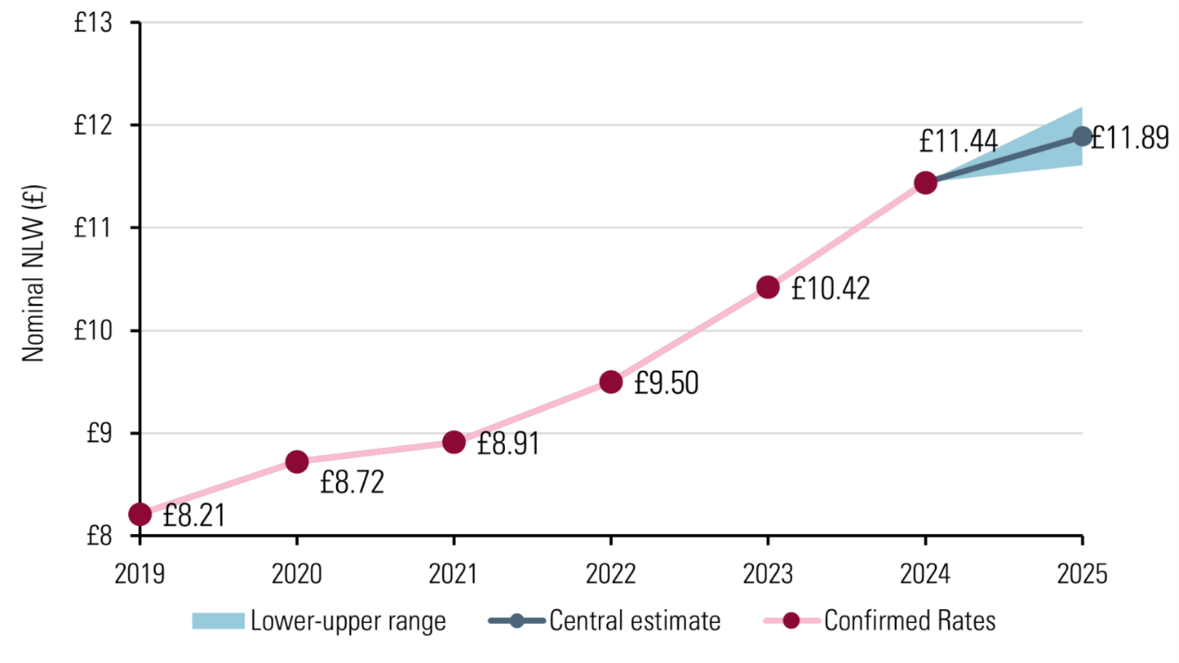
Note. The national living wage is the minimum wage for UK employees aged 21 or above. Although the projected range was from £11.65/h to £12.18/h and is plotted in the graph, the actual National Living Wage is set to £12.21/h from April 2025. From What will the minimum wage be next year?, by Low Pay Commission, 2024.
The UK's ongoing inflation and cost of living crisis have significantly impacted McDonald's operations and consumer behaviour. According to Figure @, although showing a decreasing trend, the UK's CPI remains the highest amongst EU, France and Germany, which could change consumer spending patterns and shift consumer's choices towards more budget-friendly options such as homemade food and supermarket meal deals.
Figure 2
UK inflation vs EU, France and Germany
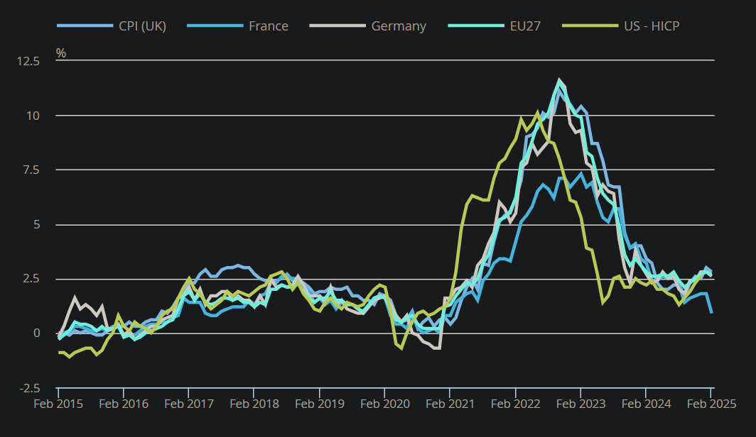
Note. The definition of the US HICP differs from CPI here and, hence, has limited comparability. From Consumer price inflation, UK: February 2025, by Office for National Statistics, 2025.
  - Social
Social factors include demographics, culture, and societal trends that can influence consumer behaviour, preferences, and attitudes. They are crucial for businesses as market demand function is shaped by consumer expectations and product acceptance. McDonald's has been very successful at diversification by customizing its menu, marketing, and store design to fit the preferences of each region. However, the impact of health-conscious consumers on the fast-food industry is increasingly evident as dietary preferences shift towards healthier options. Research by Folkvord, van der Zanden and Pabian (2020) indicates that a significant number of consumers are becoming sceptical of traditional fast food offerings, leading to a demand for healthier alternatives. This trend is reflected in the growing popularity of fast-casual dining establishments such as Five Guys and Shake Shack.
  - Technological
Advancements in technology impact everything from production to customer interactions and shape competition and innovation. McDonald's has implemented a series of mobile apps, self-order kiosks, and drive-through facilities, which enhance customer experience and operational efficiency, showing McDonald's is adapting well to technological changes.
  - Environmental
Environmental factors could directly impact operations by anticipating environmental changes. Businesses can mitigate risks reduce costs and enhance long-term sustainability and profitability through their understanding of external environmental factors. Ministry of Justice (2024) proposes the UK government and consumers demand businesses reduce carbon footprints, and McDonald's committed to net zero emissions by 2050. The company need to phase out plastic packaging and increase recycling efforts in all restaurants.
  - Legal
The McDonald's franchise agreements in the UK require compliance with legal frameworks governing business operations. In recent years, the UK government has implemented various measures to address public health concerns. One piece of legislation that came into force in 2022 (Department of Health and Social Care, 2021) made it mandatory for calorie information to be displayed on menus, third-party apps, food delivery platforms and food labels at the point a customer is making their food and drink choices.
McDonald's UK faces a complex external environment influenced by economic instability, health-conscious trends, digital transformation, and sustainability regulations. By adapting to these factors, McDonald's continues to maintain its position as a leading fast-food brand in the UK.

Microenvironment analysis
McDonald’s operates in a competitive fast-food industry that is influenced by various external and internal factors. To assess the microenvironment of McDonald’s in the UK, Michael Porter’s Five Forces framework provides a structured analysis of competitive pressures, including the threat of new entrants, bargaining power of suppliers, bargaining power of buyers, threat of substitutes, and industry rivalry. Understanding these forces helps evaluate McDonald’s market position and strategic responses.
  - Threat of new entrants (Low)
The threat of new entrants in the UK fast-food market is relatively low due to significant entry barriers. McDonald’s benefits from its strong brand recognition, economies of scale, and extensive distribution network, which new entrants struggle to replicate. High capital investment in infrastructure, supply chain management, and marketing further deters newcomers. However, the rise of niche fast-food brands focusing on health-conscious or gourmet offerings presents some level of competitive pressure. Nevertheless, McDonald’s continued expansion and brand loyalty reduces the likelihood of new entrants posing a serious threat.
  - Bargaining power of suppliers (Low)
McDonald’s maintains a vast and well-established supply chain in the UK, giving it considerable leverage over suppliers. Due to its global scale and bulk purchasing, it can negotiate favourable terms and ensure stable supply prices. However, suppliers of key ingredients such as beef, chicken, and potatoes are affected by inflation, environmental regulations, and Brexit-related trade policies, which can indirectly impact costs. While McDonald’s relies on ethical and sustainable sourcing, the relatively low number of specialized suppliers for fresh produce gives them moderate bargaining power.
  - Bargaining power of buyers
Consumers in the UK have significant bargaining power due to the presence of numerous fast-food alternatives, including Burger King, KFC, Subway, and healthier quick-service restaurants like Leon and Pret A Manger. Price sensitivity and demand for healthier options have forced McDonald’s to adapt its menu by offering plant-based products, meal deals, and digital loyalty programs. Social media and online reviews further empower consumers, as brand perception heavily influences purchasing decisions. To counteract high buyer power, McDonald’s continuously innovates and enhances customer experience through technology and promotions.

  - Threat of substitutes (Moderate)
Fast food is expected to be substitutable since it is considered an inferior good as it is often high in calories, unhealthy fats and sodium (Tedstone, 2018). As consumer's income rise, they would buy less inferior goods proportionately and spend more on higher quality goods. Hence, fast food is expected to have high negative elasticity given the substitution effect would outweigh the income effect for inferior goods (Botric and Tomic, 2018). For example, following a 1.1% decrease in global sales during the second quarter of 2024 compared to a 12% increase during the same quarter last year, McDonald's stock price rose by 4% as the company launched its £5 Meal Deal in June, since it was expected to shift customers from other industry to McDonald's by effectively decreasing price (Siegner, 2024). However, in reality, it has inelastic OPEDs (price elasticity of demand) and even positive YEDs (income elasticity of demand) as shown in Figure 3 and Figure 4.
Figure 3
YEDs across food groups
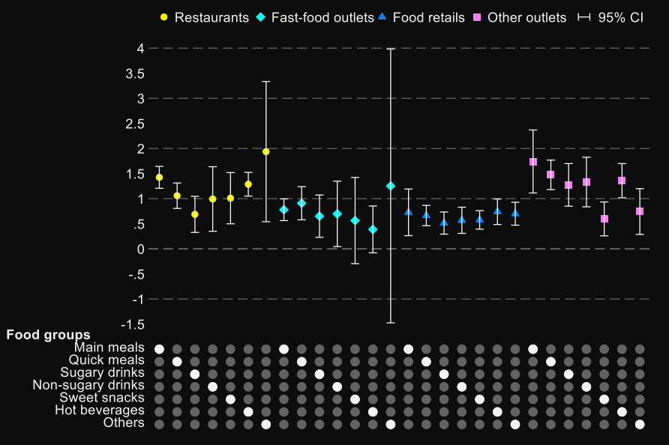
Note. Figures are calculated with 5% significant level with bootstrapped standard errors. From Place matters: out-of-home demand for food and beverages in Great Britain, by Law, Smith and Cornelsen, 2022.
Figure 4
OPEDs across food groups
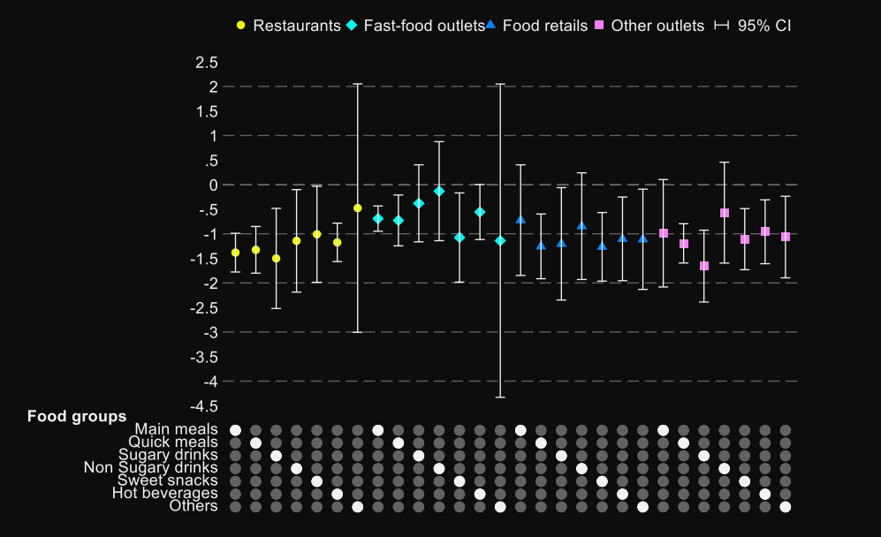
Note. Figures are calculated with 5% significant level with bootstrapped standard errors. From Place matters: out-of-home demand for food and beverages in Great Britain, by Law, Smith and Cornelsen, 2022.
Competitive rivalry
The fast food industry is one typical example of monopolistic competition (Martin, 2012). price inelastic since it is both highly substitutable and discretionary, cost-effective and has short adjustment time, the last two factors tend to make fast food more price elastic and outweigh the former two which make it less elastic, resulting in and less than 1 as shown in Figure @ and Figure @ hence, a less competitive market (Law, Smith and Cornelsen, 2022). The UK fast-food industry is highly competitive, with major players such as KFC, Burger King, Domino’s, and Greggs vying for market share. Intense price wars, promotional campaigns, and menu innovations drive competition. Additionally, the rise of online food delivery services like Uber Eats and Just Eat has intensified market rivalry, as convenience and speed have become crucial competitive factors. McDonald’s counters this rivalry with aggressive marketing, strategic pricing, and digital transformation, including mobile app discounts and drive-thru efficiency.
Porter’s Five Forces analysis reveals that McDonald’s microenvironment in the UK is shaped by intense competition, high buyer power, and the growing threat of substitutes. However, barriers to entry and McDonald’s strong supplier relationships work in its favour. By continuously adapting to consumer preferences, leveraging technology, and maintaining cost leadership, McDonald’s sustains its dominant position in the UK fast-food market. Strategic innovation and customer engagement will remain key to overcoming industry pressures and securing long-term growth.

Internally analysis

Primary activities
  - Inbound logistics
As McDonald's has operated in the UK for decades and has seen many political changes including Brexit, in response it focuses on agility and adaptation. As a result, McDonald's UK has adjusted their supply chain and cultivate a strong partnership with suppliers from Britain and Ireland and consistently purchase high-quality raw materials (McMillan, 2024).
  - Operations
McDonald’s UK operates a mix of company-owned and franchised outlets, leveraging standardization for efficiency. The company has streamlined kitchen processes using the ‘Made for You’ system, which enhances customization while maintaining speed and consistency. Automation, such as digital ordering kiosks and AI-driven drive-thrus, improves service times. Continuous innovation in food preparation, such as eco-friendly packaging and waste reduction initiatives, further enhances operational efficiency.
  - Outbound logistics
McDonald’s UK ensures fast and efficient delivery of its products through multiple channels. In-store service, drive-thru facilities, and online delivery partnerships (e.g., Uber Eats, Just Eat) allow McDonald’s to reach customers conveniently. A well-structured franchise model ensures consistency in service and product quality across locations, strengthening the company’s market presence.
  - Marketing and sales
McDonald’s UK uses aggressive marketing strategies to maintain customer engagement. TV advertisements, social media campaigns, sponsorships (e.g., grassroots football programs), and promotions like the McDonald’s Monopoly campaign enhance brand loyalty. Additionally, the McDonald’s mobile app offers personalized discounts, loyalty rewards, and exclusive deals, boosting customer retention. Health-conscious and sustainability-focused branding, such as McPlant and reduced plastic packaging, also appeal to changing consumer preferences.
  - Service
McDonald’s prioritizes customer experience through various service enhancements. Digital self-order kiosks, mobile app integrations, and contactless payment options streamline the purchasing process. Customer feedback systems help address service issues quickly, ensuring high satisfaction. Additionally, McDonald’s training programs ensure that employees maintain high service standards, contributing to a positive dining experience.

Supporting activities
  - Firm infrastructure
McDonald’s UK has a strong corporate structure supporting its operations. Strategic partnerships with suppliers, franchisees, and delivery platforms enable scalability and market penetration. Financial management, cost controls, and investment in digital transformation reinforce its strong operational framework.
  - Human resource management
McDonald’s invests in employee training and development through its renowned training programs. The company provides career advancement opportunities, employee benefits, and diversity initiatives. In response to labor market challenges, McDonald’s has implemented competitive wages and flexible work policies to retain staff.
  - Technology development
Technological innovation plays a crucial role in McDonald’s UK operations. Self-order kiosks, digital menu boards, and AI-powered order prediction systems improve efficiency. The mobile app and delivery platforms enhance customer convenience, while investments in sustainable packaging and energy-efficient kitchen appliances align with corporate social responsibility goals.
  - Procurement
McDonald’s ensures cost-effective procurement by working with approved suppliers and negotiating bulk purchases. The company emphasizes ethical sourcing, sustainability, and high-quality ingredients. By adopting sustainable farming practices and reducing carbon footprints, McDonald’s strengthens its brand reputation and meets regulatory requirements.

TWOS analysis

Conclusion

References
Ashenfelter, O. and Jurajda, Š. (2021). Wages, Minimum Wages, and Price Pass-through: The Case of McDonald’s Restaurants. IZA - Institute of Labor Economics. Available at: http://www.jstor.org/stable/resrep61703 (Accessed: 01 March 2025).
Bhaskar, V. and To, T. (1999) ‘Minimum Wages for Ronald McDonald Monopsonies: a Theory of Monopsonistic Competition’, The Economic Journal (London), 109(455), pp. 190–203. Available at: https://doi.org/10.1111/1468-0297.00427
Botric, V. and Tomic, I. (2018) ‘EU-Mediterranean youths in the crisis: Substitution vs. income effect’, Journal of Youth Studies, 21(5), pp. 653–668. Available at: https://doi.org/10.1080/13676261.2017.1406073.
Department of Health and Social Care (2021), Calorie labelling on menus to be introduced in cafes, restaurants and takeaways. Available at: https://www.gov.uk/government/news/calorie-labelling-on-menus-to-be-introduced-in-cafes-restaurants-and-takeaways (Accessed: 1 March 2025).
Department of Health and Social Care (2024), Junk food ad ban legislation progresses to curb childhood obesity. Available at: https://www.gov.uk/government/news/junk-food-ad-ban-legislation-progresses-to-curb-childhood-obesity (Accessed: 1 March 2025).
Dinçer, H. and Yüksel, S. (2019) ‘The Importance of PESTEL Analysis for Environmental Scanning Process’, in Handbook of Research on Decision-Making Techniques in Financial Marketing. IGI Global, pp. 336–357. Available at: https://doi.org/10.4018/978-1-7998-2559-3.ch016
Folkvord, F., van der Zanden, M. and Pabian, S. (2020) ‘Taste and Health Information on Fast Food Menus to Encourage Young Adults to Choose Healthy Food Products: An Experimental Study’, International Journal of Environmental Research and Public Health, 17(19), pp. 7139-. Available at: https://doi.org/10.3390/ijerph17197139.
HM Treasury (2024), What are the changes to agricultural property relief? Available at: https://www-citethemrightonline-com.ezproxy.uwtsd.ac.uk/sourcetype?docid=b-9781350927964&tocid=b-9781350927964-133 (Accessed: 1 March 2025).
Law, C., Smith, R., and Cornelsen, L. (2022) ‘Place matters: out-of-home demand for food and beverages in Great Britain’, Food Policy, 107, 102215. Available at: https://doi.org/10.1016/j.foodpol.2021.102215
Low Pay Commission (2024) What will the minimum wage be next year? Available at: https://minimumwage.blog.gov.uk/2024/04/19/what-will-the-minimum-wage-be-next-year/ (Accessed: 1 March 2025).
Martin, S. (2012) ‘Market Structure and Market Performance’, Review of Industrial Organisation, 40(2), pp. 87–108. Available at: https://doi.org/10.1007/s11151-012-9338-8 (Accessed: 1 March 2025).
McDonald’s Corporation (2025) Form 10-K. United States Securities and Exchange Commission. Available at: https://www.sec.gov/edgar/browse/?CIK=0000063908
McMillan, A. (2024) ‘How McDonald’s UK Supports Sustainable Supply Chains’, Procurement Magazine, 23 September. Available at: https://procurementmag.com/supply-chain-management/how-mcdonalds-uk-supports-sustainable-supply-chains (Accessed: 01 March 2025).
Ministry of Justice (2024) Climate change and sustainability strategy. Available at: https://www.gov.uk/government/publications/climate-change-and-sustainability-strategy-moj/climate-change-and-sustainability-strategy (Accessed: 01 March 2025).
Morton, B. (2022) ‘McDonald's puts up price of cheeseburger for first time in 14 years’, BBC News. Available at: https://www.bbc.co.uk/news/business-62317453#:~:text=McDonald's%20has%20put%20up%20the,from%2099p%20to%20%C2%A31.19 (Accessed: 1 March 2025).
Newlands, C. (2024) ‘McDonald's: Behind the fast-food firm's boycott controversy’, BBC News, 5 April. Available at: https://www.bbc.co.uk/news/business-68740617 (Accessed: 1 March 2025).
Office for National Statistics (2025) Consumer price inflation, UK: February 2025. Available at: https://www.ons.gov.uk/economy/inflationandpriceindices/bulletins/consumerpriceinflation/february2025#cite-this-statistical-bulletin (Accessed: 28 Mar 2025).
Sainato, M. (2022) ‘‘How are we supposed to live?’: fast-food workers squeezed by inflation’, The Guadian, 3 July. Available at: https://www.theguardian.com/business/2022/jul/03/fast-food-workers-inflation (Accessed: 1 March 2025).
Sherman, N. (2024) ‘McDonald's to 'rethink' prices after sales fall’, BBC News, 29 July. Available at: https://www.bbc.co.uk/news/articles/c728313zkrjo (Accessed: 1 March 2025).
Siegner, C. (2024) ‘McDonald’s sales, income drop as price-conscious consumers stay away’, Food Business News, 31 July. Available at: https://www.foodbusinessnews.net/articles/26511-mcdonalds-sales-income-drop-as-price-conscious-consumers-stay-away#:~:text=For%20the%20first%20half%20of,by%20the%20end%20of%202027 (Accessed: 1 March 2025).
Tedstone, A. (2018) ‘Putting Healthier Food Environments at the heart of planning’, UK Health Security Agency. Available at: https://ukhsa.blog.gov.uk/2018/06/29/putting-healthier-food-environments-at-the-heart-of-planning/#:~:text=Excess%20calories%20are%20the%20root,important%20to%20supporting%20healthier%20lifestyles. (Accessed: 1 March 2025).

