Finding aid
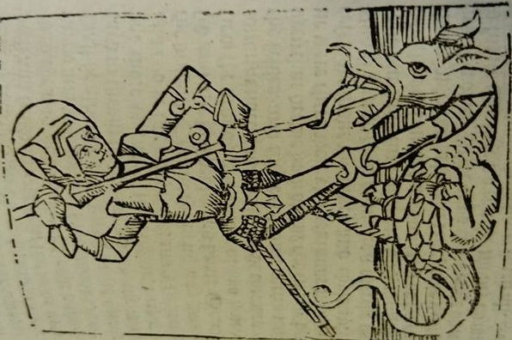
Image 1: The Golden Legend.
Call number: INC 46.
Inscriptions: Non.
Description: Image on folio CXi- Saint George slaying the Dragon with his lance. Simplistic design with only the 2 subjects in the depiction.
Production: Incunabula printed at Westminster by Wynkyn de Worde on the 8th of January 1498. Wood cut reprint of Caxton’s translation and adaption (1483) from versions in Latin, French and English, of the legenda Aurea by Jacob de Voragine.
Comments: The Golden Legend consists of legends and stories of biblical import as well as the legends of Saints and their martyrdom, each dealt with separately and contain simplistic depictions/ images. Some of the images are touched up with colour after printing, however, the image of Saint George remains colourless.
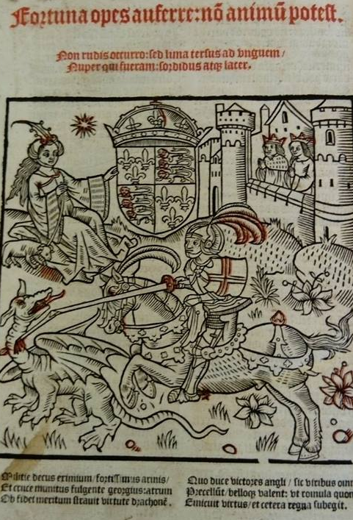
Subjects: Saint George slaying the Dragon.

Image 2: Latin Missle.
Call number: PHI 01221.
Inscriptions: Above the image;
“fortuna opes auferne: no animpotest. non rudis accurro: led lima terlus as vnguem/ nuper qui fueram: cordibus atqiu lacer.”
Below the image;
“Militie decus erimium/ fortissimus arinis/ Et cruce manitus fulgente georgius: atrum Dv fidet meritum strauit virtute Drachone.
Due duce bictores angli/ sic viribus omnes Drecellut/ bellons valent: ut romula quondam Emicuit virtus/ et cetera regna subegit.”
Description: Depiction of Saint George slaying the Dragon with his lance to save the Princess whilst the king and queen are praying in a castle far off. The princess is holding the royal English coat of arms. Wood cut and printed in black and red ink.
Production: wood cut, artist unknown.
Comments: Latin Missle image printed in Black and Red ink.
Subjects: English Monarchy, Saint George, Dragon, Virtues, Patronage of the legend.
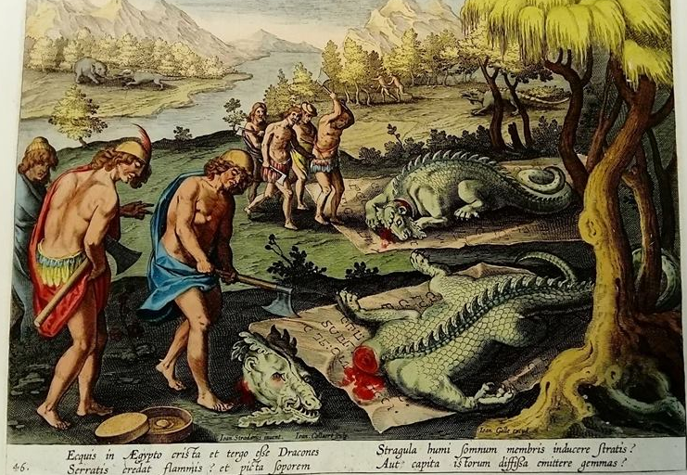
Image 3: Dutch Bestiarum.
Call number: PHILL 014.
Inscriptions: Title image at the base of the illustration;
“Ecquis in Aegypto Crista et tergo else Dracones/ Serratis Credat flammis? Et picta saporem/ Stragula humi somrum membris indecerestratis? Aut capita istorum diffisa emitter gemmas?”
Within the image at the base;
“Ioan. Strandanus inuent./ Ioan. Collaert. Sculp”
Description: 46th image in the “Venationes ferarum, Auium, pifcium. PVGNAE Bestiariorum & Mutuae Bestiarum.” Depicts 2 decapitated dragons more reminiscent of crocodiles but are names as dragons. Very colourful and detailed image.
Production: Dutch. Artist- A Ioanne Stradano. Editor- Nicolaum Visscher. Copper plate printed, as evidenced by the distortion of the paper seen at the back.
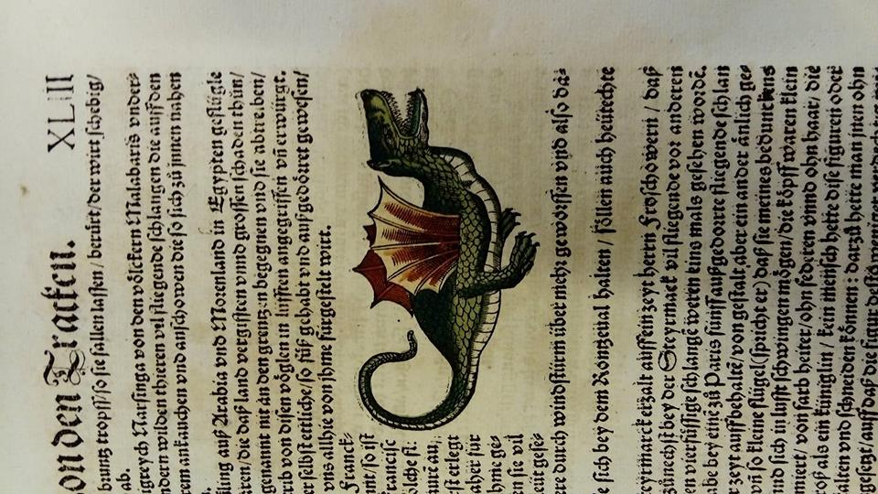
Comments: The book consists of a title page copper plate printed and is a catalogue of images of beasts are also copper plate printed. There are 102 images in the first part. The second part “VERMIS SERICVS” follows the same pattern but with only 6 images which depict scenes from life. This catalogue also serves as a catalogue for tapestry design.
Subjects: Hunting, Strange/unknown animals, zoology.

Image 4: Fisch Buch.
Call number: PHI 00359.
Inscription: Non.
Production: 1575 German catalogue of sea creatures written by Konrad Gesner. Artist Lucas Schan of Stresbourg. Wood cut print with colour and detail added by hand.
Comments: Described in text as being found commonly in an Indian context. Consists of a title page and is a catalogue of aquatic, semi-aquatic animals and animals living near water. Dragon presented as a factual creature- all images seem to be wood cut with colour and details added by hand later, as can be seen by the printing marks showing that the image outline was printed twice.
Subjects: Dragon’s physical aspect.

