Michael Oldham (2235684)
2235684@student.uwtsd.ac.uk
Geodemographic analysis using gis software
Geographical Information Systems

Contents
Introduction 2
Task 1 - Documentation Log 3
List of data sources used 7
Task 2 - GIS Build report 8
Conclusion 21
References 23

Introduction
For my assignment in Geographical Information Systems, I will use Geodemographic data in order to analyse my chosen case study. Working within the DVLA, me and colleagues within my team/area have identified that it is difficult to recruit people who are qualified in certain arears such as Software Engineers, Data Analysts and Data Scientists. The assumption is that people with these skills do not exist within the Swansea and surrounding areas; therefore, as part of my assignment and investigation, I am looking at different factors that may contribute to this theory and see what conclusion I come to based on the data and my findings.

Task 1 - Documentation Log
As part of the data gathering process, within my group, Nick, Cheng and I agreed to focus on different areas of data, in order to add to the bigger picture and combine these datasets eventually to make the GIS.
Firstly, Nick was able to locate data relating to education, qualifications and region of work for graduates (Relocation).
I was able to look at general map data including regions, postcode data and also travel routes and bus/train stops.
Finally Cheng researched data relating to technology access (in particular internet access in the local region) which included Ofcom broadband data, UK Census data on Internet access, the Welsh Index of Multiple Deprivation (WIMD) and Income and Employment Data (ONS).
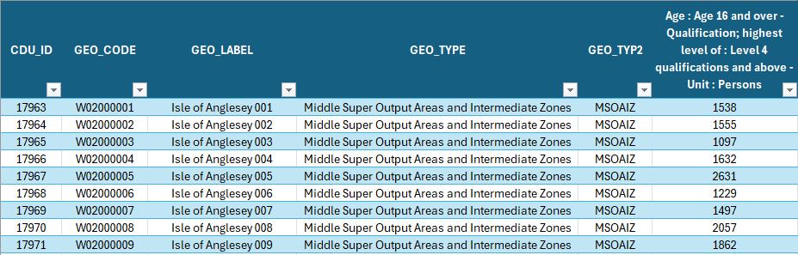

When downloading the data (example as shown above) sometimes, it requires to be cleaned in order to provided to relevant data needed in order to display the thematic map data accordingly. This was required for multiple datasets acquired during the process.

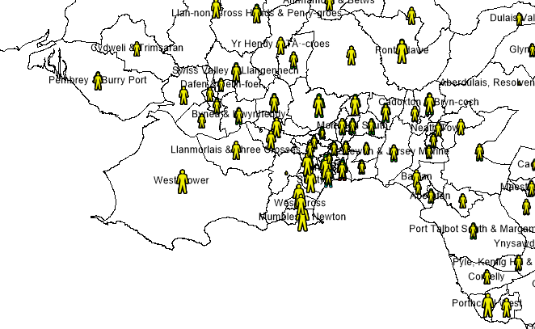
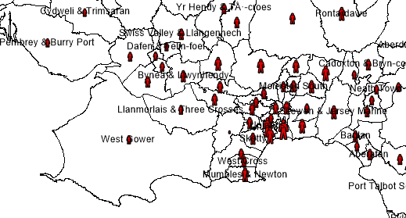
Once I had imported the data for level 4 degrees or higher into my workspace, I realised that the data I cleaned up categorised the people by age ranges. Whilst this is a good way of separating the data, I quickly realised that for this specific snip of information, it would be much more beneficial to have them combined as 1 total value as apposed to being split. The image above shows all the age ranges (in 4 different colours), but as the data points on the map are the same code for the area, they all sit on top of one another. (Below shows some of the other layers below and how this is affected).
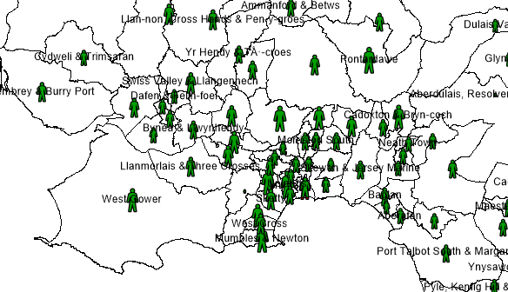
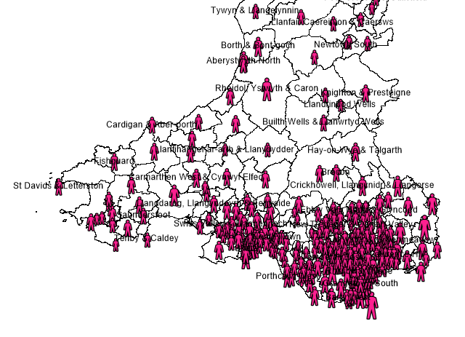
I then decided to add a total column in order to use this data more affectively in my analysis later on. This way, the data was not hidden by each other, and made more sense to see the total information as apposed to the data split by age ranges.

The following is taken from the Data Map Wales website and shows how to overall WIMD is split and the percentages it covers:
• Income 22%
• Employment 22%
• Health 15%
• Education 14%
• Access to services 10%
• Housing 7%
• Community safety 5%
• Physical environment 5%

After importing this data into my MapInfo workspace, I linked it to my map and coloured the ranges in different coloured patches.
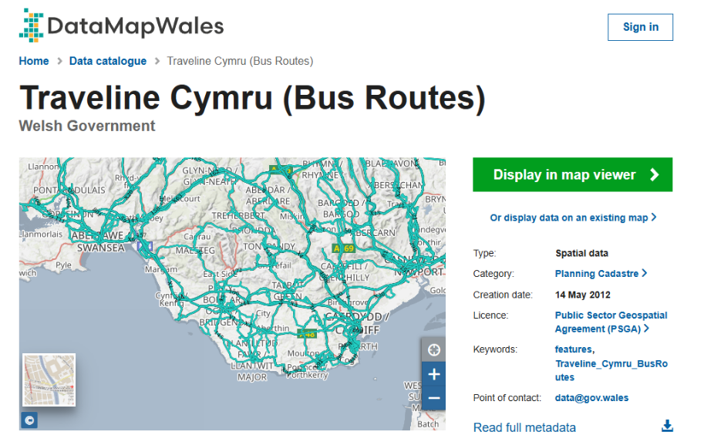

I then managed to get bus route data from DataMapWales. I plan to use this in order to analyse different transport routes that are available around the area and Wales in general, to see if this could play part or affect people’s ability to access the DVLA using public transport.

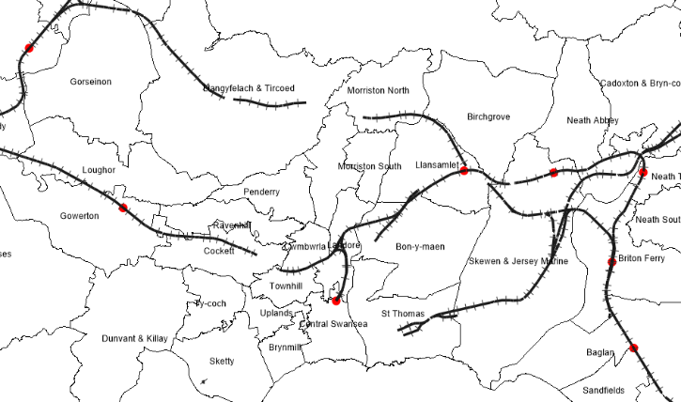
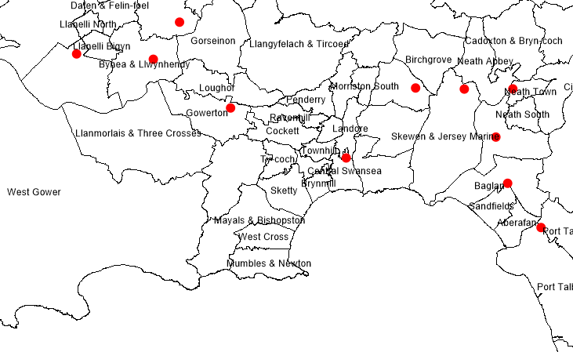
I was finding that a lot of relatable data was useful from DataMapWales and whilst there I found Train Station and Line Data. As this wasn’t available via Spatial Data, I used the WMS (Web Map Service) Endpoint Link and added this within MapInfo.

List of data sources used
- https://infuse.ukdataservice.ac.uk (Infuse UK Data Service Census data 2011)
- https://www.hesa.ac.uk/ (HESA)
- https://datamap.gov.wales (Data Map Wales)

Task 2 - GIS Build report
Firstly, as part of my case study within the DVLA, I am looking at different collections of data to try and come to a conclusion as to why the DVLA may find it hard to recruit certain job roles such as Software Engineers, Data Scientists and Data Analysts.
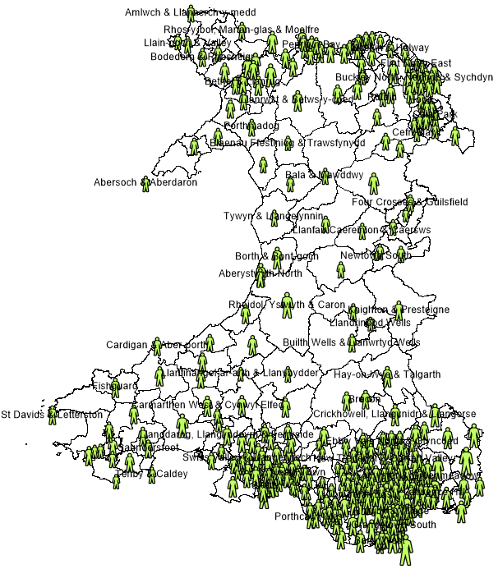
Using the data which I have acquired from HESA (the Higher Education Statistics Agency), which shows the amount of people with level 4 qualifications or higher within each area. I chose to only take the data within Wales as the DVLA currently operate a hybrid working structure requiring staff to be on site (in the office) for 60% of the time. As this equates to 3 days per week full time, I would suggest that it is very unlikely that anyone working within the DVLA or prospective staff would live outside of Wales or travel such a distance to get to work each week.
The screenshot on the page above shows a map of Wales with green data points in the shape of a person that represents people within each area that have a level 4 qualification or higher. Originally the data which I imported into my map was split by each age range, as I realised that this was irrelevant as the DVLA do not discriminate against age, I decided to go back to the data and create an additional column to sum the amount of degrees in each area and age range and combine these for a total sum.

Below is a focused screenshot around the South Wales area focusing on Swansea area to show the rough location of the DVLA.
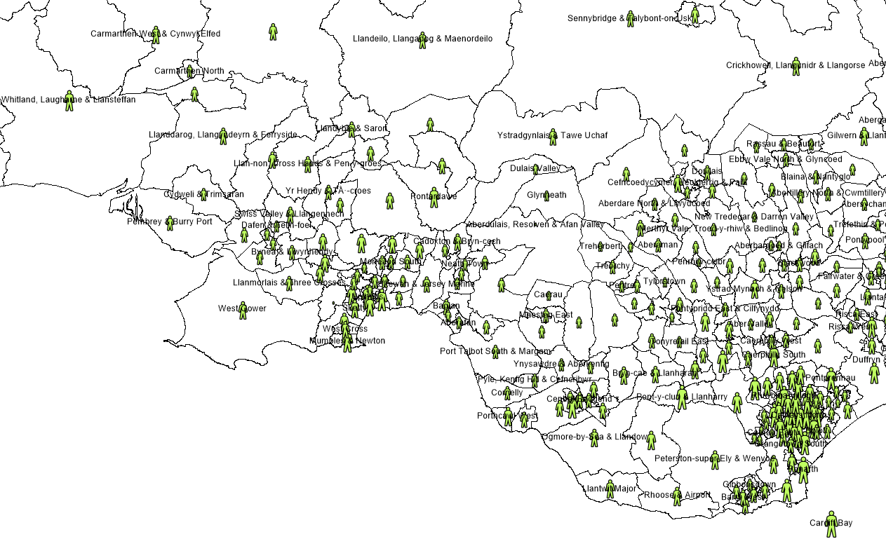
Looking at the data shown within this snapshot, its clear that there are plenty of people within the more local surrounding arears within an estimated 40-mile radius, who have qualifications that would be acceptable and desirable for recruitment into these technical roles within ITS in the DVLA. Its clear from the data that a lot more people have valid qualifications closer to and surrounding Cardiff, and with this being a large city, there are plenty of job opportunities and employment opportunities in that area, which may prevent people from needing to look further afield.

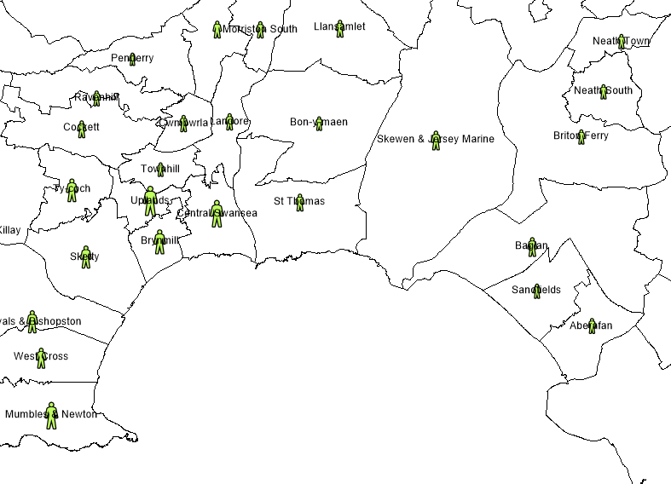
Below are close up screenshots of the Swansa and Cardiff areas to show a comparison.
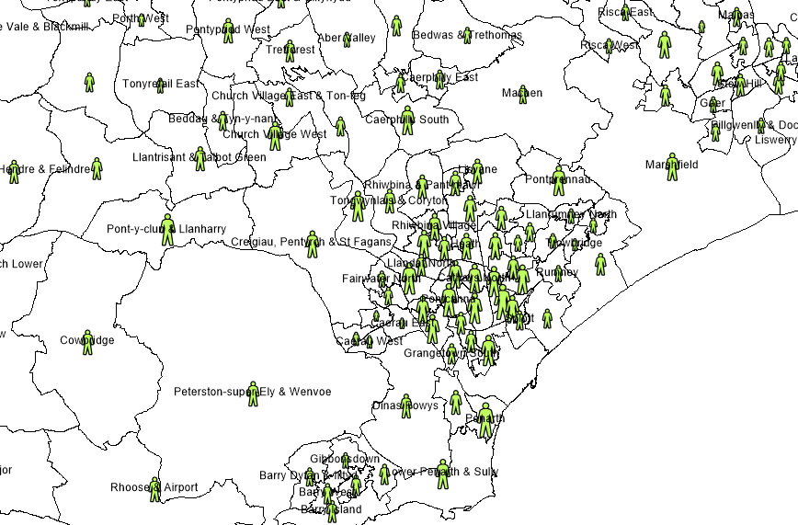
Swansea and surrounding areas.
Cardiff and surrounding areas.
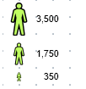
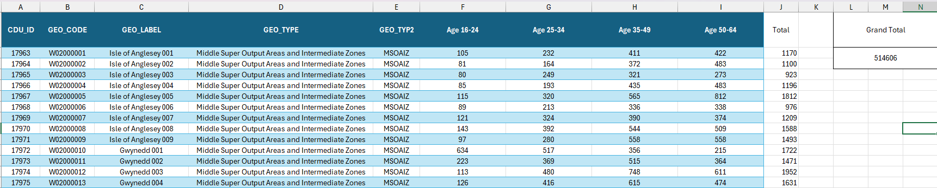
The screenshot here shows the background table of data from HESA regarding qualifications. Although this data is for the whole of Wales and shows a total of 514606 people of all ages with level 4 qualifications or above, the data plotted on the map within the areas and the size of the people shown in the legend show me that there are more than enough people at the required level needed to recruit into these roles.

Welsh Index of Multiple Deprivation
One of my next pieces of data come from the Welsh Index of Multiple Deprivation (WIMD).
This is the Welsh Government’s official measure of deprivation within areas in Wales. It is used to show by area where has the higher levels of deprivation using different categories. These include Income, Employment, Health, Education, Access to services, Community Safety, Physical Environment and Housing. The split of this information leans more towards the Income and Employment data. [1]

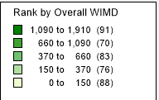
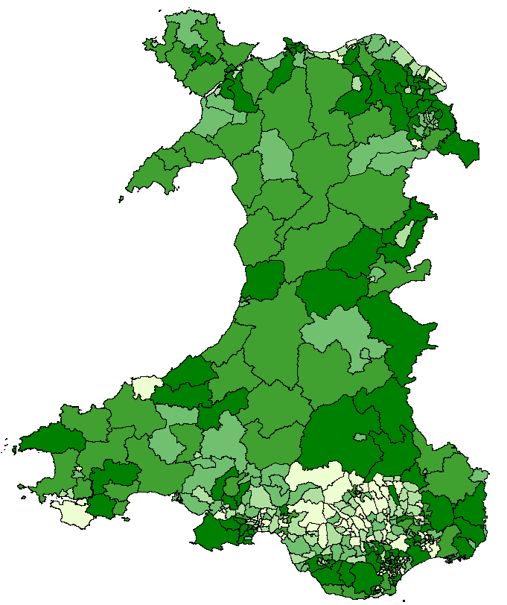
The map above shows the WIMD data imported into my map of Wales.

You can see from the Legend to the right that the higher the number (WIMD Score) the darker the colour green is and the lower the score the lighter.

The WIMD Score ranks the data of the most deprived areas at the lower end of the scale and the least deprived areas higher.

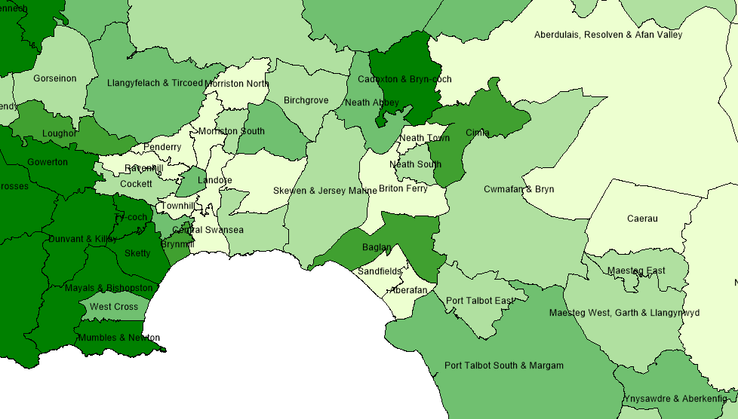
For example, when focusing on the Swansea and surrounding areas, this shows that in general, Central Swansea, Skewen, Townhill, Morriston South etc are more deprived, compared to the Mumbles region including Sketty, Dunvant and Gowerton etc.
The data shown here from the WIMD would indicate that there is a mixture of scores within South Wales area and that generally this means that the Income and Education are much lower than other areas in Wales.

Linking this in with the data from the HESA and qualifications, there could be a correlation between the general area being more deprived and therefore having a lower amount of the population with the required qualifications to work in these sectors within the DVLA.
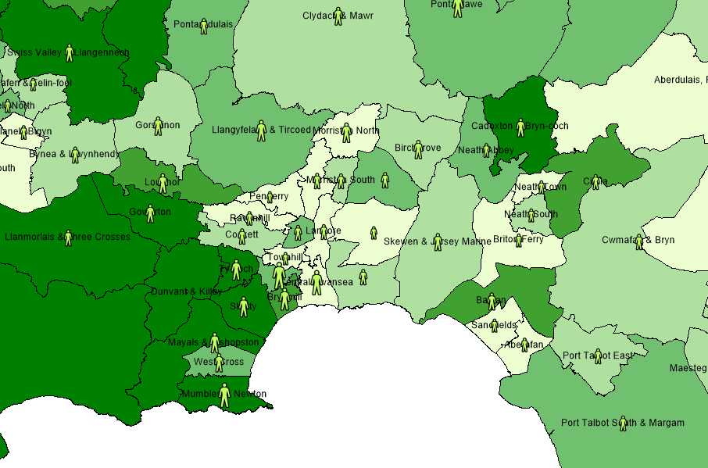

Screenshot showing the level 4 qualifications and higher data layered on the WIMD.
Whilst studying this data and looking at the WIMD scores as a whole, I also decided to look at specifically the Income data on its own.
The screenshot below shows this data.
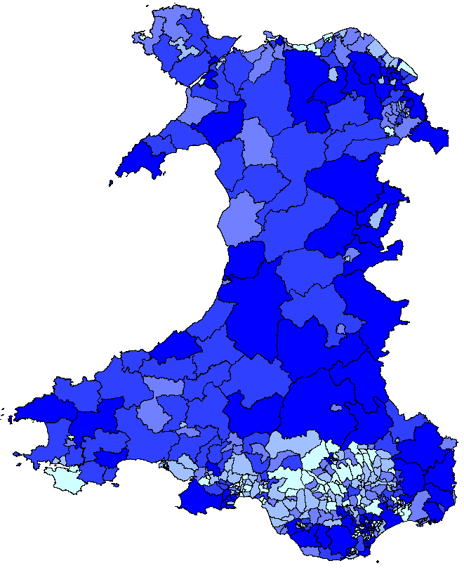

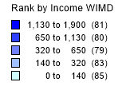

Again, within the data/map above, the darker blue shows the areas of least deprivation relating to Income and the lighter areas show those that are more deprived. As the WIMD uses Income as its highest category amongst the split, it makes sense that the maps show very similar data even when separating out just the income section.

Bus Routes
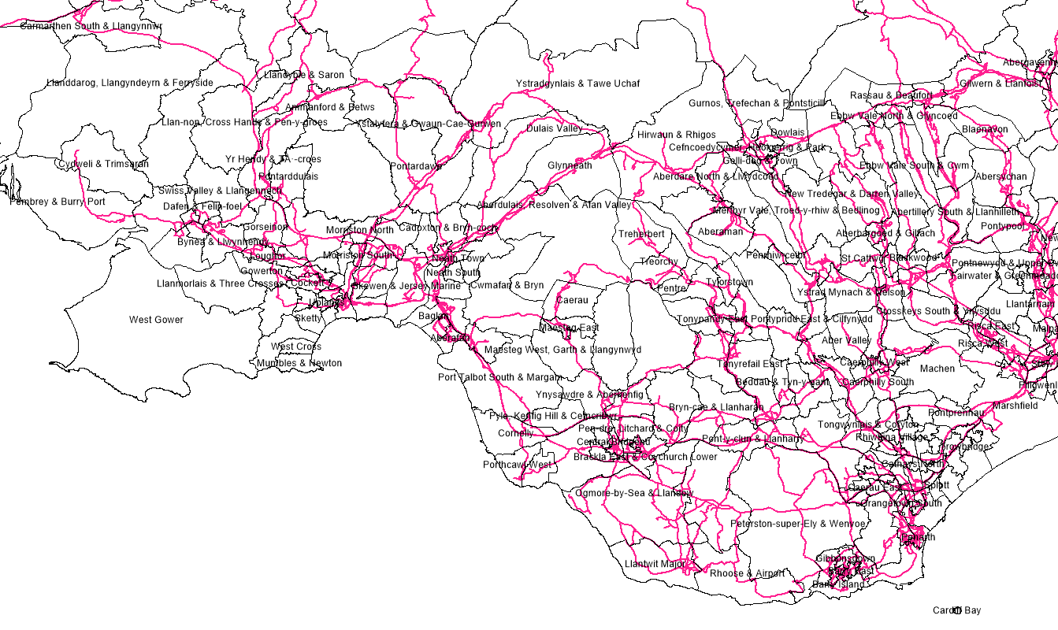
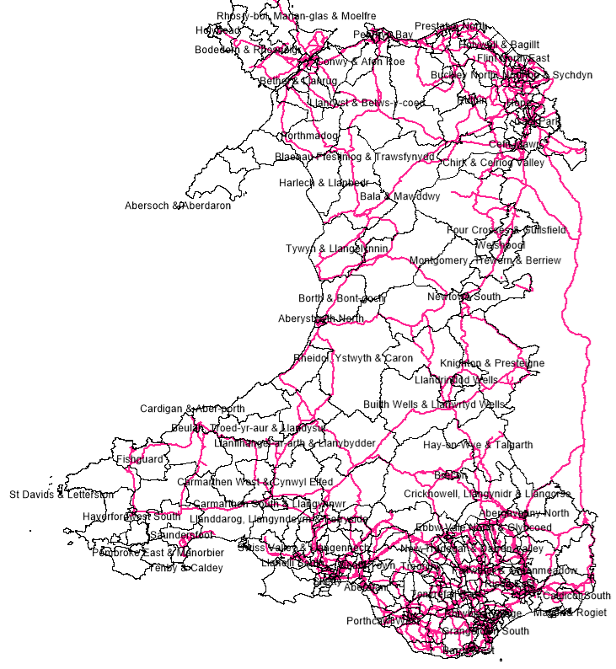
The screenshots I have here highlight the bus routes around Wales using a pink line.
Below is a more focused area again of South Wales to focus more on the areas closer to the DVLA. I have included the whole of Wales to show that the data is there and that there is access from further counties, but again, I believe it to be unlikely that people would travel beyond 50 miles using public transport.

Knowing that there are more people with degrees and higher qualifications in the Cardiff area, due to reasons already discussed and also the fact that it would be unlikely for someone to get a bus from this region to Swansea to work at the DVLA, this could affect the ability for DVLA to recruit any graduates from this area with relevant qualifications.
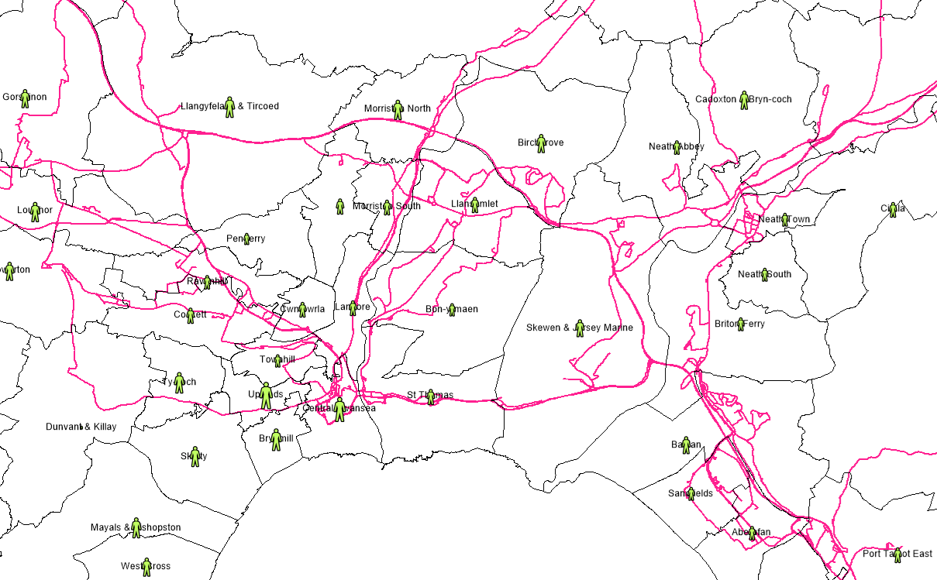
Although this could be an issue or reason why people from Cardiff wouldn’t travel to Swansea via bus, the above screenshot shows that there are viable routes within the closer areas around the DVLA for people who would be eligible and have the required qualifications who would then be able to travel to work. For this reason, I would rule out the fact that public transport by bus is a factor as to why the DVLA are unable to recruit required people into these jobs.
Train Stations and Train Lines

With regards to the data I was able to find for train stations and the train lines, I could not access any spatial data to make it easier in MapInfo; however, I was able to get a WMS (Web Map Service) endpoint link to import the sufficient data into the software. Although this did not allow me to customise the visual of the data much, It was enough to allow me to analyse it for the purpose of my case study.

Below are a few screen shots of two data sets acquired with WMS which were the train stations and then separately train lines for the whole of Wales, but also areas within England which look like this is due to the train line starting in Wales but then has an end point outside of Wales.

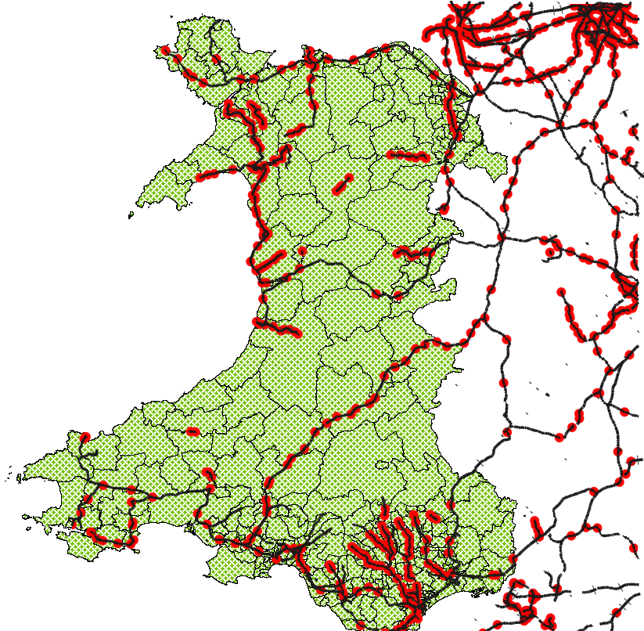

The green coloured area in the screenshot is just to highlight my map of Wales to show that the train lines and stops which lead to other parts of the UK are included but I am not using this as part of my analysis.

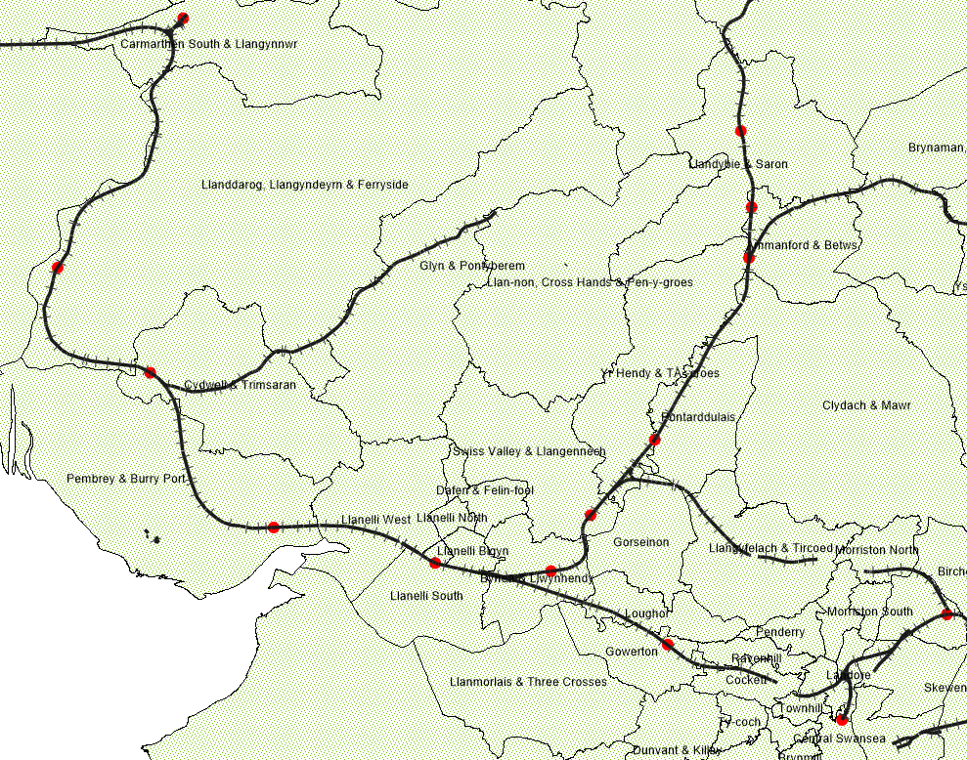
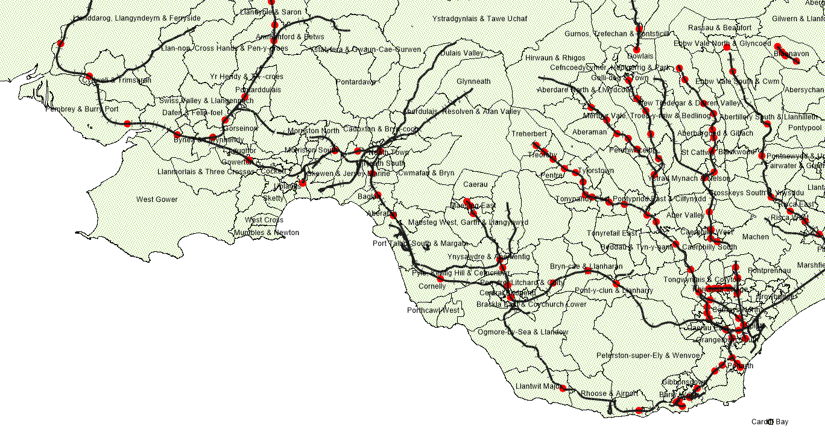
Here I am focusing on the South Wales region out as far as Cardiff/Newport in the East and then down to West Wales for Carmarthen. Here it is visible and clear that there are access routes through trains and multiple stops along each line between Carmarthen, Swansea, Cardiff and multiple valley lines.
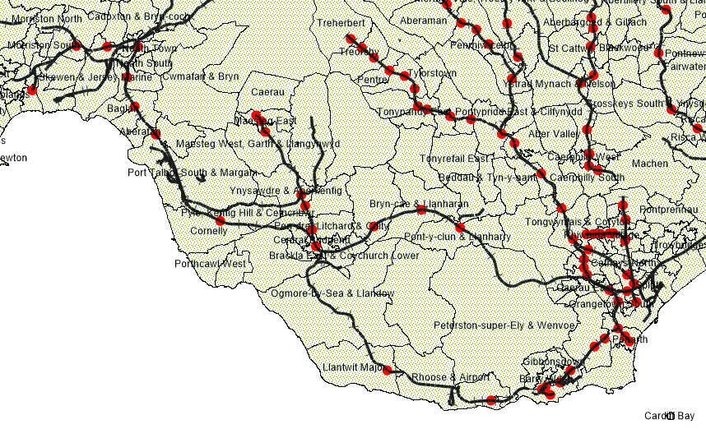
Looking closely along the South West Wales areas, there are stops through Carmarthen, Kidwelly, Llanelli, Bynea, Gorseinon, Pontarddulais, Gowerton and into Swansea.
Here I can see the train stops and lines from the East and mainly Cardiff area which cross through the coast and stop along Bridgend, Port Talbot, Baglan, Jersey Marine and into Swansea Central.

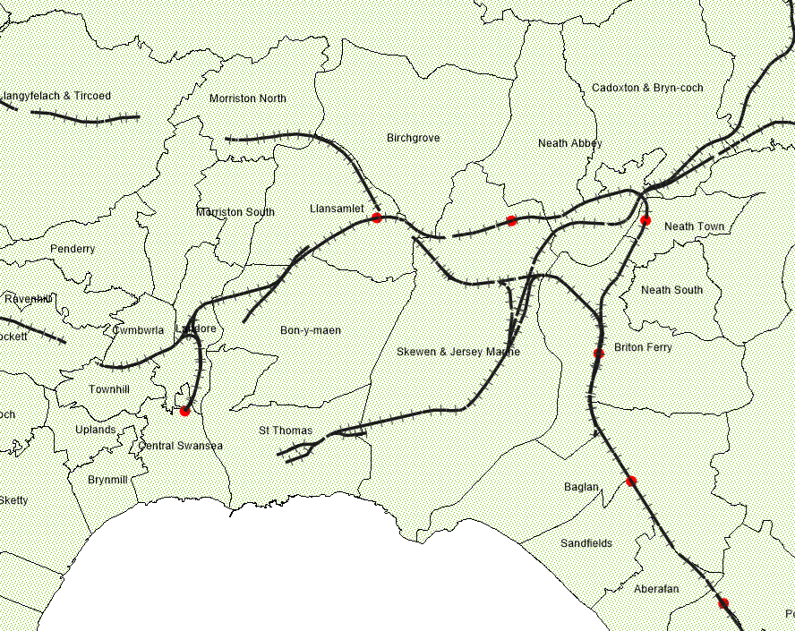
Zooming in and focusing on a smaller area around the DVLA’s main office in Morriston Swansea, (I have highlighted the area in yellow), if staff were to travel by train to get to work, they would likely need to get off at Llansamlet or Swansea Central. As neither of these are within a short walking distance, staff or prospective staff would then need to find an interim transport to get from either train station to the office, either by cycling if they were to bring a bike on the train, or bus, taxi or possibly a lift from other staff members who may live close to these areas.

Personally, if I was someone who lived further away from the DVLA and did not drive or have a car, I would find this too difficult to organise and keep up with the different modes of transport in order to travel by bus or train. However, I do believe that it could potentially work out okay if someone was to choose to travel this way. For this reason, I would again go back to a previous point made that whilst a lot of post graduate students and people with Level 4+ qualifications live in and around the Cardiff capital, and for the reason of there being plenty of work opportunities more local to themselves, the majority of people will not look too far afield for work if they can get something closer.

Conclusion

Going back to my original question and case study:

“Working within the DVLA, me and colleagues within my team/area have identified that it is difficult to recruit people who are qualified in certain arears such as Software Engineers, Data Analysts and Data Scientists. The assumption is that people with these skills do not exist within the Swansea and surrounding areas”

The first thing that I am able to see from the data I have acquired is that there are more than enough people in the local and surrounding areas with valid qualifications required to either begin an Apprenticeship program within the DVLA or even to apply for specific job roles such as Junior and Senior Software Engineers.

Whilst there are plenty of people who qualify, I also understand that this does not mean that all or even half of these people would have the interest or desire to apply for these roles. Even if this was the case, there are still enough people who would likely be interested in these opportunities.

Knowing that potential candidates are out there, I decided to plot this data on the map to see where these people were residing at the time of completing their qualifications which is what showed me that more of these people were further afield. Because of this, it led me to research into the different accessible transport routes and distances. As our main office is only around 5 minutes off the M4 motorway at junction 46, getting to the DVLA is not much of a problem for anyone living within a 20-30 mile radius who drives. I know this as I used to live in Kidwelly and travel back and forth 5 days a week (which took around 50 minutes), way before the Hybrid working system was brought into place.

From my report, you can also see that I decided to look at different public transport such as buses and bus routes as well as train lines and where each train station was along the lines. This was so that I could look at the wider picture of not only people who drive and have a car, just in case this became a factor as to why someone who lives further away wouldn’t be able to travel to the office. For the more local people around a 10-15 mile radius there are available trains and busses which could help them to and from the workplace.

After looking through all the data that I have collated and analysed, I believe that the factors I looked through regarding qualifications, public transport through buses and trains, I conclude that there are people in the local and surrounding areas that would be likely to apply and be interested in pursuing careers in these job roles with the DVLA and that most people drive and have access to personal transport and if not, there are means in the local areas to get public transport be it a bus or a train. For these reasons, I believe that the DVLA may find it difficult to recruit into these roles due to there not being sufficient marketing or publicity of these types of apprenticeship programs and job opportunities within the agency.

Even looking at my personal experience of working for the DVLA for nearly 10 years, I have only been working within the ITS department in my current role for the past 2 years. Before this, not even I was aware of these sorts of opportunities or even the job roles themselves within the Agency. I was naive to think that our ITS department was relatively small, but also the fact that I did not know of the variety of all these roles that exist within ITS and since learned that we have nearly 800 staff members just in this area.

For these reasons, I believe that the DVLA would need to focus more on the advertising, and informative campaigns to make the public and prospective future employees aware that these specialised roles do exist within the DVLA and are available to apply for at all different levels.

References
[1] Anonymous "Welsh Index of Multiple Deprivation," Available: https://statswales.gov.wales/Catalogue/Community-Safety-and-Social-Inclusion/Welsh-Index-of-Multiple-Deprivation.

