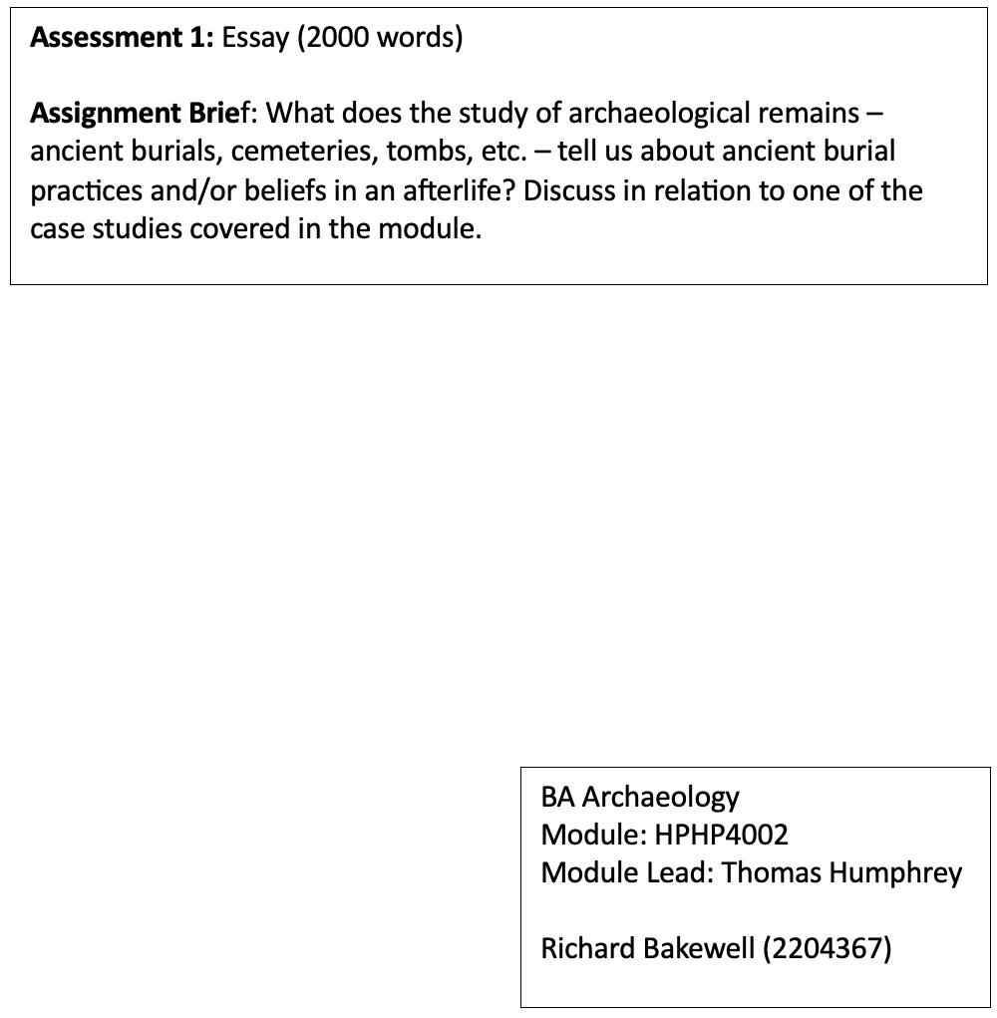

Archaeologists study past funerary practices to understand historical contexts and provide insights into social environments. Burial is a significant act that offers information about funerary practices and social contexts (Parker-Pearson, 2021, pp. 17-23). Archaeologists can reverse the burial process of the deceased, and the objects interred when they open a tomb and investigate its contents layer by layer (Lai, 2015, pp. 189-192). Since 1974, an underground army consisting of several thousand life-sized terracotta soldiers, horses, and war chariots has been excavated from a site located near the burial chamber of the First Chinese Emperor, Qin Shi Huangdi (246-210 B.C.), in Lintong, Shaanxi province located approximately thirty-five kilometres east of the provincial capital of Xi'an (Ledderose, 2000, pp. 51-73; De Gruyter, 2015; Shi, 2014). This discovery has gained widespread recognition as one of the most magnificent archaeological findings of the twentieth century (Kesner, 1995).
This essay will explore Chinese beliefs about the afterlife during the reign of Qin Shi Huangdi. The focus will be on analysing the reason the terracotta warriors were created and their significance in the Emperor's belief in the afterlife, his fear of death, and his pursuit of immortality. During his reign, the Emperor's soldiers played a crucial role in conquering and maintaining dominance over China. The terracotta soldiers were created in their likeness to allow the Emperor to protect him and allow him to continue to rule in the afterlife.
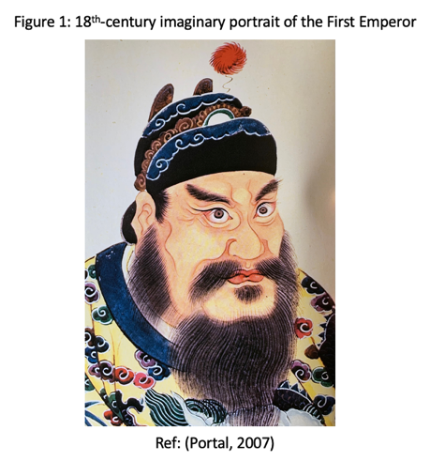
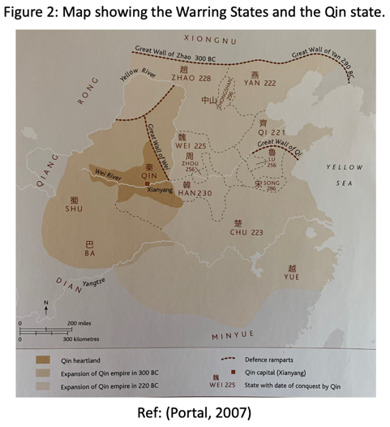
Qin Shi Huangdi is a highly significant historical figure in Chinese and world history (See Figure 1). Originally known as King Zheng of Qin, he conquered the Six States, which marked the end of the Warring States period and the unification of the territory now recognised as China (See Figure 2). In 221 B.C., the Chinese Empire was established when he declared himself as the ruler (Rawson, 2002; Portal, 2007, p. 30) and named himself Qin Shi Huangdi, which translates to the First August Emperor of Qin or Great August Thearch with its spiritual undertones (Rawson, 2023, pp. 327-360). The Emperor regarded himself as a supreme ruler with cosmic authority (Portal, 2007, pp. 114-151). Much speculation existed surrounding cosmology during the late Warring States and early Empires era (Lai, 2015, pp. 1-24). The concept of immortality had a distinct meaning in the East compared to the West. The term ' bu si ' in Chinese translates to 'non-death' and was the form of immortality the First Emperor of China sought to achieve (Portal, 2007, pp. 114-152). It was believed that every person had two souls: the hun soul and the po soul (Hung, 2009). The spirit soul would depart to the land of immortals after death, while the earth soul would stay with the body during burial. It was essential to attend to both souls to ensure they found peace. The governance system in the spirit world resembled the Chinese Kingdom, where individuals could use the same objects they had used in their previous life in the next life, and the key to these objects was realism (Man, 2018, pp. 107-145). Since the po soul cannot leave the tomb, it turns it into a replica of the deceased individual's house where it can reside, just as it did during life (Lewis, 2010, p. 199). The Emperor sought physical immortality by consulting with alchemists who recommended mercury-containing pills and potions (Portal, 2007, p. 21). Multiple voyages were despatched to the far eastern sea to find the legendary lands of Penglai, Yingzhou, and Fangzhang to find the elusive herbs and plants that held the key to immortality, but these proved fruitless. He passed away unexpectedly while on a tour of the eastern region in 210 B.C., possibly due to the consumption of mercury pills because of his pursuit of immortality (O'Connor and Weatherall, 2019, p. 46).
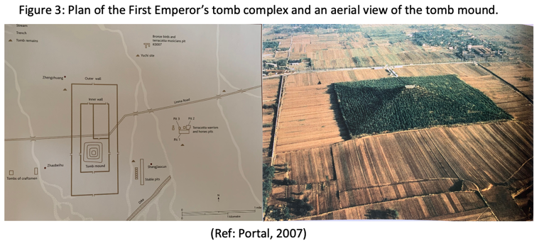
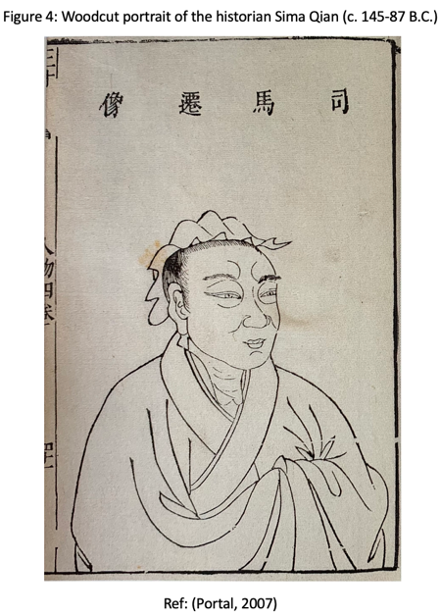
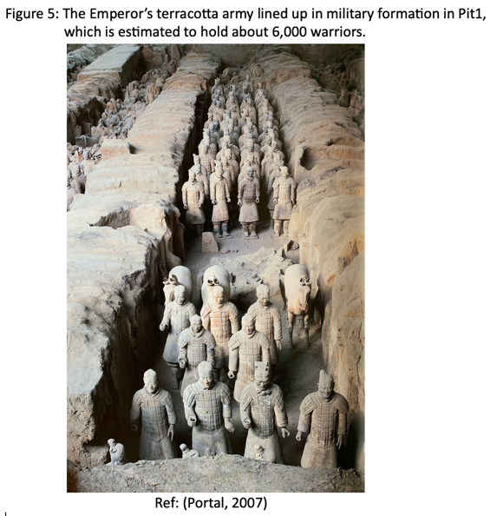
The Emperor constructed the grand tomb complex (See Figure 3) to facilitate his power on his journey into eternity, desiring to be considered a universal and eternal ruler (Portal, 2007, p. 114-151). Chinese rulers' tombs have been a significant concern since ancient times (Ledderose, 2000, pp. 51-73), and to ensure their occupants lived on after death, they were designed as miniature replicas of the world they knew in life (Portal, 2007, p. 114-151). The First Emperor's burial compound was built at a critical moment when his power was matched by his ability to command vast economic resources and exert exclusive authority over visual representation (Kesner, 1995). The burial of the Emperor included intricate bronze chariots, depictions of the cosmos on pottery, paintings, as well as the terracotta warriors (Selbitschka, 2015). After his death, the Emperor planned to govern his empire from his tomb, a miniature replica of his palace, as described by Sima Qian, the Grand Historian (See Figure 4), in his book 'Records of the Historian'. The construction of the tomb began shortly after the young prince, who was only thirteen years old at the time, became the King of Qin in 247 B.C. (Ledderose, 2000, pp. 51-73). Following the king's rise to Emperor plans for his tomb were expanded to a grander scale. With the conclusion of the military campaigns, many conscripts became available, and over seven hundred thousand men were recruited from all parts of the realm to construct the Emperor's tomb. The majority of these individuals were enslaved labourers, forced labourers, and prisoners. It is believed that work on the terracotta army began during this period (Ledderose, 2000, pp. 51-73). During the creation of the Emperor's burial compound, there was a significant shift in Chinese art. The change gradually moved towards representational concerns and psychological realism, often described as a progression from decoration to representation (Kesner, 1995). In ancient Chinese culture, it was customary to furnish graves with a wide range of sacrificial goods as a crucial part of the mortuary practice. The Li Ji and Zhouli texts from the late Zhou dynasty mention a specific type of object called mingqi or spirit vessels meant to be buried with the deceased (Kesner, 1995). They were designed to act as substitutes for real people who could not be buried with their masters for various moral and economic reasons. These surrogate beings were created to compensate for the absence of real individuals and render the same service to the tomb occupant in the hereafter, just as their models did in worldly life (Kesner, 1995). These spirit vessels are epitomised by the 7,000 life-size terracotta figures ready to serve their Emperor in the afterlife (Rawson, 2002). The authenticity of the army is convincing, and its completeness is also notable. Nonetheless, at its creation, neither the Emperor's allies nor his foes could see the army as it was hidden in underground structures. Given these circumstances, it is highly improbable that the army's impact was in its ability to impress the living but was created solely for the Emperor's service in the afterlife (Rawson, 2002). The terracotta army exemplifies the First Emperor's unwavering belief in an afterlife and his desire to remain the Emperor even after death. The primary objective behind the creation of the terracotta army was to provide unwavering loyalty and service to the Emperor in his eternal reign beyond life. The army was explicitly intended to safeguard the tomb and guarantee the Emperor's everlasting rest (Kesner, 1995).

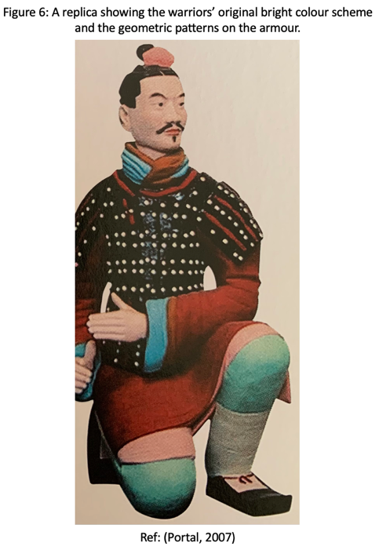
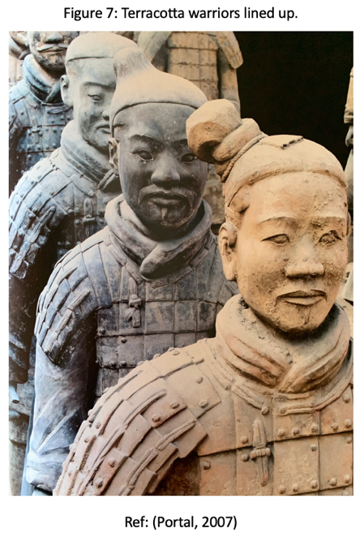
The terracotta army (See Figure 5) is located near the tomb of the Emperor. The burial compound also houses structures like a funerary precinct, sacrificial pits, and auxiliary burials. However, the most prominent feature is the terracotta army. According to the widely accepted theory, the underground army was created as a copy of the Qin Army. The figures made of clay, which included soldiers and horses, represent the army of Qin Shi Huang and stand in place of the actual soldiers. Clay is an affordable and easy-to-handle material used in large-scale manufacturing for over a thousand years (Man, 2018, pp. 175-213). The First Emperor united the nation with a balanced army of archers, infantry, and charioteers. Unity was crucial in the afterlife, where soldiers were believed to continue being a part of life in the tomb (Man, 2018, pp. 175-213). The army is a complete garrison facing East and are renowned for their remarkable realism. Every warrior is carefully designed with intricate details, including unique hairstyles and features. They differ in terms of build, expression, and posture. Due to prolonged exposure to dry air, their colours have faded, causing them to lose some of their original realism. These warriors were not created as a memorial (Hu et al., 2022). Originally, the warriors were painted in authentic colours (See Figure 6) and equipped with fully functional bronze weapons, making them even more lifelike and distinctive (Ledderose, 2000, pp. 51-73). The precision and attention given to their creation were crucial. If not for this level of accuracy, they would be unfit to function as a military force (Rawson, 2023, pp. 327-360). The terracotta warriors were created to represent soldiers accurately and exhibit diverse facial features to replicate actual army units. These statues resemble individuals from the northern and western Chinese populations and can be considered three-dimensional portraits of the Qin people (Hu et al., 2022). Experts debate whether the terracotta army was modelled after real soldiers or if the faces were created based on general stereotypes. Some archaeologists and authors believe that the lifelike features of the figures suggest they were based on actual warriors (See Figure 7). However, most scholars argue that the faces of the clay soldiers follow specific patterns and are unlikely to represent individual people (Kesner, 1995). The First Emperor commissioned the terracotta army to protect himself and his afterlife palace from potential threats (Rawson, 2023, pp. 327-360). The reason why terracotta figures were used for the army instead of actual soldiers is unclear, but opinions can be offered. Some could argue that it was a logical decision not to bury real soldiers underground, as they could no longer continue to protect the empire he left behind and would, therefore, leave it considerably weakened. However, human victims were sacrificed and buried with the Emperor, including mausoleum workers (Bonnechere, 2013, pp. 153-173; Ma, 2016). The creators of the terracotta army aimed for durability, quick completion, and realistic appearance. To make the army appear convincing as a fighting force, the number of soldiers had to be significant, approaching or equalling that of a real army. The figures also needed to have enough variety to avoid being lifeless mannequins. The makers of the army worked hard and ingeniously to achieve these goals, and clay was the most suitable material for the task (Ledderose, 2000, pp. 51-73). Figurines of soldiers, although small, were still being placed within or beside significant tombs of the later Han dynasty. However, life-sized representations were not included, and therefore, the First Emperor’s terracotta warriors are unique (Rawson, 2023, pp. 327-360).

During the Warring States period, the Emperor's army played a crucial role in unifying other states, as evidenced by its presence and enormous size in the terracotta army. To the Emperor, his army was his existence, and he knew its incredible strength. This is why it is present in his tomb, giving him the authority and power to rule eternally as the supreme ruler. As the First Emperor, he needed a large army in life and death to continue his reign. His warriors were essential in carrying out his orders in the spirit realm, demonstrating how much he relied on and trusted his army. To cope with his fear of death, the Emperor made sure that all his earthly possessions would be with him in the afterlife. This way, he hoped to alleviate his intense fear and to feel more secure. The Emperor's anxiety about death is evidenced by his desire to have every element of his life, including his soldiers, accompany him to his burial chamber. The terracotta army was created to serve as a vessel for the Emperor's actual army, allowing them to be with him in death. He believed that his po soul would continue to exist within his tomb, so he felt it necessary to include everything from his life in the burial chamber. Building the Emperor's army of spirit vessels held immense significance for him, as sacrificing his actual soldiers to accompany him in the afterlife was not a practical option. Doing so would have weakened his newly formed empire. It is worth considering whether the Emperor's pursuit of immortality was driven by a fear of death rather than a desire for eternal rule.

REFERENCES

Bonnechere, P. (2013) Sacrifices humains, Human sacrifice. Liege: Presses Universitaires de Liege. Available at: https://books.openedition.org/pulg/8173?lang=en#:~:text=63%20Human%20victims%2C%20young%20women,in%20the%20second%20century%20BCE (Accessed: 6 March 2024).

De Gruyter, W. (2015) ‘Emperor Qin Shihuang’s Mausoleum site in Xi’an’, Chinese Archaeology, 15(1). Available at: https://doi.org/10.1515/char-2015-0004

Hu, Y. et al. (2022) ‘Measurement and analysis of facial features of terracotta warriors based on high-precision 3D point clouds’, Heritage Science, 10(1), pp. 1–23. Available at: https://doi.org/10.1186/s40494-022-00662-0

Hung, W. (2009). ‘Enlivening the Soul in Chinese Tombs’, Anthropology and Aesthetics, 55/56, pp. 21–41. Available at: http://www.jstor.org/stable/25608834 (Accessed: 29 February 2024).

Kesner, L. (1995) ‘Likeness of No One: (Re)presenting the First Emperor’s Army’, The Art Bulletin, 77(1), pp. 115–132. Available at: https://doi.org/10.2307/3046084

Lai, G. (2015) Excavating the Afterlife: The Archaeology of Early Chinese Religion. University of Washington Press.

Ledderose, L. (2000) ‘A Magic Army for the Emperor’, Ten Thousand Things: Module and Mass Production in Chinese Art, 46, pp. 51–73. Available at: https://doi.org/10.2307/jj.5425913.7

Lewis, M.E. (2010) The early Chinese empires: Qin and Han. 1st edn. Cambridge, Mass: Belknap Press of Harvard University.

Ma, Y. et al. (2016) ‘Tracing the locality of prisoners and workers at the Mausoleum of Qin Shi Huang: First Emperor of China (259-210 BC)’, Scientific Reports, 6(1), p. 26731. Available at: https://doi.org/10.1038/srep26731

Man, J. (2018) The Terracotta Army: China’s First Emperor and the birth of a nation. 3rd edn. London: Transworld Publishers.

O’Connor, C. and Weatherall, J. (2019) ‘Polarization and Conformity’, in The Misinformation Age. Yale University Press. Available at: https://doi.org/10.2307/j.ctv8jp0hk

Parker Pearson, M. (2021) The archaeology of death and burial. Gloucestershire, England: The History Press.

Portal, J. (2007) The First Emperor: China’s Terracotta Army. 1st edn. The British Museum Press.

Rawson, J. (2002) ‘The power of images: the model universe of the First Emperor and its legacy’, Historical Research: The Bulletin of the Institute of Historical Research, 75(188), pp. 123–154. Available at: https://doi.org/10.1111/1468-2281.00144

Rawson, J. (2023) Life and Afterlife in Ancient China. 1st edn. Milton Keynes: Penguin Random House.

Selbitschka, A. (2015) ‘Miniature tomb figurines and models in pre-imperial and early imperial China: origins, development and significance’, World Archaeology, 47(1), pp. 20–44. Available at: https://doi.org/10.1080/00438243.2014.991801

Shi, Jie. (2014) ‘Incorporating all for one: The First Emperor’s tomb mound’, Early China, 37, pp. 359–391. Available at: http://www.jstor.org/stable/24392469

