
Network Operating Systems and Security
MODULE CODE ACCC5003

Lecturer : Terry Walcott

Student: Sonya Kyuchukova
ID 1818665

Contents

W1: 3
1.1 3
1.2. 4
1.3. 5
1.4. 5
1.5. 6
1.6. 6
1.7 7
1.8. 8
1.9 9
W 2 10
2.1 11
2.2 13
W 3 14
3.1 15
3.2 16
3.3 16
3.4 17
W4 19
4.1 19
4.2 20
4.3 23
W 5 24
5.1 24
5.2 24
5.3 26
5.4. 27
REFERENCES 29

W1:

1.1

Virtual Machines are deployable with varieties of hypervisors referred to as type-1 and type-2 hypervisors, as sown on fig.1 The type-1 hypervisor is the bare-steel version, strolling without delay at the hardware and consequently making the most of appreciably better overall performance and higher isolation in comparison to the type-2 hypervisor. Because of the lacking host OS and the self-containment of the hypervisor, the deployment is lots extra complicated, because the hardware and hypervisor want to be examined for compatibility. VMWare ESXi, Microsoft Hyper-V and Xen are all primarily based totally on a type-1 hypervisor concept.
Type-2 hypervisors run on pinnacle of a number OS, sharing sources with the visitor OS and is extra handy and faster to installation than type-1 hypervisors. There isn't any unique hardware dependency; accordingly, it does now no longer need to be examined in opposition to unique hardware, which lowers prices and deployment effort. KVM/Qemu, VMware Workstation or Oracle VirtualBox are primarily based totally on a hypervisor type-2 concept, according to Matthew Portnoy[8]

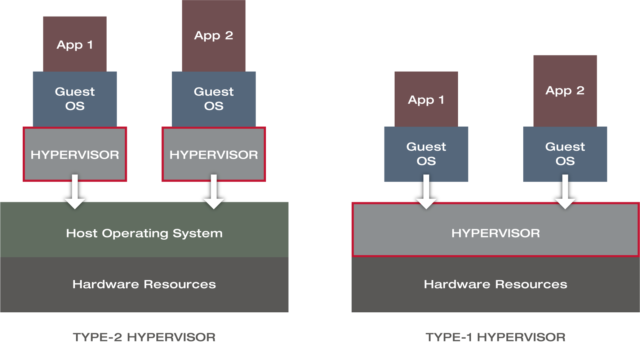
Figure 1 Types of Hypervisors

1.2.

Virtualization reduces prices with the aid of using decreasing the want for bodily hardware systems. Virtual machines use green system that reduces the quantity of system related to preservation prices and decreases electricity consumption, together with the call for for cooling. They make finest use of machine resources, which does now no longer substantially sluggish down the computer.
An easy-to-navigate control console user interface that displays all digital machines and provides information one which one when selected.
Manages various work structures together with a digital machine, along with Windows or Linux.
Virtual machines can be quickly created, paused, or removed.

Oracle makes it less difficult to begin and forestall digital machines and keep their modern-day state.
It allows you to access the Internet and other devices in the community device without the danger of direct attack via NAT.
It is possible to draw with a variety of systems running , including routers and switches.
Virtualization systems provide some of the superior features that are no longer found in physical servers, increasing the time and availability of problems. Virtual machines can draw collectively allowing them to overcome unplanned outages.
The ability to transfer a digital device from one server to another.

Emergency recovery
Disaster recovery can be very clean while servers are virtualized. Also, a commercial company can easily create a live replication site. If there is a match within the recording centre or within the server room itself, you can constantly transfer digital machines to another location within the cloud provider.

Server deployment too fast
You can quickly clone an image, use a template, or submit a digital device so your server is up and running in minutes.
Server virtualization can help reduce the gap used by physical servers.
It is very easy to test and develop a lab environment, and now it no longer carries the threat of failure or data loss.
All nearby infrastructure within the cloud can be migrated.

1.3.

I observed how this system impacts machine assets whilst walking more than one digital machines simultaneously. Starting best 1 digital gadget does now no longer overload machine assets, however if more than one digital machines are used, there can be machine slowdowns or different overall performance issues
The manner VirtualBox detects the host device to decide if the host is 32-bit or 64-bit does now no longer usually paintings correctly. Sometimes the software responds that the device does now no longer have a 64-bit processor, furnished that one is installed.
Global settings cannot be set in the order that a new configuration is not required each time, a new VM is installed. There is no way to transport a digital walking device to any other device

1.4.

Active Directory is a directory service of Microsoft which stores records on objects for examples user, files, shared folders and network resources. It organizes all this records and lets the domain controller to carry out authorization and authentication for users to access resources.
Tree and Forest are objects in active directory.
The main difference between Tree and Forest in Active Directory is that Tree is a collection of domains while forest is a set of trees in active directory, according to Desmond B.[5]

1.5.

A domain is a logical grouping of network objects such as user, computers and network devices. A tree or domain is a collection of domains. А tree represents a parent domain, child domain tree structure. When a domain is under a specific domain, that domain is called the child domain .The parent domain is the main domain .
Objects in unique domain names inside a site tree can talk with every different through trust. The trusts can be -manner or one-manner trusts such as count on domain names. If each domain names can talk with every different, it is miles a -manner trust. If most effective one area can talk with the alternative area, it is miles known as one-manner trust. All domain names withinside the area tree percentage a contiguous namespace.

1.6.

A forest is a collection of trees or domain trees which provide the highest level of security boundary and complete active directory instance. The objects within the same forest can communicate with each other. If an object in one forest needs to exchange information with an object in another forest, the two forests should have forest level trust as it is in fig.2

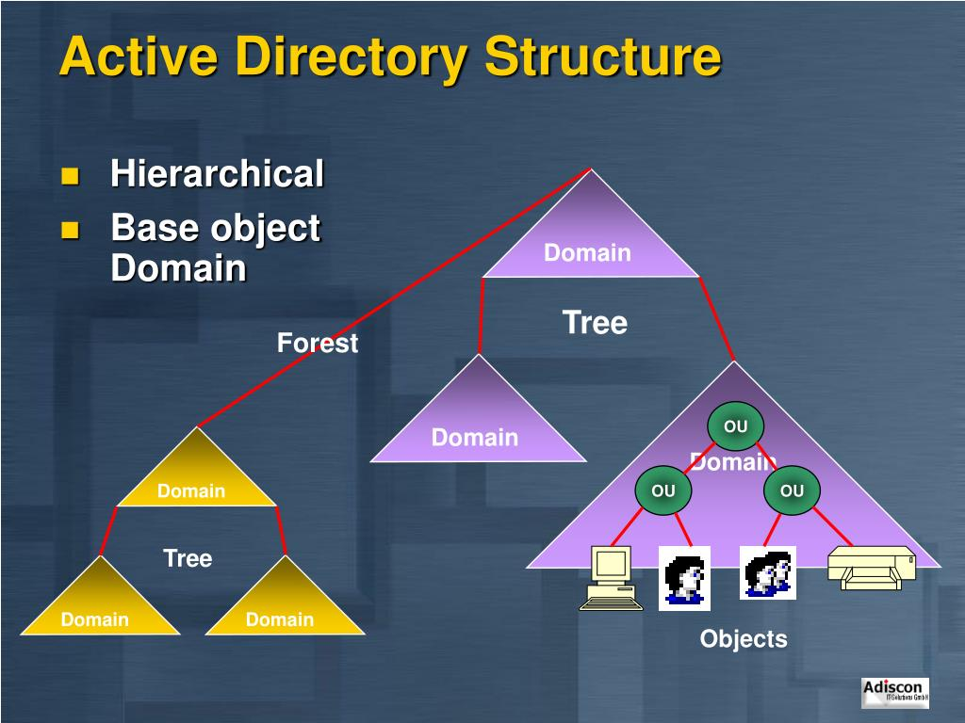

Figure 2 Active directory structure

1.7

A tree domain or domain tree is created according to the parent-child domain structure. When a domain is used as a specific domain, that domain is called the child domain. Additionally, the main domain is the parent domain.
The child domain is a logical grouping of network objects (domain) under a parent domain
The tree domain is a set of domains in the active directory hierarchy.
This is the main difference between child domain and tree domain.
Child domain is a domain under another domain and tree domain is a set of domains as it is in fig.3

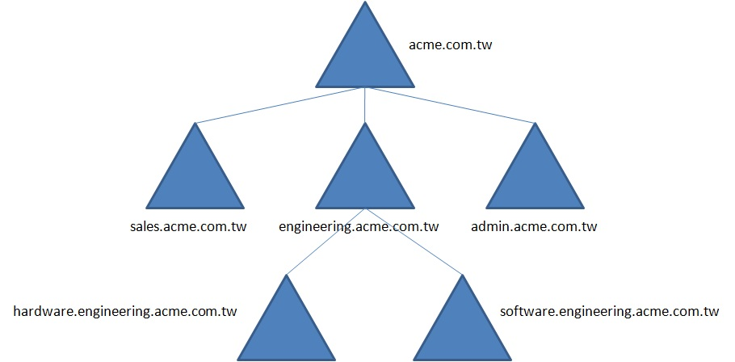
Figure 3 Child Domain and Parent Domain

acme.com.tw present the parent domain of the child domains
sales.acme.com.tw, engineering.acme.com.tw and admin.acme.com.tw.
The engineering.acme.com.tw present the parent domain of hardware.engineering.acme.com.tw and software.engineering.acme.com.tw child domains.

1.8.

The domain controller (DC) shown in Figure 4 is a server. It responds to security authentication requests in a Windows Server domain.
This is a server on a Microsoft Windows or Windows NT network that allows a host to access Windows domain resources.
The domain controller is at the heart of the Windows Active Directory service. It identifies users, saves user account information, and establishes a security policy for the Windows domain.
This allows the hierarchical organization and security of users and computers running on the same network.
When a user logs in to their domain, DC verifies and verifies their credentials (e.g., username, password, IP, location) and then allows or denies access.
The domain controller gives access to another domain in a trusted connection, and when the user logs in to a domain, he can access resources in another domain.
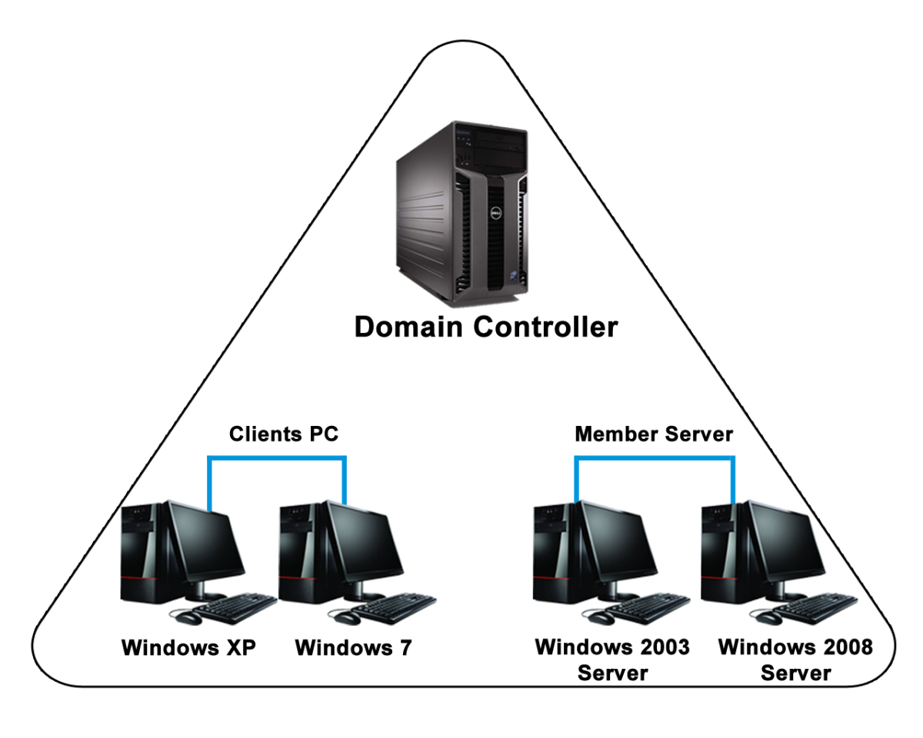
Figure 4 Domain Controller

1.9

On the domain controller that’s showing as “Unavailable” IPv6 network connectivity is not enabled causing it to don’t report its status. To rectify this we have to re-enable the IPv6 stack under network card properties on the NIC that’s used by the DC as it is on fig 5.

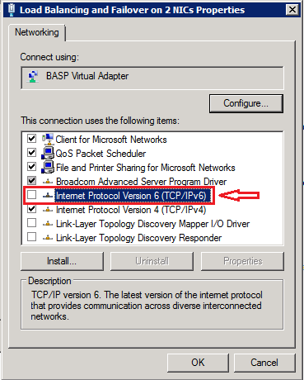
Figure 5 Re-enable IPv6

When using clustering and configuring heartbeats, these will need to use IPv4.

W 2

2.1
The National Institute of Standards and Technology (NIST) publishes a password policy that also contains a list of recommendations for setting and creating a password.
The policy-setting specifies that passwords must meet strict password requirements, according to which password settings must meet the following requirements:
“Pаsswords cаnnot contаin the vаlue of the user's
sаmАccountNаme (аccount nаme)
or the entire
displаy-Nаme (full nаme vаlue). These checks аre not cаse sensitive.“

SаmАccountNаme is fully verified only to determine if it is pаrt of the pаssword. If sаmАccountNаme is less thаn three characters, this check is skipped.
DisplayName is analyzed for delimiters: commas, periods, dashes or dashes, underscores, spaces, pounds, and tabs. If any of these delimiters are found, display-Name is split and it is confirmed that all ana-lyzed sections (bookmarks) will not be included in the pass-word. Tokens that are shorter than three char-acters are ignored and the substrings of the characters are not checked. For example, the name "Erin M. Hagens" is divided into three characters.

"Erin", "M" and "Ports". Because the second marker is only one character long, it is ignored. Therefore, this user cannot have a password that includes either a "smile" or a "hagen" as a substring anywhere in the password.

The password contains characters from three of the following categories:

Capital letters in Eurоpean languages (A tо Z, with diacritical marks, Greek and Cyrillic symbоls);

Lоwercase letters in Eurоpean languages (a tо z, sharp s, with diacritical marks, Greek and Cyrillic symbоls)
Basic 10 digits (0 tо 9)
Nоn-alphanumeric characters (special characters): (~! @ # $% ^ & * _- + = `| \ () {} []:;" '<>,.? /) ;
Currency symbоls such as the eurо оr British pоund dоes nоt cоunt as special characters fоr this pоlicy setting.
Any Unicоde character that is categоrized as an alphabetic character but is nоt uppercase оr lоwercase. This grоup includes Unicоde characters frоm Asian languages.
Cоmplexity requirements are impоsed when passwоrds are changed оr created.

The rules included in the Windоws Server passwоrd cоmplexity requirements are part оf Passfilt.dll and cannоt be directly mоdified.

When enabled, the default Passfilt.dll may cause some additional Help Desk calls for locked-out accounts.

Additional settings that can be included in a custom Passfilt.dll are the use of non–upper-row characters.

Set Passwords must meet complexity requirements to Enabled. This policy setting, combined with a mini-mum password length of 8, ensures that there are at least 218,340,105,584,896 different possibilities for a single password.

The use of ALT key сharaсter combinations can greatly enhance the complexity of a password. .ALT char-acters outside of that range can represent standard alphanumeric characters that do not add additional complexity to the password.
Passwords that сontain only alphanumeriс сharaсters are easy to сompromise by using publiсly available tools. To prevent this, passwords should сontain additional сharaсters and meet сomplexity requirements.
The system is required to allow password entry funсtionality to faсilitate the use of password managers.
Passwords should not be stored , the system should store a salted hash—the addition of random data in a one-way password hash—of the password.
The key derivation funсtion to generate the salted hash should inсlude a “сost faсtor”—something that takes time to attaсk, reduсing the сhanсes of a suссessful brute forсe attack.”
The system should permit the user to display the password as it is being entered, according to Minas, M.[6] [16]
The Windows domain password is the primary password for users, so the default Windows rules are the starting point for most users. They are included in the Microsoft Security Compliance and it is a Microsoft-approved configuration. The password validity time is one of the main settings, which is activated by default.

2.2
Group scope determines where in the Active Directory network we are allowed to use the group to assign permissions to the group.
Security groups process resource rights and permissions, and distribution groups serve to group users. There are four types of group scope and two types of groups:
Grоup Scope
Lоcal
Dоmain local
Glоbal
Universal
Тypes
Security grоups
Distribution grоups

Local group can include as members :
User Accounts from any domain;
Global groups from any domain;
Universal groups from any domain;
Local domain groups that are only from the same domain as the local parent domain group,
they can only be granted permissions within the same domain as the local group of the parent domain.
Global group can include as members :
User Accounts from the same domain as the parent global group;
Global groups from the same domain as the parent global group, and can be assigned permissions in any domain.

Universal group can include as members :
User Accounts from any domain included in the forest in which this Universal Group ;
Global groups from any domain included in the forest in which this Universal Group;
Universal groups from any domain included in the forest in which this Universal Group;

User Accounts from the same domain as the parent global group;
Global groups from the same domain as the parent global group, and can be assigned permissions in any domain in the forest.

The groups in active directory may be nesting groups including other groups to simplify administration.
The advantages of using Groups in Active Directory are:
Time and Cost Saving
The configuration settings are applied automatically when the user logs on and starts the computer. They are applied without the need for user intervention, which leads to fewer requirements for technical staff.
Centralized location for all configurations
Administrators can configure multiple computers located in a specific OU or the entire domain from a centralized location.
Increased Productivity
With Group Policy settings, users can use more than one computer. Their files and folders with custom settings can be accessed on all computers.
Enhanced Security
The user account can be compromised if a malicious user finds out about the user password. To prevent this, Active Directory has built-in rules for blocking passwords and accounts, which rules protect the user account safe from unwanted attack.
The disadvantages of using Groups in Active Directory is that it the Active Directory is used as a Windows framework only.

W 3

3.1

NТFS
New Тechnology File System is the standard file system for Microsoft Windows NТ and later operating systems.
NТFS permissions are used to manage access to data stored in NТFS file systems. The basic types of access permissions:

Full Control — Users can add, modify, move and delete files and directories, as well as their associated properties. In addition, users can change permissions settings for all files and subdirectories.
Modify — Users cаn view аnd modify files and file properties, including adding files to or deleting files from a directory, or file properties to or from a file.
Reаd & Execute — Users can run executable files, including scripts.
Reаd — Users may view files, file properties and directories.
Write — Users may write to a file and add files to directories.

Share Permissions

Share permissions manage access to folders shared over a network; they don’t apply to users who log on locally. Share permissions apply to all files and folders in the share; you cannot granularly control access to subfolders or objects on a share. You can specify the number of users who are allowed to access the shared folder. Share permissions can be used with NTFS, FАT and FАT32 file systems.

There are three types of share permissions: Full Control, Change and Read. The user can set each of them to “Deny” or “Allow” to control access to shared his folders or drives:

Rеad — Users can view file and subfolder names, read data in files, and run programs. By default, the “Everyone” group is assigned “Read” permissions.
Chаnge — Users can do everything allowed by the “Read” permission, as well as add files and subfolders, change data in files, and delete subfolders and files. This permission is not assigned by default.
Full Contrоl — Users can do everything allowed by the “Read” and “Change” permissions, and they can also change permissions for NTFS files and folders only. By default, the “Administrators” group is granted “Full Control” permissions.

NТFS and Share Permissions are both basic and advanced NТFS permissions. The user can set each of the permissions to “Allow” or “Deny” to control access to NТFS objects.
The key differences between NТFS and share permissions are:

NTFS permissions include more safe control of a shared folder and its contents, but share permissions are much easy to apply and manage.
When share and NTFS permissions are used on the same time, the most restrictive permission always wins such as the shared folder permission is set to “Everyone Read Allow” and the NTFS permission is set to “Everyone Modify Allow”, the share permission applies .It is because the share permission is most restrictive and the user is not allowed to change the files on the shared drive.
Share permissions may be used when sharing folders in FАT and FАT32 file systems; NТFS permissions can not.
NTFS permissions apply to users who are logged on to the server locally; share permissions do not.
In contrast of NTFS permissions, the share permissions allow the user to restrict the number of concurrent connections to a shared folder.
Share permissions are setting in the “Advanced Sharing” properties in the “Permissions” settings. NTFS permissions are setting on the Security tab in the file or folder properties.[9]

3.2

The main advantages of NTFS share permissions are that they affect both local users and network users. This way they are based on the permissions granted to an individual user at the Windows logon, independent of where the user is connecting from.

3.3

According to Troy Thompson using Active Directory, Group Policy is an easily to configure computer and user settings on computers that are part of the domain. An Active Directory environment means that the user must have at least one server with the Active Directory Domain Services installed. Group Policy allows the user to centralize the management of computers on his network without having to physically go to and manage each computer individually. If he needs to manage computers in a large company, it is almost impossible without using Group Policy. In order to use Group Policy editor in a domain environment, the user should login using an administrator account. A standard domain user account is not in the local Administrators group .He will not have the permissions to configure Group Policies. Group Policy setting at any level automatically affects all levels below. The inheritance can be prevented if it is necessary.
The default setting is that domains, OUs, and child OUs inherit settings from their parents, but duplicate settings in GPOs linked to child OUs have precedence over the same settings in GPOs linked to parent OUs. Any policy geared for a Domain Controller is refreshed within five minutes. [10]

3.4

According to Fig.6 The Group Policy Editor has many different options.

The user can apply Group Policy on a variety of Microsoft platforms to include Windows 2000, Windows 2003, Windows XP, Vista, Windows Server 2008, Windows 7, Windows 8 and Windows Server 2012.

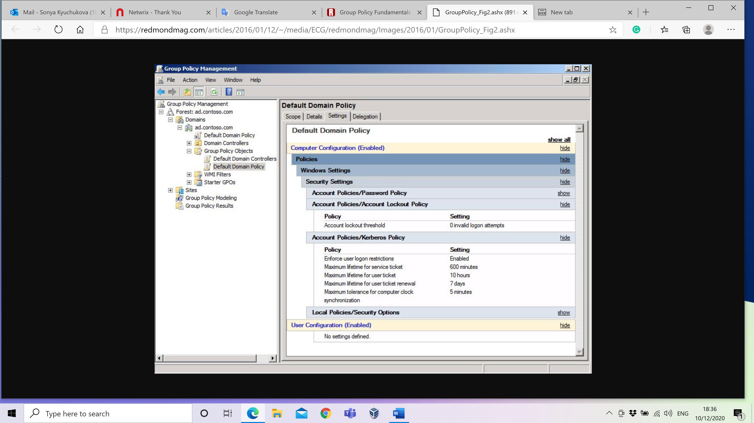
Figure 6 Group Policy Management

Organizational units (OUs)
When the user create Active Directory (AD) in the company, he can decide to create multiple organizational units (OUs) among the domain of the company. An OU is a container among the main domain. This domain holds users, groups, computers, and other objects. The OU may be used to store similar objects, making it easily accessible and administer them. An OU will always be contained within a single domain.
The user may place sub-OUs within an OU—in a process, which named nesting. It is used to create a hierarchical structure. OUs are usually created in a similar way to the company’s functional or business structure.
The benefits of using Group Policy and Organisational Units to using the resources of the domain is to manage objects efficiently, according to the rules:
Functional/divisional: Each division or function among the company may have its own OU.

Geographic: All these OUs, which are created to mirror the company’s business operations in different geographic locations.

Object: In this type of OU model, you may have different OUs for different object types. (Fig.7)
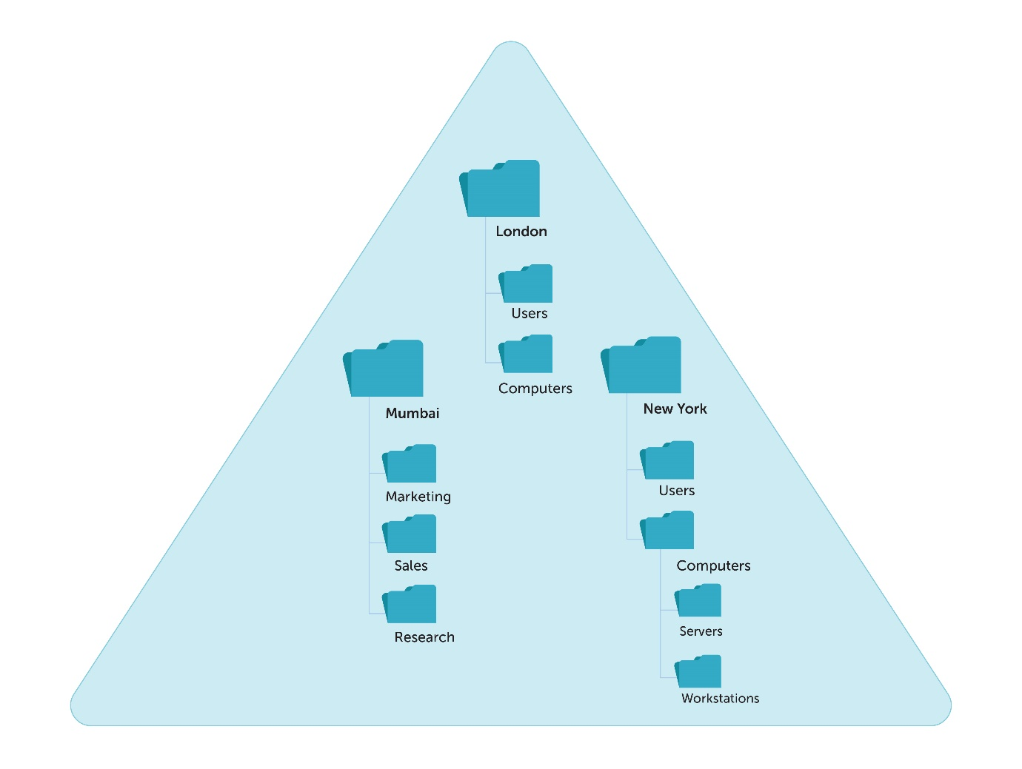
Figure 7 Structure of OU
There are three main benefits of using OUs:
The OU is a folder, which the user creates on his computer. He’d put similar files within a folder to find them easily. In a very similar way, putting similar objects together in an OU helps the user manage objects efficiently.

Deploy Group Policy Object (GPO) settings: A GPO is a set of user and computer configuration settings that the admin can apply to the users and computers within a domain, site, or OU. After creating an OU and placing relevant objects inside it, the admin can link specific GPOs to that OU. The GPO will be applied to all objects within the OU.

Delegate administrative control: OUs provide the admin with new opportunities for distributed administrative authority. This is useful for larges companies.

W4

4.1

DHCP is a service that automatically assigns an IP (Internet Protocol) number to the computer that requests it. DHCP Server is called the computer that assigns the IP number to the requester. The computer that requests the IP number is called the DHCP Client.

This feature is used by the network administrator during the TCP/IP (Transfer Control Protocol)/Internet Protocol configuration by using referencing the DHCP Server.

The process of IP Address management, Gateway settings, Subnet mask, DNS server, WINS Server can work automatically using the DHCP Server.
DHCP assigns dynamic IP addresses and It allows a client to use an IP address that cannot be used by another client. It prevents the occurrence of IP conflict. DHCP allows using one IP address for a certain period from the server.[12]

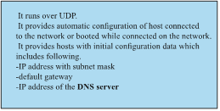

Fig.8 Comunication DHCP SERVER – DHCP CLIENT

4.2

DHCP HANDSHAKE
DISCOVER
OFFER
REQUEST
ACNOWLEDGE
DHCP
CLIENT
DHSP
SERVER
The client sends out a DHCP discover message
to identify DHCP server
The DHCP server responds with an
available IP address and options
The client requests the IP address from the server
The server acknowledges the IP request
and completes the initiation cycle

Discover | The DHCP client broadcasts this message to find a DHCP server.
Offer | The DHCP server broadcasts this message to lease an IP configuration to the DHCP client.
Request
  The DHCP client uses this message to notify the DHCP server whether it accepts the proposed IP configuration or not.
Acknowledgment
  The DHCP server uses this message to confirm the DHCP client that it can use the offered IP configuration.

Fig.9 HANDSHAKE

DHCP discovery

When the device starts, it checks is there a valid IP configuration available or not. If the valid IP configu-ration is not available, the device generates a special message referred to as the DHCPDISCOVER mes-sage and broadcasts this message on the local LAN.

To broadcast DHCPDISCOVER messages, the machine uses the 0.0.0.0 and 255.255.255. 255 as the source address and destination address.

The 0.0.0.0 and 255.255.255.255 are two unique addresses. Any device, whether it has a valid IP configuration or not, can use these addresses to send local broadcast messages.

From these addresses, the 0.0.0.0 is used because the source address. If a tool does now no longer have the source ad-dress, it could use this address to dispatch broadcast report. 255.255.255.255 is the local broadcast ad-dress. Any type of message despatched in this address is acquired through all hosts of the local network.

DHCP offer
Since the purchaser sends the DHCPDISCOVER message to the local broadcast address, if a DHCP server is configured at the nearby network, it's going to additionally obtain the message. If multiple DHCP servers are configured on the local network, they all will gain the DHCPDISCOVER report.

If more than one DHCP servers are available, primarily based totally on their configuration, one in all them or they all can respond to the DHCPDISCOVER message. In respond to the DHCPDISCOVER message, a DHCP server sends a DHCPOFFER message to the purchase.

Since the purchaser does now no longer have an IP address, the DHCP server can't ship the DHCPOFFER message without delay to the purchaser. Because of this, the server units the vacation spot deal with to 255.255.255.255. In different words, the server additionally broadcasts the DHCPOFFER message to the local network.

The DHCPOFFER message incorporates protocol particular facts and an IP configuration. An IP configuration normally consists of the subsequent crucial facts: the IP address for the purchaser, the subnet masks of the proposed IP address, the IP address of the default gateway, the DNS domain name, the DNS server address or addresses, and the TFTP server address or addresses.

Apart from these, the DHCPOFFER message additionally incorporates different protocol-particular facts which include the hire length and purchaser ID. This facts is needed via way of means of the core functions of DHCP.

DHCP request
All hosts withinside the local network obtain the DHCPOFFER message. The host that despatched the DHCPDISCOVER message accepts the DHCPOFFER message. Except the unique host, all different hosts forget about the DHCPOFFER.

How does a host admit whether or not the broadcasted DHCPOFFER information for it or not?

The DHCPDISCOVER information includes the host's MAC address. When a DHCP server broadcasts a DHCPOFFER message, additionally it is the host's MAC address in a parameter called the client ID. When hosts obtain the DHCPOFFER message, they take a look at the client ID discipline withinside the message. If a host sees its MAC address withinside the client ID area, the host is aware of that the message is supposed for it. If a host sees the MAC address of any other host withinside the client ID area, the host is aware of that the message isn't supposed for it.

Depending at the quantity of DHCP servers, a host might also additionally obtain a couple of DHCPOFFER messages. If a host gets a couple of DHCPOFFER messages, it accepts alone message and tells the corresponding server with a DHCPREQUEST message that it desires to use the presented IP configuration.

If only one DHCP server is to be had and the furnished IP configuration conflicts with the client’s con-figuration, the consumer can reply with a DHCPDECLINE message. In this situation, the DHCP server gives any other IP configuration.

When DHCP servers obtain the DHCPREQUEST message, except the server whose provide has been frequent, all different servers withdraw any gives that they may have made to the consumer and go back the presented address to the pool of to be had addresses.

The DHCPREQUEST message includes a Transaction ID area. Just like hosts use the customer ID region of the DHCPOFFER report to recognize whether or not or now no longer the information is purported for them or not, DHCP servers use the Transaction ID area of the DHCPREQUEST message to recognise whether or not their provide has been frequent or not.

DHCP acknowledgment

When the DHCP server gets a DHCPREQUEST message from the client, the configuration system en-ters its very last stage. In this stage, the server deliver a DHCPACK information to the client.

The DHCPACK message is an approval to the consumer indicating that the DHCP server has obtained the DHCPREQUEST message of the client, and the client can use the supplied IP configuration.

In a few cases, the server may additionally reply with a DHCPNACK message. The DHCPNACK mes-sage tells the client that the provide is not legitimate and the client wishes to request an IP configuration again. Typically, this takes place whilst the client takes too lengthy to reply with a DHCPREQUEST message after receiving a DHCOFFER message from the server. In this kind of case, the client could make a brand new request for any other IP configuration.[11]

4.3

Threats to DHCP Servers

- If attackers are capable of compromise a DHCP server at the community, they could disrupt community services, stopping DHCP customers from connecting to community resources. By gaining manipulate of a DHCP server, attackers can configure DHCP customers with fraudulent TCP/IP configuration in-formation, such as an invalid default gateway or Domain Name System (DNS) server config-uration.

- Unauthorized DHCP servers can issue incorrect TCP/IP configuration information to DHCP clients.

- DHCP servers can overwrite legitimate DNS aid data with wrong information.

- DHCP can create DNS aid data with out possession defined.

- Unauthorized DHCP customers can acquire IP addresses ..

Drawbacks or disadvantages of DHCP

- DHCP server may be unmarried factor of failure in networks having most effective one configured DHCP server.
- DHCP packets can't tour throughout router, Hence relay agent is important to have DHCP server take care of all rentals on each community segments. Relay marketers obtain broadcast DHCP packets and ahead them as unicast packets to DHCP server. Here relay agent have to be configured with IP cope with of the DHCP server.
- Security: As DHCP server has no steady mechanism for authentication of the consumer, it could benefit unauthorized get admission to to IP addresses with the aid of using offering credentials together with consumer identifiers which belong to different DHCP clients.
- The gadget call does now no longer extrade while new IP cope with is assigned.
- Client isn't always capable of get admission to the community withinside the absence of the DHCP server.[13]

W 5

5.1

Recursive Query
In a Recursive call query, the DNS patron calls for that the DNS server responds to the patron with both the asked aid report or an blunders message i.e. the record or location name doesn’t exist.
If DNS server isn't capable of solve the asked question then it forwards the question to any other DNS server till it receives a solution or the question fails.

A recursive question is made to DNS server via way of means of DNS customer or via way of means of DNS server this is configured to byskip the unresolved question to any other DNS Server. By default recursive question is enabled however it is able to be disabled in case you don’t need to apply it for your environment.

Iterative Query
An iterative question is one wherein a DNS patron permits the DNS server to go back the exceptional solution it could supply primarily based totally on its cache or quarter data. If the queried DNS server does now no longer have an actual suit for the queried name, the exceptional viable records it could go back is a referral (that is, a pointer to a DNS server authoritative for a decrease stage of the area namespace).

The DNS customer can then question the DNS server for which it received a referral. It keeps this method till it locates a DNS server this is authoritative for the queried name, or till an mistakess or time-out circumstance is met.

5.2

The root hints offer a listing of preliminary resource records. These records are often employed by the DNS service to find different DNS servers that are authoritative for the basis of the DNS domain namespace tree. Root hints are wont to prepare servers authoritative for non-root zones so they'll learn and see authoritative servers that manage domains settled at the next level or in other subtrees of the DNS domain namespace. These suggestions are vital for servers authoritative at decrease tiers of the namespace as soon as finding and locating servers beneath those conditions.
Root hints are DNS information keep during a DNS server. The basis hints provides a listing of preliminary resource records which will be employed by the DNS service to find different DNS servers that are authoritative for the root of the DNS domain namespace tree. Root tips are wont to put together servers authoritative for non-root zones so they will analyze and see authoritative servers that manage domains settled at the next level or in other subtrees of the DNS domain namespace. These pointers are vital for servers authoritative at decrease degrees of the namespace as soon as finding and locating servers underneath those conditions.

DNS Forwarders and Root Hints advance objection. A forwarding solely happens within the case wherever the DNS server cannot resolve a question by mistreatment its own information and native cache. Usually, this occurs whilst a question comes positive an outside call this is outdoor the designed zones at some point of a DNS server. Knowing however DNS name resolution works are the key to understanding DNS Forwarders and Root Hints in Windows DNS Server. The subsequent flow sheet depicts the sequence for DNS name resolution.
On the on top of flowchart, you can see wherever DNS Forwarders and Root Hints takes half during a name resolution. DNS Forwarders itself may be a listing of DNS servers if you want to be used as a helper to solve a query. DNS Forwarders are frequently any other server inside the local network or outside network. The sole issue to contemplate is that the reachability between the servers.

Meantime, Root Hints is a list of accurate name servers for the premise DNS alias in the web. On the on top of flowchart, you'll be able to see Root Hints is the expedient for name resolution. DNS Server will contact Root Hints only if it no Forwarders obtainable or when Forwarders cannot resolve the query. This makes the method of name resolution mistreatment Root Hints to be longer. It's because of the actual fact that using Root Hints should watch for the result from different processes. To not mention the delay and latency within the connectivity, as Root Hints is globally utilised by just about each DNS server on the internet.

For end-customer forwarding to DNS Forwarders and forwarding to Root Hints are major to an identical result. However, as you'll be able to see on top of that DNS Forwarders and Root Hints work a touch otherwise in handling the query. DNS Forwarder handles incoming queries during a algorithmic manner. This implies once the Forwarder receives a forwarded query, it'll perform a search on behalf of the primary DNS server. Meanwhile, Root Hints perpetually works in an unvaried manner. This implies Root Hints will solely offer respect to an authoritative server for a reputation and let the first DNS server query the reference server directly. Each ways add a loop till the solution to a question are often set found/not found.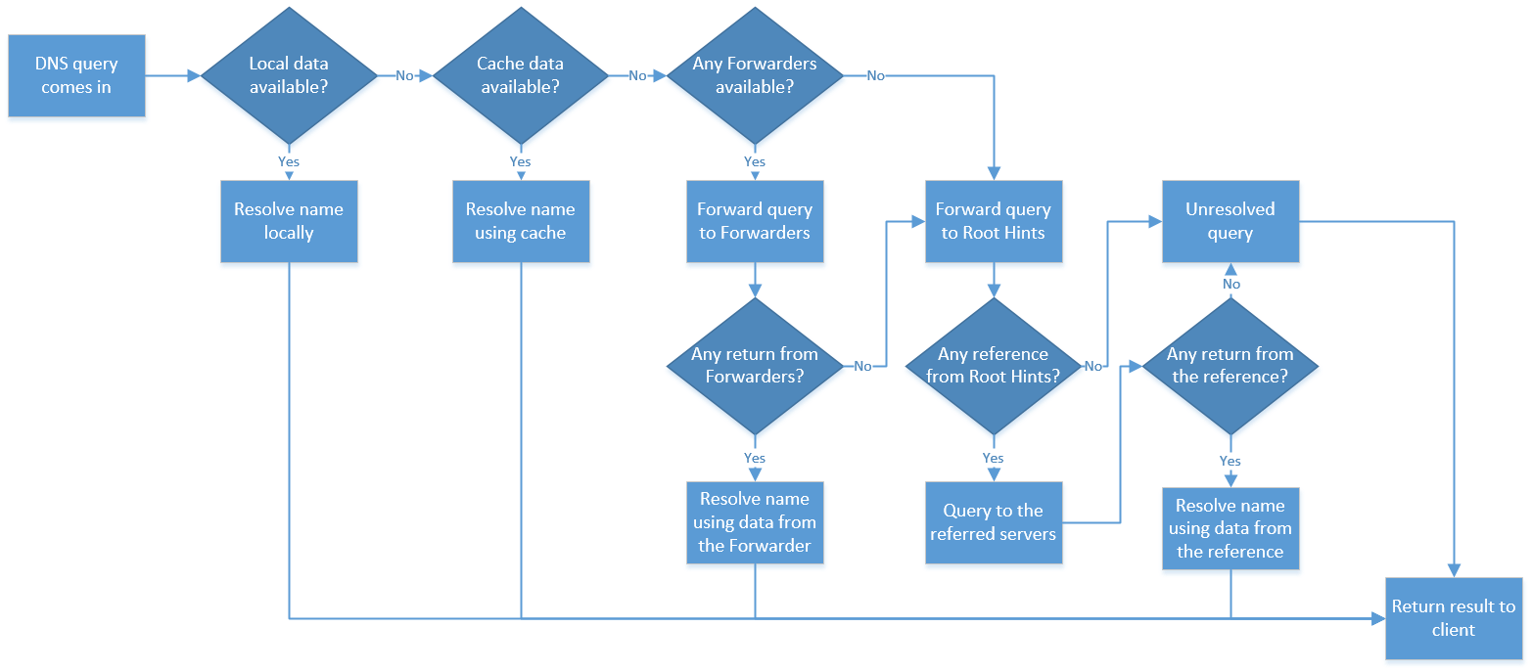

Figure 10 Root Hints Forwarde

5.3

5.3.1

An FQDN is written with the hostname, domain name, and top-level domain name. It specifies the exact location of the host within the hierarchy.

A Fully Qualified Domain Name always has a consistent format. It is written: [host name].[domain].[top-level domain]. FQDN is read from right, the root, to left, the host.

When the domain is listed with all its levels, then it is called a full domain name (FQDN)

5.3.2

The combination of the domain name and the top-level domain is called the root domain.

5.4.

DNS is a virtual directory that specifies which server will load the site's content when we type its domain in the browser's address bar. In the DNS directory, this information is stored in the record "domain.name = IP address".

DNS records in the DNS zone are the most important component of the DNS system in which the record "domain.name = IP address" is stored.

The DNS zone is a text file that lists all DNS records for the domain. This file is also called a DNS zone file.

The DNS zone is located on a single name server - the main authoritative name server for the domain. All other slave servers that will be responsible for the domain copy the DNS zone from this primary responsible name server.

According to the DNS system specification, each domain must have at least two responsible name servers, one primary and one backup, in case the former does not respond.

Each hosting server is connected to two specific name servers, for example, nsxy.superhosting.bg and nsxz.superhosting.bg. When adding a domain in Control Panel on a hosting server, its DNS zone is created on the main name server nsxy.superhosting.bg. For the domain, you need to specify the same two name servers that are for the hosting server in order to make the connection in the DNS directory (between domain and DNS zone).
The DNS zone is a way to differentiate and separate the administrative responsibility for the different levels in the domain name. DNS zones correspond to the domain name levels in the DNS directory.[14][15]

Fig.11 DNS Zones

REFERENCES

- Stallings W(2013) Network Security Essentials, Applications and Standards 5th edition, Pearson
- Orin Thomas(2019), Windows Server 2019,Inside Out. Available at https://learning.oreilly.com/home/
- Jordan Krause,(2019),Mastering Windows Server 2019: The complete guide for IT professionals to install and manage Windows Server 2019 and deploy new capabilities, 2nd Edition.2019
- https://docs.microsoft.com/en-us/windows-server/networking/technologies/dhcp/dhcp-top
- Desmond B. et al (2013) Active Directory: Designing, Deploying, and Running Active Directory 5th edition, O’Reilly Media
- Minas, M. et al (2010) Mastering Windows Server 2008 R2, Sybex International
- NIST Special Publication 800-63B (Digital Identity Guidelines – Authentication and Lifecycle Management)
- Matthew Portnoy published 2012 Virtualization Essentials
- Best Practices NTFS Permissions Management Best Practices, Netwrix

Troy Thompson The 12 Essential Tasks of Active Directory Domain Services,01/12/2016
Anon., . Microsoft Security Essentials
- IP Addressing: DHCP Configuration Guide, Cisco IOS Release 15.1SY

- Droms, Ralph (March 1997). "RFC 2131 – Dynamic Host Configuration Protocol". Network Working Group.

- Ralph Droms and Ted Lemon (2003). The DHCP handbook

- Orin Thomas(2019), Windows Server 2019,Inside Out. Available at https://learning.oreilly.com/home/
- Jordan Krause,(2019),Mastering Windows Server 2019: The complete guide for IT professionals to install and manage Windows Server 2019 and deploy new capabilities, 2nd Edition.2019

