Module: Psychopathological Classifications and Provisions (BMHP6029_BIRM)
Module Code: BMHP6029
written Assignment (Report)
COMPONENT 2
BY
KAREEMOT .A. TIJANI TIJANI.
ID: 2320438

Lecturer: Kennedy Obohwemu
Submission Date: 29th March 2026.

Autism Spectrum Disorder (ASD): ICD-11-chapter 6 Classification, Diagnosis, Treatment, Rehabilitation and Contemporary Debates in the UK
1. Introduction
Autism Spectrum Disorder (ASD) is classified within the ICD-11 Chapter 6 as a neurodevelopmental disorder (code 6A02) (World Health Organization, 2019). It is characterised by persistent differences in social communication and restricted, repetitive patterns of behaviour emerging in early development. ASD has become increasingly prominent within UK health and social care due to improved recognition, rising diagnosis across the lifespan, and growing emphasis on neurodiversity and rights-based practice.
At the same time, autism remains highly contested. While clinical frameworks define ASD as a disorder requiring diagnosis and intervention, neurodiversity perspectives conceptualise autism as a natural variation in human cognition, with disability arising from environmental barriers rather than inherent deficit (Shah et al., 2022; Green, 2023). This creates tension between medical and social models of disability, particularly in relation to diagnosis, language and service provision.
This report critically examines ASD through the lens of ICD-11 classification, diagnostic processes, treatment and rehabilitation approaches within the UK. It further explores contemporary debates regarding identity, diagnostic thresholds and equity, before proposing recommendations to improve outcomes and promote inclusive, rights-based practice.

2. ICD-11 Classification and Diagnosis
2.1 Definition and Classification
Autism is a lifelong neurodevelopmental condition affecting communication, interaction and behavioural patterns. Individuals may experience differences in initiating social interaction, maintaining conversations, sensory processing and engagement in focused interests. The term “spectrum” reflects wide variation in presentation, ranging from individuals requiring minimal support to those with complex and enduring needs.
Within ICD-11, ASD is classified under neurodevelopmental disorders as code 6A02, with subcategories based on intellectual development and functional language ability (World Health Organization, 2019). This structure aims to capture heterogeneity and support clinical clarity.
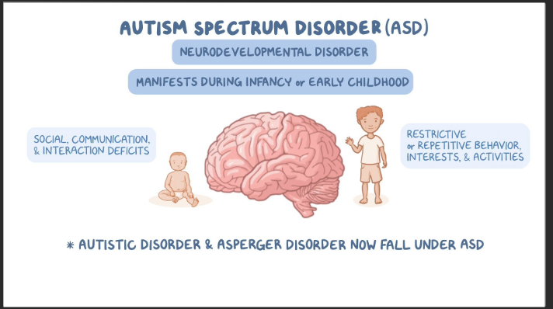However, the classification remains contested. The requirement for “clinically significant impairment” reflects a deficit-oriented model, which conflicts with neurodiversity perspectives that frame autism as difference rather than disorder (Green, 2023).
Critically, this tension highlights that diagnostic classification is not value-neutral but reflects broader assumptions about normality, disability and societal expectations.

2.2 Diagnostic Criteria in ICD-11
ICD-11 characterises autism spectrum disorder by persistent differences in reciprocal social communication alongside restricted, repetitive or inflexible patterns of behaviour, interests or activities that are atypical for the individual’s developmental and sociocultural context (WHO, 2019). These characteristics must be present from the developmental period, although they may become more evident when environmental demands exceed adaptive capacity. ICD-11 further recognises that autistic traits vary in expression across contexts depending on environmental supports (Kamp-Becker, 2024).
A central feature of ICD-11 is its functional emphasis, requiring evidence of clinically significant impact to justify diagnosis and guide access to services (Greaves-Lord, 2022). However, this criterion may disadvantage individuals who mask autistic traits, particularly women and some minority groups, as distress may be internalised and impairment under-recognised (Green, 2023).

2.3 Diagnostic Processes
Diagnosis of ASD involves a multidisciplinary assessment incorporating developmental history, clinical observation, and information from multiple sources. Diagnostic frameworks such as ICD-11 and the DSM-5 define autism through persistent social communication differences and restricted behaviours (American Psychiatric Association, 2013).
Standardised tools such as the Autism Diagnostic Observation Schedule support structured observation, often combined with caregiver interviews such as the ADI-R (Lord et al., 2012).
Epidemiological evidence indicates increasing diagnosis. The Centres for Disease Control and Prevention estimates prevalence at 1 in 31 children (CDC, 2023), while UK estimates suggest around 1 in 100 people are autistic (NHS England, 2019).
Importantly, rising prevalence should not be interpreted as increased incidence, but rather as improved recognition, expanded criteria and greater societal awareness.
Diagnostic systems also face limitations. Females and adults are frequently underdiagnosed due to masking behaviours and historically narrow criteria (Hull et al., 2020).
This demonstrates that diagnosis is shaped not only by clinical criteria but by gendered, cultural and social assumptions, raising concerns regarding equity and access.
In the UK, pathways are guided by the National Institute for Health and Care Excellence, which emphasises multidisciplinary and person-centred assessment (NICE, 2021). However, long waiting times and regional disparities persist (NHS England, 2019).
Delayed diagnosis represents a critical failure within early intervention systems, limiting access to support and increasing risk of mental health difficulties.

2.4 Prevalence of Autism Spectrum Disorder in the UK
Autism Spectrum Disorder (ASD) is estimated to affect approximately 1 per cent of the UK population, equating to over 700,000 autistic people (Office for National Statistics, 2021; NHS England, 2022). This figure reflects improved recognition and diagnostic expansion rather than a confirmed rise in underlying incidence. Recorded prevalence is higher among males, with diagnostic ratios of around 3:1, although evidence suggests this disparity is partly driven by under-diagnosis in females, particularly those who mask autistic traits or present without intellectual disability (Green, 2023). 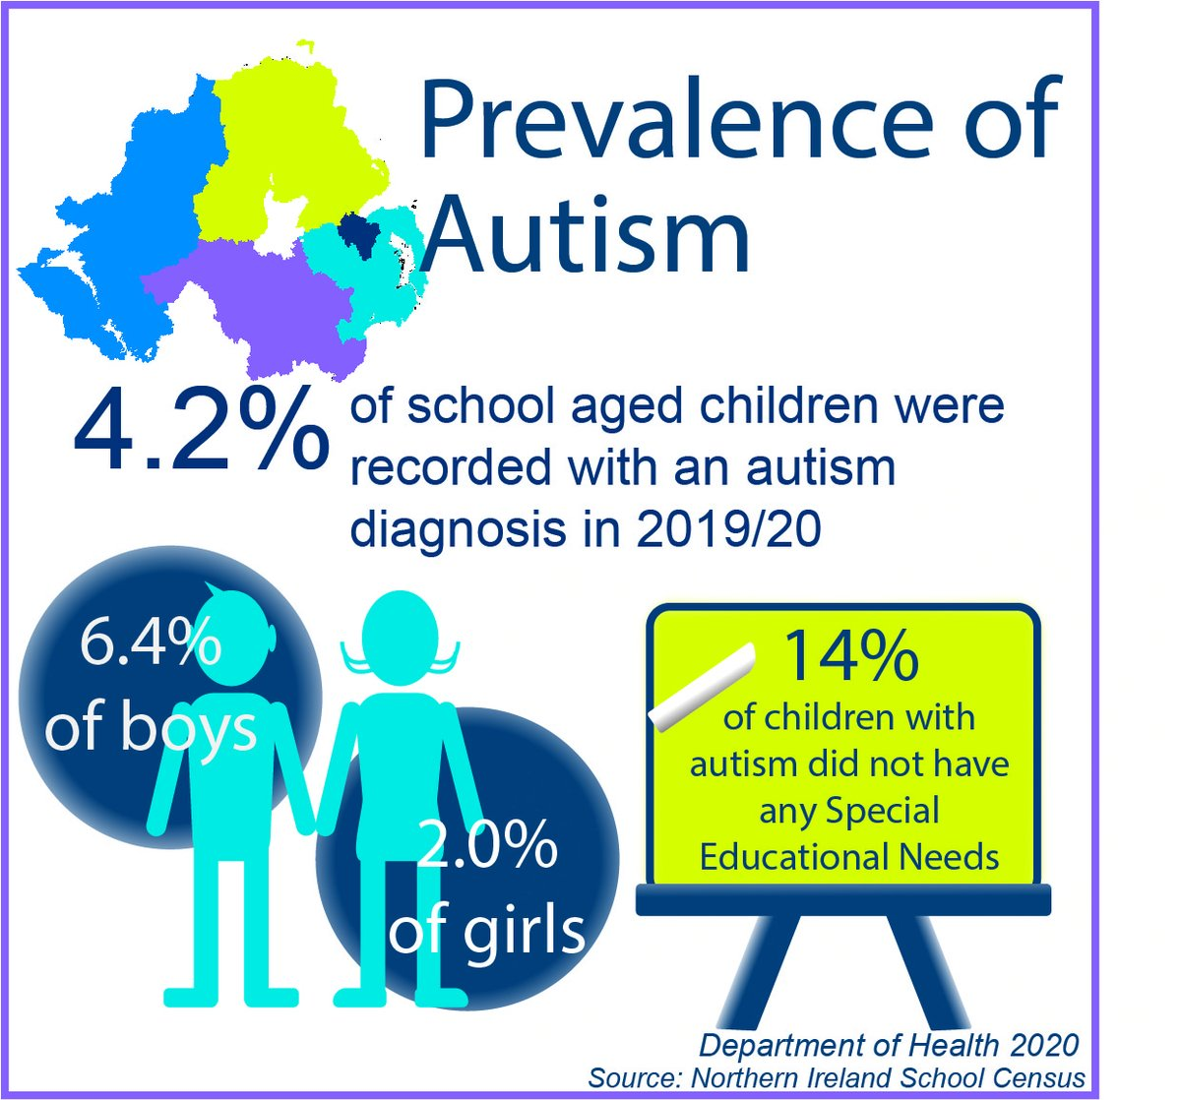
Prevalence is also higher among children and young people than adults, reflecting stronger identification through education pathways and ongoing barriers to adult diagnosis. Regional variation further indicates that diagnostic prevalence is shaped by service availability and commissioning capacity, raising concerns that recorded rates reflect access to assessment rather than true population need, with implications for equity within ICD-11 diagnostic frameworks (Shah et al., 2022).

Figure 1. Estimated Autism Spectrum Disorder Prevalence in the UK by Population Group
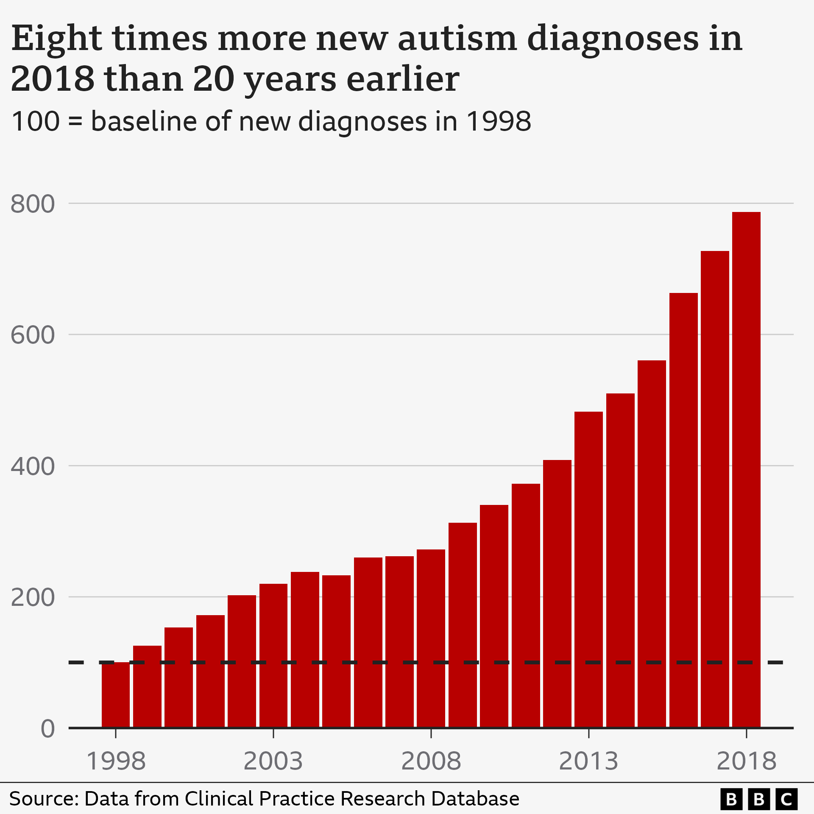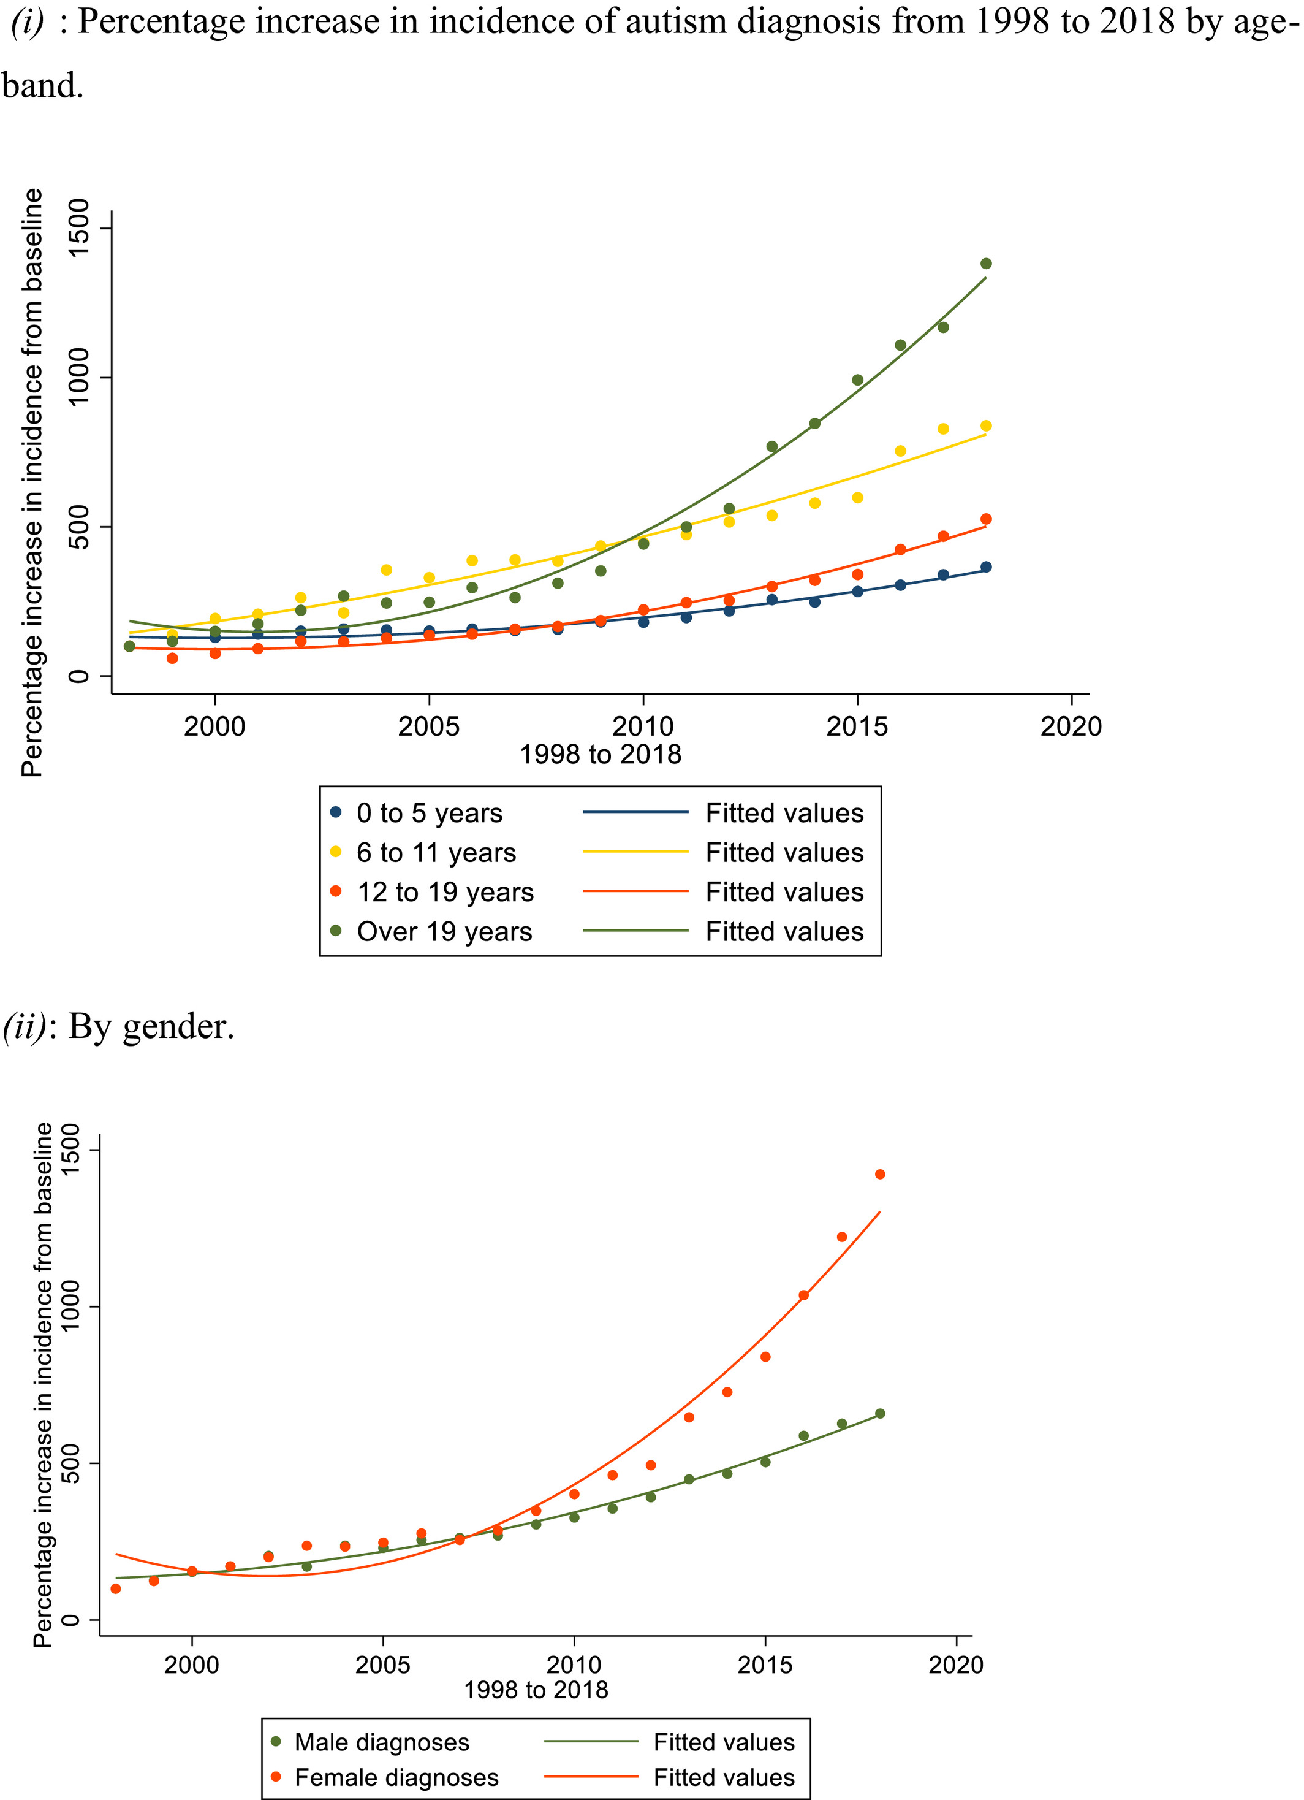

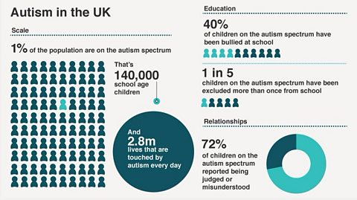
Figure 1 illustrates indicative UK autism prevalence estimates across selected demographic groups, highlighting disparities by sex and age.

Table 1. Estimated Autism Spectrum Disorder Prevalence in the UK
Population Group | Estimated Prevalence
Overall, UK population | -1.0%
Males | -1.6%
Females | -0.6%
Children and young people | -1.4%
Adults | -0.8%
Source: ONS (2021); NHS England (2022); NICE synthesis.

2.5 Critical Interpretation and Policy Implications
While prevalence statistics are essential for planning services, reliance on recorded diagnoses risks underestimating true need, particularly among adults, women, and individuals from minority ethnic backgrounds. ICD-11’s requirement for “clinically significant impairment” may further disadvantage individuals who experience high internal distress but present as externally functioning due to masking or adaptive strategies (Green, 2023).
From a UK policy perspective, prevalence data directly inform commissioning decisions, workforce planning and eligibility thresholds across health and social care. However, if prevalence reflects service access rather than population need, commissioning based solely on diagnostic figures risks perpetuating inequalities. This strengthens the case for applying ICD-11 classification alongside rights-based duties, including reasonable adjustments under the Equality Act 2010 and needs-led assessment under the Care Act 2014, ensuring that rehabilitation and supp

3. Treatment and Rehabilitation

3.1 Standard Treatment Approaches
Autism Spectrum Disorder is understood as a lifelong neurodevelopmental condition rather than an episodic mental illness. Consequent treatment in UK practice focuses on supporting communication, emotional wellbeing and participation, alongside reasonable adjustments in education, employment, and community settings (NICE, 2012; NICE, 2013).
NICE guidance states that there is no pharmacological treatment for the core features of autism. Medication may be prescribed for co-occurring conditions such as anxiety, depression, or ADHD, or for severe behavioural challenges in limited circumstances, but should not replace appropriate psychosocial support or environmental adaptation (NICE, 2012; NICE, 2013).
Psychosocial interventions may include communication support, family-based approaches, and targeted behavioural strategies for specific difficulties. NICE emphasises person-centred planning that recognises autistic strengths, needs, and avoids coercive or normalisation-focused interventions that undermine autonomy and identity (NICE, 2013).

3.2 Rehabilitation Measures in ICD-11 and UK Practice
Rehabilitation for ASD aims to enable participation and reduce disability through tailored supports rather than behavioural modification. In practice, this includes occupational therapy, sensory-informed approaches, speech and language therapy, daily living skills support, and employment assistance, increasingly framed within inclusive and rights-based models (Shah et al., 2022).
For adults, rehabilitation often requires coordination across NHS services, local authorities, and the voluntary sector to address housing, employment, and community inclusion. UK policy frameworks, including the Autism Act 2009 and statutory guidance on the adult autism strategy, emphasise shared responsibility across health and social care rather than reliance on healthcare alone (Autism Act, 2009; DHSC, 2015).
The National Strategy for Autistic People further highlights reducing health inequalities, improving access to support, and promoting societal understanding (Local Government Association, 2021). Accordingly, effective rehabilitation prioritises environmental adaptation, autonomy, and participation, aligning practice with social and rights-based models of disability rather than deficit-focused medical frameworks.
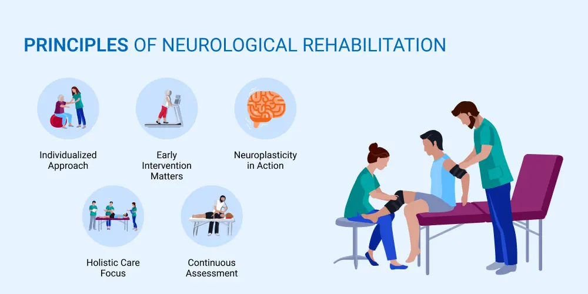

3.3 Effectiveness and Limitations
The effectiveness of ASD interventions varies according to appropriateness, timing, and respect for individual autonomy. Interventions focusing on communication support, sensory needs and practical adjustments can improve wellbeing and participation; however, effectiveness is limited where services are under-resourced, culturally insensitive or prioritise compliance over autonomy (Green, 2023).
A key limitation is that diagnostic recognition does not consistently lead to meaningful post-diagnostic support, particularly within adult services. Long waiting times, fragmented commissioning, and inconsistent eligibility thresholds undermine NICE ambitions for access and quality (NHS England, 2019). Autistic people also experience elevated rates of co-occurring mental health difficulties, which may be exacerbated by stigma, exclusion, and inadequate adjustments (Green, 2023).
From a critical perspective, over-medicalised approaches risk pathologising difference and obscuring social determinants of distress, including bullying, unemployment, poverty, and barriers to healthcare access. This highlights the need for integrated, rights-based rehabilitation models spanning health, education, and social care.
4. Current Debates and Emerging Issues
4.1 Classification, Identity, and the Neurodiversity Debate
One of the most significant debates concerns whether autism should be conceptualised primarily as a disorder or as neurodivergence. Neurodiversity perspectives argue that autism is a natural variant of human cognition, and that the social environment often produces disability through lack of inclusion and accommodations (Shah et al., 2022). This debate also affects preferred terminology, including identity-first language such as “autistic person,” which some argue reflects identity and community rather than illness (Shah et al., 2022).
Clinical and family perspectives may emphasise substantial disability, distress, and support needs for some individuals, particularly those with high care needs or intellectual disability. Green (2023) notes that neurodiversity framing can be experienced by some clinicians and families as insufficiently recognising impairment and the urgency of support. These tensions are important in practice because classification impacts funding, eligibility, and service commissioning.

4.2 Diagnostic Thresholds, Masking and Equity
Another debate relates to diagnostic thresholds and the requirement for clinically significant impairment. ICD-11 and other diagnostic systems require impairment, yet many individuals experience substantial internal distress while presenting as externally competent due to masking or compensation, especially women and some minority groups (Green, 2023). This can lead to under-diagnosis or misdiagnosis, delayed access to adjustments, and poorer mental health outcomes.
Contemporary literature also highlights that diagnostic tools and professional assumptions may not adequately capture culturally shaped communication norms, potentially affecting assessment equity. This creates a policy and practice imperative to improve culturally competent assessment, reduce bias and ensure that diagnosis does not reproduce inequalities.

4.3 Reclassification Issues and Implications for Practice
ICD-11’s spectrum approach, including sub-classification by intellectual and language profiles, reflects an attempt to improve clinical precision while recognising heterogeneity (Greaves-Lord, 2022; Kamp-Becker, 2024). However, reclassification also raises concerns about service access. If diagnostic boundaries shift, some individuals may fear losing entitlement to support, while others may gain recognition. Classification therefore has real consequences for practice, commissioning and legal duties under equality and social care legislation.
In the UK, autism policy frameworks emphasise reasonable adjustments and inclusive services. The Equality Act 2010 requires services and employers to make reasonable adjustments for disabled people, which has direct relevance for autistic people seeking healthcare access or workplace support. This strengthens the argument that debates about classification must be connected to rights and systemic obligations rather than purely clinical definitions.

5. Recommendations

5.1 Classification and Communication
Adopt balanced, non-deficit language in practice that acknowledges ICD-11 classification while recognising autistic strengths and individual preferences. Clinical reports and care plans should incorporate preferred terminology to support respectful, person-centred care (Shah et al., 2022). Public-facing explanations of autism classification should also be improved to reduce stigma and misunderstanding.

5.2 Diagnosis and Assessment Pathways
Reduce diagnostic waiting times through sustained investment in multidisciplinary services, in line with NICE guidance and national strategy commitments (NICE, 2012; NHS England, 2019). Equity in diagnosis should be strengthened through enhanced clinician training in masking, gender differences, and culturally competent assessment to address under-recognition in women and minority communities (Green, 2023).

5.3 Treatment, Rehabilitation and Policy
Guarantee access to post-diagnostic support across the lifespan, including psychoeducation, structured signposting, and reasonable adjustments. Rehabilitation should be delivered through integrated models linking NHS services, local authority social care, education, and employment, consistent with statutory guidance and the national autism strategy (DHSC, 2015; Local Government Association, 2021).

5.4 Research and Future Practice
Embed autism-informed practice across mainstream services to reduce diagnostic overshadowing and improve access. Future research should prioritise equitable diagnostic pathways and evaluate interventions that reduce inequalities and improve quality of life for late-diagnosed and marginalised groups.

6. Conclusion
Autism Spectrum Disorder is classified in ICD-11 as a neurodevelopmental disorder (6A02), defined by persistent differences in social communication and restricted, repetitive patterns of behaviour originating in the developmental period (WHO, 2019). While this classification provides a structured framework for diagnosis and service planning, its reliance on impairment-based criteria remains contested, particularly within neurodiversity perspectives that emphasise identity, difference, and social inclusion (Shah et al., 2022; Green, 2023).
In the UK, NICE guidance supports comprehensive, person-centred assessment and intervention across the lifespan. However, extended waiting times, regional variation, and limited post-diagnostic provision, especially within adult services, continue to restrict equitable access and may exacerbate mental health inequalities (NHS England, 2019). Debates surrounding masking, gender bias and cultural inequity further highlight limitations in current diagnostic frameworks, particularly for individuals whose distress is not externally visible.
Improving outcomes for autistic people therefore requires moving beyond diagnosis alone towards integrated, rights-based rehabilitation models that promote autonomy, participation and reasonable adjustment across health, education, and social care. ICD-11 classification must be applied critically and ethically, functioning as a gateway to meaningful support rather than a barrier to inclusion.

Reference
American Psychiatric Association (2013) Diagnostic and statistical manual of mental disorders (DSM-5). 5th edn. Washington, DC: APA.
American Psychiatric Association (APA) (2022) DSM-5-TR: Diagnostic and statistical manual of mental disorders (5th ed., text revision). Washington, DC: APA.
(Useful for critical comparison with ICD-11 classification)
Autism Act 2009. London: The Stationery Office. Department of Health and Social Care (DHSC) (2015) Statutory guidance for Local Authorities and NHS organisations to support implementation of the Adult Autism Strategy. London: DHSC.
Autistic (2021) Autism and mental health: evidence review. London: Autistica.
(Strong UK charity evidence on comorbidity and service gaps)
Centres for Disease Control and Prevention (2023) Autism prevalence in the United States. Available at: https://www.cdc.gov (Accessed: 21 March 2026).
Department of Health (2020) Prevalence of Autism Spectrum Disorder (Accessed: 21 March 2026).
Department of Health and Social Care (DHSC) (2015) Statutory guidance for Local Authorities and NHS organisations to support implementation of the Adult Autism Strategy. London: DHSC.
Department of Health and Social Care (DHSC) (2021) National strategy for autistic children, young people, and adults: 2021 to 2026. London: DHSC.
Fombonne, E. (2020) ‘Epidemiological controversies in autism’, Swiss Archives of Neurology, Psychiatry and Psychotherapy, 171(2), pp. 1–8.
(Excellent for critical discussion of prevalence and diagnostic inflation)
Greaves-Lord, K. (2022) ‘Innovations of the ICD-11 in the field of autism spectrum disorder’, Journal of Autism and Developmental Disorders, 52, pp. 1–12.
Green, J. (2023) ‘Debate: Neurodiversity, autism and healthcare’, Child and Adolescent Mental Health, 28(3), pp. 265–267.
Harvard medical School (2025) ‘Health Harvard education: mind and mood, What is autism spectrum disorder? - Harvard Health Publishing. (Accessed Date: March 2026)
HM Government (2023) Working together to safeguard children. London: The Stationery Office.
Hollin, G. (2017) ‘Autism, assemblages, and the life of things’, Bio Societies, 12(1), pp. 1–28.
(Strong sociological critique of diagnosis and classification)
Hull, L., Petrides, K.V. and Mandy, W. (2020) ‘The female autism phenotype and camouflaging: A narrative review’, Review Journal of Autism and Developmental Disorders, 7(4), pp. 306–317.
Kamp-Becker, I. (2024) ‘autism spectrum disorder in ICD-11: a critical reflection of its diagnostic requirements’, Frontiers in Psychiatry, 15, pp. 1–12.
Lai, M.C. and Szatmari, P. (2020) ‘Sex and gender impacts on the behavioural presentation and recognition of autism’, Current Opinion in Psychiatry, 33(2), pp. 117–123.
(Key evidence for masking and female under-diagnosis)
Local Government Association (2021) The National Strategy for Autistic People, Children and Young People. London: LGA.
Lord, C., Rutter, M., DiLavore, P.C., Risi, S., Gotham, K., and Bishop, S. (2012) Autism Diagnostic Observation Schedule (ADOS-2). 2nd edn. Torrance, CA: Western Psychological Services.
National Institute for Health and Care Excellence (NICE) (2011) autism spectrum disorder in under 19s: recognition, referral, and diagnosis (CG128). London: NICE.
National Institute for Health and Care Excellence (NICE) (2012) autism spectrum disorder in adults: diagnosis and management (CG142). London: NICE.
National Institute for Health and Care Excellence (NICE) (2013) autism spectrum disorder in under 19s: support and management (CG170). London: NICE.
NHS Digital (2022) Autism statistics: prevalence and service use in England. Leeds: NHS Digital.
(Strong for prevalence, waiting times and service pressure)
NHS England (2019) The NHS Long Term Plan. London: NHS England.
Office for National Statistics (ONS) (2021) Outcomes for disabled people in the UK: autism overview. London: ONS.
Pellicano, E., den Houting, J., and Heyworth, M. (2022) The autism advantage: perspectives from the neurodiversity movement. London: Policy Press.
(Excellent for balanced neurodiversity discussion)
Russell, G., Stapley, S., Newlove-Delgado, T., Salmon, A., White, R., Warren, F. and Pearson, A. (2022) ‘Time trends in autism diagnosis over 20 years: A UK population-based study’, Journal of Child Psychology and Psychiatry, 63(6), pp. 674–682.
Shah, P.J., Livingston, L.A., Holt, R., and MacKay, T. (2022) ‘Neurodevelopmental disorders and neurodiversity: definition of terms’, The British Journal of Psychiatry, 221(6), pp. 1–3.
World Health Organization (WHO) (2019) International classification of diseases for mortality and morbidity statistics (11th revision). Geneva: WHO.

