

Full name: Nabeel Zafar
Student ID: 2523175
Programme: CertHE Computing Skills for Workplace
Module name: Software Solutions for Business
Module code: ACCA4026
Lecturer name: Martin Svejda, Osman Elgawi
University + campus:
Submission date: 10-march-2026

Table of Contents
Introduction 3
Task 1 - E-Commerce Web Site Builders 3
Shopify 3
Wix 5
Task 2 -Mind mapping in Business 6
Mind Map of Business Software 7
Task 3 – Office Applications for Creating, Storing, Presenting and Analysing Information 7
Introduction to Office Applications 7
Microsoft Word 8
Microsoft Excel 11
Microsoft PowerPoint 14
Microsoft Access 15
Office Applications How-to Guide 16
Task 4 is on the applications of communication and collaboration 17
Introduction 17
Applications Zoom Communication 17
Practical Feature Test – Creating a Zoom Meeting 19
Collaboration Application Trello 20
Practical feature Test -Getting a Trello Board 21
Overview of Communication and Collaboration Tools 22
References 23

Introduction
In the contemporary digital economy, companies have been turning more and more to the use of software to undertake their activities effectively. Through software applications, organisations can automate their tasks, enhance communication, manage data well and aid in making better decisions. The tools find extensive application in various departments including marketing, finance, human resources and project management. Through appropriate technological applications, companies will be in a position to increase their output, decrease their expenses and enhance communication among staff in various geographic areas.
The use of cloud computing and internet-based platforms has increased the list of digital tools at the disposal of organisations in the recent years. The Microsoft Word, Microsoft Excel and Microsoft PowerPoint software applications are all common in normal running businesses to make documents, analysis and presentation of information efficient. Moreover, the online marketplace like Shopify or Wix enables businesses to have an online presence and sell through online marketplaces.
This report aims to discuss various software solutions that can be used to promote business activities. The report evaluates e-commerce Web site constructors, mind map software packages, workplace productivity tools and collaboration and coordinating tools. Besides, practical examples are explained to show how these tools may be used in a working setting to improve the workflow, productivity and decision-making process.[2]

Task 1 - E-Commerce Web Site Builders

Shopify
Shopify is a cloud-based e-commerce service that is one of the most popular and allows companies to establish and operate online stores. The site enables entrepreneurs and organisations to create professional websites without high level of program knowledge. Shopify offers numerous templates that are easy to customize, inbuilt payment worms and inventory control features that enable companies to control their products and internet sales.
Scalability is one of the important attributes of Shopify. Small startups have the opportunity to start with a simple online store and increase the operations over time as the business advances. Shopify also supports several third-party applications like marketing applications, analytics applications, and logistics applications. The integrations are also useful as they enable organisations to deal with the customer relationship, track the sales performance and automate order fulfilment process.[9]
A second benefit of using Shopify is that it has secure payment infrastructure. The site also accepts various payment options such as credit cards, PayPal and digital money, and this means that the customers would be able to finalize their transactions without any problems. Chaffey (2022) states that e-commerce systems like Shopify are vital in digital business models whereby they help companies to expand to international markets and stores to run operations online effectively.

Figure 1: Shopify overview
Nonetheless, there are also some limitations associated with Shopify. It involves a subscription fee that is paid monthly, which in the case of the very small business could be costly. Moreover, further applications or developer support can be needed to do advanced customisation. Nonetheless, Shopify can still be a viable solution to organisations that want to develop a robust presence on the web in terms of retailing their products.

Wix
Wix is another platform of developing websites that has become popular. Wix is an online website creator that enables the user to create websites through a drag-and-drop interface. Such a solution makes the platform especially appropriate to the needs of beginners and small businesses that desire to build websites within a short time without deep technical expertise.
Wix offers a diverse system of templates, which can be adjusted to the requirements of the various industries. Search engine optimisation (SEO), online marketing and e-commerce capabilities are also built-in on the platform. With the help of the Wix dashboard, businesses are able to make product catalogues, take orders and monitor customer activity.[10]
Wix is very easy to use, and this is one of its significant advantages. The platform lets one create aesthetically appealing websites with no coding. Moreover, Wix provides the cloud hosting facilities, and hence, a business does not have to take care of its own web servers. This makes the technical side of the website management simple and enables organisations to concentrate on marketing and interaction with the customers.
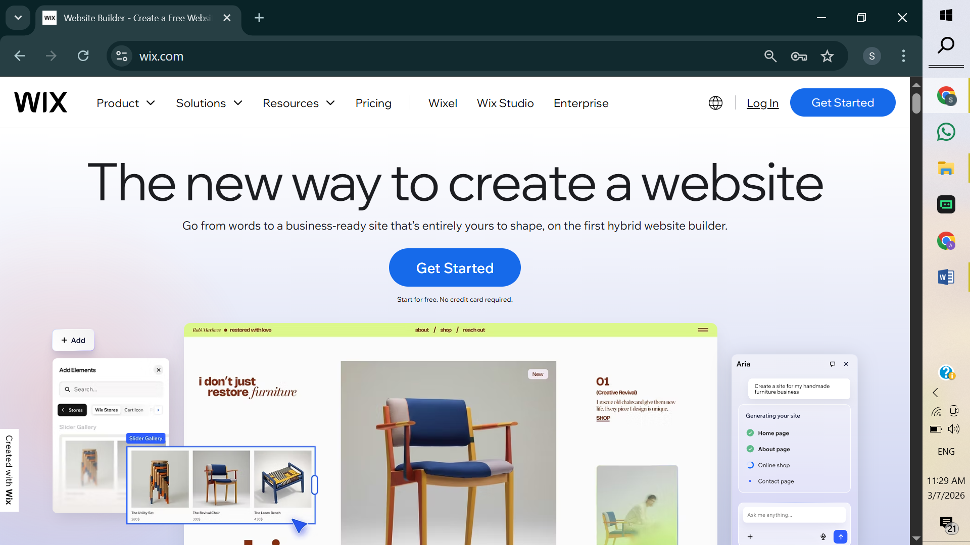
Figure 2:wix overview
Although Wix has benefits, there are also certain limitations to using this platform over specialised e-commerce platforms such as Shopify. In other words, when it comes to managing detailed product ranges or large volumes of transactions, online large-scale online stores might not be as flexible with Wix. Even then, Wix is an option that is viable and affordable to most small and medium-sized enterprises that need to establish an online presence.

Task 2 -Mind mapping in Business
A mind mapping is a graphical method of organizing information, thoughts and ideas in a systematic way. It was popularised by Tony Buzan who defined mind maps as diagrams that show the relationship between ideas by branching around a central point. Brainstorming, project planning and problem-solving may be supported in business environments with the help of mind mapping.
A normal mind map starts with a single topic that is located at the center of the diagram. Out of this focal point, several branches would be drawn outward to depict the similar notions or classifications. Each branch can have further sub-branches which can be considered as more detailed information. This visual arrangement can make the individual and groups perceive the information which is difficult to remember and find the relationships between various ideas easier.[4]
Mind mapping offers a number of benefits in the operations of a business. One, it helps in stimulating innovative thinking and generation of ideas. Employees are able to take notes quickly and sort them into significant categories during brainstorming. This practice assists teams to seek new ways of solving organisational challenges. Buzan and Buzan (2019) argue that visual thinking approaches like mind mapping can be of great use in enhancing creativity and retention of information.
Second, mind mapping can aid in proper project planning. Mind maps can be used to map project tasks, deadlines and responsibilities by managers. This graphic picture enables groups to know how a project looks like and to track progress in a better way. Strategic planning is also done using mind maps where organisations have to assess various business opportunities and risks.[5]
There are numerous software applications that can be used to make digital mind maps. XMind is one such application that has been used extensively so that users can create professional diagrams with templates, icons, and colour-coded branches. Other advantages of digital mind-Mapping tools include real-time team-work, a cloud-based library like store and the capability to export the diagrams to various other formats.

Mind Map of Business Software
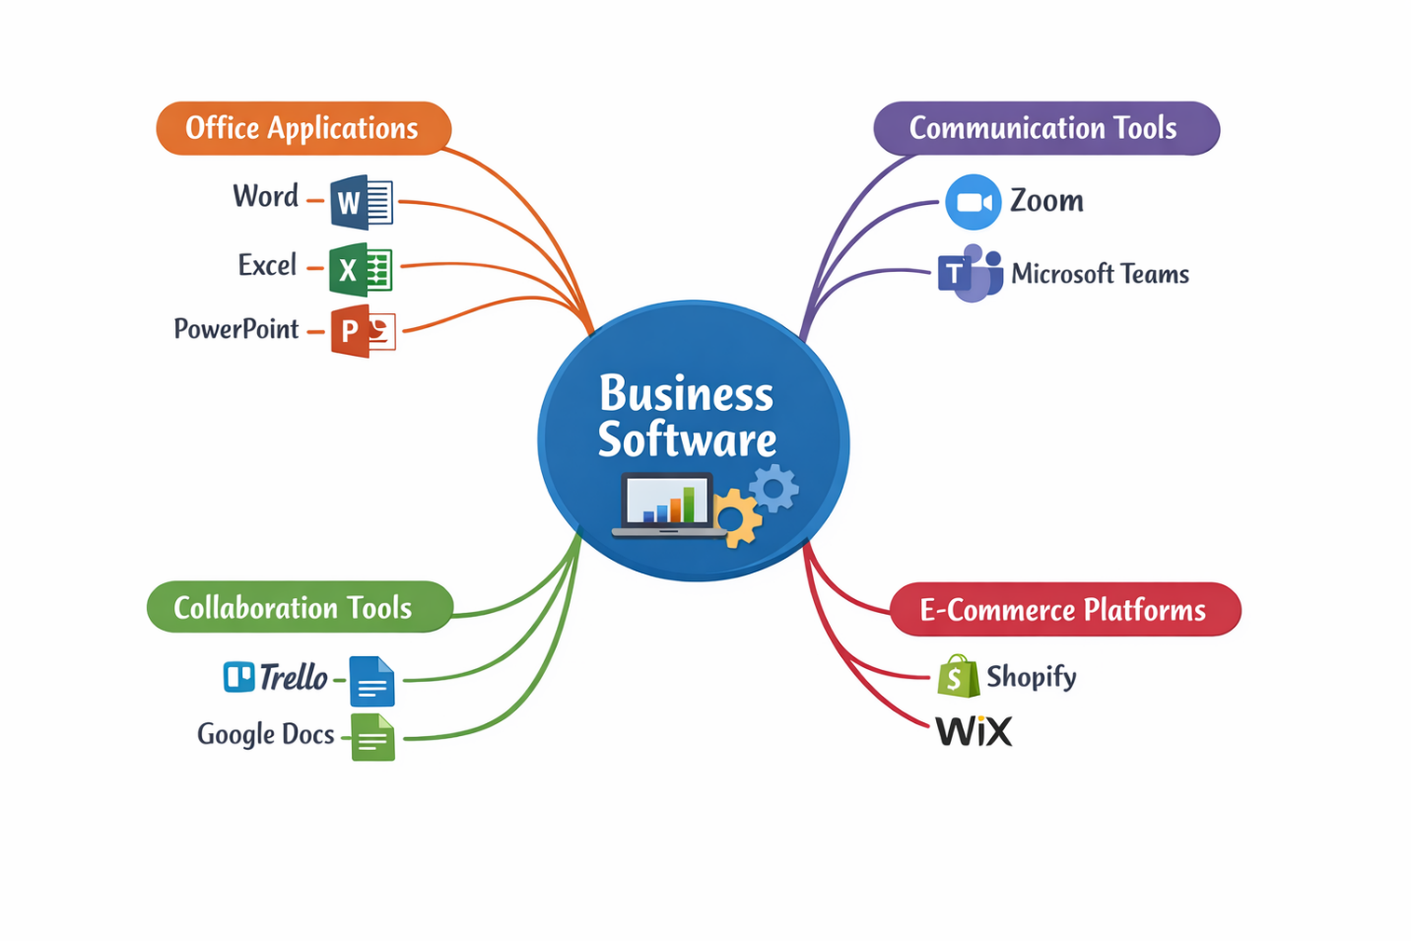
Figure 3: Mind Map of Business Software Applications

Task 3 – Office Applications for Creating, Storing, Presenting and Analysing Information

Introduction to Office Applications
Office applications are tools that are very vital in any modern organisation in the management of information, creation of documents, analysis of data and effective communication of business ideas. These applications help in work everyday, and they allow employees to work effectively. Office productivity software assists organisations deal with digital data, optimize workflow and decision-making operations.
Three of the most popular office software applications include Microsoft Word, Microsoft Excel, Microsoft power point and Microsoft Access. They belong to Microsoft Office range of applications, which are popular in various industries to conduct various business tasks. All the applications have particular functionality that is intended to assist in various areas of information management and organisational communication.

Microsoft Word
Overview
Microsoft word is a word processing application that has been used most in business and academic settings. It enables users to build up, modify and structure written records, e.g. reports, letters, proposals and business records. The software has a user-friendly interface and has a number of tools allowing a user to create documents with a professional look.
Word processing software has become a very basic communication tool in business since it allows organisations to store the written material digitally and share the documents of the written material with colleagues and clients easily. Laudon and Laudon (2022) reveal that word processing applications are very effective in terms of productivity because they enable users to edit, format and distribute documents in a short period.
Key Features
Microsoft Word has a formatting capability, which is one of the most significant features. The fonts, headings, spacing, and alignment can be customized to ensure the users make structured and aesthetic documents. It can be used to maintain consistency of organisational reports and documentation using styles and templates.
The next feature that is important is the spell check and grammar check tool which is an automatic identification of spelling mistakes and grammatical mistakes. This aspect enhances quality of written form of communication and assists in upholding the standards of professionalism in business writing.
The Microsoft word also contains a Track Changes feature which enables a number of users to work on a document. The feature is mostly applicable in organisations that require more than one team member to review and edit documents before the ultimate approval.
Mail Merge Feature
Another useful feature in Microsoft word is mail merge. This should allow users to build numerous customised documents like letters, invoices or mails by integrating a template document with a data source, usually located within a spreadsheet.
As an illustration, a business organisation will be able to mail personalised invitation letters to hundreds of customers through mail merge. The user is not expected to write every letter in a manual style, but he/she can develop a template and enter automatically customer names and addresses in database.
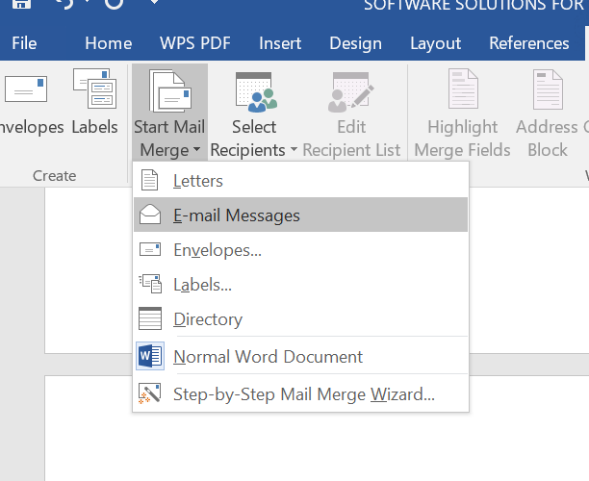
Figure 4: mail merge in word
Benefits
Microsoft Word has various advantages to business organisations. It allows to create documents efficiently, enhances the quality of communication and allows to collaborate with the employees. It is also assisted by the availability of templates to ensure that organisations are able to keep equal formatting throughout the official documents.
Limitations
Microsoft word has limitations despite the benefits it has. The handling of very large documents can at times slow down system performance and sophisticated formatting can need sophisticated user skills. These limitations, however, are rather insignificant as compared to the benefits the application offers in general.

Microsoft Excel
Overview
Microsoft excel is an effective spreadsheet software which is employed to store, organise and analyse numerical data. Excel finds a lot of application in business world in management of money, budgeting, inventory and reporting data.
The spreadsheet format enables the user to tabulate data in rows and columns, hence, easier to compute values and analyse huge datasets. Stair and Reynolds (2021) assert that spreadsheet software is important in business decision-making because organisations are able to analyse their financial and operational data using the software.
Key Features
The ability to use formulas and functions is considered one of the most significant functionality of Excel. It has inbuilt formulas that users can use to perform complicated calculations, which include SUM, AVERAGE, IF and VLOOKUP. These applications facilitate automatic calculations and decrease the possibility of errors in calculations.
Excel also has tools of charting, which is used to transform numerical data into visual information e.g.Bar charts, pie charts and line graphs. The visualisations enable managers to know trends and patterns with less effort.
Data sorting and filtering is yet another important feature where users can arrange and analyse huge volumes of data.
Practical Feature 1 IF Function.
The IF function is a logical formula that is employed to make conditional calculations. It considers the truthfulness or falseness of a condition and gives the result.
Example formula:
=IF(B2>=50,"Pass","Fail")
Here, the formula will look at the value that is in the cell B2 and determine whether it is more than 50 or not. In case the condition is true, the outcome will show Pass. In case the condition is not true, the outcome will be on the form of Fail.
Practical Steps
- Make a basic spreadsheet where the student marks are listed.
- Insert IF formula on a separate column.
- Excel will automatically calculate the pass or fail of each student.

Figure 5: IF Function as an example in Microsoft Excel.
Therefore, under these circumstances, Excel provides an efficient method for handling data and enables the user to retrieve relevant information and decide if the established rules and regulations are violated

Practical Feature 2 Pivot Table
Pivot Table is another sophisticated tool in Excel which can be used to summarise big data and conduct an analysis in a short time. It also enables users to aggregate data, get totals and discern patterns without having to alter the original data.
As it is a typical example, a company might apply a Pivot Table in order to analyse the sales performance based on region, type of product sold or sales representative.
Practical Steps
- Prepare a set of data that includes sales.
- Select the data range.
- Click Insert → Pivot Table.
- Select options like the kind of products and dollar sales.
- The summary report will be produced automatically in Excel.
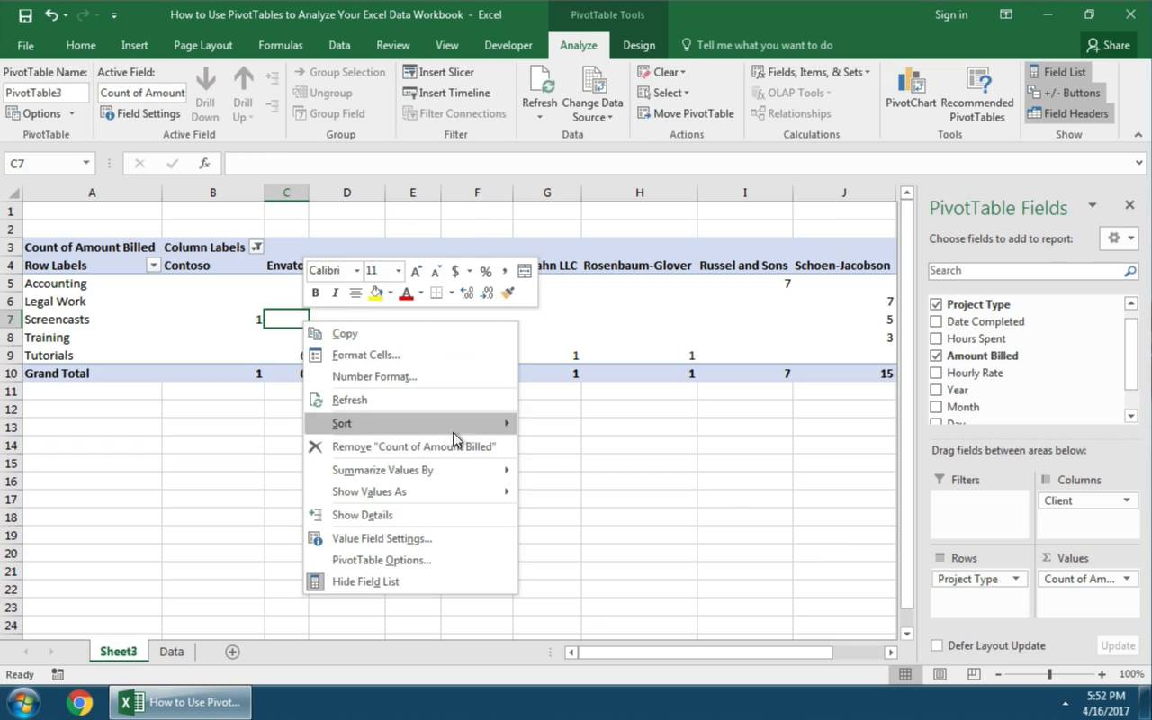
Figure 6: Pivot Table Analysis in Microsoft Excel.
Additionally, email communication will be implemented, enabling employees to notify the manager of any discrepancies in the data utilized to draw conclusions. the manager about any inconsistencies present in the information used to make conclusions.

Microsoft PowerPoint
Overview
Microsoft PowerPoint is a popular program used to draw online presentations. PowerPoint is used by business people to convey the ideas, provide reports and conduct the training. The application gives the user the ability to mix the text, images, charts, videos and animations into interesting visual presentations.[5]]
Turban et al. (2020) also discuss that presentation software is a significant part of business communication since visual presentations can make complex information easier and allow the audience to grasp the main points.

Key Features
Probably one of the most significant aspects of PowerPoint is the slide format that enables one to structure information in distinct graphical units. The headings, the bullet points, and pictures may be added to each slide in order to emphasize essential information.
Multimedia integration is another feature that comes in handy. Users are able to add videos, audio clips and images to make presentations better. Such multimedia features ensure that presentation is more interactive and keeps the audience focused.
The power point also has animation effects and transition effects which enable the presenters to have control over the way information is presented in a presentation. As an illustration, bullet points may be displayed in a one-on-one manner to allow the audiences to focus.
Benefits
PowerPoint enhances business communication as it has a clear visual support of presentations. It is mostly applied in meetings, project updates, trainings and marketing presentations. Visual slides can assist in making the audiences comprehend intricate data at ease.
Limitations
The pitfall of PowerPoint is that ill-developed slides may spoil the audience in either text or graphics. The principles of good presentation design should therefore be adhered to so as to be able to be clear and effective in the eyes of the users.

Microsoft Access
Overview
Microsoft access is an application database management programme that is employed to store, organise and access structured information. Contrary to spread sheets, databases are created to handle large amount of data effectively with the assistance of relational frameworks.[6]
Databases are usually used by businesses to store customer records, inventory information, employee record and sales transactions. Access gives a graphical interface which enables a user to make tables, queries, forms and reports without much knowledge of programming.
Key Features
Table creation is one of the chief characteristics of Access that enables the user to establish structured fields like customer name, address, product ID and details of transactions. These tables are the basis of relational database.
Queries are another significant attribute that allows users to access certain information on the database. To take an example, a query can be created to identify all the customers who bought a given product within a given time.
Forms are also available and they offer the user-friendly interface to enable the user to input and also edit data. Forms make the process of inserting new records in the database simpler.
Lastly, the report generation capability enables organisations to generate planned reports that summarise database data. The management can use these reports in decision-making.
Benefits
Microsoft Access enables organisations to handle massive data effectively without compromising the integrity of the data. The relational structure makes the information to be arranged in a logical manner and minimises duplication of information.
Limitations
Nevertheless, Access is not very good with very large enterprise databases. Major organisations have more sophisticated database systems like SQL Server or Oracle to manage the complex data management jobs.

Office Applications How-to Guide
To sum up, office applications are crucial in assisting operations of business in the modern world. The Microsoft Word allows effective document creation and communication as well as Microsoft Excel allows powerful data analysis and calculation of finance. Microsoft power point helps in visual presentation that enhances the business communication and Microsoft access provides a structured database management of storing and retrieving the vast information.[6]
These applications can be used collectively to enable organisations to have the necessary instruments to manage information, enhance productivity and decision-making processes in a technologically driven business world.

Task 4 is on the applications of communication and collaboration

Introduction
Communication and collaboration technologies have become a key element in the running of the modern organisation to sustain productivity and daily operations. Digital platforms have become a key means of uniting employees and exchanging information and project management due to the expansion of remote work and international teams. Communication applications facilitate people to communicate with each other, hold meetings and share files, and collaboration features provide teams with the opportunity to work on tasks and projects in real-time.
Zoom and Trello are two popular tools and applications in contemporary workplaces; both are a communication tool and a collaboration platform. These applications give a business an effective means of coordinating work, exchanging ideas and enhancing teamwork without considering the geographical location.

Applications Zoom Communication
Overview
Zoom is a web-based-app that enables users to organize video conferences, webinars and online conferences. It gained popularity especially in the COVID-19 pandemic when organisations all over the world moved to remote work set-ups. With Zoom, employees can hold a physical meeting virtually, and hence it is simplified to ensure the collaboration, in cases where teams are situated in different regions.
Zoom provides support to small team meetings as well as very big webinars containing hundreds of participants. The platform is available to desktop computers, laptops, tablets and smartphones, which gives flexibility to the users who are required to be connected at various locations.
Key Features
High quality video conferencing is one of the primary characteristics of Zoom and it enables users to exchange live video and audio conferencing. This can be used to reproduce the feeling of a face-to-face meeting, which is significant in the context of teamwork and decision-making.
Screen sharing is another feature that is important. In a meeting, the participants can screen share to provide their documents, slides or software demonstrations. It helps mainly in training sessions, discussions about the project and technical support.
The Zoom also has a chat feature where participants can send messages in the event of a meeting. This will be handy in sharing links, posing questions or making comments without cutting short of the speaker.
Moreover, Zoom has a recording option, and it means that the meetings can be recorded and stored to be referred to at a later stage. It may be handy when the employees could not participate in the meeting or read on some significant discussions.
Benefits for Businesses
As an organisation, Zoom has a number of advantages. To start with, it saves on the expenses of traveling because it allows virtual meetings as opposed to having in-person meetings. The employees are able to experience the benefit of interacting with their colleagues and clients without stepping out of their offices anywhere across the world.
Second, the platform facilitates the use of remote work environments. Distributed teams are currently being hired by many organisations, and Zoom enables such teams to stay in contact with each other by organising frequent online meetings.[7]
Third, the screen sharing and presentation functions facilitate knowledge sharing and training processes. Software tools could be demonstrated by managers and trainers with the help of visual materials or presented business strategies.

Practical Feature Test – Creating a Zoom Meeting
An example of how Zoom can be applied is a basic meeting, which can be built with the help of the application.
Steps
- Click the Zoom application or the Zoom site.
- Click on Schedule Meeting.
- Key in the meeting topic, date and time.
- Generate the meeting link.
- Send the participants the link.
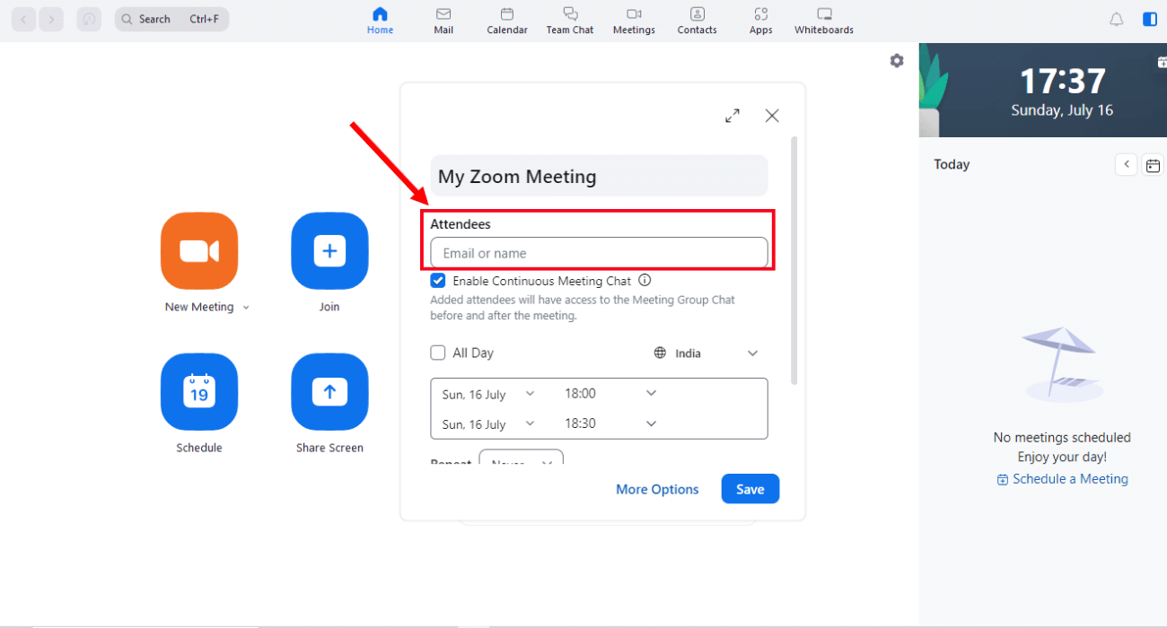
Figure 7: Zoom Scheduled Meeting Interface.
This effective experiment proves that organisations can learn to arrange online meetings using Zoom and to communicate with team members.

Collaboration Application Trello
Overview
Trello is a web-based collaboration and project management tool that is used to facilitate the organisation of tasks and monitoring progress of projects. The app is based on a visual board system, where tasks can be managed with the help of lists and cards. The boards are a reflection of each project and the tasks are sorted into various steps including To Do, In Progress, and Completed.
Companies, startups and project teams have been using Trello due to its easy interface and the ability to create and manage workflow flexibly.
Key Features
Another most unique attribute of Trello is its board system that is of Kanban style. Tasks are modeled in the form of cards that may be transferred in-between lists as work is being done. Such visual structure enables the teams to simply monitor project status and see what tasks are awaiting completion.
Task assignment is another aspect that is significant. Team members are able to put cards in the hands of certain individuals and hence responsibilities can be clearly spelled out. Every card may contain descriptions of tasks, due dates and attachments.
Collaboration capabilities are also available in Trello in the form of comments and file sharing. The team members have the possibility to discuss the tasks directly on the card, add the documents and update the progress continuously.
Also, Trello is connected with other business applications like Google drive, slack and Microsoft teams. These integrations are useful in centralising the working process in organisations and enhancing productivity.
Benefits for Businesses
Trello has some benefits to organisations that have numerous projects. The visual task management system enables the teams to have a clear view of the project progress and detect possible delays.
Team coordination is also enhanced by the platform since all the members can see all the assignment and deadlines of tasks on one platform. The transparency also aids in avoiding miscommunication and facilitates the achievement of the project goals with efficiency.
Moreover, Trello facilitates the work of a remote team. Being a cloud-based platform, team members will be able to see project boards wherever they are and can update their tasks in real time.

Practical feature Test -Getting a Trello Board
In order to illustrate the practical application of Trello, a simple project board may be made.
Steps
- Log in to the Trello platform.
- Click Create Board.
- Name the board (e.g. Website Development Project).
- Make lists like To Do lists, In Progress lists and Completed lists.
- Write task cards below each list.
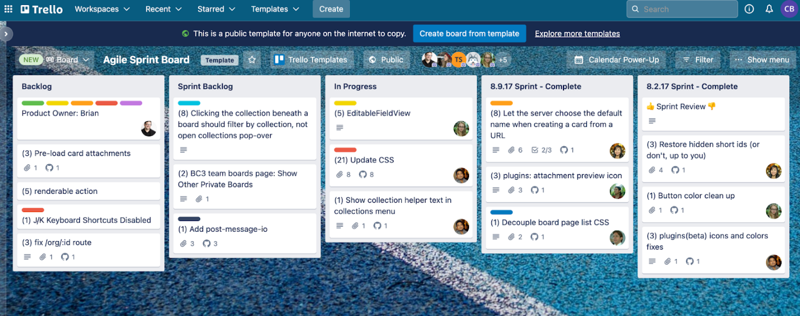
Figure 8: Trello Project management board.
Within the board, I created a Trello card to illustrate a task, which was the preparation of the hotel's budget.
This is an actual illustration of the way in which Trello can be applied to structure work, divide tasks and supervise a project in a group setting.

Overview of Communication and Collaboration Tools
In the present business world, communication and collaboration tools are very critical. Technologies like Zoom allow organisations to hold virtual meetings and have a functional communication between the employees, clients, and partners. Meanwhile, such collaboration tools as Trello are useful in assisting teams to organize projects, allocate responsibilities, and monitor progress effectively.
Integrating communication tools and project management tools can help organisations to become more productive, enhance teamwork and remote work practices. These are online solutions, and thus crucial elements of new technology-driven work environments.

References
[1] K. C. Laudon and J. P. Laudon, Management Information Systems: Managing the Digital Firm, 16th ed. Harlow, U.K.: Pearson, 2022. [Online]. Available: https://www.pearson.com/en-us/subject-catalog/p/management-information-systems-managing-the-digital-firm/P200000003417
[2] R. Stair and G. Reynolds, Principles of Information Systems, 14th ed. Boston, MA, USA: Cengage Learning, 2021. [Online]. Available: https://www.cengage.com/c/principles-of-information-systems-14e-stair
[3] E. Turban, C. Pollard, and G. Wood, Information Technology for Management: On-Demand Strategies for Performance, Growth and Sustainability, 12th ed. Hoboken, NJ, USA: Wiley, 2020. [Online]. Available: https://www.wiley.com/en-us/Information+Technology+for+Management%2C+12th+Edition-p-9781119702906
[4] D. Chaffey, Digital Business and E-Commerce Management, 8th ed. Harlow, U.K.: Pearson, 2022. [Online]. Available: https://www.pearson.com/en-gb/subject-catalog/p/digital-business-and-e-commerce-management/P200000003189
[5] T. Buzan and B. Buzan, The Mind Map Book: Unlock Your Creativity, Boost Your Memory, Change Your Life. London, U.K.: BBC Active, 2019. [Online]. Available: https://www.mindmapping.com/the-mind-map-book/
[6] Microsoft Corporation, “Microsoft Office Documentation,” 2024. [Online]. Available: https://support.microsoft.com
[7] Zoom Video Communications Inc., “Zoom Platform Features,” 2024. [Online]. Available: https://zoom.us/features
[8] Atlassian, “Trello Project Management Tool Overview,” 2024. [Online]. Available: https://trello.com/en
[9] Shopify Inc., “Shopify E-commerce Platform Guide,” 2024. [Online]. Available: https://www.shopify.com
[10] Wix.com Ltd., “Wix Website Builder Features,” 2024. [Online]. Available: https://www.wix.com
[11] A. McAfee and E. Brynjolfsson, Machine, Platform, Crowd: Harnessing Our Digital Future. New York, NY, USA: W. W. Norton & Company, 2017.
[12] T. Davenport and J. Kirby, Only Humans Need Apply: Winners and Losers in the Age of Smart Machines. New York, NY, USA: Harper Business, 2016.
[13] M. E. Porter and J. E. Heppelmann, “How smart, connected products are transforming companies,” Harvard Business Review, vol. 93, no. 10, pp. 96-114, 2015.
[14] A. Osterwalder and Y. Pigneur, Business Model Generation: A Handbook for Visionaries, Game Changers, and Challengers. Hoboken, NJ, USA: Wiley, 2010.
[15] P. Kotler, H. Kartajaya, and I. Setiawan, Marketing 4.0: Moving from Traditional to Digital. Hoboken, NJ, USA: Wiley, 2017.

