
Campaign strategy for elderly individual’s dealing with bereavement by Stacy Waldman (1701928)

Contents
Title - 1
Executive summary - 3
Introduction and theory – 4 - 6
Conclusion- 7
References – 8



Executive summary
The purpose of this campaign/debriefing report is to discuss the issues concerning elderly individuals who are going through the social transitions involved in aging, retirement, death and bereavement. Death and bereavement can affect people in many different ways, it has been said to be one of the most stressful times that a person can go through during their lifetime, especially if the person who has passed away is a spouse which causes a negative effect on the individual (Stroebe, W., & Stroebe, M.S., 1987). During the grieving process many individuals experience both physiological and psychological reactions, these can be intense feelings that are deemed natural but are seen to decrease with time. (Jordan and Litz, 2014).
For many people the loss of a spouse is deemed as an unavoidable event during their lifetime. Bonanno (2004), has stated that a common unfavourable event during an individual’s life is the loss of a loved one. It has been demonstrated by previous research that spousal bereavement has an intense effect on the well-being of an individual, this includes a comorbid incidence of depression, decreased social activities and life satisfaction, and even a reduction in physical health (i.e., Bonanno, Notarius, Gunzerath, Keltner, & Horowitz, 1998; Carr, House, Wortman, Nesse, & Kessler, 2001; Davis & Nolen-Hoeksema, 2001; Folkman, 2001; Schulz & Beach, 1999).
For those who are left behind to grieve the unexpected death of a spouse it can be particularly difficult (Carr et al., 2001), there is only a small amount of information about variability among expected deaths, including how family caregiving experiences affect the course of bereavement. With the older generation facing the loss of many loved ones during their life time, this can create an intense feeling of loss, due to their previous experiences of grief, which can leave them feeling extremely overwhelmed and even cause what is known as ‘bereavement burnout’ (DeSpelder & Strickland, 2011, p. 365). There has been minimal previous research that has examined concurrent factors of responses towards bereavement. This research has shown to vary depending on whether death is unexpected or expected, and on the depending the nature of family caregiving experiences.
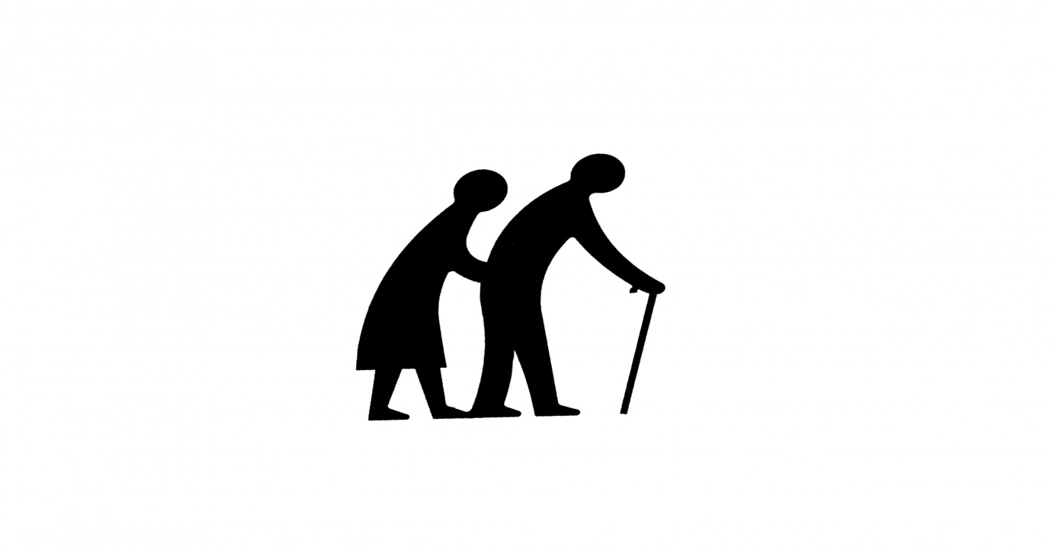

Introduction -
Even though there is much research to show that the older bereaved generation are less likely to seek help than younger bereaved people. They are also less likely to be referred for bereavement support than younger people. Many people don’t get the death they want. Most want to die at home, but nearly half of all deaths happen in hospital. Older people are more likely to experience bereavement than any other age group. Partner loss is the most severe common form of bereavement (Mulsant and Pollock 2007). Elderly individuals can struggle to adjust to their partners death due to the negative effect that their grief can have on their new -found social identity, ((Lopata, 1993).
Albert Ellis assisted to create the Rational Emotional Therapy (REBT), during the 1950’s, he primarily used this form of cognitive therapy, due to its main focus of the resolution of behavioural and emotional problems that concern individuals, with this therapy he was able to help individuals to live more content and fulfilled lives within their society (Ellis, 1985). Cognitive Behaviour Therapy (CBT), Reminiscing Therapy (RT) and Grief Therapy (GT), helps individual’s expansion of their overall knowledge, also developing their own coping mechanisms that will ultimately improve their overall well-being. Malkinson (2010) reported that by using Cognitive Behavioural Therapy - Rational-Emotion Behaviour Therapy (CBT-REBT) as a model for grief highlighted the ability of individuals to choose their own thoughts.
Reminiscence therapy (RT) is devised to enable elderly adults to recall into their thoughts previous happy occurrences that will positively highlight their own idea that they are infact a truly worthwhile and a valued person (Watt & Wong, 2008). Through the reiterating of their own upbeat true-life events, the previous upbeat feelings are recovered, these feelings can then be applied to their current day, this then reverses the negative feelings they had been experiencing and ultimately relieves depression by invoking their previous happy feelings (Watt Tricco, Talbot-Hamon, Rios, Grudniewicz, Wong, and Straus2018). The therapeutic success of reminiscence which learning new skills is not required, this is due to reminiscing of previous memories and feelings from personal memories (Watt et al., 2018).
In a previous study carried out by Robb, Haley, Becker, Polivka, and Chwa (2003), which investigated the receptiveness of 474 older adults towards mental health services, it was reported that those who had access towards mental health services due to their intense feelings of grief felt that this was of significant importance towards their rehabilitation and it had importance towards their overall psychological health, even so, the same group of adults reported that their finances were important factors that stopped them from seeking treatment.
The older generation are deemed to experience more mental health issues as a result, many feel overwhelmed due to dealing with the multiple negative effects that can arise whilst dealing with bereavement. These issues can be exacerbated by other factors that are commonly known to affect elderly individuals, such as their physical health declining, so they will not be able to physically do what their spouse may have carried out regularly for them. These issues can cause an individual to have feelings of relief, anger, altered identity, guilt confusion and even a sense of hopelessness (Münch, 1972)

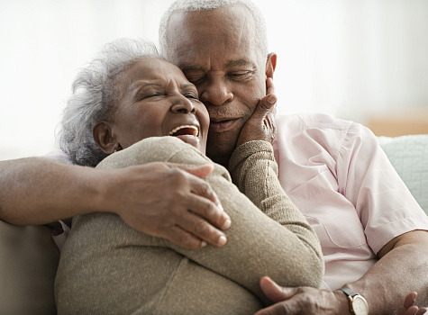

Theory -
There have been various theories that relate to the grieving process, but this campaign will focus on the effects of bereavement on the older generation. The biological theories focus on the physiological and anatomic changes that occur as an individual is aging. The biological theories explain the physiologic processes that ultimately change with aging, these are due to the manifestation of cells, tissues and bodily systematic decline within the body as individuals age. Due to the decline in their emotional status this may affect their overall progression through the grieving process. This ultimately shows that an individual has to accept their impending loss in life due to death during their senior years of their life (Harman, 2006).The psychosocial theories of aging state that there are stages of aging which can affect an individual and ultimately decide whether or not they will be able to progress through them successfully. These are the earliest psychological theories on aging which focus on an individual’s changes within their personality, behaviours and attitude as they progress through their lives as aging is a lifelong process determined by continual transitions. Without successful progression through the individual stages then an individual cannot overcome the negative effects of bereavement.
These issues can cause an individual to have feelings of relief, anger, altered identity, guilt confusion and even a sense of hopelessness. The older generation are deemed to experience more mental health issues as a result, many feel overwhelmed due to dealing with the multiple negative effects that can arise whilst dealing with bereavement. These issues can be exacerbated by other factors that are commonly known to affect elderly individuals, such as their physical health declining, so they will not be able to physically do what their spouse may have carried out regularly for them. Baarsen, (2002) created research that showed a high prevalence towards the effects of Prolonged Grief Disorder (PGD) within the elderly generation, due to the age-effect their results produced. The results suggested that 1 in 10 elderly people will show clinical signs of PGD which can show that the elderly generation are more likely to experience prolonged effects of grief. During Baarsen’s 2002 study, it was highlighted that there is a need for an individual to accept their identity change due to the loss of a loved one. This study consisted of 101 participants, who were between the ages of 55 and 89 years, these individuals had
two separate interviews, one before a spouse had passed and the second once their spouse had passed away. Earlier, theories had suggested that the older generation would be more capable of dealing with their emotions and feelings due to their grief, these claims were due to their experience of previously dealing with grief in their close social network. Baarsen’s (2002) findings specified a link between aging and bereavement associated a risk to the individuals experiencing PGD. PGD has currently been proposed for the ICD-11 as a mental health disorder (World Health Organization, 2016 as cited in Lundorff, Holmgren, Zachariae, Farver-Vestergaard, and O’Connor, 2017). similar to the DSM-5 which has recognised grief to be a likely circumstance of clinical attention when Persistent Complex Bereavement Disorder (PCBD) was included in the Appendix (American Psychiatric Association, 2013).
As the older individual participates in their own recognisable history, with the familiarity of their recognised memories resurfacing could enhance a sense of control and calm within the current moment which would enable the flow of more memories being disclosed. With the person feeling in control could enhance the process. Cappeliez and Robitaille, (2010), highlighted that when an individual recalls a previous episode of problem solving this enables them to gain a sense of being in control due to their self-efficacy. This creates a new-found confidence from focusing on their own internal resources and memories of achieving previous coping methods (Bohlmeijer, Roemer, Cuijpers, and Smit, 2007).
Even though there can be quite a lot of negativity surrounding an individual experiencing bereavement in old age, there can be positive factors that can affect an individual’s ability to cope and successfully deal with bereavement. If the individual who is grieving has a support network then these individuals can substitute the void left by the death of their loved one (Lopata, 1993). This is not just an intimate effect but also a social companionship. Carstensen et al., (1999), stated that an increased involvement with social activities and family involvement can cause a positive reaction towards older people who are dealing with bereavement. If an elderly person dealing with grief is increasingly involved in social and family interactions then this can minimise the negative effects that the loss of a loved one can have on the elderly generation, this can help them substitute the negative effects of their grief and create an ability to create more dependency sustaining relationships that impact on their social relations, this is due to the widower/s need to be dependent on others during intense periods of grief, (Bankoff, 1983).

Conclusion -
In conclusion, aging has many different factors that can be explained by multiple theoretical perspectives that need to be taken into account when an individual is dealing with bereavement in old age. Collectively, there are many theories that reveal that bereavement to be a complex phenomenon which is still in need of research. Bereavement causes a common reaction to the loss, which is commonly known as distress, for many years, bereavement has been thought to be a natural human response to the grief that the individual is going through. Even so, some individuals feel overwhelmed by their feelings of grief and this can cause an overall negative impact on their lives. Other’s may even feel a sense of relief when their loved one passes away, this could be due to the previous care needs that entailed looking after their loved one, it could also be due to their loved one no longer being in pain or struggling to carry on living. How an individual, ages is a result of biopsychosocial factors, individuals can use this information to plan and implement successful tools that will enable them to enhance their ability to grieve successfully for their loved one who has passed away. If an elderly person who is dealing with bereavement manages to substitute their previous support network of their loved one towards family support and social network’s then they will be able to successfully progress through their grief, they will be able to pursue more of their own social interests due to the more free time that is available. This would ultimately then help to combat the loneliness and social exclusion that they may have otherwise felt, family and friends can be part of a network of bereavement support but should not be solely relied upon. If individuals discuss their impending deaths with their loved ones whilst they are progressing through their stages of aging, then this would relieve some of the stress that their spouses can feel trying to ensure that their loved ones’ last wishes are fulfilled. Most discussions surrounding death are often limited to funeral wishes and plans, rather than the impending emotional aspects that death entails, rather than how bereavement affects individual’s and what stigma they feel they face during the process of bereavement and how to overcome the feeling of grief that they have ultimately faced.

References-
Bonanno, G. (2004). Loss, trauma and human resilience: have we underestimated the human capacity to thrive after extremely aversive events? American Psychologist, 59(1), 20-28.

Bonanno, G. A., Boerner, K., & Worthman, C. B. (2008). Trajectories of grieving. In M. S. Stroebe, R. O. Hansson, H. Schut, & W. Stroebe (Eds.), Handbook of bereavement research and practice. Advances in theory and intervention (pp. 287–308). Washington, DC: American Psychological Association.
Carr, D. (2008). Factors that influence late-life bereavement: considering data from the Changing Life’s of Older Couples Study. In M. S. Stroebe, R. O. Hansson, H. Schut, & W. Stroebe (Eds.), Handbook of bereavement research and practice. Advances in theory and intervention (pp. 417–440). Washington, DC: American Psychological Association.
Cohen, J. (1988). Statistical power analysis for the behavioural sciences (2nd ed.). Hillsdale: Lawrence Erlbaum.
DeSpelder, L. & Strickland, I. (2011). The last dance: Encountering death and dying (9th ed.) Boston, MA: McGraw-Hill.
Flood, M. (2006). A mid-range theory of successful aging. Journal of Theory Construction and testing, 9(2), 35-39
Johanson, B. (2008). Memory and cognition in aging. In R. Woods & I. Clare (Eds.), Clinical psychology of aging (Secondth ed., pp. 33– 56). Chichester: Wiley.
Lopata, H. Z. (1993). The support systems of American urban widows. In M. S. Stroebe, W. Stroebe, & R. O. Hansson (Eds.), Handbook of be- reavement: Theory, research and intervention (pp. 381–396). New York: Cambridge University Press.
Lundorff, M., Holmgren, H., Zachariae, R., Farver-Vestergaard, I., & O’Connor, M. (2017). Prevalence of prolonged grief disorder in adult bereavement: A systematic review and meta-analysis. Journal of Affective Disorders, 212, 138-149.
Mulsant, B. H., & Pollock, B. G. (2007). Psychopharmacology. In D. G. Blazer, D. C. Steffens, & E. W. Busse (Eds.), Essentials of geriatric psychiatry (pp. 293–336). Arlington: American Psychiatric.
Münch, R. (1972). Mentales system und verhalten: Grundlagen einer al- lgemeinen verhaltenstheorie [Mental system and behavior: Foundations for a general behavior theory]. Tübingen, Germany: Mohr.
Robb, C., Haley, W., Becker, M., Polivka, L., & Chwa, H. (2003). Attitudes towards mental health care in younger and older adults: Similarities and Differences. Aging and Mental, 7(2), 142-152.

Silverman, J. J., Galanter, M., Jackson-Triche, M., Jacobs, D. G., Lomax, J. W., Riba, M. B., ... & Yager, J. (2015). The American Psychiatric Association practice guidelines for the psychiatric evaluation of adults. American Journal of Psychiatry, 172(8), 798-802.
Stroebe, M.S., Schut, H., Stroebe, W., 2007. Health outcomes of bereavement. Lancet 370, 1960–1973.
Stroebe, M.S., Hansson, R.O., Schut, H., Stroebe, W., 2008. Handbook of bereavement research and practice: advances in theory and intervention. Washington, DC: Am. Psychol. Assoc.

Van Baarsen, B. (2002). Theories on coping with loss: The impact of social support and self-esteem on adjustment to emotional and social loneliness following a partner's death in later life. The Journals of Gerontology Series B: Psychological Sciences and Social Sciences, 57(1), S33-S42.

  - Coping with bereavement
Bergman et al., (2010), indicated the more intense distress that a person’s response is towards their loved one’s death, then there is more probability that they will seek a form of grieving services.
Many older individuals experience grief from their experiences during their later stages of their lives, recent losses for individuals can enable the resurfacing of suppressed grief from previous losses adding to amount of grief that the individual may feel (Torges, Stewart, & Hoeksema, 2008).

Cognitive Behaviour Therapy (CBT), Reminiscing Therapy (RT) and Grief Therapy (GT), helps individual’s expansion of their overall knowledge, also developing their own coping mechanisms that will ultimately improve their overall well-being. Malkinson (2010) reported that by using Cognitive Behavioural Therapy - Rational-Emotion Behaviour Therapy (CBT-REBT) as a model for grief highlighted the ability of individuals to choose their own thoughts.
Bereavement Interventions


This Photo by Unknown Author is licensed under CC BY-SA

Cognitive reconstruction, and writing strategies were viewed more valuable in the treatment of complicated of bereavement, CBT has showed positive improvements in both aspects and leaves the individual feeling empowered due to their newly learnt skills (Boelen et al., 2007; K. Shear et al., 2005 as cited in Himes, 2015). Malkinson, (2010) has stated that mourning outcomes which are deemed positive, are seen as an acceptance of their loss whilst they learn to intertwine loss into life rather than detachment from the deceased. This creates a form of rational thinking compared to the previous irrational thinking an individual would feel due to the grief of losing their partner/spouse which may then create dysfunctional thoughts and behaviours due to their personal attachment of their spouse and previous social status. As the older individual participates in their own recognisable history, with the familiarity of their recognised memories resurfacing could enhance a sense of control and calm within the current moment which would enable the flow of more memories being disclosed. With the person feeling in control could enhance the process. Cappeliez and Robitaille, (2010), highlighted that when an individual recalls a previous episode of problem solving this enables them to gain a sense of being in control due to their self-efficacy. This creates a new-found confidence from focusing on their own internal resources and memories of achieving previous coping methods (Bohlmeijer, Roemer, Cuijpers, and Smit, 2007).Evidence by Boelen, Keijser, van den Hout, & van den Bout, (2007), was shown to promote CBT as a reliable intervention due to it showing an enhancement in the bereavement-related depression that individuals may feel when they are bereaved. 54 participants were acquired due to their diagnosis of depression which was linked to a bereavement. These individuals were given homework to make sense of the loss they have faced, by creating a sense of logical thinking, that focused on the identification and challenge of negative thoughts, this enabled the individual to decide whether they wanted to change their negative thinking pattern into a more constructive thought process. This was supported by Coleman and Neimeyer (2010) who examined the possibility of the adjustment to loss being a positive factor rather than a negative. Whitfield & Williams, 2004 have stated that CBT is the preferred form of treatment for individuals with Complicated Grief (CG) as the loss of a partner can cause grief to blur into depression (as cited by Himes, 2015).

References for poster:

Afilalo, J., Eisenberg, M. J., Morin, J. F., Bergman, H., Monette, J., Noiseux, N., ... & Chamoun, P. (2010). Gait speed as an incremental predictor of mortality and major morbidity in elderly patients undergoing cardiac surgery. Journal of the American College of Cardiology, 56(20), 1668-1676.

Bohlmeijer, E., Roemer, M., Cuijpers, P., & Smit, F. (2007). The effects of reminiscence on psychological well-being in older adults: A meta-analysis. Aging and Mental Health, 11(3), 291-300.

Cappeliez, P., & Robitaille, A. (2010). Coping mediates the relationships between reminiscence and psychological well-being among older adults. Aging & Mental Health, 14(7), 807-818.

Ellis, A. (1985). Cognition and affect in emotional disturbance.
Himes, N. (2015). A psycho-educational bereavement support group for older adults. California State University, Long Beach.

Malkinson, R. (2010). Cognitive-behavioral grief therapy: The ABC model of rational-emotion behavior therapy. Psihologijske teme, 19(2), 289-305.

Stinson, C. K. (2009). Structured group reminiscence: an intervention for older adults. The Journal of Continuing Education in Nursing, 40(11), 521-528.

""&" "!'()#
$ %  !%" *+,-# !&"' .&.
%/ "!'#&".%. . "/""&"
!&%%/"#" &/&%".0/
$ %'1%%" %2$"%""%
""& "".#%" "%3%/#0' 
0%". ."&"""."%"&$ " 
%"1%' "".&%.# %$
%& #.% %4$ ' ' "/"".5
"' % !% "/  !" " ' #
&"'" &/! "'.%   !%
$""&!/"""  !%# ! &   
/'"'/
""&" "!'()#
$ %  !%" *+,-# !&"' .&.
%/ "!'#&".%. . "/""&"
!&%%/"#" &/&%".0/
$ %'1%%" %2$"%""%
""& "".#%" "%3%/#0' 
0%". ."&"""."%"&$ " 
%"1%' "".&%.# %$
%& #.% %4$ ' ' "/"".5
"' % !% "/  !" " ' #
&"'" &/! "'.%   !%
$""&!/"""  !%# ! &   
/'"'/
""&" "!'()#
$ %  !%" *+,-# !&"' .&.
%/ "!'#&".%. . "/""&"
!&%%/"#" &/&%".0/
$ %'1%%" %2$"%""%
""& "".#%" "%3%/#0' 
0%". ."&"""."%"&$ " 
%"1%' "".&%.# %$
%& #.% %4$ ' ' "/"".5
"' % !% "/  !" " ' #
&"'" &/! "'.%   !%
$""&!/"""  !%# ! &   
/'"'/
Torges, C. M., Stewart, A. J., & Nolen-Hoeksema, S. (2008). Regret resolution, aging, and adapting to loss. Psychology and aging, 23(1), 169.

Watt, J., Tricco, A. C., Talbot-Hamon, C., Rios, P., Grudniewicz, A., Wong, C., ... & Straus, S. E. (2018). Identifying older adults at risk of harm following elective surgery: a systematic review and meta-analysis. BMC medicine, 16(1), 2.

