3/15/2020
Viorel Melinteanu (1815993)

Business Plan
For Memory Box Photo Studio Swansea

UNIVERSITY OF WALES TRINITY SAINT DAVID

Executive summary

Families need the photos to record their life's special moments. People are busy, and if there is too much time between the images, those moments will be lost forever. In particular, babies grow rapidly and parents want photographs of them several times a year.
Today, everyone has a smart phone or a camera to take snapshots of, but when it comes to a special event, you need to turn to a professional. He knows how to capture the perfect moment, to put everything in the right light and to dress everything in an unforgettable story. Many people only use professional photo studios for rare occasions, such as weddings, yearbook photographs or portraits of children. However, there are also people who ask for high quality photos to preserve memories, to display family photos at home, or to share them on social media sites.
The studio is built for those who need quality photos to capture the special moments in their lives and show them in the best light. We want to make this business the first option for anyone who needs quality prints, memorable albums or simply digital collections of memories.

About the Business

The form of the business is partnership. All the four partners will be involved in the economic activity.
Even if it is a niche business, I consider a photo studio to be a successful business.

Name of the Business

The name of the studio will be ‘Memory Box - Photo Studio’.

Location of the Business

The studio will be located in the heart of Swansea City Centre, in a rented property. The address of the business is 264, Oxford Street, Swansea, Postcode SA1 3BR.
The city centre is home to several shops and attractions and benefits from an intensely transit pedestrian area.
Through its nature, the studio must have a location in the centre of the city. Here is easier to identify due to the traffic of potential customers. A LED screen and a wide illuminated panel with the company name will make a desired impact for public. Some photo services require moving to different locations, but processing and printing images requires physical space. The location will provide the necessary framework for arranging thematic spaces and will allow us to set up a product photography mini-studio.
We will also be present in the virtual environment (for promotion on social media sites, for facilitating the economic process by taking online orders or distributing digital materials).

Business Owners

The names of the partners of this business are Viorel Melinteanu, Catalina Grosu, Teodora Gavrila and Simona Gavrila.
My name is Viorel Melinteanu. I am a passionate Romanian photographer with over ten years’ experience in event photography. I love to keep emotions in my images of people and places I met. I enjoy travelling and sharing the way I see the world through my camera.

Mission and Objectives of Business

The business aims to offer a wide range of products and services for both natural and legal persons.

S |  | - To build replicable production processes
M |  | - progress can be measured by accounting values and by analysing customer databases
A |  | - To create new jobs  - To earn profit by setting a high photographic standard
R |  | - To establish a customer base that can maintain a long-term relationship
T |  | - To achieve a net profit by the third year

We chose this out of a passion for photography and people. Interacting with people occupies a prime place in our business. We want to keep the smile on their faces and revive their feelings about an old photo. That is why our motto is:
‘We keep your memories alive’.

Products and services

- Baby photography
The pictures from the infancy period excite each of us, and babies are perhaps the most photogenic subjects for a photographer. Every parent wants a beautiful memory for his baby transposed into a quality photo by a professional photographer. We want to offer a long-term service creating a special package of studio photography for the pose of the little ones from the days before birth, the first days of life, to the anniversary days.

- Photography in schools
If we are thinking about nurseries, primary schools, high schools or colleges, we have to note that each of us had the moments where a photographer was present in the landscape: the first day of school, Mother Day, the end of the year round celebration, promotional pictures, Christmas party, balls and the list can go on.

- Wedding photography
This is the field with the strongest competition. The key to success in this area is professionalism, reliability, high quality of services, establishing a customer base, latest equipment and a good promotion strategy. Then we will try to associate with complementary service providers like DJs, music bands, suppliers of floral arrangements, companies renting limousines, restaurants and so on to ensure customer influx. Making attractive joint packages can add value to both companies.

- Business photography
Here we can talk about a wide range of photos:

- Product photography: The number of online stores is constantly increasing and the sale is directly related to the quality of the product images put up for sale.
- Photos for business profiles: Investing in a business photo as a professional for your LinkedIn profile, for your CV, business card, email signature, Facebook and other such media helps to create a brand, an image that inspires confidence and professionalism.
- Corporate photography: This is the side with the highest potential. This king of imagery covers the company's anniversary celebrations, Christmas parties, team-building, internal workshops, access badges, photos for the company's internal profile and website, creative images for business presentations, photographs at winning events. In addition, we may also include networking events, promotional events, and the launch of new business or product events.

All these products and services can be dressed in both the digital and the classical form transposed into quality prints of various sizes on a wide range of paper. Depending on the type of service chosen, customized packages will be established that include digital photos, prints, memory sticks, albums and possibly their storage for a predetermined period.

Physical resources

- Location
We chose to start the business in a rented location in the city centre. Position is essential for this type of economic activity. Buying a space in the area of interest would have raised costs beyond our financial power.
The property covers an area of 130 square meters and will be divided into two sections. One is for customers. Here we will establish relationships, take orders and present products. The second area is designed for the production process, will include the thematic space area, the working surface (editing and printing) and the warehouse. (RJ Chartered Surveyors, 2020)

- Necessary equipment
New equipment are essential for the optimal conditions of the organisation, which have the advantage that they are more reliable, efficient and can provide a competitive advantage. This includes cameras, lenses, studio lights, flashes, backgrounds and other accessories, computers, printers, editing software, presentation screens, aerial photography drones.

- Furniture
The proper functioning of the business requires furniture items such as sofas, desks, chairs and shelves.

Financial resources

Each partner contributes with 20,000 pounds, making our initial investment in the amount of 80,000 pounds.

Human resources

- Persons initially employed
Full time: | 4 business partners | Part time: | -
Name and job title
Viorel Melinteanu – Production Manager (Main photographer)
Catalina Grosu – HR Manager
Teodora Gavrila – Financial Manager
Simona Gavrila – Marketing Manager

- Staff intend to take on in the next 12-month
Full time: | 1 | Part time: | -
Job title
Assistant photographer

Marketing Activities

SWOT Analysis

SWOT Analysis of Memory Box Photo Studio - Swansea

Strengths: | Weaknesses:
- Location in heart of Swansea City Centre  - Over ten years’ experience in event photography  - Lack of competition in the premium segment  - A well-made web site with high impact on the target audience  - A wide range of products and services customer oriented with high demand  - A good marketing strategy  - Good understanding of social media  - Strong understanding of marketing and self promotion  - Focused on high quality products  - Strong knowledge of editing software | - A new company on the Welsh market  - High initial costs for equipment and promotion  - Limited financial resources  - Some products and services are seasonal  - Not known in the area and in the industry  - Weak portfolio with local events  - Small client base
Current or future opportunities: | Current or future threats:
- New technology and editing software capabilities  - Business development in the area of interest  - Business growth in the online environment  - An increasing population | - Increasing competition  - Low number of local suppliers  - Rapid changes in technology

Action Plan
Our goal is to become the first option of all people who needs quality photography services and to supply the highest level of satisfaction to our customers.

PEST Analysis

Our target customers

Political | - The political framework is subject to change because of the Brexit  - Clear VAT tax policy – must be taken into account  - The taxation policy and customs duties can be modified  - The Government (2020) provides support for the opening of new businesses and the legal framework for conducting business
Economical | - Economic changes close several shops in the city centre, making our existence in a good location easier  - Companies and publicity need the photography services
Social | - People use to pay good money for photos especially for their wedding or for their children
Technological | - Technology constantly evolves. Staying on top of the latest technologies is a challenge, but keeping up-to-date allows to do better job with less effort.

Segmentation
Our target customers

Demographic details:

Age: | Gender: | Income: | Types: | Target regions:
- All ages | - All genders | - £0 - £25,000  - £26,000 - £99,000 | - Individuals  - Businesses  - Families | - Wales
Description of target customers
- Our target clients are families with average and above average incomes
- We also sell small packages that are of high quality but have a low price, so that they are affordable for those with low incomes

Market and competition

What research have you conducted to understand your market, including your industry, regions, customers, competitors?
- Surveys & questionnaires
- Online research
- Trade fairs and exhibitions
- Meetings with suppliers, companies with complementary activities and potential clients companies
- Personal experience
- Social media research

Competitor:

Name, location: | Prices:
Photostall in Quadrant Shopping Centre | - Low cost services with low quality.
Strengths: | Weaknesses:
- Self service computers for printing photos | - Low quality paper  - Small range of products

7 Ps Marketing Mix Theory

Promotion

The business will be promoted using:

- Website
- Advertising (online)
- Advertising (print, radio, TV)
- Social media
- Leaflets
- Events and exhibitions
- Personalized logo used on photos, albums, bags, presentation boxes, uniforms and badges

People
In order to reach my business goals I will continue to exceed myself and to improve my skills. Which is why I became a student at University of Wales Trinity Saint David. I became a member of BANPAS, SWPP, MPA and I attended the courses of ACAS.

Cash flow

A cash flow forecast represents an estimate of the money that your company expects to receive and pay over a period. (Start Up Loans, 2020)
Cash reserves start in April with a minimum point. Cash flow from that level on is positive, reaching a good level by the end of 2020. While sales rise, we will be supplementing our inventory by purchasing new products as current assets.

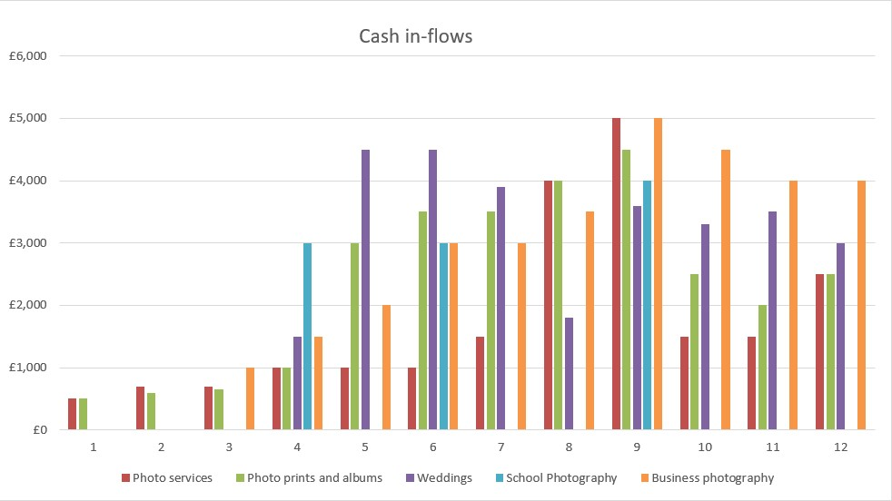

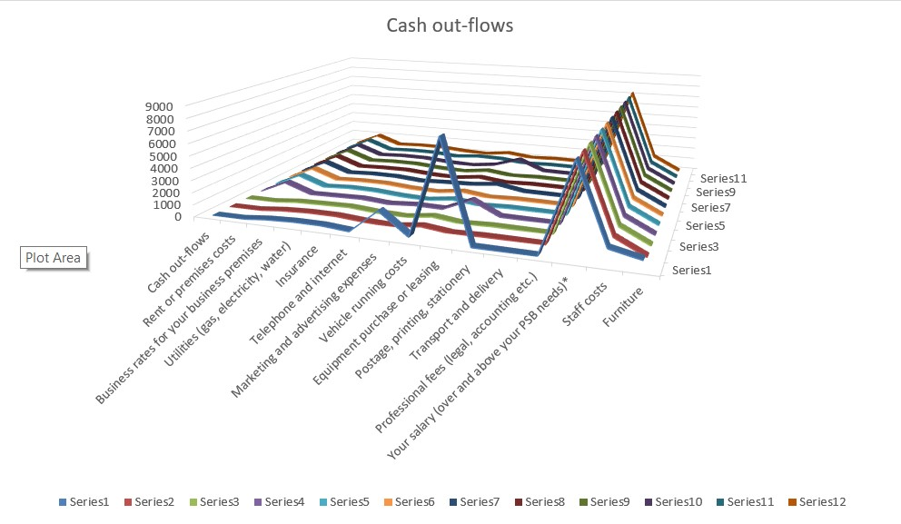

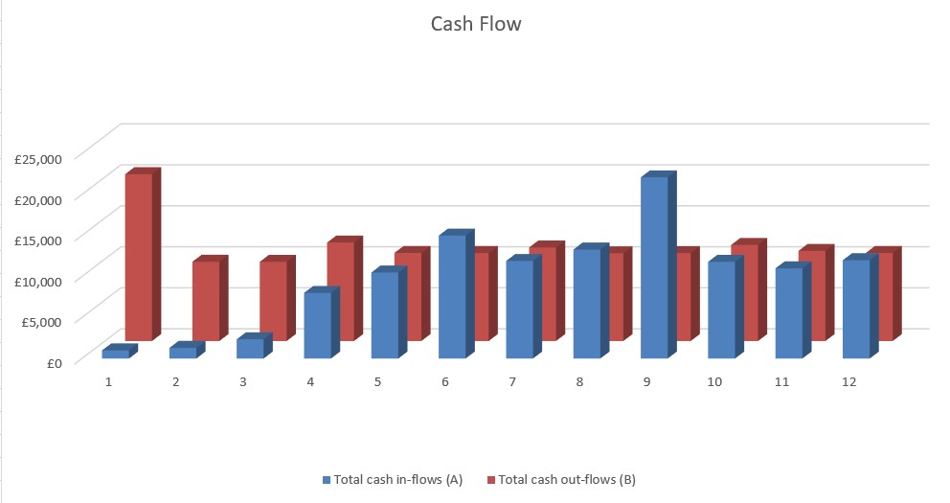

References

- ACAS (2020), Training Courses. Available at: https://www.acas.org.uk/training-courses, (Accessed 3rd Mar 2020)
- Baby and New-born Photography Association (2020), Welcome to BANPAS, Available at: https://www.banpas.co.uk/, (Accessed: 3rd Mar 2020)
- RJ Chartered Surveyors (2020), Estate Agents and Letting Agents. Available at: https://www.zoopla.co.uk/find-agents/branch/rj-chartered-surveyors-63194/, (Accessed 2nd Mar 2020)
- Start UP Loans (2020), What is a Cash Flow Forecast? Available at: https://www.startuploans.co.uk/cash-flow-forecast-template/, (Accessed 2nd Mar 2020)
- SWPP (2020), Welcome to the Society of Wedding and Portrait Photographers. Available at: http://swpp.co.uk/, (Accessed 3rd Mar 2020)
- The Master Photographers Association (2020), Welcome. Available at: https://www.thempa.com/, (Accessed 3rd Mar 2020)
- The UK Copyright Service (2017), UK Copyright Law. Available at: https://www.copyrightservice.co.uk/copyright/p01_uk_copyright_law, (Accessed 1st Mar 2020)
- UK Government (2020), Setting up. Available at: https://www.gov.uk/browse/business/setting-up, (Accessed 2nd Mar 2020)
- University of Wales Trinity Saint David (2020), Home Page, Available at: https://www.uwtsd.ac.uk/, (Accessed 3rd Mar 2020)

Table of Contents
Executive summary 1
About the Business 2
Name of the Business 2
Location of the Business 2
Business Owners 2
Mission and Objectives of Business 3
Products and services 4
Physical resources 5
Financial resources 6
Human resources 6
Marketing Activities 6
SWOT Analysis 6
Action Plan 7
PEST Analysis 7
Segmentation 8
7 Ps Marketing Mix Theory 9
Cash flow 10
References 11
Appendix 13
Gantt Chart 13

Appendix

Cash Flow
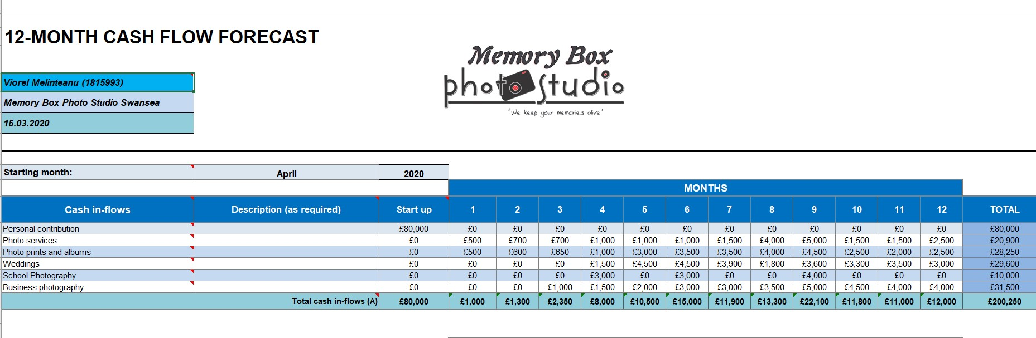
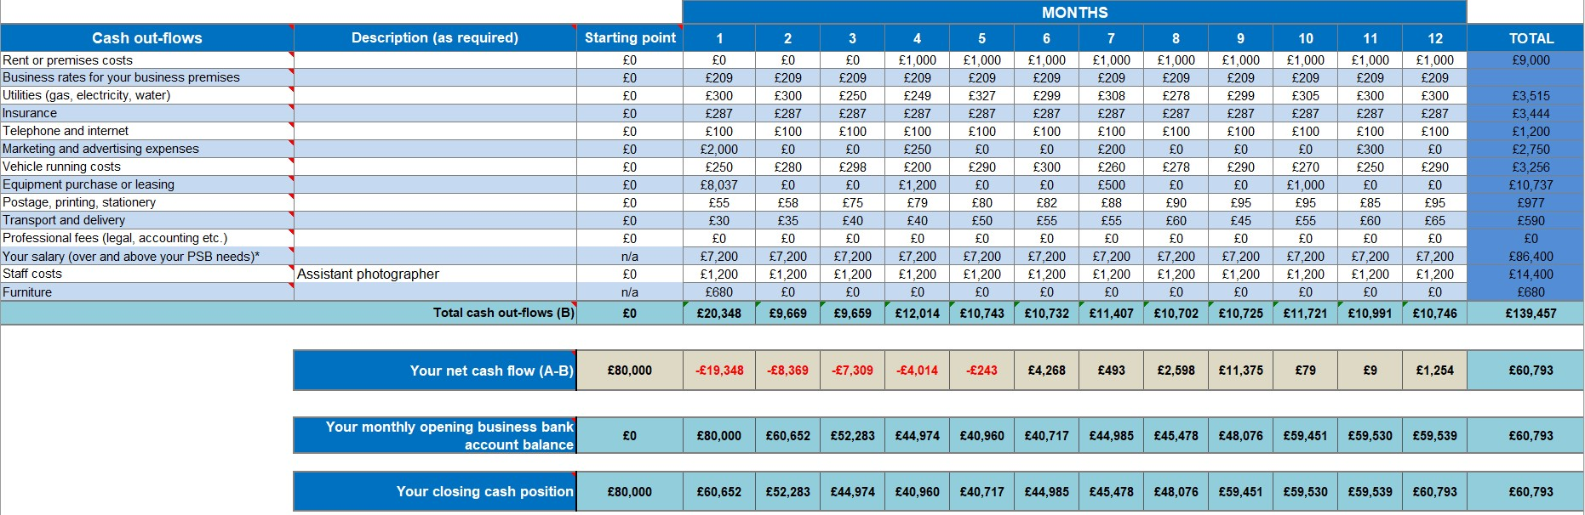

Gantt Chart

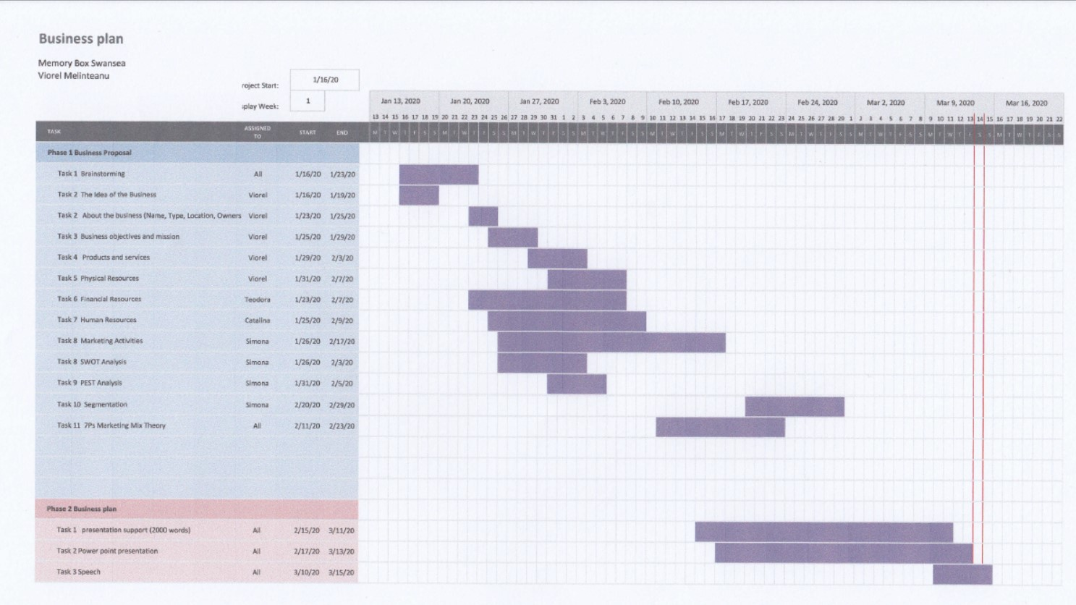

Questionnaire

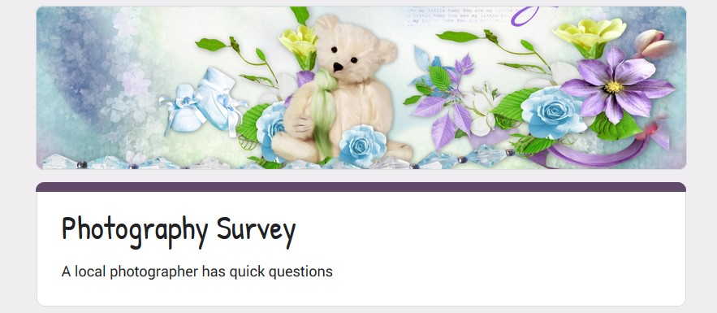
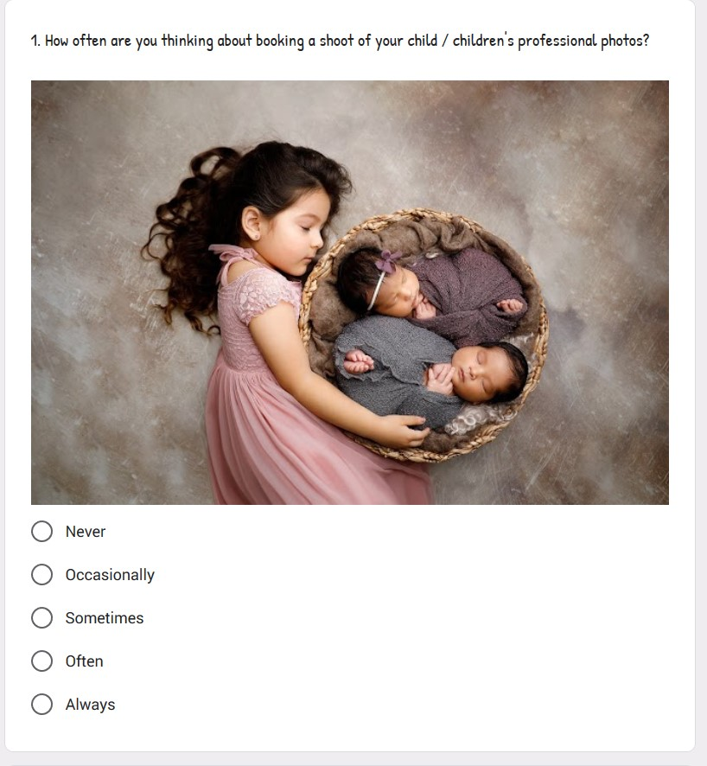
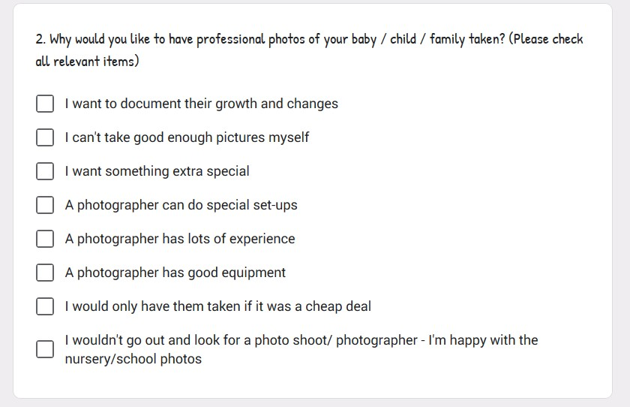
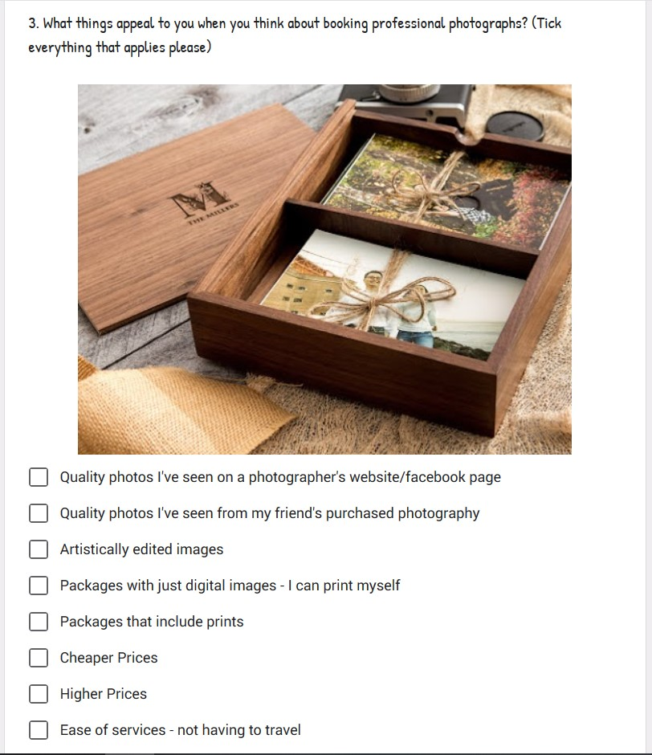
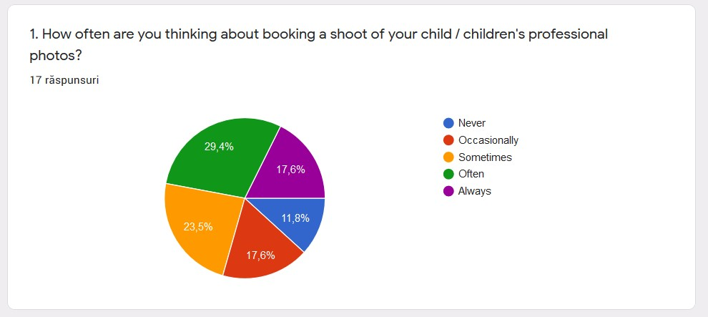
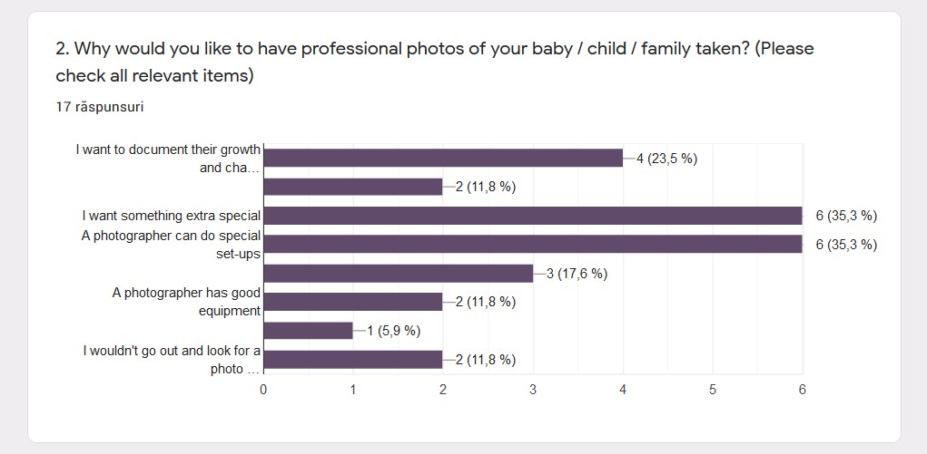
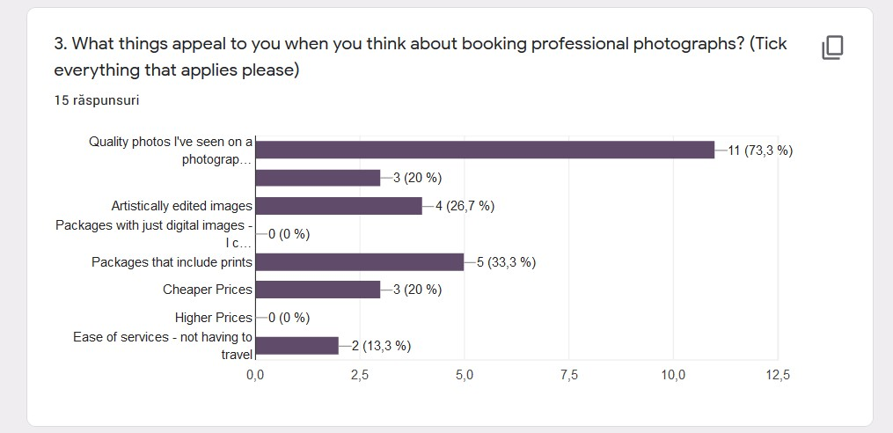

Website Print Screen



