Student name: Amy Rachel Thomas
Student number: 210059
Area of Study- BA Illustration (Year 1)

8 statements about my manifesto and practice –

- All work should be unique and should portray its own style
- Each individual piece should include a different medium or more than one
- Work can be inspired by other artists, to gather a range of ideas to put into their own work, without the risk of plagiarism
- Using sources like Pinterest can limit information and can often cause plagiarism
- All pieces should portray emotion and expression throughout – which can be portrayed through the use of colour and facial expression of the components
- All components should include at least one item that stands out from the rest which could portray a sense of boldness or contrast within the colour scheme
- All pieces should include one or more mediums to show contrast and a sense of realism
- Forms of symbols could be included to make the audience analyse and to understand the deeper meaning behind what the artist has portrayed

Chosen 3 Statements –

- Each individual piece should include a different medium or more than one
- All pieces should portray emotion and expression throughout – which can be portrayed through the use of colour and facial expression of the components
- All pieces should include one or more mediums to show contrast and a sense of realism

My manifesto – 500 words – task 1

- Each individual piece should include a different medium or more than one

As being an illustrator in practice and education, I feel that it is extremely important to value our work and to be extremely proud of every individual piece that we may create. Despite disliking some of the art pieces that are created, we are able to learn from these and explore new ideas through the use of different mediums such as, watercolour paints, pencils, print making, sketching and life drawings. This is shown through the source, “The Ultimate Guide on Different Art Mediums” (2021- ARTDEX) as it states that, “people have been using various mediums to express themselves”. It shows the idea that people use tone, texture and other methods when it’s comes to portraying emotion and feeling through what they intended to create.

- All pieces should portray emotion and expression throughout – which can be portrayed through the use of colour and facial expression of the components

When it comes to creating a particular piece, I feel that each piece should begin with a simple sketch that allows the artist to plan and map out where they want to go with the idea. After this, a large amount of detail can be included that can be portrayed through the use of the different mediums. From this, it could be understood that through the use of colour, a variety of emotion and passion can be portrayed, in order to show feelings and symbols that the artist is trying to peruse through the colours and textures of the art piece. In the book, “Mixed media-magic” (July 2018) the author, ‘Karen Campbell’ states ways in which you can become far more effective when choosing to use different mediums throughout your work. She created unique and different ways in which artists can express themselves through the colours and textures that they choose to use, as well as how to experiment effectively whilst using mediums that may never have been chosen to be used before. I believe that expression should always be portrayed to give the art piece meaning and to symbolise emotion that is trying to be perceived.

- All pieces should include one or more mediums to show contrast and a sense of realism

I also think that if the piece was portraying the concept of a life drawing, facial expression, tones and shades could be included to show the emotion and passion through what the colours are portraying. An interesting source that I have found, is a complete life drawing tutorial and journal book that explains how to maximise skill and helps to benefit artists that want to specialise in this form. It is the, “Complete Guide to life drawing” by Gottfried Bammes (2008) and includes the word from the authors, Max Beckmann, André Derain, Georg Kolbe and Pablo Picasso. Finally, I believe that all pieces should include one or more medium to show contrast and a sense of realism. This can be portrayed through the mediums listed above. Whilst including this, forms of symbols could also be included to make the audience analyse and to understanding the different and deeper meaning behind what the art piece is portraying.

Bibliography – Task 1

ARTDEX (2021). The Ultimate Guide on Different Art Mediums. (Online/Website) ARTDEX. Available at: https://www.ARTDEX.com/ (Assessed 2nd Oct. 2021)

Campbell, K. (2018). Mixed media-magic. AwesomeArtSchool.com (Campbell, 2018)

Bammes, G., Beckmann, M., Derain A., Kolbe, G. and Picasso, P. (2008). Complete Guide to life drawing ( Bammes et al.,2008)

Task 2 – semiotics – observational writing – 500 words

The word, “semiotic” is the, ‘study of signs and sign-using behaviour” as stated by Britannica. One of its founders, “Ferdinand de Saussure” describes the word, “semiotic” or seniority” as being the study of, “the life of signs within society”.The image that I have chosen to analyse is a painting entitled, “the scream” and was created by the artist, Edvard Munch(c1910). The chosen mediums as shown are oil, tempera, pastel and crayon and have been created onto cardboard. From this image, the main concept and idea that we can gather is that there is a ghost-like figure that is standing on a bridge. One of the key concepts being code, portrays the idea that the ghostly figure in this image could be lonely due to it being a singular figure. As well as, it could depict the feeling of being lonely and isolated and being strangled by this intense fear of not being able to escape this particular emotion or feeling. Another concept being colour gives us the impression that the figure is depressed, frightened or scared as the colour blue is used frequently. The painting depicts a dark tone and mood which is reflected in the characteristics and expression on the figure’s face. This image almost appears terrifying due to its chosen colour scheme, as well as the expression on the ghostly figure’s face. It is clear to understand that this piece has been created through the medium of watercolours, due to the harsh brush strokes, in order to gain the unsettling impression from the bold tone and shade of the background. The signifier of this image is that the way in which the background has been shaped and formed by the oil, is also reflected and mirrored with the way the figure’s hands and face are shaped. The waviness of the background gives the impression that the emotions are unstable and unbalanced and gives off an unsettling depiction when analysed. As stated by the website, ‘Draw Paint Academy’ (June 3rd, 2019 – Dan Scott), this painting ‘features a dramatic display of sailing lines, distorted forms and exaggerated colours’. This has been carried out to create the unsettling atmosphere and to show the audience the much deeper reasoning and meaning behind the famous ‘Scream’ painting by ‘Edvard Munch’. Not only was it just the one form of this painting, but four other versions were created in total. It can be seen that other line drawings were formed and painted, but mostly using different mediums. They were created through the form of, ‘lithograph, pastels and tempera’.

Bibliography – Task 2

Barthes, R. (2021). (Online) Britannica. Available at: https://www.britannica.com/science/semiotics (assessed 27th December. 2021)

Munch, E. (n.d). The Scream. (Oil paints) National Gallery and Munch Museum, Oslo, Norway.

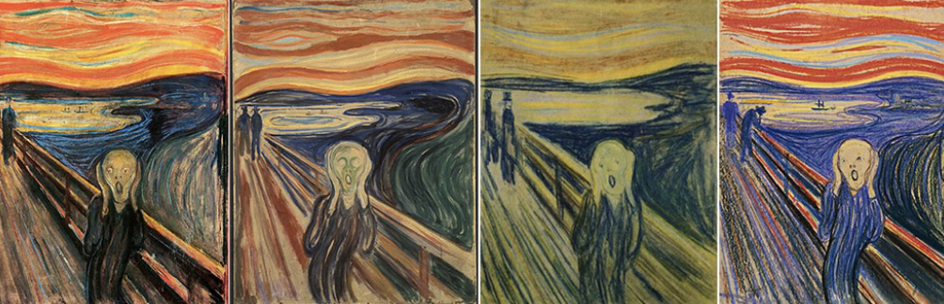
Scott, D. (2019). Draw Paint Academy (online) Draw Paint Academy. Available at: https://draw paint academy.com/ (Assessed 27th December. 2021)

Munch, E. (n.d). The Scream. (Oil paints) National Gallery and Munch Museum, Oslo, Norway.

Task 3 – analysing our own work against an Artist’s work

For one of my class pieces, I have created a watercolour piece that includes a limited colour scheme, whilst using only watercolours with diluted tones and shades. I chose to use the colour blue as the main colour for this piece as I wanted to portray the emotion of sadness and nervousness due to the illustration that this piece portrayed. It shows the illustration of a female character standing on stage, waiting to perform in front of an audience. This is based off of a personal experience as I was able to portray this emotion that I was feeling by using this limited colour palette. The artist’s piece that inspired me in order to create my watercolour painting, was entitled, the “starry night” by Vincent Van Gogh (June 1889). It is very clear to understand that Van Gogh uses the colour blue predominantly throughout a large variety of his pieces. The main difference between this artist and my own work, is that Van Gogh has used the medium of oil paints, which portrays the thicker and bolder lines and colour schemes, whereas I have used diluted tones and shades to create a variation of the blue shades to portray the emotion of sadness. After creating a colour wheel when learning about the theory of colour, I was then able to work with one colour throughout my work, by also using other tones and shades of the one colour to portray a large sense of sadness and anxiety throughout. From looking at this particular piece, I really enjoy the tone and texture that has been created by Van Gogh as it is very clear that the medium is in use is oil paints. A book was later published to show the great artwork of Van Gogh and all the pieces that were created during the, ‘blue’ period. “Vincent’s colors: Words and Pictures by Vincent Van Gogh” (15th September 2005) was edited by ‘William Lach’ who explains the mind of Van Gogh and what can be told from he paintings that were created. Despite it being an biography, it doesn’t go unnoticed the strong passion and talent that Van Gogh had and how he will be remembered for the famous artwork that has altered the society of art and design, today.

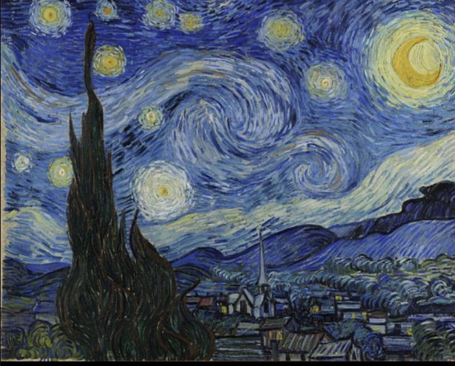
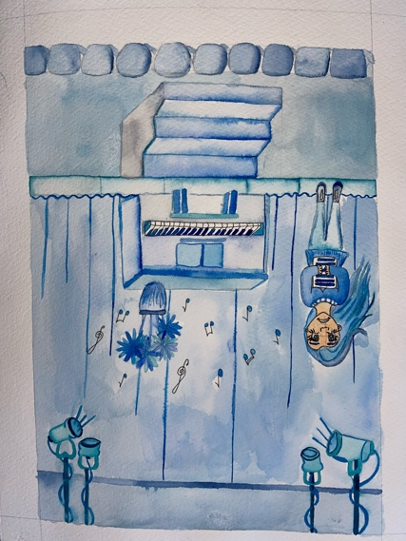
Bibliography Task 3-

Van Gogh, V. (Van Gogh, 1889)Starry Night (Watercolour paints)

Lach, W. (Lach 15th September 2005) Vincent’s Color’s: words and pictures. William Lach

Bibliography

ARTDEX (2021). The Ultimate Guide on Different Art Mediums. (Online/Website) ARTDEX. Available at: https://www.ARTDEX.com/ (Assessed 2nd Oct. 2021)

Campbell, K. (2018). Mixed media-magic. AwesomeArtSchool.com (Campbell, 2018)

Bammes, G., Beckmann, M., Derain A., Kolbe, G. and Picasso, P. (2008). Complete Guide to life drawing ( Bammes et al.,2008)

Barthes, R. (2021). (Online) Britannica. Available at: https://www.britannica.com/science/semiotics (assessed 27th December. 2021)

Munch, E. (n.d). The Scream. (Oil paints) National Gallery and Munch Museum, Oslo, Norway.

Scott, D. (2019). Draw Paint Academy (online) Draw Paint Academy. Available at: https://draw paint academy.com/ (Assessed 27th December. 2021)

Van Gogh, V. (Van Gogh, 1889)Starry Night (Watercolour paints)

Lach, W. (Lach 15th September 2005) Vincent’s Color’s: words and pictures. William Lach

