River Teifi Clean Up
Llandysul Paddlers Canoe Club.

‘An Environmental Disaster’, simply the only way we can describe what we were presented with on the 18th February as we set out to remove as much rubbish as possible from the river Teifi. As a club, Llandysul paddlers have organised and been a part of a number of river clean ups, we knew what to expect and until recently had been pleasantly surprised by how clean and trash free the river Teifi has been.
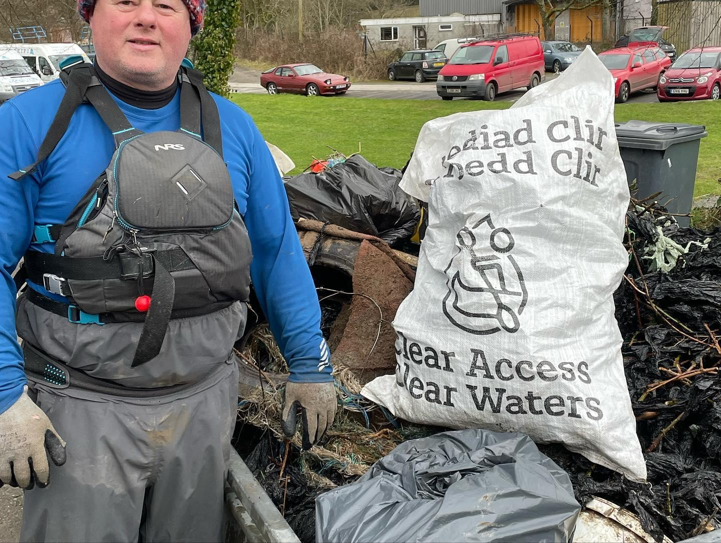
During the winter months, the river Teifi and its adjoining tributaries are prone to extremely high water, bursting their banks. This unfortunately resulted in occasional rubbish being washed into and down the river. When we organised this clean up this is what we expected, unfortunately and to great sadness, this is not what greeted us. Tonnes upon tonnes of Black silage wrap and the netting that holds it together, strung for the duration of the river trip. This section of river has been paddled for years and years, with centre manager Gareth Bryant stating this is the worst condition he has ever seen.
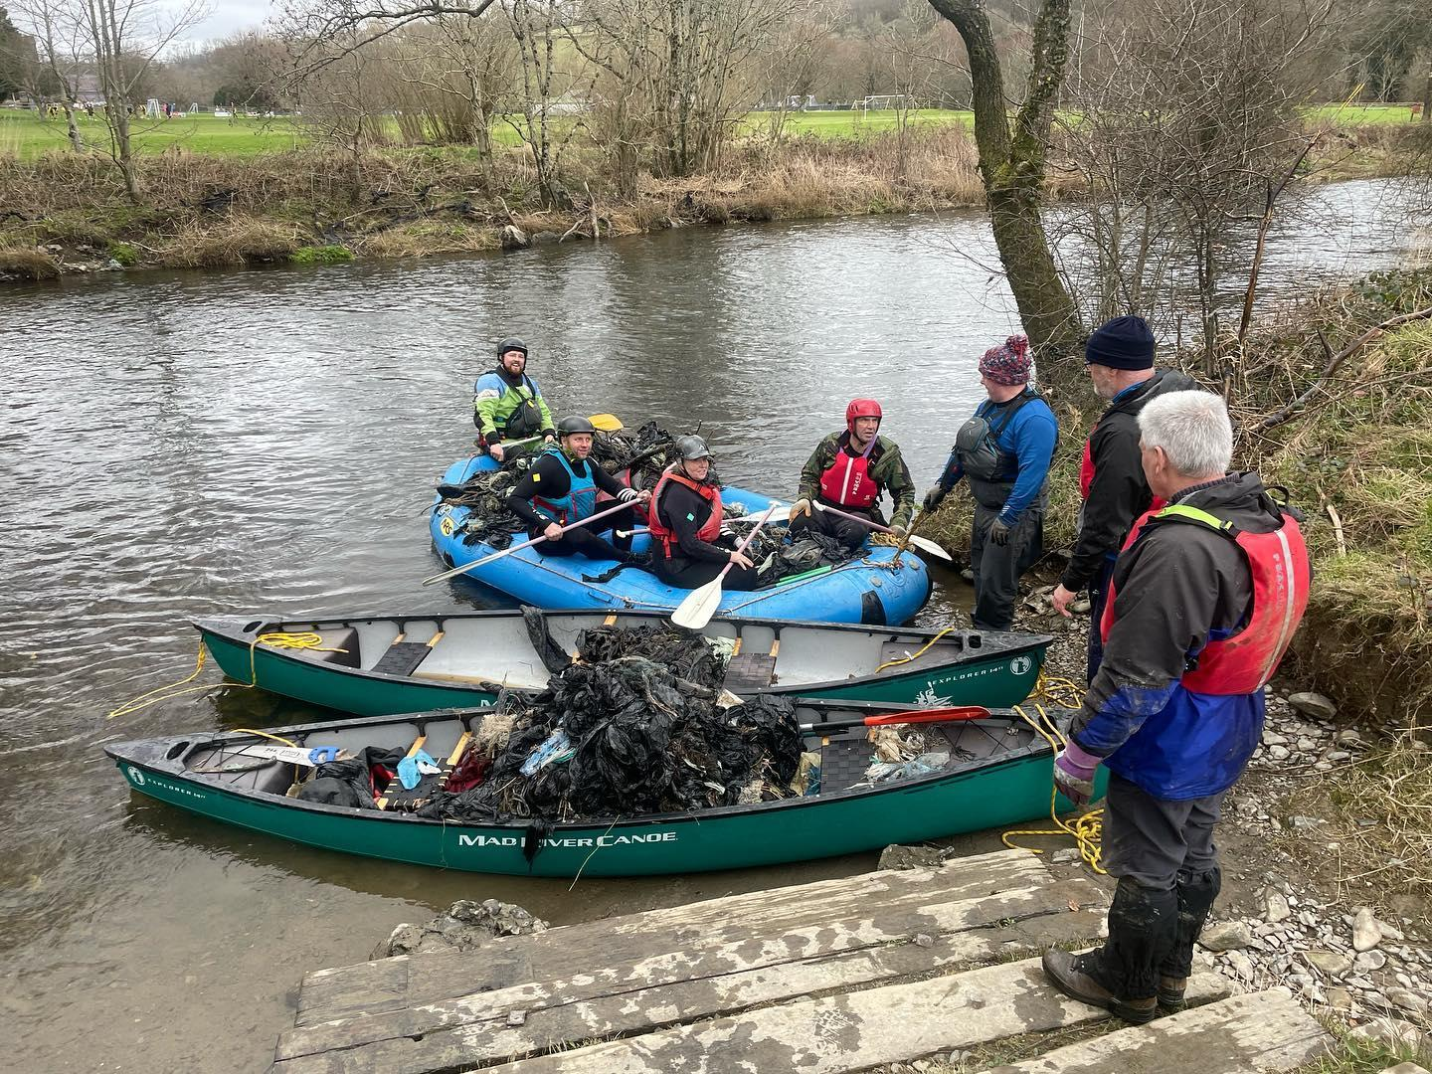
As a club we set about removing as much rubbish as possible from the river. As we got going we filled our eight person whitewater raft, two canoes and with a number of kayakers having rubbish piled on top of their kayaks, we simply could not fit anymore rubbish onto our boats. This, as good as it felt, was simply heart wrenching, at the point when we couldn't take anymore rubbish from the river, we were only two kilometres into a five and half kilometre long trip.

Feeling EXTREMELY glum, and simply broken hearted at the condition the Teifi was in, we knew we needed to get back in there and remove the rest of the rubbish, this highlighted by a number of the younger club paddlers that had come along to take part in the river clean.
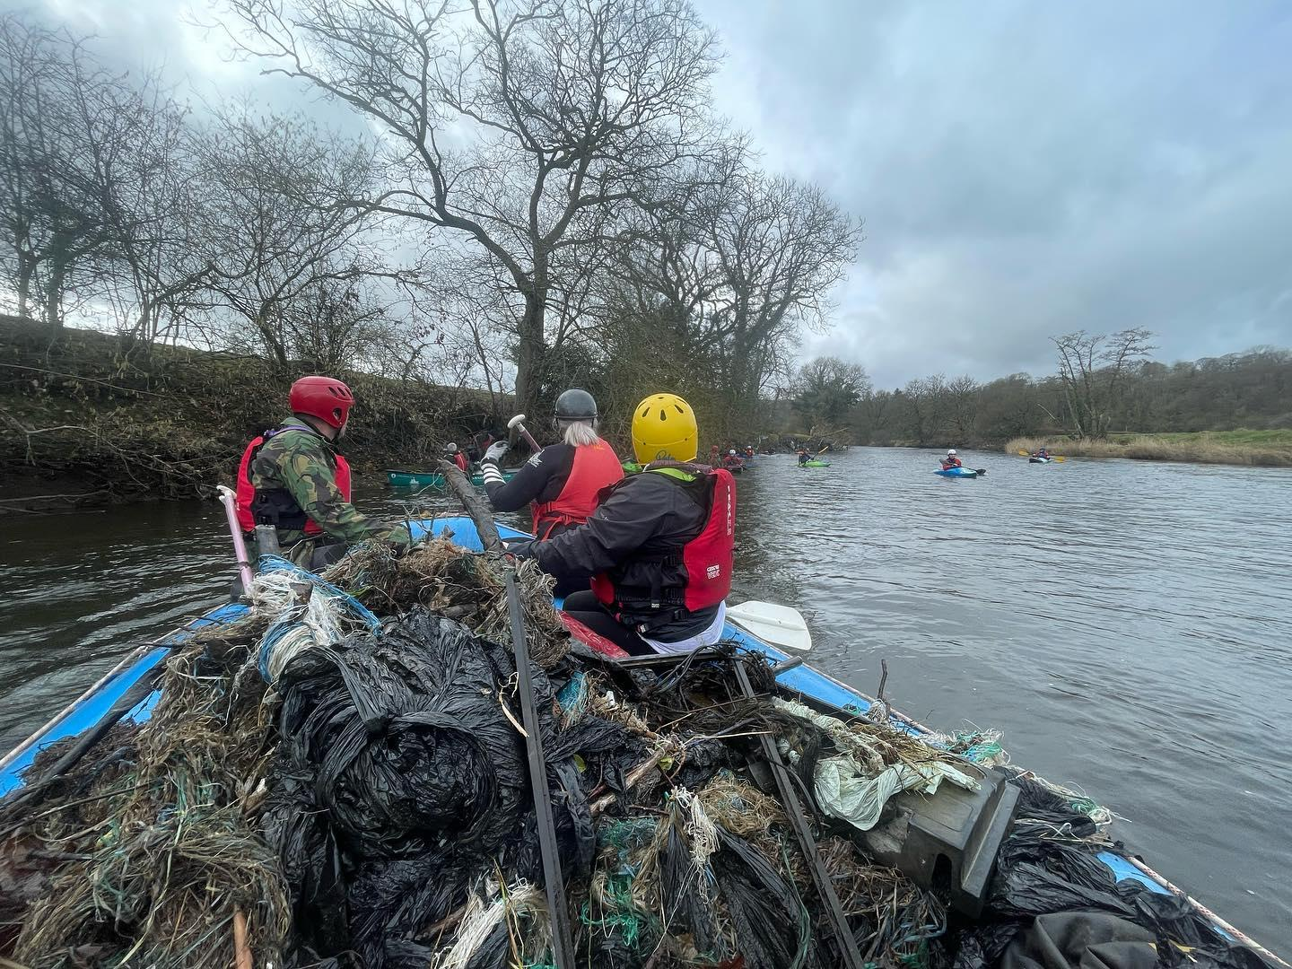
So, as I write this we have it planned, more rafts, more kayaks, more canoes and more people but more importantly more rubbish removed from our beautiful river that gives us so much.

As a club we love being on the water, and if we can give a little back to an environment that gives us so much then we are doing a good thing.

If you'd like to get involved in future river cleans, feel free to reach out to us via email on Bpaddlers@aol.com or phone us on 01559 363209

