Change Management

British Railways

Author
Elsiddig Eldaw Ibrahim / 2024641

University of Wales T. S. D
Business School/ MBA Programme
Lecturer: Marie Pitson

Change and Stability Management/ BMMB 7000

March 2023

Executive Summary
Any organization that deals with changes in processes or products needs to use change management as a tool. A better understanding of the forces driving change and the obstacles standing in the way of change is essential. Furthermore, it's critical to comprehend how environmental issues may affect change management strategies. One company that has the potential to add innovations for process innovation is British Railway. The oldest railway service in the world is this one. The company has a workforce of 710 000 people and has significantly aided in the nation's economic growth. Additionally, there have been significant infrastructure developments, and the UK government is acting to improve and innovate the infrastructure development of the nation's railroad facilities. According to the reports, the British Railways still lags behind the rail networks in Europe and Asia. Development is therefore essential. As a result, the report is about the high-speed train project's implementation through the privatization of the railways with HS2 Limited. The HS2 high-speed train process is primarily considered during development, and it is further imperative to ensure that the transition is going smoothly. In order to explain change management in the chosen context, the study has included a number of change management tools. Kurt Lewin's Force Field Analysis, Kurt Lewin's Change Model, and Kottler's eight-stage change model have all been used in its implementation. Each of the explanations of the change management process has been done well. Understanding the results of change management requires considering this crucial and worrying factor. Further explanations of the motivating factors in culture, leadership, power, and politics have been provided. The cultural aspects of change management have been described using the example of the cultural web. PESTEL analysis and SWOT analysis were also used to identify environmental factors, some of which were found to be helpful to the change management process. To ensure that the change implementation was carried out successfully, it was necessary to understand the change's resistance and remove it. The HS2 high-speed train project should consider all these factors in ensuring proper development and success in implementation. Thus, clear process of change management should be undertaken that is transparent and consistent.

Table of Content
1. Introduction 5
2. Change Management Models 6
2.1 Kurt Lewin’s Force Field Analysis 6
2.2 Kurt Lewin’s Change Management Model 7
2.3 Kottler’s Eight Step Model 8
3. Change Management Drivers 11
3.1 Culture of the Organization 11
3.2 Leadership of the Organization 13
3.3 Politics and Power 13
4. Environmental Identification 15
4.1 PESTEL Analysis 15
4.2 SWOT Analysis 17
5. Stakeholder Analysis 18
6. Resistance to Change 19
7. Conclusion 20
8. Recommendations 21
9. References 23
10. Appendix 27
10.1 Force Field Analysis 27

List of Figures
Figure 2-1: Stages of Kurt Lewin’s Change Management Model 7
Figure 2-2: Kottler’s Eight Step Model 8
Figure 2-3: Kottler’s Eight Step Application 9
Figure 3-1: Cultural Web 11
Figure 3-2: Cultural web supplication 12
Figure 3-3: Leadership and change management 13
Figure 4-1: PESTEL Analysis 15
Figure 5-1: Mendelow’s Matrix 18
Figure 8-1: Overcoming resistance to change 21

List of Tables
Table 2-1: Driving forces and resistors for the change 6
Table 4-1: PESTEL analysis 15
Table 4-2: SWOT analysis 17
Table 6-1: Methods to overcome the resistances 19

Introduction
Understanding organizational development and expansion requires knowledge of a key component called change management. To implement changes effectively, it is imperative to consider the creation of the steps and use of the models in change management. The current study has chosen a number of theoretical components for application. Kurt Lewin's force field analysis, his change management model, and Kottler's eight-step model are among the different change management models used to comprehend the change management application. The study also outlined the motivations behind change management as well as potential environmental influences on change management in the chosen organization. Understanding the resistances to change management opens up possibilities for ensuring that organizations are effectively implementing preventive measures. Additionally, the author offers suggestions that can be used by organizations to implement an efficient change management process.
British Railways was chosen as the study's chosen organization. This state-owned company was established in the 17th century (Ferranti, et al., 2018). The oldest railway in the world is thought to be this one. There are millions of people employed by this railroad, which has more than 23,000 routes (Thorner, 2017). The railway system underwent a wide variety of changes, most of which were undertaken to improve the infrastructure of the nation. The naming of the change management initiative implemented in this organization has been considered for this report's investigation. This is a high-speed train project. HS2 Limited is a company that has been tasked with carrying out the project and is anticipated to generate millions of dollars in revenue as well as thousands of jobs for the benefit of the nation's economy (Nowell, 2021). This project is mainly reflecting how the private and public leaders are facing the development of the higher speed railway projects in Britain.

Change Management Models
Change management can be identified by several change management models. These models are highly used in the literature in order to have a clear understanding regarding the implementation of the change in the organization. Thus, it is necessary to make sure these models are well applied within the change management context. Three types of change management models are applied in the study.

Kurt Lewin’s Force Field Analysis
There are driving forces for change and resisting forces for change. Driving forces are adding value and encouraging the change, while resistance forces are discouraging it. Understanding the weight of these forces is mainly understood by Kurt Lewin’s force field analysis (Capatina, et al., 2017). Understanding these is a necessity and a must to make sure the changes are applied effectively and significantly (Kobtsev, 2020). Following table gives the driving forces and resistance forces towards the change management applications.
Table 2-1: Driving forces and resistors for the change
Source: Created by Author
Drivers for change | Resistors for change
The motive for profit by private sector | Businessmen against scraping of steam Locomotives.
To put an end to state funding scheme | Local landowners, farmers, environment protection activists, HS1, HS2
Dr Beeching report, for modernization and to deliver the needs for the life style at the 21st century | Trade unions dispute for increasing wages
Creating more jobs and safe time, money and life's | Railway preservation movement led by Tom Rolt, saved Talyllyn Railway from closure in west Wales.
Catch up with forefront countries in the world with advance Railways technology | Green movement activists against coal production and steam trains
Remove Railways from short-term political control- to long term strategic plan | Politian against high cost projects.eg, Channel Tunnel, the conservative government 1984
Improving infrastructure and Railways Network | Taxpayers; privatization is benefiting overseas Gov-rather than UK Government

Understanding the weights of the forces and analysis is provided in the Appendix 01. As per the analysis it is clear that driving forces are higher than the resistors that is leading to the implementation of the change in the identified context.

Kurt Lewin’s Change Management Model
There are three stages in the change management model that has been explained by the Kurt Lewin and these three stages are (Burnes, 2020);
- Unfreezing
- Change
- Refreezing
This is a cycle and undertaking in each change management practice. This is explaining a better stage and steps on making significant applications in change management practices. Following is explaining the three stages in the change management effectively (Pawar & Charak, 2017).

Figure 2-1: Stages of Kurt Lewin’s Change Management Model
Source: Created by author
Application of change is necessary for the organization and the change identified is privatization of British Railways with HS2 project implementation. Application of three stages is as follows.
- Unfreezing – Present situation has been explained by the respective parties to all the stakeholders. Britain is lagging behind the railway development in Asian and European countries which is making it eager for change (Munro, 2021; Banister, 2018). Privatization can increase investments, and job opportunities in the field with saving time and money. Economic growth also can be gained with this change (Nowell, 2021). In 2019 the Railways subsidies also increased from £2.9 billion in 1992–93 to £7.7 billion. These are the main reasons for the application of change management within British Railways (Brock & Goodey, 2022).
- Change – Change has been implemented and investments were increased from £698m in 1994–95 to £6.84bn in 2013–14(Network improvements, electrification, signaling on the Cambrian Coast Line ‘’paid for by the Welsh Government’’ and HS2 paid by England. This was a positive point (Tetlow & Shearer, 2021). The Planet Framework model v43 has been used by the project to understand the demands and benefits of the new railway system. Still, this was stopped for 10 years by the UK government in March 2023 to spread the total costs to save money and reduce costs.
- Refreezing – The change has been implanted halfway and the imposing has occurred. Still, many stakeholders related to the change project have started to embrace the change and accept change. There are several changes faced so far by the stakeholders, employees, and even the government. Thus, each party was readying to the change and accepting the change on a positive level.

Kottler’s Eight Step Model
This is a model that is showing eight steps and these eight steps needed to be followed in understanding the change effectively. Change management is a significant identification for the successful development of the practices in change effectively (Libby, 2017). Following figure gives the steps available in the model.
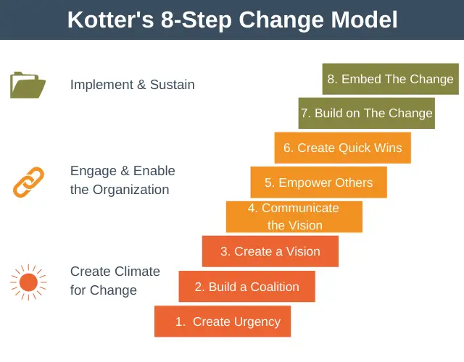

Figure 2-2: Kottler’s Eight Step Model
Source: (Pollack & Pollack, 2015)

Understanding these eight steps is necessary in change management applications. Thus, clear idea has been provided in each step regarding the change management used in the selected organization.

Figure 2-3: Kottler’s Eight Step Application
Source: Created by author
As per the steps explained in the Kottler’s Eight Step Model, change has been implemented successfully for a half way. The project has delivered significant outcomes in increasing the effectiveness of the railway system in UK. Further increasing investments and the railroad subsidies also undertaken. These are positives of the change management. Implementation steps of the change management process is significant and important. Thus, it is necessary to understand the future steps of the change process as well. Since the project is been stopped for 10 years, the implementation process also stopped (Rhodes, et al., 2019). Still, there is an effectiveness of the implementation process of the change as every action has resulted a clear outcome of the development. This model is clearly explaining the success of the implementation so far.

Change Management Drivers
Change in any organization can be impacted by different drivers, and it is highly important to have a clear understanding of these factors for better change implementation. There are drivers for change management and there are resistors for change management. Understanding the drivers for the change is necessary as it allows for the significant development of strategies to undertake the change effectively. Several factors have discussed in this section.

Culture of the Organization
Organizational culture is necessary to understand. Different factors contribute to organizational culture. Behavior, discipline, and practices within the organization can be mainly discussed in terms of the culture of the organization (Li, et al., 2018). Organizational culture is necessary to understand as it gives the path and idea to implement change management practices. Several different change management models are presented in the literature and can be used in understanding the organizational culture (Nieborg & Poell, 2018). Here, the change process has been completed for British Railways, and thus, the culture prevailing in this organization should be identified. A cultural web application has been used to explain the culture prevailing in the organization (Doherty & Stephens, 2020).
There are different factors in the cultural web and these are showing in the following figure.
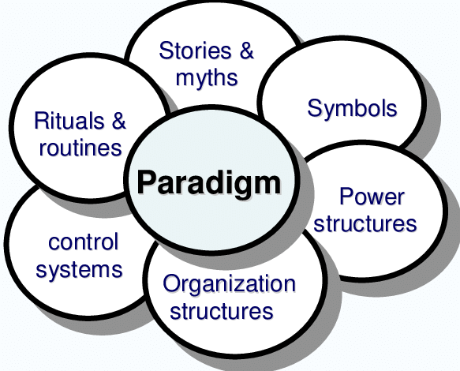
Figure 3-1: Cultural Web
Source: (Mossop, et al., 2013)

Application of cultural web for British Railways is provided as follows.

Figure 3-2: Cultural web supplication
Source: Created by Author

Leadership of the Organization
Leadership is a main concern in change management. Change management applications must include leadership practices to deliver effective outcomes (Alqatawenh, 2018). It is highly important for the companies to have a leadership favorable to change management. Transformational leadership is the best leadership method for change management (Galli, 2018). Transformational leadership is mainly concerned with the outcomes of leading the change, innovation, and strategic implementations regarded with different decisions.
The Transport Act of 1947 has been used in creating the British Railways, and the government is leading with respective management for the institute. The Great British Railways Transition Team (GBRTT) is the main body targeting change management within the organization (Tomlins, et al., 2019). Leadership was significant and strategic. Transformational leadership is present in this GBRTT. The members of the team are able to produce strategies to change the culture into one that is more innovative (Rhodes, et al., 2019; Bagwell, 2017). Further, system-wide alignment is being provided by the leadership that supports change management. Following figure gives a rough development of the leadership management towards change development effectively.
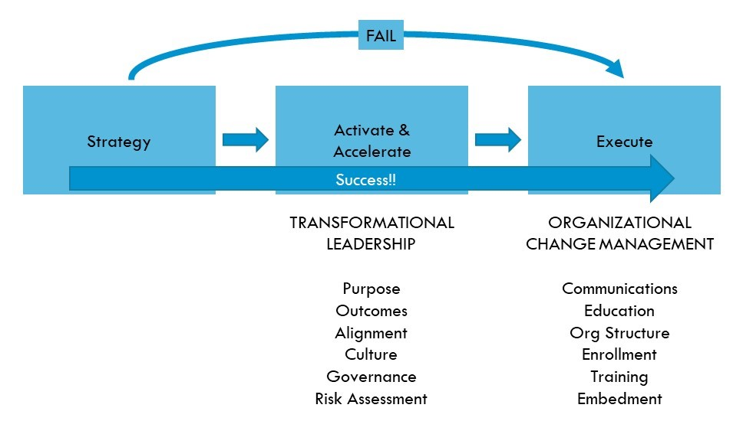
Figure 3-3: Leadership and change management
Source: (Project Management, 2019)

Politics and Power
Applications of change management require an understanding of power and politics. British Railways is a company that the government owns. The policies of the government largely determine power and politics (Casson, 2020). Organizational change management is a task that some government workers handle. In the UK government, different approaches to dealing with change practices, decisions, and even reporting are evident. In government projects, consistency between each step is an extremely important outcome (Dobbin, 2018). As a result, politics and power within the UK government are favorable to change management techniques. Understanding the advantages and disadvantages in this section is crucial for successfully implementing the change (Keep, 2018). In order to successfully complete the change, British Railways complies with all applicable laws and regulations. Practices for change management are aided by internal politics. GBRTT is crucial in addressing these internal politics and leading to a significant advancement in change management techniques. Accordingly, politics and the power with in the organization is acting favorable to the change management practices.

Environmental Identification
Environmental identification is a significant factor, and there are many different criteria that are needed to be considered in environmental identification (Casals, et al., 2019). Along with this factor, different tools are being used to investigate different factors in the environment. These factors are analyzed through PESTEL and SWOT analyses (Adefarati & Bansal, 2019). External and internal environment is been discussed by these tools.

PESTEL Analysis
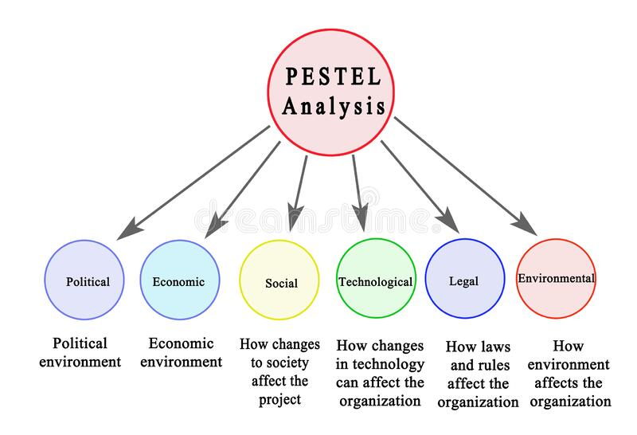
PESTEL analysis considers six factors that explain the external environment measures. These factors are well explained by the following figure: Each factor is necessary to understand regarding environmental concerns and understanding (Pan, et al., 2019). Thus, it is highly important to understand each part in the PESTEL analysis.
Figure 4-1: PESTEL Analysis
Source: (Cox, 2021)
Application of this for the British Railways is provided as follows.
Table 4-1: PESTEL analysis
Source: Created by Author
Factor | Explanation
Political Environment | Political factors are favorable for the railway’s operations in the country. There is significant support for the railway development in the country, and it is highly impacted on the development of the railway system as well (Pickard, 2019). Britain has a stable political environment. Policies and systems are clear and applied for the successful development of the country. this is a favorable factor for change management as government is aiding the change management practices.
Economic Environment | The economy of Britain is important for the development of the country. The development of the state-owned sectors depends mainly on the earnings and success of the country's economy (Lamb, et al., 2019). £43 billion in GVA has been contributed to the economy by rail in Britain. Further, there are 710,000 jobs in the railway sector and £14 billion in tax revenue from the sector. Thus, economic indicators are favorable for the change management.
Social Environment | Social trends are toward train usage. There is quick transportation by rail, and the ease of use is also higher. There are many older people who prefer convenience and comfort when traveling. This has been accepted in the country. Societal trends are having a proper impact on change. Speed trains and increasing infrastructure in railway is expected by the people in society (Bear, 2020).
Technological Environment | State of the Art SMART Coaches and sensors system for the passenger comfort is adding in the railways in present era. Further, SMART locomotive measures such as asset performance monitoring, location tracking, and rail integrity monitoring are some other moves and technological applications in the railway industry in the present era. These are needed to be added in Britain Railways to increase efficiency in service (Liu, et al., 2019).
Ecological Environment | There is disturbance to the environment as soil, air and water pollutions. Noises are also originated from this service and this is also impacting on the ecological system (Yang, et al., 2019). HS2 project also recorded to have environmental damage and this was not counted properly as well. These disturbances are impacting negatively and thus, overcoming them is a necessity.
Legal environment | Several laws related to health and safety, speed and passenger protection and mainly considered in UK railway system. Ecological protection with green transportation also legalized in the country. New act was published in UK; Railways and Transport Safety Act 2003 and following all the measures is undertaken by the respective departments.

SWOT Analysis
SWOT analysis is consisting in understanding the internal environmental factors. Strengths, Weaknesses, Opportunities and Threats are mainly considered here (Hajizadeh, 2019). SWOT analysis for British Railways is provided as follows.
Table 4-2: SWOT analysis
Source: Created by Author

Stakeholder Analysis
Stakeholders are the parties affected by the organization and affected in the organization (Choudhury & Pattnaik, 2020). There are several stakeholders that are available in the project and understanding them and the impact of the stakeholders in the project management is continuing as a significant impact on the delivery of the outcomes. Respective stakeholders of the project are as follows.
- Passengers
- Government
- Employees
- Partners and joint ventures
- Non-governmental organizations
- Technology providers
- Media
- Investors
Identify the power and interest of these stakeholders are necessary for the change management project. This is been done with the Mendelow’s Power and Metrix tool and this is been explaining as follows.
Figure 5-1: Mendelow’s Matrix
Source: Created by Author
High
Influence/power
Low
Low
Interest
High
Investor
Employees
Partners and joint ventures
Passengers
Government
Partner
Suppliers
Non – governmental organizations
Technology providers
Media
Keep Satisfied
Engage and Influence
Monitor
Keep Informed

Resistance to Change
There are several resistances that have been identified in the change project. Understanding these resistances is necessary to make sure the change management is undertaking effectively in the future. Along with this, resistances for the change has been identified and the measures to overcome them also identified as follows.
Table 6-1: Methods to overcome the resistances
Source: Created by author
Identified resistance | Overcoming actions | Strategies
Change is understanding in a wrong method | Stakeholders are not understanding the change method and the reasons to change. Communication and awareness should be provided to overcome this. | Communication plans, awareness sessions and formal and informal communication
Lack of awareness | Results should be planed and short-term wins needed to be represented effectively to deliver better success. | Awareness sessions, training sessions and workshops
Tolerance is the change is lesser | Change team members should understand the process clearly and pre-explaining should be done. It is a highly need. | Communication with formal and informal methods. Mentoring and monitoring the processes
Employee miscalculations | Onsite investigation should be provided to the change team to understand the real process of the change management. | Training sessions, onsite visits and communication plans
Poor planning (no proper calculation on environmental harm) | Investigation the situation beforehand. Involving more members to the change team and proving clear awareness. | Training and development methods, mentoring and workshops.

Conclusion
British Railways is a state-owned organization operating since the 17th century. There has been a huge development in the railway system since then, with new technology and innovations (Freeman & Aldcroft, 2018). In 1804 the first steam locomotive in the world to run on a railway, from the iron mines at Penydarren to Merthyr-Cardiff, was invented by Richard Trevithick. It was then implemented as the fastest steam locomotive, reaching 126 mph (203 km/h) with the Flying Scottish Man on July 3rd, 1938 (Herranz-Loncán & Fourie, 2018). In the 20th century, steam railways became the foundation stones that shaped Britain's industrial revolution. Likewise, the development of the British Railways has occurred over time (Roberts & Geels, 2018).
For better development initiatives in response to environmental changes, change management is required. The environmental changes and required applications have been explained using PESTEL analysis and SWOT analysis. It was determined that the organization benefits from a wide range of political, economic, technological, and legal factors. British Railways has implemented a change management process to comprehend the essential results of technology adoption. A project called HS2 was designed to give British Railways access to fast trains. The organization in charge of planning and promoting the UK's new high-speed rail system is called High Speed Two (HS2) Limited (Brock & Goodey, 2022). Government grants in aid are used to pay for it. In comparison to trains of a similar type in Europe, the high-speed train's implementation will be 15% lighter and provide 30% more seats (Munro, 2021). The goal of this project is to advance the British railway system.
The UK government put a ten-year hold on the project. This is primarily done to spread out the total cost in an effort to save money and reduce costs, which will ultimately result in long-term cost increases. It took place in March 2023. These decisions were imposed, which has stopped the flow of change. Additionally, the analysis of the current research has revealed a number of barriers to change as well as the project's motivators for change management. The project was designed to be successful, and it has also led to significant changes in the outcomes. It is further revealed that the project's creators did not take the potential environmental impact of its development into account. With more than 30 000 people employed, the project from London to Birmingham was 40% finished. The project was unable to keep up with the inflation and product prices because the prices estimated were subject to change. This was a drawback that the resistances had revealed.

Recommendations
Privatization of the Britain Railway has been implemented with HS2 speed train project. The report is mainly considered with the different factors targeting the change management and targeting the outcomes related to the project implementation. There can be several resistances to the change project and overcoming these resistances are necessary. The project has been stopped with respective to the cost concerns for 10 years by the UK government. Before that even there are situations that were considered with miscalculations and mismanagement of the processes. Understanding each of these and managing every step is considered as a critical identification. There are common recommendations for any change project to be applied in effective manner. these recommendations are as follows.
- Proper planning and identification in the process that needed to be changes and the outcomes of the change management process. There are different process management applications in past literature that can be followed in the project implementation.
- Main challenge is the resistances to the change. Company owned and unique practice can be used in the management of resistances for the change.

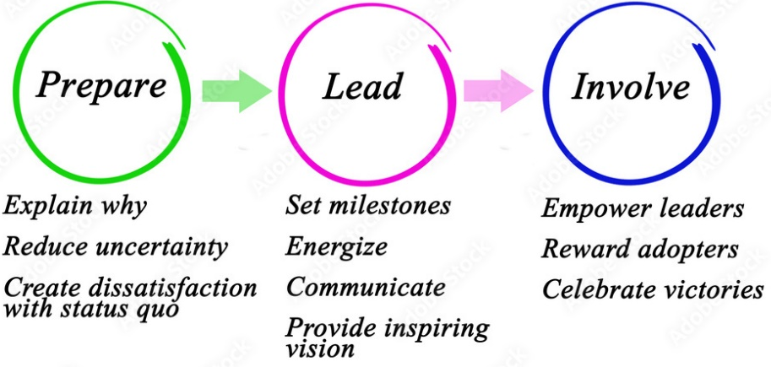
Figure 8-1: Overcoming resistance to change

- Proper communication among the different parties and stakeholders in the organization is another important identification to overcome the problems and carry on the change project effectively.
- Leadership training is another important factor for leading change in organization. Transformational leadership should be practiced among the employees to lead the change successfully.
- Monitoring the change management process is another suggestion that can be added in the change management process to have better experience in success
- Feedbacks are always needed to be welcome. Feedbacks from the stakeholders make significant impact on the development of the project by understanding the error points
- Meetings should be there in contacting every needed stakeholder to see the process is effective or not. This is a very important move to get maximum satisfaction of the stakeholders
- Arranging clear awareness among the personal involving with the change management process. Awareness is a necessary factor and this is reducing the error percentage in the change management process
- Environmental concerns are higher in the present project. Thus, separate team should be there to concern more on environmental impact of the HS2 project and to make sure the outcomes are arranged in an effective manner
- Technology applications always need several times testing before investing on the implementations permanently
- Clear vision and mission is needed to the change project and this is a must to have better development practices along with the development of the outcomes

References
Abd El-Shafy, I. et al., 2019. Decreased pediatric trauma length of stay and improved disposition with implementation of Lewin's change model. Journal of Trauma Nursing| JTN, 26(2), pp. 84-88.
Adefarati, T. & Bansal, R. C., 2019. Reliability, economic and environmental analysis of a microgrid system in the presence of renewable energy resources. Applied energy, Volume 236, pp. 1089-1114.
Alqatawenh, A. S., 2018. Transformational leadership style and its relationship with change management. Verslas: teorija ir praktika, 19(1), pp. 17-24.
Archer, M., Fuller, M., Cox, K. & Swearingen, N., 2019. Regional Stroke Program Coordinator Nurses Standardize EMS Feedback Utilizing Kurt Lewin’s Change Model.
Bagwell, P. S., 2017. The New Unionism in Britain: the Railway Industry. In The Development of Trade Unionism in Great Britain and Germany, 1880–1914 (pp. 185-200), s.l.: Routledge.
Banister, D., 2018. Policy on sustainable transport in England: the case of High Speed 2. European Journal of Transport and Infrastructure Research, 18(3).
Bear, L., 2020. Speculations on infrastructure: from colonial public works to a post-colonial global asset class on the Indian railways 1840–2017. Economy and society, 49(1), pp. 45-70.
Brock, A. & Goodey, J., 2022. Policing the High Speed 2 (HS2) Train Line: Repression and Collusion Along Europe’s Biggest Infrastructure Project. In Enforcing Ecocide: Power, Policing & Planetary Militarization (pp. 227-268), s.l.: Cham: Springer International Publishing.
Burnes, B., 2020. The origins of Lewin’s three-step model of change. The Journal of Applied Behavioral Science, 56(1), pp. 32-59.
Capatina, A., Bleojux, G., Matos, F. & Vairinhos, V., 2017. Leveraging intellectual capital through Lewin's Force Field Analysis: The case of software development companies. Journal of Innovation & Knowledge, 2(3), pp. 125-133.
Casals, L. C., García, B. A. & Canal, C., 2019. Second life batteries lifespan: Rest of useful life and environmental analysis. Journal of environmental management, Volume 232, pp. 354-363.
Casson, M., 2020. International rivalry and global business leadership: an historical perspective.. Multinational Business Review, 28(4), pp. 429-446.
Choudhury, S. & Pattnaik, S., 2020. Emerging themes in e-learning: A review from the stakeholders' perspective. Computers & Education, Volume 144, p. 103657.
Cox, J., 2021. The higher education environment driving academic library strategy: A political, economic, social and technological (PEST) analysis. The Journal of Academic Librarianship, 47(1), p. 102219.
Dobbin, F., 2018. Why the economy reflects the polity: early rail policy in Britain, France, and the United States. In The sociology of economic life (pp. 397-418), s.l.: Routledge.
Doherty, O. & Stephens, S., 2020. The cultural web, higher education and work-based learning. Industry and Higher Education, 34(5), pp. 330-341.
Ferranti, E. et al., 2018. The hottest J uly day on the railway network: insights and thoughts for the future. Meteorological Applications, 25(2), pp. 195-208.
Freeman, M. & Aldcroft, D., 2018. The Atlas of British Railway History, s.l.: Routledge.
Galli, B. J., 2018. Change management models: A comparative analysis and concerns. IEEE Engineering Management Review, 46(3), pp. 124-132.
Hajizadeh, Y., 2019. Machine learning in oil and gas; a SWOT analysis approach. Journal of Petroleum Science and Engineering, Volume 176, pp. 661-663.
Herranz-Loncán, A. & Fourie, J., 2018. “For the public benefit”? Railways in the British Cape Colony. European Review of Economic History, 22(1), pp. 73-100.
Keep, E., 2018. Scripting the future: exploring potential strategic leadership responses to the marketization of English FE and vocational provision, s.l.: s.n.
Kobtsev, I. F., 2020. An elliptic billiard in a potential force field: classification of motions, topological analysis. Sbornik: Mathematics, 211(7), p. 987.
Lamb, R., Garside, P., Pant, R. & Hall, J. W., 2019. A probabilistic model of the economic risk to Britain's railway network from bridge scour during floods. Risk Analysis, 39(11), pp. 2457-2478.
Libby, B. H., 2017. Examining Faculty Perceptions of Community College Institutional Effectiveness Using Kotter's Eight Step Model of Change, s.l.: ProQuest LLC.
Liu, S., Wang, Q. & Luo, Y., 2019. A review of applications of visual inspection technology based on image processing in the railway industry. Transportation Safety and Environment, 1(3), pp. 185-204.
Li, Y., Wang, X., Lin, X. & Hajli, M., 2018. Seeking and sharing health information on social media: A net valence model and cross-cultural comparison. Technological Forecasting and Social Change, Volume 126, pp. 28-40.
Mahmud, M. E., Baharun, H., Asykur, M. & Rochmatin, Z., 2022. Increasing Teacher Professionalism Through Change Management in Madrasah: Kurt Lewin's Perspective. Southeast Asian Journal of Islamic Education, 5(1), pp. 47-63.
Mossop, L., Dennick, R., Hammond, R. & Robbé, I., 2013. Analysing the hidden curriculum: use of a cultural web. Medical education, 47(2), pp. 134-143.
Munro, A., 2021. HS2 railway, UK–why the country needs it. In Proceedings of the Institution of Civil Engineers-Transport (Vol. 174, No. 1, pp. 3-11). Thomas Telford Ltd, s.l.: s.n.
Nieborg, D. B. & Poell, T., 2018. The platformization of cultural production: Theorizing the contingent cultural commodity. New media & society, 20(11), pp. 4275-4292.
Nowell, D. A., 2021. Geology of Marseilles to Italy high‐speed TGV railway line compared to HS2 in Britain. Geology Today, 37(1), pp. 23-30.
Pan, W., Chen, L. & Zhan, W., 2019. PESTEL analysis of construction productivity enhancement strategies: A case study of three economies. Journal of Management in Engineering, 35(1), p. 05018013.
Pawar, A. & Charak, K., 2017. Study on adaptability of change management: review of Kurt Lewins and Kotter model of change. Research Revolution International Journal of Social Science and Management, 5(4), pp. 79-83.
Pickard, S., 2019. Politics, protest and young people: Political participation and dissent in 21st century Britain. London: Palgrave Macmillan UK.
Pollack, J. & Pollack, R., 2015. Using Kotter’s eight stage process to manage an organisational change program: Presentation and practice. Systemic practice and action research, Volume 28, pp. 51-66.
Project Management, 2019. How transformational leadership and organizational change management work together to drive phenomenal results. [Online]
Available at: https://www.projectmanagement.com/blog/blogPostingView.cfm?blogPostingID=55349&thisPageURL=/blog-post/55349/How-transformational-leadership-and-organizational-change-management-work-together-to-drive-phenomenal-results#_=_
[Accessed 10 04 2023].
Rhodes, A., Hunt, G., Harwood, N. & Kuka, N., 2019. Track damage comparison between conventional and articulated trains operating on a Great Britain railways ‘classic’mainline route and a high-speed route. Proceedings of the Institution of Mechanical Engineers, Part F: Journal of Rail and Rapid Transit, 233(7), pp. 743-761.
Roberts, C. & Geels, F. W., 2018. Public storylines in the British transition from rail to road transport (1896–2000): discursive struggles in the multi-level perspective. Science as Culture, 27(4), pp. 513-542.
Tetlow, G. & Shearer, E., 2021. HS2: Lessons for Future Infrastructure Projects. Institute for Government, s.l.: s.n.
Thorner, D., 2017. Investment in Empire: British railway and steam shipping enterprise in India, 1825-1849, s.l.: University of Pennsylvania Press.
Tomlins, R., Scolari, G. & Hitchcock, J., 2019. Research in Brief: Guidance on making railways more accessible to everyone (T1117): Researching and designing a framework to measure and improve accessibility across the rail sector in Great Britain (GB), s.l.: s.n.
Yang, X., Lin, S., Li, Y. & He, M., 2019. Can high-speed rail reduce environmental pollution? Evidence from China. Journal of Cleaner Production, Volume 239, p. 118135.

Appendix

Force Field Analysis
Resistors for Change
Privatization of British Railway with HS2 project implementation
Forces to Change
The motive for profit by private sector
To put an end to state funding scheme
Dr Beeching report, for modernization and to deliver the needs for the life style at the 21st century
Creating more jobs and safe time, money and life's
Catch up with forefront countries in the world with advance Railways technology
Remove Railways from short-term political control- to long term strategic plan
Improving infrastructure and Railways Network
03
03
05
03
05
05
04
Businessmen against scraping of steam Locomotives
Local landowners, farmers, environment protection activists, HS1, HS2
Trade unions dispute for increasing wages
Railway preservation movement led by Tom Rolt, saved Talyllyn Railway from closure in west Wales.
Green movement activists against coal production and steam trains
Politian against high cost projects.eg, Channel Tunnel, the conservative government 1984
Taxpayers; privatization is benefiting overseas Gov-rather than UK Government
04
04
04
02
02
03
04

Forces to Change | 28
Resistors for Change | 23

