

University of Wales Trinity Saint David School of Engineering
Technical Report
October 12th
Reza Shafie-Pour Motlagh
1810478
Table of Contents
1 Introduction 2
2 PPE 3
3 Equipment Used 4
4 Methodology 5
5 Achievements and Lessons Learned 6
7 Conclusion 7
8 References 8

Introduction

Lathes are machines that rotate a workpiece, allowing for actions such as cutting, sanding or buffing to be performed. Using these machines allows for perfectly round and concentric parts, with very smooth surface finished and sharp edges. A lathe is the only tool/machine that can make itself. They can be very dangerous if not used correctly, hence the PPE required to use on. The aim for the session of 12/10/18 is to finish the step bar that has been assigned. This includes such actions such as: shaping diameters, lengths, drilling, and tapping. Using the tail stock, dead center, and drill chuck are methods that were taught in this session.
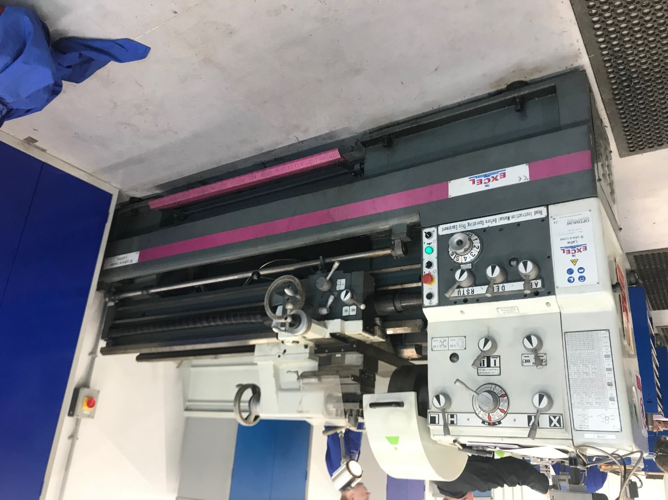

Figure 1-1: Excel Optimum Lathe used

PPE
2.2 PPE Used
- Steel Toe Boots
- Eye Protection
- Overalls
2.3 Health and Safety Breakdown
It is important when working with a lathe, and in a machine shop in general, to be aware of your surroundings and everything in them. You must also be aware of what you are doing and where you are standing. Do not operate any machines while under the influence of drugs, alcohol, and certain medications. Always follow directions provided, and unless you are qualified you should be under supervision. Proper PPE attire should always be worn, injury can result if proper steps are not taken. Long hair should be tied up, jewelry should not be worn, and any loose or dangling items should not be worn. Safety interlocks, such as on the chuck key, must not be by passed. (Health and safety in engineering workshops, 2010)

Equipment Used
- Excel Optimum Lathe
- Mitutoyo Micrometer
- Mitutoyo Height Gauge
- Instruction Sheet
- 5mm drill bit
- DRO
- M6x1.5 Tap

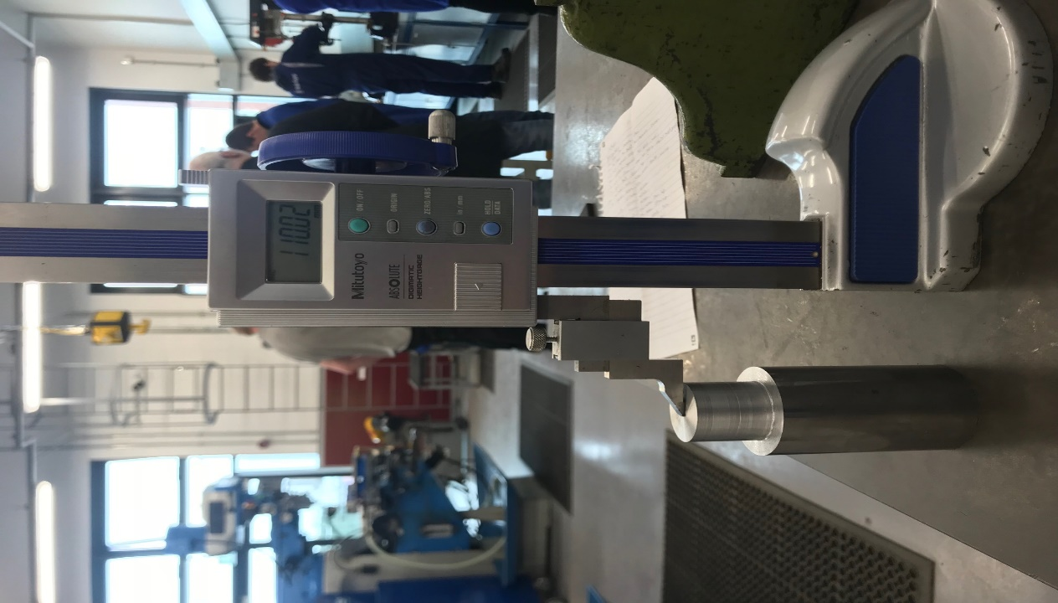
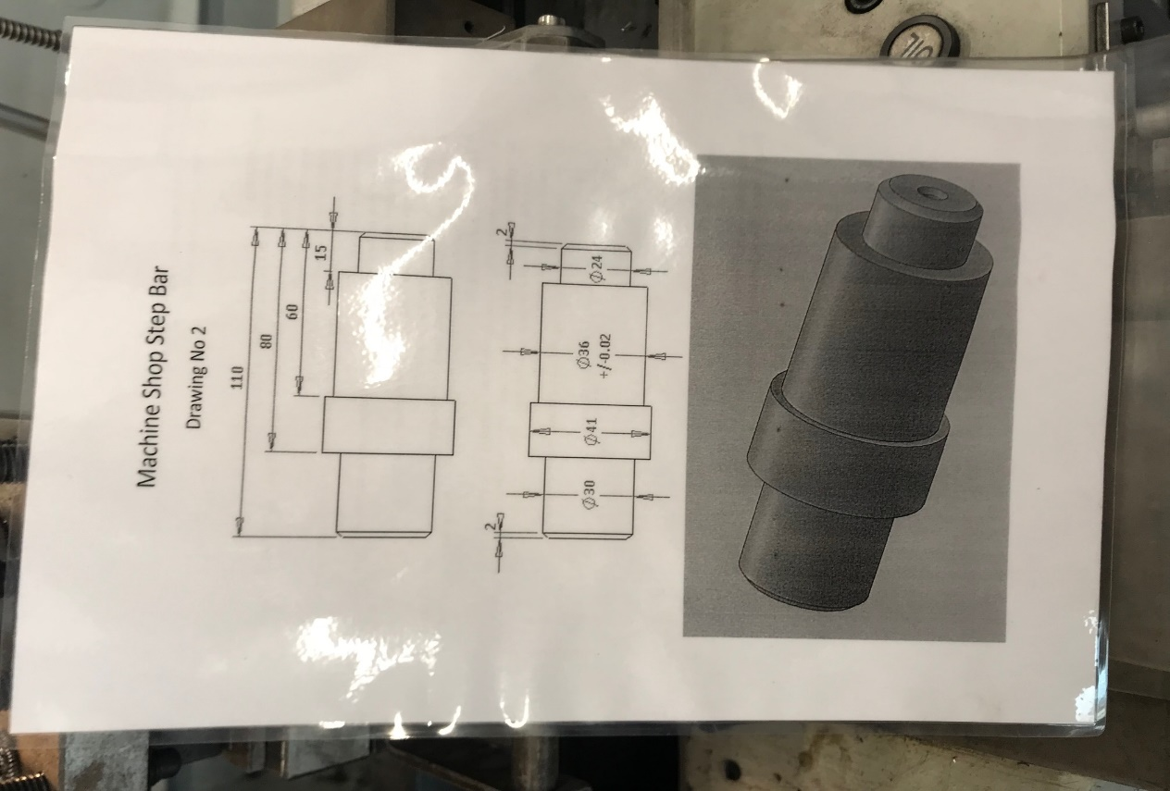

Methodology
- Place step bar in the 3 jaw chuck, tighten firmly
- Move tailstock close to work piece, firmly tighten tailstock lock
- Remove chuck key
- Zero the DRO, on the y-axis
- Start lathe by pushing down on the actuator
- We are cutting the 40mm diameter, 80mm in depth from the face
- Depth of cut should be .8mm to 1mm
- Cut to the depth of 79.5mm, leave .5 to face off at the end
- Continue cutting until the 41mm diameter is reached
- To reach the 80mm depth, move the cutting head to the 79.5mm step, and face the material off until the 80mm is reached
- Now we want to cut the 36mm diameters, 60mm in depth
- Take .75mm-1mm cuts each pass
- Stop the tool post at depth of 59.5mm
- Cut until the 36mm diameter is reached, face off the step until the 60mm depth is reached
- Make one final cut of .05mm.-01mm to create a smooth and even surface finish
- To cut the 24mm diameter, cut .75mm-1mm with a depth of 15mm
- Cut to 14.5mm, leaving the last .5mm until the last pass
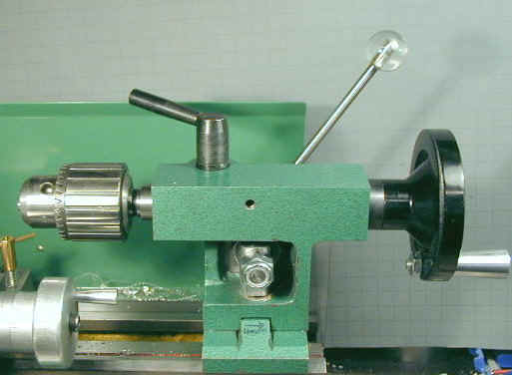
- Face off the last .5mm
- For the 5mm hole, place drill chuck in tailstock, 4-1
- Put drill bit in tail drill chuck
- Start lathe and use adjustment wheel on tailstock to
Peck drill the hole
- Use cutting oil to prevent chip welding
- Remove step bar and place in vise
Fig. 4-1: Tailstock
- Use M6x1.5 tap and tap wrench to tap threads in hole
- Use cutting oil to prevent breaking the tap

Discussion and Conclusions

At the end of this session, we achieved the completed diameters and depths of cuts we needed, as well as drilling and tapping a M6x1.5. At the end of the lathe turning process, I used emery paper to clean and smooth the surfaces and faces on the step bar, making it much smoother to handle and better to look at. The chamfers on the edges were recut after the diameters were finalized, as they became less defined, so they were recut at 45 degrees and 2mm in width.

One lesson learned was not to rush, as rushing will cause you to get inaccurate cuts and rough surface finishes. The next lesson learned was how to set up the cross feed in order to cut the chamfers properly. Improper procedure doing this will lead to rough finishes and inconsistent cuts. When drilling the hole, it is important to use the peck drilling technique, because the drill bit can break if full continues force is applied to it, which will cause many problems. When tapping threads, for every full revolution you should back off ½ revolution.

Conclusions:
The lathe is a very powerful tool that is the only machine that can be used to make itself. It is important to always pay attention to the DRO so that the depth of cut doesn’t exceed the required value. Speeds and feed rates were kept consistent, so no adjustments were made. Safety is critical when using these machines, so the use of interlocks and other safety devices reduce the chances of injury or death. (Procter Machine Safety, 2018)

References

Health and safety in engineering workshops. (2010). 4th ed. [ebook] london: health and safety executives, pp.63-65. Available at: http://www.hse.gov.uk/pUbns/priced/hsg129.pdf [Accessed 3 Feb. 2019].
Procter Machine Safety. (2018). Guide to Guarding Small Machine Tools used in Workshops | Procter Machine Safety. [online] Available at: https://www.machinesafety.co.uk/free-downloads/workshop/ [Accessed 3 Feb. 2019].

