UNIVERSITY OF WALES TRINITY SAINT DAVID LONDON CAMPUS.

COURSE NAME: BA LEADERSHIP AND MANAGEMENT SKILLS FOR THE WORKPLACE. (LEVEL 5)
MODULE NAME: MANAGING PROJECTS IN THE ORGANISATION.
MODULE CODE: BMSW5104-LONDON (MPO)
STUDENT NAME: ELIZABETH OGUNBANWO
STUDENT NUMBER: 1712627
LECTURER NAME: PAUL JENKINS

INTRODUCTION

The main purpose of this academic written report is to show how I could develop my understanding and ability to manage projects within my workplace or any chosen organisation, applying my knowledge and understanding of project management tools and techniques.
There are so many reasons for using the project management tools and techniques, they can be used to arrange several levels of work structure, trail long-term and short- term time limit, issue tracking, task management, workflow management, finishing date and target date.

Project Management
The word project means a temporary new attempt to tackle and create a rare product and service with determined objective.
Project management is implementation of knowledge skills, tools and techniques, it also comes with challenges of new economic environment, globalisation process, rapid technological advancement and excellent concerns of the stakeholders.(Americans National Standard ANSI/PMI99-001-2004)

Some of the attributes of project manager are:
Communication skills so he/she can channel messages strongly to clients and team members.

Team management skills
This is the ability of an individual or an organisation to administer and coordinate a group of individuals to perform a task. Team-working, communication and performance appraisals, fairness, confidence, functional skills, respect, and adaptability are all needed

Negotiation skills
Negotiation skills is the process of developing effective verbal communication to get from opposition to agree, managing conflict and reaching agreement. Constructive speaking and valuable listening.

Leadership skills
Leadership skills are abilities to motivate and direct people, by helping people grow in their own abilities, helping people to achieve their success by themselves. A leader must have vision, courage, passion, clarity and humility. (https://www.inc.com>peter-economy .

Risk management skills
Risk is the possibility or fear of something that may or may not take place, it is therefore something which can be measured . Many non- profit organisations face a obvious number of risk, whether it is securing the health and well-being of their volunteers or protecting their establishments .Therefore it is very important to every organisation to acquire knowledge of risk management from the beginning of the operation.(docshare04.docshare.tips>files).

Four Seasons Health Care Group Limited was founded in 1987 by Jeremy Richardson.It is a British provider of health and social care services, it owns the huntercombe group, a provider of inpatient mental healthcare and brain injury rehabilitation, also care home operator, brighter kind. The headquarter is united kingdom, it has 440 locations, the subsidiaries are Four seasons healthcare group limited, Ringdane Ltd and Four seasons (DFK) Limited. (fshc.co.uk)
Four seasons healthcare is one of the largest independent healthcare providers caring for more than 10,000 people across the Uk, they provide long term and respite residential and nursing care for older people and an award winner also an outstanding leader and a specialist in dementia care. (http://www.fshc.co.uk).
This organisation has over 33,000 employee across UK, it has bought many homes and rebranding them such as Tamaris quality care homes and Bettercare which was the second largest care home operator in the UK.

MY PROJECT MANAGEMENT PLAN :
BUILDING NEW KITCHEN AND DINNING HALL FOR STAFF
I am privileged to have been awarded this big project, being my first project as a project manager, I need to do all the necessary research and information that are available within the Four seasons care home I could get.
The project management tools am using to manage this project is (The BIS project lifecycle) my organisation four seasons health care has been expanding in the region, as a result the organisation is employing more staff and needed in domestic departments, kitchen staff, carers and nurses as well, so more space is needed for the staff to take their break in the restaurant, which has never been in the premises, more-so family and friends of the residents could have something to eat while visiting their love ones
As a project manager, there are so many things to be done, firstly to get the project going, I have to set up a meeting to communicate the plan with my colleagues and project sponsor four season care home because the primary reason some projects fail is a result of lack of communication problem and not for usual technical reasons people assume. This project…..

BIS project implementation processes
A BIS implementation is not an easy task, it needs only the purchase of a combination of software and hardware, it is a complex undertaking, therefore it is not easy to understand.(Nofal and Yusof, 2016)

Project Management Tools and Techniques
Project management tools and techniques provide the efficiency and effectiveness in managing and handling the projects. There are several tools and techniques that can be used for project.
International and local companies can benefit from project management because of it application of the plan.

Work Breakdown Structure (WBS)
Work breakdown structure transforms big project activities into chunks of manageable tasks a team can easily understand and complete. Work breakdown structure can be used as a project management technique as well as a tool, helping you to understand all the tasks and resources that go into producing the final deliverables.
Work breakdown structure
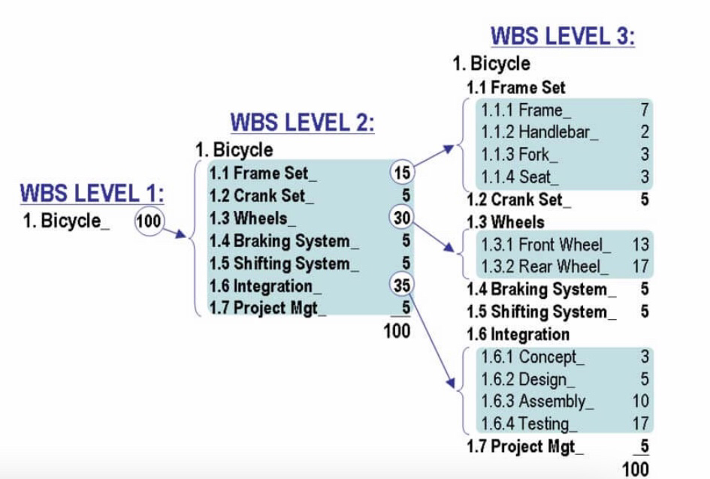

Waterfall/ Linear
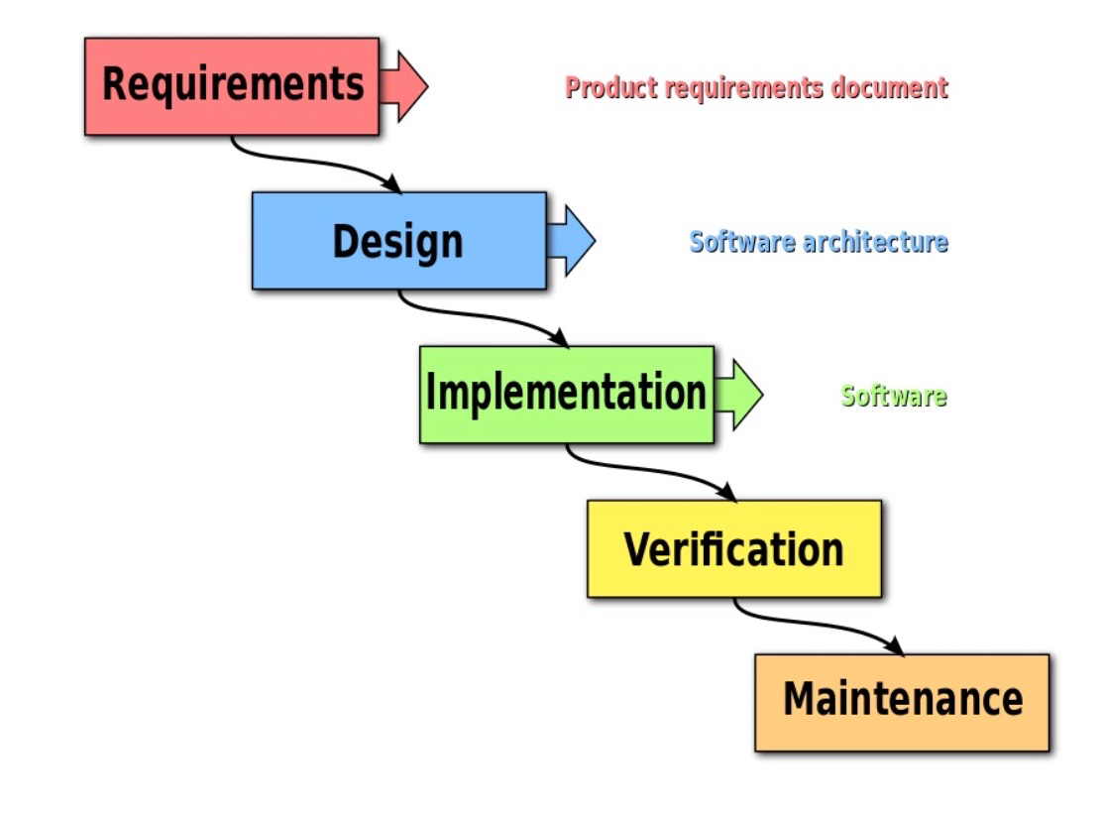
Water is one of the oldest project management techniques, this project has 5 phases of activities and tasks. It is good for project with marked phases that need very few iterations all through the project life cycle.

Waterfall/Linear technique

Gantt Chart for all project
Gantt charts are useful for planning and arranging projects, they help to one to rate how long a project should take, determine the resources needed and plan the order to complete your tasks.
(https://www.mindtools.com>article).

Gantt chart
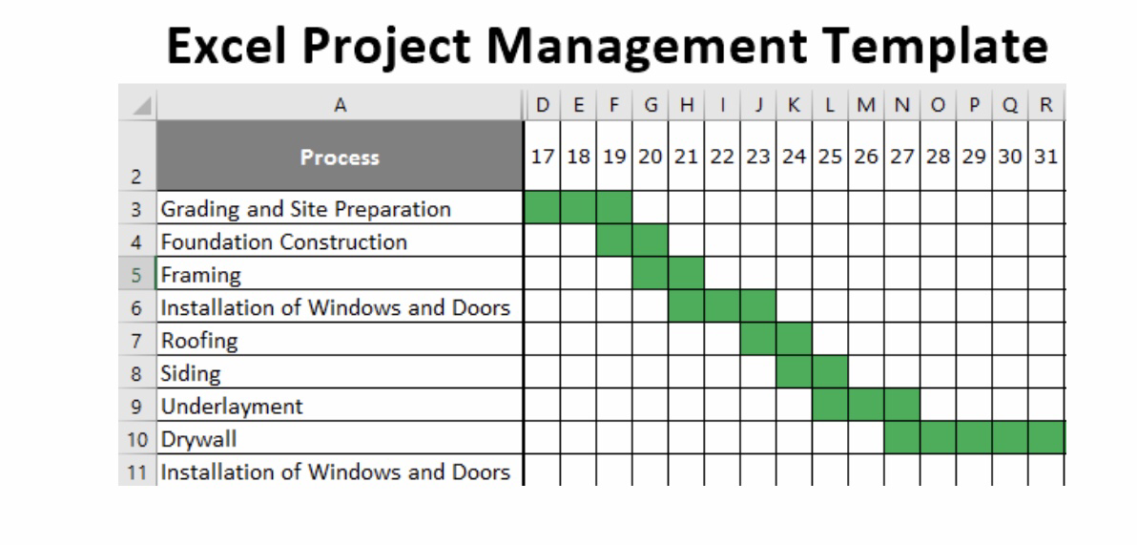

Reference
- Anthonio B,Barbara G.- Perspectives Business Culture
- Americans National Standard ANSI/PMI99-001-2004
- Four Season (DFK) Limited – fshc.co.uk
- https://www.inc.com>Peter-economy -The 5 essential qualities of a great leader.
- https://www.indeed.com>projectmanagement
- https://www.fshc.co.uk>media.
- https://www.cio.com>article
- https://www.mindtools.com>article
- The tripple constraint theory of projects/smartsheet
- Docshare04.docshare.tips>files
- Nofal and Yusof, 2016 – Strategic Impact of Business Intelligence : A Review of Literature.

