Resource pack


Using Kahoot! to support
classroom management in a family learning setting.

Contents
Rationale Page 3
Instructions for use Page 8
Reference list Page 11
Appendices Page 14

Rationale
Teaching staff are under increasing pressure to implement strategies and resources that not only engage learners and manage behaviour but also promote learning and development in inclusive ways that align with national policy frameworks such as the Curriculum for Wales (Welsh Government, 2023) and the Additional Learning Needs Code for Wales (Welsh Government, 2021). These expectations can be particularly challenging within family learning environments, where children and their adult family members learn together while presenting differing educational experiences, motivation levels, and emotional needs.
The use of online quiz platforms such as Kahoot! (2024), which has 70 million unique monthly users (Wang and Tahir, 2020), has become an increasingly popular addition to classroom practice, particularly in family learning sessions. These low-stakes, formative assessments provide immediate feedback and can serve multiple purposes: they reinforce learning, sustain motivation, and offer teachers valuable insights into learner progress. Importantly, they can also act as a form of positive reinforcement, interpreted by learners as a reward at the end of a session, illustrating the continued relevance of behaviourist approaches such as Skinner’s (1963) theory of operant conditioning.
This rationale explores how educational theory supports the use of online quizzes such as Kahoot! not only as a learning and assessment tool but also as a means of enhancing family engagement and relationships, while demonstrating their alignment with key Welsh educational policies.
Student Response Systems (SRSs) have been integrated into classroom practice since the 1970s, originally using clickers to promote active learning and formative assessment (Premkumar, 2016). Kahoot! represents a new generation of SRSs that incorporate elements of game-based learning to enhance learner motivation and engagement. Notably, Kahoot! was one of the first game-based response systems (GSRSs) to embed principles of intrinsic motivation (Harlow, 1950) within its design, encouraging users to participate for enjoyment and personal satisfaction rather than solely for external rewards. The platform transforms learning sessions into a game-show format, with the facilitator acting as host and learners as contestants. This approach was developed through the Lecture Quiz research project, which found that it led to “increased student motivation, engagement, and perceived learning through entertaining social learning activities” (Wang, Øfsdahl, & Mørch-Storstein, 2008). These outcomes support Bandura’s (1977) social learning theory, demonstrating that learners acquire knowledge and skills through observing and modelling behaviour in a real-time, collaborative environment.
The motivational and interactive nature of such tools offers particular value in learning contexts where classroom management can be difficult to sustain. Managing behaviour within a family learning environment presents unique challenges due to the complexity introduced by the presence of adult family members. Both adults and children may display disengagement or disruptive behaviour, which cannot be addressed effectively through traditional punitive methods such as detention. In many cases, participating family members are unfamiliar with the school’s behaviour management approaches and may not be regular visitors to the setting. This lack of familiarity can hinder the development of positive relationships between staff and families, making the implementation of relational strategies such as restorative practice more difficult to achieve effectively.
The use of Kahoot! supports Skinner’s (1963) theory of operant conditioning, which emphasises that feedback should be delivered soon after the desired behaviour to reinforce learning effectively. In this context, the reward of completing a competitive quiz is offered at the end of each session, while immediate feedback after every question reinforces correct responses and prompts reflection on errors. This process not only aligns with behaviourist principles of reinforcement but also supports cognitive theories of learning, particularly that of Atkinson and Shiffrin (1968), who highlighted the role of timely feedback as a crucial step in the processing and retention of information. By linking behavioural reinforcement with cognitive processing, Kahoot! effectively strengthens both engagement and long-term memory.
The impact of Kahoot! on motivation in a family learning session can also be explained through Self-Determination Theory (Ryan and Deci, 2000), as the elements of competence, autonomy, and relatedness are all met through the quiz format, personal choice, and collaborative family participation. Studies show that Kahoot! motivates students to engage and encourages group interaction in the classroom, with learners reporting that the platform captures their attention and interest (Licorish et al., 2018).
The competitive element of Kahoot! can further enhance learner motivation by allowing individuals to compare their performance with that of their peers. This process reflects Festinger’s (1954) Social Comparison Theory, which proposes that people are driven to evaluate their abilities and progress through comparison with others. Recognising that such comparisons can also have negative effects if learners perceive themselves as underperforming, Kahoot! mitigates this risk by displaying only the top three scorers. This approach maintains the motivational benefits of competition while minimising potential demotivation among those who do not achieve the highest scores. The use of extrinsic rewards, such as prizes for high-scoring teams, is also discouraged as this may undermine the benefits of intrinsic motivation and shift focus from achievement to external reward (Bandhu et al., 2024).
In addition to supporting learner motivation, Licorish et al. (2018) found that participants felt Kahoot! helped them remember information during and after class. Formative assessments such as quizzes promote retrieval practice, which aids long-term memory and enables learners to recall information more effectively. Research demonstrates that people quickly forget around 70% of what they hear; however, testing helps solidify information in memory, making it easier to retrieve later. Identifying knowledge gaps through testing also encourages individuals to seek further information and deepen understanding (Brown, Roediger III, & McDaniel, 2014).
The benefits of using Kahoot! extend beyond individual learner outcomes, having a broader impact on family relationships within family learning environments. This collaborative approach places parents and children on equal footing as team members working toward a shared goal, fostering mutual respect and cooperation. By temporarily removing traditional hierarchical roles, Kahoot! encourages open communication and strengthens trust between parents and children (Lamb, 2009). Parents are able to scaffold their children’s learning, playing the role of the more knowledgeable other and supporting their child within their zone of proximal development (Vygotsky, 1978). Additionally, this interactive format allows parents to observe their children’s learning processes and identify any gaps in knowledge that can be supported at home. As a result, Kahoot! not only enhances engagement and motivation during sessions but also contributes to the development of stronger, more supportive parent–child relationships that extend beyond the classroom.
The learning benefits of Kahoot! are not limited to children. Its use to reinforce learning aligns with the Digital Competence Framework (Welsh Government, 2021a), providing pupils with opportunities to develop digital literacy while also enabling parents to explore how technology can support learning within the family. Engaging with digital tools in a safe, non-threatening environment can increase parents’ confidence and motivation to participate in further adult learning opportunities related to digital skills, which in turn strengthens their capacity to support their child’s ongoing development (NIACE, 2013). Using digital skills to reinforce learning also highlights the cross-curricular integration of essential competencies, as required by the Curriculum for Wales (Welsh Government, 2023).
At the same time, drawing on the principles of the Universal Design for Learning Framework (CAST, 2024), Kahoot! incorporates a variety of features that promote inclusivity. These include accessibility tools such as read-aloud functionality and high-contrast visuals to support users with visual impairments, as well as the option to remove the question timer, allowing all families more time for comprehension and discussion. Additionally, Kahoot! offers flexible learning options that accommodate neurodivergent learners and can help reduce the stress often associated with traditional knowledge checks (Kahoot, 2025). These inclusive practices align closely with the Additional Learning Needs Code for Wales (Welsh Government, 2021b).
Incorporating a Kahoot! at the end of each session provides learners with consistent routine and structure, benefiting not only children with additional learning needs but all students. Bronfenbrenner’s ecological systems theory (1979) highlights that “routines play a crucial role in child development by shaping the interactions within an individual’s environment,” emphasising the developmental value of predictable patterns. Using Kahoot! as a closing activity offers clear session closure and encourages learners to reflect on the material they have covered. As a classroom management tool, it not only reinforces learning within the session but also enables teachers to evaluate their lesson planning and make ongoing improvements.
When a well-designed and thoroughly researched Kahoot! is used as a closing activity, it proves to be a highly effective and versatile educational tool in family-learning contexts. By combining formative assessment with game-based elements, it reinforces knowledge, sustains motivation, and delivers immediate feedback, supporting both behaviourist and cognitive learning theories. Its design incorporates intrinsic and extrinsic motivational strategies while balancing competition to engage learners without causing discouragement. Beyond individual learning, Kahoot! fosters positive family interactions, strengthens relationships, and allows parents to scaffold their children’s learning. The platform also enhances digital literacy, boosting parental confidence and encouraging further adult learning. Its inclusive features enable teaching staff to adapt the resource to meet diverse learner needs. The flexibility and wide-ranging benefits of Kahoot! not only support learners but also provide educators with a meaningful tool that enriches and enhances their teaching practice.

Instructions for use

Before the Session
- Visit kahoot.com (See Appendix A).
- Select Classic Kahoot! and follow the online steps to create a free teacher account using your professional email address.
- Select “Create Kahoot!” to design your quiz. Use either a blank canvas or import Lesson resources such as PDF’s and slides.
- Include a variety of question types including multiple choice, true/false, and polls, to maintain interest and assess understanding in different ways.
- Add any accessibility features required to meet any additional learning needs.
- Add a few light-hearted “guesswork” questions (e.g. “To the nearest metre, how far is it from here to London?”) to encourage discussion and enjoyment.
- Incorporate some easier quick-response questions that reward speed rather than knowledge.
- Keep questions clear, concise, and written in language appropriate to your learners.
- Choose a suitable number of questions based on the children’s age and attention span.
- Use relevant images and age-appropriate content to engage both children and adult family members (See Appendix B)
- Plan your grouping strategy — decide whether families will work individually or in mixed groups depending on class dynamics.
- Check that all devices and Wi-Fi connections are working properly, and connect the tutor’s laptop to the interactive whiteboard.
- Test the quiz on a learner device to ensure visuals display correctly and functionality is smooth.

During the Session
- Introduce Kahoot! at the start of the session, explaining how it will be used later in the lesson.
- Refer to the upcoming quiz during the session to maintain motivation and focus, drawing attention to key information that may appear in quiz questions.
- Distribute devices to learners at the end of the session.
- On the tutor’s laptop, select your quiz from the library and choose “Host Live”, then click “Start” to generate the Game PIN, which will appear on the whiteboard (See Appendix C)
- Support learners in accessing kahoot.it on their device (See Appendix D).
- Ask families to enter the Game PIN, choose a team name, and select a family avatar and add any accessories (See Appendix E).
- Explain the point system, timing, and importance of completing each question.
- Emphasise that the quiz is low-stakes, designed for fun, teamwork, and learning.
- Once all family team names are visible, select Start to begin the quiz.
- Read each question and answer options aloud to ensure everyone understands (See Appendix F).
- Encourage discussion within family teams before submitting responses.
- Remind participants to focus on learning and collaboration rather than competition.
- Review correct answers after each question, expanding on the topic if needed to reinforce learning.
- Encourage families to reflect on incorrect answers, discussing strategies for improvement.
- Use the leaderboard to celebrate participation and progress, while keeping the atmosphere supportive and inclusive (See Appendix G).

After the Quiz
- Facilitate a short reflection discussion: ask families what they learned and which strategies helped them succeed.
- Summarise the key learning points from the quiz.
- Celebrate participation and teamwork, offering positive feedback on engagement.
- Encourage families to continue learning at home — explain that Kahoot! can be used for family quizzes or revision.
- Suggest that children or families create their own Kahoot! quizzes on topics they enjoy to extend their learning.
- Recommend other follow-up activities that consolidate the session’s learning outcomes.

After the Family Learning Session
- Review which questions or rounds were most engaging and effective.
- Identify any areas where learners struggled and adapt future lesson plans to address gaps in understanding.
- Note any learners or family members who may need additional support based on quiz results or participation.
- Record any technical issues or logistical challenges to improve future sessions.

Reference list

Atkinson, R.C. and Shiffrin, R.M. (1968). Human Memory: a Proposed System and Its Control Processes. Psychology of Learning and Motivation, [online] 2(1), pp.89–195. doi:https://doi.org/10.1016/s0079-7421(08)60422-3.
Bandhu, D., Mohan, M.M., Nittala, N.A.P., Jadhav, P., Bhadauria, A. and Saxena, K.K. (2024). Theories of motivation: A comprehensive analysis of human behavior drivers. Acta Psychologica, 244(1), pp.1–16. doi:https://doi.org/10.1016/j.actpsy.2024.104177.
Bandura, A. (1977). Social Learning Theory. Englewood Cliffs: Prentice-Hall.
Bronfenbrenner, U. (1979). The ecology of human development: Experiments by nature and design. Cambridge: Harvard University Press.
Brown, P.C., Roediger III, H.L. and McDaniel, M.A. (2014). Make it stick: The science of successful learning. Cambridge, Massachusetts: The Belknap Press of Harvard University Press.
CAST (2024). Universal Design for Learning. [online] CAST. Available at: https://www.cast.org/what-we-do/universal-design-for-learning/ [Accessed 1 Nov. 2025].
Festinger, L. (1954). A theory of social comparison processes. Indianapolis: Bobbs-Merrill.
Harlow, H.F. (1950). Learning and satiation of response in intrinsically motivated complex puzzle performance by monkeys. Journal of Comparative and Physiological Psychology, [online] 43(4), pp.289–294. doi:https://doi.org/10.1037/h0058114.
Kahoot (2024). Kahoot! [online] Kahoot! Available at: https://kahoot.com/ [Accessed 31 Oct. 2025].
Kahoot (2025). Inclusive & accessible learning with Kahoot! | Kahoot! [online] Kahoot! Available at: https://kahoot.com/accessibility/ [Accessed 1 Nov. 2025].
Lamb, P. (2009). The impact of learning as a family: a model for the 21st century IFLL Sector Paper 9. [online] Available at: https://learningandwork.org.uk/wp-content/uploads/2021/01/The-impact-of-learning-as-a-family-a-model-for-the-21st-century-Sector-Paper-9.pdf [Accessed 1 Nov. 2025].
Licorish, S.A., Owen, H.E., Daniel, B. and George, J.L. (2018). Students’ perception of kahoot!’s influence on teaching and learning. Research and Practice in Technology Enhanced Learning, 13(1), pp.1–23. doi:https://doi.org/10.1186/s41039-018-0078-8.
NIACE (2013). Family Learning Works The Inquiry into Family Learning in England and Wales Acknowledgements. [online] Available at: https://www.nationalnumeracy.org.uk/sites/default/files/documents/family_learning_works/family_learning_works_2013.pdf?_gl=1 [Accessed 1 Nov. 2025].
Premkumar, K. (2016). Use of Student Response Systems for Summative Assessments. Creative Education, 07(13), pp.1851–1860. doi:https://doi.org/10.4236/ce.2016.713187.
Ryan, R.M. and Deci, E.L. (2000). Self-determination theory and the facilitation of intrinsic motivation, social development, and well-being. American Psychologist, [online] 55(1), pp.68–78. Available at: https://selfdeterminationtheory.org/SDT/documents/2000_RyanDeci_SDT.pdf [Accessed 31 Oct. 2025].
Vygotsky, L. (1978). Mind in society: the Development of Higher Psychological Processes. Harvard University Press.
Wang, A.I., Øfsdahl, T. and Mørch-Storstein, O.K. (2008). An Evaluation of a Mobile Game Concept for Lectures. [online] IEEE Xplore. doi:https://doi.org/10.1109/CSEET.2008.15.
Wang, A.I. and Tahir, R. (2020). The effect of using Kahoot! for learning – a literature review. Computers & Education, [online] 149(103818), p.103818. doi:https://doi.org/10.1016/j.compedu.2020.103818.
Welsh Government (2021a). Digital Competence Framework (DCF) - Hwb. [online] Gov.wales. Available at: https://hwb.gov.wales/curriculum-for-wales/cross-curricular-skills-frameworks/digital-competence-framework-dcf [Accessed 1 Nov. 2025].
Welsh Government (2021b). The Additional Learning Needs Code for Wales 2021 WG21-23. [online] Available at: https://www.gov.wales/sites/default/files/publications/2024-04/220622-the-additional-learning-needs-code-for-wales-2021%20%282%29.pdf.
Welsh Government (2023). Curriculum for Wales: overview. [online] GOV.WALES. Available at: https://www.gov.wales/curriculum-wales-overview#:~:text=ambitious%2C%20capable%20learners%2C%20ready%20to.

Appendices

Appendix A
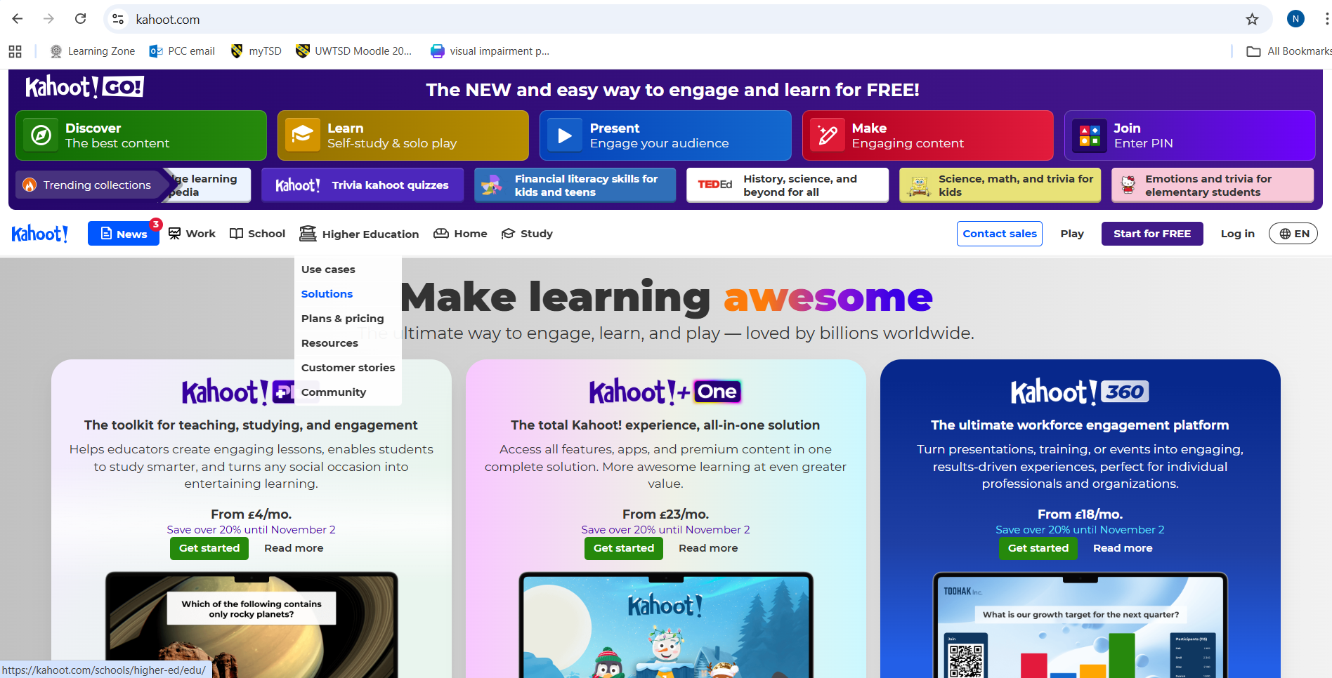
(Kahoot, 2024)

Appendix B
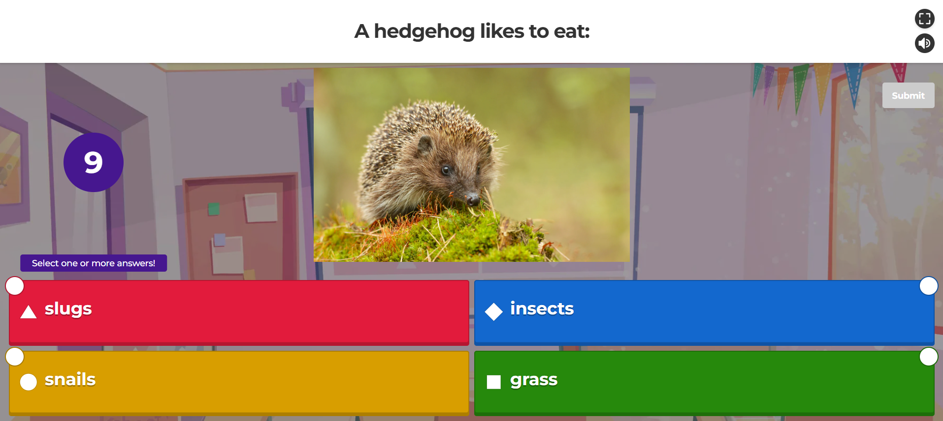
(Kahoot, 2024)

Appendix C
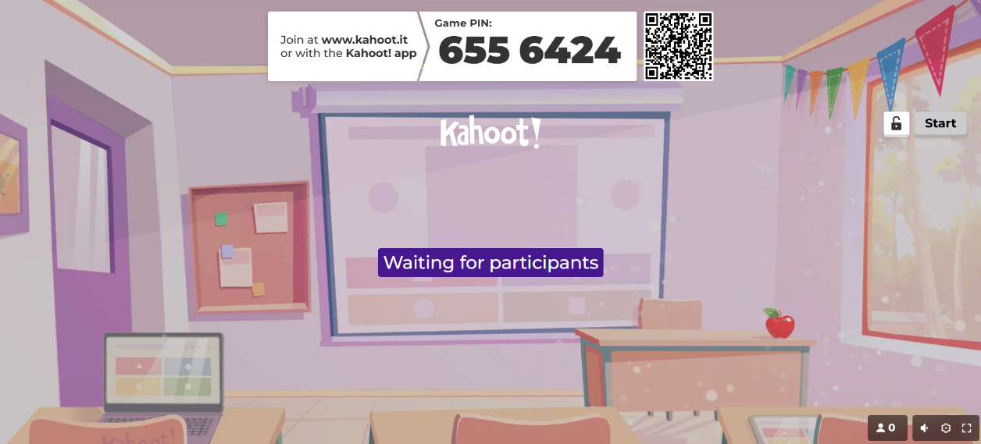
(Kahoot, 2024)

Appendix D

(Kahoot, 2024)

Appendix E
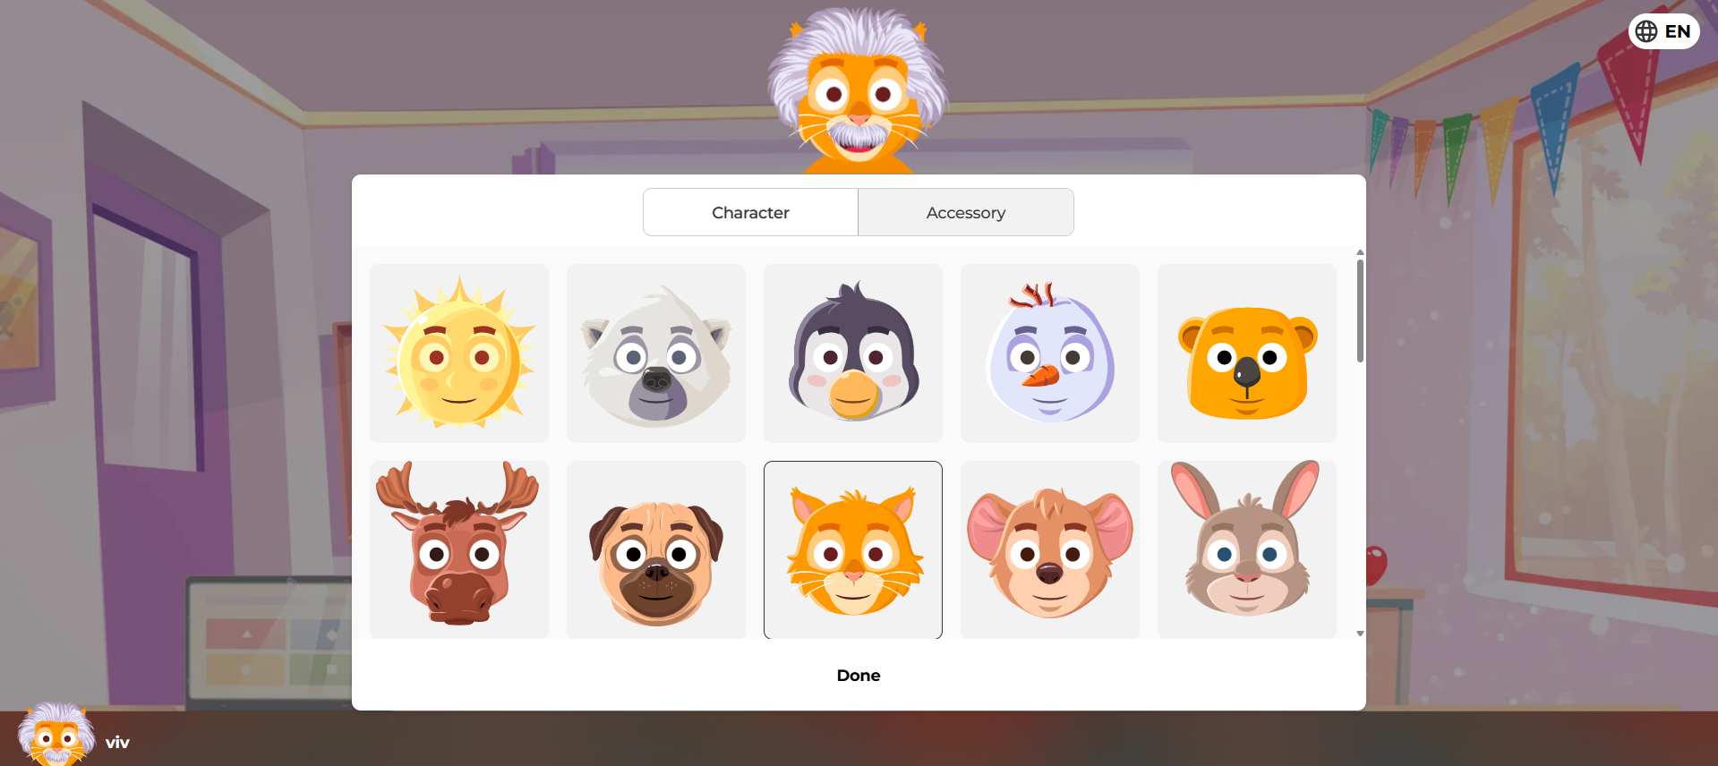
(Kahoot, 2024)

Appendix F
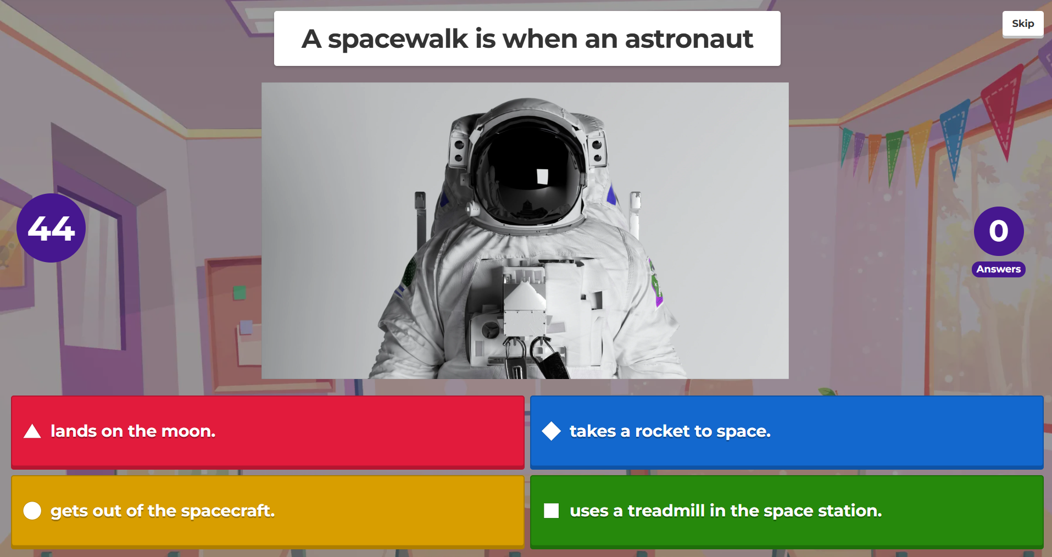
(Kahoot, 2024)

Appendix G
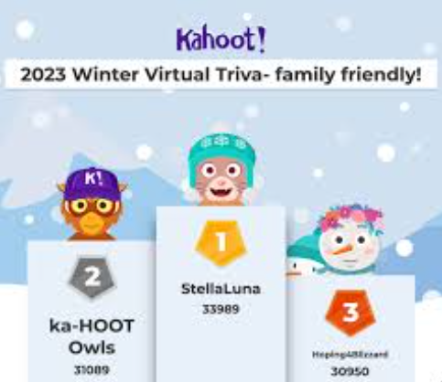
(Kahoot, 2024)

