How food can affect the physical and psychical state of our body? Why it is important to consume natural and high-quality nuts, dried fruits and seeds? And why we should choose Mr. Almond company?


Mr. Almond is a company with many years of experience in the sale and distribution of а wide variety of healthy foods and products such as Nuts, Seeds, Dried fruits and Herbs. Recently, a manufacturer of some of the products it offers, such as various types of tahini, oils and flours.
The company has more than 30 luxury stores where the customers will always find products of the highest quality, well-trained and helpful staff, as well as very useful information about all products and promotions in the brochures that each customer receives when entering each of the stores in the chain. The company relies on the high quality of the products, the good price, also all the stores in the chain are located in convenient and easy places for access, such as public transport stops or in large retail centers. Good customer awareness of products and promotions is also important for the company. Recently, they also offer home and office delivery.

For more information you can contact us: https://mralmond.bg/ mralmond@icloud.com

For more information you can contact us: https://mralmond.bg/ mralmond@icloud.com

What to eat to be Healthy

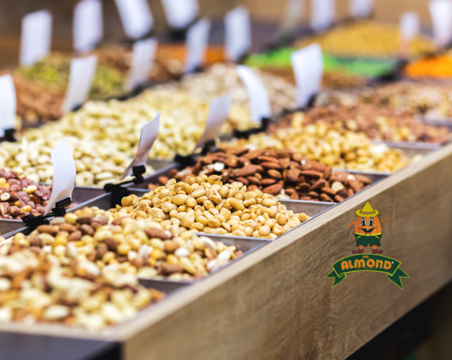

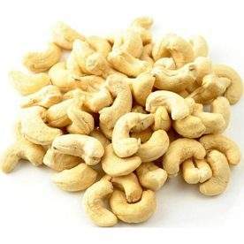
Cashew nuts benefits
healthy heart
Cashew nuts contain a lot of monounsaturated fats, which help lower bad cholesterol. They are also very good for lowering blood pressure, and protect blood arteries from the accumulation of toxins, also help the body reduce triglyceride levels, all together protects the body from heart disease, stroke and heart attack.
healthy skin and hair
The high content of honey in cashews helps to produce melanin (the pigment that gives color to the eyes, skin and hair). Healthy melanin production protects both skin and hair from harmful UV rays, which damage the skin and can cause cancer by blocking them and preventing them from penetrating the skin. Eating cashews regularly acts as a natural sunscreen. It can also improve the color of your hair. Cashews also contain antioxidants that prevent the accumulation of free radicals and thus reduce skin aging.
healthy bones
Cashew nuts are high in phosphorus, copper, vitamin K and magnesium, which work together to build and maintain bone and bone density. The high content of copper makes them healthier and less susceptible to fractures and osteoporosis. Magnesium and phosphorus help build bone structure. Vitamin K helps the body regulate calcium levels in the body.
Also, cashews are very useful for the blood, eyes, protects the body from migraine headaches, type 2 diabetes, gallstones, also stimulates the brain and regulates thyroid function (Healthline, 2021).

Almond nuts benefits
Almonds contain a wide range of healthy nutrients, and also have a high content of antioxidants, which help protect the body from infections.
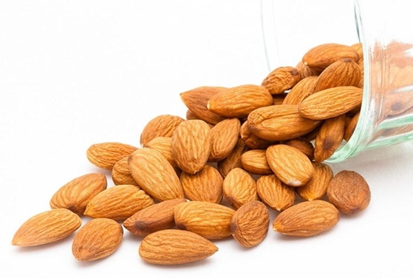
Almonds are high in fat, potassium and protein, which makes them extremely good for the heart. The content of vitamin E in almonds protects, which acts as an oxidant, also protects the heart, and the magnesium content protects against heart attack. Almonds are rich in folic acid, which makes them a mandatory food for pregnant women, and reduces the accumulation of fatty plaques in the arteries.
The potassium content in almonds regulates blood pressure. The content of copper, riboflavin and manganese improves metabolism and gives energy to the body.

Almonds are a good food especially when you are on the road and do not have time, a handful of almonds will satisfy your hunger and charge you with energy. Consumption of Almond has a number of benefits for the body, such as improving digestion, protecting the skin, strengthening the bone system and controlling blood sugar in the body and reducing stress (Meyer,2019).

Pecan nuts benefits
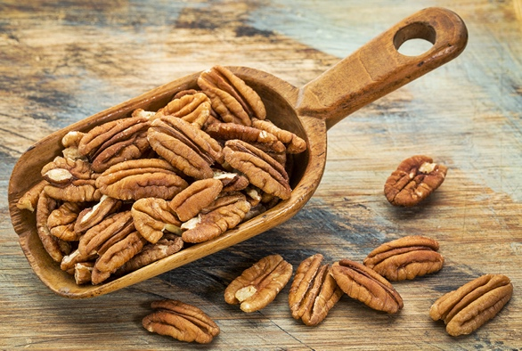
Pecans contain a lot of vitamins and nutrients that help the body to be healthy. Pecans are high in protein, fat, amino acids, sugars and starch. It also contains a number of vitamins such as vitamin C, vitamin A, vitamin B6 and vitamin K. It also contains many minerals such as selenium, zinc, copper, phosphorus, magnesium, potassium, calcium, manganese. A handful of pecans a day contain so many nutrients substances for the body that are difficult to obtain even with laboratory-prepared supplements.
Like all other nuts the pecan nuts also controls cholesterol levels, regulates blood sugar levels and protects against diabetes, is good for the heart, controls body weight and protects against gallstones (Benefits of Pecans,2021).

For more information about our products, you can contact us: https://mralmond.bg/ or mralmond@icloud.com

Have you ever wondered how useful dried fruits can be for you and your Family’s health?

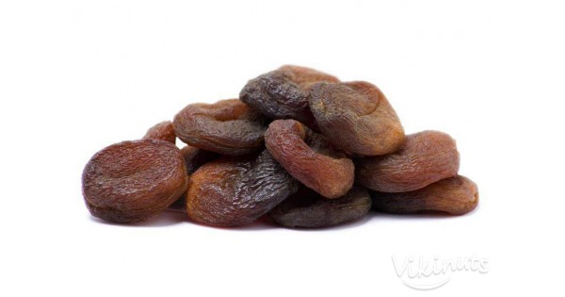
Apricots, for example, are low in calories and fat, great for overweight people. They are also rich in vitamin A, E and C and are a very good antioxidant. They also protect the eyes from damage, as well as the skin from dirt, sunlight and cancer. They are also useful for digestion, improve heart function, protect the liver (Davidson, 2019).

Тhe secret of health in dried fruit


Dried figs- or also called the fruits of the Kings and the Gods, because of their divine taste and the healing qualities they possess. They are rich in fiber, regular consumption is good for the digestive system and the cardiovascular system. They are rich in minerals, also supply the body with Potassium, Calcium, Zinc, Iron, Magnesium and thus help the nervous and skeletal system. Regular consumption of figs reduces the levels of harmful estrogen in the body, which can cause headaches, weight gain, mood swings, depression and some cancers.

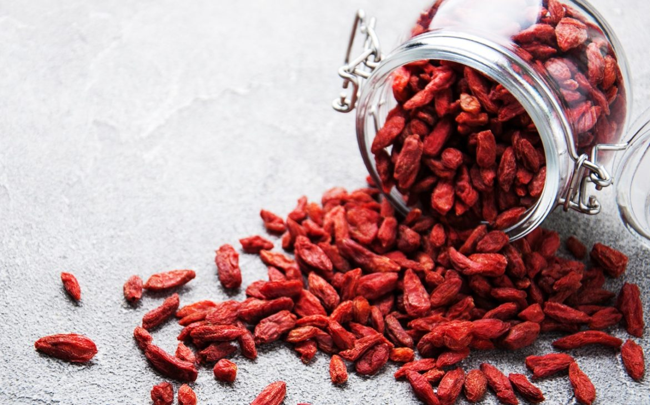
Goji berry, also called super food, was been used in Chinese medicine more than 2,000 years ago. According to some legends, thousands of years ago monks in the Himalayas ate wolf grapes to support their meditation and gain better health, vitality, longevity, energy and endurance.
These small fruits are known to be able to improve the neurological and mental state, help the work of the gastrointestinal tract and intestines, nourish the cardiovascular system, and strengthen the musculoskeletal system. Goji berry is high in calcium, potassium, iron, selenium, vitamin C, and beta keratin. Also has a high content of antioxidants that stimulate the immune system and prevent inflammation in the body (Barhum, 2018).
Тo be healthy and always in good physical shape Mr Almond recommended you to eat goji berry every day about 30g, for example in the morning for breakfast with yogurt and oatmeal, can also be prepared as a tea or in the morning smoothie.

For more information about all dried fruits,
you can contact as on: https://mralmond.bg/
our email: mralmond@icloud.com

The Health Benefits of Seeds

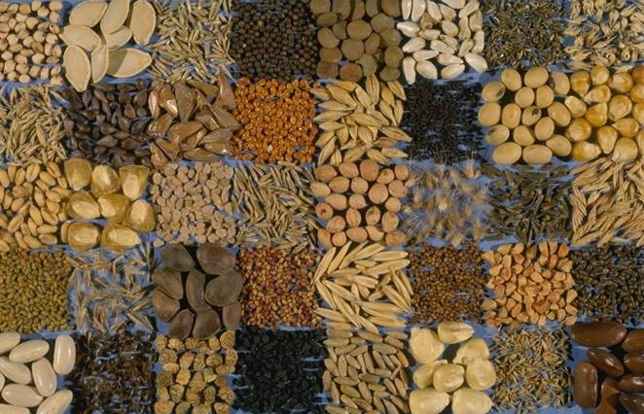

The seeds have a very important role in healthy eating. Seeds are a great source of energy, they contain large amounts of minerals, proteins, essential oils, enzymes and also have a high concentration of vitamins. It is recommended that the seeds be eaten raw, because in this way they retain their useful ingredients, they are a great breakfast because they saturate quickly and at the same time fill the body with useful ingredients.

Chia seeds, for example, are rich in minerals, fiber, protein, antioxidants and omega-3 fatty acids. Consumption of chia seeds can help you fоr joint pain, as well as protect against diabetes and heart problems (Morgan, 2014).

Hemp seeds are rich in proteins and phytonutrients that strengthen the immune system and protect the heart, improve blood circulation, protect tissues and cells in the body and skin.

Flaxseed is high in alpha linolenic acid (ALA), dietary fiber and lignans. It is very often used for abdominal pain. Reduces the risk of breast and prostate cancer. The high fiber content helps the good functioning of the intestines. Flaxseed also suppresses appetite, making it a good addition to any weight loss diet.

For more information you can contact us:
https://mralmond.bg/ mralmond@icloud.com



For the convenience of its customers Mr. Almond company offers home and office delivery. The company does everything necessary to meet the satisfaction of its customers, this is their main goal over the years. This is the main reason why they are so long on the market and continue to develop.

Throughout the years the company has shown that it has a profitable relationship with its customers and has managed to achieve the main goal of marketing, namely creating value for the customer and taking value from the customer in return (Kotler, Armstrong, 2010).

For more information you can contact us: https://mralmond.bg/ mralmond@icloud.com

References:

Morgan, E., 2014. Health Benefits and Healing Powers of Chia Seed. Available at: https://www.booksamillion.com/p/Health-Benefits-Healing-Powers-Chia/Ellie-Morgan (Accessed: 23/02/202).

Benefits of Pecans,2021. Available at: https://nuts.com/healthy-eating/benefits-of-pecans(Accessed: 23/02/2021).

Food in Care,2021. Food Active Available at: https://foodactive.org.uk/what-we-do/campaigns-and-interventions/food-in-care (Accessed: 23/02/2021).

Davidson, K., 2019. 9 Health and Nutrition Benefits of Apricots. Healthline. Available at: https://www.healthline.com/nutrition/apricots-benefits (Accessed:23/02/ 2021).

Barhum, L., 2018. 7 goji berry benefits backed by science. Medicalnewstoday.com. Available at: https://www.medicalnewstoday.com/articles/322693#_noHeaderPrefixedContent (Accessed: 23/02/2021).

Healthline, 2021. Are Cashews Good for You? Nutrition, Benefits, and Downsides. Available at: https://www.healthline.com/nutrition/are-cashews-good-for-you (Accessed: 23/02/ 2021).

Meyer, K., 2019. Eat to Sleep. Massachusetts: Adams media, p.46.

Kotler, Armstrong, P., 2010. Kotler & Armstrong, Principles of Marketing: Global Edition, 13th Edition Available at: https://www.pearson.com/uk/educators/higher-education-educators/product/Kotler-Principles-of-Marketing-Global-Edition-13th-Edition/9780137006694.html (Accessed: 23/02/ 2021).

