API Implementation
Ethan Hopkins (2201011)
Network Programmability
1/16/24

Overview: 2
Features 2
User Interaction: 2
API Integration: 2
Data Processing: 2
Conditional Statements: 2
Forecast Information: 3
User Interaction Loop: 3
Development Process 3
API Integration: 3
Error Handling: 3
Testing and Iteration: 3
Documentation: 4
Conclusion 4

Overview:
Weather Lookup is a Python application that uses the weather data from WeatherAPI to provide users with current conditions along with a one-day forecast of any location they would like, as long as it is on the API database. The design of the code aims at making it easy for one to input a destination and get weather details in just an instance. I have also made the code very concise and simple, although aiming to keep it as failsafe as possible.

Features
User Interaction: The program first greets the user and asks them to provide a location on which they would like information about. I have created this in a way so that the user clearly understands what they have to input. The user will be asked multiple questions about what they would like to do next, including whether they would like further information about their chosen location, and whether they would like to look at the weather for another location. These are yes or no questions in order to keep it simple for the user.
API Integration: The code uses the WeatherAPI to get current weather conditions and a one-day prediction for the selected location. An API key is included in the URL for authentication and is used to access the required endpoints in order to receive the required data to fulfil the command of the user. For example, if the user requests information about the weather in Swansea, the code will request information from the API database using the API key for authentication and send the queried information back to the user through the console.
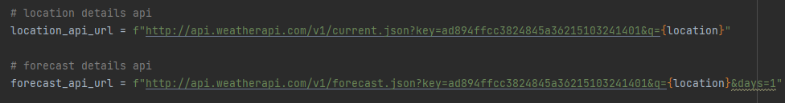
Data Processing: The Json data that is received from the weatherAPI is processed by the Json module in order to extract the relevant data, such as the current weather, the time is was last updated and the predicted forecast for the next day.
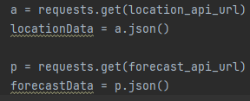
Conditional Statements: The code uses conditional statements to cover various cases, including successful API calls (HTTP status code 200) and unsuccessful ones. If the call is successful, the program displays current information about weather and gives an opportunity for further revelation of forecast. If it is unsuccessful, it will display text in the console notifying the user and asking them to try again, or to try a different location.
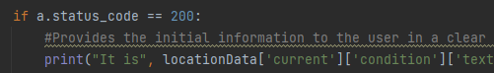
Forecast Information: Users can check more of the forecast information for that location. The program shows the forecasted amount of rain, maximum temperature, and minimum temperature for tomorrow.
User Interaction Loop: Secondly, the user is asked to determine whether they want another weather search. Depending on the user’s choice, either the program restarts or it ends.

Development Process
API Integration: The core functionality depends on integrating WeatherAPI to obtain the weather information. For authentication and to access the endpoints that are required, API keys are part of the URL. User Interaction: The program promotes the active participation of users by asking them to indicate where they want. The use of conditional statements allows the program to respond appropriately according to user responses.
Error Handling: The code has a backup mechanism that would execute in case of an unsuccessful API call (status other than 200). In case the API call fails, it will show the user a message and requests them to reattempt.
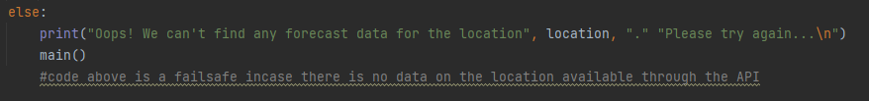
Testing and Iteration: I have done many tests with the code to ensure that it is working correctly, trying locations from all around the world and seeing if the weather matches up to other sources while also testing that the code itself doesn’t have any major issues. I did run into one problem where my code was working in terms of showing the correct data, but it was not printing properly into the console. After some research online and some trial and error I managed to re-write the code and got it printing correctly. I intentionally left the broken code in the document as a comment so that I would be able to return to it in a situation where my new code did not work, leaving me with a foundation to work off of.
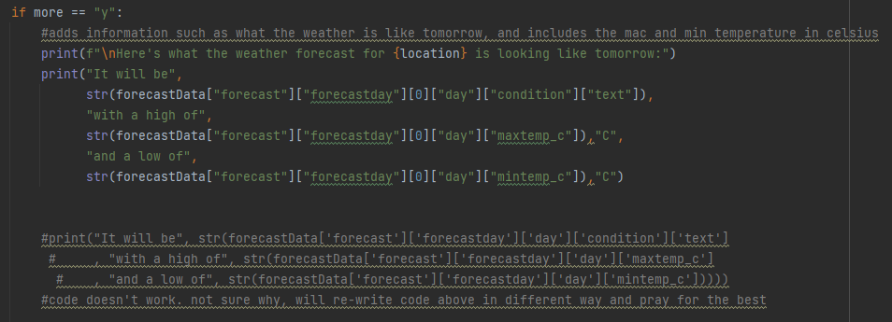
Documentation: The code has added comments that describe the purpose of each section, making it easier to understand not only for developers but also for maintainers. I also used comments to show what code I used initially that did not work or didn’t give the required outcome. I did this so that I would not repeat my mistakes in future lines of code, and if the future code did not work as well, I would have a foundation to go back to without having to go back to an old save etc.

Conclusion
In conclusion, the Weather Lookup app works seamlessly in conjunction with the WeatherAPI to provide users with a convenient and time-saving weather data service. This simplicity of the code is reflected in its clear prompts, concise structure, and error handling. Users can quickly enter the location they want, get current weather data and a one-day forecast. The use od statements ensures that successful and unsuccessful attempts are dealt with quickly, providing a reliable user experience on top of the comprehensive testing that involves location checks being carried out to confirm the information.

