Independent Project
Assignment 2 - 2021
Investigation – Aim – To identify how working from home during this pandemic has affected employees’ mental wellbeing.
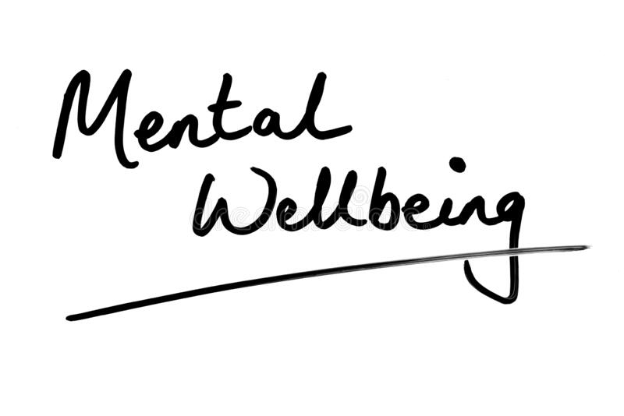
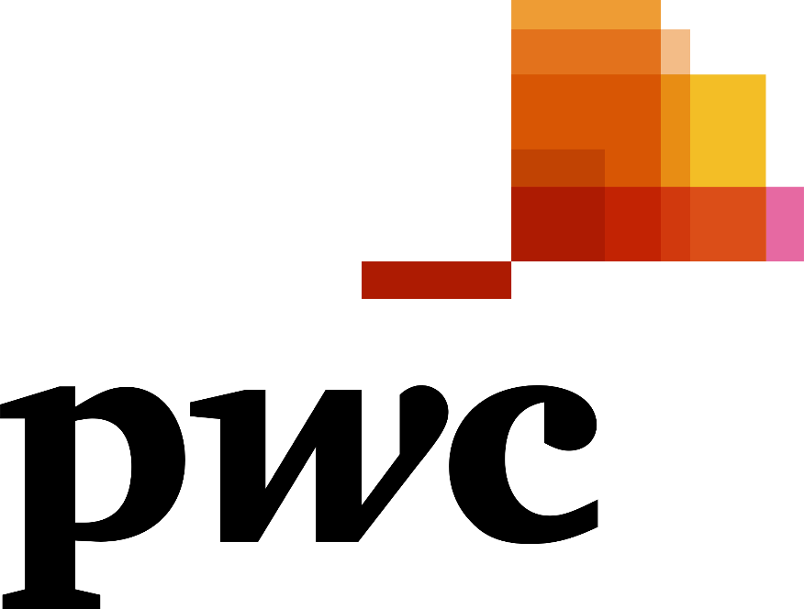

April 2021

MODULE NAME: Independent Project (BMBM6020)
Name: Kate oliver
Student Number: 1702582

Contents
1. Introduction 3
1.1. Report Remit 3
1.2. Background of the organisation 3
2. Working from home pre covid 4
3. Working from home post covid 5
4. findings 6
4.1. Methodology 6
4.2. Primary Research Findings 7
5. conclusion 9
5.1. Recommendations 10
6. References 11
7. Appendix 13

Introduction
Wellbeing is defined by the Oxford Dictionary (2021) as “the state of being comfortable, healthy or happy.” However, mental wellbeing does not have one specific definition, it is seen as more than key happy moments, the term is used to describe how a person is feeling and coping with their daily lives (Mind, 2021). Depending on an individual’s mental welfare it can affect how they handle stress, make decisions, and communicate with others (U.S. Department of Health & Human Services, 2020). According to Mind (2021), 1 in 4 people will experience some level of mental health problem each year in England and approximately only 1 in 8 adults with a mental health problem are getting some level of treatment.
In 2019 a virus was identified and later determined as SARS-CoV2, which has caused a pandemic of respiratory issues, known to the public as COVID 19/Coronavirus (Johns Hopkins Medicine, 2021). The earliest recorded case of the virus was November 17th, weeks before authorities publicised and acknowledged the new virus’s existence (The Guardian, 2020). According to the BBC (2021) Covid Map, there has been a total of 144,761,922 cases and 3,072,417 deaths recorded worldwide.

Report Remit
This report will discuss and analyse working from home (WFH) before COVID 19, focussing on the advantages and disadvantages to its implementation into business. Next, it will look at the impact COVID 19 has had on the way the population WFH and how it has affected their mental wellbeing. In addition, using PwC as a case study, primary research has been conducted into how individuals have been affected by COVID 19 while working from home, how they have adjusted and how it has influenced their mental health; the findings of this research will be included in this report. Finally, any recommendations for ways in which PwC can improve upon their current WFH policy will be discussed.

1.2. Background of the organisation
Pricewaterhouse and Cooper (PwC) was created from the merge of Price Waterhouse and Coopers & Lybrand in 1998 (PwC US, 2021). Since then, they have become one of the world’s leading global professional services firms and as of 2020, PwC UK has over 24,207 employees (Marketline, 2020). As the organisation has grown, so has the selection of industries that PwC operates within. PwC operates in 26 industries ranging across immigration, tax, assurance, transactions, human resources, crisis management plus others (PwC US, 2021). PwC continue to reassure both their staff and clients that during the COVID 19 pandemic they are following their ‘infectious disease and pandemic management response’ plan to maintain business continuity. They have also released a Health and Safety Risk Assessment highlighting the adjustments they have made so that when staff do start returning to the offices, they will be in compliance with Health and Safety regulations (PwC UK, 2020).

Working from home pre covid
Working from home, also known as telecommuting, is where an individual uses the internet to work from a distance from their place of employment (Ince, 2019). This way of working has been utilised by businesses all over the world and has been said to increase morale, decrease stress and improve job satisfaction (CIO Insight, 2007). WFH has a selection of advantages, such as lowering the cost of working, as it eliminates commute time and costs, and most businesses do not make business formal dress a requirement whilst WFH (Gajendran & Harrison, 2007). As a result, employees wake up with a lower stress level than if they were going into the workplace, resulting in an increase in their motivation and work effort (Rupietta & Beckmann, 2018). This also saves the business money as they spend less on costs such as rent, electricity, maintenance etc; especially when most large businesses have their workplace located in city centres, there is also a reduction in payments for overtime expenses (Robert & Borjesson, 2006). As the use of WFH increases, so does its impact on society, as it reduces the municipal investments that need to be made such as road repairs, transport infrastructure etc (Zhu & Mason, 2014). Furthermore, most organisations that offer the choice to WFH will provide the option for flexible hours, which is where employees can drift from the traditional 9-5 working hours and tailor their workday to increase personal productivity as well as working around any personal commitments (Ford & Butts, 1991). In addition, an employer who offers the choice to WFH highlights their willingness to alter the working environment to best suit staff’s needs, enabling them to do all they need to succeed. This may strengthen the relationship between an employee and their place of work as it enables them to find a more cohesive work-life balance (Gajendran & Harrison, 2007).
Working from home also comes with a selection of disadvantages; in an office there is a wide variety of support available to employees, whether it be technical support, secretaries, or maintenance teams, whereas from home these support systems are unavailable and an employee’s work could be affected (Harpaz, 2002). Without this support and being present in the office, employees’ loyalty and commitment to the business can dissipate. With WFH it is harder for a business to influence and control motivation and dedication to the business (Hajdin, 2005). To be able to WFH effectively there are certain skills/characteristics an individual should ideally possess, as those who struggle to work independently not only need constant supervision that comes with working in an office, but will also find it difficult when deprived of social contact, and thus may not be suitable to WFH (Nakrošienė, et al., 2019).

Working from home post covid
Coronavirus is circulated through the air, droplets of the disease that originate from an infected individual can then be inhaled spreading it to the next host (Department of Health and Social Care, 2020). To ensure public safety, most countries went into lockdown and businesses had to transition their staff to begin working from home as they had to close headquarters and satellite offices. As of April 2020, 46.6% of the employed population were working from home in some capacity (Office for National Statistics, 2020). This meant that individuals who had never worked from home were now having to acclimatise to the new way of life, and for those who had worked from home previously once a week were now having to transform their home to accommodate a functional work space. The main reason employees have been asked to WFH is to keep the population safe from the virus. Notably, it has been identified that in countries with higher percentage of businesses that offer the option to work from home have had less cases of COVID 19 as well as fewer registrations for short – term work (Alipour, et al., 2021). This indicates that how accustomed a country is with WFH directly impacts its number or COVID 19 cases. This could be because for those who have worked from home previously understand how to work efficiently from home and due to their familiarity with the process it has had less of an impact on their mental wellbeing and as a result have followed lockdown precautions more diligently.
It was identified that WFH has both strengths and weaknesses however, the pandemic has illuminated further weaknesses to this approach now that it is being adopted long term and by a vast number of people. For example, before the pandemic WFH offered individuals the opportunity to work without any of the distraction that comes from being in the office (Aczel, et al., 2021). But due to the pandemic, people are now struggling with the distractions at home, whether it is children needing home schooling or living in a household where multiple people are working from home each needing their own work space (Bucurean, 2020). Other distractions that come from being at home are household chores, people feel as they are at home, they must complete tasks whilst trying to work and this results in lower productivity (Bucurean, 2020). This highlights that the strengths that came with WFH before the pandemic are having a negative affect on individuals now that it is full time and they are not allowed to enter the office. Furthermore, as people transition into the virtual workplace, a big impact on people mental wellbeing has been the loneliness and isolation from society. As the pandemic continues and lockdowns are extended so are individuals social and emotional isolation which can have a direct impact on their mental wellbeing (Kato, et al., 2020). For those living alone they are not only isolated from the social side of the workplace but also from family and friends, this can provoke feelings of disconnectedness, loneliness and can result in reduced motivation and a desire to disengage (Gao & Sai, 2020). Overall, this indicates that the benefits and drawbacks associated with WFH have been altered due to COVID 19 changing individuals home environment as well as the long-term future of this virtual workplace with no end date in sight at the moment.

findings

4.1. Methodology
The aim of this investigation was to identify how working from home during the pandemic has affected employees’ mental wellbeing. As a result, when the research was being conducted, an interpretive philosophy was adopted. Interpretivism emphasizes the need to understand and interpret beliefs and motives of different social groups, it focusses primarily on people and how they are impacted by scenarios and what that means, with the aim of gathering a better understanding of social reality (Saunders, et al., 2016) (Kent, 2007). It was decided that for this investigation a deductive approach was better suited than inductive. The deductive approach is where research is used to test a theory rather than using research to determine a theory (Yu, 2015). Primary research was conducted with the aim of gathering a more in depth understanding of how COVID 19 has impacted individuals, specifically employees of the PwC Belfast office. To gain a realistic and detailed perspective of the situation both quantitative and qualitative data were required. Quantitative data, provides the information necessary for a statistical analysis of ‘before’ and ‘after’ the COVID pandemic surfaced, giving a clear indication of the changes to people lives that have occurred (Mayoux, 2006). In contrast, the qualitative data focusses on an individuals’ personal experiences thus providing a holistic view of the impact this pandemic has had on them and their lives (Wenger, 1999). For this particular investigation both of these types of data are vital. Quantitative data provided a foundation of information giving an insight into how people were affected, highlighting any pattern as to what type of people were affected, its objective is to describe and explain. Qualitative data was then collected, exploring in more depth how specific individuals were affected and their personal experiences (Zefeiti & Mohamad, 2015).
To gain quantitative data, a questionnaire was created consisting of six sections with questions ranging from working from home pre pandemic, current working environment, and personal experiences throughout each lockdown. A group of 20 PwC employees were asked to take part anonymously in the research, five gave no response, one declined due to the topic of the investigation, one accepted but later had to withdraw and 13 accepted. The questionnaire was made up of a selection of multiple choice, closed, open and rating scale questions (see Appendix 1). Using multiple choice and closed questions ensures participants do not overthink their answers and can be done so with a specific piece of information; whereas open questions enable them to give as much information as they deem appropriate (Worley, 2015). Scale rating questions require participants to express their opinion in a visual format and the results can be easily averaged (Treiblmaier & Filzmoser, 2009). For reliable results, a list of criteria was created to determine which individuals should participate in the study. It was decided that to gain a well-rounded consensus, there needed to be a range in age and grade, as well as a balance between both male and female participants. This widened the scope of the investigation providing a realistic overview of how different demographics have been affected. Due the current pandemic, the questionnaire was developed on Google Forms and circulated over email on the 10th of February, and they were returned within the week by the 17th February.
Of the 13 who took part in the questionnaire, eight agreed to take part in a recorded interview, due to work load one had to withdraw from the study. It was decided that the interviews would be conducted face to face, enabling the interviewer and participant to take social cues such as voice, body language, facial expressions etc (Opdenakker, 2006). However, due to the current pandemic this was unattainable, so to compromise, the interviews were held and recorded on Zoom. The interview itself was made up of 17 questions, with additional probing questions ( see appendix 2). With the use of open questions, the interviews gathered qualitative data. To ensure validity and reliability each participant was asked the same set of questions in both the questionnaire and the interview.
Mixing methods provided the investigation with both quantitative and qualitative data, this done through the use of questionnaires and conducting interviews in addition. Due to the circumstances of the global pandemic, they were also the most achievable and measurable methods.

4.2. Primary Research Findings
The questionnaire was completed by 5 men and 7 women, varying from associate 1 to senior associate 2, whose working weeks range between 37.5 to 47 hours. Before the pandemic a third of the subjects WFH once every two weeks, a sixth WFH once a month, a further sixth WFH once a week and a third either WFH occasionally or never. The results identified that 75% did not have a work space in their home before the pandemic, since the beginning of the pandemic all of them now have an official work space however a third of them share that space with someone else. Since the pandemic 5 of the 12 have designated a specific room as their work space and have purchased both a desk and a chair and 8 bought additional monitors. This indicates that when WFH became long term the subjects had to adapt their home environment to better suit their new lifestyle. This is further confirmed with 2/3 of the subjects investing money in their living situation ranging from redecorating the house to purchasing new furniture. When they were asked if lockdown had improved time spent with those in their household, 58.3% answered yes, 16.67% answered no there had been no change and 25% answered no it has had a negative impact as can be seen in the chart below.
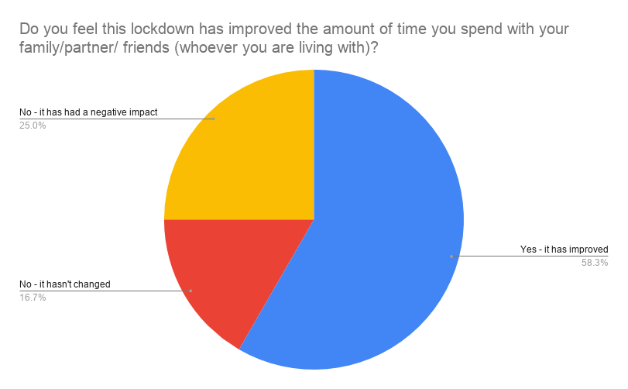
When asked what have you learnt from this pandemic 100% made reference to spending time with family and loved ones, 75% also made reference to what they have realised they took for granted such as the choice to exercise and to own a car especially in Northern Ireland where there is limited public transport. This identifies that COVID 19 has pushed individuals to re-evaluate what they need and want in life. However only 3 of the subjects utilise the use of flexible hours to help balance childcare, exams or when working with international clients and over 83% stated they struggled in some way with sleep since the pandemic began. Which illustrates that even though they have a better understanding of what is important to them and what makes them happy they are yet to change their traditional work day to better accommodate it. Finally, when asked to rate their motivation out of 10 for over the three lockdowns, half of the participant’s had a gradual decrease in motivation.
After this data was gathered the interviews were conducted with 7 of the participants, 5 of which explained how due to the pandemic and their new living situations that as they may have saved money on commute and travel expenses, these funds were reallocated to pay for living and work improvements such as kitchen repairs and office refurbishments. Interviewee’s 4,5, and 7 all stated that when they begin to lose motivation it is really hard to regain it without either stopping and starting again after time away from the computer which they explained had a domino effect on their self-confidence. This highlighted that they place a high level of pressure on themselves that even though they are WFH they feel they must work for the full 7.5 hours otherwise they are performing inadequately.
Interviewee 4 explained as a team lead, he was able to have welfare check ins with his team but struggled with being able to form relationships with the members of his team he had yet to meet due to the fact they joined during the pandemic. It was also highlighted that it was hard to gain check ins with management, where he would usually connect with them in a free 5 minutes they had at their desk, it was now a struggle to find a gap in their calendar. Of the 7 interviewees 6 also made comment on how they have struggled with not having social interactions with colleagues that are not about work. Interviewee 5 explained that to talk to someone a meeting has to be made in their calendar and that is uncomfortable to do so when it is not regarding work. This shows that even though different measures are in place to help with social interaction certain aspects of the office work place can not be duplicated in the virtual workplace.

conclusion
In Conclusion it was identified that working from home offers individuals an entirely different way of working than the traditional in office work space. It lowers working costs as money is saved on transport/commute, it also offers flexible hours which allows individuals to plan their work day around any day time commitments that would be usually missed due to being at work additionally it provides space away from the normal office distractions thus boosting productivity. However, this does not mean it does not come with the disadvantages of losing out on the support available within an office as well as the fact it is best suited to certain personalities and work styles. Further analysis was then conducted into how COVID 19 had impacted individuals’ experiences of WFH. It indicated that with the increased amount of time spent working from home and being confinement to one building has had a knock-on effect on people’s mental wellbeing and motivation levels. This was confirmed when primary research was conducted using PwC as a case study. The questionnaire highlighted that individuals who lived in different situations and were working at different grades all had to change and adapt the way in which they were living to better suit their new lifestyle. The interviews further confirmed that even though savings were noticed that money was then spent on the home alternative it was also identified that isolation and lack of socialising can lead to a lack of motivation that in turn can cause feelings of insecurity.

Recommendations
From the information gathered in primary research there are three recommendations for how PwC can improve upon their current WFH program to help with employee’s mental wellbeing.
- The use of one forum to post information on the rules and regulations of working from home and another for mental wellbeing support and announcements as to new supportive measures and ways in which people can better balance their work and home life.
- Check ins with management, due to the virtual workplace employees have lost the opportunity to have an informal check in with management.
- Further explanation as to how flexible hours can be utilised by employees. Making sure they understand it can be utilised by all not just those with children or an alternative commitment.

References

Aczel, B., Kovacs, M., Van Der Lippe, T. & Szaszi, B., 2021. Researchers working from home: Benefits and challenges. PLOS ONE, 16(3), pp. 1-13.
Alipour, J.-V., Fadinger, H. & Schymik, J., 2021. My home is my castle – The benefits of working from home during a pandemic crisis. Journal of Public Economics, Volume 196, pp. 1-11.
BBC News, 2021. Covid map: Coronavirus cases, deaths, vaccinations by country. [Online]
Available at: https://www.bbc.co.uk/news/world-51235105
[Accessed 23 April 2021].
Bucurean, M., 2020. The Impact of Working From Home on Productivity. A study on the pandemic period.. Annals of the University of Oradea, Economic Science Series, 29(2), pp. 267-275.
CIO Insight, 2007. Telecommuting Found to Boost Morale, Cut Stress: Working remotely benefits both businesses and workers, a new analysis shows. CIO insight, Issue 87, pp. 1-3.
Department of Health and Social Care, 2020. New film shows importance of ventilation to reduce spread of COVID-19. [Online]
Available at: https://www.gov.uk/government/news/new-film-shows-importance-of-ventilation-to-reduce-spread-of-covid-19#:~:text=New%20short%20film%20released%20by,to%20keep%20your%20home%20ventilated.&text=A%20new%20public%20information%20campaign,from%20coronavirus%20b
[Accessed 26 April 2021].
Ford, R. C. & Butts, M. A., 1991. Is Your Organization Ready for Telecommuting?. S.A.M. Advanced Management Journal, 56(4), pp. 19-20.
Gajendran, R. S. & Harrison, D. A., 2007. The Good, the Bad, and the Unknown About Telecommuting: MetaAnalysis of Psychological Mediators and Individual Consequences. Journal of applied Psychology, 92(6), pp. 1524-1529.
Gao, G. & Sai, L., 2020. Towards a ‘virtual’ world: Social isolation and struggles during the COVID‐19 pandemic as single women living alone. Gender, Work, and organization, 27(5), pp. 754-762.
Goebert, B., 2002. Beyond listening: learning the secret language of focus. New York: Wiley-Blackwell.
Hajdin, M., 2005. Employee Loyalty: An Examination. Journal of Business Ethics, 59(3), pp. 259-280.
Harpaz, I., 2002. Advantages and disadvantages of telecommuting. International Journal of productivity and performance management, 51(2), pp. 74-80.
Ince, D., 2019. A dictionary of the Internet. 4th ed. Oxford: Oxford University Press.
Johns Hopkins Medicine, 2021. What Is Coronavirus?. [Online]
Available at: https://www.hopkinsmedicine.org/health/conditions-and-diseases/coronavirus
[Accessed 23 April 2021].
Kato, T. A., Sartorius, N. & Shinfuku, N., 2020. Forced social isolation due to COVID‐19 and consequent mental health problems: Lessons from hikikomori. Psychiatry and clinical neurosciences, 74(9), pp. 506-507.
Kent, M., 2007. The Oxford Dictionary of Sports Science & Medicine. 3rd ed. Oxford: Oxford University Press.
Marketline, 2020. Companies Listing. [Online]
Available at: https://advantage-marketline-com.ezproxy.uwtsd.ac.uk/Company/Index?q[]=PricewaterhouseCoopers%20LLP&pageSize=50&direction=Descending&SearchKey=CompaniesSearch&exactWord=1
[Accessed 23 November 2020].
Mayoux, L., 2006. quantitative, qualitative or participatory? which method, for what and when?. 1st ed. London: SAGE Publications.
Mind, 2021. How to improve your mental wellbeing. [Online]
Available at: https://www.mind.org.uk/information-support/tips-for-everyday-living/wellbeing/wellbeing/
[Accessed 24 Arpil 2021].
Mind, 2021. Mental Health facts adn statistics. [Online]
Available at: https://www.mind.org.uk/information-support/types-of-mental-health-problems/statistics-and-facts-about-mental-health/how-common-are-mental-health-problems/
[Accessed 24 aPRIL 2021].
Nakrošienė, A., Bučiūnienė, I. & Goštautaitė, B., 2019. Working from home: characteristics and outcomes of telework. International Journal of Manpower, 40(1), pp. 87-97.
Office for National Statistics, 2020. Coronavirus and homeworking in the UK: April 2020. [Online]
Available at: https://www.ons.gov.uk/employmentandlabourmarket/peopleinwork/employmentandemployeetypes/bulletins/coronavirusandhomeworkingintheuk/april2020
[Accessed 26 April 2021].
Opdenakker, R., 2006. Advantages and disadvantages of four interview techniques in qualitative research. FORUM: QUALITATIVE Social Research, 7(4), pp. 1-13.
Oxford Dictionary, 2021. Well-being. [Online]
Available at: https://www.lexico.com/definition/well_being
[Accessed 24 April 2021].
PwC UK, 2020. Health & Safety Risk Assessment. [Online]
Available at: https://www.pwc.co.uk/who-we-are/assets/documents/covid-19-mobilization-of-offices.pdf
[Accessed 23 April 2021].
PwC US, 2021. History and Milestones. [Online]
Available at: https://www.pwc.com/us/en/about-us/pwc-corporate-history.html
[Accessed 23 April 2021].
Robert, M. & Borjesson, M., 2006. Company Incentives and Tools for Promoting Telecommuting. Enviroment and Behaviour, 38(4), pp. 521-549.
Rupietta, K. & Beckmann, M., 2018. Working from Home What is the Effect on Employees' Effort?. Schmalenbach Business Review, 70(1), pp. 25-55.
Saunders, M., Lewis, P. & Thornhill, A., 2016. Research Methods for Business. 7th ed. Harlow: Pearson.
The Guardian, 2020. First Covid-19 case happened in November, China government records show - report. [Online]
Available at: https://www.theguardian.com/world/2020/mar/13/first-covid-19-case-happened-in-november-china-government-records-show-report
[Accessed 23 April 2021].
Treiblmaier, H. & Filzmoser, P., 2009. Benefits from using continuous rating scales in online survey research. [Online]
Available at: https://www.researchgate.net/profile/Horst-Treiblmaier/publication/228397243_Benefits_from_using_continuous_rating_scales_in_online_survey_research/links/09e4150bdffdc28ef9000000/Benefits-from-using-continuous-rating-scales-in-online-survey-research.pdf
[Accessed 21 April 2021].
U.S. Department of Health & Human Services, 2020. What is Mental Health?. [Online]
Available at: https://www.mentalhealth.gov/basics/what-is-mental-health
[Accessed 24 April 2021].
Wenger, C., 1999. Advantages Gained By Combining Qualitative and Quantitative Data in a Lonitudinal Study. Journal of aging studies, 13(4), pp. 369-371.
Worley, P., 2015. Open thinking, closed questioning: Two kinds of open and closed question. Journal of Philosophy in Schools, 2(2), pp. 17-18.
Yu, L., 2015. Back to the fundamentals again. Journal of Documentation, 71(4), pp. 795-803.
Zefeiti, S. & Mohamad, N. A., 2015. Methodological Considerations in Studying Transformational Leadership and its Outcomes. International Journal of Engineering Business Management, Volume 7, pp. 1-8.
Zhu, P. & Mason, S. G., 2014. The impact of telecommuting on personal vehicle usage and environmental sustainability. International Journal of Enviromental Science and Technology, 11(8), pp. 2185-2000.

Appendix
Appendix 1 – Questionnaire Questions
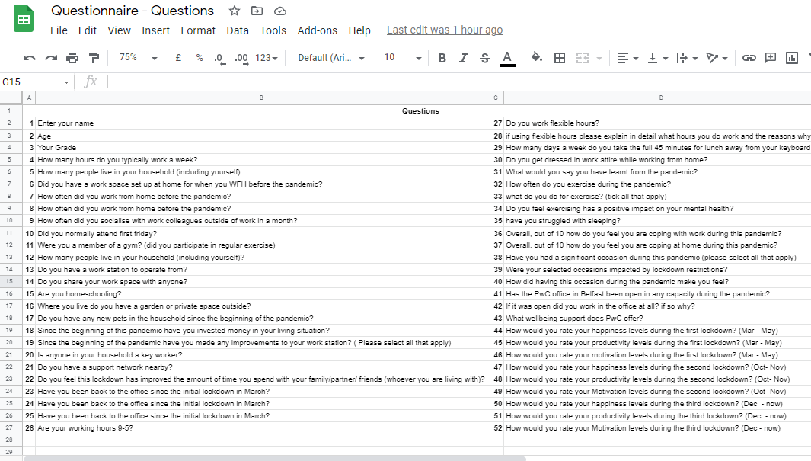
Appendix 2 – Interview Questions


