
LEVEL 7 ASSESSMENT SPECIFICATION
Student name: | Bogdan Alexandru Vasile | Student ID number: | 2114284
Programme: | Master of Business Administration
Module: | International Business Concepts
Module code: | LCMB7034 | Contribution to  Overall Module Assessment (%): | 100%
Lecturer: | Akshay Narayanan | Internal Verifier: | Vasilios Tavlaridis Hoang Nguyen
Assignment Title: | Report | Word count (or equivalent): | 5,000 (± 10%)
Submission deadline: | 27th April 2026 by 2PM | Return date of provisional marks & written feedback: | 25th May 2026
Student ID |  | Name

Table of Contents
Section 1: Report 3
1. Introduction 3
2. Industry and Country Overview 4
Overview of the UK Retail Supermarket Industry 4
Size, Scope and Economic Importance of the UK Retail Supermarket Industry 4
Comparative Strategic Positioning 5
3. Porter’s Diamond Model Analysis 7
Factor Conditions 7
Demand Conditions 8
Related and Supporting Industries 8
Firm Strategy, Structure and Rivalry 8
Role of Government 9
Chance 9
Critical Evaluation of Competitiveness 9
4. Analysis of Aldi in the UK Market 10
Overview of Aldi 10
Market Attractiveness - PESTLE Analysis of Aldi (UK) 11
Cultural 13
Entry Mode and International Strategy 14
Overall Critical Evaluation of Aldi’s Success in the UK 16
5. Conclusion 17
Section 2: Reflective Account (Gibbs Reflective Cycle) 18
1. Description 18
2. Feelings 19
3. Evaluation 19
4. Analysis 20
5. Conclusion 20
6. Action Plan 21
References 22

Section 1: Report

1. Introduction
The retail supermarket sector in the United Kingdom is among the most competitive and strategically significant industries in the national economy since it can play an important role in the GDP, employment, and household consumption. The market is also low-margin and very competitive, and the main players in it include the large domestic brands such as Tesco, Sainsbury, and Asda, and the discounters that are foreign to the country, such as Aldi and Lidl (Vogel et al., 2023). It is a critical report on competitiveness in the industry, and proceeds to report on the strategic position of Aldi in the UK market. The entry mode theory, the CAGE Framework, Porter, along with the Diamond Model, PESTLE Analysis, have been used in the conversation about the assessments of market attractiveness and long-term sustainability. The overall evaluation of the industry competitiveness and the future of Aldi in the UK is the conclusion of the report.

(Source: ALDI, 2026)

2. Industry and Country Overview

Overview of the UK Retail Supermarket Industry
The United Kingdom retail supermarket market has been positioned as one of the largest markets in the national retail market, with the annual revenue rate exceeding PS 200 billion and the number of employees in the food retail, wholesale, and distribution business surpassing three million. The economic stability and consumer welfare of the food and grocery retailing industry are such that consumer spending on food and groceries is a sizeable percentage of the total household spending, based on the figures released by the Office for National Statistics and also the industry reports. The market structure is oligopolistic with a small number of strong players that dominate the majority of the market share; therefore, high interdependence and competition on a price basis (Hasan, 2023).
Trends in performance have been affected in recent years by macroeconomic volatility. Consumer price sensitivity has increased due to the cost-of-living crisis and the pressure of inflation, which has encouraged trading down to discount forms and own-label merchandise. This has witnessed a massive growth in discount retailing, in which other organisations such as Aldi and Lidl are making inroads into the market. The other post-Brexit trade arrangement implication is on the supply chains, where the friction is evident at the customs and the cost of imported goods, which is affecting the sourcing strategies and the price models. The trend of grocery retailing over the internet has also been rising (the COVID-19 pandemic is a significant impulse towards it), and the leading supermarkets are investing significant sums of money in web stores, home delivery services, and omnichannel providers. They are such structural changes that imply that a sector is undergoing transformation, but it is fundamental to the UK economic activity (O'Connell et al., 2025).

Size, Scope and Economic Importance of the UK Retail Supermarket Industry
One of the most significant branches of the overall retail economy of the UK is the UK retail supermarket industry. It generates massive annual revenues, contributes significantly to the UK GDP, and has hundreds of thousands of workers operating in the retail sector, logistics, warehouses, and the supply chain management sector. The industry is country-wide in nature, and boasts of extensive chain stores, regional distribution centres, and computerised procurement systems that ensure there is a lot of availability and consistent prices of food. It can expand its spectrums of grocery retailing to enter into financial service venturing, fuel retailing, and expand digital grocery platforms (Luo et al., 2025).
The industry is highly concentrated, and the major players such as Tesco, Sainsbury, and Asda constitute a large portion of the total sales. The Big Four has been widely identified with these four firms, and this has considerably influenced the national pricing behaviour, the supplier negotiating, as well as the competitive relationship issues. Discounts that are foreign-owned, like Aldi and Lidl, have grown in the last few years, thereby enhancing the competition and redefining the market shares. Overall, the importance of national food security, the role in employment, and the scope of the industry in the United Kingdom help to emphasise the economic significance of the industry (Wairimu, 2023).

Comparative Strategic Positioning
The UK supermarket market exhibits a particular rivalry position in which the generic strategies of Porter's are ascribed to the structural differences of the cost structure and the value propositions. The operational simplicity is what underlies the low-cost leadership strategy adopted by the low-cost retailing companies such as Aldi and Lidl. Their strategic competitiveness is in the form of the curbed product mix, homogeneous store designs, simple staffing designs, and oversaturation of home brand products. The structure results in minimisation of complexity, experience higher supplier bargaining power, and achieve higher economies of scale. Quite on the contrary, principal competitors like Tesco and Sainsbury adhere to hybrid or differentiation-based courses. They possess lengthy and extended product lines, blend brands and their very own, and invest heavily in the online platform, reward programs, and omnichannel incorporation. The following parts will help to create customer loyalty, acquire a larger shopping cart, and afford relatively high prices (MUSYOKA, 2023).
The disparity of strategies in an oligopoly market, whereby interdependency and reactive pricing behaviour exist, is high. Cost leaders will be more effective during an economic downturn when the sensitivity of consumer prices is the highest. The differentiators, in turn, rely on the brand equity and the service enhancement that might be quite poor when inflationary pressure takes place. The prevalence of private-labels also elevates the efficiency of the distribution chain of supply, and the relationship with suppliers at different brand plates has to be managed by the incumbents. Lastly, the constant growth of efficiency, scale economies, and flexibility to adjust to the needs of the consumers defines what makes the competitive advantage sustainable, which justifies the intense competition across all sectors of the UK supermarket market (Majka, 2024).

3. Porter’s Diamond Model Analysis
The Diamond Model of Porter is a suitable model that can be used to analyse the competitiveness of a retail supermarket market in the UK. Although the supermarkets are oriented mostly within the domestic arena, the model is useful in the evaluation of the reasonability of the national conditions based on effectiveness, creativity, and strategic ability. The UK is a modernised and mature market in terms of retail that is characterised by developed demand, infrastructure, and stiff competition. Regulatory pressure, compression of margins, and external shocks, on the other hand, affect the sustainability of the competitive advantage (Bankova and Tsvetanova 2024).
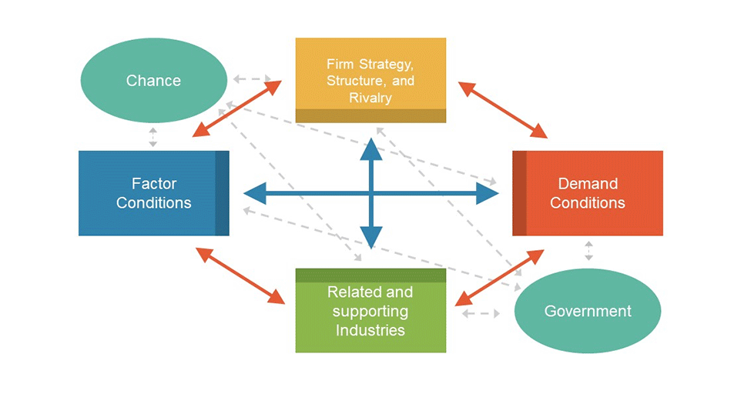
(Source: Slide Model, 2026)

Factor Conditions

Advanced factor conditions are beneficial to the UK and, in the process, make retail competitive. Efficiency is enhanced by an efficient workforce in the logistics, supply chain management, and retail operations. Transport systems and port/ warehousing facilities are established, which can support the distribution of the country at high speed. Strong financial services improve access to capital and investments towards the development and enhancement of technology. Aldi does not have a strong footprint in e-commerce; therefore, it is not able to capitalise on the opportunities that the UK has, even with its developed digital infrastructure. Compared to Tesco and Sainsbury, Aldi does not have strong data analytics and omnichannel integration. As a result, the process of translation of national technological capabilities is not carried out to develop a competitive advantage fully (Adeniran et al., 2024).

Demand Conditions

Domestic demand in the UK is very developed, and as such, the competition is driven by domestic demand. The consumers are informed and have turned out to be price-sensitive, especially during periods of economic instability. The low-end market and the pressure on margins have improved because of the inflationary pressure on the cost of living. Meanwhile, the tendencies towards ethical consumption, e.g., requirements on sustainable sourcing, reduced use of plastics, and improved welfare of animals, generate innovations in the direction of transparency and product labelling. The changes in lifestyle are illustrated by the development of convenience forms and web grocery stores. Even though the discount inherent to Aldi lends credence to its model being the most adequate when it comes to the UK and its prices, the customers are abandoning it in favor of convenience, digitalisation, and sustainability. The long-term performance based on competitiveness would be unstable with excessively low pricing as long as Aldi is not able to adapt to the changes in the qualitative factors of demand. However, hard price competition may cripple the differentiation based on the premium and institutionalise the price-based competition (Tahmasbi, 2024).

Related and Supporting Industries
The UK supermarket market has the advantage of the growth of associated and supportive sectors. The collaboration with the technology providers enhances automation and e-markets. Finance risk management and expansion. However, Brexit and the upheavals in the world have challenged the resilience that a supply chain should have. Retailers are also exposed to exchange rate risks and geopolitical risks due to reliance on imports. Structural constraints of supply chain independence are expressed through susceptibility to exogenous impulses, and the efficiency of scale and coordination is mentioned (Nwani et al., 2022).

Firm Strategy, Structure and Rivalry
Competition is a hard-fought thing in an oligopolistic industry. They are not contested over and over; therefore, price wars and price reductions are present. The focus on the strategies is basically cost leadership, promotions, and the creation of their own label. The convenience outlets and online fulfilment centres are adapted strategies that are manifested in the form of innovation. Domestic competition is good and increases managerial talent; the long-term avoidance flexibility might be watered out by the sustained strain on the margin (Miura, 2025).

Role of Government
Competitiveness is highly determined by the government policy. The competition statute brings the competitive aspect of the market with some sense of fairness, and the employment laws are covered in the cost structures. Imports have been associated with customs procedures that have been brought with the Brexit trade policies. Sustainability and environmental policies incur compliance costs, promote packaging and sourcing innovation. Predictability of regulations is high, but compliance is expensive (Rashied et al., 2024).

Chance
One of the factors in the industry has been accidents. Brexit changed trade relations and the free flow of labour. The COVID-19 crisis has enhanced the advancement of the online grocery and shattered the chains of supply. Global inflation and geopolitical tension led to the high expenses of energy and commodities. Such shocks have only led to uncertainty, along with the focus on the issue of resilience and living in an ever-changing world (Imtiaz and Muzaffar 2025).

Critical Evaluation of Competitiveness

The Diamond by Porter is founded on conditions that remain stable in a nation and underestimate unstable worldwide supply chains. Another problem that international sourcing exposes Aldi to is the geopolitical and logistical upheavals, along with local gains. Therefore, the model partly explains the competitiveness in a globalised retailing business. It does, however, have a weakness on the global front as it is largely local, and the cost model is high relative to the emerging markets. Porter's diamond offers a platform to understand the theoretical analysis of the country, but it does not comprehend the influence of the global supply chain and multinational ownership. The competitive advantage lies not only on the national grounds, but on the transnational relations of the globalised food system, that is, the contextual limitation of the model is not advantageous towards the study of retail (Vuorio, 2024).

4. Analysis of Aldi in the UK Market

Overview of Aldi
Aldi was founded in Germany in 1946 and has since become one of the best-known discount retailers of supermarkets that operates in the world with its stores in Europe, North America, and Australia. It began its operation in the United Kingdom market in 1990, with a cautious and strict expansion policy. Aldi did not struggle to compete on scale with its existing and well-developed competitors but leveraged cost-effectiveness, site-selective acquisition, and slow geographic coverage to build operational stability. The company accelerated the growth rate over the years and introduced the idea of organic growth through investment to the fullest in the expansion process, development of new stores, expansion of the centre in the regions, and effectiveness of the supply chain (Spanjaard and Freeman 2023).
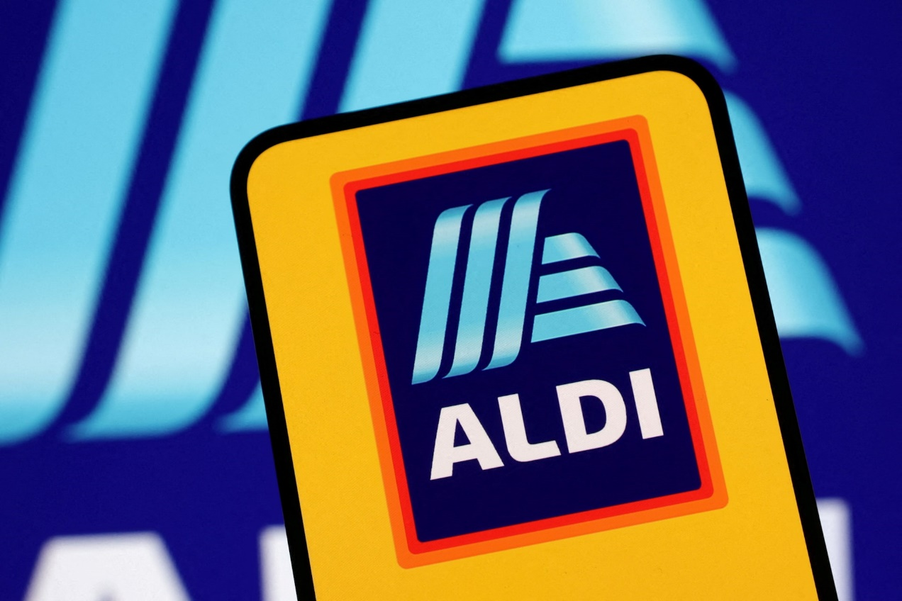
(Source: ALDI, 2026)
Aldi is one of the fastest-growing store chains in the UK, and has, over time, become a niche player within the country, slowly taking market share and threatening to exert pressure on other competitive players. Its business model is anchored on extreme cost leadership that is supported by the small product mix, a massive investment in its own label products, and a simple store design. By simplifying the work of the company and improving its purchasing efficiency, Aldi has been able to maintain low prices in order to make profits. It is a good policy of well-regulated and regulated discounts that has deeply rooted Aldi as a solid competitive power in the UK retail supermarket market (Huang et al., 2025).

Market Attractiveness - PESTLE Analysis of Aldi (UK)
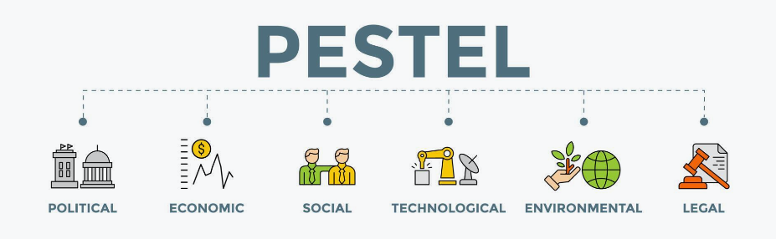
(Source: Vecteezy, 2026)
Political
The trade arrangements have presented Aldi with a complex cross-border supply chain because Brexit trade arrangements have exposed it to even more numerous checks on imports, customs reporting, and administrative costs; this is true even when it comes to EU-source products. Congestion at the borders and inconsistency in regulations have caused uncertainty in cost pressure and operation. Strong competition is being sustained by the very competitive policy and regulation that regulates the unhealthy dominance of major market players such as Tesco. Overall, compliance costs are high because of political circumstances, and the retail market has an organisation and a well-established structure (Sarder, 2022).
Economic
The current cost-of-living crisis in the UK and its massive effects on consumer buying behaviour have led to growth in purchase pressure within the value-oriented retailers. This can enable Aldi to take advantage of the macroeconomic environment in which consumers are abandoning the high-priced supermarkets to move towards low costs. The consumer spending remains cautious and supports the demand for low-priced products and those of the own label. Although the economic crisis gave birth to the cost problems, Aldi, owing to its lean operating model, strong cost management, and high volume buying method, has enough chances to remain in operation despite the limited economic environment, which is price sensitive (Schuster, 2024).
Social
The social moods are shifting towards the Aldi value-based proposition. There has been an emergence of budget-consciousness into pop culture, and low-end shopping is increasingly being accepted by middle-income families rather than low-income groups. The growing health, sustainability, and environmental sourcing awareness makes retailers grow organic, plant-based, and environmentally sourced products. However, enlarged requirements of society regarding corporate responsibility, equal labour standards, and ecological considerations also require continuous monitoring and change. Overall, the UK market is more appealing to the social trends as far as Aldi orientates its business activities to the evolving consumer values (Shams et al., 2025).
Technological

The introduction of technological opportunities in the supply chain through online grocery systems, online payment systems, and chain automation is changing the UK Supermarket industry. Aldi has traditionally been concentrated on the physicality of the store format, and as a result, the company has not been able to build a considerably strong online presence like some of its rivals, such as Sainsbury. Compared to Tesco and Sainsbury, the lag in digitalisation in Aldi poses a risk to the company that other digitally oriented customers will be lost. As the use of online grocery has become a more common practice, there exists the threat of an online omnichannel taking away long-term market share despite short-term cost advantages. The size of capital cash requirements may turn the cost-leadership business of Aldi upside down, however, without adequate alignment of the digitalisation expansion with the objectives of efficiency (Wolniak et al., 2024).
Legal

The labour laws of the UK, including minimum wages and the labour regulations, make Aldi more expensive in labour costs and affect the overall costs of operations. This, as well as consumer protection, is based on the high standards of food safety and hygiene standards that require a comprehensive compliance system and demand administrative complexity. Carbon expense reduction schemes, responsible sourcing, and green packaging schemes are also demanded by the environmental regulations. Although these legal demands raise the compliance costs, they contribute to better clarity and predictability of the regulatory situation, allowing the investments to become stable in the long term in the UK supermarket competition and, consequently, create more consumer confidence within the industry. Although the lean structure will make Aldi more efficient, further regulatory and labour costs will put pressure on margins. The low price strategy it employs means that it can only pass on the cost to the consumers; hence, operational innovation is required to survive (Brass, 2025).
Environmental

The sourcing, availability, and pricing system of food is strongly influenced by environmental pressures like climate change and the destruction of the supply chain globally. Some of the sustainability goals that are set by retailers in the UK include reducing carbon emissions, ensuring a reduction in the use of plastic packaging, and making improvements in the energy consumption of all their operations. Green investments improve the long-term image, and they are associated with high costs in the short term. Failure to make proper investments to buffer profitability will see Aldi lose its goodwill. A balance has to be in the strategy to retain the cost leadership and brand versatility. The competitive advantages, therefore, are strategic dangers and competitive advantages over the long run of the environment as a part of an Aldi operation in the UK market (Malik et al., 2022).

Cultural
The continuously evolving shopping behaviour in the UK retail market is culturally determined, with factors of convenience, digitalisation, and heightened price sensitivity all the more so during periods where the economy has no guarantees of where it is heading. People are still more concerned with value for money, and this reinforces the acceptance and growth of low pricing formats such as Aldi. In addition, sustainability and ethics are critical problems that influence the purchase decision, and the growing popularity of locally produced goods, the minimisation of the number of items used in packaging, and the use of plastic packages, as well as more transparency in the supply chains. In a CAGE framework analysis, the cultural distance between the United Kingdom and Germany is quite smaller, which will provide an opportunity to strategically align, standardise operations, and promote an easier coordination of managers working in German-based retailers in the United Kingdom market (Pelet, 2025).

Entry Mode and International Strategy
Foreign Direct Investment and Ownership Structure
Aldi entered the market in the United Kingdom through Foreign Direct Investment (FDI), where it did not franchise or use a licensing system or joint venture in entering the market. It established wholly owned subsidiaries. According to the entry mode theory, this entry mode provided Aldi with a high strategic control of operations and procurement systems, pricing structures, and coordination of supply chains as individual factors that constitute the heart of its low-cost leadership positioning. Another theory to explain such a strategic choice is the transaction cost theory. Aldi would reduce the chances of opportunistic behaviour of the local partners due to internalisation of transactions and retaining full ownership, in addition to minimising the inefficiencies in coordination. Wholly owned structure will ensure that Aldi is in a position to have normal management practices, buying discipline, and build power with suppliers. Such a type of governance is congruent with its low-cost philosophy and centralised decision-making hierarchy (Paudel et al., 2024).
Standardisation, Location and Institutional Context
The UK internationalisation strategy did not imply observation of global standardisation much, and Aldi does the same. The company replicates its stores that have smaller ones, efficient store formats, smaller workforces, and high dependency on personal label stocking. The overall standardisation is, however, moderated through selective adaptation. Another example of how Aldi adapts its product range is fresh products and the higher quality own-brand products, which are adjusted based on the tastes and quality expectations of the UK consumer (Rana et al., 2022).
This is based on the use of the OLI paradigm developed by Dunning to support the strategic account. The strengths of Aldi as a positive ownership are a strong brand name in terms of discounts, operations expertise, and supply chains. A high and wealthy consumer base, better infrastructure, and institutional stability are the benefits of location that the UK possesses. On the one hand, however, the open legal and regulatory environment permits the UK to make long-term investments, and on the other hand, the increasing compliance costs and regulatory approval also suggest some restrictions inherent in the operations, requiring the strategies to be changed continuously (Meyer et al., 2023).
Competitive Challenges and Strategic Risks
Aldi is a competitive oligopolistic business company that operates in a hostile UK supermarket market that is characterised by cutthroat pricing and structurally low profit margins. The classical values such as Tesco and Sainsbury have made measured steps in opposition to the rise of the discount competitors by raising their own brand of low-cost and further value addition to their own brand, and also by introducing certain price-cutting marketing activities. The reason why long-term investment in innovation, technology, and store development is curtailed under sustained pressure on margins is that it will not facilitate long-term investment (Hernandez et al., 2023).
Other external factors include economic and geopolitical factors, which have increased the risks involved in the operation. The Brexit rules of customs have introduced additional administrative costs and supply chain strains, particularly on embedded imported foods. Global market forces that create inflation have increased the price of inputs, the energy price, and the transportation price, which create cost variability and put Aldi in an arduous circumstance of strict efficiency due to its stringent efficiency model. The wage rates and the labour stability are also undermined by the shortages of labour in the logistics, warehousing, and retail business (Roscoe et al., 2022).
It has an additional strategic risk of regulatory compliance. The increasing requirements of sustainability, ecological regulations, and work policies complicate the operations and make them costly to manage. Also, the weakness of the structure is the digital competition. As consumer behaviour changes in the use of online grocery and online (omnichannel) retailing, Aldi has enough space to grow, though its comparatively poor online presence can restrain the expansion prospects. In spite of the fact that its lean business structures allow it to stay afloat during periods of economic downturn, it will only retain its competitive edge through additional cost reduction and strategically calculated digital and operational transformation (Apooyin, 2025).

Overall Critical Evaluation of Aldi’s Success in the UK
The UK grocery market is structurally attractive based on the fact that it has a gigantic number of customers, institutional stability, and proportionately higher household purchases of groceries. However, the industry is in the mature stage and is very competitive, and the threat to profitability remains under threat considering the presence of powerful players and maintained margins. In such a competitive world, Aldi has somehow been able to ride along with its cost-leadership concept in order to capture market share, particularly in situations where the economy is uncertain, and prices turn highly sensitive. Its slenderness and dominance in its own brands and regulated expenses have rendered it more difficult to eliminate the competitors (Spanjaard and Freeman 2023).
However, the sustainability of the long run will depend on whether Aldi will be able to balance between the standardisation of operations and selective adaptation. Competition that is imitated by long-established businesses, tighter control of the environment and employment, and an ongoing instability of the supply chain that can be explained by geopolitical and economic instabilities, would all threaten the company in the future. To make the enhanced appearance without too much jeopardising the price aspect, Aldi should dedicate more resources to the areas of digital capabilities, supply chain resiliency, and pursue more holistic strategies toward the development of the higher-value own-label segments. These measures, in general, will guarantee maintaining a competitive edge by incremental innovation and cost discipline (Belec Gergek, 2025).

5. Conclusion
This report was a review of competitiveness in the market of the retail supermarket in the United Kingdom, and a critical review of the strategic position of Aldi in the industry. According to the findings, the industry had earlier been characterised by intense competition between oligopolies, well-established logistic networks, discriminating and up-market consumers, and thriving support and related industries. Porter's situation analysis has shown that the UK has been blessed with a favourable position of ease of factors, a high level of population density, and a hard domestic clientele, which contributed to operational efficiency and increased competition. However, high labour expenses had stifled the sustainability of cost advantages and resultant pressures of operation volumes within the industry, and high standards of regulation and structurally based operation.
The Aldi international strategy has been analysed to show that the focused cost-leadership model has assisted the organisation in achieving a steady market share expansion, particularly during economic uncertainties and rising inflation. Aldi had maintained a good discipline in procurement systems, prices, and supply chain coordination by using Foreign Direct Investment and a mass-standardised operating structure. But strategic threats had been perennial with the constant margin squeeze, increasing digital competition, and unremitting supply chain volatility. Generally, the UK market has been favourable in size, institutional stability, and consumer buying power, but it has only had sustained success when Aldi was able to overcome the issue of maintaining efficiency in the necessity to respond to the challenges of technological change and the shift in the competitive forces.

Section 2: Reflective Account (Gibbs Reflective Cycle)

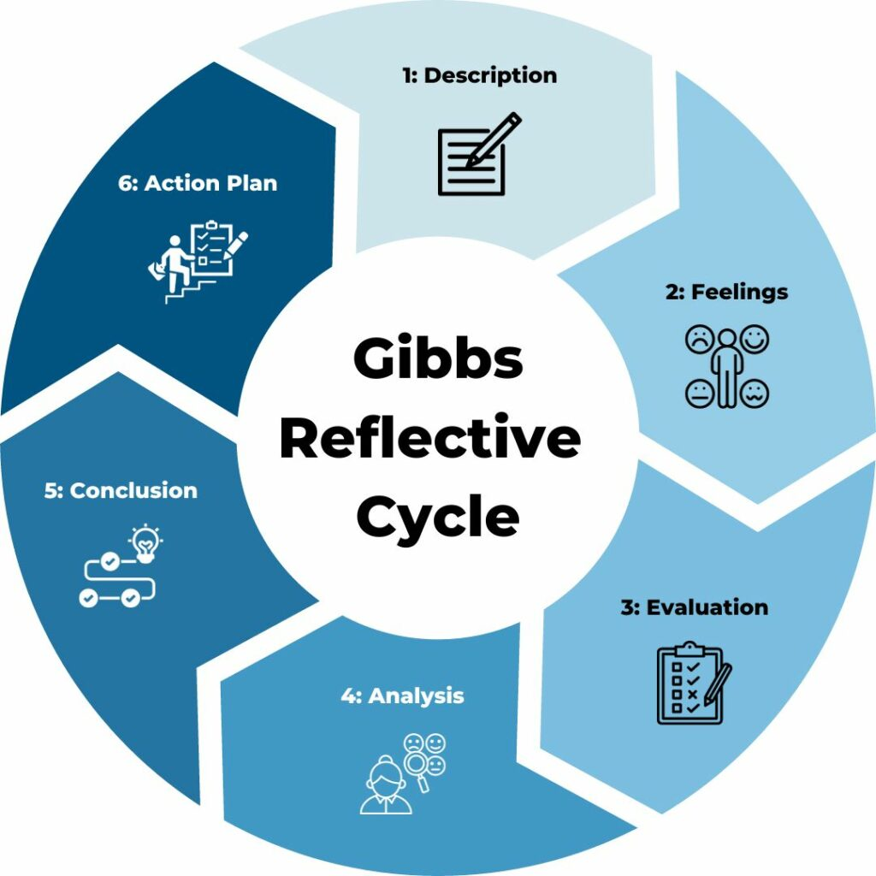
(Source: TSW Training, 2026)

1. Description
This is the analysis assignment of the competitiveness of the UK retail supermarket industry and the strategic position of Aldi in the industry. I selected this topic because the supermarket industry is highly opportune for the overall economic existence, and it embodies the real-world competition strategy. This provided a good grounding in strategic frameworks application since there are such large companies as Tesco, Sainsbury, Asda, and discount shops such as Aldi and Lidl. I implemented much academic and industry research to complete the report. I structured the analysis according to the government statistics, industry reports, and academic theory. They were done with a methodological use of frameworks such as the diamond model by Porter, PESTEL analysis, theory of entry mode, CAGE paradigm, and Dunning OLI paradigm. I have split the report into specific sections. The first section summarises the industry, the second part summarises the competitiveness analysis, and lastly, presents the strategy of Aldi in the UK, in a critical way. This systematic approach made this flow reasoned and academic as it was supposed to be.

2. Feelings
The selection of the topic at the beginning of the assignment was not an issue of concern since I already had the knowledge about the competitive nature of the UK supermarkets. However, as the research progressed, I understood that there was not all the information about the macro-environment and strategic data as I assumed. Another weakness is that I had a problem thinking critically about theory instead of describing it. The applications made to the Diamond Model, created by Porter, needed additional elaboration of each of the determinants and the analysis of the limitations of the model in a globalised retail context, as an example. It might occur that I was bombarded with the quantity of information that existed out there. Personally, however, I felt confident because I got more critical in my structure as well as the slide instead of the description. It assisted in following each section one by one and reducing uncertainty, in addition to improving my analysis capability.

3. Evaluation
My strengths were also good organisation and well-structured writing. The report was easy to sub-categorise into meaningful bits and, hence, increased coherence and readability. I was able to integrate a number of strategic models and applied them to the Aldi activities in the UK. I also conveyed the knowledge of the real-life problems, such as Brexit, inflation, and digital transformation, that made the analysis all the more timely. However, I had certain weak points with my approach, too. One, certain sections were too explanatory and not critical in depth. It also came to my realisation that one should be cautious whenever trying to strike a balance between theory and evidence of what is occurring in the industry. I was at other times too keen to explain the frameworks rather than assessing them according to whether they were suitable or not. The control over the word limit and the preservation of the quality of analysis were the other weaknesses. It was very expensive to edit the content to be understandable without the meaning being lost.

4. Analysis
There were a number of academic and professional skills that were improved in this assignment.
Critical Thinking:
This ability assisted me in becoming more critical when it comes to my analysis, as I could look at the flaws of theoretical models along with their strengths. I did not simply set out to take the frameworks blindly, but then I assessed their suitability in a fully developed industry, which is domestically oriented. I can elaborate by citing the fact that I came to realise that Porter's diamond is no more than a spotlight onto the problem of national advantage and underestimates the importance of the global chain of supply in the food retail chain.
Academic Research Skills:
My ability to locate trustworthy sources was greatly developed. I was taught to read in an organised way with industry statistics, government documents, and macroeconomic statistics. Indeed, the theory and practical evidence of the world assisted me in polishing my academic writing and reference abilities.
Strategic Evaluation:
I enhanced my skills in competitive strategy, particularly cost leadership and standardisation. The analysis of the entrance mode of Aldi through Foreign Direct Investment made me know how ownership control is applicable to the theory of transaction cost and operational efficiency. My perception of how external shocks partly affect this aspect of organisational resiliency and strategic risk also improved in response to COVID-19 and Brexit.

5. Conclusion
Through this report, I managed to learn that the strategic analysis should not only be an exercise with some theoretical knowledge but also with an awareness of the context. It is noted that using multiple frameworks on one industry has indicated that competitiveness is influenced by an interdependence of the factors economic, political, technological, and organisational. I realised that good academic work is grounded in systematised argumentation, critical comparison, and supporting evidence. It was also carried out to teach me the importance of being flexible. External forces such as inflation and alterations in regulation, among others, make the world change in its strategic positioning, making businesses dynamic. Above everything, I was also informed on how to subject theoretical models to critical questioning and how they could be constrained in practice.

6. Action Plan
Improved academic future performance will entail improvement in writing first draft reports rather than revising during the second or even third drafting of the reports to be discussed. To develop the theoretical background and the enrichment of the analysis vocabulary, I will read more peer-reviewed articles. In addition, I will equally train on how to synthesise data in a smaller format to enable me manage word limits. I will also enhance my skills to analyse information, particularly when doing the analysis of the economic indicators and industry reports. Additionally, I will think more about the use of more time in editing and reflections in order to become clear, coherent, and critical where and when needed in future assignments.

References
Adeniran, I.A., Efunniyi, C.P., Osundare, O.S. and Abhulimen, A.O (2024) ‘Optimizing logistics and supply chain management through advanced analytics: Insights from industries’. Engineering Science & Technology Journal, 5(8), pp.2691-3280. Online available at: https://www.researchgate.net/profile/Angela-Abhulimen/publication/383860789_UK_3_Nigeria_Inter-Bank_Settlement_System_Plc_NIBSS_Nigeria_4_Independent_Researcher/links/66ddaff464f7bf7b199f1fbd/UK-3-Nigeria-Inter-Bank-Settlement-System-Plc-NIBSS-Nigeria-4-Independent-Researcher.pdf Last accessed on: 22nd Feb 26
ALDI (2026) ‘ALDI Logo’. Online available at: https://www.aldi.co.uk/corporate/about Last accessed on: 22nd Feb 26
ALDI and LiDL (2026) ‘ALDI and LiDL Logo’. Online available at: www.aldi.co.uk Last accessed on: 22nd Feb 26
Apooyin, A (2025) ‘Risk management and compliance in a globalized economy: Navigating regulatory challenges and strategic adaptations’. International Journal of Science and Research Archive, 15(10.30574). Online available at: https://www.researchgate.net/profile/Agboola-Apooyin/publication/388644613_Risk_Management_and_Compliance_in_a_Globalized_Economy_Navigating_Regulatory_Challenges_and_Strategic_Adaptations/links/67a0b3f452b58d39f267b958/Risk-Management-and-Compliance-in-a-Globalized-Economy-Navigating-Regulatory-Challenges-and-Strategic-Adaptations.pdf Last accessed on: 22nd Feb 26
Bankova, Y. and Tsvetanova, T (2024) ‘The Diamond Model of Porter to Measure Rural Regions' Competitiveness: A Case from Bulgaria’. Annals of the University Dunarea de Jos of Galati: Fascicle: I, Economics & Applied Informatics, 30(3). Online available at: https://www.researchgate.net/profile/Tsvetelina-Tsvetanova-2/publication/388310777_The_Diamond_Model_of_Porter_to_Measure_Rural_Regions'_Competitiveness_A_Case_from_Bulgaria/links/67bd73fcf5cb8f70d5bea78b/The-Diamond-Model-of-Porter-to-Measure-Rural-Regions-Competitiveness-A-Case-from-Bulgaria.pdf Last accessed on: 22nd Feb 26
Belec Gergek, J (2025) ‘An Approach to Corporate Sustainability Through Collective Learning and Pragmatic Decision Making (Doctoral dissertation, ETH Zurich)’. Online available at: https://www.research-collection.ethz.ch/bitstreams/4a946299-f9c2-411d-8cad-deacb6a378c8/download Last accessed on: 22nd Feb 26
Brass, M (2025) ‘Governance, Risk and Compliance: Demystifying the Risk and Data Privacy Landscape’. CRC Press. Online available at: https://books.google.com/books?hl=en&lr=&id=dEyWEQAAQBAJ&oi=fnd&pg=PT7&dq=The+high+level+of+food+safety+and+hygiene+standards+demands+a+full-fledged+compliance+system+and+provides+consumer+protection+at+the+expense+of+administrative+complexity.+&ots=YVEXzbTuey&sig=fLw0fxDXxSinhp4yMK3l_Ori3L0 Last accessed on: 22nd Feb 26
Hasan, A.U (2023) ‘The Impact and mitigation of Climate Change on the building performance of nonresidential buildings: Case studies of typical UK supermarkets (Doctoral dissertation, University of West London)’. Online available at: https://repository.uwl.ac.uk/id/eprint/10596/1/Hasan%20-%20PhD%20Thesis%20Final%20(Oct%2023).pdf Last accessed on: 22nd Feb 26
Hernández, M.A., Espinoza, A., Berrospi, M.L., Deconinck, K., Swinnen, J. and Vos, R (2023) ‘The role of market concentration in the agrifood industry (Vol. 2168). Intl Food Policy Res Inst’. Online available at: https://books.google.com/books?hl=en&lr=&id=Vs6sEAAAQBAJ&oi=fnd&pg=PR4&dq=Competitive+Challenges+and+Strategic+Risks++Aldi+is+a+business+company+in+a+highly+competitive+oligopolistic+UK+supermarket+market+that+is+defined+by+&ots=mhBAUappNf&sig=ZETxYX5xZGrqD2bgjf2KqW1rIqY Last accessed on: 22nd Feb 26
Huang, N.X., DeAngelis, J., Wollerton, K. and Crawford, C (2025) ‘Secondary Research: ALDI’. Online available at: https://media.journoportfolio.com/users/363810/uploads/5edb2f04-1024-4b5a-9832-c59165647f50.pdf Last accessed on: 22nd Feb 26
Imtiaz, A. and Muzaffar, M (2025) ‘Trade Barriers and Broken Supply Chains: Economic Fallout of Brexit’. Journal of Development and Social Sciences, 6(2), pp.80-90. Online available at: https://www.ojs.jdss.org.pk/journal/article/download/1371/1284 Last accessed on: 22nd Feb 26
Luo, X., Che Rose, R.A. and Awang, A (2025) ‘The evolution of retail outlet distribution: a systematic review of spatial patterns, drivers, and implications for urban development and economic growth’. Frontiers in Sustainable Cities, 7, p.1628137. Online available at: https://www.frontiersin.org/journals/sustainable-cities/articles/10.3389/frsc.2025.1628137/pdf Last accessed on: 22nd Feb 26
Majka, M (2024) ‘Competitive pricing: Staying ahead in a crowded market [online]’ Online available at: https://www.researchgate.net/profile/Marcin-Majka-2/publication/386063409_Competitive_Pricing_Staying_Ahead_in_a_Crowded_Market/links/6741901c868c966b9326129b/Competitive-Pricing-Staying-Ahead-in-a-Crowded-Market.pdf Last accessed on: 22nd Feb 26
Malik, A., Li, M., Lenzen, M., Fry, J., Liyanapathirana, N., Beyer, K., Boylan, S., Lee, A., Raubenheimer, D., Geschke, A. and Prokopenko, M (2022) ‘Impacts of climate change and extreme weather on food supply chains cascade across sectors and regions in Australia’. Nature Food, 3(8), pp.631-643. Online available at: https://idp.nature.com/authorize/casa?redirect_uri=https://www.nature.com/articles/s43016-022-00570-3&casa_token=weLaIZ770H0AAAAA:BpSn9OdYi7q4BpSF2MKgsOTwsHAaPziP6QFPOpQUGG7UBxZblHDu_aG0eTda3ZpXRVqSYtonq9vuvw Last accessed on: 22nd Feb 26
Meyer, K.E., Li, J. and Brouthers, K.D (2023) ‘International business in the digital age: Global strategies in a world of national institutions’. Journal of International Business Studies, 54(4), p.577. Online available at: https://pmc.ncbi.nlm.nih.gov/articles/PMC10072045/pdf/41267_2023_Article_618.pdf Last accessed on: 22nd Feb 26
Miura, T (2025) ‘A Complete Guide to Strategies for Mitigating Price Competition: The Co-opetition Approach’. Available at SSRN 5371718. Online available at: https://papers.ssrn.com/sol3/Delivery.cfm?abstractid=5371718 Last accessed on: 22nd Feb 26
MUSYOKA, M.N (2023) ‘PORTER’S GENERIC COMPETITIVE STRATEGIES, ALLIANCE PARTNERSHIPS AND PERFORMANCE OF MOBILE TELEPHONE NETWORK SERVICE PROVIDERS IN KENYA (Doctoral dissertation, MksU Press)’. Online available at: http://ir.mksu.ac.ke/bitstream/handle/123456780/16416/MUSYOKA%20MARGARET%20NDUNGE%202%20%281%29%20PDF.pdf?sequence=1&isAllowed=y Last accessed on: 22nd Feb 26
Nwani, S.H.A.R.O.N., Abiola-Adams, O., Otokiti, B.O. and Ogeawuchi, J.C (2022) ‘Constructing revenue growth acceleration frameworks through strategic fintech partnerships in digital e-commerce ecosystems’. IRE Journals, 6(2), pp.372-374. Online available at: https://www.researchgate.net/profile/Sharon-Nwani/publication/392483455_Constructing_Revenue_Growth_Acceleration_Frameworks_through_Strategic_Fintech_Partnerships_in_Digital_E-Commerce_Ecosystems/links/684624066b5a287c3049f22a/Constructing-Revenue-Growth-Acceleration-Frameworks-through-Strategic-Fintech-Partnerships-in-Digital-E-Commerce-Ecosystems.pdf Last accessed on: 22nd Feb 26
O'Connell, M., Smith, H. and Thomassen, O (2025) ‘The rise of discounters and its impact on concentration, market power and welfare’. Online available at: https://ora.ox.ac.uk/objects/uuid:2db4839f-5cc5-46ef-aaf3-9d688e5d5cb8/files/s6w924f111 Last accessed on: 22nd Feb 26
Paudel, R., Sherm, A. and Tehrani, S (2024) ‘Strategic For Direct Investment: Market Entry Dynamics And Policy Implications For Multinational Corporations’. Jurnal Ilmiah Multidisiplin Indonesia (JIM-ID), 3(02), pp.89-102. Online available at: https://ejournal.seaninstitute.or.id/index.php/esaprom/article/download/4602/5219 Last accessed on: 22nd Feb 26
Pelet, J.E (2025) ‘Consumer Behaviour: Understanding Consumers in a Digital Landscape’. Kogan Page Publishers. Online available at: https://books.google.com/books?hl=en&lr=&id=j8tJEQAAQBAJ&oi=fnd&pg=PP1&dq=Cultural++The+ever-changing+shopping+behaviours+in+the+UK+retail+sector+are+culturally+defined+by+considerations+of+convenience,+digitalisation,+and+increased+price+sensitivity,+especially+at+times+when+the+economy+is+not+sure+of+its+future.+&ots=ENEl_azS2t&sig=cYM9jzUyQlMyOJsvVKsiaih2Tso Last accessed on: 22nd Feb 26
Rana, S., Verma, S., Haque, M.M. and Ahmed, G (2022) ‘Conceptualizing international positioning strategies for Indian higher education institutions’. Review of International Business and Strategy, 32(4), pp.503-519. Online available at: https://www.emerald.com/ribs/article-pdf/32/4/503/2873001/ribs-07-2021-0105.pdf Last accessed on: 22nd Feb 26
Rashied, A.S., Obaid, S.A.A., Baban, O. and Muhsin, A.I (2024) ‘The effects of market structure and competition policy on consumer welfare and economic efficiency’. Journal of Ecohumanism, 3(5), pp.949-962. Online available at: https://digitalrepo.alnoor.edu.iq/files/original/85da7312b18c9d6fa846dcb5c77439cae5f783df.pdf Last accessed on: 22nd Feb 26
Roscoe, S., Aktas, E., Petersen, K.J., Skipworth, H.D., Handfield, R.B. and Habib, F (2022) ‘Redesigning global supply chains during compounding geopolitical disruptions: the role of supply chain logics’. International Journal of Operations & Production Management, 42(9), pp.1407-1434. Online available at: https://www.emerald.com/ijopm/article-pdf/42/9/1407/1014342/ijopm-12-2021-0777.pdf Last accessed on: 22nd Feb 26
Sarder, M.M (2022) ‘Marketing plan for Mixmart: Marketing communication perspective’. Online available at: https://www.theseus.fi/bitstream/handle/10024/785861/Sarder_MuhammadMehedi.pdf?sequence=2 Last accessed on: 22nd Feb 26
Schuster, S (2024) ‘Linking Customer Lifetime Value (CLV) and brand loyalty: an exploratory study of the car insurance market in the UK (Doctoral dissertation, University of Greater Manchester)’. Online available at: https://ub-ir.bolton.ac.uk/view/pdfCoverPage?instCode=44UOBO_INST&filePid=1310413940008841&download=true Last accessed on: 22nd Feb 26
Shams, S.R., Brown, D.M. and Hardcastle, K (2025) ‘Sustainable Marketing: Strategic Marketing for People, Planet and Profit’. Springer Nature. Online available at: https://books.google.com/books?hl=en&lr=&id=VnFREQAAQBAJ&oi=fnd&pg=PR6&dq=The+changing+social+attitudes+are+moving+in+the+direction+of+Aldi%27s+value-based+proposition.+&ots=pd4XOzE8E4&sig=dACz_eyay8XtncXQAhNqsConmJk Last accessed on: 22nd Feb 26
Slide Model (2026) ‘Porter’s Diamond Model’. Online available at: https://slidemodel.com/porters-diamond-model/ Last accessed on: 22nd Feb 26
Spanjaard, D. and Freeman, L (2023) ‘Supermarket tribes and the temple of Aldi: a comparison between the UK and Australia’. Journal of Consumer Culture, 23(1), pp.3-26. Online available at: https://journals.sagepub.com/doi/pdf/10.1177/14695405211073080?casa_token=3ESNvNQFI38AAAAA:QunzLkjAA3foFhEAdz3liURJGKsMGfgJ7qA5FoVsQK7DhDWcIVlyxzNBtuDS5hI5KXc-IpyREA Last accessed on: 22nd Feb 26
Tahmasbi, P (2024) ‘Investigation in the relationship between competition, quality, price, market share, and financial efficiency in the poultry industry (Doctoral dissertation, University of Essex)’. Online available at: https://repository.essex.ac.uk/39297/1/TAHMASBI%202003190%20BE.pdf Last accessed on: 22nd Feb 26
TSW Training (2026) ‘Gibbs Reflective Cycle’. Online available at: https://www.tsw.co.uk/blog/leadership-and-management/gibbs-reflective-cycle/ Last accessed on: 22nd Feb 26
Vecteezy (2026) ‘PESTEL Analysis’. Online available at: https://www.vecteezy.com/free-vector/pestle-analysis Last accessed on: 22nd Feb 26
Vogel, C., Dijkstra, C., Huitink, M., Dhuria, P., Poelman, M.P., Mackenbach, J.D., Crozier, S., Seidell, J., Baird, J. and Ball, K (2023) ‘Real-life experiments in supermarkets to encourage healthy dietary-related behaviours: opportunities, challenges and lessons learned’. International journal of behavioral nutrition and physical activity, 20(1), p.73. Online available at: https://link.springer.com/article/10.1186/s12966-023-01448-8?dm_i=1GFR,8D3ED,5R1BAD,YGXTN,1 Last accessed on: 22nd Feb 26
Vuorio, L (2024) ‘Market Entry Expansion into the German Market’. Online available at: https://www.theseus.fi/bitstream/handle/10024/846991/Vuorio_Linda.pdf?sequence=5 Last accessed on: 22nd Feb 26
Wairimu, D.M (2023) ‘Relationship between Dynamic Supply Chain Capabilities and Resilience of Retail Chain of Stores in Kenya (Doctoral dissertation, JKUAT-COHRED)’. Online available at: http://ir.jkuat.ac.ke/bitstream/handle/123456789/6196/Wairimu%2C%20Desmond%20Mwangi%2C%20PhD%20SCM%2C%202023.pdf?sequence=1&isAllowed=y Last accessed on: 22nd Feb 26
Wolniak, R., Stecuła, K. and Aydın, B (2024) ‘Digital transformation of grocery in-store shopping-scanners, artificial intelligence, augmented reality and beyond: A review’. Foods, 13(18), p.2948. Online available at: https://www.mdpi.com/2304-8158/13/18/2948 Last accessed on: 22nd Feb 26

