

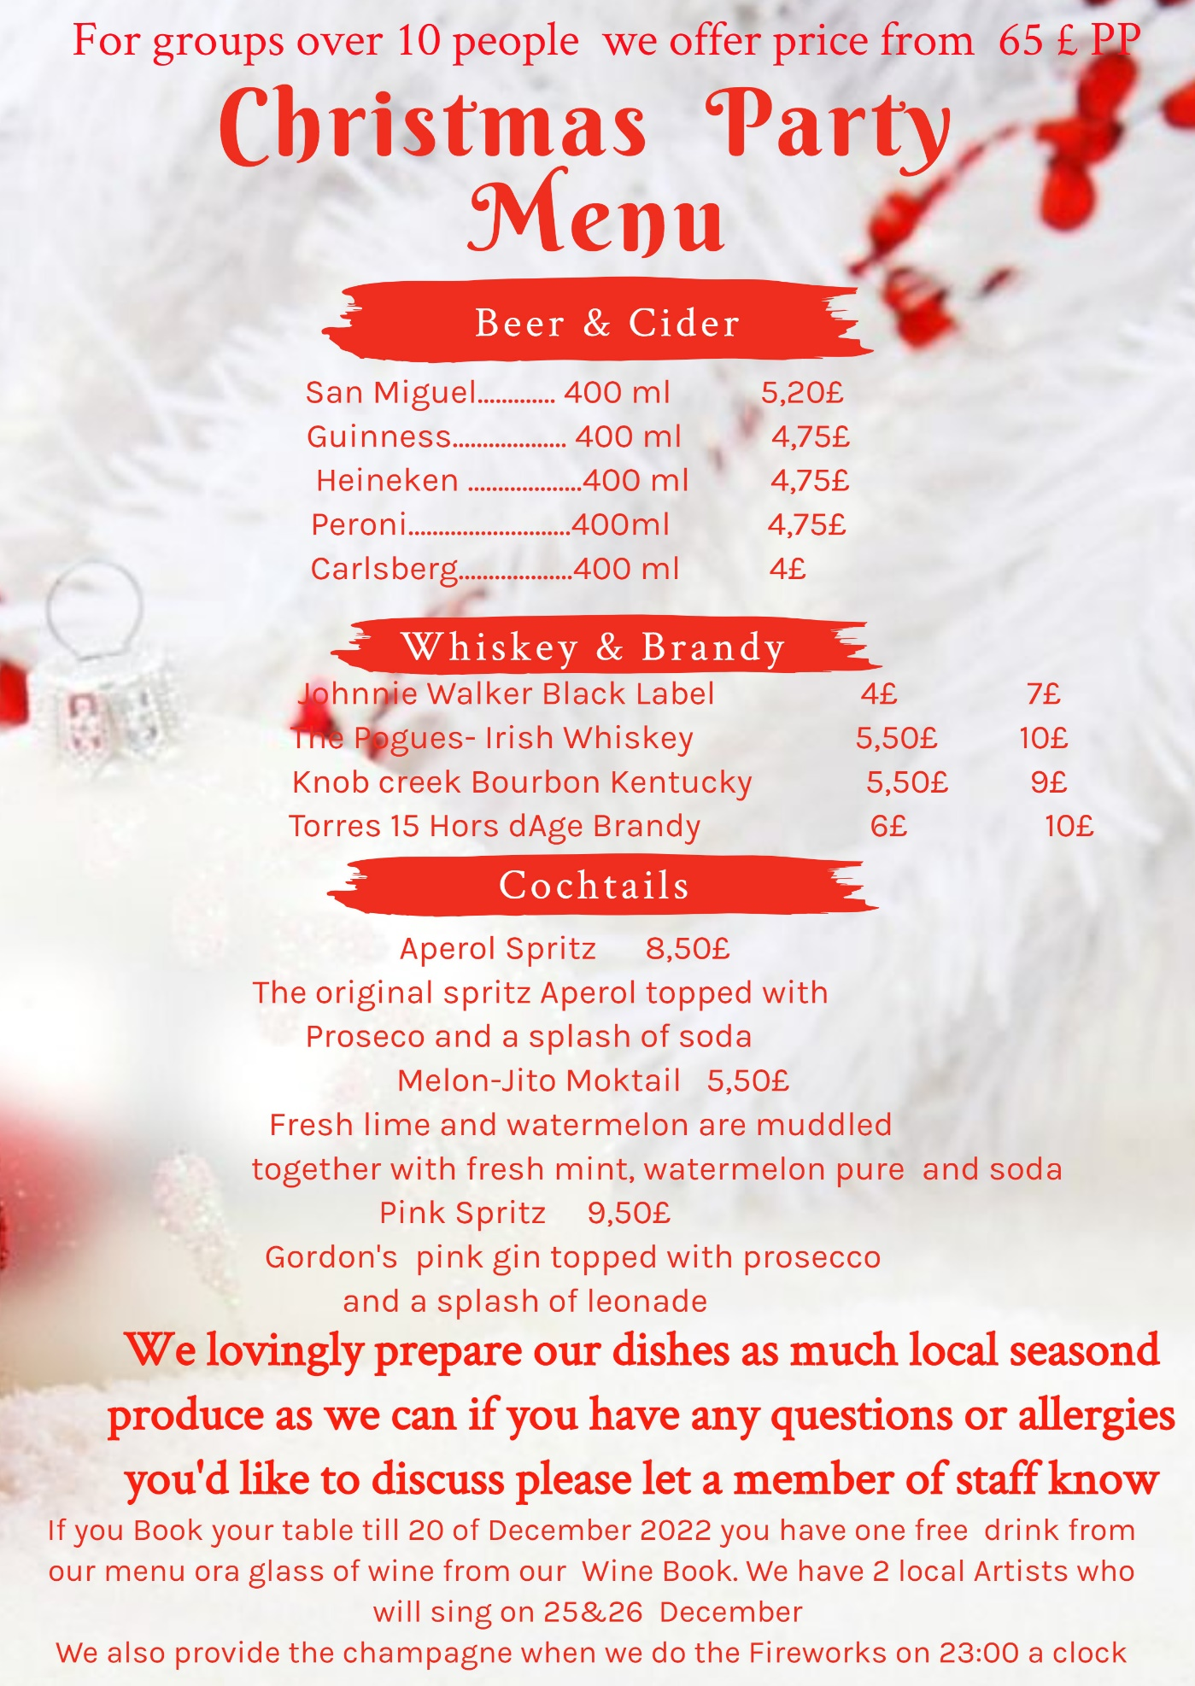

Reference
Bacon Beef Tenderloin with Cranberry Glaze Recipe: How to Make It (tasteofhome.com) (Accessed:16November2022)
Chocolate truffle & honeycomb torte recipe | BBC Good Food By Barney Desmazery (Accessed:16November2022)
Choc-cherry fudge torte with cherry sorbet recipe | BBC Good Food By Sarah Cook (Accessed:16November2022)
Christmas Goose Recipe - Great British Chefs By Marcus Wareing (Accessed:16November2022)
Celeriac, hazelnut & truffle soup recipe | BBC Good Food Sophie Godwin – Cookerry writer (Accessed:16November2022)
EDIT.org - online editor was used to made this templait (Accessed:16November2022)
Horseradish Beef Carpaccio with Tarragon and Grapes Recipe - Great British Chefs (Accessed:16November2022)
Jamie's Christmas curry | Vegetable recipes | Jamie Oliver recipes (Accessed:15November2022)
Oysters with apple & horseradish dressing recipe | BBC Good Food By Diana Henry (Accessed:13November2022)
Salmon Wellington with white wine cream sauce recipe - Recipes - delicious.com.au (Accessed:16November2022)
White forest meringue roulade recipe | BBC Good Food (Accessed:16November2022)
Japanese-Style Deep-Fried Shrimp Recipe (allrecipes.com) (Accessed:16November2022)

