8/10/2026
University of Wales Trinity Saint David
London campus
Module Name: Problem Solving and Systems Thinking
Module Code: ACCA4019_LON

Student Name: Yaroslav Tsyrul
Student ID: 2511421
Group: 4

Lecturer’s Name: Dr Amitave Banik

Optimising the Scheduling of Student Group Project Meetings

Table of Contents
1. Problem Deconstruction 2
1.1 Decomposing the problem 2
1.2 Prioritising requirements with the MoSCoW technique 2
1.3 Key variables of the problem 3
2. Proposed Solution and Explanation 3
2.1 Flowchart of the solution 4
2.2 Step-by-step explanation of the logic 4
2.3 Key assumptions 5
2.4 Justification of solution effectiveness 5
3. Reflection and Justification 6
3.1 Problem-solving techniques applied 6
3.2 Why the chosen approach is appropriate 6
3.3 Limitations and assumptions 7
References 7

1. Problem Deconstruction
Students on a college computing course struggle to organise regular group project meetings because members hold part-time jobs, follow different class timetables and have personal commitments. As the number of group members and constraints per member increases, the number of possible conflicts grows combinatorially, which is why manual, ad-hoc arrangement of meetings so often fails, causing missed deadlines and uneven workloads. To make the problem tractable, it is broken down here, following the principle that a complex task is best attacked by dividing it into smaller, independently solvable parts [1], [2].

1.1 Decomposing the problem
1. Collect individual constraints — for every student, the time blocks occupied by paid work, timetabled classes and personal commitments; these are 'hard' constraints that cannot be violated.
2. Build the shared availability space — compute the intersection of free time across every member, i.e. the periods during which all are simultaneously free.
3. Incorporate the project time dimension — anchor the meeting to the weekly deadline, so it occurs early enough for the group to act on its outcomes.
4. Account for workload — avoid multiple meetings for the same student in one period, or a meeting during a week of unusually high workload (e.g. an exam week).
5. Provide a fallback when no ideal solution exists — a contingency strategy (sub-groups, asynchronous collaboration), bounded by a limit on how many times it may be attempted before the case is escalated.
Items 1 and 2 concern data collection; items 3 and 4 act as filtering constraints; item 5 is the contingency mechanism invoked when no formal solution is available.

1.2 Prioritising requirements with the MoSCoW technique
To separate mandatory conditions from desirable refinements, the MoSCoW technique has been applied. It was devised by Clegg at Oracle for rapid application development [3] and later adopted by the Dynamic Systems Development Method, through which it became established in agile practice [4]. MoSCoW groups requirements into Must have, Should have, Could have and Won't have, letting a project team agree unambiguously on what is essential and what may be deferred [4], [5]. It is preferred here over a simple high/medium/low classification because its category boundaries are better suited to a time-constrained weekly deadline [5].
MoSCoW category | Requirement / constraint
Must have | The solution shall account for 100% of each member's fixed work-shift and timetable commitments; no meeting shall overlap a class or paid shift; every meeting shall be scheduled early enough to leave adequate time before the deadline [4], [5].
Should have | Negotiation rounds needed to agree a time should be minimised; personal commitments should be accommodated where possible; meeting load should be distributed evenly so no member is repeatedly inconvenienced.
Could have | Automated reminders; several alternative slots offered for selection; individual 'productivity window' (morning/evening) preferences taken into account.
Won't have | Integration with employers' work-rota systems; automatic alteration of a student's paid-work shifts; unattended, fully automatic resolution of an unresolved schedule — the procedure escalates to a tutor instead.

1.3 Key variables of the problem
The following variables formalise the problem for the solution logic in Section 2, following the general structure of a constraint satisfaction problem (CSP), in which a value is assigned to each variable from a finite domain so that all constraints are satisfied [6], [7]
Variable | Description and role in the model
Student availability (Ai) | Time intervals when student i is free from classes, paid work and personal commitments.
Work-shift constraint | Fixed blocks of paid employment; the least negotiable constraint in the model.
Personal commitments | A softer, negotiable constraint such as household or family duties.
Project deadline (D) | The date by which the weekly deliverable is due.
Deadline buffer (B) | Minimum interval required between a meeting and D so agreed actions can be completed.
Workload (Wi) | The number of other commitments student i already has that week.
Candidate slot (Sk) | A time interval formed as the intersection of every member's availability Ai.
Slot score | A ranking of a candidate by overlap size, proximity to D and workload evenness.
Relaxation counter (r) and limit (r_max) | Records constraint relaxations in the current cycle, capped at a pre-agreed limit r_max.

These variables are the minimum data set needed to determine whether a common time exists and whether it is acceptable given the deadline and workload, and form the basis of Section 2.

2. Proposed Solution and Explanation
The proposed solution is an algorithmic procedure — implementable as a lightweight scheduling application, a shared spreadsheet with a script, or a scheduling bot — that reconciles members' constraints, generates candidate meeting slots, checks each against the Must-have criteria from Section 1, and selects the optimal time. The logic is presented as a flowchart (Fig. 1), produced with a diagramming tool comparable to draw.io or Microsoft Visio. Following flowchart convention, input/output activities are drawn as parallelograms and processing steps as rectangles.

2.1 Flowchart of the solution
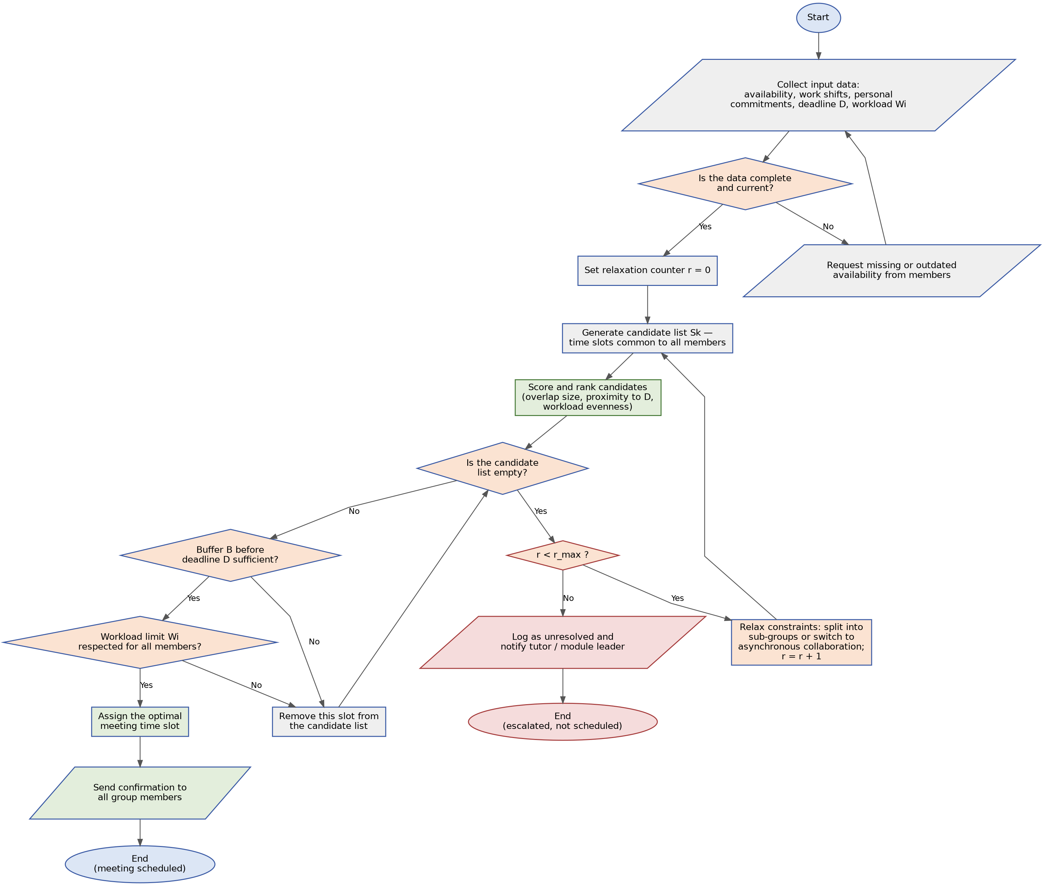
Fig. 1. Flowchart of the meeting-scheduling optimisation logic, showing the data-validation loop, the bounded relaxation cycle and the two distinct terminators.

2.2 Step-by-step explanation of the logic
1. Start. Triggered whenever the group needs its next meeting, e.g. weekly or ahead of a milestone.
2. Collect input data. Each member's availability Ai, work shifts, personal commitments, deadline D and workload Wi are gathered.
3. First decision point — 'Is the data complete and current?'. Added to stop outdated availability entries silently producing a schedule that is formally valid but practically unworkable (see 2.3).
• 'No': the system requests missing/outdated availability and returns to data collection.
• 'Yes': the procedure continues.
4. Initialise the relaxation counter r = 0. Together with a pre-agreed maximum r_max, this guarantees the procedure cannot loop indefinitely (see 2.3).
5. Generate candidate list. The intersection of all availability intervals produces candidate slots Sk that are, in principle, free for every member.
6. Score and rank candidates. Each candidate slot Sk (Section 1.3) receives a score combining three components: the size of the availability overlap, since more overlap gives the group flexibility if a member's plans shift; proximity to the deadline D, since an earlier slot leaves more time to act on what is agreed; and evenness of workload Wi, since a slot that avoids overloading any one member is preferred. These three were chosen because they map directly onto the brief's three objectives — a workable time, fewer conflicts, and meeting the deadline — rather than being an arbitrary weighting, and the highest-scoring candidate is tested first, so 'the best-ranked candidate' in later steps is always well defined.
7. Second decision point — 'Is the candidate list empty?'.
• 'Yes': a third decision point, 'r < r_max?', is checked. If not reached, constraints are relaxed: the group is offered a split into sub-groups of at least two members able to meet, rather than a single member acting alone, or a move to asynchronous collaboration; r is incremented, and the procedure returns to candidate generation. A counter was chosen over a fixed timeout because relaxation is measured in discrete search attempts, not elapsed clock time, so the limit ties directly to how many times a slot has actually been sought rather than to how long that search took. If r_max is reached, the case is logged as unresolved, the tutor is notified, and the procedure ends at 'escalated, not scheduled'.
• 'No': the top-ranked candidate is tested against the deadline buffer.
8. Fourth and fifth decision points — 'Is buffer B before D sufficient?' and 'Is workload limit Wi respected for all members?'. These are tested as two separate conditions rather than one, so whichever constraint rejects a candidate can be identified from the path taken.
• Either check fails: the slot is dropped and control returns to the second decision point.
• Both pass: the slot is accepted.
9. Assign the slot and send a confirmation to all members.
10. End (meeting scheduled) — a terminator distinct from the escalation reached in step 7, so the two outcomes are always visibly different.

2.3 Key assumptions
• Data validation confirms availability is complete and current, not that it is truthful; students are assumed to report constraints honestly.
• Work shifts and classes are hard constraints (Must have); personal commitments are softer and more negotiable (Should have).
• The deadline buffer B is a fixed value agreed in advance (e.g. no less than two days), not recalculated per task.
• The relaxation limit r_max is a fixed, pre-agreed number of attempts, beyond which manual tutor intervention is required.
• Sub-groups or asynchronous collaboration are an acceptable fallback, provided this is agreed with the group in advance.

2.4 Justification of solution effectiveness
The logic addresses the three stated objectives concurrently. A suitable meeting time is found through the intersection of every member's availability: any slot chosen is feasible for all members, not merely a majority — the central principle of constraint satisfaction approaches to scheduling [6], [7]. Timetable conflicts are minimised through the sequential filtering at the buffer and workload decision points, eliminating unsuitable candidates one at a time and recording which constraint caused each rejection, an approach well established as reliable in bounded solution spaces [6]. Deadlines are met through the explicit buffer check B, echoing the finding that frameworks like MoSCoW work because they force teams to reconcile competing constraints against a fixed delivery date [4], [5]. The relaxation counter r and its limit r_max guarantee the procedure cannot loop indefinitely: every path leads either to a scheduled meeting or a logged escalation.

3. Reflection and Justification

3.1 Problem-solving techniques applied
Two interrelated techniques were applied. The first is decomposition: the broad problem of 'getting the group together' was broken into five bounded, independently solvable components, following the computational-thinking process of breaking a complex problem into smaller, manageable parts for effective analysis [2], [8]. This avoided a single monolithic algorithm, letting each part of the logic be built and checked in turn, including the validation step and termination guarantee added once earlier gaps were identified.
The second technique is abstract thinking. Concrete constraints — a café shift on Tuesdays, an evening training session, a Friday deadline — were translated into generalised variables (Ai, D, B, Wi, Sk, r, r_max), simplifying away irrelevant detail so the problem's essential structure could be represented and reused [1], [2]. This let the solution be expressed as a structure that works regardless of group size or specific timetables.
The solution also formalises conditional logic as explicit decision points and uses an iterative loop, where a failed candidate returns to an earlier step rather than ending the process — a pattern from constraint satisfaction and backtracking search [6], [7], detailed further in Section 2.2.

3.2 Why the chosen approach is appropriate
The approach is appropriate for three reasons. Decomposition reduces cognitive load, turning one hard question into simpler ones so a constraint is less likely to be overlooked. Applying MoSCoW separates what the solution cannot function without from what is merely a refinement, consistent with evidence that it helps teams manage scope under time pressure [4], [5]. Representing the logic as a flowchart with single-purpose decision points makes it transparent: a reader can trace a situation to a labelled outcome without inspecting implementation detail.
Alternatives were considered and rejected. Doodle and When2Meet collect availability efficiently but have no concept of a deadline or workload, so cannot enforce this brief's buffer and workload checks. A weighted-optimisation model could rank candidates more finely than the deterministic filter used here, but its reasoning is opaque, whereas students need to see why a time was chosen [6]. A fully manual negotiation model is the most flexible option but does not scale as group size and constraints grow — the same combinatorial problem identified in Section 1.
The system also shows behaviour decomposition alone does not capture. A missed meeting leaves that week's tasks unclosed; unclosed tasks raise workload Wi next week; a higher Wi makes the workload check reject more candidates; fewer slots make the group harder to schedule the week after. The algorithm evaluates each week in isolation and never sees this feedback loop — a property of the group as a whole, and the essential claim of a systems-thinking view [9].

3.3 Limitations and assumptions
The solution has notable limitations. Data validation confirms availability is complete and current, not accurate, so a student who misreports rather than forgets to update still receives a result that is formally correct but impractical. The buffer B and relaxation limit r_max are fixed, though the appropriate buffer may vary with task complexity and attempts may vary between groups. Reaching the relaxation limit escalates to a tutor rather than resolving automatically — a deliberate choice to guarantee termination, but one that reduces the group's control exactly where scheduling is hardest. The model also has no memory between cycles, so cannot track the Section 3.2 feedback loop, where a missed meeting raises next week's workload and further limits later slots. Finally, the relaxation branch is a compromise that may reduce group interaction and should be a fallback, not a primary mode.
Ranking personal commitments below paid work (Section 2.3) is a design decision, not an objective hierarchy: childcare or care for a sick relative can be no less rigid than a café shift. The logic is best suited to small groups of three to six members with regularly updated availability data and buffer/relaxation values agreed in advance.

References

[1] | J. M. Wing, “Computational thinking,” Communications of the ACM, vol. 49, no. 3, pp. 33-35, 2006.
[2] | T.-T. Wu, A. Asmara, Y.-M. Huang and I. Permata Hapsari, “Identification of Problem-Solving Techniques in Computational Thinking Studies: Systematic Literature Review,” SAGE Open, vol. 14, no. 2, pp. 1-20, 2024.
[3] | D. Clegg and R. Barker, Case Method Fast-Track: A RAD Approach, Wokingham: Addison-Wesley, 1994.
[4] | Agile Business Consortium, “MoSCoW Prioritisation,” 2023. [Online]. Available: https://www.agilebusiness.org/resource/what-is-moscow-prioritisation.html. [Accessed 10 August 2026].
[5] | A. Ali, Y. Hafeez, S. Hussain and S. Yang, “Role of Requirement Prioritization Technique to Improve the Quality of Highly-Configurable Systems,” IEEE Access, vol. 8, pp. 27549-27573, 2020.
[6] | E. Tsang, Foundations of Constraint Satisfaction, London: Academic Press, 1993.
[7] | A. Schaerf, “A Survey of Automated Timetabling,” Artificial Intelligence Review, vol. 13, no. 2, pp. 87-127, 1999.
[8] | OpenStax, “Computational Thinking,” in Introduction to Computer Science, Houston, TX, OpenStax, 2024.
[9] | P. Checkland, Systems Thinking, Systems Practice: Includes a 30-Year Retrospective, Chichester: Wiley, 1999.

