Alin Raducan
2522566
Computer Architecture and Operating Systems (ACCA4022_BIRM)

Introduction
This report provides a comprehensive exploration of operating systems, divided into several key sections. It begins by outlining the key functions of general-purpose operating systems, moving into practical demonstrations of command-line interface (CLI) commands for both Windows and Linux environments. The report also showcases the creation of simple automation scripts for both operating systems. Through this investigation, the report aims to demonstrate a foundational understanding of operating system concepts, CLI proficiency, and the practical application of scripting for system automation, supported by relevant screenshots and cited sources.
Key Functions of General Operating Systems
In modern operating systems, process management is not merely about launching and closing programs; it is an incredibly complex orchestration of system resources managed by the CPU scheduler . Because CPUs can execute instructions at lightning speeds, the operating system uses scheduling algorithms to determine which process gets access to the processor core and for how long.
In non-preemptive scheduling, a process retains CPU control until it terminates or enters a waiting state. In contrast, modern preemptive scheduling allows the operating system to interrupt a currently running process to allocate the CPU to another task, ensuring high responsiveness in multi-user environments. Algorithms such as Round Robin (RR) use a designated time quantum to slice execution cycles fairly among threads, while Shortest Job First (SJF) minimizes average waiting times by prioritizing shorter tasks.
Furthermore, the OS must handle the complications of concurrent execution. When multiple processes access shared resources or memory addresses simultaneously, race conditions can occur. To prevent data corruption, operating systems implement synchronization primitives such as semaphores and mutexes (mutual exclusion locks) to ensure that only one process can access a critical section of memory at any given time.
Advanced Memory Management: Paging, Segmentation, and Virtual Memory
While basic memory management allocates block spaces to active programs, advanced operating systems decouple physical hardware addresses from logical software addresses using virtual memory systems. This architectural virtualization is governed by the Memory Management Unit (MMU) of the CPU, working in close synchronization with the operating system kernel.
The most prevalent memory allocation technique is paging. In paging, physical memory is split into fixed-size blocks called frames, and logical memory is split into program blocks of the equal size called pages. When a program executes, its pages are mapped to available frames anywhere in physical RAM using a page table. This eliminates external fragmentation—where memory is wasted in gaps between non-contiguous allocations.
To expand RAM capacity, the operating system utilizes a technique known as demand paging, where pages are only loaded into physical memory when they are actively needed. If a process requests a page that is not currently residing in physical RAM, the hardware issues a page fault. The OS intercepts this interrupt, retrieves the missing page from disk storage (swap space), and loads it into a physical memory frame. If RAM is full, the OS implements page-replacement algorithms like Least Recently Used (LRU) to write inactive pages back to the disk, dynamically balancing physical performance with storage limits.
Storage Hierarchy and File System Structures
Operating systems structure storage devices into logical abstractions to hide the physical complexities of spinning platters, magnetic domains, and silicon cells. This abstraction is achieved through different file systems, such as New Technology File System (NTFS) on Windows, and Extended File System (ext4) on Linux.
The OS organizes storage hierarchically, beginning with physical sector addressing and mapping it to logical blocks. A file system relies on structure tables to track metadata, permissions, ownership, and cluster allocations. For instance, Windows NTFS uses a Master File Table (MFT) as a database containing metadata for every file and folder. Conversely, Linux systems rely on inodes (index nodes). An inode stores all essential information about a file—such as file size, access permissions, creation timestamps, and direct/indirect block pointers—except for the actual filename itself, which is kept in directory lists.
Furthermore, modern file systems utilize journaling to protect data integrity. By recording changes in a dedicated journal log before committing them to the physical directory structure, the operating system can quickly reconstruct and repair the file system in the event of an unexpected power failure or system crash.
Hardware Interfacing and Device Driver Architecture
At the lowest abstraction layer, the operating system acts as an intermediary bridge between application software and highly varied physical hardware architectures. Because it is impossible for an OS kernel to natively support every third-party component, it utilizes modular programs called device drivers.
Drivers translate generic system instructions (such as "read block") into hardware-specific signals required by physical controllers. Communication between the CPU and hardware controllers is managed via I/O ports, Direct Memory Access (DMA), and interrupts. When a peripheral needs attention, it sends an interrupt request (IRQ) to the CPU. The OS immediately pauses current executions and calls the appropriate Interrupt Service Routine (ISR) to handle the hardware request, maintaining flawless system responsiveness.

General-purpose operating systems (OS) serve as the fundamental software layer that manages computer hardware and software resources, providing common services for computer programs. The key functions of these systems include process management, memory management, file system management, device management, and providing a user interface. These functions ensure that the system runs efficiently and that applications can operate without needing to interact directly with the hardware.
Process management involves the creation, scheduling, and termination of processes, which are the instances of running programs. The OS allocates system resources like CPU time and memory to these processes, ensuring fair and efficient execution. Memory management handles the allocation and deallocation of memory space to processes, including virtual memory management, which allows the system to use disk space to extend the apparent amount of RAM available to applications.
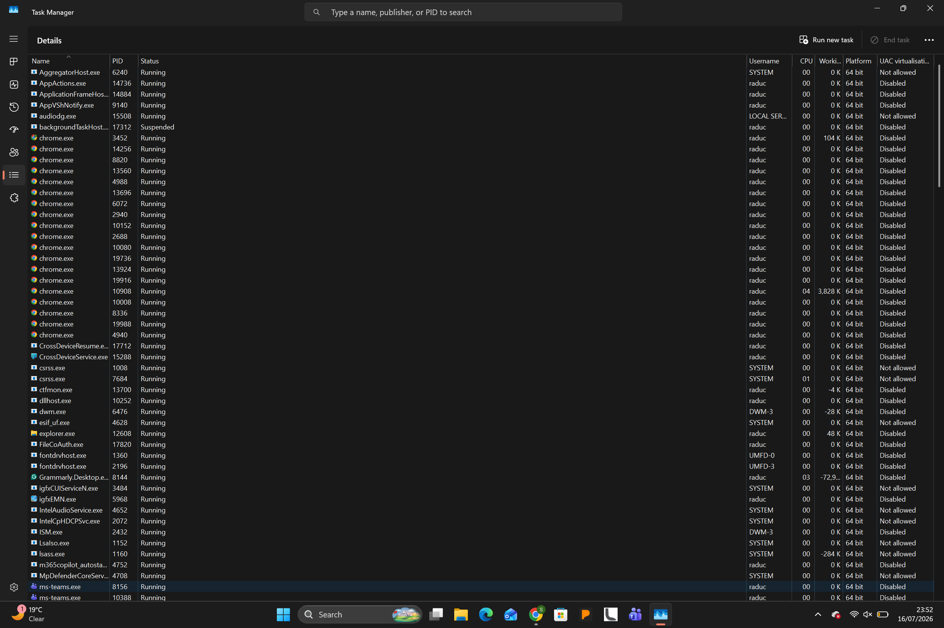

File system management provides a structured way to store, organize, and retrieve data on storage devices. It manages permissions, directories, and files, allowing users and applications to access data logically. Device management controls hardware peripherals like keyboards, mice, printers, and storage drives through device drivers, which act as translators between the hardware and the OS. A user interface, which can be graphical (GUI) or command-line (CLI), provides a means for users to interact with the computer system [1].
On a Windows system, many of these functions can be monitored and managed through the Task Manager. For instance, the "Processes" tab shows all running processes, their CPU and memory usage, providing a real-time view of process management. In the "Performance" tab, users can monitor overall CPU, memory, disk, and network utilization, offering insights into memory and device management. The "File Explorer" is a clear example of file system management, allowing users to navigate, create, and manage files and directories.
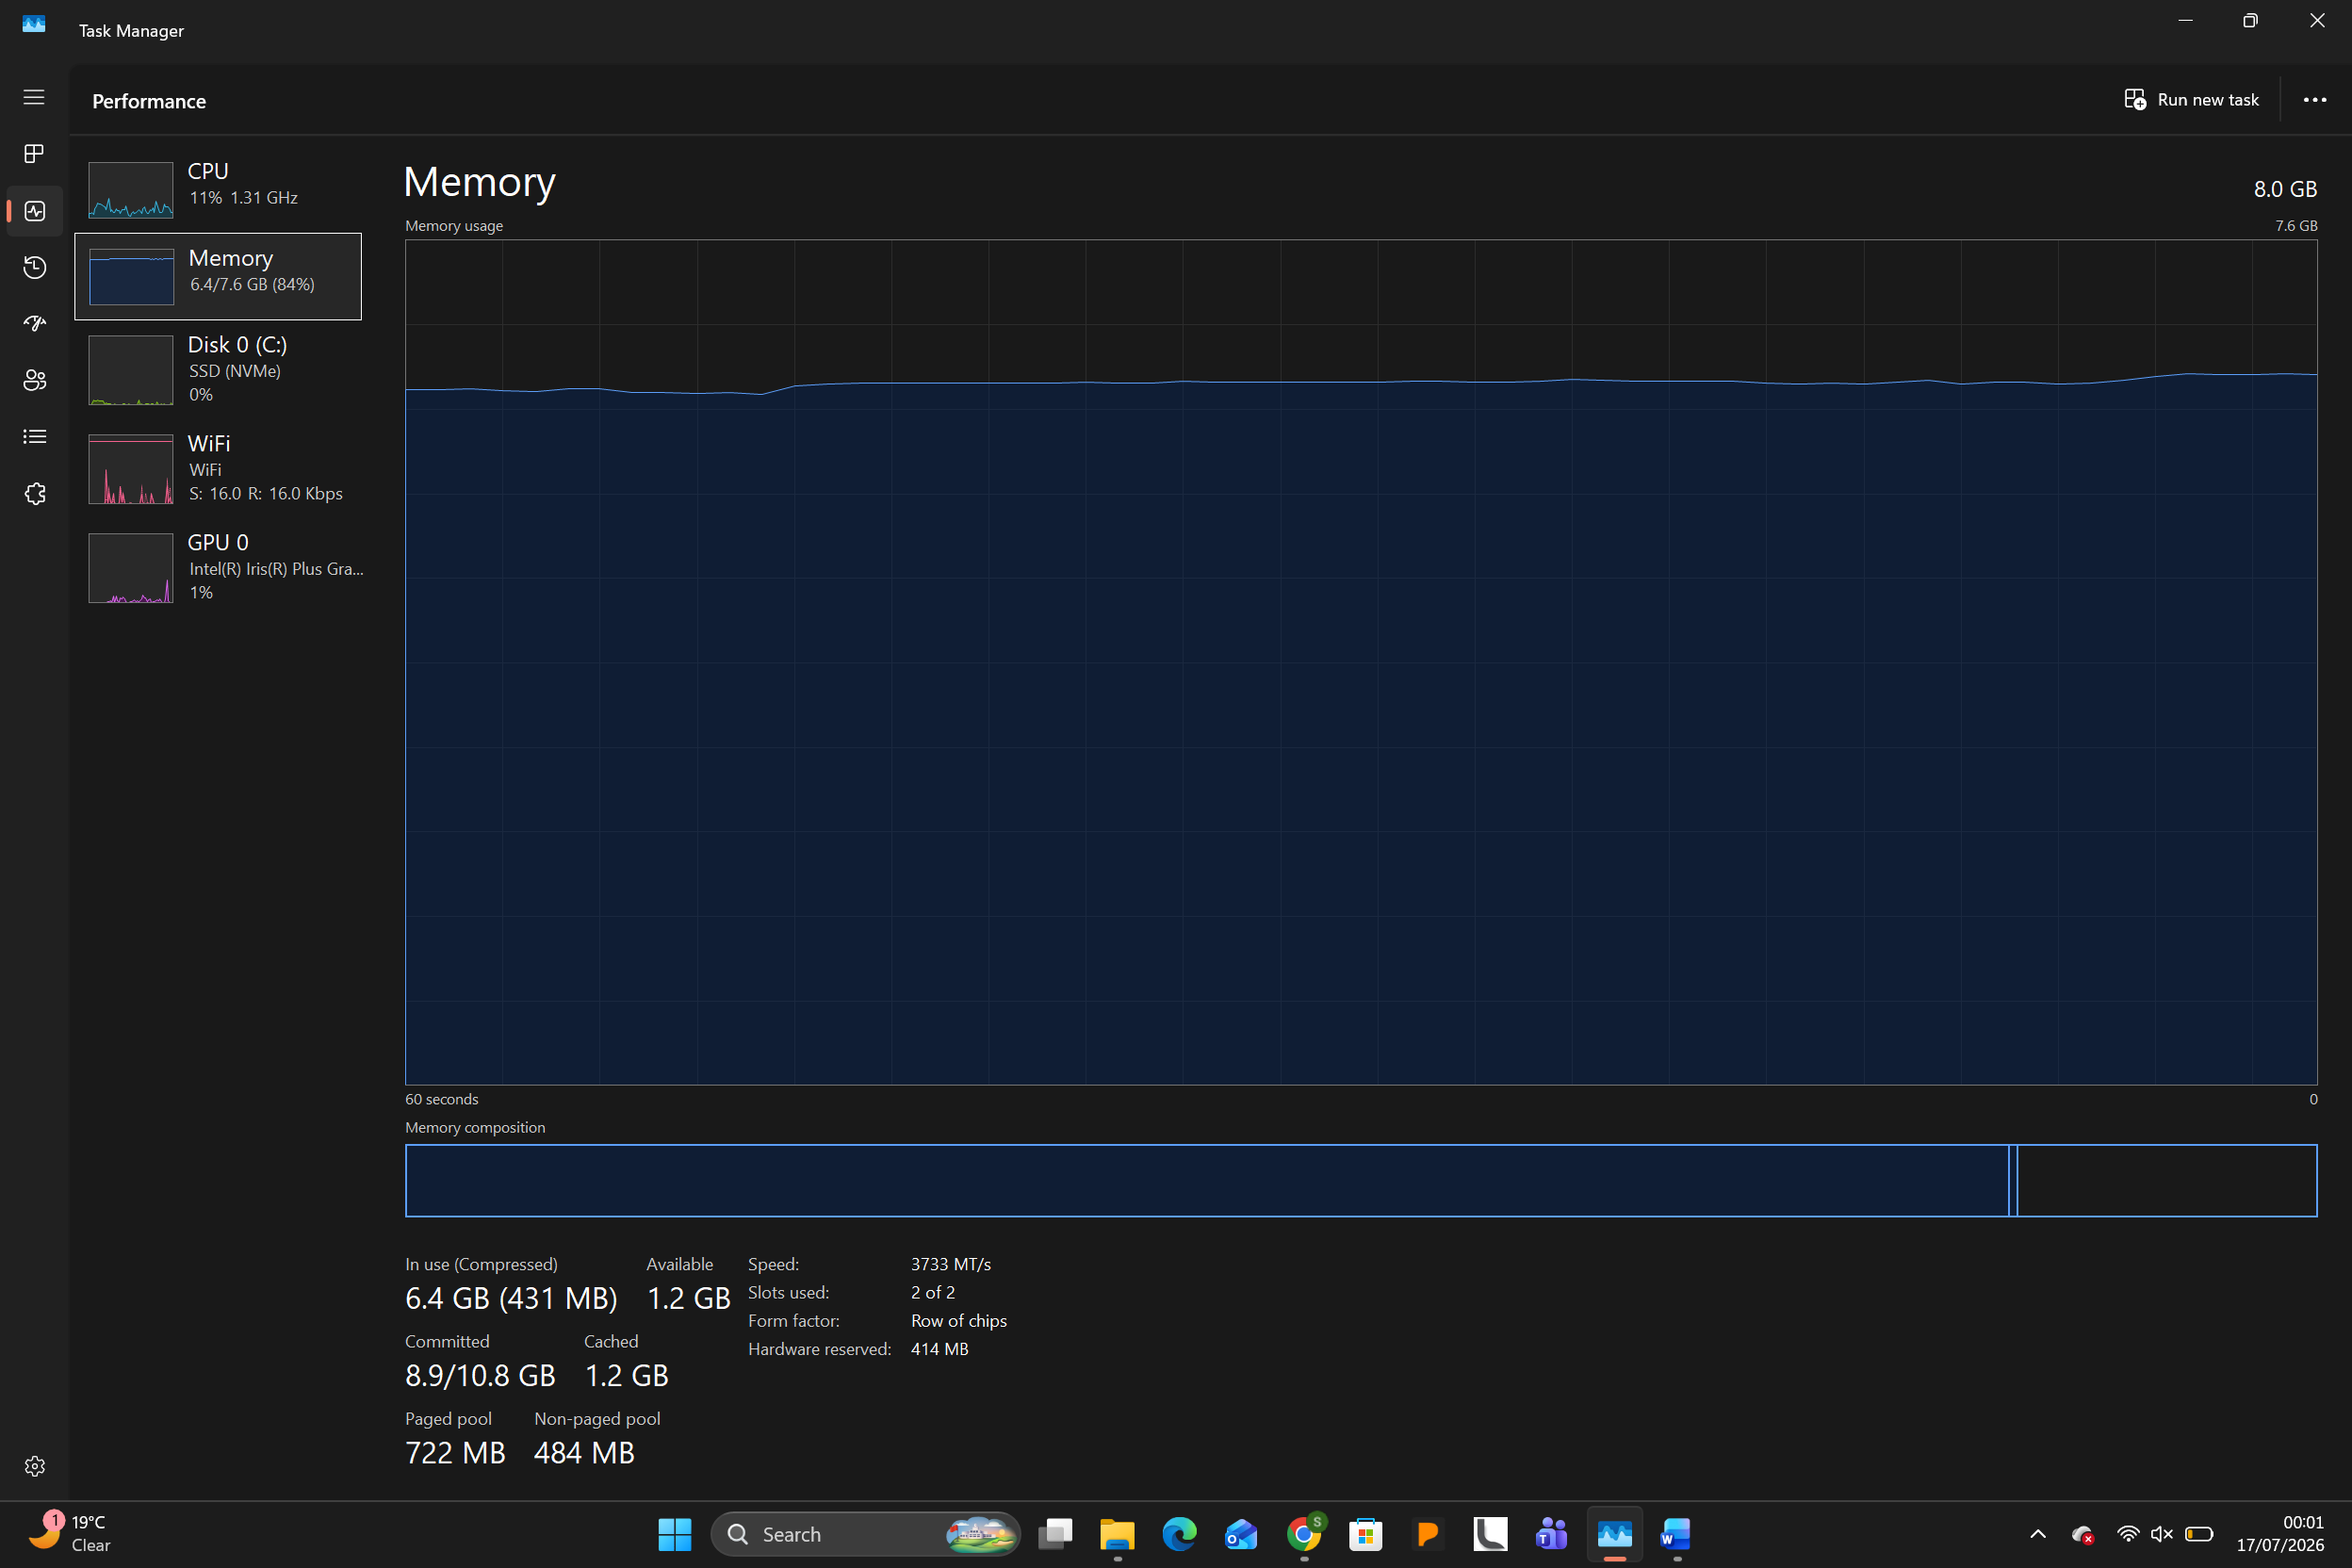

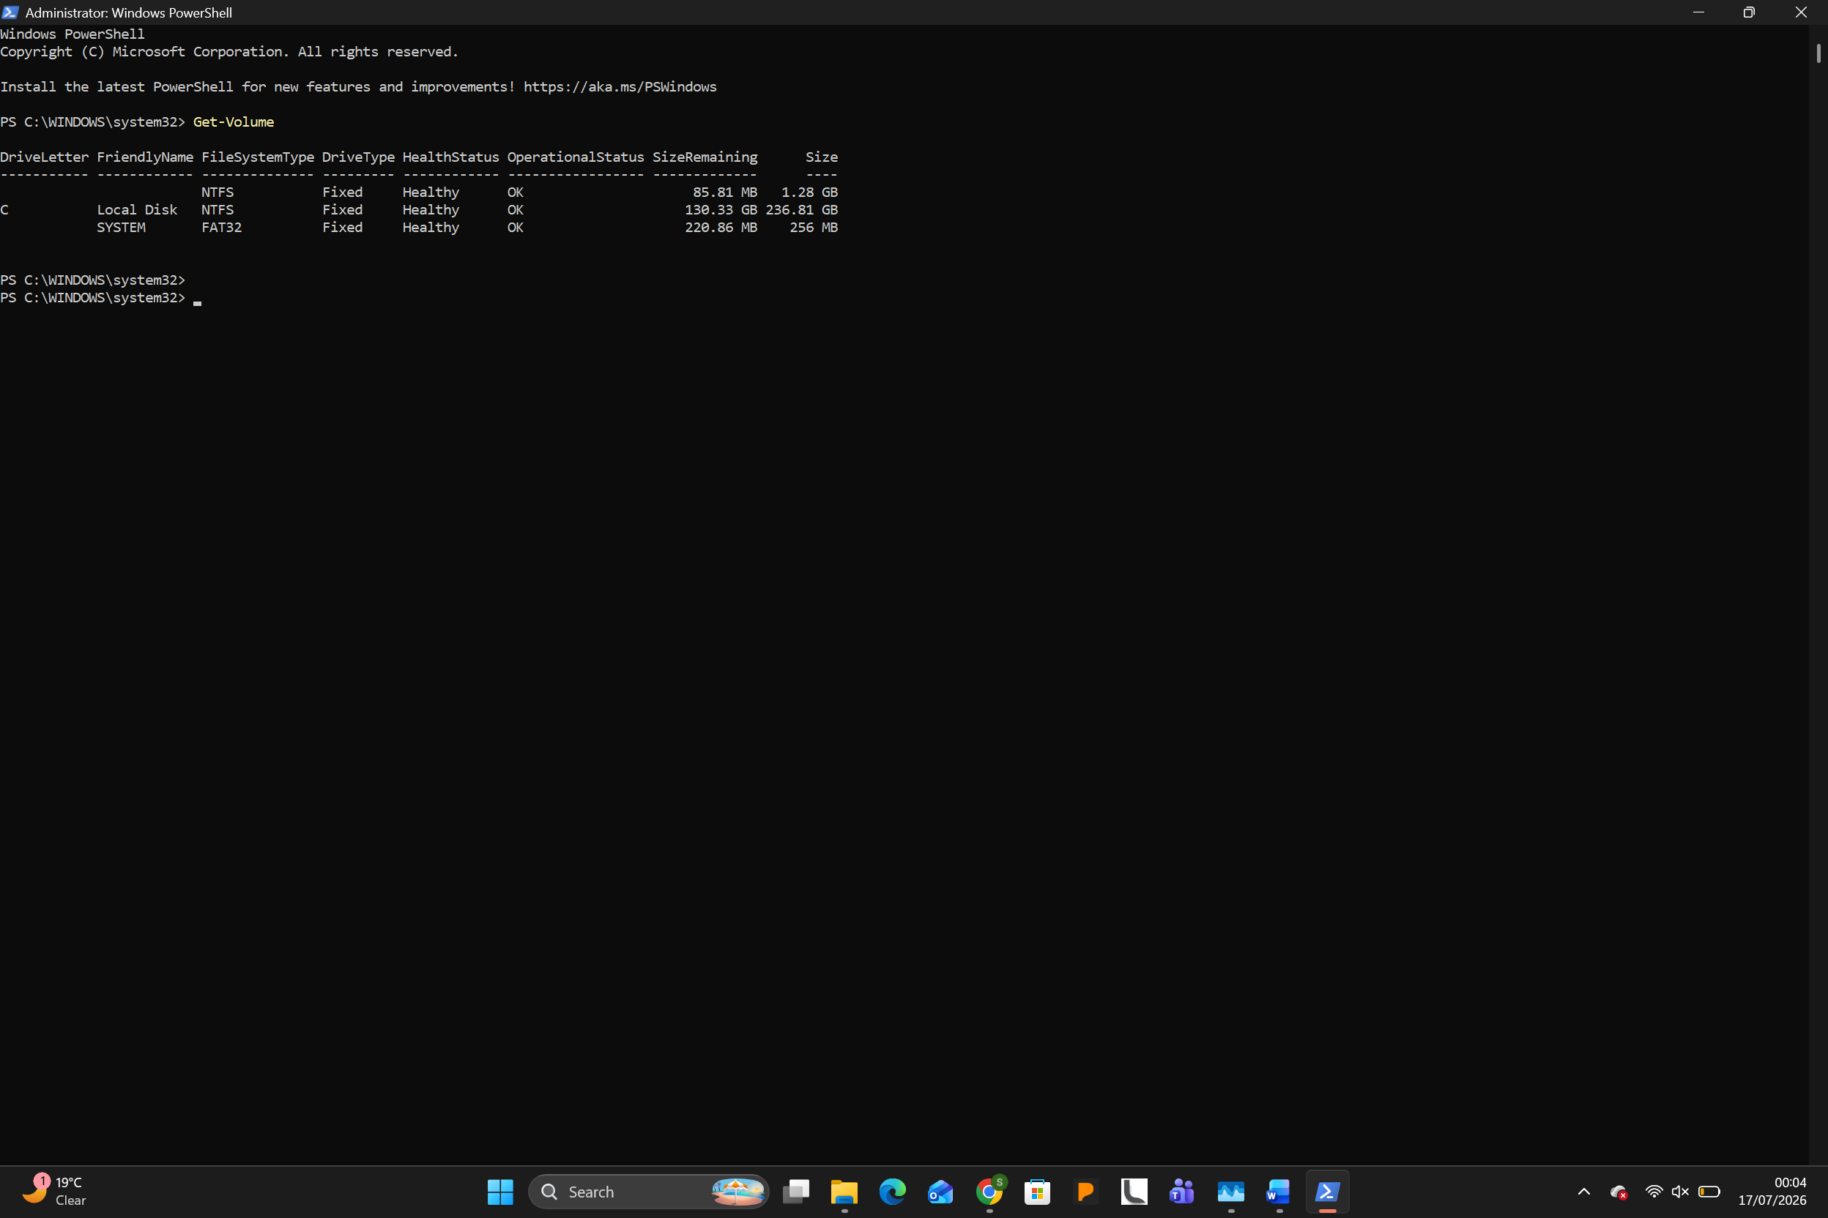

Similarly, on a Linux system, the top or htop commands provide a dynamic, real-time view of running processes and system resource usage, directly reflecting process and memory management. The lsblk command lists information about block devices, which is a function of device management, while commands like df and du are used for file system management, showing disk space usage and file space usage, respectively. The gnome-system-monitor application provides a GUI equivalent to Task Manager for monitoring and managing these key OS functions [2].
In modern operating systems, process management is not merely about launching and closing programs; it is an incredibly complex orchestration of system resources managed by the CPU scheduler. Because CPUs can execute instructions at lightning speeds, the operating system uses scheduling algorithms to determine which process gets access to the processor core and for how long.
In non-preemptive scheduling, a process retains CPU control until it terminates or enters a waiting state. In contrast, modern preemptive scheduling allows the operating system to interrupt a currently running process to allocate the CPU to another task, ensuring high responsiveness in multi-user environments. Algorithms
such as Round Robin (RR) use a designated time quantum to slice execution cycles fairly among threads, while Shortest Job First (SJF) minimizes average waiting times by prioritizing shorter tasks.
Furthermore, the OS must handle the complications of concurrent execution. When multiple processes access shared resources or memory addresses simultaneously, race conditions can occur. To prevent data corruption, operating systems implement synchronization primitives such as semaphores and mutexes (mutual exclusion locks) to ensure that only one process can access a critical section of memory at any given time.
While basic memory management allocates block spaces to active programs, advanced operating systems decouple physical hardware addresses from logical software addresses using virtual memory systems. This architectural virtualization is governed by the Memory Management Unit (MMU) of the CPU, working in close synchronization with the operating system kernel.
The most prevalent memory allocation technique is paging. In paging, physical memory is split into fixed-size blocks called frames, and logical memory is split into program blocks of the equal size called pages. When a program executes, its pages are mapped to available frames anywhere in physical RAM using a page table. This eliminates external fragmentation—where memory is wasted in gaps between non-contiguous allocations.
To expand RAM capacity, the operating system utilizes a technique known as demand paging, where pages are only loaded into physical memory when they are actively needed. If a process requests a page that is not currently residing in physical RAM, the hardware issues a page fault. The OS intercepts this interrupt, retrieves the missing page from disk storage (swap space), and loads it into a physical memory frame. If RAM is full, the OS implements page-replacement algorithms like Least Recently Used (LRU) to write inactive pages back to the disk, dynamically balancing physical performance with storage limits.
Operating systems structure storage devices into logical abstractions to hide the physical complexities of spinning platters, magnetic domains, and silicon cells. This abstraction is achieved through different file systems, such as New Technology File System (NTFS) on Windows, and Extended File System (ext4) on Linux.
The OS organizes storage hierarchically, beginning with physical sector addressing and mapping it to logical blocks. A file system relies on structure tables to track metadata, permissions, ownership, and cluster allocations. For instance, Windows NTFS uses a Master File Table (MFT) as a database containing metadata for every file and folder. Conversely, Linux systems rely on inodes (index nodes). An inode stores all essential information about a file—such as file size, access permissions, creation timestamps, and direct/indirect block pointers—except for the actual filename itself, which is kept in directory lists.
Furthermore, modern file systems utilize journaling to protect data integrity. By recording changes in a dedicated journal log before committing them to the physical directory structure, the operating system can quickly reconstruct and repair the file system in the event of an unexpected power failure or system crash.
At the lowest abstraction layer, the operating system acts as an intermediary bridge between application software and highly varied physical hardware architectures. Because it is impossible for an OS kernel to natively support every third-party component, it utilizes modular programs called device drivers.
Drivers translate generic system instructions (such as "read block") into hardware-specific signals required by physical controllers. Communication between the CPU and hardware controllers is managed via I/O ports, Direct Memory Access (DMA), and interrupts. When a peripheral needs attention, it sends an interrupt request (IRQ) to the CPU. The OS immediately pauses current executions and calls the appropriate Interrupt Service Routine (ISR) to handle the hardware request, maintaining flawless system responsiveness.

Use of Windows OS CLI Commands
The Windows Command Line Interface (CLI), primarily accessed via Command Prompt and PowerShell, provides powerful tools for system administration. This section documents several commands covering key areas of system management.
Process Management
tasklist displays a list of all currently running processes. Using the /v switch provides verbose output, showing details like the process name, PID, session name, and memory usage. This command is useful for identifying running applications and their resource consumption.
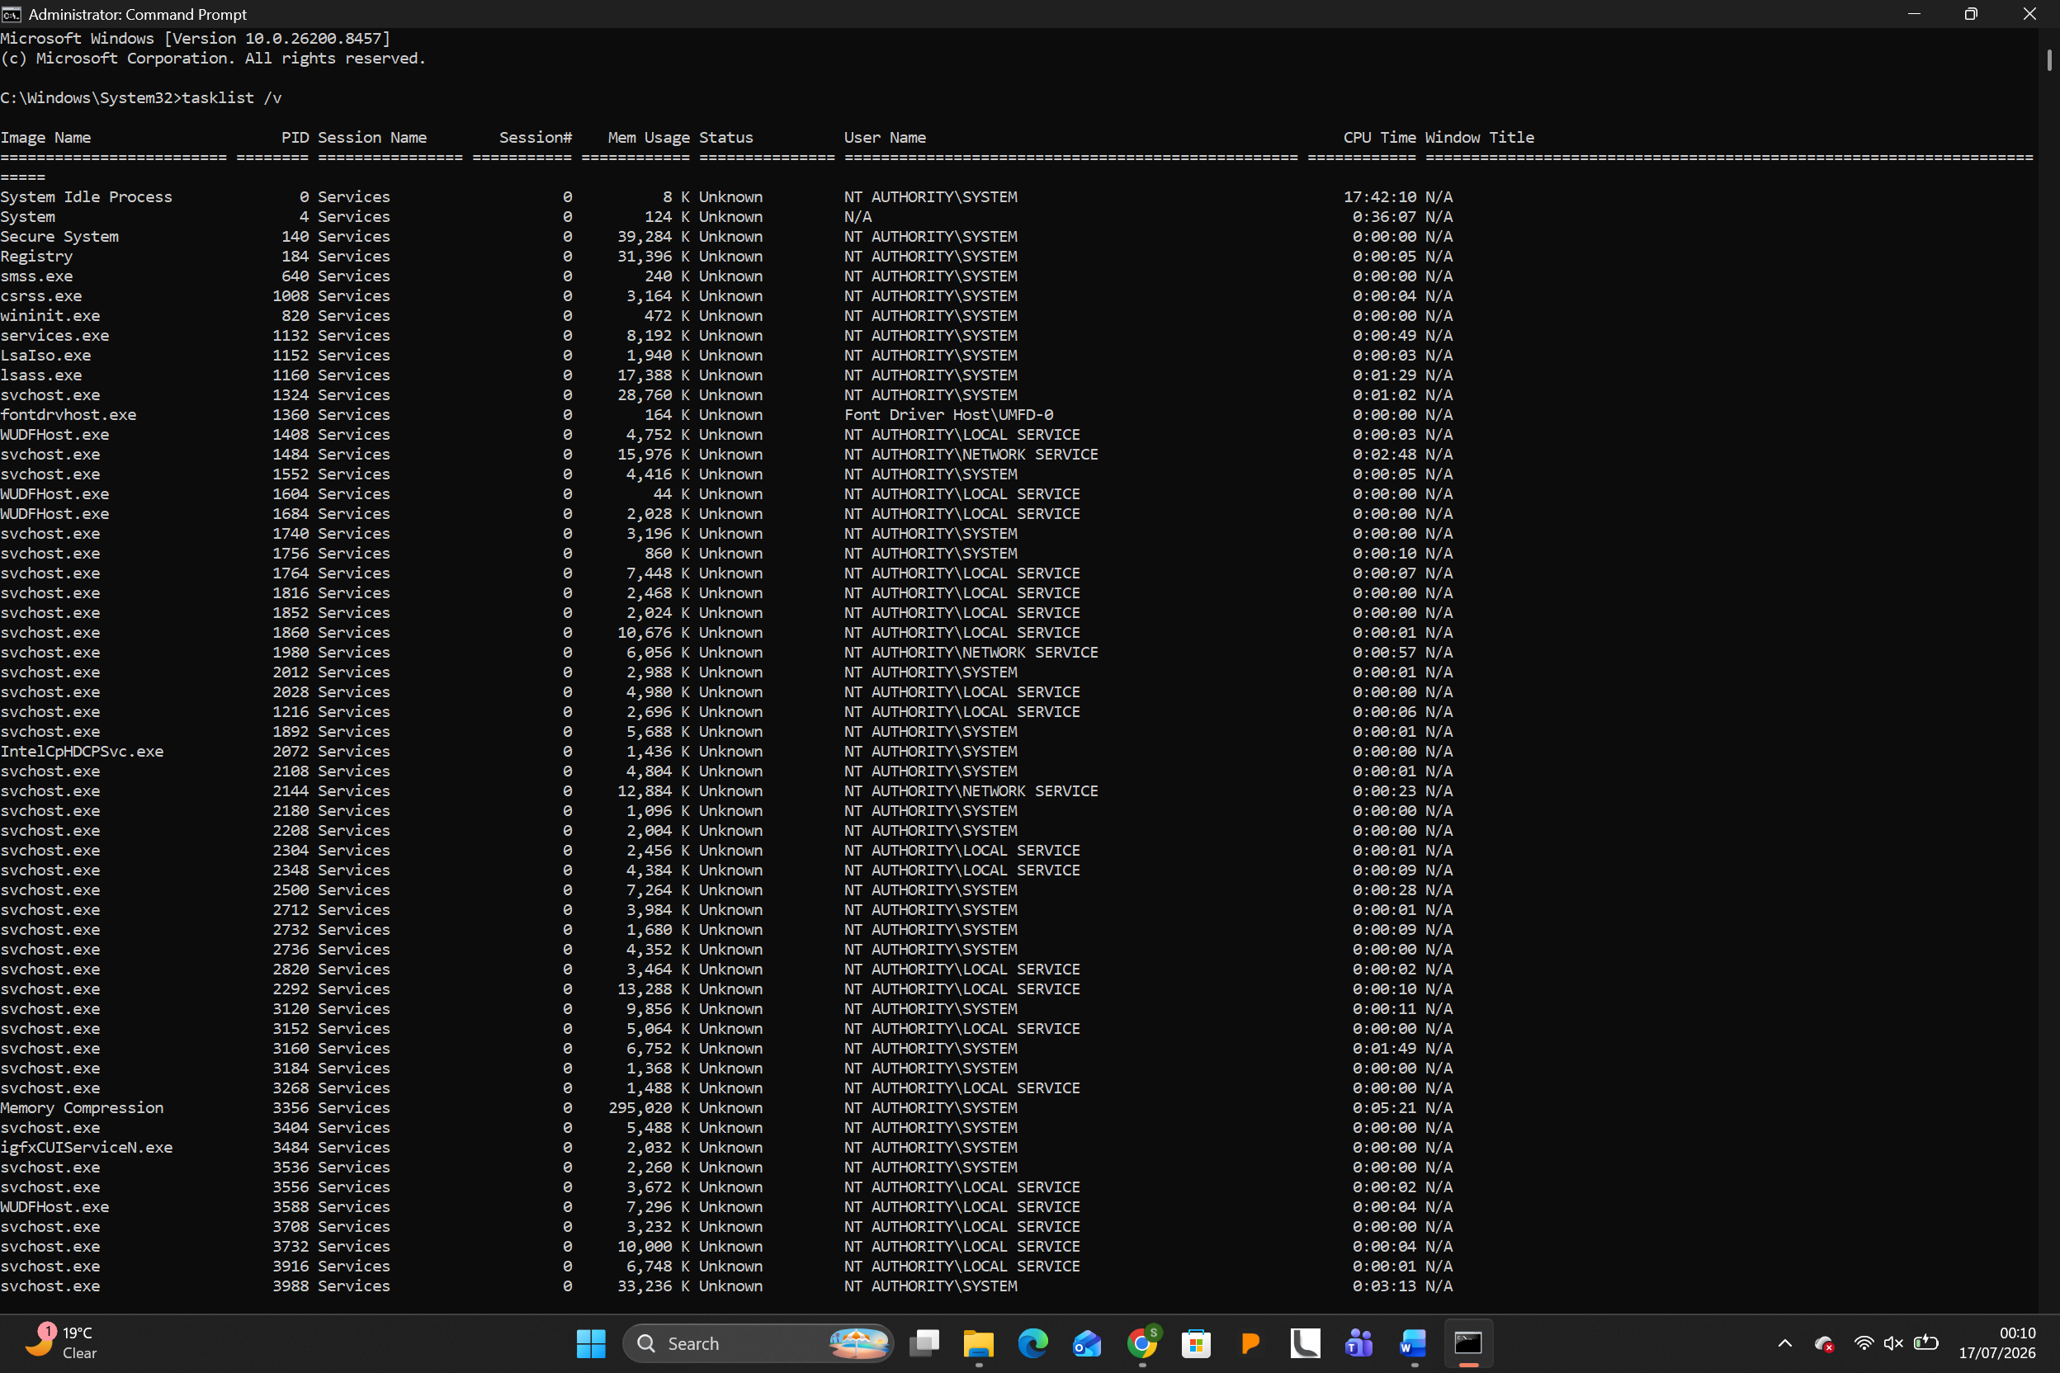
taskkill is used to terminate a running process, often by its Process ID (PID) using the /PID switch or by its image name using the /IM switch. For example, taskkill /IM notepad.exe /F forcibly terminates all instances of Notepad.
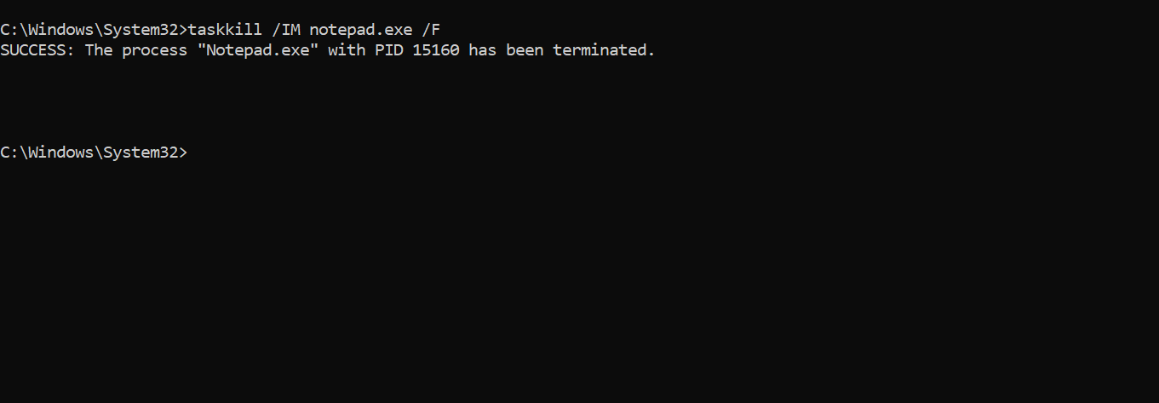
File & Directory Management
dir lists the contents of a directory. Using /w displays the list in wide format, and /s lists all files in the specified directory and all subdirectories. For example, dir C:\Users\ /s /w would list all files and folders in the Users directory recursively.
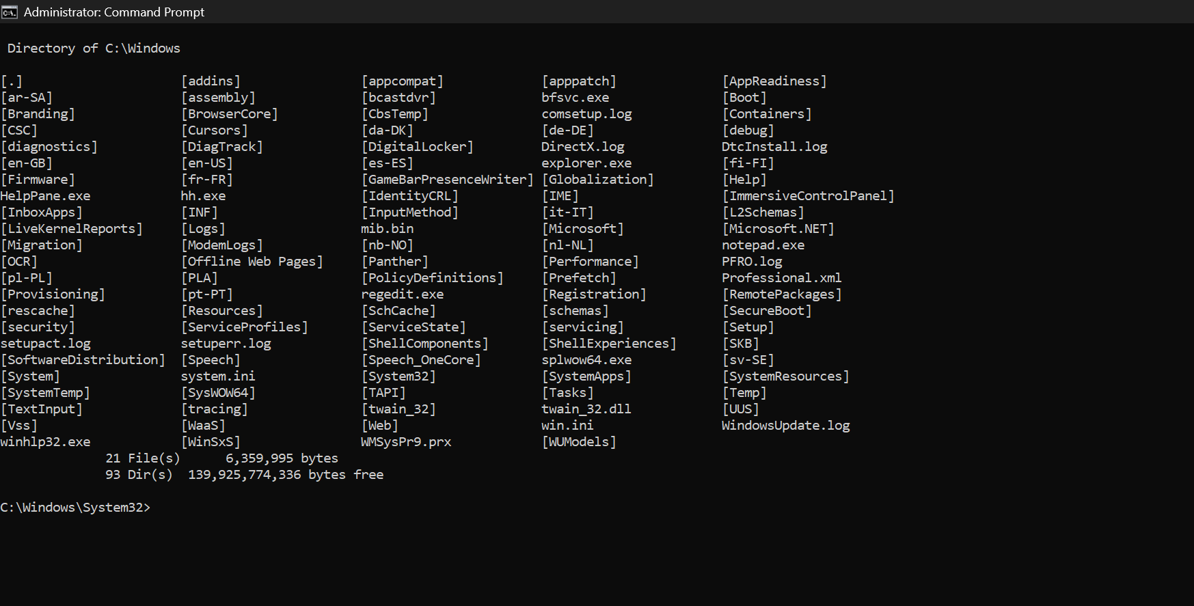
mkdir (md) creates a new directory. For instance, mkdir NewFolder creates a folder named "NewFolder" in the current directory. del deletes one or more files, while rmdir removes a directory (which must be empty unless the /s switch is used).
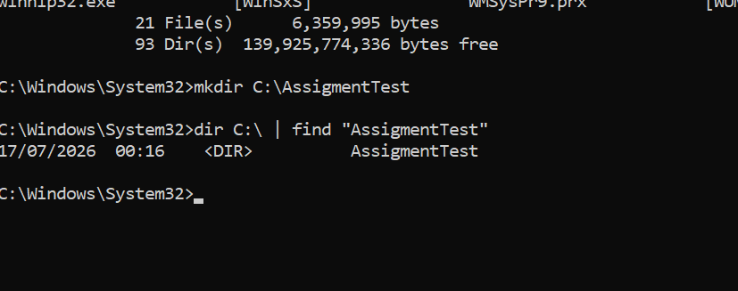
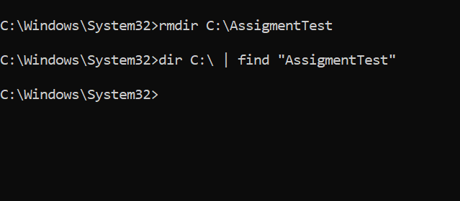
Network Testing/Monitoring
ping tests the reachability of a host on an Internet Protocol (IP) network. The -t switch continues pinging the target until stopped manually, which is useful for monitoring

network stability over time. For example, ping -t google.com will continuously test connectivity to Google.
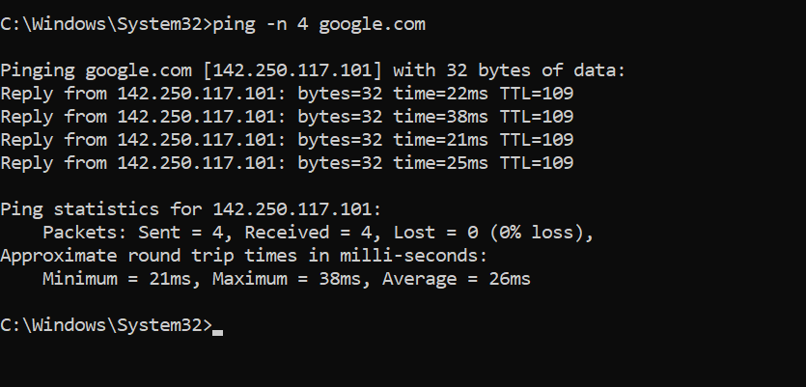

ipconfig displays the IP configuration for all network adapters. The /all switch provides detailed information including MAC addresses, DHCP status, and DNS servers for every network interface, which is essential for network troubleshooting [3].
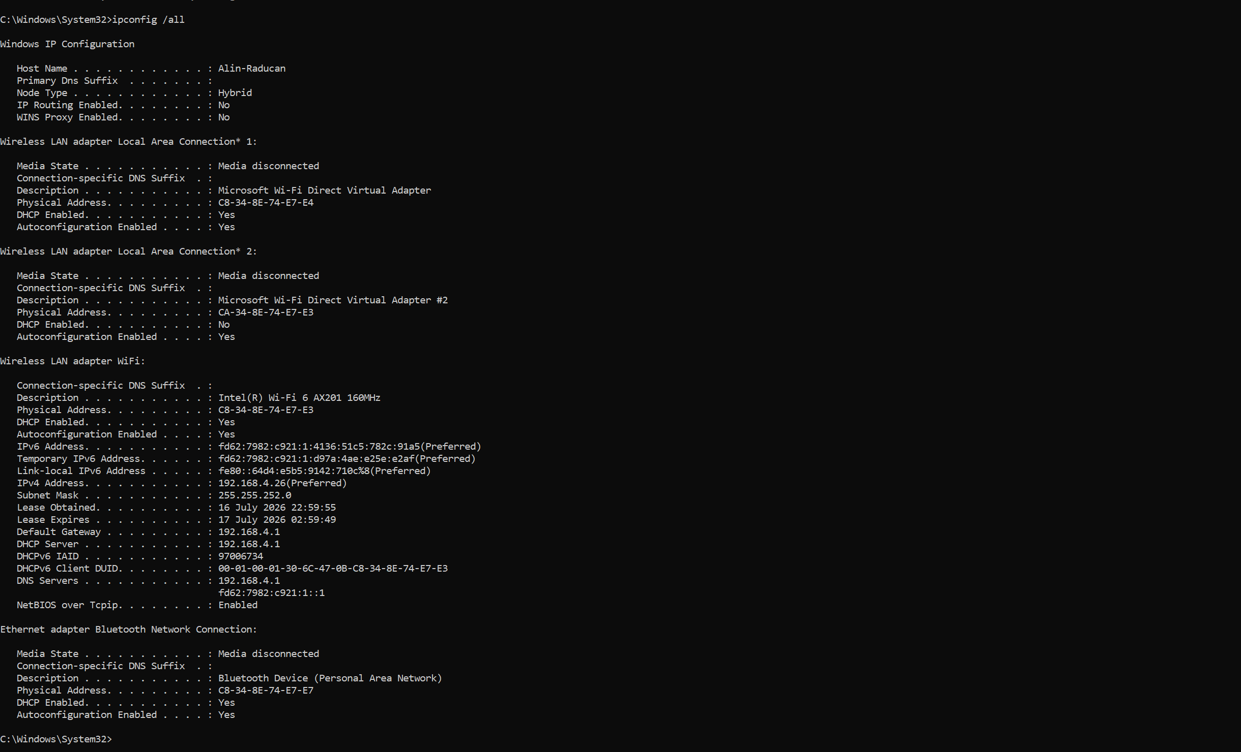
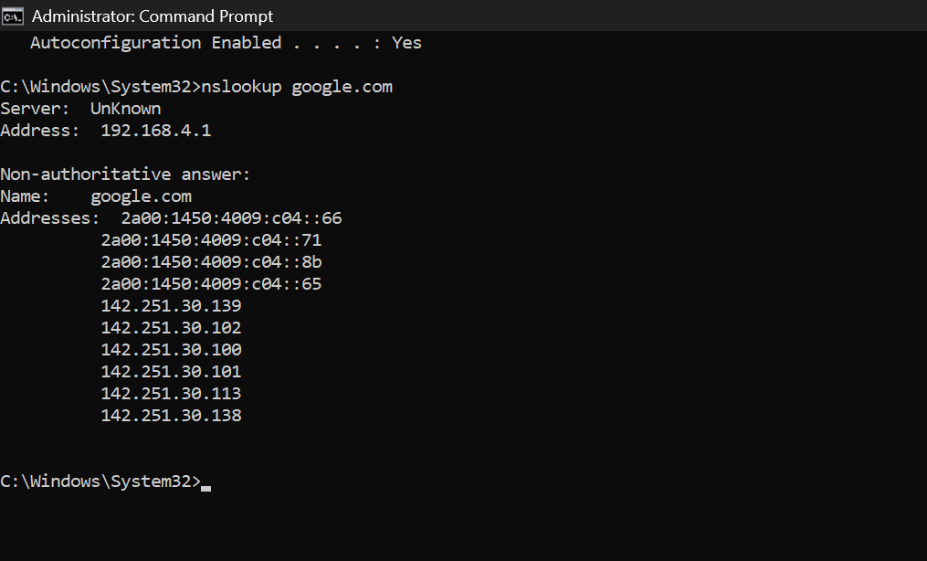
User Management
net user is a powerful command for managing user accounts. Using net user [username] [password] /add creates a new user. To see a list of all users, simply run net user. To view details of a specific user, use net user [username].
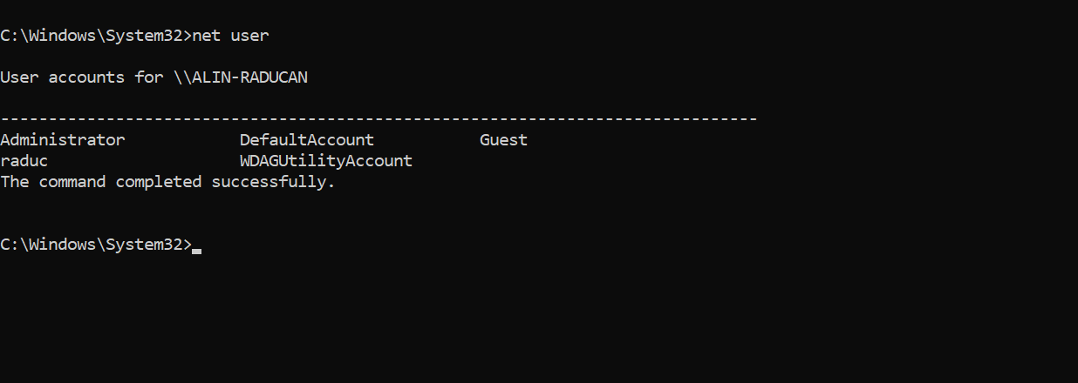
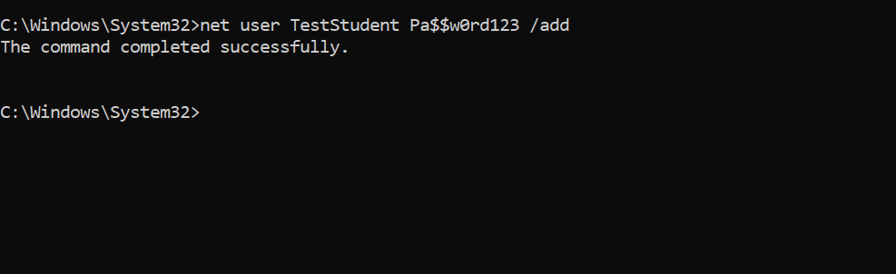

Task Scheduling
schtasks is the command-line tool for the Task Scheduler. For example, schtasks /create /tn "MyTask" /tr "C:\path\to\script.bat" /sc daily /st 09:00 creates a new task named "MyTask" that runs a script daily at 9:00 AM. The /sc switch defines the schedule frequency (e.g., daily, weekly), and /st specifies the start time [4].
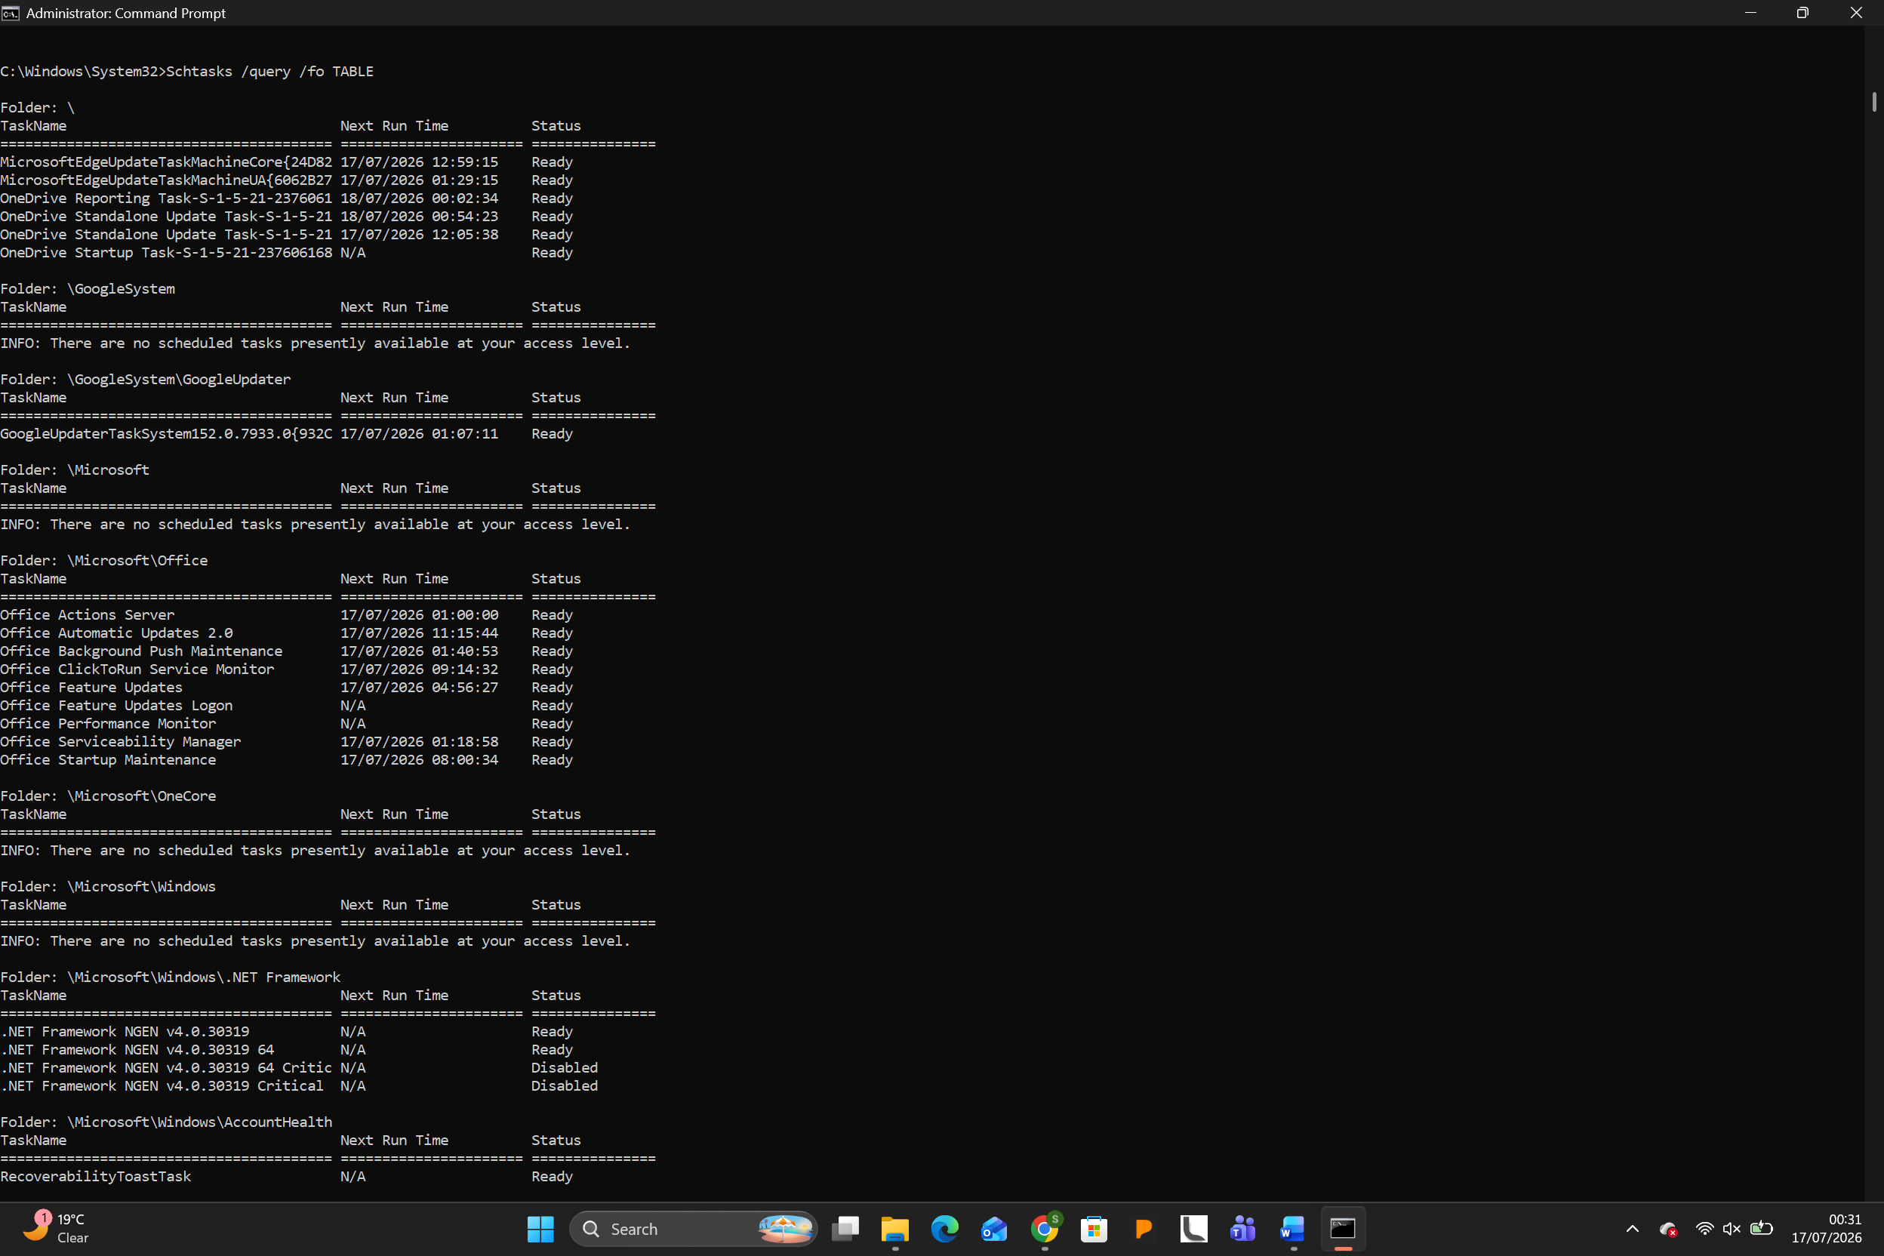
Use of Linux OS CLI Commands
Linux's command-line interface, typically Bash, is renowned for its power and flexibility. This section documents Bash commands that perform similar tasks to their Windows counterparts.
Process Management
ps displays information about active processes. Using ps aux is a very common command that shows all processes for all users (a), displaying the user who owns the process (u), and includes processes not attached to a terminal (x). This command provides a comprehensive snapshot of the system's process state.
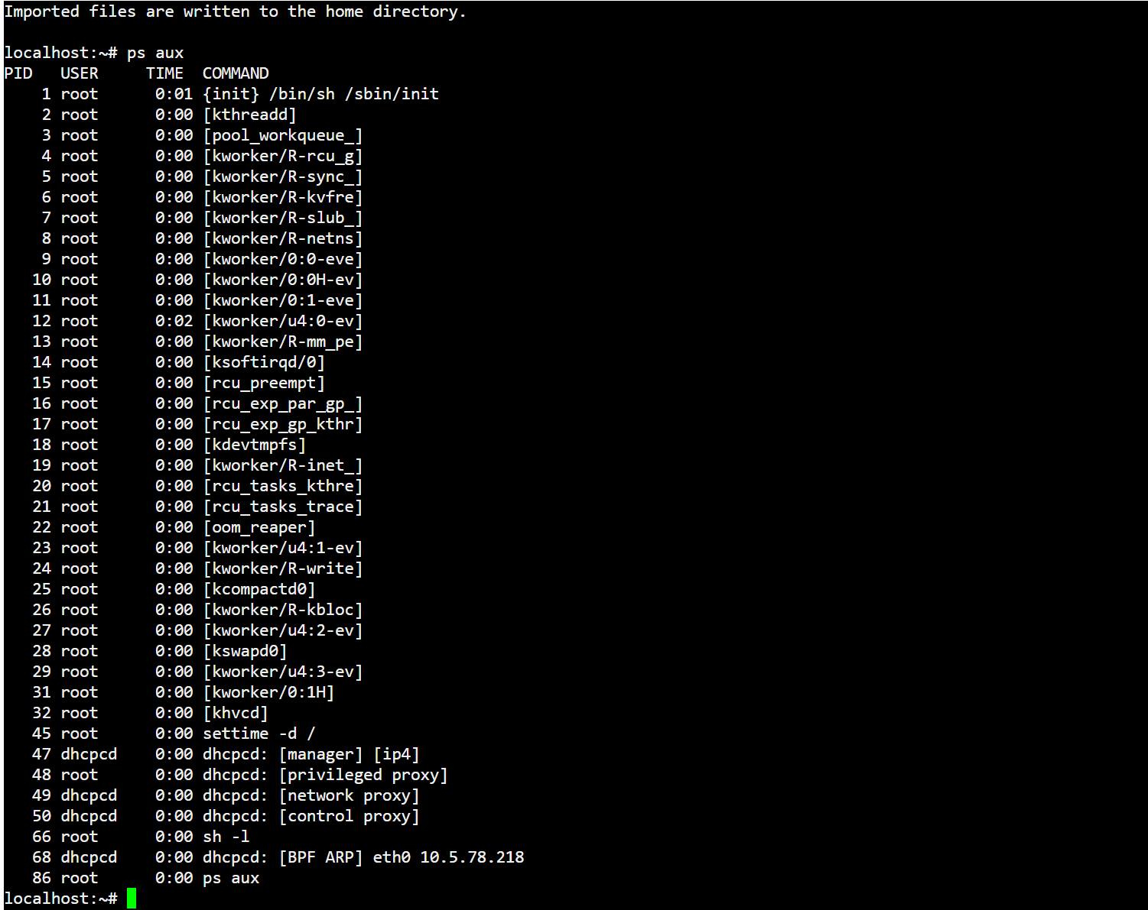

kill sends a signal to a process, typically to terminate it. The default signal is SIGTERM (signal 15), which requests a graceful shutdown. For an immediate forced termination, kill -9 [PID] sends SIGKILL, which cannot be caught or ignored by the process.
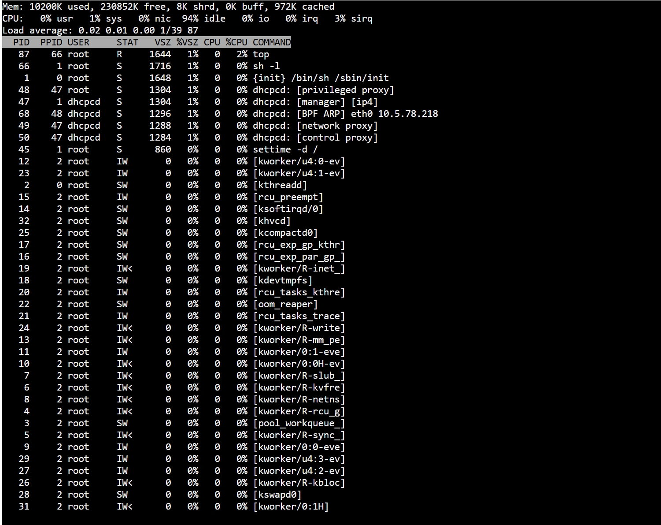
File & Directory Management
ls lists directory contents. The -la switch combination is one of the most common, where -l uses a long listing format (showing permissions, owner, size, and modification date) and -a shows all files including hidden files (those starting with a dot).
mkdir creates a new directory. The -p switch is powerful, as it creates parent directories as needed. For example, mkdir -p new/directory/structure will create all three nested directories if they do not exist. rm is used to remove files or directories; rm -r [directory] recursively deletes a directory and its contents [5].
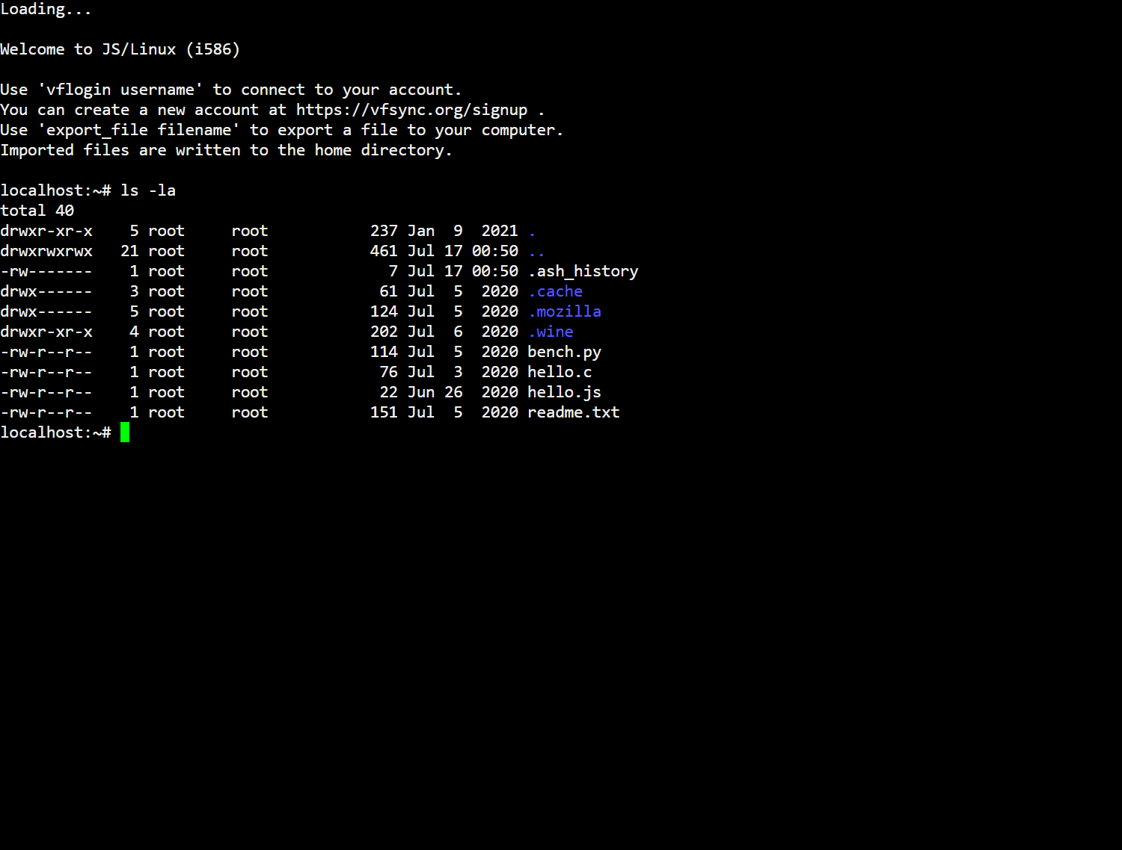
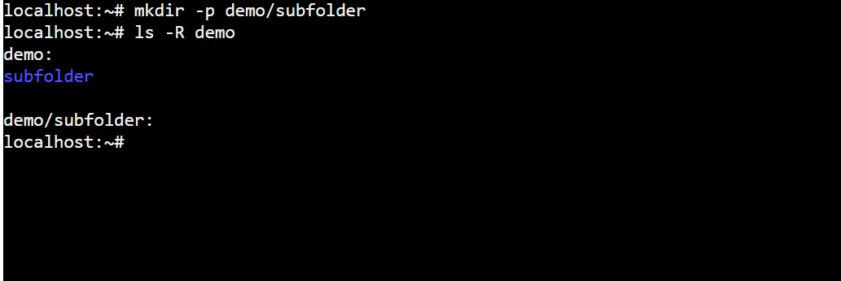
Network Testing/Monitoring
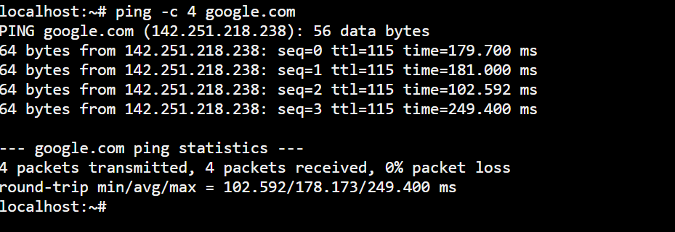
ping is the same fundamental network testing tool as in Windows. Using ping -c 4 google.com will send 4 ICMP echo requests to Google and then stop, as opposed to the continuous default behavior. The -c option controls the count of packets to send.
ip addr or ifconfig displays network interface configuration. The ip command is more modern and powerful. For instance, ip addr show shows detailed information for all interfaces, including IP addresses, MAC addresses, and interface states [6].
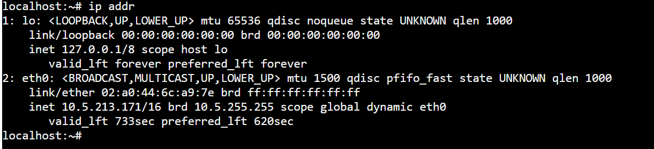

User Management
useradd creates a new user account. A common usage is sudo useradd -m newuser, where the -m switch creates the user's home directory. passwd is then used to set or change the user's password (e.g., sudo passwd newuser). usermod modifies an existing user account, such as adding them to a supplementary group with -aG.
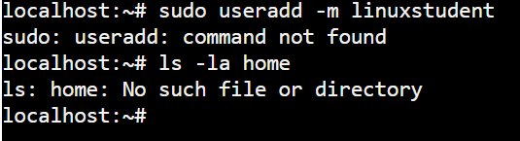
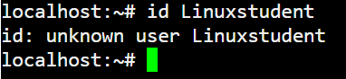
Task Scheduling
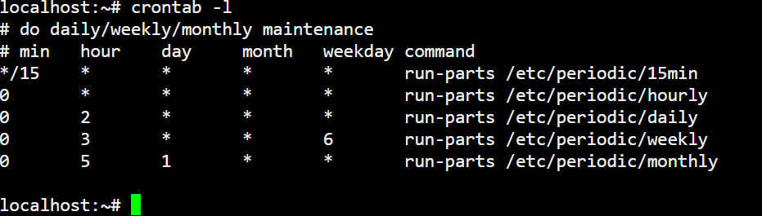
crontab is the tool for scheduling recurring tasks. The -e switch edits the user's current crontab file (or creates one). To schedule a task, a line is added in the format: minute hour day month weekday command. For example, 0 2 * * * /home/user/backup.sh would schedule the backup script to run every day at 2:00 AM. The -l switch lists the current crontab entries [7].
Use of Windows OS Scripts
Batch scripting allows for the automation of tasks in Windows. The following scripts demonstrate the use of variables, user input, and conditional statements.
Script 1: Simple File Backup Script
This script prompts the user for a source file and a destination folder, copies the file, and verifies the operation.
Script Code (backup.bat):
@echo off
set /p source=Enter the full path of the file to back up:
set /p dest=Enter the full path of the backup folder:
if exist %source% (
copy "%source%" "%dest%"
if %errorlevel% equ 0 (
echo Backup successful.
) else (
echo Backup failed.
)
) else (
echo Source file not found.
)
This script uses set /p to get user input into variables. The if exist conditional checks if the source file exists before attempting to copy. The if %errorlevel% checks the return code of the copy command to report success or failure, a simple form of flow control [8].
Script 2: Disk Cleanup Notification Loop
This script monitors the free space on the C: drive and alerts the user if it falls below a threshold, running in a loop.
Script Code (diskmonitor.bat):
@echo off
set threshold=10
:loop
for /f "tokens=3" %%a in ('dir C:\ /-c ^| find "bytes free"') do set freespace=%%a
set /a freespace_gb=%freespace% / 1073741824
if %freespace_gb% lss %threshold% (
echo WARNING: Low disk space on C:. Only %freespace_gb% GB free.
)
timeout /t 300 >nul
goto loop
This script demonstrates the use of a :loop label and goto to create an infinite loop. The for loop parses the output of the Dir command to extract the free bytes. A mathematical operation (set /a) converts bytes to gigabytes, and an if...lss (less than) conditional compares the free space against the threshold [8].
Use of Linux OS Scripts
Bash scripting provides powerful automation capabilities in Linux. The following examples show the use of variables, user input, loops, and conditionals.
Script 1: User Account Creation Script
This script creates a new user account, sets a password, and confirms the action, requiring root privileges.
Script Code (create_user.sh):
#!/bin/bash
read -p "Enter the new username: " username
read -sp "Enter the password for $username: " password
echo
if id "$username" &>/dev/null; then
echo "User $username already exists."
else
useradd -m "$username"
echo "$username:$password" | chpasswd
if [ $? -eq 0 ]; then
echo "User $username created successfully."
else
echo "Failed to create user $username."
fi
fi
This script uses read -p for a prompt and read -sp for a silent password read. The if conditional uses the id command to check if a user already exists. The $? variable captures the exit status of the last command (like chpasswd) to determine if the operation succeeded. Variables $username and $password are used to store user input, and the script makes use of command substitution implicitly with $? [9].
Script 2: Automated System Health Check
This script performs a series of system health checks and outputs a report, demonstrating loops and conditionals.
Script Code (system_health.sh):
#!/bin/bash
echo "System Health Report - $(date)"
echo "=============================="
echo "Disk Usage:"
df -h / | awk 'NR==2 {print "Root partition usage: " $5}'
echo "Memory Usage:"
free -h | awk '/^Mem/ {print "Used: " $3 " / Total: " $2}'
echo "CPU Load:"
uptime | awk -F 'load average:' '{print $2}'
echo "Top 5 processes by memory:"
ps aux --sort=-%mem | awk 'NR<=5 {print $11, "%"$4}'
This script uses several commands piped into awk for text processing, which is a powerful data manipulation technique in Bash. The date command is used within command substitution $(date) to get the current timestamp. It also features the ps command with --sort=-%mem to sort processes by memory usage in descending order. This script demonstrates the automation of gathering diverse system metrics into a single report, utilizing background knowledge of multiple command-line tools in conjunction [9].
Conclusion
The exploration of operating systems from both a theoretical and practical perspective has highlighted the critical role of the OS in managing system resources and enabling user interaction with hardware. Understanding the key functions of process, memory, file, and device management is fundamental to leveraging the system's capabilities effectively.
The practical work with Windows and Linux CLI commands has shown that while many core tasks are similar across platforms, the syntax and specific tools can differ significantly. Commands like ping are universal, while commands like tasklist (Windows) and ps (Linux) provide analogous but distinct mechanisms for process management. This comparative understanding is valuable for IT professionals who operate in heterogeneous environments.
Developing simple scripts for both Batch and Bash has proven to be a powerful method for automating routine administrative tasks. These scripts, even those of modest complexity, demonstrate how system administration can be made more efficient and less error-prone by automating repetitive tasks like backups, user creation, and system monitoring. The skills acquired in command-line navigation and scripting provide a foundation for more advanced system management and automation.

Reference List
[1] A. Silberschatz, P. B. Galvin, and G. Gagne, Operating System Concepts, 10th ed. Hoboken, NJ: John Wiley & Sons, 2018.
[2] M. Kerrisk, The Linux Programming Interface: A Linux and UNIX System Programming Handbook. San Francisco, CA: No Starch Press, 2010.
[3] Microsoft Corporation. "Command-line reference." Microsoft Docs. https://docs.microsoft.com/en-us/windows-server/administration/windows-commands/windows-commands
[4] W. R. Stanek, Windows Command-Line Administrator's Pocket Consultant, 2nd ed. Redmond, WA: Microsoft Press, 2009.
[5] W. Shotts, The Linux Command Line: A Complete Introduction, 2nd ed. San Francisco, CA: No Starch Press, 2019.
[6] C. Negus, Linux Bible, 10th ed. Indianapolis, IN: Wiley, 2020.
[7] E. Nemeth, G. Snyder, T. R. Hein, B. Whaley, and D. Mackin, UNIX and Linux System Administration Handbook, 5th ed. Boston, MA: Addison-Wesley Professional, 2017.
[8] T. A. Powell, Windows PowerShell: The Definitive Guide, 2nd ed. Sebastopol, CA: O'Reilly Media, 2010.
[9] R. Blum and C. Bresnahan, Linux Command Line and Shell Scripting Bible, 3rd ed. Indianapolis, IN: Wiley, 2015.

