BMHP5019
Introduction to Independent Research Skills
Component 2: Scoping Review Report
The Impact of Social Media on Mental Health Among UK University Students – A Scoping Review
Student Name: ___Uzma Muhammad___________________________
Student Number: __2406912_________________________
Lecturer: __Raheela Shaikh_______________

Contents
1. Introduction 3
2. Background 4
3. Methods 6
3.1 Design and justification 6
3.2 Review question and scope 8
3.3 Search strategy and databases 8
3.4 Eligibility criteria 8
3.5 Selection and data charting 9
3.6 Thematic analysis 9
3.7 Ethics and quality 11
4. Results 12
4.1 Study characteristics 12
4.2 Codes Generation 13
4.3 Frequency and Discussion of each theme 13
4.3.1 Theme 1: Harm is linked to how social media is used 14
4.3.2 Theme 2: Connection can reduce or increase loneliness 15
4.3.3 Theme 3: Purposeful use can support awareness and help-seeking 15
4.3.4 Theme 4: Effects vary by population, platform and design 16
5. Discussion 17
5.1 Findings linked to the objectives 17
5.2 Interpretation 17
5.3 Implications for policy and practice 18
5.4 Strengths and limitations 18
5.5 Research gaps 18
6. Conclusion and Recommendations 20
References 21

1. Introduction
Social media is part of everyday university life. In this review, it means internet-based platforms that allow users to create, share and respond to content and build online networks. Kaplan and Haenlein (2010) describe social media as platforms based on interaction and user-generated content. Common examples in the reviewed studies include Instagram, TikTok, Snapchat and WhatsApp.
Mental health is treated broadly. It includes anxiety, depression, stress, loneliness, low self-esteem, sleep problems and psychological distress. It also includes wellbeing, social connection, awareness and willingness to seek help. This broad definition is suitable because the studies use different designs and outcomes. Ahmed et al. (2024) and Koh et al. (2024) show that social media research includes both risks and benefits.
University students face academic pressure, changing relationships, financial concerns and the move towards independent living. Cage et al. (2021) describe university as an important period of transition. Campbell et al. (2022) show that student mental health is shaped by personal, social, academic and institutional factors. Social media may interact with these pressures. It can help students stay connected and find support. It can also increase comparison, fear of missing out and pressure to show an ideal life.
Review Question:
The review question is: What is the impact of social media use on the mental health of UK University students?
Aim:
To explore the impact of social media on mental health among UK University students through a scoping review of peer-reviewed literature. The objectives are:
Objectives:
- To identify the main mental health outcomes associated with social media use among UK University students.
- To examine the social media behaviours that may contribute to positive or negative mental health outcomes.
- To identify gaps in current UK research related to social media and student mental wellbeing.

2. Background
Mental health of students is a substantial issue in the UK higher education. Campbell et al. (2022) identified relationship and access to support, academic demands, financial pressure, and loneliness as risk factors for poor mental health. Cage et al (2021) also identified that transitions into, through and out of university can cause distress. Therefore, Social media should not be seen as only part of the reason. Its impact can relate to a student's overall life circumstances, current mental health, intent to use and online experiences.
Students rely on social media to keep in touch with friends, to follow University groups, learning, celebrating self-identification and getting support. Moreton and Greenfield (2022) observed that Instagram positively contributed to UK students' sense of connection but also to unrealistic depictions of life and cyberbullying/pressure for approval. A similar trend was observed by Anto et al. (2023). Reduction of anxiety was related to social support and increase of anxiety was related to comparison, FOMO, cyberbullying and procrastination. These results highlight the need to investigate alternatives to screen time to explain mental health outcomes.
Ordinary and problematic use are considered a key distinction. The problematic use is characterized by loss of control, emotional dependence, repeated checking or sleeping disturbance, study or relationship disruption. However, Ahmed et al. (2024) reported weak associations of general use and depression and anxiety and stronger associations for problematic use. Koh et al. (2024) also linked excessive and passive use with poorer outcomes, while purposeful use could improve support and wellbeing.
Loneliness is important but complex. Taylor et al. (2023) found that loneliness helped explain the link between passive use and distress. In contrast, Matthews et al. (2025) found that total use was not linked with loneliness. Compulsive use and online victimisation were more important, while WhatsApp use was linked with lower loneliness. Different platforms and behaviours may therefore have different effects.
Social media can also support mental health. Montagni et al. (2019) found that students use digital resources because they are accessible and private, although privacy and credibility are concerns. Wilde, Foster et al. (2025) co-developed an Instagram intervention with students. Wilde, Foxcroft and Davies (2025) later found it acceptable and engaging. Lea et al. (2023) also reported positive engagement with student-led mental health content.
The UK policy setting now places greater attention on platform responsibility and online harm. Schmidt (2024) explains the role of the Online Safety Act 2023, while Trengove et al. (2022) highlight the need to balance protection with privacy and expression. For universities, this supports digital wellbeing education, clear reporting routes and links to professional care. Riboldi et al. (2024) found that students wanted digital tools to complement, not replace, face-to-face support.
University support is usually delivered through counselling, wellbeing teams, disability services, personal tutors, student unions and links with NHS care. Digital channels can improve reach, especially for students who fear stigma or do not know where to ask for help. However, unequal access, language, culture and disability may affect who benefits. A social media strategy should therefore be accessible and connected to several support routes, not designed as a single solution.

3. Methods

3.1 Design and justification
A scoping review design was used. Arksey and O’Malley (2005) set out five stages: identifying the question, finding studies, selecting studies, charting data and summarising findings. Levac et al. (2010) strengthened this framework by linking each stage to the purpose of the review. Peters et al. (2020) explain that scoping reviews are suitable when evidence is broad, varied and still developing.
This design was selected because the literature includes interviews, surveys, longitudinal studies, mixed-method work, interventions and reviews. Populations and outcomes also differ. A meta-analysis would require more similar measures and designs. The aim here is not to calculate one effect size. It is to map harmful and supportive patterns and identify gaps. The report follows PRISMA-ScR guidance from Tricco et al. (2018). The supplied material contained 5 included publications but no full record of database results, duplicates or excluded full texts. A flow diagram is shown in figure 1.
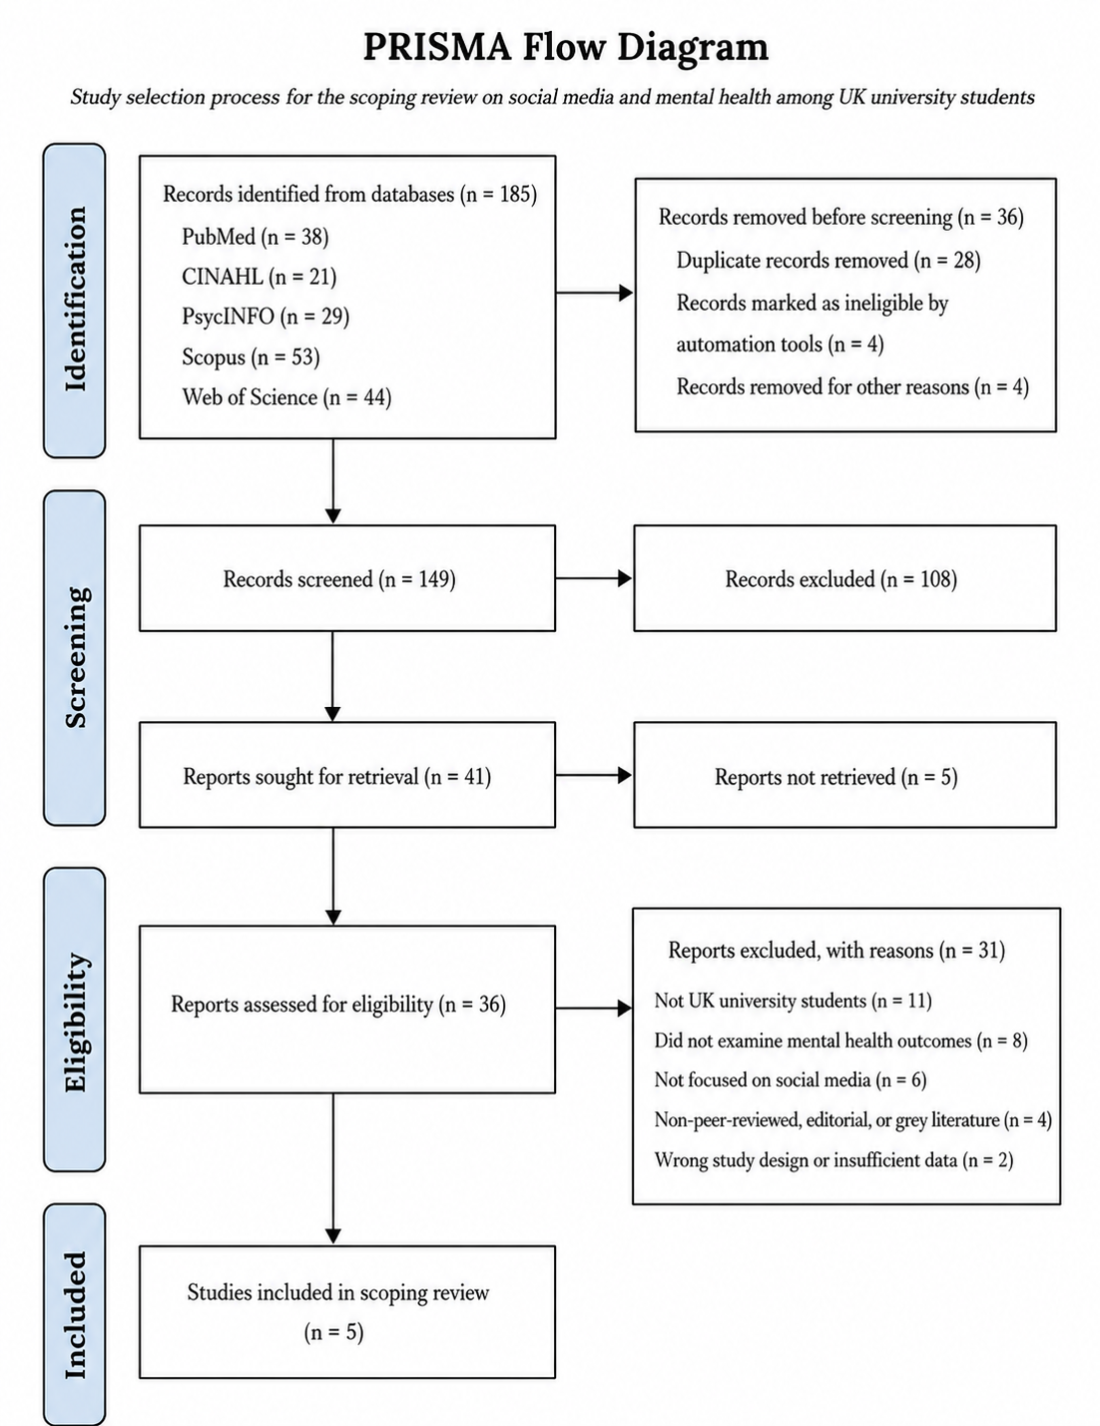
Figure 1: PRISMA Flow Diagram (Created by using Visual Paradigm Online Tool)

3.2 Review question and scope
The question was structured using Population, Concept and Context. The population was university students. The concept was social media use and mental health. The context was the UK. PCC was chosen because the review does not require one intervention or comparator, as explained by Peters et al. (2020).
Some supplied papers did not directly study UK University students. They included UK adolescents, young adults, mixed-country students and global reviews. These were retained as contextual evidence because all studies in the supplied table were required. They were not given the same weight as direct evidence. This distinction improves transparency.

3.3 Search strategy and databases
PubMed, CINAHL, PsycINFO, Scopus and Web of Science databases were searched using a structured search. Health research is included in PubMed. CINAHL has information about nursing and student support. PsycINFO includes coverage in the fields of psychology and mental health. Scopus and Web of Science offer wide multi-disciplinary coverage. Subject databases as well as broader indexes are recommended by Booth et al. (2022) and by Boland et al. (2017).
Search terms were grouped into social media, mental health and population terms. Examples included “social media”, Instagram, TikTok, Snapchat, “problematic social media use”, anxiety, depression, stress, loneliness, wellbeing, sleep, “help seeking”, “university students”, undergraduate, “higher education”, UK and “United Kingdom”.
An example search was: (“social media” OR Instagram OR TikTok OR Snapchat OR “problematic social media use”) AND (“mental health” OR anxiety OR depression OR stress OR loneliness OR wellbeing OR sleep OR “help seeking”) AND (“university students” OR undergraduate* OR “higher education”) AND (UK OR “United Kingdom”).
Search terms and subject headings would be adapted for each database. Reference lists would also be checked because platform language changes quickly.

3.4 Eligibility criteria
Key inclusion criteria were peer-reviewed, English-language journal articles published between 2020 and July 2026, with a focus on social media and a mental health and/or wellbeing outcome. UK university students were involved in core studies. Qualitative, quantitative and mixed-method research was acceptable. Intervention studies that involved using social media for awareness or to help seek were included.
Montagni et al. (2019) was kept as a boundary paper since it provided a mapping of the pre-pandemic use of digital mental health in universities. The contextual studies of adolescents and young adults as well as wider populations were also kept but clearly labeled. Grey literature, theses, policy papers, editorials and non-peer-reviewed material were excluded from the formal evidence set. Papers focused only on education or professionalism were considered indirect evidence.

3.5 Selection and data charting
Titles and abstracts were screened, followed by full texts. Each paper was classified as core, supportive or contextual. Boland et al. (2017) advise using clear criteria consistently. A second reviewer would normally check decisions. If one student completed screening, this should be reported as a limitation.
A charting table recorded author, year, aim, location, sample, design, platform, outcome, findings, relevance and limitations. The supplied study matrix was used as the base. This follows Arksey and O’Malley’s (2005) approach to organising varied evidence.

3.6 Thematic analysis
Braun and Clarke’s (2006) thematic analysis was used. Complete flow chart diagram for all steps is shown in figure 2. The summaries were read several times. Repeated findings were coded. Codes included social comparison, FOMO, cyberbullying, passive scrolling, compulsive use, loneliness, peer support, help-seeking, misinformation and privacy. Related codes were grouped into themes and checked against the review question and all studies.
Braun and Clarke (2021) state that themes should answer the question rather than act as simple topic lists. Four themes were developed: harmful engagement patterns; connection and loneliness; supportive use and help-seeking; and variation by context and design.
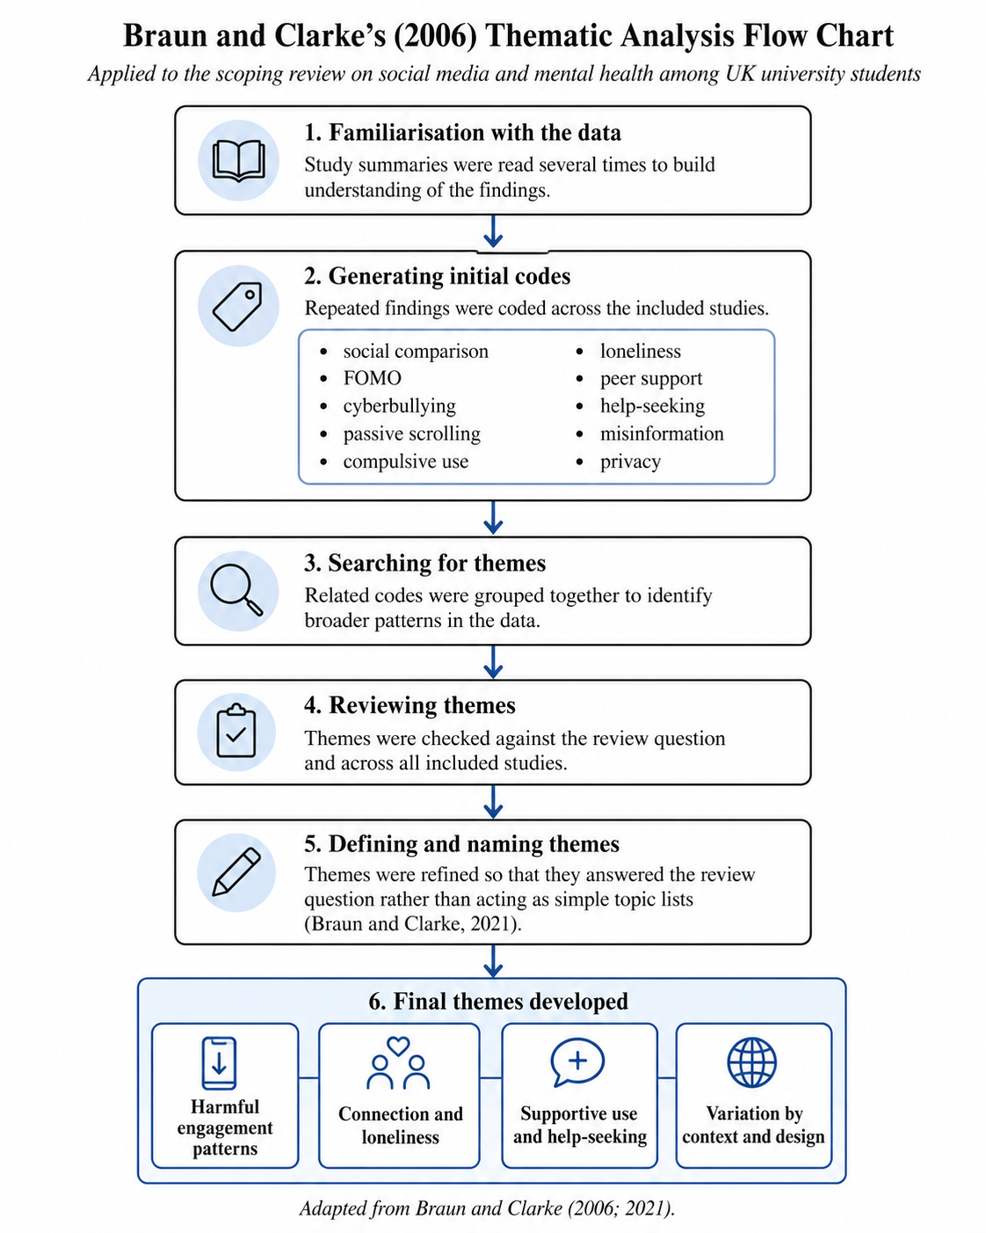
Figure 2: Flow Chart Using Braun and Clarke’s (2006) thematic analysis (Created by using Visual Paradigm Online tool)

3.7 Ethics and quality
Formal ethical approval was not required because only published literature was used. Ethical practice still required accurate citation, honest reporting and no unsupported causal claims. Studies outside the target population were labelled clearly.
Formal risk-of-bias exclusion was not used because the aim was mapping. However, design quality shaped interpretation. Longitudinal studies and reviews were useful for broad patterns. Small interviews offered depth but limited generalisation. Feasibility studies showed acceptability, not proven effectiveness.

4. Results

4.1 Study characteristics
5 publications were charted. Table 1 presents every study in the supplied evidence set and shows how its codes contributed to the themes.
Table 1: Included studies characteristics
Objective | Methodology (Sample, Country/Region) | Key Findings | Relevance to Review Question | Citation
Explore UK university students' views on how Instagram affects mental wellbeing. | Qualitative study; semi-structured interviews; n = 16 undergraduate students; UK; thematic analysis. | Instagram supported social connection but also harmed mental wellbeing through unrealistic ideals, cyberbullying, and pressure for social approval. | High relevance. Directly examines the impact of social media (Instagram) on the mental health of UK University students. | (Moreton & Greenfield, 2022)
Explore how social media affects anxiety among UK University students. | Qualitative; 29 undergraduate students from 6 UK universities; semi-structured interviews; thematic analysis. | Social media reduced anxiety through social support but increased anxiety via comparison, FOMO, stress, cyberbullying, and procrastination. | Very high. Directly examines social media's impact on the mental health (anxiety) of UK university students. | (Anto et al., 2023)
Explore how UK undergraduates use online resources, including social media, for mental health support. | Cross-sectional survey; n = 156 undergraduate students; UK (single university). | Students used video-based social media for peer support and text-based platforms for support from friends/family; online resources complemented mental health help-seeking. | Moderate. Focuses on UK University students and social media but examines mental health support-seeking rather than the direct impact of social media on mental health. | (Di Campli San Vito et al., 2025)
Review evidence on how social media use affects adults’ mental health and well-being. | Scoping review; 114 studies; global adult populations (2005–2021). | Excessive/passive social media use was linked to higher depression, anxiety, loneliness and poorer mood, while purposeful use improved social support and well-being. | High. Supports the mental health impact of social media | (Koh et al., 2024)
Explore how social media influences social connectedness among UK adolescents. | Qualitative interviews; n = 24 adolescents (13–14 years); England, UK; thematic analysis. | Social media both strengthened and weakened social connectedness, depending on how it was used; effects varied by individual circumstances. | High. UK-based and relevant to social media and mental health. | (Winstone et al., 2021)

4.2 Codes Generation
Table 2 summarises the main analytical codes identified in each included study and shows how these codes contributed to the four themes.
Table 2: Final code dictionary and frequency
Study | Main analytical codes | Theme and relevance
Moreton and Greenfield (2022) | Connection; unrealistic ideals; approval pressure; cyberbullying | Themes 1 and 2; core evidence
Anto et al. (2023) | Support; anxiety; comparison; FOMO; stress; cyberbullying; procrastination | Themes 1 and 2; core evidence
Di Campli San Vito et al. (2025) | Peer support; friends and family support; online help-seeking | Theme 3; core/supportive evidence
Koh et al. (2024) | Excessive/passive use; distress; purposeful use; support | Themes 1, 3 and 4; broad evidence
Winstone et al. (2021) | Stimulation; displacement; conditional connectedness | Themes 2 and 4; contextual evidence

4.3 Frequency and Discussion of each theme
Table 3 presents the frequency and coverage of each theme and explains how each theme addresses the scoping review question.
Table 3: Number of themes vs studies frequency and Coverage
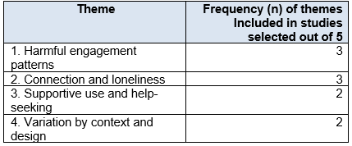
Figure 3 compares the number of included studies linked to each theme.
￼
Figure 3: Number of Themes Vs. Frequency of Studies Included

4.3.1 Theme 1: Harm is linked to how social media is used
The strongest negative pattern concerned passive, compulsive and emotionally invested use. Moreton and Greenfield (2022) found that idealised images, approval pressure and cyberbullying could reduce wellbeing. Anto et al. (2023) found that comparison, FOMO, stress, cyberbullying and procrastination increased anxiety. Taylor et al. (2023) linked passive use with anxiety, depression and stress. Hendrikse and Limniou (2024) found that TikTok use predicted depression and problematic use.
The wider reviews supported this pattern. Ahmed et al. (2024) found weak links for ordinary use but stronger links for problematic use, poor wellbeing and sleep problems. Koh et al. (2024) linked excessive and passive use with depression, anxiety, loneliness and poorer mood. Carter et al. (2024) found similar links among UK adolescents. This evidence is indirect for university students but supports concern about loss of control and disrupted sleep.
The main codes were social comparison, unrealistic ideals, FOMO, cyberbullying, passive scrolling, emotional investment, compulsive checking, procrastination and sleep disruption. Risk appeared higher when use was hard to control, hostile or disruptive to daily life.

4.3.2 Theme 2: Connection can reduce or increase loneliness
Connection was a common benefit, but it was conditional. Moreton and Greenfield (2022) and Anto et al. (2023) found that communication and support could improve wellbeing or reduce anxiety. Winstone et al. (2021) found that social media could strengthen or weaken connectedness depending on the person and situation.
Bonsaksen et al. (2023) linked greater use with more loneliness in a cross-national adult sample. Taylor et al. (2023) found that loneliness helped explain distress linked with passive use. However, Matthews et al. (2025) found that total use was not linked with loneliness. Compulsive use and online victimisation were harmful, while WhatsApp use was linked with lower loneliness.
Akram et al. (2025) did not examine social media, but showed that loneliness is highly relevant in UK universities and is associated with serious mental health outcomes. The theme therefore reflects conditional connection. Trusted contact may help, while exclusion, comparison and victimisation may harm.

4.3.3 Theme 3: Purposeful use can support awareness and help-seeking
Wilde, Foster et al. (2025) worked with UK students to design the CoMUni Instagram intervention. Peer stories aimed to reduce stigma and encourage help-seeking. Wilde, Foxcroft and Davies (2025) found that the intervention was acceptable and increased awareness and help-seeking intentions. The study was small and short, so it did not prove clinical effectiveness.
Lea et al. (2023) found positive engagement with a student-led Instagram welfare initiative. Di Campli San Vito et al. (2025) found that undergraduates used video-based platforms for peer support and text-based tools for support from friends and family. Riboldi et al. (2024) found that students valued easy access to information but wanted digital support to complement face-to-face care. Montagni et al. (2019) reported benefits of access and anonymity, with concerns about privacy and credibility.
Sandhu et al. (2023) found that social media improved access to public health information during COVID-19, but could increase anxiety, isolation and misinformation. Guckian et al. (2024) found benefits for peer learning and professional identity among medical students, while misinformation remained a concern. O’Connor et al. (2022) found mixed confidence about professional social media use among nursing students. These indirect studies support the need for digital literacy.
The main codes were peer support, accessible information, lived experience, reduced stigma, anonymity, help-seeking, co-design, misinformation, privacy and credibility. Purposeful and well-designed use appeared more helpful than unstructured exposure.

4.3.4 Theme 4: Effects vary by population, platform and design
The evidence did not support one simple conclusion. Plackett et al. (2023) found no significant long-term link between higher use and later mental health problems after adjustment in a large adolescent cohort. Matthews et al. (2025) also found that compulsive use and negative experiences mattered more than total use.
Many negative findings came from cross-sectional studies. These show association but not direction. Students who are already anxious or lonely may use social media differently. Interviews explain possible mechanisms but have small samples. Intervention studies show acceptability but remain early. Reviews include varied countries and ages.
Overall, the evidence supports a conditional model. Problematic behaviours and harmful experiences were linked with poorer mental health. Purposeful connection and support could be helpful. Platform, motive, vulnerability and offline context changed the outcome.

5. Discussion

5.1 Findings linked to the objectives
The first objective was to identify mental health outcomes. Repeated outcomes were anxiety, depression, stress, loneliness, lower wellbeing, low self-esteem and sleep problems. Positive outcomes included connection, awareness, peer support and willingness to seek help.
The second objective concerned behaviours. Passive scrolling, comparison, FOMO, compulsive checking, cyberbullying, victimisation, procrastination and sleep disruption were harmful patterns. Purposeful communication, trusted contact, peer stories and evidence-based content were more positive. Advice based only on reducing screen time may therefore be too simple.
The third objective was to identify gaps. There are few large longitudinal studies focused specifically on UK University students. Direct evidence often comes from small samples or one university. There is limited comparison of platforms, student groups and types of engagement over time. Positive intervention evidence is promising but early.

5.2 Interpretation
Social media acts as an environment rather than one standard exposure. One student may use WhatsApp to maintain close relationships. Another may view idealised images for long periods. A third may follow a mental health campaign. These experiences can lead to different outcomes.
The relationship may also work in both directions. Poor mental health may increase passive use or reassurance seeking. These behaviours may then worsen sleep, comparison and isolation. Cross-sectional surveys cannot separate these directions. This may explain why Plackett et al. (2023) found weaker long-term effects and why Ahmed et al. (2024) found stronger links for problematic use than general use.
Loneliness may be a pathway, but findings conflict. Taylor et al. (2023) found a mediating role. Matthews et al. (2025) found that total use was not linked with loneliness. Measures of compulsive use, victimisation and passive use may therefore be more useful than simple time measures.
The positive intervention findings are valuable but must be interpreted carefully. Co-designed content may feel relevant because students recognise peer language and experiences. Wilde, Foster et al. (2025) show the value of student involvement. However, views, likes and intentions do not prove reduced anxiety or depression. Larger trials with longer follow-up are needed.

5.3 Implications for policy and practice
Universities should provide practical digital wellbeing education during induction and wellbeing programmes. It should cover comparison, FOMO, cyberbullying, misinformation, privacy, sleep and signs of compulsive use. It should not claim that all social media is harmful.
University accounts can play a role in supporting mental health by providing clear and inclusive content that is connected to tangible services. Peer stories can help to reduce stigma, however, there is a need for consent and safeguarding. Support routes should be included in crisis posts. Digital support should be used in conjunction with counselling, disability support, tutors, primary and specialist care as recommended by Riboldi et al. (2024).
A review of the digital communication of universities should also be done. Being on constant alerts and feeling constant pressure to be on may introduce a bit of stress. Cyberbullying reporting procedures should be well established. Students need to understand how to block and report, and keep evidence, of harmful behaviour.

5.4 Strengths and limitations
Varied methods are included in the evidence set. Interviews provide depth. Surveys show patterns. Longitudinal studies study change. Reviews provide general evidence and interventions demonstrate potential solutions. Both negative and positive effects were considered.
Important weaknesses remain. Self-reported behaviour is used in many studies. In cross-sectional designs, there is no proof of causes. Small (one university) samples make generalisation difficult. The use of platforms is rapidly evolving. Other studies include both social media and smartphone usage. There are also variations in the mental health measures.
Papers that did not completely address the question were included in this review. Akram et al. (2025) examined loneliness and not social media. O'Connor et al. (2022) highlighted professionalism. Guckian et al. (2024) targeted the education sector. Plackett et al. (2023), Carter et al. (2024) and Winstone et al. (2021) studied adolescents. These papers provide context and detract from directness. Montagni et al. (2019) was beyond the intended time period. Original screening counts were not available and study selection may have been done by one reviewer. Therefore, the conclusions have to be guarded.

5.5 Research gaps
Future studies should separate platform exposure from online experience. They should record whether students post, message, scroll, seek reassurance or use mental health content. Objective usage data may improve accuracy when it is collected with informed consent and strong privacy protection. More research is also needed on international students, disabled students, mature students, minority ethnic groups and students with existing mental health conditions. These groups may face different risks, support needs and barriers to care.

6. Conclusion and Recommendations
6.1 Conclusion
This review found mixed effects of social media on UK University students’ mental health. The clearest risks were linked with problematic, passive and comparison-based use. Cyberbullying, victimisation, FOMO, procrastination and sleep disruption were also important. These patterns were associated with anxiety, depression, stress, loneliness and lower wellbeing.
Social media also supported relationships, peer support, mental health information and help-seeking. Student-led and co-designed Instagram interventions were acceptable and may reduce stigma. However, early engagement findings do not prove clinical effectiveness.
6.2 Recommendations
Universities should provide practical digital wellbeing education rather than only advising students to reduce screen time. Support should cover sleep, comparison, online safety, misinformation, privacy and compulsive use. Mental health content should be co-designed with students and linked to professional services. Social media should complement, not replace, face-to-face care.
Future research should use larger and more diverse UK samples. Longitudinal studies should examine direction of effect. Researchers should compare active, passive, compulsive and supportive use, not only total time. Intervention studies need validated outcomes and longer follow-up.
The overall conclusion is that impact depends on how, why and in what context social media is used. A balanced response should reduce harmful patterns while protecting the benefits of connection and support.

References
Ahmed, O., Walsh, E.I., Dawel, A., Alateeq, K., Oyarce, D.A.E. and Cherbuin, N. (2024) ‘Social media use, mental health and sleep: A systematic review with meta-analyses’, Journal of Affective Disorders, 367, pp. 701–712. https://doi.org/10.1016/j.jad.2024.08.193
Akram, U., Drabble, J., Irvine, K., Allen, S., Akram, A., Stevenson, J.C. and Gardani, M. (2025) ‘Prevalence and psychiatric correlates of loneliness in UK University students’, npj Mental Health Research, 4(1), 45. https://doi.org/10.1038/s44184-025-00144-8
Anto, A., Asif, R.O., Basu, A., Kanapathipillai, D., Salam, H., Selim, R., Zaman, J. and Eisingerich, A.B. (2023) ‘Exploring the impact of social media on anxiety among university students in the United Kingdom: Qualitative study’, JMIR Formative Research, 7, e43037. https://doi.org/10.2196/43037
Arksey, H. and O’Malley, L. (2005) ‘Scoping studies: Towards a methodological framework’, International Journal of Social Research Methodology, 8(1), pp. 19–32. https://doi.org/10.1080/1364557032000119616
Boland, A., Cherry, M.G. and Dickson, R. (eds.) (2017) Doing a Systematic Review: A Student’s Guide. 2nd edn. London: SAGE.
Bonsaksen, T., Ruffolo, M., Price, D., Leung, J., Thygesen, H., Lamph, G., Kabelenga, I. and Geirdal, A.Ø. (2023) ‘Associations between social media use and loneliness in a cross-national population: Do motives for social media use matter?’, Health Psychology and Behavioral Medicine, 11(1), 2158089. https://doi.org/10.1080/21642850.2022.2158089
Booth, A., Sutton, A., Clowes, M. and Martyn-St James, M. (2022) Systematic Approaches to a Successful Literature Review. 3rd edn. London: SAGE.
Braun, V. and Clarke, V. (2006) ‘Using thematic analysis in psychology’, Qualitative Research in Psychology, 3(2), pp. 77–101. https://doi.org/10.1191/1478088706qp063oa
Braun, V. and Clarke, V. (2021) ‘One size fits all? What counts as quality practice in (reflexive) thematic analysis?’, Qualitative Research in Psychology, 18(3), pp. 328–352. https://doi.org/10.1080/14780887.2020.1769238
Cage, E., Jones, E., Ryan, G., Hughes, G. and Spanner, L. (2021) ‘Student mental health and transitions into, through and out of university: Student and staff perspectives’, Journal of Further and Higher Education, 45(8), pp. 1076–1089. https://doi.org/10.1080/0309877X.2021.1875203
Campbell, F., Blank, L., Cantrell, A., Baxter, S., Blackmore, C., Dixon, J. and Goyder, E. (2022) ‘Factors that influence mental health of university and college students in the UK: A systematic review’, BMC Public Health, 22, 1778. https://doi.org/10.1186/s12889-022-13943-x
Carter, B., Ahmed, N., Cassidy, O., Pearson, O., Calcia, M., Mackie, C. and Kalk, N.J. (2024) ‘There’s more to life than staring at a small screen’: A mixed methods cohort study of problematic smartphone use and the relationship to anxiety, depression and sleep in students aged 13–16 years old in the UK’, BMJ Mental Health, 27(1), e301115. https://doi.org/10.1136/bmjment-2024-301115
Di Campli San Vito, P., Macdonald, S.A., Brewster, S., Fusar-Poli, P. and Uhlhaas, P.J. (2025) ‘Use of online resources by UK undergraduate students for mental health questions’, International Journal of Human–Computer Interaction, 42(7), pp. 5551–5569. https://doi.org/10.1080/10447318.2025.2545462
Guckian, J., Edwards, S., Rees, E.L. and Burford, B. (2024) ‘Social media quality in undergraduate medical education: A reconceptualisation and taxonomy’, The Clinical Teacher, 22(1), e13825. https://doi.org/10.1111/tct.13825
Hendrikse, C. and Limniou, M. (2024) ‘The use of Instagram and TikTok in relation to problematic use and well-being’, Journal of Technology in Behavioral Science, 9(4), pp. 846–857. https://doi.org/10.1007/s41347-024-00399-6
Kaplan, A.M. and Haenlein, M. (2010) ‘Users of the world, unite! The challenges and opportunities of social media’, Business Horizons, 53(1), pp. 59–68. https://doi.org/10.1016/j.bushor.2009.09.003
Koh, G.K., Yong, J.Q.Y.O., Lee, A.R.Y.B., Ong, B.S.Y., Yau, C.E., Ho, C.S.H. and Goh, Y.S. (2024) ‘Social media use and its impact on adults’ mental health and well-being: A scoping review’, Worldviews on Evidence-Based Nursing, 21(4), pp. 345–394. https://doi.org/10.1111/wvn.12727
Lea, A., Baskar, A., Haseen, A., Modalavalasa, H., Moody, A., Nathan, D., Shajan, G., Tremain, B. and Young, E. (2023) ‘Student-led approaches to mental health support’, Future Healthcare Journal, 10(2), pp. 171–172. https://doi.org/10.7861/fhj.2023-0042
Levac, D., Colquhoun, H. and O’Brien, K.K. (2010) ‘Scoping studies: Advancing the methodology’, Implementation Science, 5, 69. https://doi.org/10.1186/1748-5908-5-69
Matthews, T., Arseneault, L., Bryan, B.T., Fisher, H.L., Gray, R., Henchy, J., Moffitt, T.E. and Odgers, C.L. (2025) ‘Social media use, online experiences, and loneliness among young adults: A cohort study’, Annals of the New York Academy of Sciences, 1548(1), pp. 194–205. https://doi.org/10.1111/nyas.15370
Montagni, I., Tzourio, C., Cousin, T., Sagara, J.A., Bada-Alonzi, J. and Horgan, A. (2019) ‘Mental health-related digital use by university students: A systematic review’, Telemedicine and e-Health, 26(2), pp. 131–146. https://doi.org/10.1089/tmj.2018.0316
Moreton, L. and Greenfield, S. (2022) ‘University students’ views on the impact of Instagram on mental wellbeing: A qualitative study’, BMC Psychology, 10(1), 45. https://doi.org/10.1186/s40359-022-00743-6
O’Connor, S., Odewusi, T., Smith, P.M. and Booth, R.G. (2022) ‘Digital professionalism on social media: The opinions of undergraduate nursing students’, Nurse Education Today, 111, 105322. https://doi.org/10.1016/j.nedt.2022.105322
Peters, M.D.J., Marnie, C., Tricco, A.C., Pollock, D., Munn, Z., Alexander, L., McInerney, P., Godfrey, C.M. and Khalil, H. (2020) ‘Updated methodological guidance for the conduct of scoping reviews’, JBI Evidence Synthesis, 18(10), pp. 2119–2126. https://doi.org/10.11124/JBIES-20-00167
Plackett, R., Sheringham, J. and Dykxhoorn, J. (2023) ‘The longitudinal impact of social media use on UK adolescents’ mental health: Longitudinal observational study’, Journal of Medical Internet Research, 25, e43213. https://doi.org/10.2196/43213
Riboldi, I., Calabrese, A., Piacenti, S., Capogrosso, C.A., Paioni, S.L., Bartoli, F., Carrà, G., Armes, J., Taylor, C. and Crocamo, C. (2024) ‘Understanding university students’ perspectives towards digital tools for mental health support: A cross-country study’, Clinical Practice and Epidemiology in Mental Health, 20(1), e17450179271467. https://doi.org/10.2174/0117450179271467231231060255
Sandhu, S., Wilson, E. and Chattopadhyay, K. (2023) ‘Perceptions and experiences of undergraduate students regarding social media as a tool for government COVID-19-related messages: A qualitative study in Nottingham, UK’, International Journal of Environmental Research and Public Health, 20(20), 6903. https://doi.org/10.3390/ijerph20206903
Schmidt, H. (2024) ‘The Online Safety Act 2023’, Journal of Media Law, 16(2), pp. 202–210. https://doi.org/10.1080/17577632.2025.2459440
Taylor, Z., Yankouskaya, A. and Panourgia, C. (2023) ‘Social media use, loneliness and psychological distress in emerging adults’, Behaviour & Information Technology, 43(7), pp. 1312–1325. https://doi.org/10.1080/0144929X.2023.2209797
Trengove, M., Kazim, E., Almeida, D., Hilliard, A., Zannone, S. and Lomas, E. (2022) ‘A critical review of the Online Safety Bill’, Patterns, 3(8), 100544. https://doi.org/10.1016/j.patter.2022.100544
Tricco, A.C., Lillie, E., Zarin, W., O’Brien, K.K., Colquhoun, H., Levac, D. et al. (2018) ‘PRISMA extension for scoping reviews (PRISMA-ScR): Checklist and explanation’, Annals of Internal Medicine, 169(7), pp. 467–473. https://doi.org/10.7326/M18-0850
Wilde, N., Foster, J., Jones, V., Kossivas, A., Çakmak, J., Knight, O.C., Grzywacz, M., Foxcroft, D. and Davies, E.L. (2025) ‘Co-development of the CoMUni intervention: A social-media-based resource to increase mental health help-seeking behaviours in UK undergraduates’, Health Expectations, 28(4), e70400. https://doi.org/10.1111/hex.70400
Wilde, N., Foxcroft, D. and Davies, E. (2025) ‘Feasibility and acceptability of CoMUni: A social media-based intervention to increase mental health help seeking in UK undergraduate students’, Advances in Mental Health, pp. 1–22. https://doi.org/10.1080/18387357.2025.2523005
Winstone, L., Mars, B., Haworth, C.M.A. and Kidger, J. (2021) ‘Social media use and social connectedness among adolescents in the United Kingdom: A qualitative exploration of displacement and stimulation’, BMC Public Health, 21(1), 1736. https://doi.org/10.1186/s12889-021-11802-9

