Flixborough Nypro Plant 1974
By Jack Twaddle
Jack Twaddle
University of wales trinity saint david Human Factors Assignment

Introduction
On the 1st of June 1974 in Flixborough, North Lincolnshire, England at the Nypro Chemical Plant a powerful explosion struck the site causing the death of 28 workers, injuring a further 36 and major damage to the surrounding environment. This event was caused by the failure of a temporary bypass pipe containing a very flammable chemical called cyclohexane. During investigation it was clear at first that the mechanical failure was the main cause, but it was then revealed that there was much more to the cause than just mechanical failure, discovering a series of human and organisational failures that were seen as the root cause. [1]
This essay will examine the cause and explain the human factors which contributed to the disaster by using the ‘dirty dozen’ to discuss the top three biggest causalities and why they are in a particular order.
Human factors are crucial in the investigation of industrial accidents as they hold the mental, physical and social aspects that influence human performance and behaviour. To improve safety in the workplace, understanding and addressing these factors are essential and reduce the likes of other accidents.

Background
The plant was owned by Nypro (UK) Ltd which was a dual partnership between Dutch State Mines (DSM) and Fisons Limited. The plant was used to manufacture a chemical compound called caprolactam which is a key raw material used in the production process of nylon. One of the main parts in the manufacturing process included the oxidation of cyclohexane which is a very highly flammable liquid when it is introduced to high temperatures and pressures. The process of oxidising cyclohexane involves pumping the chemical into a series of 6 reactors, where in the presence of oxygen it makes a reaction, and the cyclohexane oxidises producing a mixture of cyclohexanol which is an alcohol and cyclohexanone which is a ketone. For this reaction to happen the reactor system needs to operate at high temperatures and pressure such as around 155-165°C and 8-10 bar. The produced mixture of alcohol and ketone were the desired intermediates to for caprolactam production. [1]

Build up to the Explosion
As seen in figure 1 is a photograph of the Nypro Plant before the explosion with arrows showing each part of the site.
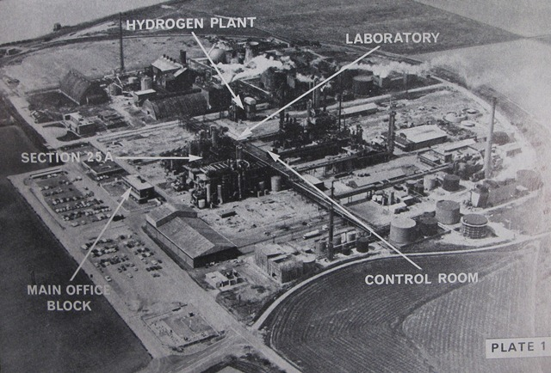
Figure 1 Flixborough Nypro Plant Before the Explosion
On the 27^{th of} March 1974 a vertical crack was discovered in the 5th reactor leaking cyclohexane. The plant was then shutdown for investigation, it was found that there was a major problem with the reactor. To solve this problem the decision was made to remove the reactor completely and install a temporary pipe section connecting reactors 4 and 6 so that production could resume. Figure 2 diagram shows the temporary pipe section that was built connecting the reactors.
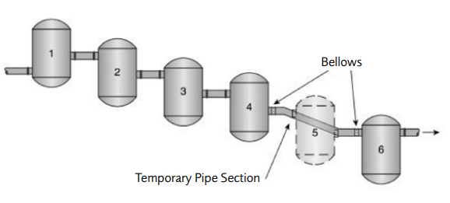
Figure 2 Temporary Pipe Section Built Connecting Reactors 4 and 6
On the 29th of May the plant was shut down for a second time as a leak was found on a sight glass. After the sight glass was repaired it was discovered that there was issues in attaining the correct pressure and temperature conditions that are crucial for the start up process.
At 3:00PM on the 1st of June there was a shift change. 1 hour and 35 minutes later, the two bellows and temporary pipe section completely failed causing two 700mm openings and the release of a vast amount of cyclohexane. As the gas travelled across the plant it quickly came into contact with a heater and ignited. In the control room all 18 workers died instantly along with further 10 plant operators. Figure shows the aftermath of the explosion and how catastrophic this disaster was.
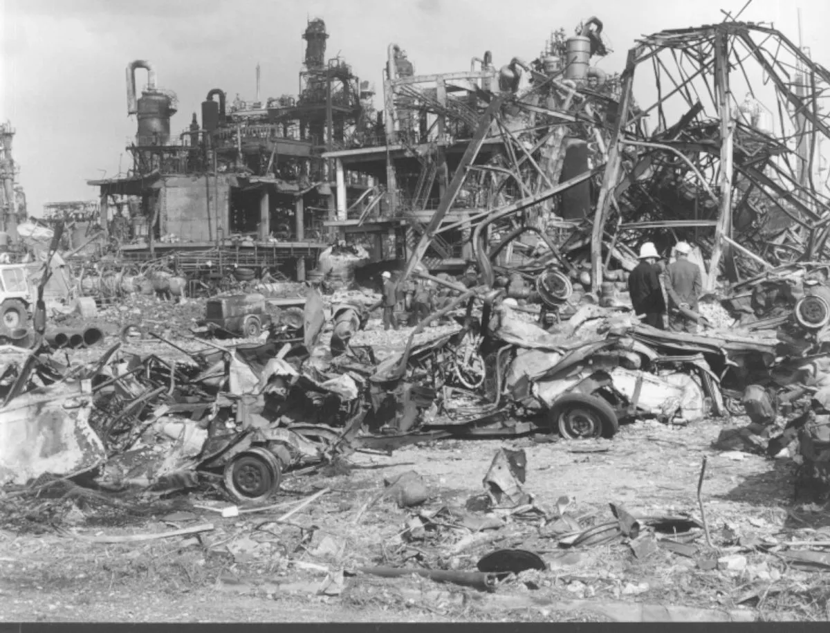
Figure 3 Aftermath of the Explosion

Human Factors of the Disaster

Lack of Assertiveness
My number one main causality towards this disaster is lack of assertiveness. This human factor was critical in allowing unsafe decisions to be made without challenge, especially during a period when the plant was vulnerable due to staff changes. Workers that may have had concerns about safety failed to voice them or were not empowered to do so. As the plants works engineer Mr Riggall who was a chartered mechanical engineer had left the company, the decision was made to appoint an underqualified replacement named Mr Boyton. This decision meant that high risk engineering choices like the design and installation of the temporary bypass pipe went unopposed. This should not have happened as in a more assertive safety culture these decisions would have been questioned or even stopped altogether. [2]
There were several staff members that reported to the Works Engineer before Mr Riggall had left the company but none of them were professionally qualified mechanical engineers. After Mr Riggall had left those staff members were left overburdened and underqualified. The fact that no one formally objected to this lack of engineering oversight shows a wider organisational failure in assertiveness. Yet again staff either felt unempowered or were unwilling to challenge this leadership gap that had clear safety implications. [2]
The company were fully aware that its engineering structure was weak and sought external advice, yet no one on site had the authority or assertiveness to insist on safe, qualified oversight following the departure of the works engineer. Although staff were told they could contact Mr. Hughes for support, his limited availability and external responsibilities meant that real-time intervention was unlikely. The absence of a senior mechanical engineer and the failure to demand one left critical decisions unchallenged, further exposing the consequences of a culture lacking assertiveness. [2]

Lack of Awareness
My second main causality towards this disaster is lack of awareness. This human factor refers to the failure of understanding the risks involved in the situation. In an industrial site environment like Flixborough where the risks are high, lack of awareness results in critical decisions being made without full understanding of their potential consequences.
During plant modification when the number 5 reactor was decided to be removed and replaced with a temporary bypass pipe to keep the plant running, no hazard assessment such as a HAZOP (Hazard and Operability Study) was completed before the bypass was installed. There were only limited mechanical calculations made for the bypass focusing on the 20-inch pipe between the two reactors, but the actual shape of the pipe and the use of the bellows were not considered which introduced structural weaknesses. This shows a major lack of awareness about the risks of the installed bypass as no stress analysis or structural review was carried out. [3]
Pressure testing was also not performed on the temporary bypass pipe before recommissioning the plant. This was a crucial failure of mechanical integrity as pressure testing is a vital step in confirming the safety of the installation before startup. On top of that the use of flexible bellows in unsupported and unaligned installations were cautioned according to industry design standards. Those responsible did not understand how these design flaws were a major hazard and would lead to the loss of containment under high pressure conditions.
On a broader scale, the lack of awareness did not stop at mechanical design. There was no consideration of a major disaster since there were occupied buildings in close proximity to the hazardous reactor system. Another reason this was not considered is the control room failed to account for structural reinforcement that could withstand an explosion which left the workers dangerously exposed.
Overall, the understanding of any risks was clearly missing. The lack of awareness allowed design assumptions to go unchecked, unsafe modifications to proceed and the risk management to fail at every level. If there would have been more awareness in safety culture, then the bypass pipe would not have been allowed as it would have failed during proper testing.

Pressure
My third most important causality is pressure. This factor is important as it refers to the priority of productivity, speed and cost-saving over safety. There was clear evidence that the need to maintain output and avoid prolonged shutdowns contributed to a series of decisions not regarding safety.
When the leak was found in reactor 5, instead of keeping the plant shutdown until a safe engineered solution could be made, the management and staff felt pressured to restore operations quickly. This pressure led to the design and installation of the temporary bypass pipe without the necessary analysis, calculations and testing. The thought of the financial and operational consequences that came along with a prolonged shutdown drove unsafe compromises. [2]

Conclusion
In conclusion, the Flixborough Nypro Plant disaster is one of the biggest industrial disasters in British history which killed and injured a total of 64 people out of the 72 people that were on site. If the explosion would have happened on a weekday the casualty figures would have been much higher, as it was the weekend the main office block was not occupied by any workers.
This disaster shows clearly how human factors can combine to cause such a catastrophe in high-risk industrial environments like Flixborough. Overall, this essay has identified lack of assertiveness, lack of awareness and pressure as the top three causalities to the disaster. The failure of key personnel to challenge unsafe decisions or demand qualified oversight allowed dangerous modifications to proceed unchecked. A widespread lack of awareness meant that the risks associated with the temporary bypass pipe’s design and installation were underestimated. Meanwhile, operational and organisational pressures to maintain production encouraged shortcuts and suppressed vital safety concerns.

References

[1] | T. T. a. K. Hideo, “Disaster of Chemical Plant at Flixborough,” [Online]. Available: https://www.shippai.org/fkd/en/hfen/HB1058048.pdf. [Accessed 5 July 2025].
[2] | Department of Employment , “Institute of Chemical Engineers,” 27 June 1974. [Online]. Available: https://www.icheme.org/media/17752/the-flixborough-disaster-report-of-the-court-of-inquiry.pdf. [Accessed 5 July 2025].
[3] | Health and Safety Executive , “Flixborough (Nypro UK) Explosion 1st June 1974,” [Online]. Available: https://www.hse.gov.uk/comah/sragtech/caseflixboroug74.htm. [Accessed 5 July 2025].
[4] | Turney, Robin, “The Chemical Engineer,” 30 May 2024. [Online]. Available: https://www.thechemicalengineer.com/features/flixborough-50-years-on-lessons-for-managers-and-engineers-today/. [Accessed 5 July 2025].

