

Student name: Abosede Dehinbo
Student ID: 2313077

Module name: Independent Project Poster
Module code: BMHP6020_LON
Supervisor’s name: Jolly Nwankwo

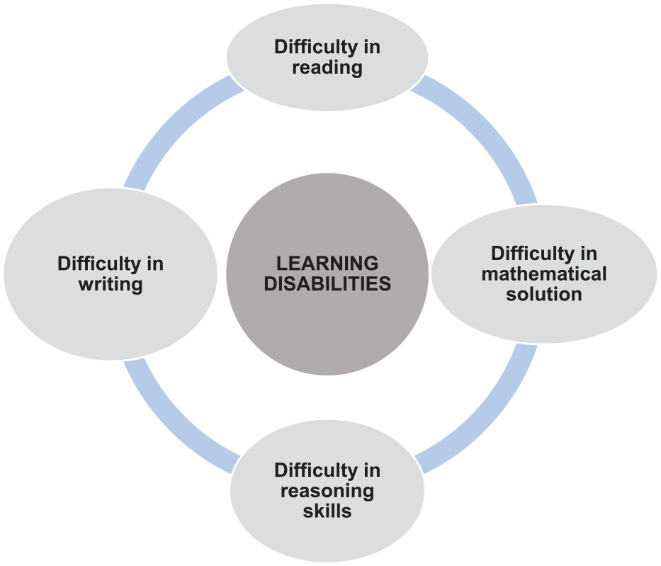 |  | Developmental Learning Disorder with Impairment in Reading  Aim:  This project aims to explore the development of Learning Disorder with Impairment in Reading (dyslexia) and examine its impact on health and social care services in the UK through a qualitative secondary research approach.  Objective:  1. This research aims to explore how developmental learning disorder with impairment in reading, commonly known as dyslexia, affects individuals’ experiences of health and social care in the United Kingdom.  2. The study will examine the challenges of reading health information, communicating with professionals, and accessing appropriate support.  3. It will also consider how person-centred care, reasonable adjustments and multidisciplinary collaboration can improve service accessibility and promote equality.  Dyslexia primarily affects reading, spelling and written language processing, but it does not indicate low intelligence. Individuals may struggle to understand written instructions, complete forms, and interpret health information (NHS, 2026). |  | 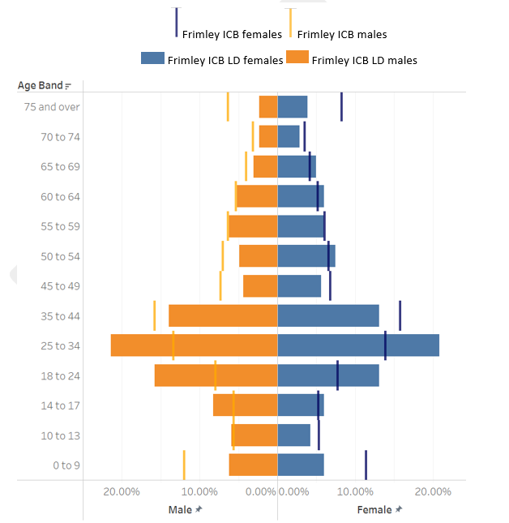
Methodology  This project will adopt a qualitative secondary research design, using existing published evidence rather than collecting new information directly from participants. A qualitative approach is appropriate because it enables an in-depth exploration of lived experiences, professional perspectives and barriers to inclusive care. The research will focus on literature published between 2016 and 2026 (Department for Education, 2026).  The study will use a structured literature review approach to identify and critically examine relevant evidence. This will include peer-reviewed journal articles, NHS publications, UK government guidance and research indexed in PubMed and Google Scholar. Evidence will be selected according to its relevance to dyslexia, reading impairment, health literacy, accessibility and health and social care practice (Crouch, 2019).  The review will also consider how health and social care professionals can identify communication needs and adapt their practice to support individuals with specific learning difficulties. NHS guidance highlights the importance of appropriate assessment, educational support and individualised interventions for children experiencing dyslexia (NHS, 2026). |  |  |  | Data Analysis Method.  The collected evidence will be examined using thematic analysis, which involves identifying recurring patterns and organising findings into meaningful themes. This approach will guide familiarisation with the literature, initial coding, theme development, theme review and interpretation.  Potential themes include communication barriers, access to written health information, stigma, professional awareness and reasonable adjustments. Findings from different sources will be compared to identify similarities, differences and gaps in current knowledge. Critical appraisal will consider research credibility, methodological transparency, relevance to UK services and potential bias.  The analysis will distinguish dyslexia from intellectual disability because reading impairment does not necessarily involve reduced intellectual functioning. Government guidance confirms that reasonable adjustments should address individual barriers to accessing services (Public Health England, 2020).  Ethical considerations  Although secondary research does not involve direct recruitment, ethical standards remain essential. Only legitimate, publicly accessible or institutionally available sources will be used, and all material will be accurately cited using UWTSD Harvard referencing. Findings will be represented fairly without changing authors’ intended meanings or presenting unsupported conclusions.  The researcher will avoid stigmatising language and recognise individual differences in reading ability, communication preferences and support requirements. Confidentiality will be respected when examining published accounts, particularly where individuals discuss sensitive experiences. Copyright requirements will be observed through appropriate paraphrasing and attribution.

Data Collection Method.
Secondary data will be collected through systematic searches of Google Scholar, PubMed, relevant academic journals, NHS websites and UK government publications. Search terms will include developmental dyslexia, specific learning disorder with impairment in reading, qualitative research, health literacy, person-centred care, reasonable adjustments and social care accessibility.
Inclusion criteria will cover English-language publications from 2016 to 2026 that address reading impairment, service accessibility, professional practice or the experiences of individuals with dyslexia in the UK.
A search record will document databases, keywords, publication dates and reasons for excluding studies. Priority will be given to peer-reviewed qualitative research and authoritative guidance. For example, Louch et al. (2021) explored patient safety experiences using focus groups and publicly available narratives, demonstrating how qualitative evidence can illuminate barriers within health and social care systems.

.
The study will also consider equality, dignity and accessibility. The Equality Act 2010 establishes duties concerning reasonable adjustments, including accessible information where applicable (UK Government, 2010).

References

Crouch, A.T. (2019) “Perceptions of the possible impact of dyslexia on nursing and midwifery students and of the coping strategies they develop and/or use to help them cope in clinical practice,” Nurse Education in Practice, 35, pp. 90–97. Available at: https://doi.org/10.1016/j.nepr.2018.12.008. (Accessed: 4 October 2026).
Department for Education (2026) Special educational needs in England: Academic year 2025/26. Available at: https://explore-education-statistics.service.gov.uk/find-statistics/special-educational-needs-in-england/2025-26 (Accessed: 12 October 2026).
Equality Act 2010, c. 15. Available at: https://www.legislation.gov.uk/ukpga/2010/15 (Accessed: 12 October 2026).
Louch, G. et al. (2021) ‘Systemic safety inequities for people with learning disabilities: a qualitative integrative analysis of the experiences of English health and social care for people with learning disabilities, their families and carers’, International Journal for Equity in Health, 20, article 136. Available at: https://doi.org/10.1186/s12939-021-01612-1 (Accessed: 12 October 2026).
NHS (2026) Dyslexia in children. Available at: https://www.nhs.uk/conditions/dyslexia-in-children/ (Accessed: 12 October 2026).
Public Health England (2020) Reasonable adjustments: a legal duty. Available at: https://www.gov.uk/government/publications/reasonable-adjustments-a-legal-duty/reasonable-adjustments-a-legal-duty (Accessed: 12 October 2026).UK Government (2010) Equality

