Research in Practice
Paul Duerinckx
ADAD5004/C

Documentary Photography and Visual Activism
Rebecca Davies

Word count: 2,498

Historically, photography has been seen as a way of preserving memory, as it allows lived experience to remain accessible through visual means beyond their original moment. However, it can be argued that memory itself is unstable and unpredictable due to its ability to be constantly reshaped through time, emotion, and perception. This essay explores the relationship between photography and the unreliable nature of memory. Through the three keywords memory, trace, and liminality, I will investigate how photographs attempt to preserve lived experiences, although they can never truly capture or reconstruct them. This will be done by looking into theory and photographic imagery that explores this tension within photography, where it can be seen as both a trace of the past and a space of uncertainty.

The word memory can often be explained as a way of preserving lived experiences, whereby it functions as a stable and accurate replica of the past. However, some argue that memory operates through a more reconstructive process, whereby memory is constantly reshaped by perception, emotion, and time. Apart from photography being seen as having a documentary purpose, they cannot fully convey the emotional or sensory aspects of the experience, removing the true reality around the image. This means that instead of photographs containing the truth and holding onto memories, they become more of a storage of fragmented traces that are constantly reinterpreted as time goes on.

Henri Bergson (2012) argues that perception and memory are inseparable, “In truth, every perception is already memory. Practically we perceive only the past” (p. 150). Bergson argues that people never experience things in a truly objective way because all moments are influenced by previous memories and knowledge; photographs can never be viewed in a completely neutral sense there will always be some sort of external influence. For instance, the viewer brings emotional association, personal experience, and subjective interpretation into every assumption they make within an image. This means that photographs cannot fully function as true evidence of a lived experience because memory changes how the image is understood over time and manipulates the reality of the situation. Bergson (2012) explains that “every perception fills a certain depth of duration, prolongs the past into the present, and thereby partakes of memory.” (p. 325). For Bergson the concept of duration stipulates that past and present coexist and can never exist separately. Whilst a photograph captures a singular moment, lived experience exists beyond the time it was captured. While this keeps the moment slightly alive, it does become fragmented over time. The image becomes suspended between two states; a photograph is connected to a past event whilst also generating new meaning within the present. This shows how memory operates less as a fixed process and more as a continuous reconstruction.

Maurice Halbwachs (1997) argues that “we recapture the past only by understanding how it is, in effect, preserved by our physical surroundings.” (p. 267). This suggests that objects, spaces, and environments can often trigger memory. This supports the idea that photographs function as a physical form of memory whereby they preserve remnants of experiences that no longer exist through a visual form. Things that are more personal, such as family albums, can become emotionally charged, allowing individuals to reconnect with fragments of the past. This suggests the need for a personal connection with photographs, for memories to exist within them. Halbwachs implies that memory is dependent upon interpretation because a photograph itself does not directly contain memory. Instead, it can create meaning, but this is reconstructed through the viewer’s relationship with the image. For instance, if a stranger viewed an image, the only thing created would be meaning rather than significant memory.

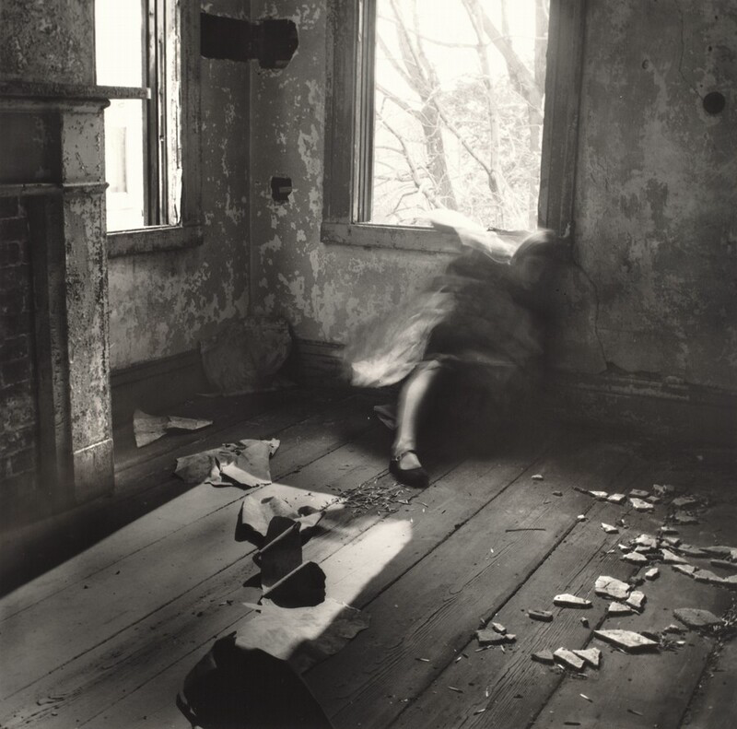
Figure 1: House #3, Providence, Rhode Island (Francesca Woodman, 1976).

The idea of instability that surrounds memory can be seen within photographic work created by Francesca Woodman. Woodman’s photographs are known to depict blurred bodies and fragmented interiors, whereby figures appear to disappear and almost look as if they are suspended between visibility and absence (see figure 1). Her work directly rejects the idea that photography can showcase a stable form of identity and instead uses it to visualise identities as both present and absent. Within Figure 1, the body appears partly erased through a mixture of long exposure and layering to create a ghost like form that resists permanence. Not all her body appears with the same amount of transparency, as some parts remain more visible than others, creating the idea that although she is not fully there, fragments remain. This links closely to fragmentation within memory. This distortion reflects the instability of memory and how recollection functions similarly through fragmentation. “The idea being that there are invisible moments between objects and events that a well-executed photo makes visible.” (McWilliams, 2017). Woodman suggests that photography can reveal experiences that are often unnoticed or hard to describe. Despite being an objective method of documenting lived experience, photography has become a method for showcasing emotional states that are subjective. Woodman's work reflects the nature of memory where moments are partially visible but can never fully be accessible; her use of the blurred body and transparent states become more of a symbolic visual of an unstable recollection.

Hirsch (1997) argues that “The photographs temporal irony elicits mourning and empathy.” This creates an emotional connection between the past and the viewer supporting the concept that Woodman’s images are deeply rooted in emotional aspects such as feelings of loss and absence. Through her work, the viewer becomes aware of absence within the image and, despite this, still tries to reconstruct meaning from what remains visible. Photography in this instance lacks objectivity and is emotionally influenced preserving traces of existence whilst emphasising that true moments can never be fully recovered. Instead, the only thing that can be relied upon is the emotions felt based on the image, making the image itself subjective rather than completely truthful.

The concept of trace within photography explains the action of fragmentation and residue of something that is no longer fully present, specifically in terms of memory. Photographs often appear to be a source of evidence for capturing reality and become a record of moments that once existed. However, it is argued that photography does not simply preserve the truth, but instead constructs meaning through framing, interpretation, and cultural context. It is through this that we understand photographs become traces of lived experience rather than a direct mimic of reality.

Temporality within a photograph can arguably be defined through a trace; “what the photograph reproduces to infinity has occurred only once.” (Barthes, 2011, p. 4). Photography can both preserve a moment whilst also providing a reminder that the moment is gone. Photography exists as proof that something once existed, but it also reinforces the impossibility of accurately reliving that event again. Barthes (2011) challenges the assumption that photographs permanently preserve memory, by suggesting that although an image can survive physically, emotionally, and symbolically, the reality attached to that moment can never be fully recovered. This creates a tension between preservation and loss.

“Photographs furnish evidence, something we hear about, but doubt, seems proven when we’re shown a photograph of it.” (Sontag, 1979, p. 5). Sontag highlights how photographs hold a type of authority within society, explaining how images are frequently trusted because they appear to mimic reality. Throughout the years, photographs have relied on assumptions of truthfulness, where they have mainly been seen as documentary, journalistic, or archival evidence. However, Sontag suggests that photographic evidence is more emotionally persuasive rather than neutral or objective.

“Every photograph is a result of a specific and, in every sense, significant distortion which render its relation to any prior reality deeply problematic.” (Tagg, 1998, p. 2). Tagg states that photography is reconstructed through selection, framing and editing. He claims that the camera does not passively record truth but instead constructs meaning itself. This idea suggests that meaning, memory, and perception are all shaped by the artist and the narrative they create, arguing that an image itself has little meaning without interpretation. Overall, this argument weakens photography’s documentary authority that many people believe it holds.

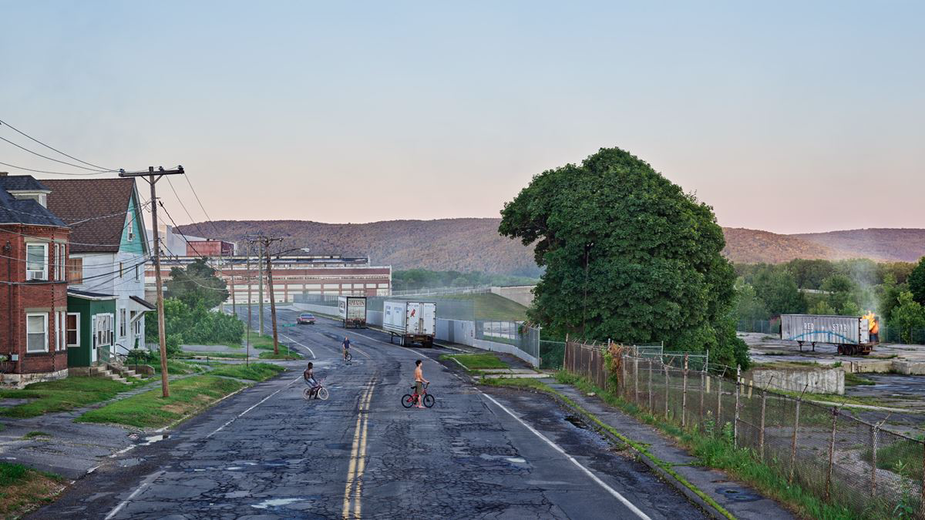
Figure 2: Red Star Express. Gagosian. (Gregory Crewdson, 2018-2019).

Although photographs have often been seen as realistic and truthful, they can also manipulate perception through composition, narrative implication, and construction. His images appear realistic, yet they are completely staged through lighting, constructed sets, and carefully directed performances (see figure 2). His images present fragments of a narrative that does not have a complete explanation. When viewing figure 2, there is an empty street, isolated figures, dramatic lighting, and an overall sense of emotional tension that is never fully resolved or explained. This encourages viewers to construct their own meaning through assumptions, interpretation, and emotion. Therefore, these photographs become similar to memory and traces, as they remain incomplete and open to subjectivity.

“The viewer is more likely to project their own narrative onto the picture.” (Loh and Vescovi, 2015). Rather than creating fixed meaning within his images, Gregory Crewdson intentionally creates scenes filled with mystery and ambiguity (see figure 2). This forces viewers to create their own emotional connection to the visual elements and construct completely subjective narratives from his images. He demonstrates how photography functions less as direct documentation and more as a space for personal projection and interpretation. “The camera is an instrument of evidence,” (Tagg, 1998, p. 1) This quote becomes especially interesting when looking at Crewdson’s work. While his photographs appear realistic and have a documentary quality to them, they are completely fabricated, staged, and cinematic. Overall, his work demonstrates that photography can visually create its own version of truth through constructed meaning. In conclusion, this argument weakens the authority images appear to hold and showcases how unstable the reality of photographs and memories can be.

Liminality refers to a transitional or in between space that exists outside of fixed or stable categories. This concept was first discussed by Victor Turner (1995), who described liminality as a moment of transformation that happens between two social positions. Liminality becomes significant in explaining how photographs themselves exist between spaces of presence and absence, reality and imagination, memory and forgetting. Photography captures moments that physically no longer exist, creating images that are suspended between these different states. This reflects how memory, trace, and liminality all connect, because memories and traces themselves exist within a liminal space.

This instability is explained by Victor Turner (1995); “liminal entities are neither here nor there, they are betwixt and between” (p. 95). This statement highlights how liminality creates uncertainty by existing between two fixed states rather than being fixed itself. Photography functions in a similar way whereby photographs preserve visible traces of absent experiences, existing between presence and absence. This is further supported by the idea that the subjects within photographs existed before the camera captured that moment, yet they are no longer physically present when the image is viewed in the present day. “The attributes of liminality or of liminal personae (threshold people) are necessarily ambiguous.” (Turner, 1995, p. 95) This explains how uncertainty becomes a defining characteristic of liminal spaces and experiences. Photographs often create uncertainty around time, identity, and reality. Whilst an image freezes a moment outside of its original time, it also produces experiences that feel suspended between life and disappearance. Therefore, photographs themselves become liminal objects whereby they exist simultaneously as forms of presence and absence.

Roland Barthes (2011) expands, “the photograph mechanically repeats what could never be repeated existentially” (p. 4). Barthes suggests that photography reproduces visual moments of lived experience, while the reality attached to them remains permanently inaccessible. This creates tension within a liminal sense between preservation and loss. Photography becomes haunted by absence, acting only as confirmation that an experience once existed rather than evidence of the full reality it captured.

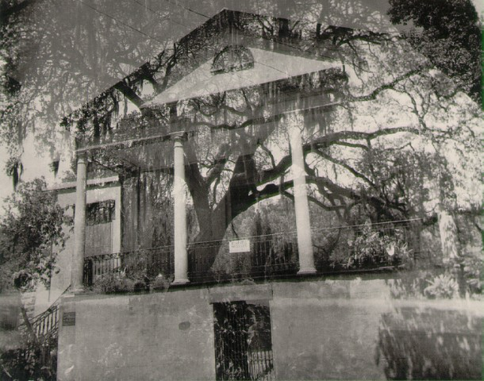
Figure 3: The Besieging Wilderness, Number Two. (Clarence John Laughlin, 1938).

Clarence John Laughlin’s surreal photographs of abandoned and decaying architecture create dream like environments that feel suspended between reality and imagination (see figure 3). The symbolism and atmosphere within the image create a connection between the viewer and the photograph, producing a sense of reality and truth. The abandoned buildings appear haunted by traces of past lives and memories. This produces imagery that exists between the spaces of memory and forgetting. His work effectively explores space that exist between two states.

Laughlin states that “everything that I see must become personal; otherwise, it is dead and mechanical” (Alexander, 2014). This quote directly rejects the purely documentary purpose of photography. Laughlin explains that images have little significance unless people personally connect to the memories they hold. It argues that rather than objectively recording environments, Laughlin transforms architectural space into emotional experience. His photographs therefore function less as records of reality and more as visual representations of memory, imagination, and absence.

The liminal atmosphere within Laughlin's work connects directly to Marianne Hirsch’s (1997) statement that, “they are visibly ghosts and shadows,” (p. 267). Hirsch’s description represents the haunting qualities associated with photography, specifically within Laughlin’s work, whereby photographs preserve traces of places, people, and experiences no longer fully present. Throughout Laughlin’s abandoned interiors there is a sense of emptiness and stillness, whereby these spaces feel suspended between existence and disappearance. His work visualises liminality through absence and uncertainty.

Despite memory, trace, and liminality all functioning as their own distinct conceptual areas, they all contribute towards a wider investigation into photography, exploring how photography will never be able to truly preserve lived experience due to the instability of memory. Memory itself operates as a process of reconstruction, reshaping itself through emotion and interpretation rather than just being seen as a true recall of a past event. In contrast, trace refers to photography’s ability to preserve fragments of reality, exploring how photography functions as evidence of past moments through a visual form. Liminality is a representation of the intersection between these two aspects, whereby this liminal space is created from the tension between present and past, reality and reconstruction, remembrance and forgetting.

This relationship between these keywords has become increasingly significant in terms of photographic practice. Over the years, photography has attempted to preserve memory through capturing lived experience and transforming it into a visual form. It has always been seen as an act of freezing a moment in time forever; however, it only captures a fraction of the true moment, a moment that is highly subjective and is open to interpretation from society. This shows that photographs cannot fully preserve the experience, missing aspects of emotion, perception, and context. Photography is not a perfect archive of memory but a fragmented trace of the past, clearly representing the instability of recollection.

In conclusion, these conceptual areas suggest that photography preserves whilst also weakening our connection to the past. It could be seen that images do allow memories to remain visible, but they do not reveal the distance between the lived experience and what it now represents in a modern context. This creates a liminal space where photographs can exist between documentation and reconstruction. This essay has highlighted the instability of memory and photographic truth.

To what extent does photography preserve memory, rather than reconstruct it?

List of Figures
Figure 1: Woodman, F. (1976). House #3, Providence, Rhode Island. The New York Review. Available at: https://www.nybooks.com/online/2011/01/24/long-exposure-francesca-woodman/. (Accessed: 5 May 2026).
Figure 2: Crewdson, G. (2018-2019). Red Star Express. Gagosian. Available at: https://gagosian.com/artists/gregory-crewdson/. (Accessed: 4 May 2026).
Figure 3: Laughlin, C.J. (1938). The Besieging Wilderness, Number Two. Lion Heart Autographs. Available at: https://lionheartautographs.com/autographs/photographer-clarence-laughlin-draws-the-third-eye/. (Accessed: 5 May 2026).

Bibliography
Alexander, S. (2014). The Object and The Artist: Clarence John Laughlin and Iceland’s Bellstop. [online] Medium. Available at: https://medium.com/about-south/the-object-and-the-artist-ec88e4da2da3 (Accessed: 6 May 2026).

Barthes, R. (2011) Camera Lucida: Reflections on Photography. Hill and Wang.
Bergson, H. (2012) Matter and Memory. 1st ed. Dover Publications.
Halbwachs, M. and Coser, L.A. (1992) On Collective Memory. University of Chicago Press.
Hirsch, M. (1997) Family Frames: Photography, Narrative, and Postmemory. Harvard University Press.
Loh, A. and Vescovi, A. (2015). Interview with Photographer Gregory Crewdson | The American Reader. [online] Available at: https://theamericanreader.com/interview-with-photographer-gregory-crewdson/ (Accessed: 9 May 2026).
McWilliams, J. (2017). Ideas and a New Hat. [online]. Available at: https://www.theparisreview.org/blog/2017/01/19/ideas-and-a-new-hat/ (Accessed: 3 May 2026).
Sontag, S. (1979) On Photography. Penguin.
Tagg, J. (1998) The Burden of Representation: Essays on Photographies and Histories. Macmillan.
Turner, V.W. (1995) The Ritual Process: Structure and Anti-Structure. Aldine de Gruyter. Available at: http://www.gbv.de/dms/ilmenau/toc/185467008. (Accessed: 10 May 2026).

