

Submitted by: Peter Olaniyi Hamza
Student Number: 1706491
Module Title:
“Digital Skills and Research Methods”
Assignment Title:
“Digital Skills/Modern Tools Technology”
Module Lecturer’s Name: Anly Chandra Mohan

Table of Contents
Introduction: 3
What is Technology? 3
Improved Workplace Efficiency and Employability: 4
Smart Phones: 4
Web Based Email: 4
Video Conferencing: 5
File Storage and Social Networking: 5
Employee Perspective towards Technology: 5
Effects of Social Media to Make a Better Communication, Marketing and Information Gathering: 6
Efficiency in Social Media: 8
LinkedIn Profile for Promoting Business: 8
Appropriate Use of Technology: 10
Safety and Securities of the Social Media and Web Based Applications for the Workplace: 11
Conclusion: 11
Reference: 12
Appendix: 13

Introduction:
Digital skills are important in the world. As globalization is happening I every corner of the globe, so it is important to have the skills that has emerged with the technological advancement. According to Sarah A Paul, Digitalization is the process where people and organizations both are getting benefitted (Sarah A Paul, 2012). In the workplace in this competitive world, digital skills are needed. Due to a rapid increasing of technology based services, the employees and the organizations both maintain a systematic way of communications. In this report we are going to analyze the workplace efficiency through web based mail, web conferencing, file storage and social networking and how social networking media (Also known as Social Media) improves and helps the system of marketing, what is LinkedIn and its process of promoting a business or a profile and what is the security policy, safety measures for providing a better service with digital skills. This report will help and guide us to demonstrate the fact of digitalization of the recent world. In past companies are using the lengthy process of communication. But nowadays, email, telephone, fax is easily using without any hesitation among the employees and management with a safeguard. Internet protocol, firewall and many more things are emerging for the security of the process.

What is Technology?
The term technology is a word of various meaning. It is the process of innovation. According to Muller, people are nowadays using various things and these things are depend on technology (Muller, 2011). It is a broad definitive word to write. In this age of globalization, market is becoming competitive. New innovations are happening. Because of smart devices like smart phone, tablets, laptops and many types of new and tech gadgets, technology is advancing. Telecommunication companies are offering high speed internet (3G, 4G/LTE) service for their customers. Customers are nowadays demanding the best possible choices among the newest technologies. Technology emerges our life into a different scenario. Like, we are using various social networking websites like Facebook, Twitter, YouTube, SnapChat etc. These sites help us to reflect ourselves, promoting the business as well. Organizations are now fully depending on the technology and recruiting employees with digital skills to maintain effective and efficient working environment. So, technology is the very important factor for modern organizations to ensure a better service and communication.

Improved Workplace Efficiency and Employability:
Employee’s workplace efficiency and employability totally depends on the technological advancement of organizations. According to Betner, organizational goals and objectives are nowadays based up with the technological advancement of the company (Betner, 2010). Organizations are now totally dependent on e-service program and maintain a strong database and IT back up for their better communication. Smart phones, web based email, video conferencing are the main things to maintain a better communication for inside and outside of the organizations.

Smart Phones:
Smart phones are the most important thing for communication. Employees can easily communicate with the help of smart phones and tablet by using the voice calling, video calling, SMS, MMS services. Organizations can have a specific mobile number, fax number for communicating with them and thus HR are recruiting employees having the knowledge of smart phones. Browsing internet, receiving calls and other stuffs are very much needed for an employee.

Figure: Smart phones

Web Based Email:
Web based email are the main blessings for the organization to maintain a secure communication with the employees internally as well as externally. Web based means where internet connection is needed. According to Gordon, web based emails are the blessings nowadays and taking the communication is a new way (Gordon, 2013). There are various web based email service providers are found like Gmail, Yahoo, Hotmail and many more.


Figure: Web Based Email Service Provider

Video Conferencing:
It’s the most responsive and reliable communication nowadays for the companies. Organizations can easily communicate with the employees with video conferencing and maintain a better communication. It requires a high-speed internet connection. Employees should have the skills to represent themselves with a video conferencing, must have a minimum knowledge of web conferencing, e chat communication.

File Storage and Social Networking:
There are a lot of file storage domains are found like Google, Yahoo, Hotmail and they have different cloud storage space for their users. This data base servers are working as the security for their client’s data. Organizations can easily buy their desired domain for their organizational purpose. Some file storage domains are Drive (Google), Dropbox (Yahoo), OneDrive (Hotmail/Outlook).
Social networking is nowadays a burning question for the digitalization. Each and every company has maintained their e-commerce services through social sites. Employees should have the digital skills of maintaining social sites, promoting their business and target the beneficial audience. So, as a result, organizations are recruiting the Digital Marketing Executives for giving the better-quality services. Search Engine Optimization (SEO), database maintaining are the common jobs among the employees with the technological advancement.

Employee Perspective towards Technology:
Employees are nowadays very much career oriented as life styles has changed. So, they are well enough to know about latest technology and suited up for the use of the latest technology in their organizations. Employees are easily gaining the maximum output by giving the minimum input by using latest technology. As employee satisfaction, engagement and motivation ensured. According to Slever, employee satisfaction of an organization is totally depending on the working environment (Slever, 2009).

Effects of Social Media to Make a Better Communication, Marketing and Information Gathering:
Social media helps organizations and employees to maintain a better communication. Companies are opening a social account to maintain a good communication with their audience as well as customers. As online business is emerging for Facebook, organizations are creating new pages, group in Facebook, Twitter and maintain a good communication.
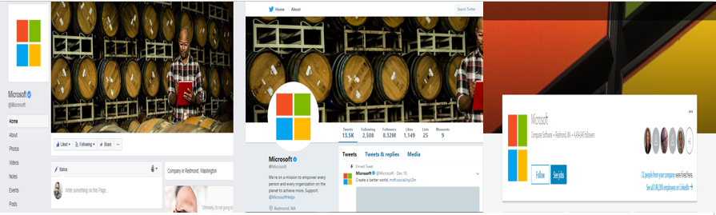
Figure: Microsoft’s Facebook, Twitter and LinkedIn Account
For marketing and promotion, different companies are implementing different policies and taking the policies in the new way. Just like others, companies are promoting their business in social media and taking the online business market by doing Search Engine Optimization (SEO), data maintenance with the effective, digital skilled employees. Many organizations are nowadays up to date with their social websites/addresses to be the first with their communication. Social media marketing is a broad sector for doing business. According Sherel, social media marketing nowadays become an extra income source for both the organizations and individuals for the rapid digitalization of the technology (Sherel, 2015). Just like others, every companies are now promoting their business by doing live chat session, posting a video, giving a post on Facebook, Twitter to attract and let their customers to know about products/services.

Figure: Promotional Post by Microsoft on Facebook.
In this above picture, Microsoft is advertising about their latest windows “Windows 10”. So, they know how popular Facebook becomes for the digitalization of the communication.
For gathering information, social media is a big platform nowadays. Telecommunications are offering high speed internet connection and thus people are now always connected with the internet. As latest news of sports, drama, political, celebrities are now in hand of us. News portals are now giving their news update of different section on Facebook, Twitter.
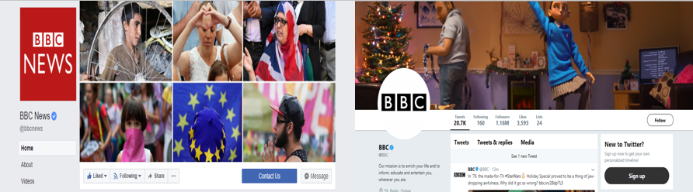
Figure: Facebook and Twitter Page of BBC

Efficiency in Social Media:
It is obvious nowadays that people are engaging themselves in internet. Social sites are one of the most internet based communication system in the recent world. So, efficiency of social media, communication by social media has brought people in one place. By social media, organizations are recruiting and cut the cost of recruiting internally. Students are making subject related group and making their lessons easily. Organizational information, culture, universities, hospitals, each and every institution are nowadays engaged with social media. When organizations are recruiting people, they now see the candidate’s extracurricular activities by Facebook or Twitter account. A social media account can reflect person’s attitude, behavior nowadays. Because when you want to create an account in social site, you are authorized to give some personal and academic information for your preference. Thus, people can get an idea about yourself.

LinkedIn Profile for Promoting Business:
LinkedIn is an online social media website where people can add their academic and non-academic qualifications in a structured way. It’s a formal communication site for both the employees and the organizations. People are nowadays recruiting employees with LinkedIn profile and thus recruitment is easier ever than before.
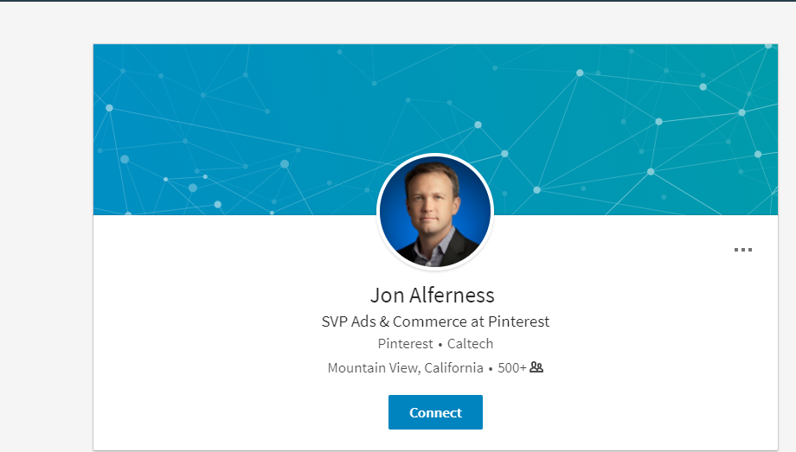
Figure: A LinkedIn Profile
Here the profile belongs to “Jon Alferness”, who is SVP (Senior Vice President) of Caltech. This profile has 500 friends, and this is the formal account for his business and job. In this picture, we see he is from California and working in an ad agency as SVP.
For promoting business, a LinkedIn page should create by the organizations. So, organizations should need digital skilled employees having the knowledge of SEO tools, database marketing, and strategy planner. For promoting a business, a business page helps a lot. From that page organizations can make various types of post for their product/service. After that follower of that page should get the notification if any update given by the page. Recruiters often post job circular form LinkedIn and also check the LinkedIn profile of the candidate. So, it becomes an easier process as no filtering is needed. Recruiters just check the profile and make the 2nd phase of the recruitment process.
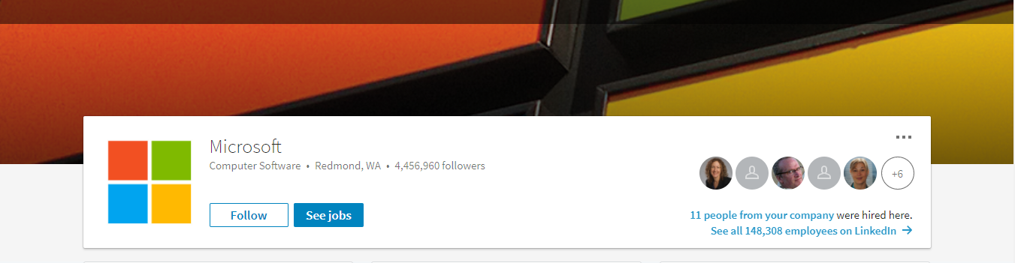
Figure: LinkedIn Page of Microsoft
The page contains overall available jobs in Microsoft. It also helps to create a dynamic and strategic plan to make the Microsoft’s next movement. If a normal user follows the page, he/she will get the job notification from Microsoft. And by opening a page in LinkedIn, corporate as well as the employees can get the notifications from Microsoft. And Microsoft also opened a door to purchase directly through LinkedIn by clicking an URL link. It has enhanced a lot for Microsoft for doing business globally and locally which increased their sales and brand reputation.

Appropriate Use of Technology:
Use of technology is faster for any forms of communications nowadays. Because of many social networking sites like Facebook, LinkedIn, Twitter, YouTube people both formally and informally using them as a means of communication. For example, organizations are nowadays recruiting by giving vacancy announcement in Facebook, LinkedIn and thus getting their desired candidates for the business. Employees are also emailing their CV’s to the organizations and get the interview notification. So, communication process is getting quite easy. Facebook has some unique benefits of communication. Like chatting, voice calling, video calling, giving posts and comments, giving like to other’s post are the very basic form of communication for Facebook.
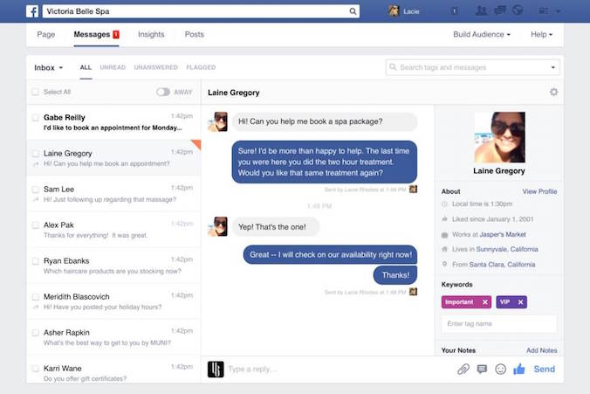
Figure: Chat Log on Facebook
Technology has blessed us not only with the social sites like Facebook, Twitter but also with a revolutionary changes of internet connection and speed. People are nowadays using smart devices and thus they are using high speed internet connection. Operators already come up with 3G and 4G technology. 3G means HSPA+ or 3rd generation and 4G means LTE or 4th generation connection for data services. Wi-Fi and some other internet based modems and also available and affordable for the people nowadays. But sometimes misusing of technology has found. Hacker and many black-market investors hacks the database of a company and steal the important document from the cloud. And the whole system will be in danger. Sometimes celebrities fan page or verified account get hacked by hacker. As a result, fans become angry and inappropriate communication occurs. For appropriate communication procedure, some steps should be taken immediately by the concerns.

Safety and Securities of the Social Media and Web Based Applications for the Workplace:
For the workplace, employee engagement and motivation among the employees are essential. For measuring safety for the technology based communication, both organizations and employees should help the management. For external communication, there always should be some potential strategy maker to maintain all the external communications of the management. For internal communication, social media, web sites and some other internet based software and database can be used. Organizations nowadays are taking a safety measurement for data safety. Employees of the HR department of Apple Inc. uses the face detection identity card and all the things have been smoothly maintained by CC cameras. Password of internal software, database security should be taken by the management as soon as possible for the company. For web based communications, company should buy a unique domain of itself. Like Samsung, all the employees should communicate with the specific email address hr@samsung.com.korea which noted that Samsung’s domain is “@samsung.com.korea”. By taking some steps organizations can maintain a good and effective workplace environment for the company.

Conclusion:
From the very beginning of the assessment, we have seen the technological advancement of smart phones, web based service and many more. With the help of those, organizations and employees can maintain workplace effective and efficient. Organizations are rapidly becoming modernized and uses the best possible choices of technology. Social media is the blessings of technology. Communication is now become a one-handed operation for people. Organizations are using Facebook, Twitter, YouTube, SnapChat etc. to promote their business by creating ID, fan page and many more. Recruitment of employees are always going on the social sites. Most of the companies has fan page nowadays which ensure the customer satisfaction in terms of service and responsiveness. Digital skills are really needed.

Reference:
- Sarah A Paul (2012), Digitalization for the Employees, 2nd edition, Pearson Publications.
- Muller (2011), Technological Advancement for Digitalization; an Empirical Study of Online Business, p 345-456, Hudson Publications.
- Betner (2010), Effective Communication and Employability Skills for the Mangers, 4th edition, p 560-456, Pearson Publications.
- Gordon (2013), Digitalization of Communication, A Study of Malaysian E-Commerce Company, Journal of Article, Published on 5th June 2013.
- Selver (2009), Employee Perspective towards Technology, p56-89, Management and Organizational Behavior.

Appendix:


