

Breathe for Two – A Technology- Enhanced Smoking Cessation Pathway for Pregnant Women in the UK (POSTER & PITCH)
Name: Abeer Al Qadhi
Student Number: 2410956
Course Name: Changemakers: Creativity and Value Creation
Class Group: G2
Course Code: (BMHP5014_BIRM)
Lecturer Name: Parese Ahmed

Contents
Introduction 2
Poster: Breathe for Two 3
Pitch: Breathe for Two – A Technology- Enhanced Smoking Cessation Pathway for Pregnant Women in the UK 4
Reference list 7
Images Reference list: 8

Introduction
This assignment outlines an innovative UK health and social care initiative aimed at smoking cessation during pregnancy. Smoking in pregnancy remains a significant and preventable public health issue, which disproportionately affects women in socioeconomically deprived communities and contributes to adverse maternal and neonatal outcomes. In response, in this assignment, I proposes Breathe for Two, a technology-enhanced, midwife-supported smoking cessation pathway embedded within NHS maternity services. The accompanying academic poster outlines the innovation, while the written pitch provides a detailed rationale, explores its potential impact on health and well-being, and considers relevant policy, ethical, and professional frameworks. Together, the poster and pitch demonstrate how digital innovation can improve engagement, reduce health inequalities, and support national public health priorities.

Poster: Breathe for Two
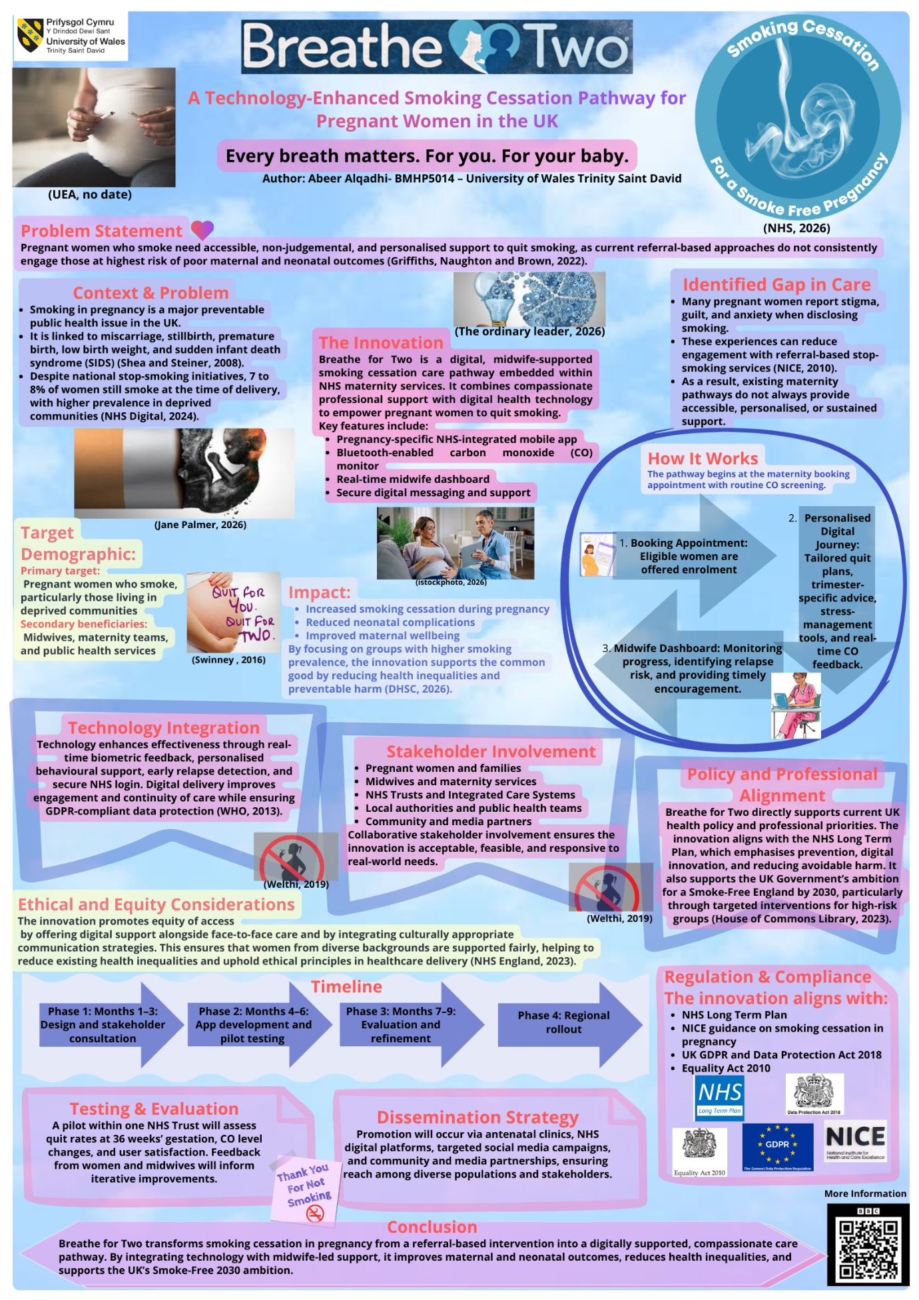

Pitch: Breathe for Two – A Technology- Enhanced Smoking Cessation Pathway for Pregnant Women in the UK
Smoking during pregnancy poses one of the most significant preventable public health challenges in the UK, impacting maternal and neonatal outcomes. Despite long-standing awareness campaigns and readily available stop-smoking services, a significant number of women continue to smoke throughout their pregnancy, particularly in areas of socioeconomic deprivation. I propose Breathe for Two, a digitally integrated, midwife-supported smoking cessation pathway embedded within NHS maternity services. This innovation aims to improve engagement, reduce health inequalities, and support national public health priorities through compassionate, personalised, and technology-enabled care.
Smoking during pregnancy is associated with miscarriage, stillbirth, premature birth, low birth weight, and sudden infant death syndrome (Shea and Steiner, 2008). Although national initiatives have reduced overall smoking prevalence, approximately 8–9% of women in England are still recorded as smokers at the time of delivery, with significantly higher rates among women in deprived communities (NHS Digital, 2024). This demonstrates that existing approaches, which often rely on brief advice and referral-based pathways, are not consistently effective for those at highest risk.
Through my research, and practice, it is clear that many pregnant women experience stigma, guilt, and anxiety when disclosing smoking behaviour (Grant et al., 2020). These emotional barriers can discourage honest conversations and reduce engagement with stop-smoking services, particularly when support feels impersonal or judgemental (NICE, 2010). Breathe for Two directly addresses this gap by reframing smoking cessation in pregnancy as a supportive, continuous care pathway, rather than a one-off intervention.
Breathe for Two is a digital, midwife-supported service designed to integrate seamlessly into routine maternity care. The programme begins at the maternity booking appointment, a point at which routine carbon monoxide (CO) screening is already standard practice. Women who smoke are offered enrolment into the programme, thereby ensuring early intervention without additional stigma. Once enrolled, women gain access to a pregnancy-specific, NHS-integrated mobile application, a Bluetooth-enabled CO monitor, and ongoing support from their midwife via a secure digital dashboard.
The mobile application provides personalised quit plans, trimester-specific advice, stress-management tools, and real-time CO feedback. It also supports behavioural change through motivational messaging, progress tracking, and accessible educational content. Significantly, the app is designed to enhance professional care, not replace it. This enables midwives to monitor CO trends, identify early relapse risk, and offer timely encouragement, thereby strengthening therapeutic relationships and promoting continuity of care.
The innovation primarily targets pregnant women who smoke, especially those in deprived communities where smoking prevalence is higher. Secondary beneficiaries, including midwives, maternity teams, and public health services, gain access to improved monitoring tools and more effective engagement pathways. By focusing on groups disproportionately affected by smoking-related harm, Breathe for Two supports the common good by reducing health inequalities and preventable morbidity (Department of Health and Social Care, 2026).
From a health and wellbeing perspective, the anticipated benefits are substantial. Increased smoking cessation during pregnancy improves birth outcomes, reduces neonatal complications, and enhances long-term child health. Moreover, women who successfully stop smoking during pregnancy are more likely to remain smoke-free postpartum, benefiting families and communities (Public Health England, 2015).
Technology is central to enhancing the innovation's effectiveness. Real-time biometric feedback, via CO monitoring, enables women to observe immediate physiological improvements, reinforcing motivation and promoting behaviour change. Digital delivery supports sustained engagement, while secure NHS login and GDPR-compliant data protection ensure confidentiality and trust (World Health Organization, 2013). This approach aligns with the NHS's increasing emphasis on digital health solutions and reflects contemporary best practice.
Breathe for Two aligns closely with current UK health policy and professional guidance. The innovation supports the NHS Long Term Plan, prioritising prevention, digital innovation, and reducing avoidable harm (Action on Smoking and Health, 2025). It also adheres to NICE guidance on smoking cessation in pregnancy, which recommends intensive behavioural support, CO monitoring, and ongoing engagement throughout pregnancy. Furthermore, it directly contributes to the UK Government's ambition for a Smoke-Free England by 2030, particularly through targeted support for high-risk populations (House of Commons Library, 2023).
Ethical and equity considerations are central to the design of Breathe for Two. Smoking during pregnancy is closely linked to social disadvantage, mental health challenges, and stress. Acknowledging that a purely directive or punitive approach risks increasing stigma and disengagement, Breathe for Two adopts a non-judgemental, woman-centred approach that promotes autonomy, dignity, and informed choice. To ensure equitable access and ethical healthcare delivery, the pathway offers digital support alongside face-to-face care and incorporates culturally appropriate communication strategies (NHS England, 2023).
Breathe for Two would be implemented in phases. The initial phase would involve design and stakeholder consultation with pregnant women, midwives, and public health professionals to ensure the app's acceptability and feasibility. Following this, the app would be developed and pilot tested within one NHS Trust. Evaluation would focus on quit rates at 36 weeks' gestation, changes in CO levels, and user satisfaction. Feedback from women and healthcare professionals would inform iterative improvements before a regional rollout.
Designed with paramount ethical considerations, this innovation adheres to relevant legislation and professional standards, including NICE guidance on smoking cessation in pregnancy (NICE, 2021), the UK General Data Protection Regulation, and the Equality Act (2010). Acknowledging the close links between smoking in pregnancy and social disadvantage, trauma, and mental health challenges, Breathe for Two adopts a woman-centred, non-judgemental ethos. This approach ensures the programme avoids punitive or moralising stances, which risk further marginalisation, and instead respects autonomy, promotes dignity, and supports informed choice.
Public and stakeholder engagement is essential to the success of this innovation. Dissemination will occur through antenatal clinics, NHS digital platforms, targeted social media campaigns, and community and media partnerships. Encouraging public involvement is vital because smoking cessation in pregnancy benefits not only individuals but families and wider communities. Furthermore, public awareness and support can help reduce stigma, normalise help-seeking, and reinforce shared responsibility for maternal and child health (Modak et al., 2023).
In the longer term, the digital infrastructure developed for Breathe for Two could be adapted for other public health priorities, such as preventing postnatal smoking relapse or supporting wider family-based smoking cessation, thereby enhancing sustainability and value for money through the efficient use of NHS resources.
In conclusion, Breathe for Two represents a compassionate, evidence-based, and technologically enhanced approach to smoking cessation in pregnancy. Integrating digital innovation with midwife-led care, this pathway will address current gaps in maternity services, improve health outcomes, reduce inequalities, and support national public health priorities. I am seeking support to pilot and implement this innovation within NHS maternity services, with the long-term aim of contributing to healthier pregnancies, healthier babies, and a smoke-free future.

Reference list
Action on Smoking and Health (2025) Overview: NHS tobacco treatment commitments. Available at: https://ash.org.uk/for-professionals/nhs-tobacco-dependence-treatment-resources/nhs-long-term-plan-tobacco-treatment-hub/overview-nhs-long-term-plan-tobacco-commitments#:~:text=The%20NHS%20Long%20Term%20Plan,Cookie%20Policy%20for%20more%20information. (Accessed: 26 February 2026)
Department of Health and Social Care (2026) Smoking and inequalities. Available at: https://fingertips.phe.org.uk/profile/tobacco-control/supporting-information/smokingandinequalities (Accessed: 22 February 2026)
Equality Act 2010, c. 18. Available at: https://www.legislation.gov.uk/ukpga/2010/15/section/18 (Accessed: 28 February 2026)
Grant, A., Morgan, M., Gallagher, D. and Mannay, D. (2020) ‘Smoking during pregnancy, stigma and secrets: Visual methods exploration in the UK,’ Women and birth : journal of the Australian College of Midwives, 33(1), pp. 70–76. Available at: https://doi.org/10.1016/j.wombi.2018.11.012.
Griffiths, S.E., Naughton, F. and Brown, K.E. (2022) ‘Accessing specialist support to stop smoking in pregnancy: A qualitative study exploring engagement with UK‐based stop smoking services,’ British journal of health psychology, 27(3), pp. 802–821. Available at: https://doi.org/10.1111/bjhp.12574.
House of Commons Library (2023) The smokefree 2030 ambition for England. Available at: https://commonslibrary.parliament.uk/research-briefings/cbp-9655/#:~:text=In%202019%2C%20the%20government%20published,or%20after%201%20January%202009 (Accessed: 21 February 2026)
Modak, A., Ronghe, V., Gomase, K. P., Mahakalkar, M. G. and Taksande, V. (2023) ‘A Comprehensive Review of Motherhood and Mental Health: Postpartum Mood Disorders in Focus,’ Curēus (Palo Alto, CA), 15(9), p. e46209. Available at: https://doi.org/10.7759/cureus.46209.
NHS Digital (2024) Statistics on Women's Smoking Status at Time of Delivery: England, Quarter 4, 2023/24. Available at: https://digital.nhs.uk/data-and-information/publications/statistical/statistics-on-women-s-smoking-status-at-time-of-delivery-england/statistics-on-womens-smoking-status-at-time-of-delivery-england-quarter-4-2023-24 (Accessed: 24 February 2026)
NHS England (2023) Inclusive digital healthcare: a framework for NHS action on digital inclusion. Available at: https://www.england.nhs.uk/long-read/inclusive-digital-healthcare-a-framework-for-nhs-action-on-digital-inclusion/#:~:text=Digital%20exclusion%20can%20compound%20health,groups%20of%20people%20may%20face (Accessed: 20 February 2026)
NICE (2010) Smoking: stopping in pregnancy and after childbirth. Available at: https://www.nice.org.uk/guidance/ng209/evidence/ph26-smoking-stopping-in-pregnancy-and-after-childbirth-guideline-june-2010-pdf-10892314911 (Accessed: 21 February 2026)
NICE (2021) Tobacco: preventing uptake, promoting quitting and treating dependence. NG209. Available at: https://www.nice.org.uk/guidance/ng209/chapter/Treating-tobacco-dependence-during-pregnancy-and-in-the-first-year-after-childbirth#:~:text=Provide%20routine%20carbon%20monoxide%20testing,4%20ppm%20or%20above%20or (Accessed: 28 February 2026)
Public Health England (2015) Health Matters: Smoking and Quitting in England. Available at: https://www.gov.uk/government/publications/health-matters-smoking-and-quitting-in-england/smoking-and-quitting-in-england (Accessed: 26 February 2026)
Shea, A.K. and Steiner, M. (2008) ‘Cigarette smoking during pregnancy,’ Nicotine & tobacco research, 10(2), pp. 267–278. Available at: https://doi.org/10.1080/14622200701825908.
World Health Organization (2013) WHO RECOMMENDATIONS FOR THE PREVENTION AND MANAGEMENT OF tobacco use and second-hand smoke exposure in pregnancy 2013. World Health Organization.

Images Reference list:
BBC (2026) How the QR code was invented. Available at: https://www.bbc.co.uk/programmes/w3ct5ykn (Accessed: 23 February 2026)
IStock photo, (2026) Happy nurse and pregnant woman using digital tablet during home visit. stock photo. Available at: https://www.istockphoto.com/photo/happy-nurse-and-pregnant-woman-using-digital-tablet-during-home-visit-gm2249078055-662880814 (Accessed: 23 February 2026)
Jane Palmer (2026) Smoking in Pregnancy. Available at: https://www.pregnancy.com.au/smoking-in-pregnancy/?srsltid=AfmBOooPnDztHFi6oIQoYv1DoQMXAmwfa_gnWp9F-nlz620pV5PPHqKF (Accessed: 23 February 2026)
NHS (2026) Maternity Smoking Cessation. Available at: https://www.bradfordhospitals.nhs.uk/maternity-smoking-cessation/ (accessed: 23 February 2026)
Swinney (2016) Pregnant? Here’s Help to Be Smoke-Free. Available at: https://eatrightmama.com/pregnant-smoke-free/ (Accessed: 23 February 2026)
The ordinary leader (2026) 5 Keys to Leading Innovation. Available at: https://theordinaryleader.com/blog/leading-innovation/ (Accessed: 23 February 2026)

UAE (no date) Understanding women's health: stopping smoking during pregnancy. Available at: https://www.uea.ac.uk/health/understanding-womens-health-stopping-smoking-during-pregnancy (Accessed: 23 February 2026)
Welthi (2019) Quit Smoking during Pregnancy. Available at: https://www.welthi.com/Quit-Smoking-during-Pregnancy (Accessed: 23 February 2026)

