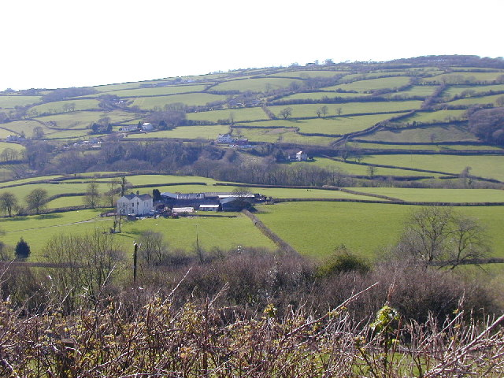
Lens Look
BMSP 4008

Leonard Betton
1910735
Lens Look – Gwendraeth Valley

Blog 1 – Identify issues involving people

The Gwendraeth valley comprises of a group of villages home to approximately 21,000 people. The largest villages of Crosshands, Tumble, Gorslas, Llanon, Pontyberem, Pontyates and Cefneithin are where the largest clusters of people reside. Surrounding this area are the towns of Ammanford, Llanelli and Carmarthen, these areas are where most shops and facilities are situated. (admin, 2014)

One of the smaller villages in the area, the village of Drefach is situated on the outskirts of Crosshands in the middle of the Gwendraeth Valley. It falls into the Gorslas ward which is in the UK Parliamentary Constituency of Carmarthen East and Dinefwr. Its population 4747 with 24% over the age of 65 years old.
This Gorslas ward has the highest proportion of people aged over 45. The ratio of male to female is relatively equal and the welsh language is prominently spoken, boasting a 20% higher rate of welsh speakers in comparison to other areas in the valley. (Senedd Cymru Elections 2021, n.d.)
There are many types of issues that can have an effect on people today they include such things such as poverty, climate change, wars, human rights and global health to name but a few, all are serious and very important and I hope to tackle a few more in my next blogs. (Filipenco, 2022)
Today’s blog will look at the topic of global health and even more directly the health and fitness in our local area .
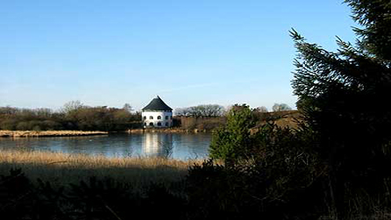

Formerly a population of working class people, the 2021 census suggests that the figures for the Gwendraeth Valley overall depict an older population, with a 32% increase in over 65 years old by 2043.
Research shows that as we get older we have many issues such as loneliness, adjusting to retirement, relocation, depression, bereavement and sometimes self-neglect. These are of course issues without looking at potential ill health that can also be associated with getting older.
A number of these issues are in the hands of our excellent health carers however there are also elderly who are keen and able to keep themselves as well as they can, and maintaining the independence they have for as long as they can. This involves taking care of their physical health, fitness and flexibility as well as their mental wellbeing.
Research shows that to keep fitter when your older can help reduce falls and can help prevent heart disease. It can also improve mental health and cognitive functions, and encourages social engagement if the person can get involved in a group exercise.
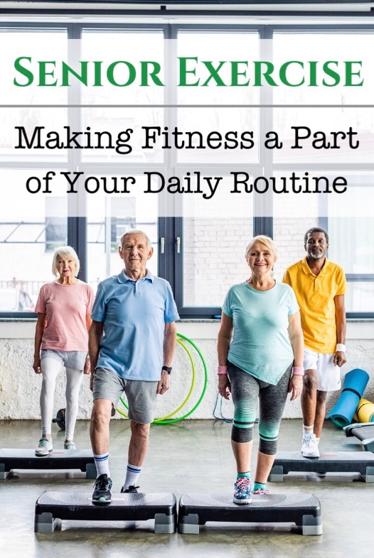

The NHS Wellbeing survey 2021, emphasises the right to age well and promotes an intergenerational society where age friendly societies are encouraged and supported and older people are applauded for their contributions to society. This survey showed that the over 65’s stated that they were anxious about their health and mental fitness; with 52% saying they were concerned if not able to spend time outdoors or in a facility where they could be with others.
Follow my next blog, come with me to look at the facilities there are in this area for socialising, fitness and general wellbeing for its residents.

Blog 2 – The everchanging role of community facilities

A community can be described as a population who share something in common, who share values and interact within a social system.
Community facilities are extremely important for many things in the community. ‘They provide the social, educational, welfare, health, spiritual recreational, cultural and leisure needs of the community and can inspire a sense of place by providing safe, vibrant neighbourhoods where people can meet and socialise’. (WAG, 2021).
The community centres have, dated back to pre-war times and over the years inherited an image of apple pies and crafts, jumble sales and concerts. This image of a dowdy building with velour heavy draped curtains are what sits in our minds when thinking of these halls. However, it didn’t really matter what was being held there its purpose, was always with the focus, as it is now of bringing the village community together. (Rowe, 2022).
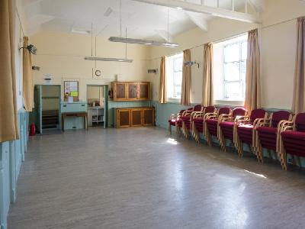

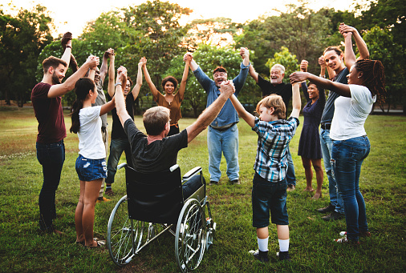

This new vision of community centre or village hall has got to eradicate that memory when you see the bright spacious buildings and the warm welcome received when you enter. It unites a community and everyone is treated equally with all ideas and work gratefully acknowledged and received.
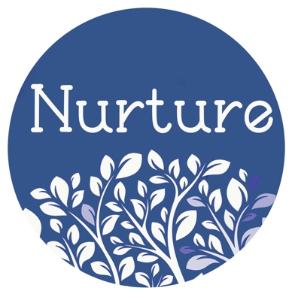
During my research I visited two venues, very similar in their mission but different in their approach.

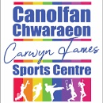

The Nurture Centre Carmarthen, is a place founded by busy Mums who wanted to socialise with their babies after having children, this place has grown and now offers many holistic therapy practices as well as hosting events such as ‘clothes swap’, inflatable play for children and warm space for anyone to chill. They profess to support groups such as

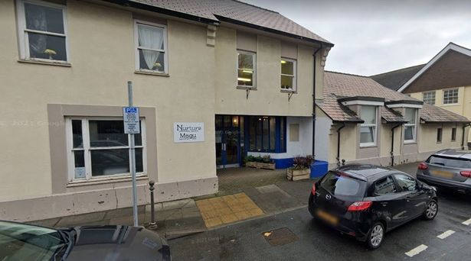

Canolfan Carwyn, is a venue that has been leased by the Baton Twirlers Association Cymru (BTAC). They use this hall as a base for their ‘Twirlers’ but also allow members of the community to use the facilities. They offer kickboxing, badminton, squash, box fit, walking football as well as ‘Dreigiau bach’, a local toddler rugby group and private hire of any of the facilities. They have changing rooms with showers and offer refreshments through vending machines. They offer a ‘Warm space’ for everyone.
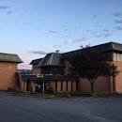

alcoholics anonymous and cancer support groups and have rooms available for hire for practically any community event. They also offer refreshments.
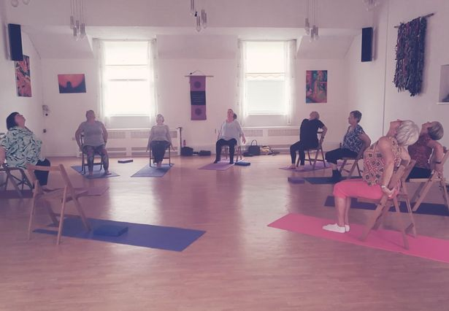

The Village Community centre can be used as a Hub for village life where the local football team train in the big hall or the ladies crochet class takes place in one of the smaller rooms. It doesn’t really matter what the event or activity as long as it serves its ultimate goal of allowing people to socialise in a clean, warm, safe environment.
Our next task is to come up with a plan to help people exercise. Here we go.

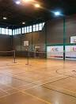
Blog 3 – Activity plan – Tai Chi

The group met and discussed the demographic area of Canolfan Carwyn taking into consideration its location within the larger Gwendraeth Valley. Through research the population of the area was found and it was determined that the population in Drefach is mainly over 45 years age.
We were tasked with a fitness and wellbeing community idea for this area and so discussed the possible exercises that could be offered to the target age group whilst not isolating any younger participants who may have wanted to try out a new skill.
Walking football was suggested, but that might be only supported by the male trainers and was already offered by the venue. Indoor golf, or indoor bowls, raised flower beds and soft bowls were other suggestions as well as the possibility of a martial art such as Tai Chi or Yoga.

The National Health Service (NHS) suggests that any activity is better than none, and the more done is better even if it is light activity. They recommend a combination of activities for optimum health and suggest activities that improve strength, balance and flexibility (Katie, 2023).

The excellent facilities in Canolfan Carwyn meant we were almost unlimited in what we could offer. The main hall is very spacious so would allow numerous activities to be done there. The smaller studio offered a more intimate room which could be used should the group be smaller or the activity not needing so much room.
However, it was suggested that some of this target age group could have mobility problems and so as not to exclude anyone from participating we narrowed our choices.
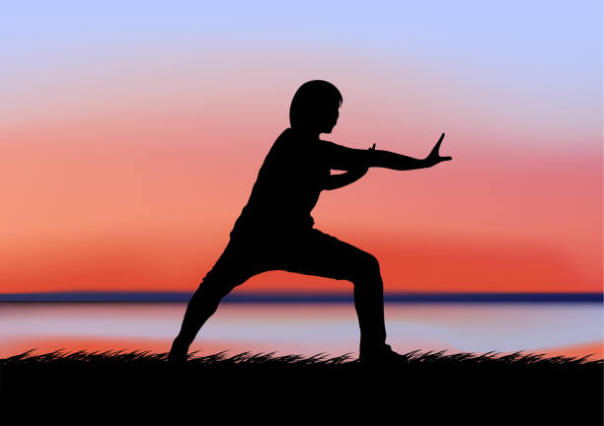
The final decision was a class in Tai Chi, this ancient Chinese art focuses on slow, gentle movements which supports balance and posture, strengthens muscles and is also known for its exceptional effects on mental wellbeing and stress reduction. It has the advantage of being able to be offered to any age group or fitness ability and there were adaptations available to use should there have been mobility problems. It was an unanimous decision.

We were fortunate that in our group as I am a Martial Arts 7th Dan in Karate and have also taught Tai Chi so I was the obvious choice of instructor for the event.
We discussed a poster and each member was tasked with a part to play in the organisation. From phoning the venue to booking the hall, to producing a poster, to planning the class structure. I suggested a seated Tai Chi option for any person who felt they might need the support of a chair.
I will end my blog now – Don’t forget it is open to everyone.- See you there!

References
Admin. (2014, June 23). Getting to Know: Cwm Gwendraeth Valley | Valley Commandos. Valley Commandos. https://www.valleycommandos.com/getting-to-know-cwm-gwendraeth-valley/
‌
Age UK. (2019). Exercise and keep fit classes for seniors | Age UK. Ageuk.org.uk. https://www.ageuk.org.uk/services/in-your-area/exercise/
‌
Filipenco, D. (2022, August 2). DevelopmentAid. DevelopmentAid. https://www.developmentaid.org/news-stream/post/147458/top-10-world-problems-and-their-solutions
‌
https://www.facebook.com/visualpropertyinsights. (2019, June 7). Gorslas, Carmarthenshire : Ward Level Demographics Composition Covering The Last Two Census. Vinsights.co.uk; VInsights. https://vinsights.co.uk/CensusWard/W05000477
‌
Katie. (2023, January 13). 7 Sport and Fitness Activities for Older People. LifeConnect24. https://www.lifeconnect24.co.uk/blog/sport-and-fitness-activities/
‌
Local Well-being Assessment. (n.d.). https://hduhb.nhs.wales/about-us/your-health-board/board-meetings-2022/board-agenda-and-papers-26-may-2022/agenda-and-papers-26-may-2022/carmarthenshire-assessment-of-local-wellbeing-may-2022pdf/

MacQueen, K. M., McLellan, E., Metzger, D. S., Kegeles, S., Strauss, R. P., Scotti, R., Blanchard, L.& Trotter, R. T. (2001). What is community? An evidence-based definition for participatory public health. American Journal of Public Health, 91(12), 1929–1938. https://doi.org/10.2105/ajph.91.12.1929
‌
Rowe, R. (2022, January 16). What’s the point of village halls? The BV. https://www.theblackmorevale.co.uk/2022/01/16/whats-the-point-of-village-halls/

Senedd Cymru Elections 2021. (n.d.). Www.carmarthenshire.gov.wales. Retrieved April 14, 2023, from https://www.carmarthenshire.gov.wales/home/council-democracy/elections-voting/senedd-cymru-elections-2021/#.ZDmlmy2ZPPA
‌
WAG . (2021, October 7). Age friendly Wales: our strategy for an ageing society [HTML]. GOV.WALES. https://www.gov.wales/age-friendly-wales-our-strategy-ageing-society-ht

