Module: Professional and Career Development
Module Code: BMSW 4005

Assignment Title: Task 3 – Reflective Portfolio of Work

Student Name: Kushna Begum
Student ID Number: 1813048

Module Leader: Abdi Rahman

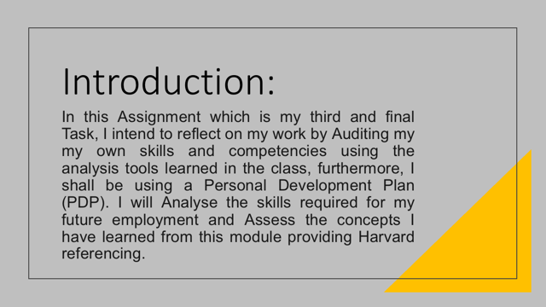

Audit of Own Skills and Competencies:
Initially unaware of my skills and competencies, nevertheless, I had confidence to enhance my future.

Using Analysis Tools – learned in class:
In class initially learned elevator pitch and this has reflected on me, thinking – Reflection based cycle. Gibbs, G. (1988) Learning by doing.

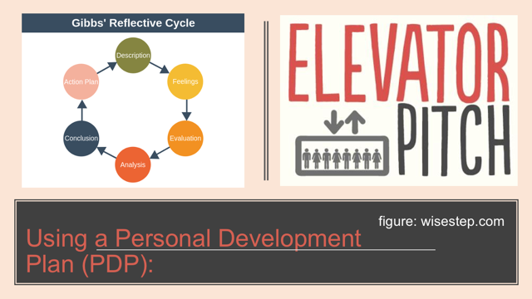

Smart Goals / Skills: | Reason: | Action / Achieve by: | Challenges: | Success Criteria / Resources: | Success Measures:
Digital IT | I have always enjoyed working digitally & especially in this current time with the virus everything is virtual so it is important to be aware digitally. | 6 Months | Lack of tools and technical issues | Capital tools such as laptop & internet | 80 Hours completed
Employability Skills | This is very dear to me as employment to me does not only mean wages or salary, it is my bread & butter, as well as spending more time at work than home. | 6 Months | Lack of work experiences with lockdown | Online researches | 80 Hours completed
Problem Solving | Always open to ideas to solve problems. | 3 Months | Confrontations | Online education | 40 Hours completed
Decision Making | Do not wish to be indecisive. | 3 Months | Always have to be fair & wise even with family business | Reviews & searching for information | 40 Hours completed
Team Work | Thoroughly enjoy working with a team. | 3 Months | Different personalities | Socialise professionally | 40 Hours completed
Communication Skills | I am well-mannered, this would-be bonus to my personality. | 2 Months | Cultural barriers | Intense research on these skills | 30 Hours completed
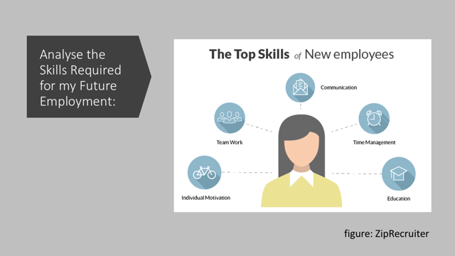

After analysing within my research, according to careers.govt.nz> uk – I have been aware that it is not only correct to be self aware but also is essential to have a Positive attitude. Being calm and cheerful when things go wrong. As well as having the Communication skills is vital as you can listen and say information clearly when you speak or write. Furthermore, Teamwork, Self-management, Willingness to learn, Thinking skills (problem solving and decision making) and Resilience skills will take you a long way in your employment journey. After reading chapter 18 of the core text book – page 29 – 31 of Morgan, P (2017) the Johari window, my view is that it is key to use within the skills as it will be a good guideline to follow, it is always a great bonus to have the hard skills as well as the soft skills in employment.
Being able to identify the weaknesses and ability to work on them is also a skill it self which organisations require to weigh your willingness of development. The capability of convincing the potential employer of your ideas and your input within is a skill that the employers will appreciate. The best way to analyse the employment requirement skills is to overview the career development such as “the process of learning and improving skills for employment and generating progression” Cambridge Dictionary. Teamwork, time management, individual motivation and education skills is the upmost employment requirements.

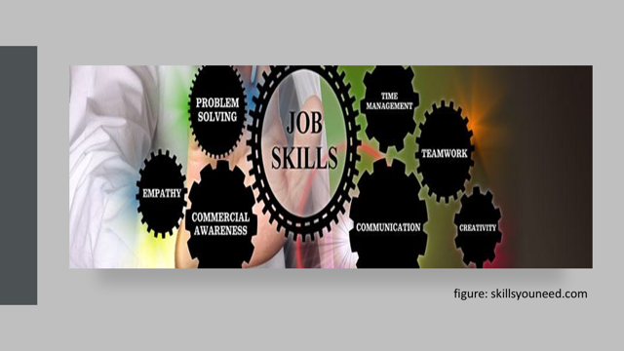

Empathy skill is the power of entering into another personality (Chambers English Dictionary, 1989 edition) and is awareness of feelings and emotions of other people. It is a key element of emotional intelligence, the link between self and others, it is an individual understanding of other people’s experience – empathy goes further than sympathy. Prioritising time better is a technique and it will help get more things done within timeframe and this set of skills are very effective in front of the employers eyes. Which means using time wisely, time management skills guides / prioritise work, leaves enough time to delegate, helps make decisions correctly, reach goals at a set timing, time for multitasking, can think strategically and in schedule.
It helps focus more at work and leaves with less distractions or interruptions, which means reviewing entire day and reflect on it, even if it means taking a small break. Time management skills is more important than efficient, it will generate less stress and anxiety. Creativity will be most required and needed skill, to resolve complex problem-solving and critical thinking, this skill gives the ability to be open minded and think about a task or a problem in a new or different way, it even enables to use the imagination to generate new ideas as creativity, looking at things from a new unique perspective, you can find the patterns and make connections to find opportunities. Creative thinking skills help combine two different ideas and making them better into one idea.
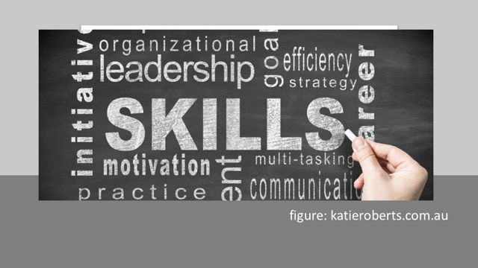

Although there are many different leadership skills required in employment, but most in – demand ones are; active listening – another technique that is used in training and solving disputes or conflicts. Ability to share messages and make complex ideas easy to understand for everyone. Ability to inspire and convince others. Flexibility is important – being versatile, resilient and responsive to changes – adapting to unexpected demands in employment. Organisation skills are abilities that lets focus on different tasks, and use time, energy, strength, mental capacity, and physical space effectively and efficiently in order to achieve the desired outcome. Ability, meeting deadlines – [a critical skill set] by prioritising tasks in time factors and plan ahead, understanding requirements and not be shy or afraid to ask question.

Perseverance and motivation skills are vitally required in employment purely for the purpose of pursuing higher goals and developing an ability to deal with setbacks and failure on the way. By persisting and overcoming obstacles including physical barriers, criticism, and discouragement. Motivation skills encourages to increase the chances of getting positive results when interfacing with customers, upper management, suppliers and team members. The ability to work under pressure skills involves dealing with constraints which are often outside of your control – these might be resource or time constraints, the difficulty of the task or having insufficient knowledge required to complete tasks, or unforeseen changes or problems. Also highly demanded by the employers to maintain calm demeanour when expectations change or things do not go accordingly to plan.
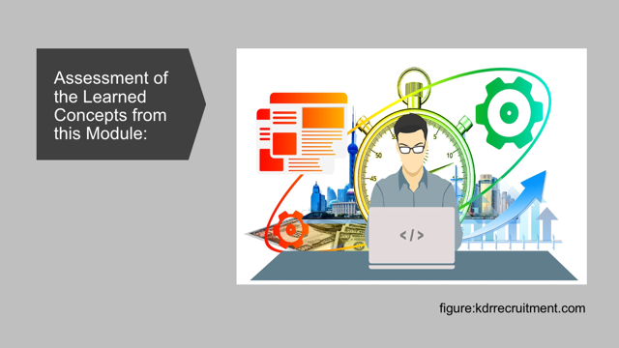

The learned concepts from this module enabled establishments for employment goals and develop a personal action plan. Main aim was introducing strategies for personal reflection and career development planning, to gain confidence and competence as effective employee. To learn and understand the skills and knowledge needed for working effectively and then be able to demonstrate readiness for employability and personal advancement through an understanding of personal strengths and areas for further development. The process of the professional career development journey was encouragingly incredible and the focus was tremendous, the activities carried out was a realisation of self reflective personality. Even there were individual support provided which effectively worked well in this module as there was a wide range of career transition to cover throughout the entire concept at all stages and there were plenty of ideas in the discussion.
Overall wonderfully educational, there were participation of performance researches and employment job description / advertisement. Bolles, R.N. (1994). What colour is your parachute?: A practical manual for job hunters & career changers. Berkeley. Ten Speed Press. – Looked upon this, it was interesting. The career development log posting is a generous bonus for reviewing learning concepts from this module, being aware of the different learning styles in week / session 2. Exploring employment opportunities in week / session 3 was knowledgeable as there were considerations of appropriate strategies to be used in exploring employment opportunities and finding the steps to follow. Google internships YouTube video was motivational, however, not so diversified.


Assignment Task 1 – week / session 4 was reading upon the case study on Diversity and Inclusion. Title being; The Open Book Assessment, where it was required to be ready for a question and having to answer within 2 hours, providing 500 words. This could have been anything to do with diversity and inclusion or even on talent, competitive market or corporate reputation. The best way to appropriately be prepared is to research on the topic and create the assessment and be ready for the question which leaves ample time for corrections. As well as learning the recruitment selection process for further knowledge and identification of the planning and the forecasting of the successful candidates using the appropriate tools.
Learning how to analyse the trend, and dealings with the challenges of recruitment effectively by discussing the Yield Pyramid. Mixing the development of application forms with the candidates CV’s and going through the screening process. Personally went through 10 CV’s of potential candidates who have applied for the customer services vacancy, in one of the task to do, according to the completed selection sheet, a summarisation was generated and the key information from all the candidates, a decision was made on CV number 8, the chosen candidate was Lisa Renny as the best fit for the Job, as the Job is customer service and the experience in the CV was customer based as a team leader, which covers all aspects of the Job, furthermore, the position is open for further opportunity.
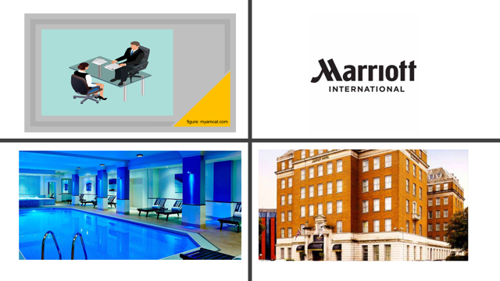

Assignment Task 2 – week / session 5 was fully supported by Lecture of the structural creation of the CV for the mock interview and how to perform appropriately such as; practising good non-verbal communication, dress for the job or company, listen, do not talk too much, do not be too familiar, use appropriate language and take care to answer the questions. Appearance is the first thing a potential employer notices when meeting for a job interview, make a good first impression, look professional and be well groomed. Body language suggests making use of hand by way of subtle gestures, clasping palms, and moving fingers as you suggest.
The mannerisms must be efficient, such as sit up straight and look genuinely interested, do keep good eye contact, do not cross your arms, do not stare for too long, and do not fidget. The key concept of the CV was identified and there was a gathering of tips on how to improve the CV and the performance at the interview, which is when the realisation took place after watching the video from YouTube of the personal branding and to ensure to create a unique personnel branding by understanding the desired career path. There was further availability of support for producing covering letter, and understanding the difference between a general CV and a job focused CV. It is also crucial to research upon the company for the individual benefit for instance for the assignment task 2 the chosen company was www.marriott.co.uk

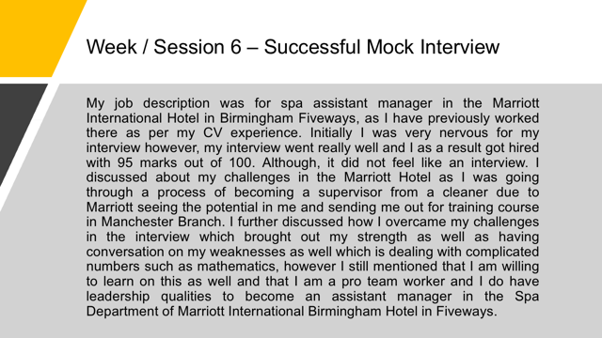

Assignment Task 3 – week / session 7 was on career development and how to develop the career path. Whilst preparing on assignment task 3, it was interesting understanding the difference between a job and a career. Reading page 338 and 339 of Maund et al (2017) – Training Learning and Development. There was further acknowledgement on career development process such as the personal discovery, the exploring of options, making choices and taking action with the right correct approach as well as implementing and reviewing periodically by creating a mental model to help understand which career will be suitable.

Employment legislation, understanding the purpose of employment regulation and explanation the way it is enforced in practice. The regularity of the relationship between employers and employees [employment law], how legal standards are set, this includes; employment contract, data protection, pay and holiday entitlement, working time, health and safety at work, discrimination, discipline and grievance, dismissal and redundancies. Alternatives after graduation was explored and focused on the availability after graduation. Information on prospects was provided, further education options and points to consider was provided on week / session 9. The advantages and disadvantages for self-employment was identified, week / session 10 was workshop and revision and further general submission guidance which left enough time for assignment task 3.

Conclusion:
After reflecting and auditing my own skills and competencies using the analysis tools learned in the class such as the PDP, I am more organised for my career path in the future. And I will take with me all the concepts that I have learnt in this module and use them in my journey of employment or career path. Furthermore, after the analysing of requirement for employment, I have understood how important the skills take place in a workplace and how to behave in a workplace carrying yourself with dignity and pride with your personal branding, as this will go with you whether you choose self-employment or employment.



