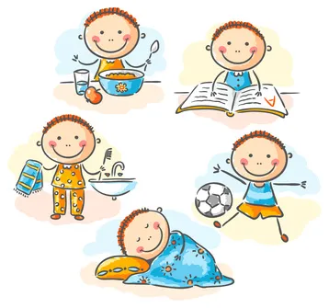

Source: CBC: How To Help Kids Who Struggle With Daily Transitions (edmontonfetalalcoholnetwork.org)
An early year’s practitioner handbook: A guide to transitions

Contents
Introduction to transitions Page 2

Reference list page 14
Proposed outcomes page 12
Interventions page 10
Partnerships page 8
The needs of the child page 6
The role of the adult page 4

Introduction to transitions

Aims
The aim of this handbook is to support early year’s practitioners with helping children through transitions. The handbook will look at the role of the adult, the needs of the child, partnerships, interventions, and proposed outcomes. It will also discuss some different theories related to transitions in the early years setting.
What are transitions?
According to Birmingham City council (2022), transition is a time of change. There is a list of possible transitions the child may experience in their early years. These could include:
- The child’s first attendance at any setting outside of the home for childcare or early education
- The child moves from one key setting to another
- The child moves from one early year’s educator to another
- The child starts school in reception class
Vogler et al. (2008) advises that there are different types of transitions that a child will go through in their early childhood. One of these transitions is vertical, this means the child will progress from nursery to reception or from baby room to toddler room in their nursery setting, these are key changes and have a big impact on the child’s future development. Another transition phase is horizontal, these transitions happen daily and are less impactful, this could mean going from task to task or home to school.
There are different ways in which the practitioner can support children with transitions, one way the practitioner can help the child with transitions is to find out more about the child and the different routines or attachments the child may have at home and plan to best support the child in the setting to settle in and make transitions easier. The aim of this handbook is to support the practitioner in making educated decisions on what can best help the child in the transition process and ensure the child is in the centre of the plan made for their transition.

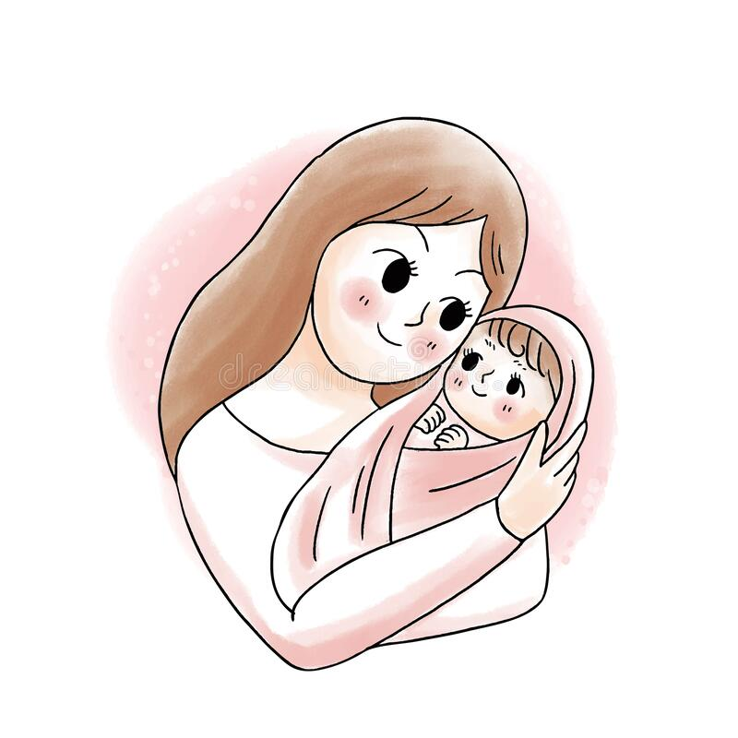

Source: mother and baby cartoon images - Google Search

The role of the adult
What is the role of the adult during transitions?
The adult has a responsibility to ensure that each transition a child may go through during their time at the setting, goes as smoothly and positively as possible. Liz Brooker (2008 p.21) discusses the works of Bronfenbrenner (1979) and how he suggests that the immediate environment in which the child exists is a microsystem. This means the people involved in this system including teachers, parents, siblings, care givers and professionals are responsible for ensuring the environment is nurturing and the child can be encouraged to develop. If the environment is pushed mor toward isolation, loneliness, or self-sufficiency this can be detrimental to the child’s physical and emotional development. To support the child in transitions the practitioner could:
- Make a visible or picture timetable so the child may look at what they are meant to be doing now and what they are meant to be doing next. This takes away some of the anxiety or anticipation the child may feel before switching from task to task.
- Give advance warning to remind that child that the transition is going to happen in two minutes, then one minute, then countdown from 10. This lets the child know how much time they have to complete what they are doing and give them time to come to terms with their task ending.
- Develop rituals with the child, for example when dropping the child off with a teacher or carer give the child two high fives and ask for two in return. This will give the child something to look forward to and help them predict what is going to happen next.
- Give the child choices. By doing this you are letting the child take lead in what they do next, this can help the child feel more in control of their day and make them more comfortable as they know what they are to expect next.
By making the child more comfortable and confident during transitions they will be happier and more likely to take part in the next task of the day. The child may going from constantly being with their mother to then suddenly being placed in a nursery setting, this can be hard for the child and the key worker or responsible adult for the child should understand this and help the child settle into the setting by meeting their needs and assisting them in being made to feel welcome and comfortable.

The importance of attachment during transitions
The practitioner that is taking in a child from the home setting into nursery or school is responsible for meeting that child’s needs and ensuring they feel the same comfort and safety in the setting as they do at home with mum or dad. This comes down to forming an appropriate attachment with the child and getting to know the child as much as possible. The practitioner should be careful not to mirror the parent’s attachment style as this may not be in child’s best interest. There are four different styles of attachment that can be made with the child, and these depend on the relationship and bond you form with the child. The four different attachment styles are, as discussed by John Bowlby (1958) are:
1. Secure Attachment
Securely attached children are more confident and content in their everyday life. They know that their needs will be met, and their parent will be consistent in meeting that need. This helps child develop at a progressive rate and ensures a good relationship with other carers or professionals in the child’s life.
2. Avoidant Attachment
Children who have an avoidant attachment have learnt that their emotions are not responded to empathically. These children have learnt to anticipate that expressions of their emotions will anger or irritate their carer. Their cries, anger or other feelings have resulted in the child being punished; this makes the child keep their feelings a secret to avoid upsetting the adult.
3. Ambivalent Attachment
Children who show an ambivalent attachment style have typically experienced the type of parent or carer who is inconsistent and unreliable in their ability to meet the child’s emotional needs. This can make the child unsure on whether their needs will be met, for example the child may have thoughts such as “will I be fed tonight or will there be someone home when I finish school today”.
4. Disorganised Attachment
Disorganised attachment is the hardest style to work with. This is typically shown by children exposed to a parenting style which does not allow them to develop a safe response to their attachment needs, this could mean that the child is neglected and left to cry for long periods time, ending in the child realising there is no point in crying as my needs are not being met either way.
If the practitioner is vigilant and looks for signs from the child, it can be easier to spot problems the child may be having at home or with forming attachments with friends, teachers or family members. By spotting these signs and problems the practitioner can make any necessary reports or

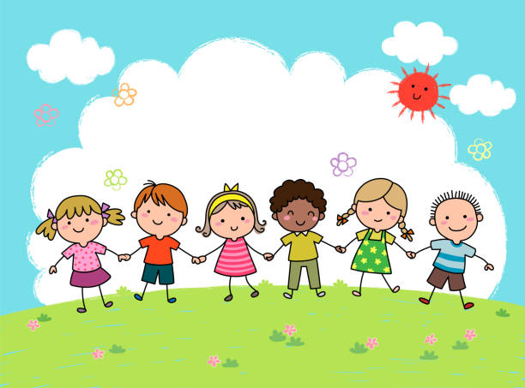

Source: nursery play cartoon - Google Search
The needs of the child
How can we recognise the needs of the child?
Maslow (1943) has a hierarchy of needs pyramid that the practitioner or responsible adult can use as a check list to ensure the basic needs of the child are being met. For example, is the child hungry, cold, or tired? These would be the physiological needs of the child. Is the child healthy, do they feel safe and looked after? This would be the safety aspect of the child’s needs. Does the child have friends and supportive family connections, are they able to accept and show appropriate intimacy? This would be the love and belonging part of the pyramid. Is the child showing respect for themselves and others and have good self-esteem? This would come under the esteem segment of Maslow’s (1943) pyramid. Finally does the child want be the best they can be and push themselves to do so? This is self-actualization, the top of the pyramid. A child can only be at the top of the pyramid if the other needs are being met and fulfilled appropriately. Practitioners can use this pyramid with each individual child and plan to help the child reach their full potential.
How can we support the child’s needs?
If the practitioner suspects a child’s needs are not being met and the child may be neglected, they should contact their superior and support staff for advice on how to report this in the correct way. There are different types of neglect, and these can be hard to spot sometimes, so it is important that practitioners are vigilant and pay attention to the children in their care. The NSPCC website has plenty of information on the different types of neglect and how these can be spotted, it states that,
Neglect can be a lot of different things, which can make it hard to spot. But broadly speaking, there are 4 types of neglect.
- Physical neglect
A child's basic needs, such as food, clothing or shelter, are not met or they aren't properly supervised or kept safe.
- Educational neglect
A parent doesn't ensure their child is given an education.
- Emotional neglect
A child doesn't get the nurture and stimulation they need. This could be through ignoring, humiliating, intimidating, or isolating them.
- Medical neglect
A child isn't given proper health care. This includes dental care and refusing or ignoring medical recommendations
Neglect can have an ongoing effect on children, and this can show during transitions. If the child has trouble with horizontal transitions (these are everyday occurrences) such as not wanting to go back to class after break or not wanting to move onto the next task this could be a sign that the child is not used to having a routine as the parent’s are not supervising correctly at home. If the child doesn’t show emotion on the bigger transitions (vertical transitions) such as from home to school for the first time or moving up a year group, this could be because they are used to big changes in their life such as foster home to adoptive home or not being in a stable home with parents. These are signs the practitioner should pick up on and try to understand more while working with the child to see which needs are not being met in their life.
The practitioner can make the transitions easier for children by evaluating their needs and ensuring things are put in place that help the child thrive. This could be a visual timetable or sticker chart. Children are more likely to want to participate if they can see a reward or something they enjoy at the end of the task. The practitioner should always be patient and kind when helping a child process a transition and should never try to rush the child through it, this can be more damaging and make the child regress through their transition period making it harder for the child to settle in a more natural way.

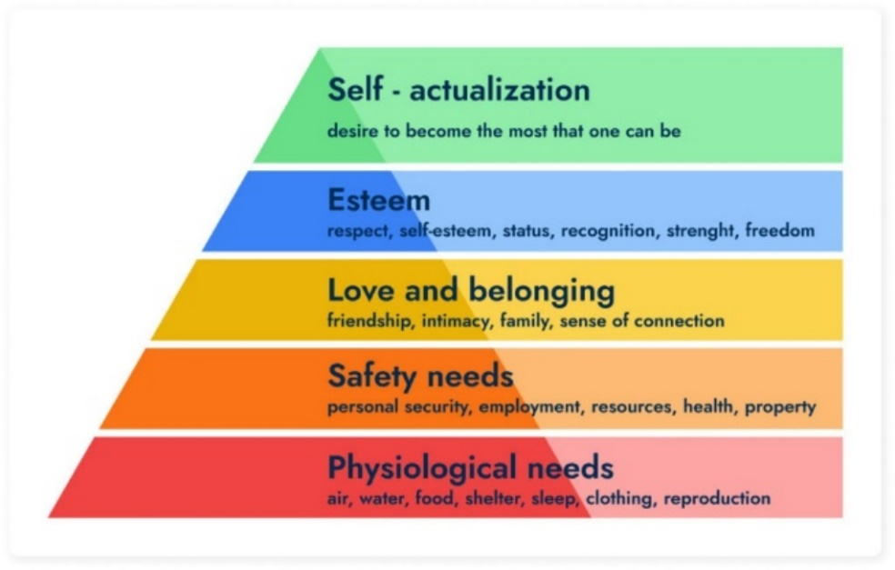

Source: maslows hierarchy of needs - Google Search

Partnerships
Why are partnerships important during transitions?
It is important that the practitioner has successful and professional partnerships with the parent/carer, the setting manager, the supporting staff, and the child itself. Without these partnerships the child would not have a smooth and progressive transition. Putting the child at the centre of everything the practitioner does they are promoting the child’s confidence and skills whilst practicing safe practice in the setting.
From birth being supportive for the child and allowing the child to lead in play is important, this could mean discussing with the setting manager and the parent of the child how the practitioner expects to help the child develop their skills in an education setting and what this means for the child.
In a learning environment for infants and toddlers, the focus is on:
- Providing a safe and nurturing environment – ensuring there are no risks or harmful equipment in the way of the child.
- Promoting children’s self-trust – let the child lead the practitioner and show them what they are able to do without intervention.
- Developing a child’s confidence in their emerging abilities – praise the child when they learn how to pull themselves up and walk along side the table, but ensure the space is clear of obstacles and you are available to observe and interfere only if necessary.
- Developing language, motor and coordination skills – giving the child freedom to use pencils, paints and books to encourage them to use fine motor skills and encouraging the child to talk or babble if the are younger this can be done by saying the colour they are holding or the item they are using.
- Giving children opportunities to perform tasks independently – The practitioner should never interfere in a child’s task unless it becomes unsafe or there are risks that have not been observed in a timely manner. By allowing the child do perform tasks independently they are able to show how much they already know and what they may need support with.
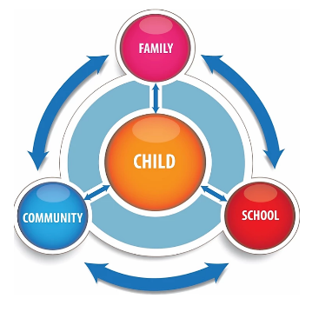

Source: child centred approach - Google Search

How can practitioners best support partnerships with parents and children?
Dalli (2002) has summarised in Damien Fitzgerald (2004) ‘Parent partnership In the early years’, several strategies that can support transitions:
‘providing families with printed and oral information about the setting, routines and settling-in procedure prior to the child starting;
• having a specific practitioner to communicate with about transition;
• respecting and responding to input from parents about how to support their child during transition;
• practitioners should proactively approach children during transition periods to support them and assist in the 'fitting-in' process;
• practitioners need to be aware of strategies to ease anxieties that parents may be feeling and use these to offer support’
By reporting a child’s ability or daily log to a parent or fellow educator the practitioner can then discuss what they think the child may need support with and how best to accomplish this with the supporting adults. Without these partnerships formed the child will be more likely to slip through the cracks and not have the necessary support to progress and transition to a higher level of learning and development without detrimental affects on their emotional and physical wellbeing.



Source: teacher parent relationship - Search Images (bing.com)
Interventions

What are interventions and how can they be used to ease transitions?

Proposed outcomes

Reference list

