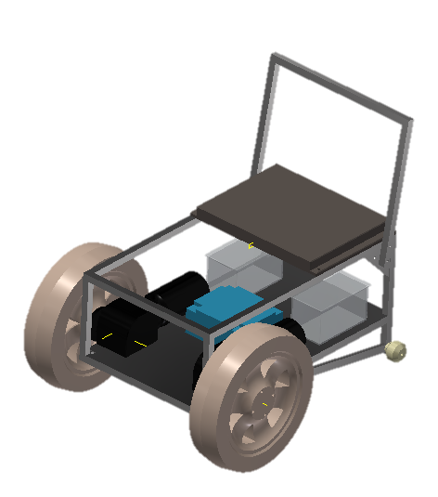

Manufacturing Team Challenge Reflective Report
  - Group Proect
Ahmed, Josef (J.I.)
Table of Contents
Introduction 2
Roles and Responsibilities 3
Josef Ahmed – Electronic/electrical 3
Belbins Theory 3
Tuckman’s Model 5
Forming 5
Storming into Norming 5
Performing 6
Gateway and Milestones 7
Gateway 7
Milestones 8
Areas of Concern 9
Motor/Motor Driver Selection 9
Lead times 10
Conclusion 11
References 12
Appendix 1 13

Introduction
This report analyses a project undertaken by ‘The Real SDR’, a team of 3 apprentices, from Ford Motor Company, Bridgend. The project was performed as part of an engineering competition, World Skills UK, Manufacturing Team Challenge. It required teams of 3 to design and build a wheel chair, in accordance to a specification provided by the competition organizers. This report will reflect on the project and discuss the challenges and obstacles the team faced during their journey. The objective of the project was to meet the criteria set by the competition organisers. Appendix 1 shows the project specification. It breaks down the value (in marks) of each individual target that was to be achieved. These targets were to be met with the lowest possible budget.

Roles and Responsibilities
Josef Ahmed (Writer)
- Electronics/Electrical
Samuel Da Rosa
- Fabricating/Metal Work
William May-White
- Metal Work/CAD

Josef Ahmed – Electronic/electrical
The following section appraises the roles and responsibilities carried out by myself. The three members of the team were all part taking in a 4-year mechanical apprenticeship. This meant none of the team were electronically/electrically biased. Although, I had previously studied electronic engineering at BTEC Level 3, this gave me a better understanding of this side of the project. Therefore, I volunteered myself to take on the challenge, with the aid of lecturer from Bridgend College. The task I was given, was for me to design the electronic system to power and move a wheel chair in correspondence with the competition project specification (see Appendix 1).

Belbins Theory
To enable me to distinguish the role I would play as a team member, I carried out a ‘Self Perception Inventory’ (SPI). According to UK Essays (2016), Dr Meredith Belbin developed the inventory to allow people to gain a better understanding of their behaviour role within a team. The SPI uses numerous statements and a points system to enable someone to identify which roles best resemble themselves. According to Belbin there are 9 types of team behaviour, these are as follows:
- Implementer
- Co-ordinator
- Shaper
- Plant
- Resource Investigator
- Monitor Evaluator
- Team Worker
- Complete Finisher
- Specialist

I believe these are the 3 key characteristics needed with reference to Belbin’s SPI, to carry out the role I did within the project (Belbin, 2019):
- Team Worker – Works well in a team, listens and avoids conflict.
- Plant – Creative, good problem-solving skills and can generate ideas.
- Shaper – Enthusiastic, dynamic and works well under pressure.
Table 1 shows the results of a SPI that had been completed by me. I feel I could fit into the role that was given to me. Although the score was slightly under average for shaper and team worker, plant was higher than the average. The two areas that were below average could have been developed to give me a better chance of fulfilling my role.
Table 1
 | Implementer | Coordinator | Shaper | Plant | Resource Investigator | Monitor Evaluator | Team Worker | Complete Finisher
Average Score | 10.0 | 8.8 | 11.6 | 7.3 | 7.8 | 8.2 | 10.9 | 5.5
My Score | 14 | 8 | 8 | 9 | 9 | 5 | 9 | 8

Tuckman’s Model
In 1965 a psychologist named Bruce Tuckman developed a four step model, to resemble the steps that teams undergo during something such as the project we were tasked with. The 4 steps were:
- Forming
- Storming
- Norming
- Performing
This was written in an article named “Developmental Sequence in small groups”. Tuckman later went on to add a fifth step named “Adjourning”. As the Mind Tool Content Team (2019) stated, the adjourning stage, this was simply where the project would come to an end, leading to disbandment of the team. The following section will focus on the 4 previously mentioned steps and how they relate to the competition project.
Tuckman’s model path was fulfilled by the team members over 3 and half years prior to the project starting. The three team members started a Ford mechanical apprenticeship together in 2015. This gave ample amounts of time to form a strong bond with one another. Various team building activities were carried out during the years running up until the project. This allowed for development of working in a team and learning each team member’s strengths and weaknesses. This enabled us to focus on utilising strengths as well as minimizing any weaknesses.
Although the team had already experienced each stage. The ‘Manufacturing Team Challenge’ gave the team new challenges to overcome which we had not undergone previously. Due to this, the team experienced each step of the model again. The following section will relate Tuckman’s model to the team’s experiences during the project.

Forming
This stage of the model began once the team entered the competition. According to BusinessBalls (2019) the forming phase of the model is where the group are in the process of discovering what roles each member suited best. It appears to focus on the leadership role and how their opinion impacts the team. It was clear that the oldest of the group naturally became the leader of the group. This decision was mutual and was considered appropriate due to his experience and leadership attributes. Furthermore, assigning each team members roles was stress-free due to each member having suffice experience in their chosen roles e.g. I was to have the role of overlooking the electronics, this was due to having previous experience and qualifications in this area.

Storming into Norming
According to The Team Building Company (2019), the storming phase involves conflict between the team. It can cause a break in relationship between members, but it can also cause the team to underperform due to making decisions which are less successful for the sake of keeping the team civil. This phase of the model can be related to within our project. Once design stage of the project had started, each of us had varied ideas. There were numerous disagreements about what route to take but, previous experience with each other allowed us to overcome this by brainstorming each idea. According to Matliveski, M (2019), an advertising executive named Alex Osborn created the concept of brainstorming. Four vital rules are to be used to enable brainstorming to be as effective as possible. These are:
“No judgements. This is the first rule of creativity in general, really. Don’t discard anything when you’re brainstorming.
Think freely. As I said before, no matter how crazy it is; while brainstorming, ideas are neither silly nor impossible. Allow yourself to imagine as much as you want.
Big numbers. The more ideas, the better. It obviously depends on the situation but try to produce at least 20 solutions and then you’ll see how much it helps.
Many heads are better than one. When you’re doing it in a group, accept other people’s ideas. You all work on each other’s contributions and then these will grow.”
Brainstorming allowed the team to move into the “Norming” section of Tuckman’s model. The Team Building Company explain the norming stage as the acceptance of each team members role and how it plays a vital part in achieving their goal. Although, this stage can also cause the team to become less creative with ideas. We were lucky to not experience this section of the norming phase. The norming stage took place over approximately a month.

Performing
It was obvious once the team had progress to the performing stage. There was very little if any conflict, targets were being met and the design was finally starting to become a reality. Each team member was making very good progress on their specified areas. With the performing stage in full flow, it enabled the team to overcome a major issue. 3 weeks prior to the competition a complete re-design was needed to achieve the goal of climbing a 150mm step (appendix 1). This created huge amounts of stress and worry for all of us. We managed to stay composed and think of a design which we deemed successful and it was. I believe that due to us previously going through each stage of Tuckman’s model. We were able to work together without any conflict and efficiently complete the design and produce it from raw materials in the 3 weeks.

Gateway and Milestones

Gateway
According Herridge, D (2019) setting objectives are a fundamental when carrying out a project. Herridge also states that a goal needs to be clear when setting it. This is where SMART objectives come into the equation. ‘SMART objectives’ is a method using to set a measurable goal. The breakdown of the meaning of ‘SMART’ is shown follows:
- Specific - What, exactly, is it that we want to achieve?
- Measurable – How will we know we’ve achieved it?
- Attainable – What is our realistic desire (10) x the possibility (10) = __ /100
- Relevant - Why are we doing this? Is it really what we want?
- Time Bound - When will we achieve this by?
(Lawlor & Hornyak, 2012)
This method was used when setting the gateway for my role. It allowed me to make a measurable goal for my contribution to the project. The following shows how this was complete by answering each question put forward by Lawlor & Hornyak.
Specific – To design and produce a system that will meet the specification for the electronics of the project.
Measurable – The designed system will be able to move a wheel chair frame forward, backwards and be able to turn on itself whilst holding a person weighing 80kg. This needed to be considered when selecting motors and motor drivers- the project was dependent on this to enable the wheelchair to move. The technical performance of the project was approximately 60% dependant on this system working successfully.
Attainable – 9 * 9 = 81/100
Relevant/Realistic – With reference to the previous item, yes, it is possible, but it will be challenging.
Time Bound - This must be achieved in time for the competition date (3 months)
The Gateway that was set for my role was to complete the full system in 3 months and ensure that the system worked as it should. The system needed to do be able to do the following:
- Have a charging point built into it, to replenish the batteries.
- Have an electrical system of 36 volts or less.
- Have a joystick that controls forward movement.
- Have a joystick that controls reverse movement.
- Have a joystick that controls left turning movement.
- Have a joystick that controls right turning movement.
- Have an LCD panel to display, battery charge status, high, medium and low as a minimum.
- Have an LCD panel to display a “System active” message, when the wheelchair is turned on.
- Have an LCD panel to display a “moving” message when the wheelchair is performing any movement.
- Emit an audible sound, that is clear to hear from 5 Meters away when and only when reversing.
Approximately 60% of the project was dependant on the electronics. It would also be 80% of the cost.

Milestones
To enable me to complete my section of the project, I had set milestones. This allowed me to schedule my work and set deadlines for different areas of my role. Table 2 shows each milestone and the date they were to be completed by.
Table 2
Milestone | Date
Circuit Design | 10/10/2018
Motor Selection | 13/10/2018
Motor Driver selection | 15/10/2018
Completion of coding | 25/10/2018
Testing of system (not Fitted) | 05/11/2018
Testing of System (Fitted to wheelchair) | 10/11/2018
By using milestones, I was able to track progression and keep on top of the tasks I needed to carry out. As stated in the performing stage of Tuckman’s model, the project ran into a problem during the last 3 weeks. Changes were made to the motors and motor drivers as they were not powerful enough once attempting to move the wheel with a person weighing approximately 80kg. There for these milestones were not met.
Appendix 2 shows the Gantt Chart produced for the overall project with timings of each part.
Appendix 3 shows the Gantt Chart produced specifically for the days of the competition, it displays each process that was complete.

Areas of Concern

Motor/Motor Driver Selection
Motor selection became a major problem during the project. It became very difficult for me to determine the correct motors to use. This was due to lack of knowledge. As part of the specification (see Appendix 1) the wheelchair needed to climb a 150mm step, move back and forth, left and right, along with stopping on and climbing a 15-degree inclined ramp. This did not appear to be a problem at first but later became a major one. This was due to the many types of motors that could be utilized, along with their varying weights and sizes. In a guide to correct motor selection Skidmore (2018), stated “Finding the right size is crucial for choosing a motor as well as balancing torque, speed, and inertia for optimal application performance” The article written by Skidmore, breaks down into steps, the correct procedure that should be adopted when selecting motors for specific applications, like that of the project taken on by ourselves.
The original motors that had be chosen were two 18v Makita drills. These were capable for moving a person weighing up 100kg on a flat surface. Unfortunately, the torque they developed was not suffice for climbing the 150mm step. This meant the motors needed replacing, this is a problem that occurred only 3 weeks prior to the competition. We had managed to find some wheelchair motors which we were confident would be up to the job, and they were. If we had not found the motors in time, we would have had to pull out of the competition. To avoid this happening again, a matrix analysis could be used to determine what motor to use. The following shows a step by step guide on how to use a matrix analysis along with an example (Mind Tools, 2019):
- List all of your options as the row labels on the table, and list the factors that you need to consider as the column headings. For example, if you were buying a new laptop, factors to consider might be cost, dimensions, and hard disk size.
- Next, work your way down the columns of your table, scoring each option for each of the factors in your decision. Score each option from 0 (poor) to 5 (very good). Note that you do not have to have a different score for each option – if none of them are good for a particular factor in your decision, then all options should score 0.
- The next step is to work out the relative importance of the factors in your decision. Show these as numbers from, say, 0 to 5, where 0 means that the factor is absolutely unimportant in the final decision, and 5 means that it is very important. (It's perfectly acceptable to have factors with the same importance.)
- Now multiply each of your scores from step 2 by the values for relative importance of the factor that you calculated in step 3. This will give you weighted scores for each option/factor combination.
- Finally, add up these weighted scores for each of your options. The option that scores the highest wins!

Factors: | Cost | Quality | Location | Reliability | Payment Options | Total
Weights: | 4 | 5 | 1 | 2 | 3
Supplier 1 | 4 | 0 | 0 | 2 | 9 | 15
Supplier 2 | 0 | 15 | 2 | 4 | 3 | 24
Supplier 3 | 8 | 10 | 1 | 6 | 0 | 25
Supplier 4 | 8 | 15 | 3 | 6 | 0 | 32

Lead times
Lead times could have become a major issue for obtaining parts in time. Some parts took up to 4 weeks to arrive. If these parts had taken any longer, we would have had to source replacements with only a week to do so. If we were unable to find replacements, it could have led to us having to redesign the system to cater for parts that were attainable. To avoid any close calls due to lead times MCL (2017), has given 8 methods:
- Use a domestic supplier
- Increase order frequency
- Provide sale forecasts
- Convert to standard components
- Consolidate suppliers
- Consider kitting services
- Create an incentive
- Communicate
These 8 methods can be used to reduce lead times. Although not all will be useable due to the nature of the project. Methods such as converting to standard components and communicating with the supplier should help reduce the lead time as well as having a clearer understanding of the arrival date of any parts.

Conclusion
To conclude, the project was a success. We had achieved the goal we had set out to attain. Although we had a major issue with the design three weeks before the competition date. We were able to work well as a team, communicate and develop a new design which met the specification. Communication was aided hugely by the access to social media applications such as Whatsapp. This enabled us to communicate outside of working hours to make progress on the project. It was a massive benefit during the three-week period running up to the competition, as we required to put many of hours of work into the project, this included weekends so ease of communication was essential.
Although the project was a success, we were very fortunate to have produced a working model in the three-week time frame. To avoid a situation like that again. Milestones should have been set for a completion date 2-3 weeks earlier than the original chosen date. This would give enough time for suffice testing of the product and allow for any major changes to be made, leaving enough time for extensive testing on a revised product.

References
Belbin. (2019, April). The Nine Belbin Roles. Retrieved from www.belbin.com: https://www.belbin.com/about/belbin-team-roles/
BusinessBalls. (2019, March). Tuckman: Forming, Storming, Norming, Performing Model. Retrieved from www.Businessballs.com: https://www.businessballs.com/team-management/tuckman-forming-storming-norming-performing-model/
Herridge, D. (2019, April). What are smart objective and how do I apply them? Retrieved from www.professionalacademy.com: https://www.professionalacademy.com/blogs-and-advice/what-are-smart-objectives-and-how-do-i-apply-them
Lawlor, B., & Hornyak, M. (2012). Smart Goals. Developments in Business simulation and Experimental Learning. Retrieved from www.Journals.tdl.org: https://journals.tdl.org/absel/index.php/absel/article/viewFile/90/86
Matlievski, M. (2016, November). Four Rules of Brainstorming. Retrieved from www.medium.com: https://medium.com/@miha_matlievski/four-rules-of-brainstorming-9c1561dcd9de
MCL. (2017, July). 8 Ways to reduce supply chain lead times. Retrieved from www.MCL.bz: https://www.mcl.bz/blog/ways-to-reduce-supply-chain-lead-times
Mind Tools. (2019, march). Matrix Analysis. Retrieved from www.mindtools.com: https://www.mindtools.com/pages/article/newTED_03.htm
Mind Tools Content Team. (2019, April). Formind, Storming, Norming and Performing. Retrieved from www.Mindtools.com: https://www.mindtools.com/pages/article/newLDR_86.htm
Skidmore, A. (2018, December). Picking the Right Motor Size. Retrieved from www.PlantEngineering.com: https://www.plantengineering.com/articles/picking-the-right-motor-size/
The Team Building Comapny. (2019, April). Forming-Storming-Norming-Performing. Retrieved from www.Teambuilding.co.uk: https://www.teambuilding.co.uk/theory/Forming-Storming-Norming-Performing.html
UK Essays. (2016, December). Self Perceptiobn Inventory. Retrieved from www.UKessays.com: https://www.ukessays.com/essays/psychology/self-perception-inventory.php


Appendix 1


MANUFACTURE TEAM CHALLENGE

COMPETITION BRIEF

Competition registration March 1st 2018 - 7th of April 2018
https://www.worldskillsuk.org/

Technical Briefing – 23rd April 2018

Semi Finals – July 1st-July 10th 2018

Submitted By: Daytun Unitt
The project brief.

This brief specifies the requirements for the design and manufacture of an electric powered wheelchair, suitable for use by a single person with mobility needs.

In this instance the Wheelchair must be highly manoeuvrable in order that it can be used both indoors and outdoors. It should be able to overcome obstacles such as kerbs, potholes, doorsteps and similar obstacles that may be encountered during everyday use. The wheelchair will be expected to negotiate a course, which is designed to simulate obstacles that may be encountered at the end of the competition. The wheelchair should be lightweight and fit in as small a space as possible to accommodate lifting into and out of a vehicle. The wheelchair can be disassembled or folded to facilitate this, but must be simple and quick to set up and take down.

There are examples found on the internet, some of which include:

https://www.youtube.com/watch?v=6Ym6qPSuFV8

https://www.youtube.com/watch?v=TCc0PDRPCQg

https://www.youtube.com/watch?v=H177xwFE0N0

https://www.youtube.com/watch?v=gC712I1eyIE

https://www.youtube.com/watch?v=Sz1c1Y-A7mQ

Description of Project.

- The Wheelchair must be designed to fit into a range of vehicle boot spaces, so that a purchaser could use it with any vehicle they have.

- The wheelchair should be designed to be dismantled or folded so as to fit a boot space as quickly and easily as possible.

- The wheelchair should be as light as possible order that lifting into a car boot be as easy as possible.

- The wheelchair must be powered by electricity via a battery system that is positioned onboard the wheelchair.

- The battery should last under movement for a minimum of 1 hour. (calculations of power required in the portfolio)

- The battery should be able to be charged in situ on the wheelchair, but the supplied charger should plug into the wheelchair and be purchased for safety purposes.

- The electrical system should be a maximum of 36volts.

- The wheelchair should be joystick controlled, where the joystick can be mounted universally on either side of the chair, to ensure it can be used by left and right-handed persons.

- The wheelchair must be able to negotiate being driven over a square sided object of 150mm in height, to simulate a sharp entry step, or high Kerb.

- The wheelchair should have as small a turning radius as possible to ensure it is easily manoeuvrable.

- The wheelchair should have a comfortable seat for long term use.

- The seat should be adjustable to ensure maximum user comfort and flexibility in user size and build.

- The wheelchair should have a LCD display on the control panel, to display, battery charge status, high, medium and low as a minimum, a “System active” message, when the wheelchair is turned on and a “moving” message when the wheelchair is performing any movement.

- The wheelchair should emit an audible sound, that is clear to hear from 5 Meters away when reversing.

- The Wheelchair should be able to move safely up and down a 15-degree incline/decline under control.

- The wheelchair should be designed with aesthetics in mind.

Safety

● The electrical system should be able to be switched off via a key.

● Any mechanisms and surfaces should be free from being a trap, crushing or cutting hazard.

● The Wheelchair should have a mechanism to lock the wheels when not powered.

● The wheelchair should be unable to fold or dismantle unless it is wished. I.e. have a safety lock mechanism to prevent folding unless released.

● All electrically conductive parts must be guarded.

● No sharp edges should be evident.

Maintenance

The following components should have ease of access for removal and replacement: -

● The battery.

● The wheels.

EQUIPMENT, MACHINERY, INSTALLATIONS AND MATERIALS REQUIRED EQUIPMENTS PROVIDED BY ORGANISERS
All equipment, tooling and materials in the infrastructure list – see MTC forum and technical description.
All materials for surprise project as listed in the technical description. Testing equipment for Surprise Project.
Testing equipment and testing materials for the Wheelchair

EQUIPMENT AND MATERIALS NOT PERMITTED
Laptop or portable computers. PDA’s e.g. Palm, IPAQ etc. Memory sticks/MP3 Player/Digital Storage. Walkman radio/CD Player. Electronic organizer/diaries. Wireless communication devices. None approved CDs, memory stick/cards or floppy discs – approval by Experts or delegate is required for all Storage media. Any additional software not supplied by organizers unless approved by Experts. Pre-programmed IC’s. Purchased items modified in any way prior to the Competition. All subassemblies for the wheelchair. Equipment that is similar or operates in similar manner as supplied equipment. Example – if a metal cut-off saw is provided by organisers, then no team may provide their own metal cut-off saw.

ITEMS TO BE PROVIDED BY TEAMS
Each team must provide and wear team identification (e.g. coloured shirt) or armbands that indicate their team or company. These must be worn at all times during the Competition. It is the responsibility of the team to supply all the components and raw materials to manufacture the wheelchair. This may include but is not limited to the following items:
Battery/batteries. Electronic circuit board – not mounted (circuit board components must be assembled on the board at the Competition). All Electrical and electronic components. Electric cables, connectors and couplings. Readymade cables with connector are not permitted. All connectors must be fitted during the competition. Jigs, fixtures, formers and clamping devices. All materials with which to construct the wheelchair and all other associated equipment and consumables (sheet metal, screws, nuts, pins, pegs, etc.). Machining consumable tooling required for manufacturing the components. Lathe tools and hand tools for manufacturing components. All hand tools, cutting tools and measuring equipment. All hand tools for assembly. All personal protective equipment. Other specific manufacturing equipment required that is not in the infrastructure list. Bearings (unmodified), Sprockets, pulleys, gears, couplings, chain and belts (as supplied and must not be altered). Catalogue or standard must be provided. Hydraulic or pneumatic components and fittings not assembled.

DURING THE COMPETITION, NO TOOLS, EQUIPMENT, STATIONARY, COMPONENTS, MANUALS, DRAWINGS OR DIGITAL STORAGE DEVICES, UNLESS APPROVED BY THE CHIEF EXPERT, MAY BE REMOVED FROM OR BROUGHT INTO THE COMPETITION VENUE.

Marking Scheme

Section |  | Criteria | Marks
A | Main project performances  (Inc. Section B of portfolio) |  |  | 40  10
B | Main project costs:  Manufacturing Time  Materials  Machining Time |  |  | 5  2  3
C | Portfolio (Section A only) |  |  | 10
D | Surprise project |  |  | 30
Total

A. Main Project (40 Marks)

The wheelchair should: -

● Fit into a range of vehicle boot spaces so must dismantle or fold into a box, (to simulate a small car boot), of no more than 900mm by 600mm by 450mm.
(2 Marks)
● Be dismantled or folded so as to fit a boot space as quickly and easily as possible. This will be marked as a time trial with one team member dismantling the wheelchair into the box, then reassembling the wheelchair and driving it a short distance. Fastest time 2 Marks, slowest 0 marks and all others graded between.
(2 Marks)
● Be as light as possible order that lifting into a car boot be as easy as possible. Lightest Wheelchair will receive 2 marks, heaviest 0 and all others graded between.
(2 Marks)
● Have a battery system that is positioned onboard the wheelchair.
(1 Mark)
● Have a charging point built into it, to replenish the batteries.
(1 Mark)
● Have an electrical system of 36 volts or less.
(1 Mark)
● Have a joystick that controls forward movement.
(0.5 Marks)
● Have a joystick that controls reverse movement.
(0.5 Marks)
● Have a joystick that controls left turning movement.
(0.5 Marks)
● Have a joystick that controls right turning movement.
(0.5 Marks)

● Have a joystick that can be mounted universally on either side of the chair, to ensure it can be used by left and right-handed persons.
(1 Mark)
● Be able to negotiate being driven over a square sided step of 150mm in height.
(1 Mark)
● Have as small a turning radius as possible. Smallest turning circle 2 marks, largest 0 marks, all others graded between.
(2 Marks)
● Have a comfortable seat for long term use.
(1 Mark)
● Have an adjustable seat providing back rake and height adjustment.
(1 Mark)
● Have an LCD panel to display, battery charge status, high, medium and low as a minimum.
(1 Mark)
● Have an LCD panel to display a “System active” message, when the wheelchair is turned on.
(1 Mark)
● Have an LCD panel to display a “moving” message when the wheelchair is performing any movement.
(1 Mark)
● Emit an audible sound, that is clear to hear from 5 Meters away when and only when reversing.
(1 Mark)
● Be able to move safely up and down a 15-degree incline/decline under control. A full stop will be required on the incline and restart of manoeuvre in both directions. 1 mark for each successful stop.
(2 Marks)
● Be designed with aesthetics in mind and should be a marketable product.
(2 Marks)
Safety

● The electrical system should be able to be switched off via a key.
(1 Mark)
● Any mechanisms and surfaces should be free from being a trap, crushing or cutting hazard.
(2 Marks)
● The wheelchair should have a mechanism to lock the wheels when not powered. Mechanical or electrical handbrake. This will be tested on the 15-degree incline.
(2 Marks)
● The wheelchair should be unable to fold or dismantle unless it is wished.
I.e. have a safety lock mechanism to prevent folding unless released.
(1 Mark)
● All electrically conductive parts must be guarded.
(1 Mark)
● No sharp edges should be evident.
(1 Mark)

Maintenance

The following components should have ease of access for removal and replacement: -

● The battery.

● The wheels.

One of the two will be randomly selected during the test. The fastest time for removal and replacement of the selected item will receive 2 marks, the slowest will receive 0 marks. All others graded between.
(2 Marks)
Time Trial
During the testing the course laid out in Figure 1, the wheelchair will be driven by one member of the team. The time for the completion of the course will be recorded, any of the following appropriate penalties will be added to the time:

For each time the wheelchair goes outside of the track. 2 Seconds
Driver unseating 2 seconds
Using any means to move the wheelchair bar its own power/drive system
5 seconds
Breakdown and maintenance required 30 seconds

The total time with penalties added will then be used to determine the total time.
Fastest time 5 marks, slowest time 0 marks, all others graded between.
(5 Marks)

Note: for all graded marks for each 10% between the highest and lowest a band is set. Your time, weight etc will score the points for the band you fall into.

e.g. if the fastest time is 120 seconds and the slowest 170 seconds, if your time is 151 seconds, the for each 10% between the bands will be.

120-124.9 5 marks. 125-129.9, 4.5 marks. 130-134.9, 4 marks. 135-139.9, 3.5 marks. 140-144.9, 3 marks. 145-149.9, 2.5 marks. 150-154.9, 2 marks. 155-159.9, 1.5 marks. 160-164.9, 1 mark. 165-169.9, 0.5 marks. 170 0 marks.
Therefore, a time of 151, would score 2 marks.

Portfolio B – to be completed during the competition
(10 Marks)

During the competition the participants will carry out the following I.T. related tasks, rough sketches can be brought to the competition: -

● Manufacturing drawings for all components to be made. (Autodesk Inventor)

● 3D Assembly drawing(s). (Autodesk Inventor)

● Electronic diagrams/drawings. (AutoCAD Electrical)

B. Manufacturing Costs (10 Marks)

Working hours (5 Marks)
For every 10% more expensive than the team with the lowest calculated working hour cost (see note below). 0.5 Marks will be deducted proportionally.

Additional cost for using equipment (3 Marks)
For every 10% more expensive than the team with the lowest additional equipment cost (see note below). 0.3 Marks will be deducted proportionally.

Raw materials (2 Marks)
For every 10% more expensive than the team with the lowest additional equipment cost (see note below). 0.2 Marks will be deducted proportionally.

Compliance.
The total cost of equipment, materials and labour will be modified by project compliance to specification.
Compliance to specification means that your marks for your built project will be calculated as a percentage and adjust your costings as follows.

Final build cost = . Total cost x 100 .
% compliance to specification

Example
If total cost is £2,500 and compliance is 100% then build cost would be £2,500
If total cost is £2,500 and compliance is 80% then build cost would be £3,125
If total cost is £2,500 and compliance is 60% then build cost would be £4,167
If total cost is £2,500 and compliance is 40% then build cost would be £6,2500
If total cost is £2,500 and compliance is 20% then build cost would be £12,500
If total cost is £2,500 and compliance is 0% then no marks awarded for cost section.
Note: Marks will be calculated using calculations in the CIS scoring system
C. Portfolio A (10 Marks)

A portfolio is to be presented prior to the competition. This portfolio is to be assessed as a component of this project. The portfolio is to be in electronic format but presented in both hard copy and electronic form and to include: -

● Team member details. Name, company, company address, qualifications and job title.

● Team preparation.

● Design calculations and sketches/drawings.

● A Spreadsheet list of materials and components used with catalogue prices ex Vat.

● Evidence of material and component costs.

● A work schedule for the team during the competition and build with estimated costs for time and machinery usage. (See costings sheet.)

● Operation and maintenance manual.
To include: -
● Troubleshooting guide.
● Operation and installation of the joystick control.
● Replacement of any batteries and wheels.
● Safe operating procedures.
● Calculations of battery longevity.

● A poster display 1000mm x 600mm (minimum size) detailing each team member’s details and their employers, a description of the project solution including a 3D model of their vehicle, which will be presented prior to the competition and displaying during the competition.

D. Surprise Project (30 Marks)

An unseen project requiring welding and fabrication, machining and electronics skills will be supplied with all materials to be completed during the challenge period.

Appendix 1
Additional rules

● Teams may have any notes and sketches they require to build the project, but these must be handwritten/drawn and not printed.
Printed circuit diagrams are acceptable

● Teams are required to provide all the tools and raw materials they require for the project. Teams may borrow tools and equipment from other teams, if they are willing, but will incur a 15-minute time penalty added to their build time for each tool or piece of equipment borrowed.

● Any areas that are not fully understood should be queried prior to the competition. Any misreading of the rules of the competition will be deemed as your own fault and the judges’ decisions as to interpretation will be final.

● You are required to wear Safety Goggles/Glasses and Steel Toe Cap Boots/Shoes as a minimum at all times during the competition.

● As a guide you will be able to work from 9:30AM to 6PM on day one of the competition, from 8:30AM to 6PM on day two and one hour of “tinker time” will be given on the Saturday morning prior to judging and final competition. You are expected to design and schedule your activities to fit within these times, including an allowance for the surprise project. Failure to complete all elements within these times will lead to the forfeiture of marks for uncompleted areas. Extra time can be given to all teams at the Judge's discretion.

● All of the components and parts should be manufactured during the competition by the team. Items it is not possible to manufacture such as wheels, batteries, solar panels etc. will be allowed. Any item that the Judges deem the team could have made will incur a penalty. See penalty table.

● All teams registered by the closing date in 2018, will be given the opportunity to attend a briefing and development session. This will take place at Coleg Cambria’s Bersham Road site in Wrexham. This is not mandatory in order to compete, but is put in place to give support to teams. Teams are expected to meet their own transportation and any accommodation costs.

● A technical forum is also available via google community , where questions can be asked and any areas discussed. Search Skills UK MTC. However support is also available via Email. Daytun.unitt@cambria.ac.uk

Penalties:
● Penalties may be incurred by activities, seeking help, or noncompliance to the rules, these are as follows:

Penalty | Incurred
Seeking help from an expert | 15 minutes of time or any part of £20 cost addition
Health and safety minor infraction  Non-use of PPE  Unsafe use of tools and equipment  etc. | 15 minutes added to team working time
Health and safety dangerous infraction  Non-use of guards  Dangerous horseplay  etc. | You may be stopped from working for the remainder of the competition
Interfering with other teams | 1 hour added to working time
Borrowing of tools or equipment from other teams | 15 minutes team working time added for each piece of equipment or tool borrowed
Not properly cleaning down machinery after use | 15 minutes working time added to the team
Use of pre- made items that the team could have manufactured and/or programmed | Judges will estimate the time taken to manufacture the item and add a time penalty to the teams working time equal to three times this figure.
Noncompliance to instructions given by any judge during the competition | 15 minutes working time will be added to the team
Discretionary penalty for any other situation that may occur | A working time penalty will be added to suit the infraction, based on the judge's opinion of its severity

Costings

Item | Cost
Working time: If one team member is working it is costed as all are working. | £90 per hour
Use of Lathe and Welding equipment | £40 per hour
Use of Pillar Drill, Cut off Saw, Box and Pan, or Guillotine | £20 per hour
Pre-manufacture of Printed circuit boards | £0.25 per CM²

The minimum time for booking each machine is fifteen (15) minutes, and 15-minute intervals thereafter.

All of the materials that the team will require to manufacture the Caravan will be put into the spreadsheet at VAT free prices, with a section evidencing this in the team portfolio.

NOTE: After using a machine, the machine must be cleaned, i.e. swarf removed from working area of the machine. Each machine will be inspected by an Expert after each team’s use of that machine and a penalty of 15 minutes of cleaning time will be applied if machine is not cleaned. If a machine is considered not cleaned, Experts will be called to inspect that machine. Their decision is final. Equipment use costs only to be applied to equipment supplied by the organizers. No cost for using portable equipment provided by teams.

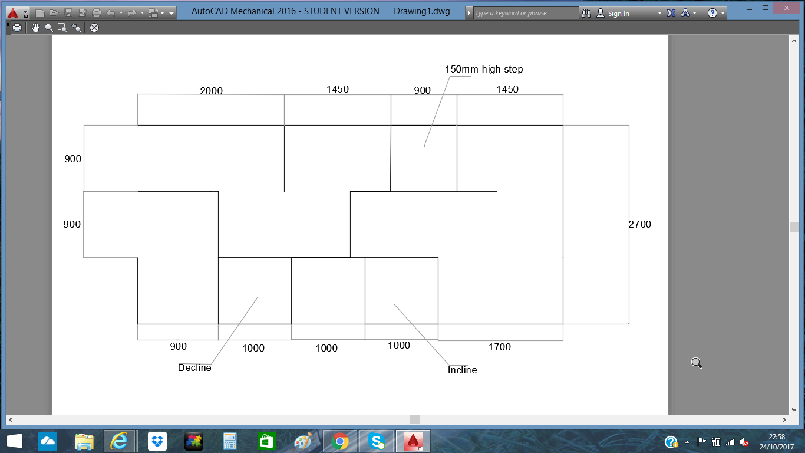

Appendix: 2
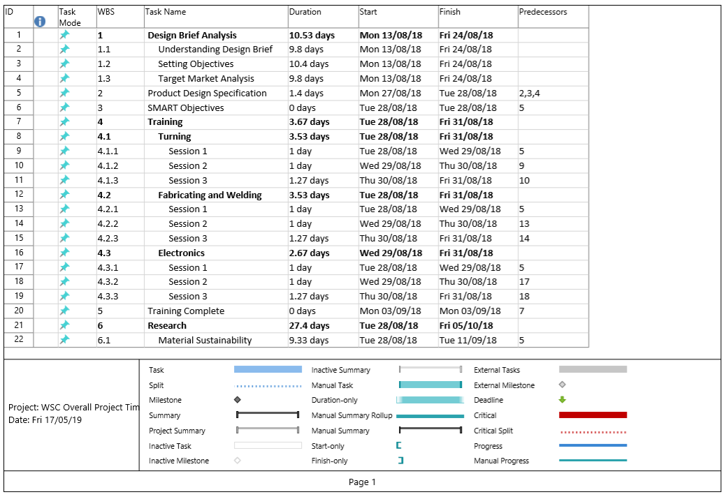

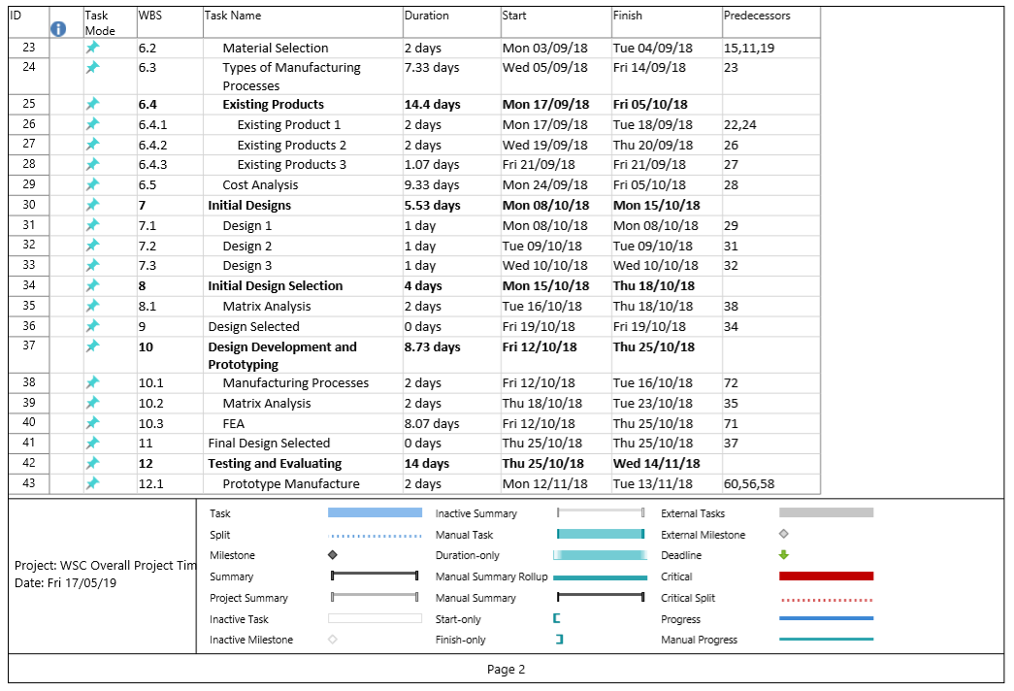
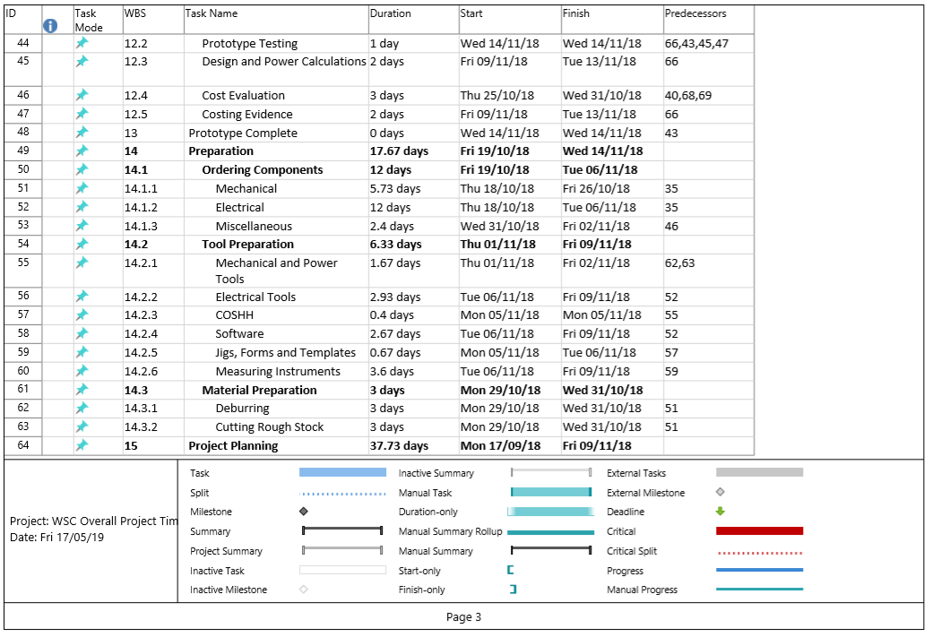
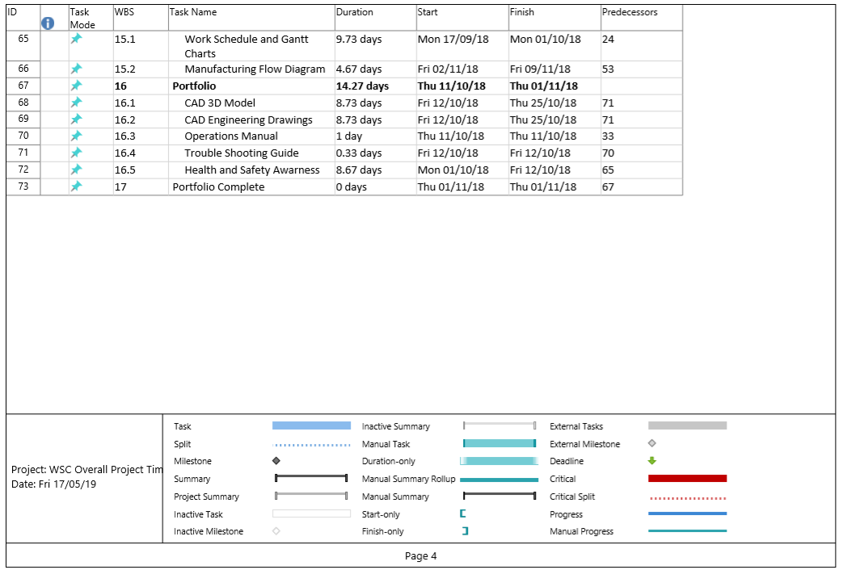
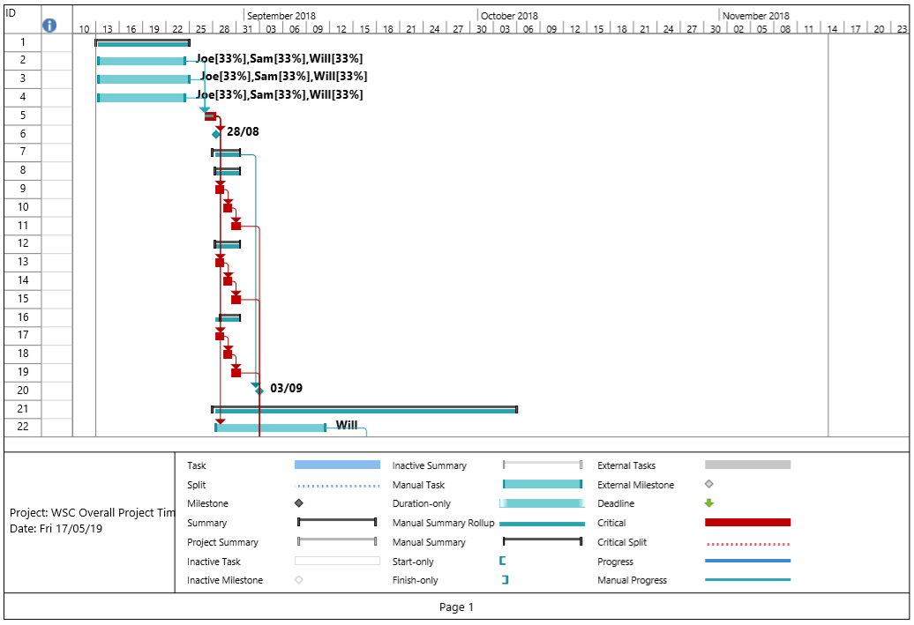
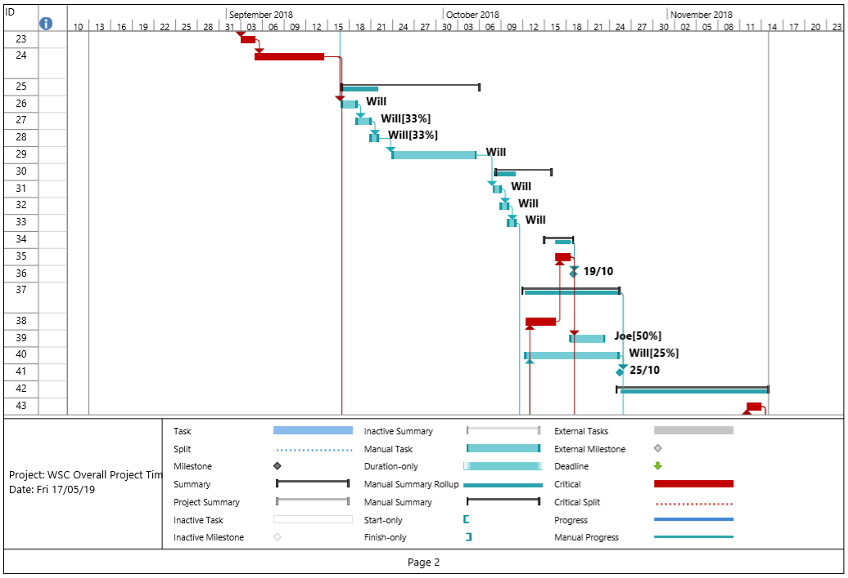
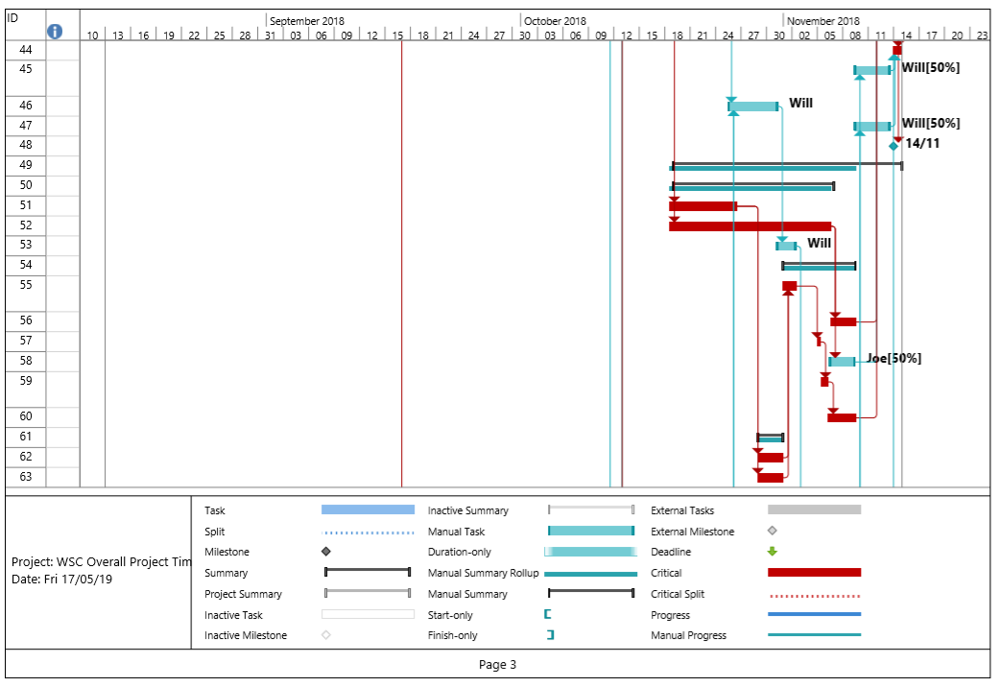
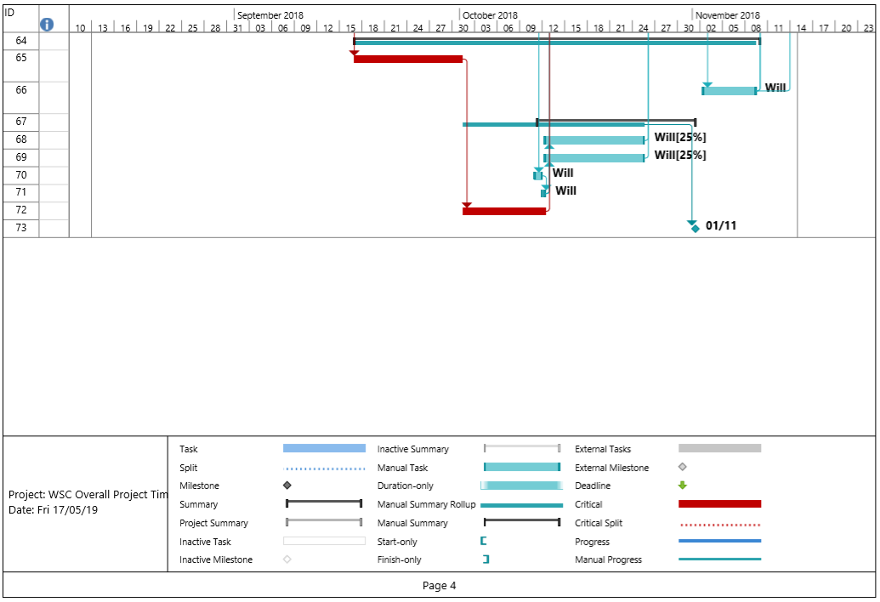

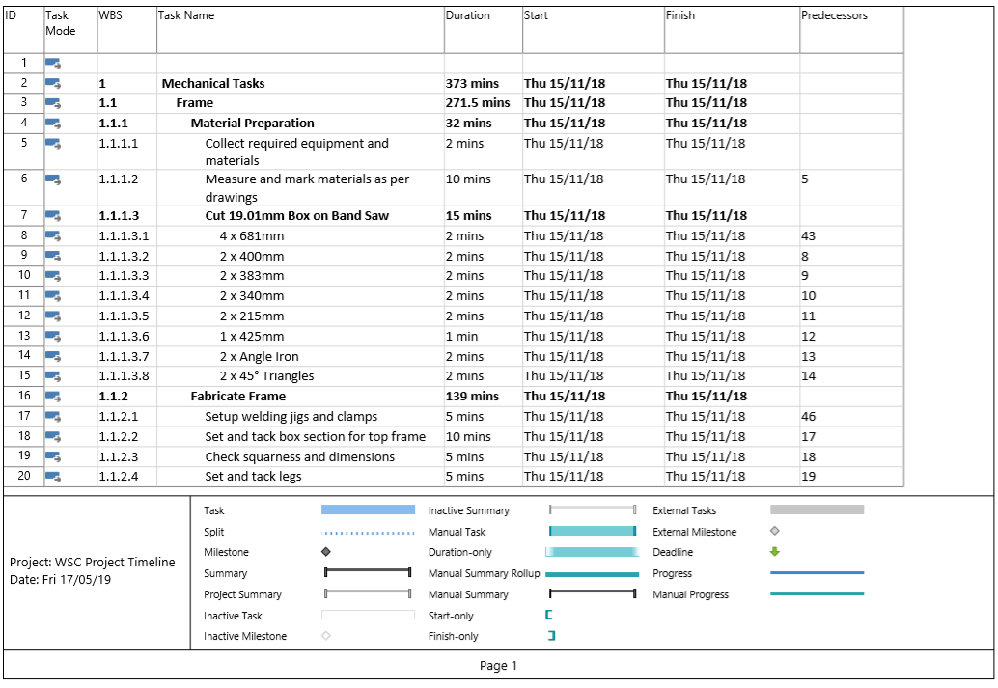
Appendix: 3



