DS 1 ASSESSMENT

My Photos

Photo 1
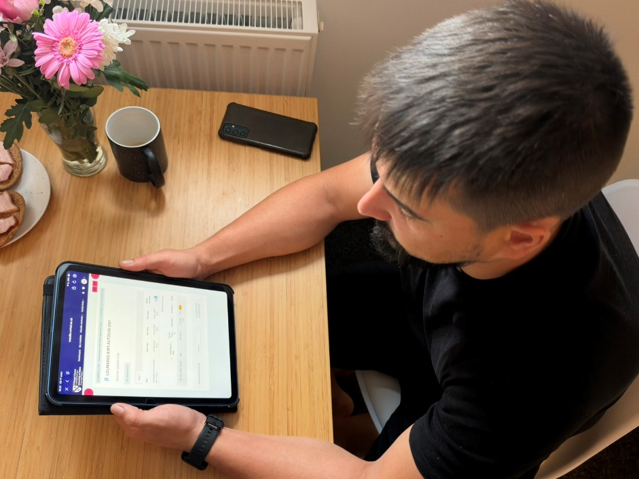
I use my iPad for my university lessons. It helps me learn new things and improve my skills.

Photo 2
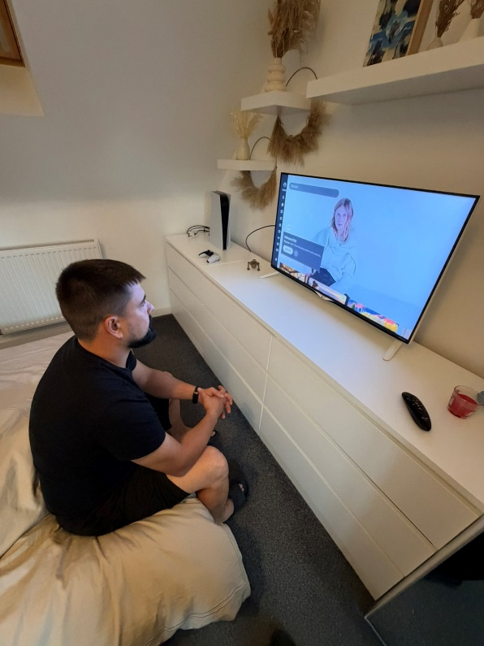
I watch interesting programmes on TV. It helps me learn new things and improve my knowledge.

Photo 3
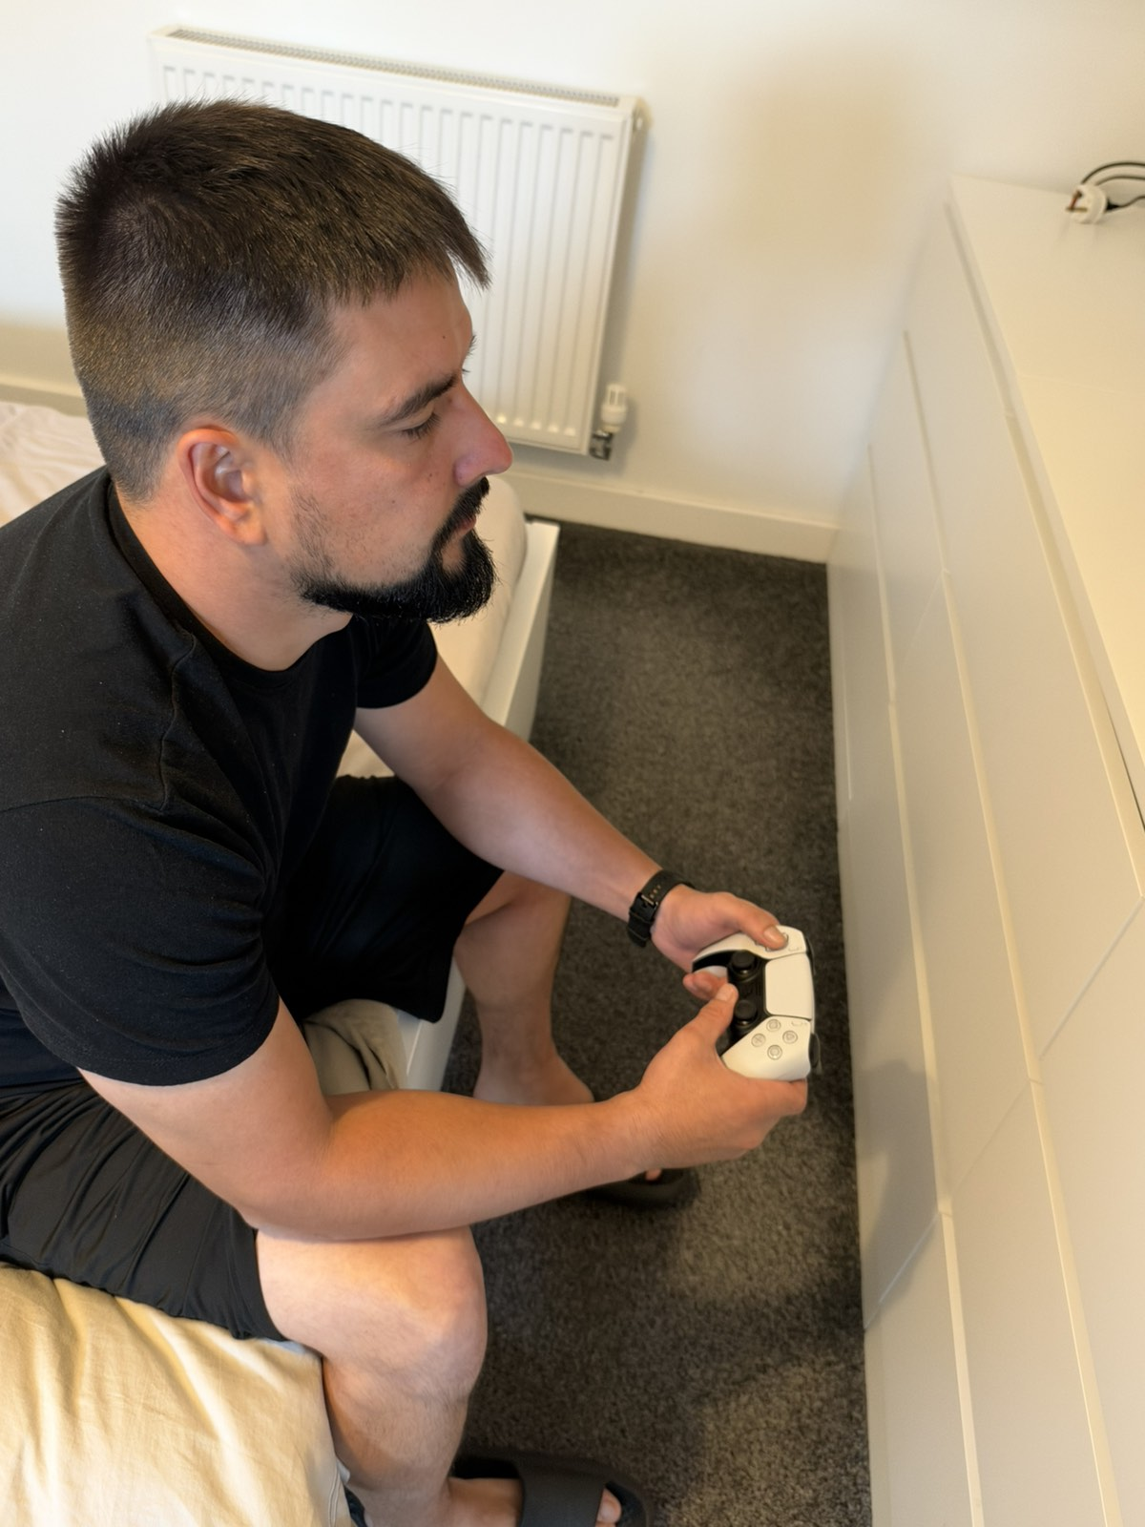
I use my joystick to play video games. It helps me relax and improve my thinking skills.

Photo 4
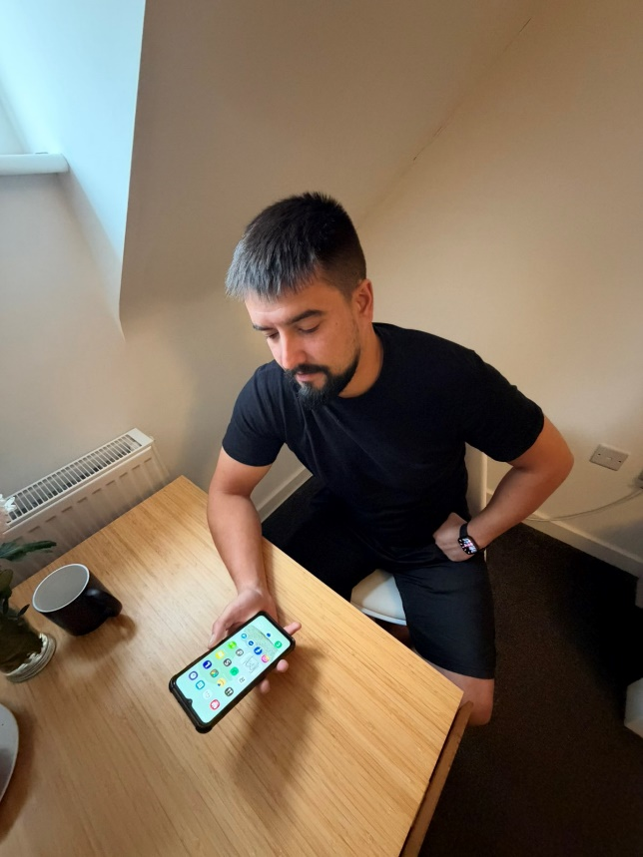
I use my phone to communicate with friends and family. It also helps me learn English and improve my skills.

Photo 5
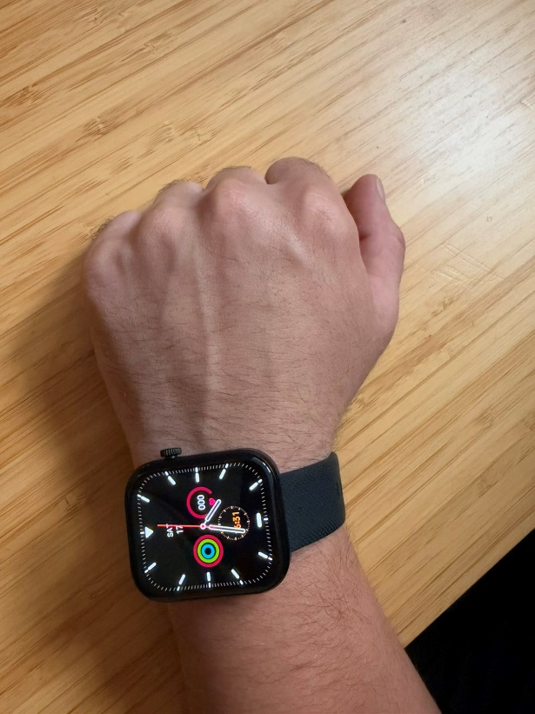
I use my smartwatch every day to check the time and track my activity. It helps me stay active and healthy.

Photo 6
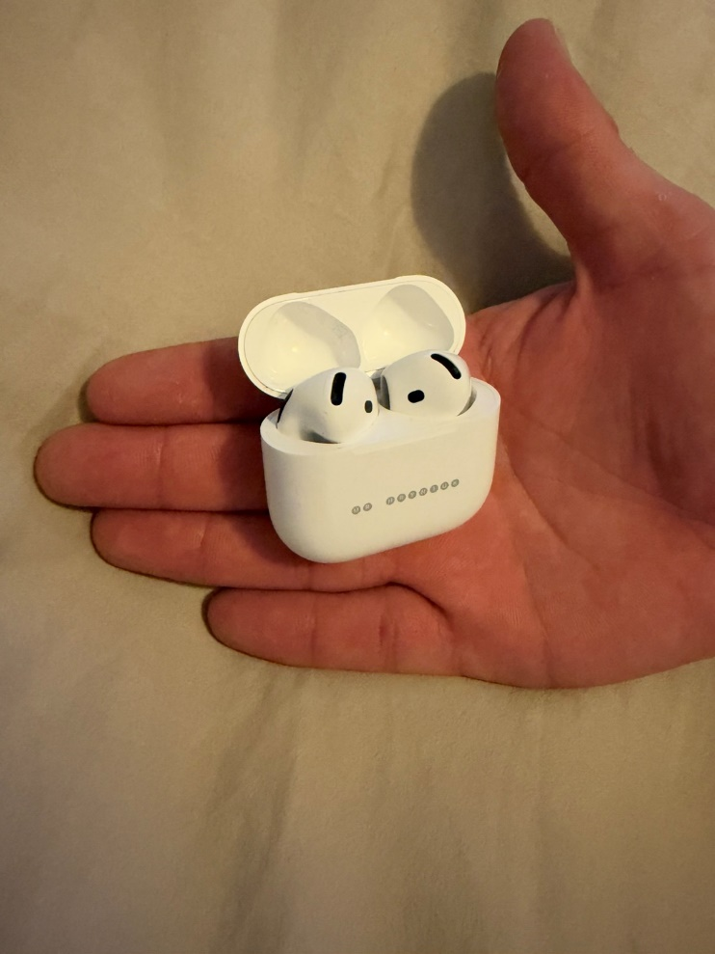
I use my wireless headphones to listen to music and learn English. They help me relax and improve my listening skills.

My Short Reflection

I use digital tools every day for studying and communication. I often use my iPad and phone to learn new things. I feel confident when I use my phone. I like watching TV and playing video games in my free time. I use my headphones to listen to music and learn English. I want to improve my computer skills. Digital skills are important for my studies and future job.

