How to engage employees throughout the employee lifecycle

Name: Corina Maria Danila
Student ID Number: 2118573
Module Title: Personnel Resourcing and Development BMIH5005
Lecturer: Emma Roberts

Table of Contents

Introduction 3
Main Body 3
Conclusion 11
References 12

Introduction
Human Resources (HR) department plays a very important role in every organisation. It fulfils the gap between management and employees, helps increasing the growth of the company and the engagement of the employees, being the only department who directly interacts with every people in the company. There are many techniques to involve employees throughout the employee lifecycle within an organisation. For example, Hilton Hotels creates a positive work environment to absorb their employees which helps them in employee retention.
The essay will include employee engagement through various sources with examples, the role of Human Resources in employee engagement, the techniques, and the advantages of employee engagement within a team, the employee lifecycle, also the employee engagement model and the way of implementation.
The main purpose of the essay is employee engagement that is the most important part of every hotel (Wilton, 2019). It also increases the productivity of employees along with the company’s progress.

Main Body
Human Resources plays different types of roles: a partner in strategy making, an advocate of employees, managing the change, and also thinking about the wellbeing of employees.
The role of Human Resources in employee engagement is to maintain the employees for the long term, and to create an environment in which the employees can work with happiness. Human Resources must give the assurance to the employees that they have the skills and talent to perform their job with efficiency. Also, they can motivate better the employees by realising the value of the employees in a company. Human Resources also helps to solve the problem of the employees and to communicate any information related to the company. For Example, The Hilton Hotel decided to expand its business which is why the Human Resources department started recruiting people for the newly expanded business, providing individual attention to every employee and also to their customers so that they can easily understand the needs and wants of the customers, motivates employees for performing their job with more passion and dedication, and also creates some interactive activities that help employees to know about other colleagues and help them to learn new skills increasing their knowledge. Human Resources department plays many roles in employee engagement like convincer, motivator, problem solver, etc.
Employee engagement means encouraging the employees to get involved in the activities of the company, building a good image of the business.
There are many ways for employee engagement like giving feedback on the regular basis and providing the appraisal. Feedback on any work is necessary because it shows the quality of work whether it is good or not and appraisal is also necessary for better performance. The second way of employee engagement is to maintain good relations with the manager (Chams and García-Blandón, 2019). Human Resources department is not only responsible for employee engagement, but other managers should also involve in employee engagement so the employees will be able to interact with other members also. There should be a good relationship between employees and managers so a healthy work environment will be created in the organisation. The third way is to clarify the values of the company that they want to deliver and also followed all the members of the company. The value of the company is not their vision, the values are the principles that guide them to do work in the right direction. The fourth way is to use the digital mode, there are many new technologies through which employee engagement can be done. There are many software and applications that help to engage the employees in business activities and also reduce their boredom of employees. As technology is updating day by day and everyone is likely to work on the digital platform so it will be very attractive for gathering the employees and employee engagement also. There are many advantages of employee engagement for example employees will not switch quickly, productivity will be increased, and the skill will be developed by the employees. The employees will feel valued in the company, Employees will get to know that their talent and presentation skills are properly utilised it is not wasted or not get misused.

Human Resources Management is defined by Armstrong as “a comprehensive and coherent approach to the employment and development of people”. (Armstrong, 2020). Human Resources management plays a crucial role in employee engagement and is responsible for creating and implementing policies, programs and practices that support and improve employee satisfaction, motivation, and commitment to their work.
David McClelland’s explained different traits of motivation but the only one will be dominant and the Company should identify the dominant trait of employees.(M. Badubi, 2017) A successful Human Resources management strategy is critical to the success of an organization as engaged employees are more productive, provide better customer service, and contribute to overall business success.
One of the key responsibilities of Human Resources management is to create a positive work environment that fosters employee engagement. This includes creating a culture of trust, open communication, and collaboration. The Human Resources team can also play a role in developing policies that support work-life balance, flexibility, and professional development opportunities. These policies can help to reduce stress and increase job satisfaction, leading to higher engagement levels.
HR management also has a role in providing opportunities for employee feedback and involvement in decision-making. For example, conducting regular employee surveys, focus groups, and suggestion programs can help HR gather valuable information about employee perspectives and make changes that respond to their needs and interests (Carter et al., 2016).
Another important aspect of Human Resources management is talent development and management. This includes evolving and implementing programs that support employee learning and growth, as well as managing performance and reward systems that recognize and reward employee contributions. These programs can help employees feel valued and motivated to continue making positive contributions to the organization.
Human Resources management has a crucial role to play in fostering employee engagement and building a positive workplace culture. By creating a supportive work environment, providing opportunities for employee feedback, and developing talent, HR management can help to build a strong and motivated workforce that is committed to achieving the organization's goals.

Employee engagement is a critical component of organizational success as it can lead to increased productivity, better job satisfaction, and improved employee retention. Three main factors that influence employee retention are identified by decades of real-world organisational experience at Employee Retention Connection (ERC)Model:
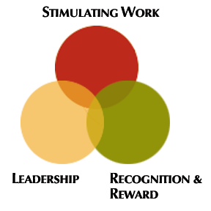
ERC's Retention Model (Kaur, 2014)
There are several ways in which organizations can effectively engage their employees, including open and regular communication, recognition and reward programs, supportive work-life balance policies, involvement in decision-making processes, and employee wellness programs. For example, Hilton Hotel also provides noteworthy employee perks. These benefits include paid time off, paid paternity leave, paid bereavement leave, and extended bereavement leaves for their employees. We are aware that the concepts of rewards, recognition, and education are not new. Hilton, however, has managed to do them incredibly well. Hilton demonstrated that your hotel business will succeed if you keep your employee’s content. They are aware of how important retention is to the hospitality sector. Hilton outperforms in terms of recognition. They regularly offer programmes, events, and awards to recognise outstanding team members.
5 Steps for employee retention in hotel industry:
- Concentrate on hiring people that match company values. To retain employees, you must hire them correctly.
- Provide means of professional advancement. The company should provide employees with the opportunity to learn more about culture, business, and leadership, offering them opportunities for continuous professional networking and personal growth.
- Show appreciation and recognition regularly. Workers in the hospitality industry generally feel valued when they are given appreciation and recognition.
- Provide flexible work hours and shift arrangements.
- Delivering a quality experience to employees can have a significant impact on retention rates.
The Hilton example shows how offering travel programs, paid time-off, and similar perks can affect retention. (www.linkedin.com, n.d.). Rewards are important for motivation and retention of employees (Cherian and Jacob, 2013).
Maslow’s hierarchy is also very crucial in the retention of employees. According to Maslow, there are five levels of needs people must have met to feel motivated. These five needs are grouped under two categories such as basic needs (physiological, safety and social) and the upper-level needs (esteem and self- actualization). Businesses should strive to meet all the needs of employees. The employees will be inspired to commit and work for the company for a longer time as a result. Such actions help employees form a positive opinion of the company and help them realise that it cares about their needs. In turn, they will show their loyalty and commitment to the company. Contrary to this, if an employee subject to a bad and very toxic environment will not be committed and interested in staying in his job.(Hanif, Khalid and Khan, 2013)
Effective communication is crucial for employee engagement. Regular team meetings, one-on-one conversations, and employee feedback sessions can help to foster a culture of open communication and ensure that employees feel valued and heard. Recognition and reward programs, such as employee of the month awards or opportunities for professional growth and development, can also help to motivate employees and boost engagement.
Work-life balance is another important factor in employee engagement. Flexible work arrangements, such as flexible hours and telecommuting, can help employees to balance their work and personal lives, leading to improved job satisfaction and engagement. Additionally, offering opportunities for personal and professional growth, such as training and development programs, can also contribute to employee engagement. (Mone and London, 2018).
Involvement in decision-making processes is also critical for employee engagement. By allowing employees to provide feedback and input on workplace policies, processes, and projects, organizations can increase engagement and motivation. Encouraging employees to take on leadership roles and responsibilities can also help to engage and motivate them.
Finally, employee wellness programs play an important role in employee engagement. Providing health and wellness benefits, such as gym memberships, and promoting healthy habits in the workplace, such as providing healthy food options and encouraging regular exercise, can help to create a positive workplace culture and improve employee well-being.
Employee engagement is a critical component of organizational success, and there are several effective ways in which organizations can engage their employees. By prioritizing open communication, recognition and reward programs, supportive work-life balance policies, involvement in decision-making processes, and employee wellness programs, organizations can build a strong and motivated workforce that is committed to achieving their goals (Osborne and Hammoud, 2017).

Employee engagement is a vital aspect of organizational success, and the advantages of engaging a team are numerous. Engaged employees are more productive, motivated, and focused on their work. This results in increased productivity, as engaged employees are more likely to go the extra mile and contribute to the organization's success. Additionally, engaged employees are more satisfied with their job, leading to lower turnover and improved retention. Engaged employees are also more likely to provide high-quality customer service, bringing new ideas and suggestions to the table and contributing to increased innovation and creativity. This in turn creates a positive workplace culture where employees feel valued and supported, leading to improved morale, better collaboration, and a more enjoyable work environment. Engaged employees are also more committed to their work and the organization, increasing employee loyalty and leading to increased employee retention (Bakker and Leiter, 2019). Organizations that prioritize employee engagement are more likely to build a strong and motivated workforce that is committed to achieving their goals.

Development of engagement in the attraction phase or can be said engaging the employee before recruiting maybe even before he becomes a potential candidate. At this stage, the potential candidates research the company and its values by reading online about the workplace and environment of the company (Kwon and Park, 2019). Engagement in the recruitment process is the stage at which conversation between recruiters and the candidates is involved and it also includes maintaining a positive environment and experience for the candidate. Engagement during Onboarding involves ticking checklists of the new hire, management of induction paperwork and providing training to settle them in the job (Cattermole, 2019). Engagement in the retention phase concentrates on employee satisfaction and making sure that the employee has the appropriate tools and resources for the job and rewards for their efforts. The Development Phase is about enhancing the skills and providing motivation to the employees and ensuring that the employee is at their best capabilities and can provide support to the team. The Separation Phase includes letting go of the employee due to the promotion or retirement and it is important to separate on good terms and minimise the disturbance in the team (Kwon and Park, 2019).
The Zinger Model of employee engagement concentrates on ten important activities that managers should take to build engagement in employees. It follows a pyramid structure and highlights why employee engagement is crucial and the importance of the needs of the employees (Hussainy, 2020).

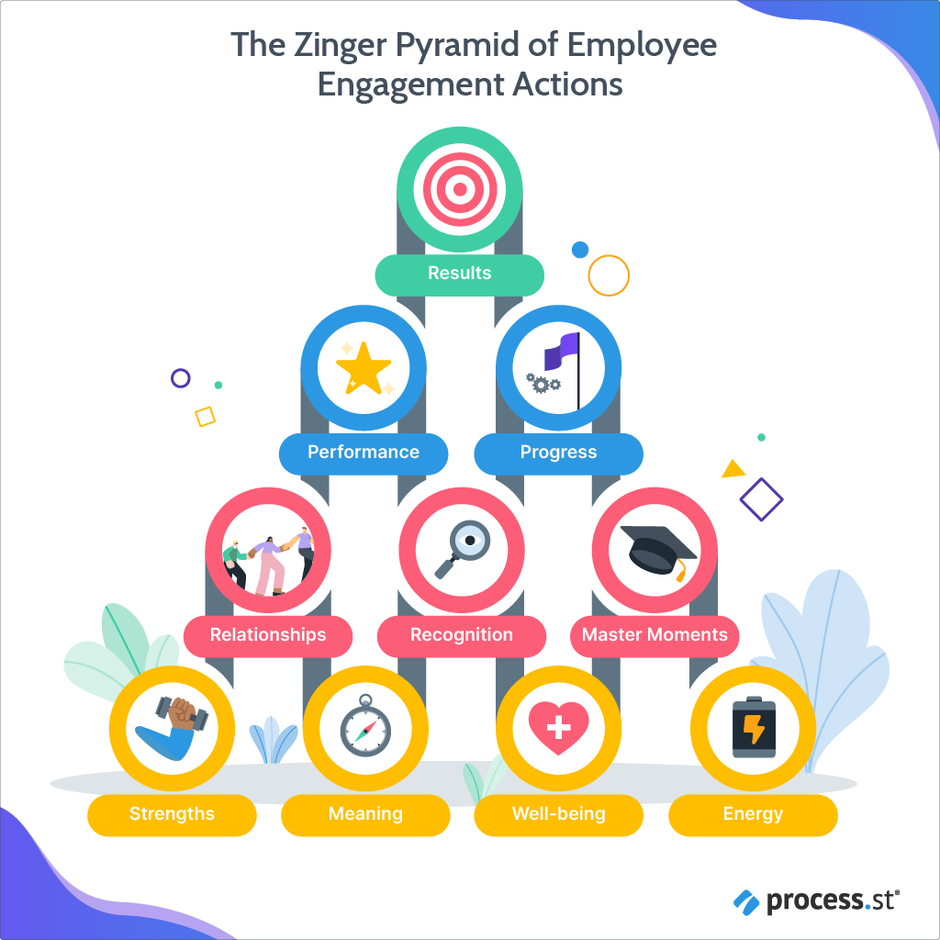
Zinger Model (Anon, 2022)
These building blocks are designed to be mobile and rearranged as required. Your team might be inspired and engaged by praise for one goal, but for another, it might be relationships or meaning that needs to be explored.
Bottom Row indicates the necessities that every individual needs to work effectively, the action is to enhance well-being which means physical and mental condition should be healthy otherwise employees will not be able to do their best work, enliven energy which includes creating an environment in which workers can bring energy in their work and can gain energy at work, make meaning focus to find purpose in life, around 90% of employee are more concern about their purpose in life more than their paycheck, leverage strengths mean environment in which employees can grow and increase their strength (Ramakumar and G, 2021).
The Second Row consisted of building a healthy relationship, fostering recognition, and mastering moments at the workplace.
The Third Row includes performance-boosting actions like maximising performance by giving opportunities and marking progress by providing rewards and recognition for the achievement and the top row includes achievement of results the final goal is the engagement of the employee to achieve ensure that strategic goals are clearly defined. (Delbahari, Soltani and Etebarian Khorasgani, 2019).
According to its creator David Zinger, the essence of why this pyramid functions is not to be a straightforward structure you adhere to:
“I like the 10 bricks and the pyramid, but you can use your own bricks or another structure for employee engagement. Perhaps you can use my bricks or structure as a foundation or a launching pad. Or maybe in rejecting my bricks and structure you make a stronger declaration of your own approach. They key is that it has to work for you and who you work with.” – David Zinger, 2015

Conclusion
Employee engagement is very important for the growth of the organisation, it helps the employee to get connected with the mission and vision of the organisation and encourages them to provide innovative ideas to the organisation to achieve the organisational goal more effectively and efficiently. The Human Resources department plays a crucial role in employee engagement because it is their responsibility to keep the employee involved in the organisation and encourage them to make their contribution to the accomplishment of the goals of the organisation. Employee engagement is done through the phase of the employment cycle of an employee which starts from engagement even before hiring till letting go of the employee for promotion or retirement. The Zinger Model of engagement explains that employee engagement can be done by ten actions which are divided into four rows in the form of pyramids at first it includes looking for the well-being of the employee, enlivening energy, making meaning and building strength in the second row involves building a healthy relationship, recognition and master moments, third row includes boosting of performance by maximising the performance and marking of progress and the fourth or top row includes achieving the results by defining the strategic goals clearly.

References

Anon, (2022). Employee Engagement & Motivation Policy: Why You Need One For Retention – Yesterday | Process Street | Checklist, Workflow and SOP Software. Available at: https://www.process.st/employee-engagement-and-motivation/. (Accessed: 12 February 2023).

Armstrong, M. (2020). Armstrong’s Handbook Of Human Resource Management Practice. 15th ed. S.L.: Kogan Page.

Badubi, M (2017). Theories of Motivation and Their Application in Organizations: a Risk Analysis. International Journal of Innovation and Economic Development, 3(3), pp.44–51. doi:https://doi.org/10.18775/ijied.1849-7551-7020.2015.33.2004.
Bakker, A. and Leiter, M. (2019) Strategic and proactive approaches to work engagement. Organizational dynamics,46(2), pp.67-75. doi:https://doi.org/10.1016/j.orgdyn.2017.04.002.
Carter, W.R., et al. (2016). The effects of employee engagement and self-efficacy on job performance: a longitudinal field study. The International Journal of Human Resource Management,29(17), pp.2483–2502. Available at: https://doi.org/10.1080/09585192.2016.1244096. (Accessed: 10 February 2023).
Cattermole, G. (2019). Developing the employee lifecycle to keep top talent. Strategic HR Review, 18(6), pp.258–262. Available at: https://doi.org/10.1108/SHR-05-2019-0042. (Accessed: 9 February 2023).
Chams, N. and García-Blandón, J. (2019). On the importance of sustainable human resource management for the adoption of sustainable development goals. Resources, Conservation and Recycling, 141, pp.109–122. doi:https://doi.org/10.1016/j.resconrec.2018.10.006.
Cherian, J. and Jacob, J. (2013). Impact of Self Efficacy on Motivation and Performance of Employees. International Journal of Business and Management, 8(14). doi:https://doi.org/10.5539/ijbm.v8n14p80.
Delbahari, V., Soltani, I. and Etebarian Khorasgani, A. (2019). Designing an organizational engagement model using structural equation modelling: case study of National Iranian Oil Company. Problems and Perspectives in Management, 17(3), pp.1–13. doi:https://doi.org/10.21511/ppm.17(3).2019.01.
Hanif, A., Khalid, W. and Khan, T.N. (2013). Relating Maslow’s Hierarchy of Needs with Employee Turnover and Retention: Case Study of Local Telco. International Journal of Human Resource Studies, 3(2), p.51. doi:https://doi.org/10.5296/ijhrs.v3i2.3864.
Hussainy, S.S. (2020). Review on Motivational Theories & Models: Its application for Employees’ Retention in Organizations. International Journal of Business and Applied Social Science, 6(1), pp.40–46. doi:https://doi.org/10.33642/ijbass.v6n1p5.
Kaur, R. (2014). Employee Retention Models and Factors Affecting Employees Retention in IT Companies Ramind er K aur Ph.D Scholar (Management) En r ol l me n t No. 1 5 0 2 1 1 2 8 ( K U0 0 2M MX I V0 2 0 10 6 8 0). Available at: https://www.ripublication.com/ijbamspl17/ijbamv7n2spl_15.pdf.( Accessed 12 February 2023)
Kwon, K. and Park, J. (2019). The Life Cycle of Employee Engagement Theory in HRD Research. Advances in Developing Human Resources, 21(3), pp.352–370. doi:https://doi.org/10.1177/1523422319851443
Mone, E.M. and London, M. (2018). Employee engagement through effective performance management a practical guide for managers. New York Routledge.
Osborne, S. and Hammoud, M. (2017). Effective Employee Engagement in the Workplace. International Journal of Applied Management and Technology, 16(1), pp.50–67. doi:https://doi.org/10.5590/IJAMT.2017.16.1.04.web
Ramakumar, K. and G, P.R. (2021). Employee Engagement during Organizational Crisis – with special reference to the COVID Scenario. PURUSHARTHA - A journal of Management, Ethics and Spirituality,14(1), pp.105–115. Available at: http://journals.smsvaranasi.com/index.php/purushartha/article/view/997. (Accessed: 10 February 2023).
Wilton, N. (2016). An introduction to human resource management. Los Angeles: Sage
www.davidzinger.com. (n.d.). Pyramid of engagement. Available at: http://www.davidzinger.com/tag/pyramid-of-engagement/. (Accessed 12 February 2023).
www.linkedin.com. (n.d.). How Hilton Keeps its Employees Happy (And Five Employee Retention Tips for the Hospitality Industry). Available at: https://www.linkedin.com/pulse/how-hilton-keeps-its-employees-happy-five-employee-tips-bybee-cpa#:~:text=They%20offer%20regular%20awards%2C%20events. (Accessed 12 February 2023).

