Random number generation applied in Turtle (SOLUTIONS)

1. Let's draw a standard circle, 30 radius, with Turtle:

import turtle
myTurt = turtle.Turtle() # create turtle
myTurt.circle(30)
turtle.done() # keeps screen open

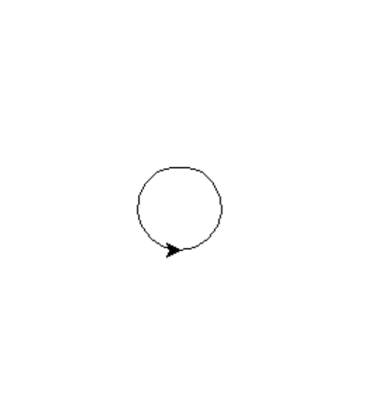

2. Let's make the width of the circle random, between 10 and 100. We will generate the random number and then feed it in to the circle:

import random
import turtle
myTurt = turtle.Turtle() # create turtle
width = random.randint (10,100)
myTurt.circle(width)
turtle.done() # keeps screen open

Sample output:
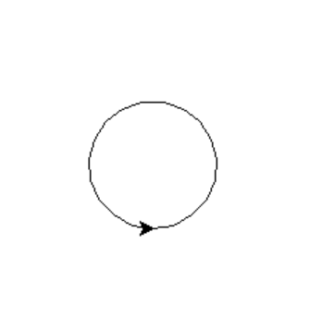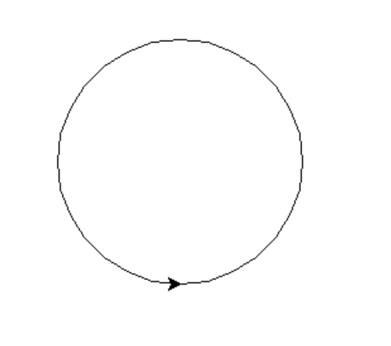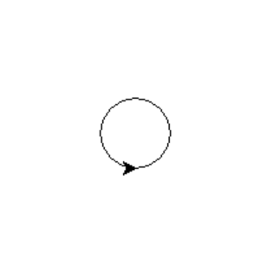

3. We could also change the start point for the circle randomly, generating co-ordinates within a 500 x 500 square:

import random
import turtle
myTurt = turtle.Turtle() # create turtle
width = random.randint(10,100)
x = random.randint(-250, 250)
y = random.randint(-250, 250)
myTurt.penup()
myTurt.goto(x, y)
myTurt.pendown()
myTurt.circle(width)

Sample output:
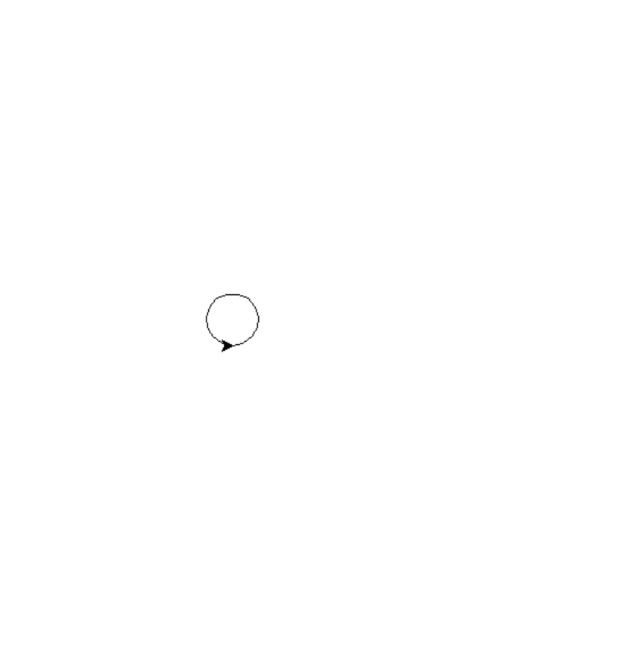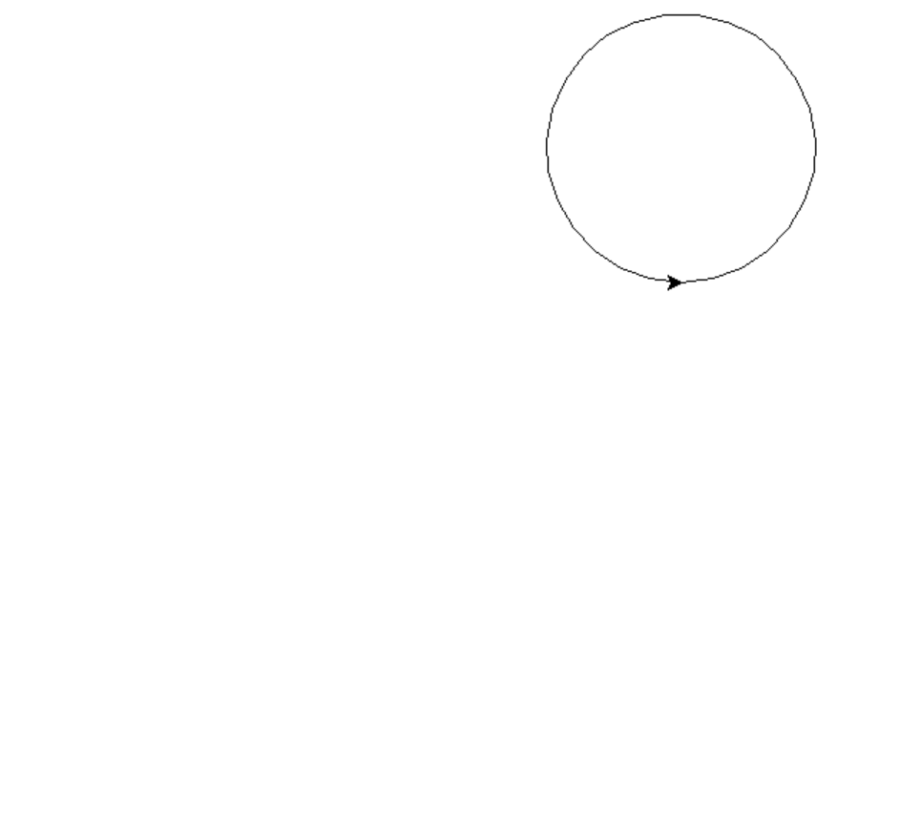
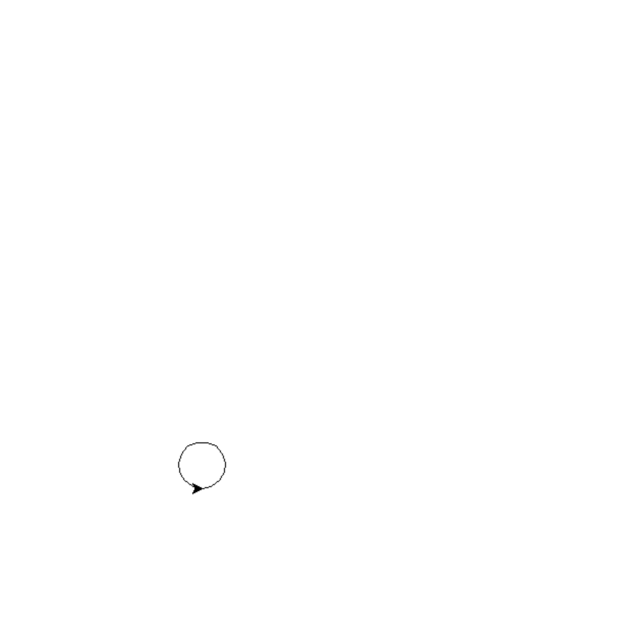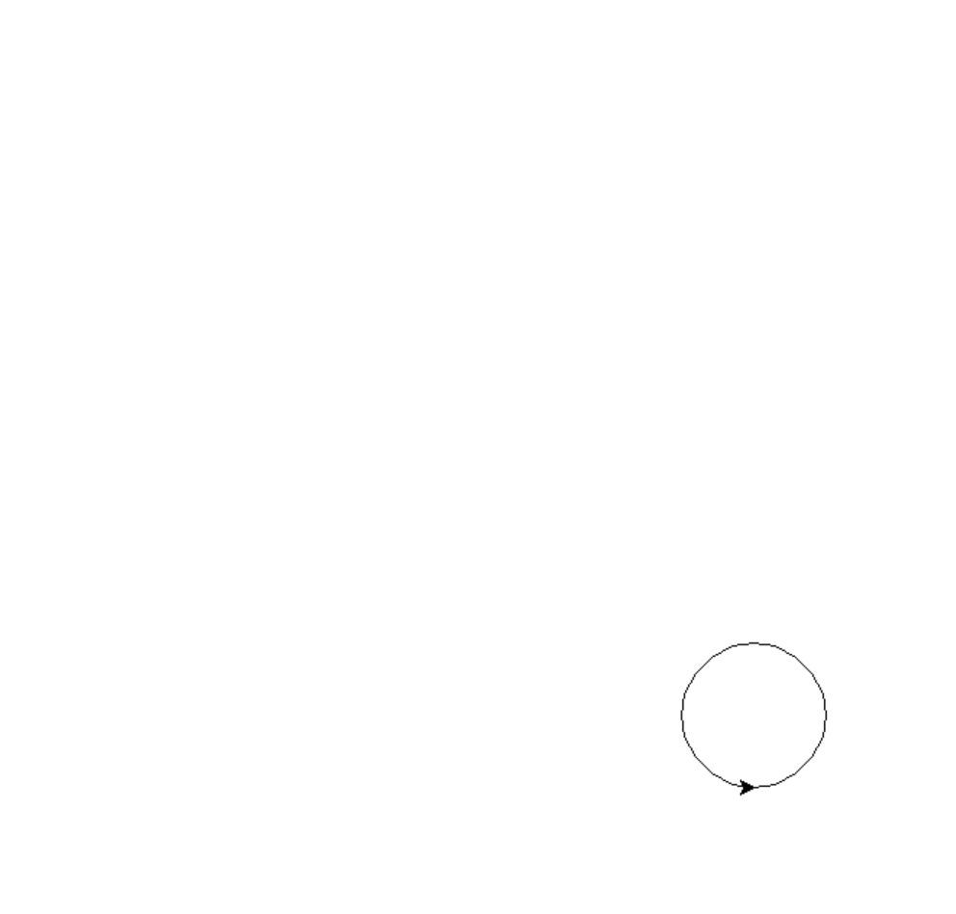

4. I could then loop my code so I get more than one circle (a randomized animation!):

import random
import turtle
myTurt = turtle.Turtle() # create turtle
for counter in range (1, 10, 1):
width = random.randint(10,100)
x = random.randint(-250, 250)
y = random.randint(-250, 250)
myTurt.penup()
myTurt.goto(x, y)
myTurt.pendown()
myTurt.circle(width)
turtle.done() # keeps screen open

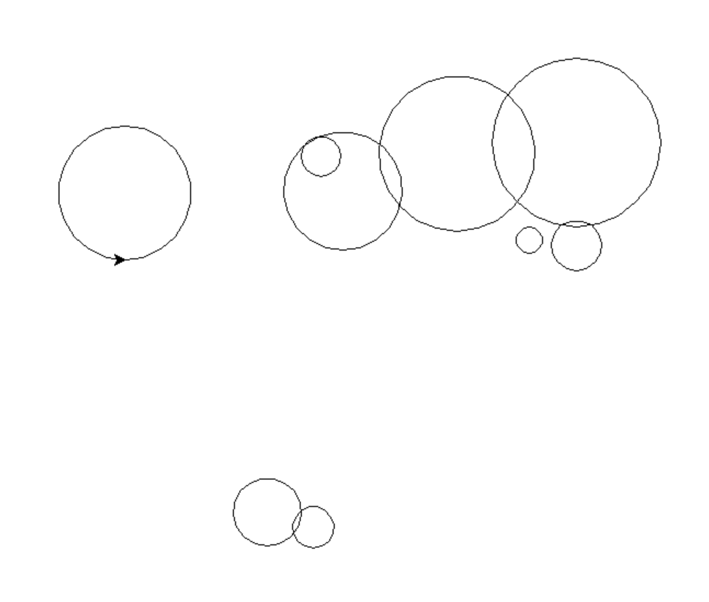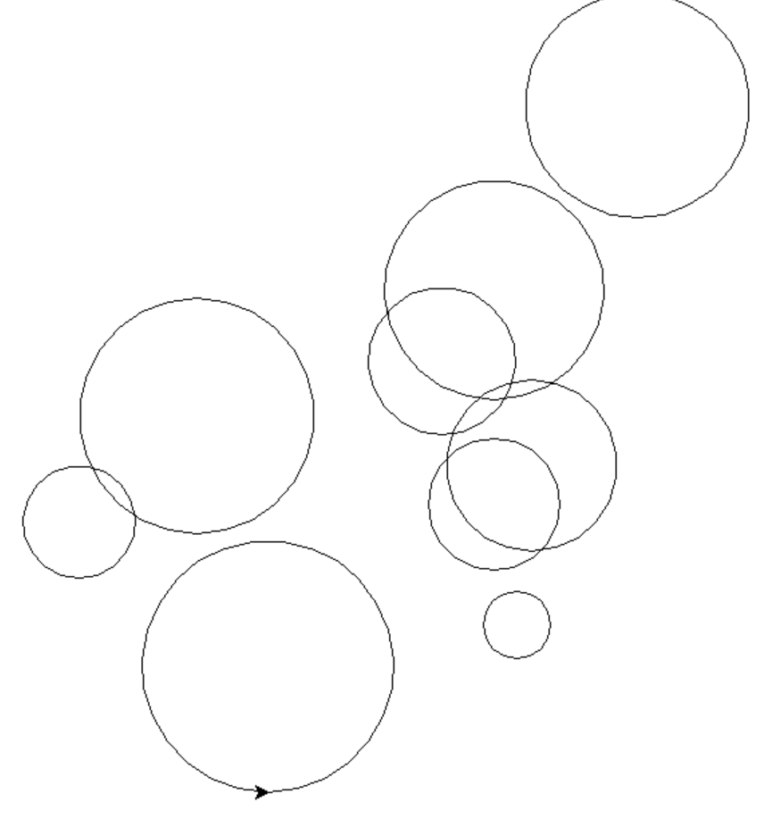

5. I'll keep going with the random theme and loop for a random number of times, rather than 10 as I did before….say between 5 and 100:

import random
import turtle
myTurt = turtle.Turtle() # create turtle
noOfCircles = random.randint(5,100)
for counter in range (0, noOfCircles):
width = random.randint(10,100)
x = random.randint(-250, 250)
y = random.randint(-250, 250)
myTurt.penup()
myTurt.goto(x, y)
myTurt.pendown()
myTurt.circle(width)
turtle.done() # keeps screen open

Sample output:

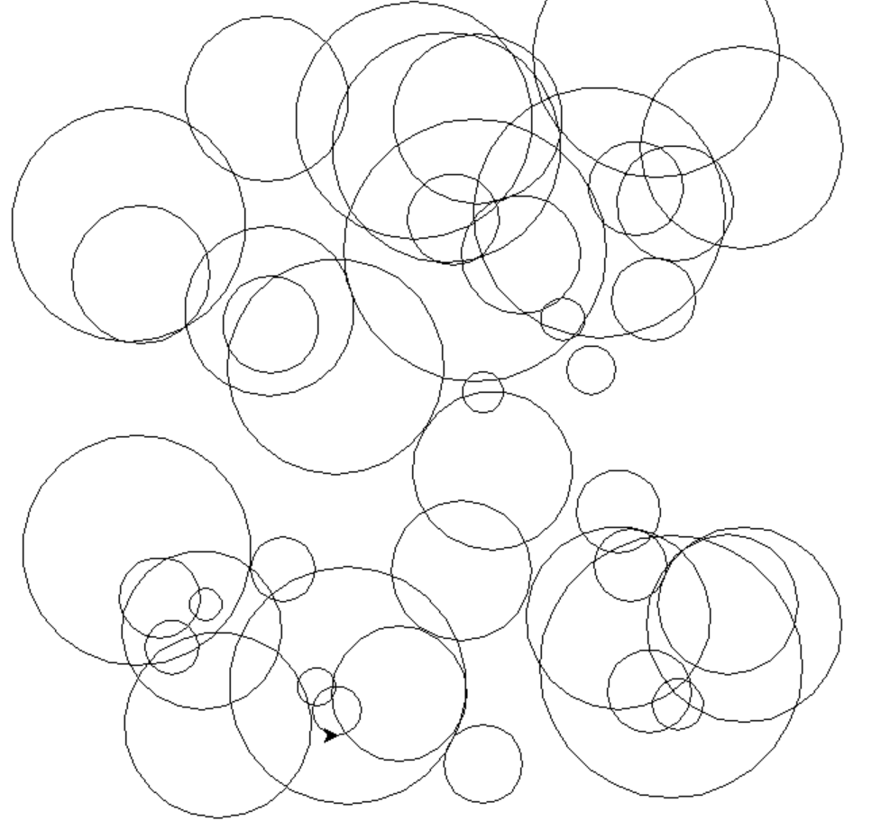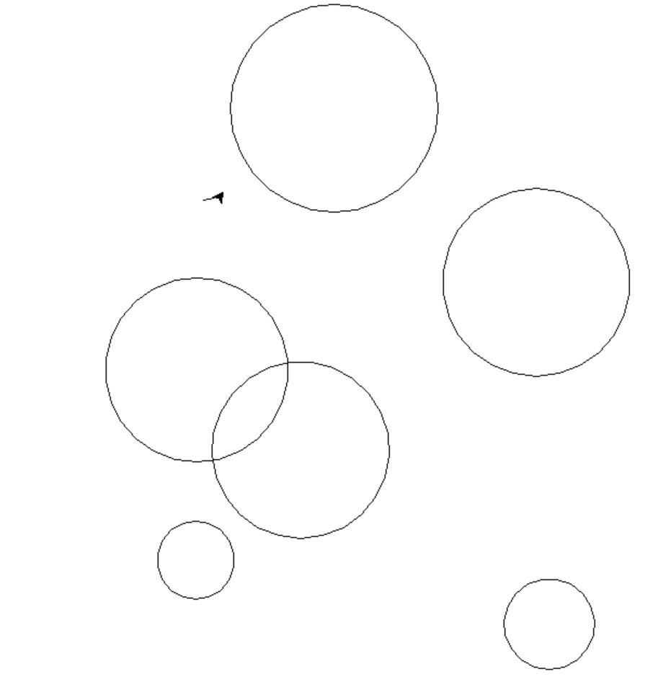

0…34 0…6
6. You start to be limited only by your own imagination

Here's another extension where the fill colours for the circle are randomised using a list to help:

import random # imports the turtle command functions from library
import turtle
myTurt = turtle.Turtle() # create turtle
noOfCircles = random.randint(5,100)
turtle.colormode(255) # set colour mode to RGB format
for counter in range (1, noOfCircles):
width = random.randint(10,100)
x = random.randint(-250, 250)
y = random.randint(-250, 250)
myTurt.penup()
myTurt.goto(x, y)
myTurt.pendown()
r = random.randint(0, 255)
g = random.randint(0, 255)
b= random.randint(0, 255)
myTurt.fillcolor(r, g, b) # feed in variables for random colour
myTurt.begin_fill()
myTurt.circle(width)
myTurt.end_fill()
turtle.done() # keeps screen open



