

University of Wales Trinity Saint David
School of Engineering

Application of Automation in Wastewater Treatment
Control & Automation – ACMA5001

Simeon Scoberg-Evans
1252150
08/04/2025
Table of Contents
1 Introduction 1
2 Historical Context of Instrumentation, Control, and Automation (ICA) Implementation in Wastewater Treatment 2
2.1 A Brief History of Wastewater Treatment 2
2.2 The Introduction of ICA 3
3 Key Components of ICA in the Wastewater Treatment Process 4
3.1 Sensors 4
3.1.1 Level Sensors 4
4
3.1.2 Flow Sensors 4
5
3.1.3 Chemical Sensors 5
3.2 Valves 6
3.2.1 Gate Valve 6
3.2.2 Check Valve 6
3.2.3 Butterfly Valve 7
3.3 Actuators 7
3.3.1 Types of Actuators 7
3.4 Process Controllers 8
4 Supervisory Control and Data Acquisition Systems (SCADA) 9
5 Regulation and Standards 10
6 Conclusion 11
7 References 12

Introduction
Currently, significant changes in water quality and quantity are taking place around the world (WMO (World Meteorological Organization), 2018), that pose a fundamental threat to the water sector. An effective and sustainable method of water conservation is the treatment of wastewater, or water reclamation (Yadav, et al., 2019). Wastewater treatment is an incredibly complex process that require the control and management of various physical, chemical, and biological processes, while the system is at the mercy of ever-changing weather patterns and weather-related disasters, such as floods (Capodaglio, 2003).
This report will analyse the implementation of instrumentation, control, and automation (ICA) technologies in the wastewater treatment process, and evaluating their effect. ICA have become integral components in the operation of wastewater treatment facilities around the world, ensuring that processes are conducted efficiently, safely, and in conjunction with regulatory standards.

Historical Context of Instrumentation, Control, and Automation (ICA) Implementation in Wastewater Treatment

A Brief History of Wastewater Treatment
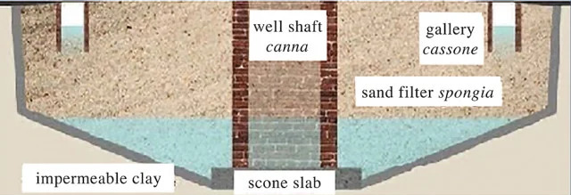
Water treatment dates back to ancient Egypt and India, where methods were devised to treat municipal water by boiling, filtering through charcoal, straining, and exposure to sunlight (EPA, 2000). Later, in Medieval Venice, they captured rainwater and filtered it into cisterns through beds of sand (Gentilcore, 2021). Similar straining and filtering methods were used in the 17th century when London’s New River was constructed, where the slow flow passed through a series of screens to catch weeds and debris (Melosi, 2000).
Figure 1 diagram of a Venetian cistern (Water Museums Global Network, 2025)

It was not until the early 19th century in Paisley, Scotland, that John Gibb invented a filter that removed debris from the water and supplied the city with clean water (Scott, 1955) and then, in 1828, London devised its own slow sand filter, the Chelsea filter; a two foot layer of sand over layers of shells and crushed bricks and glass, that removed 95% of impurities (Halliday, 2014).
Figure 2 slow sand filter diagram (Maiyo, et al., 2023)
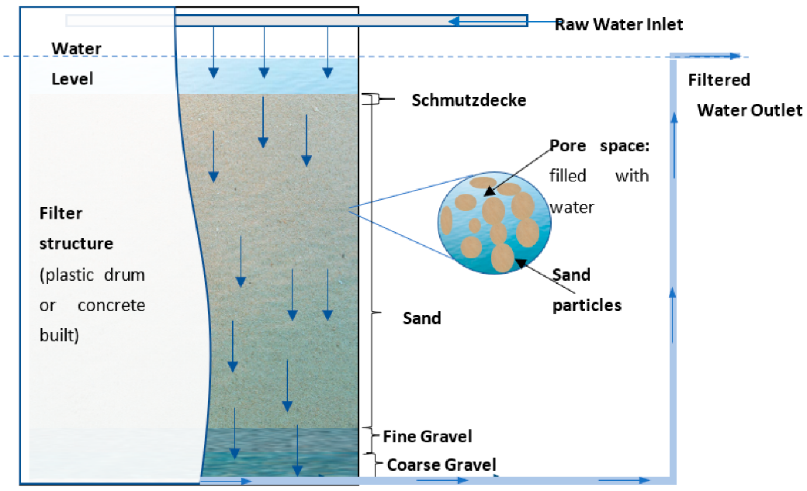

The Introduction of ICA
In the early 1970’s, water treatment was considered more an art than it was a science. Chemical processes were not subjected to the same vagaries as biological processes and had far more control. It was then decided to introduce instruments, control methods, computer programming and operating equipment, all as the fundamental kinetics upon which automation systems must be based was just becoming apparent (Olsson, 2012).
Seeing this, in 1971 the International Association on Water Pollution Research (IAWPR) organised a conference in Vienna to bring attention to ICA and open a discussion on the automation of water treatment facilities. The discussions were so lively and the interests and ideas so widespread that they decided there would be a subsequent conference to follow and to have it entirely devoted to ICA development (Andrews, 1972).
Operations moved from periodic sampling for process control to more consistent monitoring of key parameters, such as flow rates and pH levels, and over decades of research and development in ICA and with the advent of digital technologies in the late 20th and early 21st centuries, the control systems have become far more sophisticated, and the data monitoring has gone from periodic to real-time (Vieira, et al., 2019). The most sophisticated and revolutionary control and monitoring tools, that will be covered later in this report, are Supervisory Control and Data Acquisition (SCADA) systems, which are implemented to facilitate higher levels of monitoring and real-time data analysis (Humoreanu & Nascu, 2012).
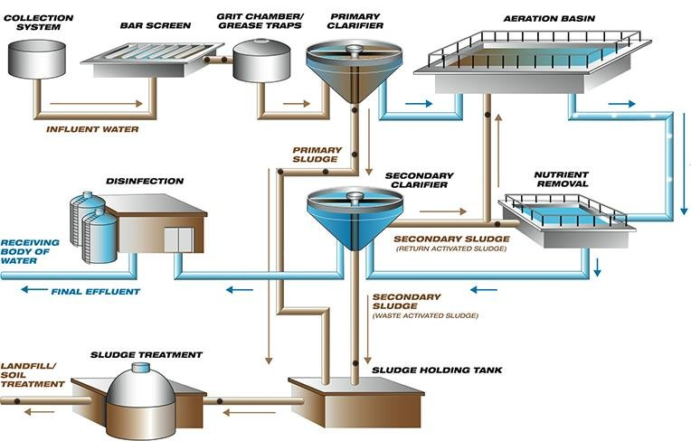
Figure 3 the modern wastewater treatment process scientific diagram (Mallik, et al., 2018)

Key Components of ICA in the Wastewater Treatment Process

Sensors
A sensor is a device that detects and measures physical properties from its environment and then converts them into signals that can be read or processed. Said signals can be electrical, mechanical, optical, or digital, depending on the type of sensor (Vetelino & Reghu, 2011). When measuring process variables and providing data for control systems, sensors are a critical component.

Level Sensors
They measure the height of liquids or gases in tanks, or chambers, to ensure proper flow and to prevent overflow or dry conditions (with liquids). Point sensors as well as continuous position sensors are utilised, depending on application, to ensure that as much data is being processed as possible (Niazi, 2021). For example, you will find level sensors in a storm water holding tank to monitor capacity, so that overflowing is avoiding during heavy rainfall.
Figure 4 examples of capacitance water level sensors (RS Hydro, 2025)
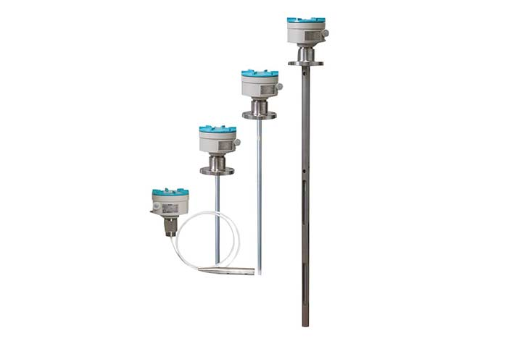

Flow Sensors
Flow sensors, more commonly referred to in the water industry as flow meters, are devices used for measuring the flow rate or quantity of a moving gas or liquid (Ejeian, et al., 2019). Flow as measured may be influenced by pressure, velocity, temperature, or chemical content of the system (de Graaf, et al., 2015), so flow sensing devices are usually based on the direct detection of volume, mass, velocity, or combination of those variables, by measuring a variety of physical properties (Abbasnejad, et al., 2018).
One example of a use of a flow meter, would be to monitor the rate of flow of an overflow line so that the storage tank is not at capacity if there were a sudden surge caused by extreme weather, such as flooding or heavy rainfall.
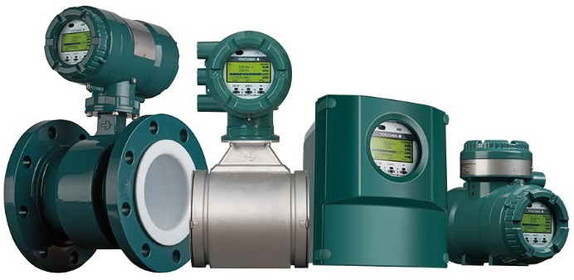
Figure 5 examples of flowmeters (Yokogawa, no date)

Chemical Sensors
- pH Meters: an instrument used to measure hydrogen-ion activity in solutions, which expresses the acidity or alkalinity of the solution as a pH value; a scale of 1-14 with 7 being neutral, <7 being acidic, and >7 being alkaline (or basic) (Iowa State University: Holme Research Group, no date). In an aeration tank, pH sensors monitor organic compounds, allowing for adjustment to attain optimal results (GAOTek, no date).
- Conductivity sensors: conductivity is a measurement of the ability of an aqueous solution to transfer an electrical current, which indicates the overall salinity of the water and the general water quality (Zuo, et al., 2020). For example, the water salinity in a grit chamber affects the oxygen levels and thus the efficiency of the activated sludge process (Levlin, 2010).
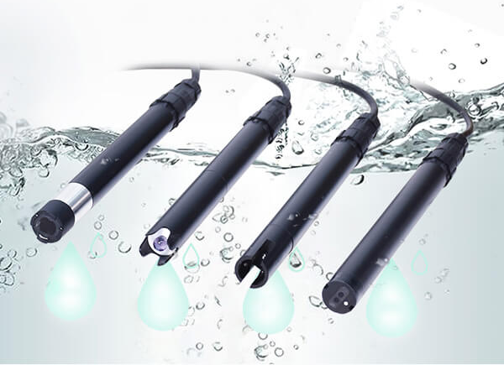
- Dissolved Oxygen Analysers: an instrument to determine the amount of oxygen dissolved in water, to provide valuable information about the biological and biochemical reactions in the water (Wetzel & Likens, 2000). It is essential for aerobic biological treatment processes, which is why they are used to monitor oxygen levels in aeration tanks to ensure that the conditions are as favourable as possible for organic waste decomposition (Santin, et al., 2019).
Figure 6 various chemical sensors/probes (Renke, 2025)

Valves
A valve is a device that, at its most basic, works to regulate, control or direct flow within a system or process (Unified Alloys, no date). There are numerous different types of valves used for a wide range of applications, but this report will focus on valves most commonly used in wastewater treatment based on the author’s first-hand experience designing pipework for wastewater treatment facilities.

Gate Valve
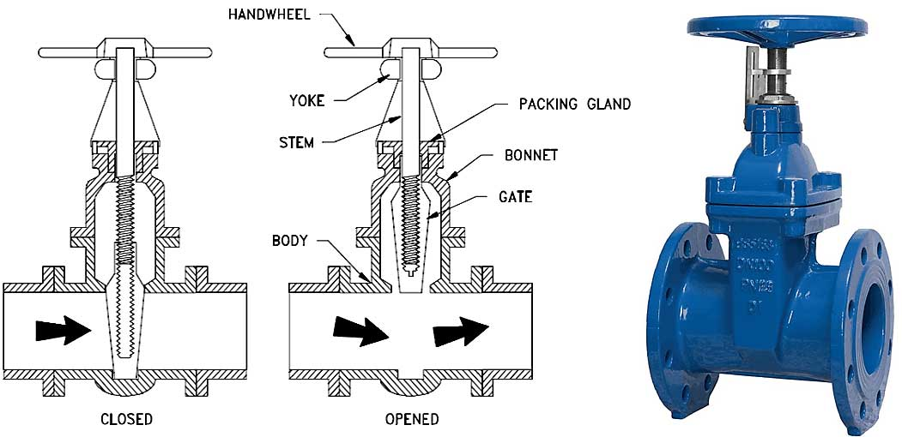
A gate valve is a linear valve that can be used to either control or isolate fluid (gas, water, slurry, etc.) flow. There are various applications for a gate valve but, more often than not, they are installed for maintenance or safety reasons because they can isolate the flow to permit access for maintenance, inspection, or installation of new processes, without having to shut down the process and causing a loss of production (Nesbitt, 2011).
Figure 7 gate valve and process diagram (Bertram Products Inc., 2024)

Check Valve
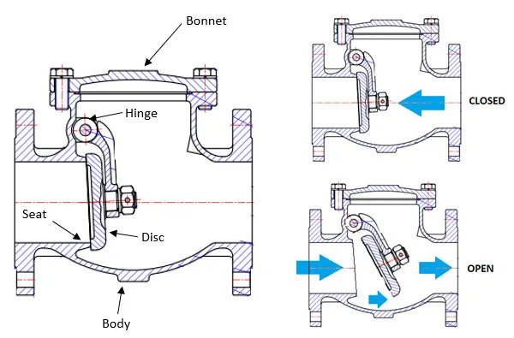
Check valves, also known as non-return valves, are used to control internal fluid flow. They allow the fluid to flow in one direction, and if the flow is reverse, the valve shuts and stops the completely (Hussein, et al., 2020). One typical use for a check valve is to position one downstream of a pump, to ensure that the pump is protected should there be a back surge for any reason and the chamber being pumped is protected from overflow/cross-contamination caused by the aforementioned back surge.
Figure 8 check valve diagram (pipingtechs.com, no date)

Butterfly Valve
A butterfly valve is popularly used to control flow or for isolation. It consists of a disc the width of the internal diameter of the pipe, that can be rotated to allow flow. The further open the butterfly valve, the greater the flow, so they are primarily used to control the rate of flow in a line (Kimura, et al., 1995). A common use in wastewater treatment would be the control of the flow of sludge between tanks.
Figure 9 butterfly valve diagram (Brown, 2024)
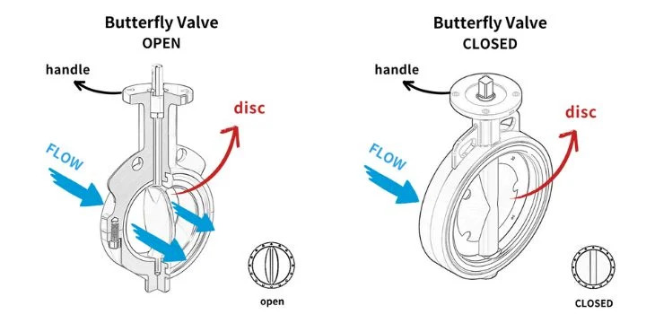

Actuators
An actuator is a functional element that connects the information processing part of an electronic control system with a technical or nontechnical (i.e. biological or chemical) process (Janocha, 2004). It takes energy – usually provided by electricity, liquid, or air – and converts that into motion (International Society of Automation (ISA), 2025).
It is essentially the “muscle” of a device (e.g. a valve), it does the physical work based on a signal received.

Types of Actuators
- Electric: uses an electrical signal to operate, a transducer (Butterfield & Szymanski, 2018), and are known for having a good level of precision, a relatively high level of force, a long lifecycle, and minimal maintenance required (Tisserand, 2019).
- Hydraulic: cylindrical tube and piston assemblies that utilise hydraulic power – the compression of an incompressible fluid – to generate linear, rotary or oscillatory motion. Compared to pneumatic and electrical actuators, they offer a far greater range of power, affordability and versatility (Maverick Machine & Hydraulics, no date).
- Pneumatic: a very similar principle to hydraulic actuators, but the medium is a gas instead of a fluid (Global Spec, no date). Ideal for low speeds and pressures, as well as extreme temperatures, offering much greater high-speed motion than hydraulic actuators, but lacking in power output (DomBor, 2022).
- Mechanical: the mechanism is directly driven by the force or motions from other parts of the system, such as a camshaft in an internal combustion engine (Pasquale, 2003). At its most basic, it could be a lever or handwheel for opening a valve, for example.
All of the aforementioned type of actuators also contains a subtype of operation, which is whether they operate in a linear motion (e.g. gate vales, valve stems) or in a rotary motion (e.g. butterfly valves or turning a wheel) (Manral, 2019).
Figure 10 example of a Rotork electrical actuator (Hu, et al., 2024)
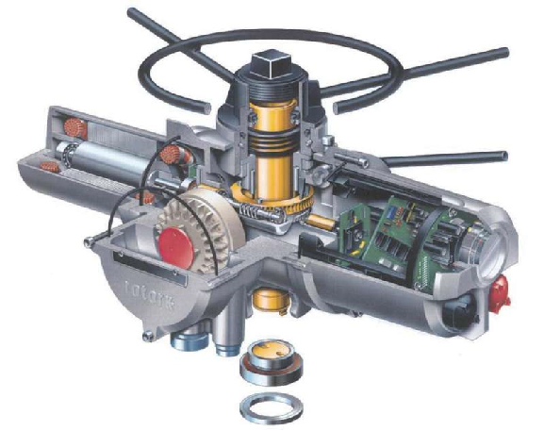

Process Controllers
Process controllers are used to interpret data from sensors and to then make decisions to maintain optimal operating conditions at speeds and to precision that could not be achieved purely by human control (Paul & Kautish, 2024). The Programmable Logic Controller (PLC) is the first and most common process controller, having been developed in 1968 by the Hydramatic Division of General Motor Company to cut production costs and increase quality (Erickson, 1996).
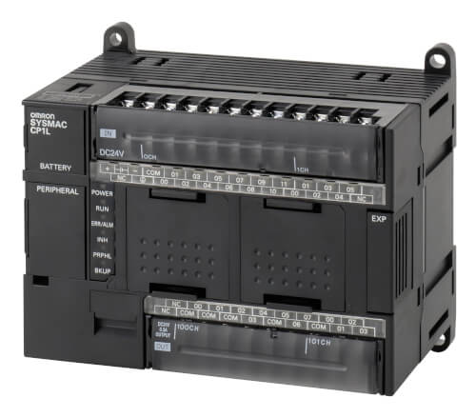
PLCs provide an ecosystem of relatively simple software logic, networks with controllable real-time behaviours, robust and ruggedised hardware, and extensive availability of interoperable components such as sensors and actuators, making them an established platform for plant automation and industrial process design (Sehr, et al., 2020).
Figure 11 example of a PLC unit (Omron, 2024)

Supervisory Control and Data Acquisition Systems (SCADA)
As the name suggests, a SCADA is not a full control system but focuses on the supervisory level. It is a purely software package that oversees the hardware to which it is interfaced, generally PLCs (Daneels & Salter, 1999). Using the combination of telemetry and data acquisition, SCADA encompasses the collecting of information across the site (wastewater treatment plants can be across several square kilometres), transferring the information back to the central site, while carrying out any necessary analysis and control and then displaying that information across various screens or displays for operators to assess, before conveying the required control actions back to the process (Bailey & Wright, 2003).
In short, SCADA systems enable remote control of equipment, data trending, alarm management, and reporting, which leads to a more autonomous and efficient wastewater treatment plant.

Regulation and Standards
For public health and environmental protection purposes, wastewater treatment facilities, like all industrial facilities, must adhere to numerous regulations and standards. These have become even more important in recent times because of an increase in pollution to public waterways in the UK, as well as an increase in the awareness of climate change as wastewater treatment plants account for around 3% of worldwide electrical consumption (Cairone, et al., 2024). Here are a few key regulators, regulations and standards:
- Environment Agencies: in the UK, the regulators for Wales are natural Resources Wales (NRW), the Environment Agency (EA) in England, the Scottish Environment Protection Agency (SEPA) in Scotland, and the Northern Ireland Environment Agency (NIEA) in Northern Ireland.
- Water Industry Act 1991: “sets out the main powers and duties of the water and sewerage companies, thus replacing those set out in the Water Act 1989, and defined the powers of the Director General of Water Services (now the Water Services Regulation Authority (Ofwat)).” (Ofwat, 2025)
- The Water Industry Mechanical and Electrical Specification (WIMES): defines the requirements for a wide range of mechanical and electrical equipment, as well as design standards to be abide by, for the UK water industry, of which all major UK water companies have signed up to the WIMES initiative (Pump Centre, 2024).
- Urban Waste Water Treatment Regulations 1994 (UWWTR): sets requirements for collection, treatment, and discharge of urban wastewater and particular industrial effluents (HM Government, no date).
- UK Water Industry Research (UKWIR) Standards: provides technical guidance and standards, often best practices and technical design specifications, for the water industry. The UKWIR themselves facilitate, manage and deliver a strategic programme of research projects to address key challenges facing the UK water industry (UKWIR, 2025).

Conclusion
The adoption of ICA in wastewater treatment has significantly improved the efficiency, safety, and reliability of treatment facilities by harmonising sensors, process controllers, actuators and valves, with minimal human intervention. They remain in compliance with strict environmental and public health and safety regulations and standards, utilising SCADA systems to enhance the automation of the plant, centralising control and real-time analytics – across a site several kilometres squared.
Currently, in the UK, due to a loosening of regulations in emergency discharges by the previous government, the waterways are in a critical state. Only 14% of the UK’s riverways are considered to be in good ecological health, with every single one of them still failing to meet required chemical standards (Mann, 2021). To turn this around, and along with new stricter regulations, ICA systems will play a crucial role in resolving this issue and advancing the wastewater treatment process.
Global water demand will increase by 55% over the years 2012-2050 and the rise in demand for manufacturing, electricity production and domestic use are predicted to increase by 400%, 140%, and 130%, respectively (Yuan, et al., 2019), and the only way that those demands can be met is by the implementation, development, and advancement of ICA technologies.

References
Abbasnejad, B. et al., 2018. MEMS piezoresistive flow sensors for sleep apnea therapy. Sensors and Actuators A: Physical, Volume 279, pp. 577-585.
Andrews, J. F., 1972. Design-operation interactions for wastewater treatment plants. Water Research, 6(4-5), pp. 319-322.
Bailey, D. & Wright, E., 2003. Practical SCADA for industry. 1st ed. Amsterdam: Elsevier.
Bertram Products Inc., 2024. Gate Valves: Types. [Online]
Available at: https://bertrem.com/gate-valves-types/
[Accessed 27 March 2025].
Brown, B., 2024. 10 Common Types of Valves. [Online]
Available at: https://www.lorric.com/en/Articles/valve/valve-all/valves
[Accessed 2 April 2025].
Butterfield, A. & Szymanski, J., 2018. A Dictionary of Electronics and Electrical Engineering. 5th ed. Oxford: Oxford University Press.
Cairone, S. et al., 2024. Revolutionizing wastewater treatment toward circular economy and carbon neutrality goals: Pioneering sustainable and efficient solutions for automation and advanced process control with smart and cutting-edge technologies. Journal of Water Process Engineering, Volume 63, p. 105486.
Capodaglio, A., 2003. Wet-weather transient impacts on wastewater treatment. In: R. Arsov, J. Marsalek, E. Watt & E. Zeman, eds. Urban Water Management: Science Technology and Service Delivery. Dordrecht: Springer Netherlands, pp. 215-222.
Daneels, A. & Salter, W., 1999. What is SCADA?. Trieste, International Conference on Accelerator and Large Experimental Physics Control Systems.
de Graaf, G., Abarca, A., Ghaderi, M. & Wolffenbuttel, R., 2015. A MEMS Flow Compensated Thermal Conductivity Detector for Gas Sensing. Procedia Engineering, Volume 120, pp. 1265-1268.
DomBor, 2022. Pneumatic Actuator vs. Hydraulic Actuator: Key Differences?. [Online]
Available at: https://www.dombor.com/pneumatic-actuator-vs-hydraulic-actuator/
[Accessed 2 April 2025].
Ejeian, F. et al., 2019. Design and applications of MEMS flow sensors: A review. Sensors and Actuators A: Physical, Volume 295, pp. 483-502.
EPA, 2000. The History of Drinking Water, Washington D.C.: United States Environmental Protection Agency.
Erickson, K. T., 1996. Programmable logic controllers. IEEE Potentials, 15(1), pp. 4-17.
GAOTek, no date. Applications of PH Meters in Waste Water Treatment. [Online]
Available at: https://gaotek.com/applications-of-ph-meters-in-waste-water-treatment/
[Accessed 23 March 2025].
Gentilcore, D., 2021. The cistern-system of early modern Venice: technology, politics and culture in a hydraulic society. Water History, 13(1), p. 375–406.
Global Spec, no date. Pneumatic Valve Actuators Information. [Online]
Available at: https://www.globalspec.com/learnmore/flow_transfer_control/valve_actuators_positioners/pneumatic_valve_actuators
[Accessed 2 April 2025].
Halliday, S., 2014. Water: A Turbulent History. 1st ed. Stroud: Sutton Publishing.
HM Government, no date. The Urban Waste Water Treatment (England and Wales) Regulations 1994. [Online]
Available at: https://www.legislation.gov.uk/uksi/1994/2841/contents
[Accessed 5 April 2025].
Humoreanu, B. & Nascu, I., 2012. Wastewater treatment plant SCADA application. Cluj-Napoca, IEEE.
Hussein, E. Q., Raheem, B. & Lafta, F., 2020. Fluid Structure Interaction of Non–Return Valve Using CFD. Journal of Mechanical Engineering Research and Developments, 43(7), pp. 137-148.
Hu, X. et al., 2024. Research on vibration test method of electric actuator. Journal of Physics Conference Series , 2785(1).
International Society of Automation (ISA), 2025. ISA96.01, Terminology for Actuators. [Online]
Available at: https://www.isa.org/standards-and-publications/isa-standards/isa-standards-committees/
[Accessed 2 April 2025].
Iowa State University: Holme Research Group, no date. pH Meter - Instrument. [Online]
Available at: https://group.chem.iastate.edu/Holme/augmented-reality-in-educational-laboratories/ph-meter/
[Accessed 23 March 2025].
Janocha, H., 2004. Actuators: Basics and Applications. 2nd ed. Berlin: Springer.
Kimura, T., Tanaka, T., Fujimoto, K. & Ogawa, K., 1995. Hydrodynamic characteristics of a butterfly valve — Prediction of pressure loss characteristics. ISA Transactions, 34(4), pp. 319-326.
Levlin, E., 2010. Conductivity measurements for controlling municipal waste-water treatment. Stockholm, KTH Royal Institute of Technology.
Maiyo, J. K., Dasika, S. & Jafvert, C. T., 2023. Slow Sand Filters for the 21st Century: A Review. International Journal of Environmental Research and Public Health (IJERP), 20(2), p. 1019.
Mallik, A., Arefin, M. A. & Shahadat, M. M. Z., 2018. Design and feasibility analysis of a low-cost water treatment plant for rural regions of Bangladesh. AIMS Agriculture and Food, 3(3), pp. 181-203.
Mann, J., 2021. How healthy are our rivers?. [Online]
Available at: https://theriverstrust.org/about-us/news/how-healthy-are-our-rivers
[Accessed 5 April 2025].
Manral, K., 2019. How Does a Rotary Valve Actuator Differ from a Linear Actuator?. [Online]
Available at: https://blog.se.com/buildings/building-management/2019/12/03/how-does-a-rotary-valve-actuator-differ-from-a-linear-actuator/
[Accessed 2 April 2025].
Maverick Machine & Hydraulics, no date. Hydraulic Actuators 101: What is a hydraulic actuator?. [Online]
Available at: https://www.maverickmachine.ca/news/hydraulic-actuators-101/
[Accessed 2 April 2025].
Melosi, M. V., 2000. The Sanitary City: Urban Infrastructure in America from Colonial Times to the Present. 2nd ed. Baltimore: Johns Hopkins University Press.
Nesbitt, B., 2011. Nesbitt, B., 2011. Handbook of valves and actuators: valves manual international. 2nd ed. Amsterdam: Elsevier.
Niazi, M. A., 2021. Types of Instrumentation Used in Wastewater Treatment Facilities. [Online]
Available at: https://control.com/technical-articles/types-of-instrumentation-used-in-wastewater-treatment-facilities/
[Accessed 17 March 2025].
Ofwat, 2025. Legislation. [Online]
Available at: https://www.ofwat.gov.uk/regulated-companies/ofwat-industry-overview/legislation/
[Accessed 5 April 2025].
Olsson, G., 2012. ICA and me – A subjective review. Water Research, 46(6), pp. 1585-1624.
Omron, 2024. Programmable logic controllers (PLC). [Online]
Available at: https://industrial.omron.eu/en/products/programmable-logic-controllers
[Accessed 2 April 2025].
Pasquale, M., 2003. Mechanical sensors and actuators. Sensors and Actuators A: Physical, 106(1-3), pp. 142-148.
Paul, S. K. & Kautish, S., 2024. Computational Intelligence Techniques for Sustainable Supply Chain Management. 1st ed. Amsterdam: Elsevier.
pipingtechs.com, no date. What is a Non-Return Valve?. [Online]
Available at: https://pipingtechs.com/what-is-a-non-return-valve-non-return-valve-pid-symbols/
[Accessed 2 April 2025].
Pump Centre, 2024. WIMES. [Online]
Available at: https://www.pumpcentre.com/project/wimes
[Accessed 5 April 2025].
Renke, 2025. Top 11 water quality sensors for water treatments easily. [Online]
Available at: https://www.renkeer.com/top-7-water-quality-sensors/
[Accessed 29 March 2025].
RS Hydro, 2025. Water Level Sensors. [Online]
Available at: https://www.rshydro.co.uk/water-level-sensors/
[Accessed 17 March 2025].
Santin, I., Barbu, M., Pedret, C. & Vilanova, R., 2019. Dissolved Oxygen Control in Biological Wastewater Treatments with Non-Ideal Sensors and Actuators. Industrial & Engineering Chemistry Research, 58(45), pp. 20639-20654.
Scott, G. R., 1955. Short History of Filter Construction and Operation. AWWA (American Water Works Association), 47(8), pp. 749-752.
Sehr, M. A. et al., 2020. Programmable logic controllers in the context of industry 4.0. IEEE Transactions on Industrial Informatics, 17(5), pp. 3523-3533.
Tisserand, O., 2019. How Does an Electric Actuator Work?. [Online]
Available at: https://www.indelac.com/blog/how-does-electric-actuator-work
[Accessed 2 April 2025].
UKWIR, 2025. Leading the Water Research Agenda. [Online]
Available at: https://ukwir.org/leading-the-water-industry-research-agenda
[Accessed 5 April 2025].
Unified Alloys, no date. Introduction to Valves: What Are Valves & How Do They Work?. [Online]
Available at: https://www.unifiedalloys.com/blog/valves-101
[Accessed 27 March 2025].
Vetelino, J. & Reghu, A., 2011. Introduction to Sensors. 1st ed. Boca Raton: CRC Press.
Vieira, A. et al., 2019. The impact of the art-ICA control technology on the performance, energy consumption and greenhouse gas emissions of full-scale wastewater treatment plants. Journal of Cleaner Production, Volume 213, pp. 680-687.
Water Museums Global Network, 2025. Managing Groundwater in Venice: The Cistern-System from the 12th Century to Today. [Online]
Available at: https://www.watermuseums.net/campaigns/valuing-ancient-water-cultures/venetian-cisterns/
[Accessed 15 March 2025].
Wetzel, R. G. & Likens, G. E., 2000. Dissolved Oxygen. In: Limnological Analyses. New York: Springer, p. 73–84.
WMO (World Meteorological Organization), 2018. WMO Statement on the Status of the Global Climate in 2018, Geneva: WMO (World Meteorological Organization).
Yadav, M., Gupta, R. & Sharma, R. K., 2019. Chapter 14 - Green and Sustainable Pathways for Wastewater Purification. In: S. Ahuja, ed. Advances in Water Purification Techniques: Meeting the Needs of Developed and Developing Countries. Amsterdam: Elsevier, pp. 355-383.
Yokogawa, no date. Flowmeters. [Online]
Available at: https://www.yokogawa.com/uk/solutions/products-and-services/measurement/field-instruments-products/flow-meters/#Overview
[Accessed 23 March 2025].
Yuan, Z. et al., 2019. Sweating the assets – The role of instrumentation, control and automation in urban water systems. Water Research, Volume 155, pp. 381-402.
Zuo, W., Zhang, X. & Li, Y., 2020. Review of flue gas acid dew-point and related low temperature corrosion. Journal of the Energy Institute, 93(4), pp. 1666-1677.

