Name:Liam Jenkins_____________________

Student Number: 2502497
__________________________________________________________

WORKSHEET 2 – TESTING (Tiles)

- Original code:

import math

flag = 0
while flag == 0:
try:
length = float(input("How tall is your wall in cm: "))
except ValueError:
print("Please enter a valid length")
else:
if length > 0:
flag = 1
else:
print("must be greater than 0")

flag2 = 0
while flag2 == 0:
try:
width = float(input("How wide is your wall in cm: "))
except ValueError:
print("Please enter a valid width")
else:
if width > 0:
flag2 = 1
else:
print("must be greater than 0")

area = length * width
areaLow = ((length // 20) * 20) * ((width // 20)*20)

print("The area of your wall is", area)

areaTiles = 20 * 20

extraLength = math.ceil(length/20)
extraWidth = math.ceil(width/20)

extraTileL = length % 20
extraTileW = width % 20

finalExtraTileL = extraTileL / 20

finalExtraTileW = extraTileW / 20

tilesNeeded = areaLow // areaTiles

roundedTiles = extraWidth * extraLength
minimumTiles= finalExtraTileL * (length // 20) + finalExtraTileW * (width // 20) + tilesNeeded + 1
print("The amount of tiles needed are",roundedTiles)
print("or the minimum need is", minimumTiles)

- Code Testing

For each test below (i – vii), run your code and enter the values provided. Present a screenshot of the of what happened when the programme ran. Did the programme behave correctly or did it do something unexpected, and if so, why?

Input:

- Enter dimensions of wall: Width 40 Length 45
- Enter dimensions of wall: Width 100000 Length 200000
- Enter dimensions of wall: Width -16 Length -20

Logic:
- Enter dimensions of wall: Width 80 Length 80. The result should be 16 tiles
- Enter dimension of wall: Width 40 Length 45. The result should be 6 tiles
- Enter dimensions of wall: Width 85 Length 90. The result should be 25 tiles.
- Enter dimensions of wall: Width 15 Length 15. The result should be 1 tile.

Note: If you decided to include logic within your program to allow a tile to be cut such that 2 pieces can be used from the same tile where possible (therefore reducing the total number of tiles required), your results may differ from the above. In this case, explain your logic as part of your answer. If you did not, consider adding this logic to your final code.

Fill in a box for each test above. You should present 7 separate boxes, 1 for each test. (Note: the first box is provided as a template)

Test :
Input i. - Enter dimensions: Width 40 Length 45

Screenshot(s) of output:
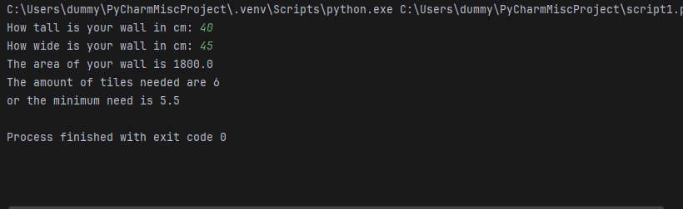
Result: Did the programme behave as expected ie syntactically and logically correct?
YES
If YES, comment on what happened
Outputted the results and allowed input of the numbers with no issues.

Continue the rest of the tests below. (Copy and paste a box for each one)

Test: input ii Enter dimensions of wall: Width 100000 Length 200000
Screenshot(s) of output:
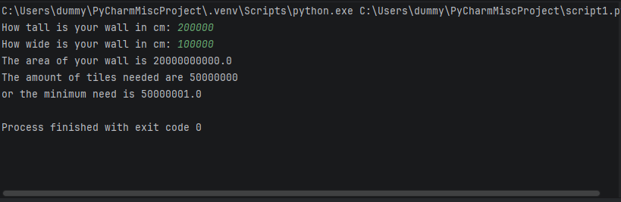
Result: Did the programme behave as expected ie syntactically and logically correct?
NO
If NO, what went wrong?
Didn’t create a validation rule preventing the input of unrealistically large walls.

Test :
Input iii. Enter dimensions of wall: Width -16 Length -20

Screenshot(s) of output:
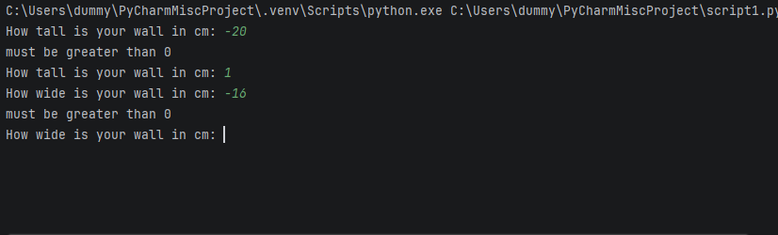
Result: Did the programme behave as expected ie syntactically and logically correct?
YES
If YES, comment on what happened
Asked the user to re input when entering a value less than 0 as that isn’t possible.

Test :
Logic iv. Enter dimensions of wall: Width 80 Length 80. The result should be 16 tiles

Screenshot(s) of output:
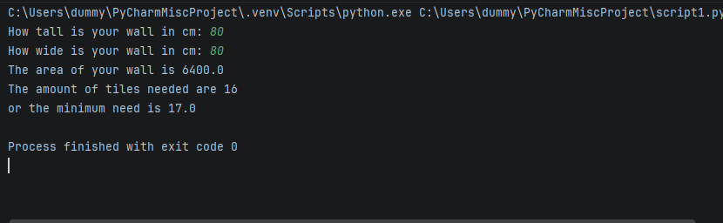
Result: Did the programme behave as expected ie syntactically and logically correct?
YES/NO (delete as appropriate)
If NO, what went wrong?
The minimum tiles output is wrong as I had set it up to add one to account for an extra corner tile.
If YES, comment on what happened
The normal required tiles outputs 16 as expected

Test :
Logic V Enter dimension of wall: Width 40 Length 45. The result should be 6 tiles

Screenshot(s) of output:
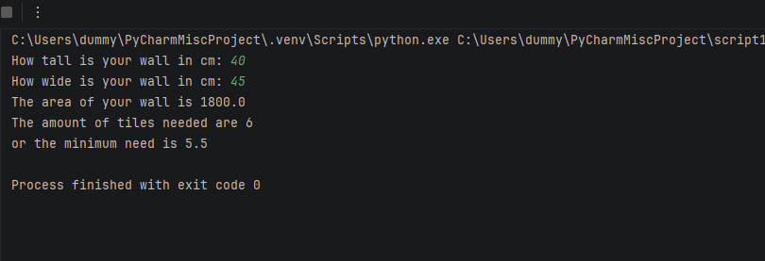
Result: Did the programme behave as expected ie syntactically and logically correct?
YES
If YES, comment on what happened
Produced 6 as expected, for the minimum only half a tile is needed to fit the required amount so one tile can be used to create two halves.

Test i:
Logic vi: Enter dimensions of wall: Width 85 Length 90. The result should be 25 tiles.

Screenshot(s) of output:
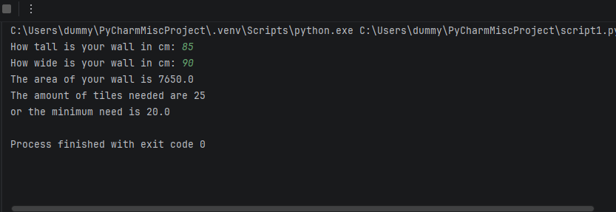
Result: Did the programme behave as expected ie syntactically and logically correct?
YES
If YES, comment on what happened
Outputted 25 as expected, and for the minimum tiles are split up to account being able to cut the tiles in half.

Test:

Logic vii Enter dimensions of wall: Width 15 Length 15. The result should be 1 tile.
Screenshot(s) of output:
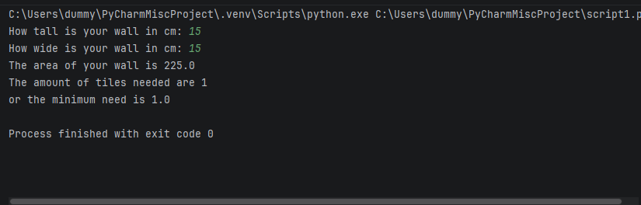

Result: Did the programme behave as expected ie syntactically and logically correct?
YES
If YES, comment on what happened.
Output 1 tile as expected.

- Consider the results of the above tests and revisit your code in order to solve any problems discovered at the testing phase. (Note: you may not be able to solve all of them, but solve as many as you can.)

Paste your revised code here:

[Copy and paste your revised code here – note, do not use a screenshot]
import math
flag = 0
while flag == 0:
try:
length = float(input("How tall is your wall in cm: "))
except ValueError:
print("Please enter a valid length")
else:
if length > 0 and length <= 1000:
flag = 1
else:
print("must be greater than 0 and less than 10000")
flag2 = 0
while flag2 == 0:
try:
width = float(input("How wide is your wall in cm: "))
except ValueError:
print("Please enter a valid width")
else:
if width > 0 and width <= 1000:
flag2 = 1
else:
print("must be greater than 0")
area = length * width
areaLow = ((length // 20) * 20) * ((width // 20)*20)
print("The area of your wall is", area)
areaTiles = 20 * 20
extraLength = math.ceil(length/20)
extraWidth = math.ceil(width/20)
extraTileL = length % 20
extraTileW = width % 20
finalExtraTileL = extraTileL / 20
finalExtraTileW = extraTileW / 20
tilesNeeded = areaLow // areaTiles
roundedTiles = extraWidth * extraLength
if finalExtraTileW == 0 or finalExtraTileL == 0:
minimumTiles = extraWidth * extraLength
else:
minimumTiles= finalExtraTileL * (length // 20) + finalExtraTileW * (width // 20) + tilesNeeded + 1
print("The amount of tiles needed are",roundedTiles)
print("or the minimum need is", minimumTiles)

