

MODEL CODE:M4X01917

COURSE TITLE: BUSINESS SKILLS FOR INTERNATIONAL HOTEL INDUSTRY

NAME: BISWAJIT MUKHERJEE

NUMBER:1815040

LECTURER: DALE CLARK

WRITTEN ASSIGNMENT 1

TABLE OF CONTENT

INTRODUCTION……………………………………………………………P1

CURRENT ACADEMIC AND EMPLOYBILITY SKILLS………………. P2

SWOT…………………………………………………………………………P2a

PERSONAL DEVOLOPMENT PLAN……………………………………. p2b

SKILLS TO FIND EMPLOYMENT IN THE HOTEL INDUSTRY………. P3

CONCLUTION…………………………………………………………………P4

REFFERNCE………………………………………………………………….P5

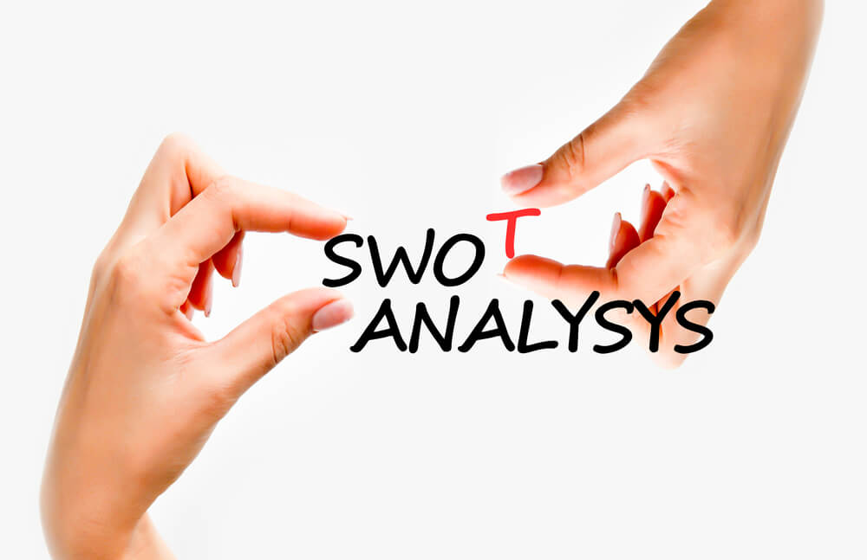

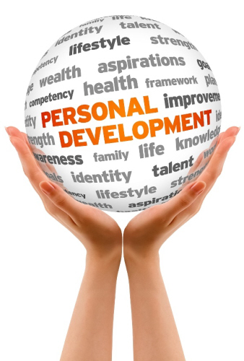

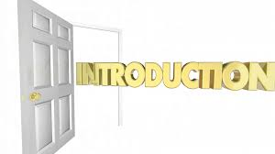

This assignment designed for swot and personal development plan. It is my personal development plan and swot and with this I am discussing theoretically, and my working skills. My future plan is to use this skill in hotel industry.

Swot specially help me to uncover my opportunity that I am not able to spot it. If I know my weakness I can manage and move away threats that stop me to improve. If I look at myself using the swot frame work I can start to separate myself from obstacles and improve myself able to achieve my goal. swot is an effective process typically business and company use for themselves and competitor’s formula is their strategy. Swot analysis is useful method to understand my own strength and weakness and to identifying both the opportunities for me and obstacles I have.

Personality development is the broken series of gesture. I must be as positive as a proton. I have to more passionate and handle with care. always I have to share a little and care a little. Praise the one in front of you. There is a one more thing need to remember which is communicate effectively. Always be a fighter and possess the quality of patience. I have to learn the art of breathing.


Academic knowledge is very important of our life. we use our knowledge to get good opportunity. In part of academic skills, I can discuss about how to solve problem? how to make decisions? I have idea about different types of questions and conversations. Organisations and their supporting team have different types of topics to discuss, that help me to get easy in my class for getting notes from my lecturer which I need for my progression. Academic skills are necessary in our everyone life. Base on our academic skills my knowledge will be increase. I will get good jobs. I can get good wages to look after my family. I am a good decision maker, I can make planning. In academic skills I can say come to class in proper time. This is one of the important things. In my academic carrier I always maintained my class time. Participation is another part of academic skills. When I come to class I do participate in all conversation such as with lecturer or my class mate. I always did the same way in my school academic year. I believe it is very help full and by this participation I can gather my knowledge and improve my knowledge also. I must be organised always and all the time. It is important that for getting proper path I must be organised by everything. Another part of academic skills is be flexible and be good. I must be realistic I need always follow instructions. I never did plagiarize in school academic period and this thing I believe don’t work. Always be honest which I follow. My focus always will be to achieve my goal, so I need to be stay focus. Everyone wants to sign in their life or wants to achieve success. I am also part of that. This is the main and important thing which is always I must stay in positive, if want to achieve my goal or success then negative things I must keep far away from my life. I must think positive always.

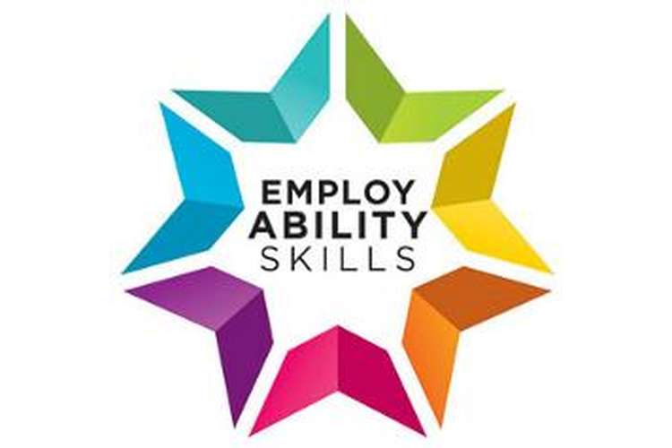

Employability skills takes important part in our life. I believe If I have good subject and technical knowledge then easily I can get good company. Every company wants to see quality and attitude. these are very important and much needed in every sector or work place. At this present situation is very crucial and competitive to get a good job. Their main agenda is to make customer happy, so in that situation they want from me quality service, positive attitude, hard work, invention about new things. They also want from me if any problem arises then I can solve easily.

COMMUNICATION: I believe communication is important things in my work place.
This communication can be both ways, either between team or
Customer. Communication make easy to work get done.
Communication can be many ways. Such as-one to one
to one communication, web communication, via social media
communication etc;

1. Listening
2. speaking clearly or using my device communicate.
3.reading independently
4.using numbers.
5.sharing information

TEAMWORK : Team work is another important part for every company.
Team work make job done and for that reason customer
get their products or service properly and reason they feel
happy and for that reason company’s business grown up.
I can trust behind build up strong team work management
takes important part.
1.Being able listen clearly and speak clearly
2.I must know my role in the team.
3. work shoulder to shoulder.

PROBLEM SOLVING: We need to do solve problem in our everyday life and work
place. When problem arise always we must think that how
can solve the problem. I am working in company at present.
So many of problem every day is arising. Sometimes with
Customers or with employee. Our company gave lesson to
Me that if any difficult situation comes then how to manage.
I always keep calm when I do any solve problem or about
About customer issue.

1.I always listen to customer or my team member
2. I think about how I solved the problem in the
3.I always try do apology if any arise problem with customer
4.I always share my experience with my team member if
Any problem arises.
5.I try to solve problem easy way that nobody cannot be
disappointed.
6. In time of problem solving I always take initiative.
7. I do solve problem without help by my manager.
8. I have experience, so I know my next step.

I am working in one of the giant super market which is Tesco.
I am working around 8 years. i am in management role. I am also following my employability skills which I learn earlier. such as:

I like to work with team.
I always help my team to get job done.
I always make fun in my work place to keep my team energetic
Customer is always main priorities for every company, so I always try to keep them
happy.
Always I become friendly with my team and customers.
I always maintain equality.
I maintain company health and safety guidelines, procedure, rules etc;

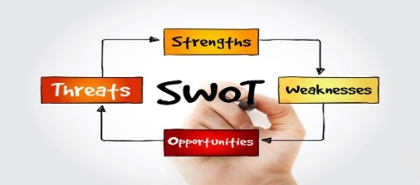
STRENGTH  Trusty: trustworthy  Team: I like to work with people and help them to  achieve goal as a team work.  Leadership: I like to take leadership and get people together. I can take leadership and I am currently doing in my work place.  Communication: communication is one of the important parts of it. I have a good communication skill and I am experience by my work. I believe good communication always make customer happy and grow business. | WEAKNESS  Slow learner  Don’t take risk to do some new things.  I can do hard work, but I can’t understand is it right way to achieve my goal.  I have idea, but I sometimes confused to place in proper area.  I have to take more knowledge about technology  Such as new software  .  Sometimes problem to find reliable people to participate.
OPPURTUNITIES  Study to get proper way to improve my knowledge.  Wherever I study I must achieve goal in my qualification and I believe the reflects will be in my workplace.  Now this time social media is important part of our life so its help me to interact or communicate with people and use it as my good ways.  I will do more study for my increase knowledge. | THREATS  Health  Family  Friend  Environmental issue  Strong competitors.  Potential financial difficulties.  Unfavourable economic condition  (recession)  Changes in the market place that invalidate my skills.

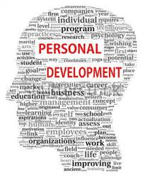

Personal development plan is to improve our personal skills. In time of study or after finish study my next step will be work on basis of my learning skills. I discuss earlier that I have work experience, so my employability skills also will help me to get new future. After finishing my education, I can set my goal which is very important for everyone’s life. I believe that time I will be fully technically trained with experience then I will get good job and I will be improve my self.

Here after I completed swot analysis I create my pdp, which will help me to improve my personal life and achieve my goal.

I want to increase my idea about hospitality industry. production is my one of the favourite departments which I like to work in future, from my very childhood I was very fond of cooking. I always watch cooking show in television, and I like to experiment about recipe. I got inspiration about cooking from my mom. From that age I want study hospitality management to achieve my goal. I want to study for that reason more and want to attend my universities regularly to reach my destination. I like to improve my consistency there are some areas that I need to improve myself, and to achieve my specific goal.

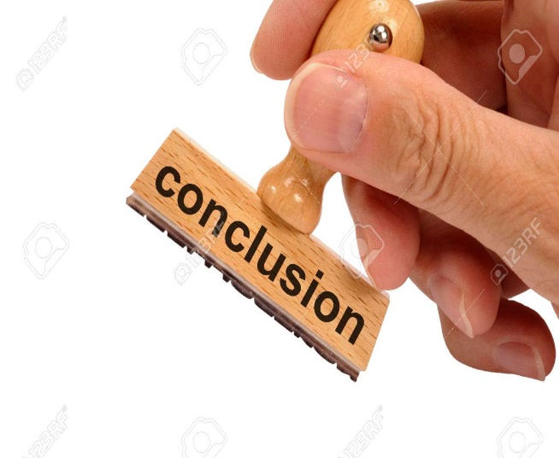

After I completed swot and personal development plan which I understood that from swot I can get guidance to be successful in academic and work life. I will achieve easily to my goal in future. Personal development plan is important for everyone life. pdp direct towards achievement of our short term and long term goals.my weakness, my strength, my learning ability, prospect my future everything how will I achieve, pdp allows individuals to learn more. i believe employability skills much more important to our life. This skill helps me to get employability to get technical and subject knowledge, quality and attitude. So, these are all important in every one life to achieve success and reach in proper destination



1.Benito Ca. (2001 S.W.O.T. Analysis PPT Cited 23 March 2009 at:
www.sonoma.edu/users/b/benito.swot.ppt

2.Droun, C. (2007) Strategic planning SWOT. Cited
Feb 15, 2009 at http://www.planonline.org/

3.Hind.D. and Moss, S. (2005) Employability Skills Sunderland, business Education
Publishers Ltd.

4.Major, J, (1998), Success in sight, Fallen press, Sydney, NSW.

5. Miller.L.Biggart.A. and Newton.B.2013.Basic and employability skills.
International Journal of Training and development. 17(3). pp.173-175
.
6.Moon, J,(1999a) reflection in learning and professional development. London:

7.Sid Savara (2017), “How to Write A Personal Development Plan for Your
Career and Life”. http://sidsavara.com/personal-development-plan/#ninja-popup-6572 Accessed
On 19.10.2017

