Jess Eardley (2217994)
UWTSD

Fault Tree Analysis
Systems Engineering

Contents
Table of Tables 2
Table of Figures 2
Introduction 3
Calculations of Probabilities 4
AND Gates 4
OR Gates 4
Conclusions 7
Reflections 7
Works Cited 8

Table of Tables

Table 1 Fault Tree Probabilities 4

Table of Figures

Figure 1 Example of a Fault Tree [2]. 3
Figure 2 AND Gate [2]. 4
Figure 3 OR Gate [2]. 4
Figure 4 Fault tree for making a hot drink 6

Introduction

Fault Tree Analysis (FTA) is a tool used for identifying the causes of system failures. Its starts with a specific (top) event of interest and works backwards to determine its root causes using logic diagrams. FTA is used in risk assessment, safety engineering and reliability analysis to pinpoint system vulnerabilities and improve system performance [1]. There are two different types of symbols on a fault tree diagram: gates and events. An example of a fault tree with events and squares is shown in Figure 1 [2]. Basic events are shown in a circle, and intermediate events are shown in a rectangle [2].
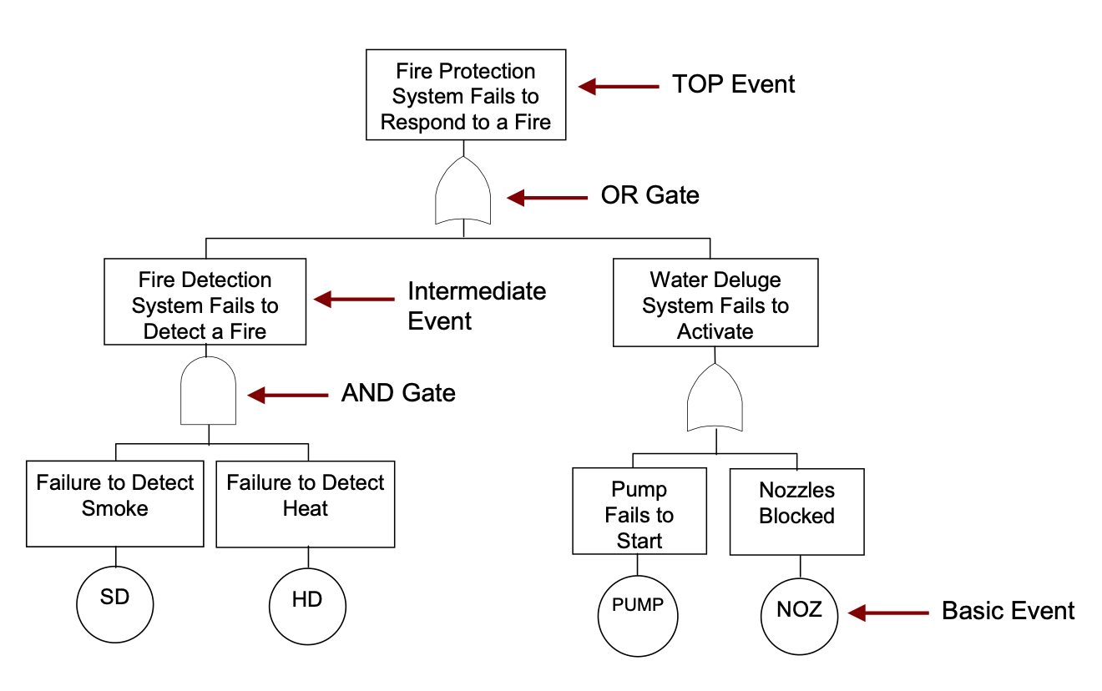
Figure 1 Example of a Fault Tree [2].

Calculations of Probabilities

Fault tree values for making a hot drink using the probabilities in Table 1. The addition of human error to the plug in reliability, switch on reliability and cup availability causes them to change, see Table 1. The Probabilities are paired with the fault tree, see Figure 4. The calculated probability of success of making a hot drink is 0.103, take this value away from 1 and the probability of failure is 0.897.

AND Gates
Below shows the calculation for AND gates, how to multiply the probabilities on the tree together to ascend the fault tree. Figure 2 shows an AND gate.
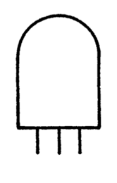
Figure 2 AND Gate [2].
Probability of (A) X Probability of (B)
$$=\left(0.99\right) × \left(0.9\right)$$
$$=0.891$$

OR Gates
Below shows the calculation for OR gates, how to multiply the probabilities on the tree together and take away from 1, to ascend the fault tree. Figure 3 shows and OR gate.
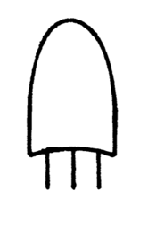
Figure 3 OR Gate [2].
1- (1-Probibility of A) X (1-Probibility of B)
$$=1-\left(1-0.8\right) × \left(1-0.9\right)$$
$$=0.98$$

Table 1 Fault Tree Probabilities for making a hot drink.
Event | Probability | Event | Probability
Tea availability | 0.8
Coffee availability | 0.9
Chance of leaky Kettle | 0.1 | No Leak | 0.9
Chance of water supply failure | 0.01 | Water Supply Ok | 0.99
Kettle reliability | 0.99
Plug in operation reliability | 0.7 | Human Error of 75% | 0.7 x 0.75= 0.525
Switch on reliability | 0.7 | Human Error of 75% | 0.7 x 0.75= 0.525
Mains supply failure chance | 0.01 | Main Supply Ok | 0.99
Cup availability | 1 | Human Error of 90% | 1 x 0.9 =0.9
Cup reliability | 0.7
Milk availability | 0.9
Milk freshness | 0.8
Sugar availability | 0.6
Sweetener Availability | 0.9

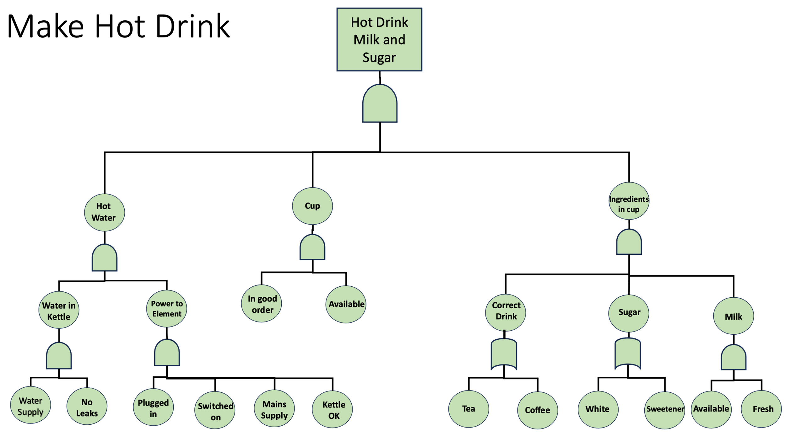
Figure 4 Fault tree for making a hot drink
0.99
0.9
0.525
0.525
0.99
0.99
0.891
0.27
0.24
0.7
0.9
0.63
0.8
0.9
0.6
0.9
0.9
0.8
0.98
0.96
0.72
0.677
0.103

Conclusions

The fault tree analysis showed the chance of system success, by taking this away from 1 the system failure could be calculated. The chance of success was dramatically decreased because of human errors. The fault tree showed visually and in probability the chances of success of the system. A fault tree is a better tool to use when a system becomes more complex, and the consequences of accidents become catastrophic [1]. If a single point of failure is required for a small system is at subsystem level, Failure Mode Effect Analysis (FMEA) is a more suitable tool [1].

Reflections

The fault tree analysis was easy enough to perform once the correct probabilities were calculated. Care was taken to ensure the right formulas for the different gates were calculated correctly. The fault tree showed how the components were interconnected leaving the users a more in-depth view of how faults as a subsystem level have an impact on the overall system. The fault tree could be adapted to add further faults and their probabilities calculated to grow into a more detailed fault analysis. Using this tool helped to understand the number of failures possible with in a simple task such as making a hot drink, also the effect of human errors on a system. As soon as humans are involved the chance of success plumets as humans bring a range of failures such as fatigue or accidents causing system failure. These failures need to be understood to capture them before they cause whole system failure.

Works Cited

[1] | D. G. F. T. C. H. L. W. S. Lee, “Fault Tree Analysis, Methods, and Applications - A Review,” IEEE TRANSACTIONS ON RELIABILITY, vol. 34, no. 3, pp. 194 - 203, 1985.
[2] | P. J. A. a. D. S. Lunt, “An Introduction to Fault Tree Analysis,” [Online]. Available: https://www.nottingham.ac.uk/research/groups/resilience-engineering/documents/nxgen/outputs/an-introduction-to-fault-tree-analysis.pdf.
[3] | S. Kabir, “An overview of fault tree analysis and its application in model based dependability analysis,” Expert Systems with Applications, vol. 77, pp. 114-135, 2017.

