The similarities of ‘Game Level Design’ and ‘Urban Design’, how people’s behaviour and choices are influenced and can be manipulated.

By:
Joel David Gray
P143919
A Student of Creative Computer Games Design

Dissertation submitted to the University of Trinity Saint David as a requirement of the BA Creative Computer Games Design degree.



Moderated by: Julian Hainsworth
Module: Major Written Project - Dissertation [M6X01791]
Faculty of: Swansea College of Art
Word Count: 4538

Declaration:

I, Joel David Gray hereby declare that the work within this dissertation has been wholly created by myself for the degree of: BA Creative Computer Games Design. This academically purposed document has not been submitted whole or in part to any other university, degree, course, association or recognised background. External information and sources have been acknowledged in both the ‘References’ and ‘Bibliography’ section of this document with their authors/creators accurately credited, their work not created by myself, complementary to this document.

Name: Joel David Gray
Signed:
Date: 12/12/2017

Abstract:

This report covers the similarities in both game level design and urban city design by first establishing their different purposes of each as the goals of people compared to players are different.
The layout in each medium can successfully and indirectly divide people and player, a similarity on how desire paths mean that layout indicating paths to be used are ignored in both mediums as seen in the eroded paths and speed running game community.
Lighting is key in reality and in game levels, it has a direct effect on the human psyche has been utilised in both the cityscape and in LED screens that typically display video games, the colour of lighting also shown to influence the mood of people/players.
Music is present in both games and the cityscape, its tempo though discussed in this report as to not effect player, is utilised in games to manipulate the player in as in supermarket music manipulating people. The volume also has a key impact on the player as devices such as alarms do on people in the cityscape, genre also playing a role in how the player is influenced to act in game scenarios, similarly in reality.
Although mechanical progression is incompatible to guide people its closest counterpart in cityscapes is law, the method of high score systems has been used in a cityscape context with strong similarities in how people/ players are manipulated.
Conclusively is that most methods of manipulation shared in games are shared as players although in a simulated reality still respond humanly, though there is room for wider research and testing within this field.

Contents:

Declaration Page 2
Abstract Page 3
Contents Page 4
Introduction Page 5
Literature Review Page 6
Goals Page 7
Layout Pages 8-11
Lighting Page 12
Music Page 13-14
Mechanic and Law Page 15-16
Conclusion Page 17
Further Work Page 18
References Pages 19-20
Bibliography Pages 21-23

Introduction:

This paper will cover the similar methods employed in both game level design and the urban cityscape in the indirect manipulation of the behaviour of people and players.
The literary review will cover specific terminologies mentioned within this paper that’s understanding is required to understand this paper.
The main body of the paper is broken into sections, ‘Goals’ covering the reason of existence for the manipulation within the urban cityscape and game levels guiding people and players.
Case studies and comparatives between Game level design and urban city design manipulation will be covered in the following sections; ‘Layout’ referring to the methods the physically exist/simulate physicality, ‘Lighting’ covers how colour physically impacts people and how its properties to manipulate feelings are reflected in game levels, the ‘Music’ section covers how tempo, volume and genre each effect people and players in similar ways, ‘Mechanics and Law’ will cover how incompatible the two systems would seem, but has the strongest case study of how systems directly lifted from gaming are being used in the urban cityscape.
The ‘Conclusion’ section will provide a summary and conclusions of the findings within this report, followed by what further work is required within this field to draw stronger comparatives and discover if the similarities apply in a further context. ‘References’ will cover content used directly referenced in this report, the ‘Bibliography’ will have content that influenced the wider reading of the report.

Literature Review:
A game is “A form of competitive activity or sport played according to rules.” (Oxford Dictionaries | English, 2017). A video game takes this concept and makes it digital, the game is electronic data providing visual/audio stimuli on a screen. Game level design refers to the game world presented on the screen and how it was/is designed for the user to play in.
Urban Design refers to how cities have been designed over time not just for the focus or single architectures but for neighbourhoods, districts, public spaces and keeping them functional.
Game level design and the architecture of the urban contemporary share similar components that can be broken down into categories:
The layout of each refers to the spacing of certain features in the real world that could potentially manipulate people into set paths. In a game instance, the layout refers to how game objects are placed in a way to manipulate how a player progresses through a game level.
Lighting in the contemporary reality refers to the colour and intensity of different ambient lights and light sources found in reality. Likewise, lighting in a game instance refers to the illusionary lighting effects that imitate real lights.
Music refers to the audio/acoustics heard by a person when in the context of reality, this includes its volume, tempo, frequency and even genre. Similarly in the virtual context, music is replicated digitally when called upon by the game and is heard by the user.
Game mechanics in a game instance are the games gameplay functionality, such as jumping or having special abilities. In the game instance they are wholly controlled by the designer and are unbreakable for the user (unless errors or glitches occur) these are essentially rules that bind the user to specific actions. The closest component to game mechanics found within reality are the constants, the physical laws of physics that limit people’s actions in reality.
Law in reality refers to restrictions placed on a people or area imposed by a governing authority. These are abided by the people by choice, as are they are typically punishable if ignored. In a game instance, the laws can be translated as the goal of a game, that the player is incentivised to complete or punished for not completing.

Goals:

Although there may be many similarities that both game level design and urban city design share in how people’s behaviour is controlled. Both design types have different purposes, a game exists to challenge a player with a goal and create an enjoyable experience that can be beaten/finished when the goal is reached. While an urban city design has to facilitate many different ‘goals’ of many people and allow those people to accomplish those goals as efficiently as possible. Fundamentally a game designer has more control on where a player can go and what they can do to reach a goal, while a city council has influence but not full control over things such private property and how they are maintained. This means that to manipulate people/player’s behaviour in each medium would theoretically require different approaches, however as players are people it can be hypothesised that both can be manipulated in similar ways.

Layout:
Game levels and Urban Architecture share one very dominant feature that determines strongly the behaviour of people. The physical dominance of features/buildings in a cityscape are walls designed to stop people moving to an area they are not supposed to be in. Similarly, in games the level will contain the player(s) with collision (simulated walls) that the player cannot pass through, both drastically impede any player/person on a direct route for many reasons. This is a direct influence on behaviour that’s physically binding, this doesn’t influence the choice on where to go, but how they get to a location. On the journey to a goal there are other subtle ways within a level/city that utilise layout to manipulate behaviour.
An example of this idea can be found in New York low bridges [Figure 1] designed by Robert Moses (Ex-chief of public authorities) were implemented on Long Island to prevent busses using the roads, and effectively stopping the poor minorities of people inside them from visiting the Jones Beach State Park (Caro, 1974). This is a physical barrier that does not physically stop all people, yet by stopping busses, it financially limits who can visit the Jones Beach State Park controlling what type of people visit the area.

Figure 1: New York Low Bridges (Credit Unknown)

An example related to game level design, the popular online game League of Legends (Riot Games, 2009) pits players against each other to achieve their goal of destroying the other team’s base. The most direct routes called ‘Lanes’ are the fastest way to the other team’s base, the ‘jungle’ between these lanes are fraught with danger for small rewards. The game uses the connected layout of these areas to encourage where the player should go. As the game progresses, defensive towers that would have given a combat advantage are destroyed by the opposing team, this means there are more entry points into the lanes for the enemy from the jungle. This often encourages the behaviour of the players to travel in groups as getting attacked from the connected areas is more likely, and likewise it encourages other players to risk the ‘jungle’ paths to attack their foes. This layout [Figure 2] dividing the team members often by the individual selected characters that are more suited for each strategy.
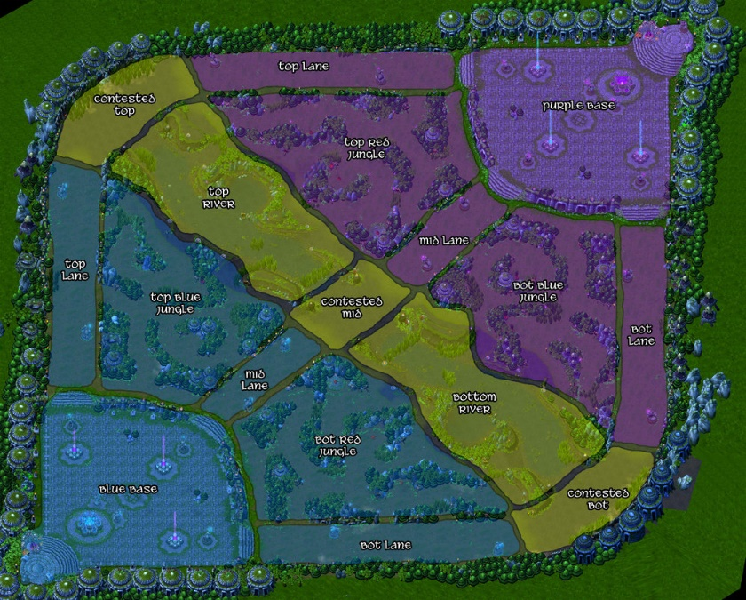
Figure 2: LOL Map Sections (Credit: Unknown, 2013)

Both of these designs use their layout to control how the individuals approach their goal, using the design to filter out who approaches their goal by using physical layout. In the New York, Robert Moses’s low bridges stopped buses making it an unworthy goal for poorer individuals, while in the game League of Legends the ‘jungle’ paths access to the main ‘lanes’ encouraged more players who picked specific characters to use the jungle lanes for different strategies to achieve victory. However, the physical layout does not always influence people’s behaviour in the intended way.
A path within a city is an allocated space for people to walk between locations safely without concerns of traffic or impassable terrain. Yet a path’s layout if not direct enough for an individual’s goal will remain unused and ignored. Often referred to as ‘Cow Paths’ or ‘Desire Paths’, these are paths walked by people to get to a goal as efficiently as possible, these may ignore conventional city set paths, and can often be seen as mud or dust paths in grass as the plants struggle to grow where people frequently walk. [Figure 3] shows a dirt desire path between two conventional paths that has been eroded away as many people have found a faster route than the one provided to their location. This is an instance of a physical layout failing to control where people go.
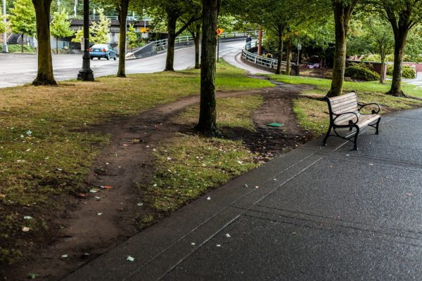
Figure 3: Desire Path (Credit: Duncan Rawlisno)

Designers likewise lay out an intended route for players to accomplish their goals often rewarding and challenging the player along the way. Yet some players find it more enjoyable to ‘speed run’ a game, vying to complete it as efficiently as possible, during these gameplay sessions the layout of a level and intended play route is often ignored in an act called ‘sequence breaking’. The player pushes the games mechanics to their limits and exploits gameplay bugs to complete the game as efficiently as possible and out of its intended gameplay order. [Figure 4] Super Metroid (Nintendo, 1994) is one of the most speed-run games and although not linear by design, essential areas are often bypassed with sequence breaking leaving entire map sections unused for efficient runs. Super Metroid is often associated heavily to the speed-running community as its ending changed slightly when beaten with faster times encouraging players to post online in forums on faster strategies to complete the game.
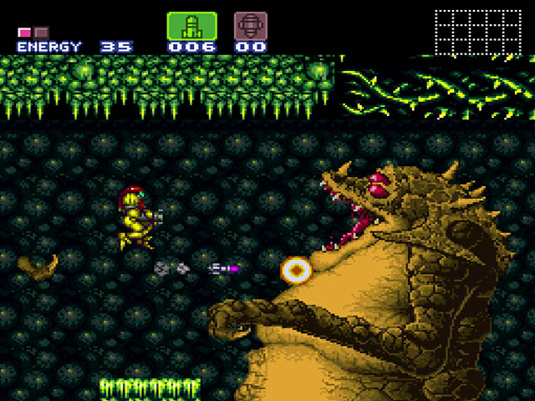
Figure 4: Super Metroid Gameplay (Jacob Mathias, 2017)
Both designs of both game level and cityscape are similar in regards that their methods of guidance to goals are both ignored by players/people. Desire paths show people using the more efficient route to their goals instead of using city’s pathways. Likewise, players will find the most efficient way to their goals in games as seen in the prevalence of the speed-running communities online.

Lighting:
Lighting is one of the subtle enhancers in both the urban cityscape and game level design. Light colour projected from a real light can physically affect a person, short wavelength (blue) light is absorbed particularly well by cells in the human body containing melanopsin effecting the suprachiasmatic nucleus, also known as the body clock, (Hattar, 2002) and disrupting the circadian rhythm. Because of these lights emitting a blue colour have been shown to boost energy, increase alertness and productiveness as the ‘day cycle phase is increased’ (Cajochen, 2017). In 2009 blue LED lights were installed in train platforms such as Tokyo Station to theoretically help tackle the country’s problem with suicides at the station by ‘boosting their mood’. The result of the implemented lights was a fall in suicide attempts by 74% in all platforms where the lighting was introduced. This shows that the lights successfully influenced people’s behaviour at the stations (Matsubayashi, 2014).
Light that would affect a player can should theoretically affect a user in the same manner, as discussed above, LED lights have an effect on human psychology, and games played on LED screens emit (in light) the colour rendered by the game at a current time. In this regard, lighting within a gaming context can affect the player in two ways, light directly from a screen being used to play the game directly effecting the person playing the game, and simulated lighting in the game environment relative to its simulated surroundings effecting player choices in the perceived environment.
Simulated light in a scene is a powerful tool that can affect the player according to Magy Seif El-Nasr, Simon Niedenthal, Igor Knez, Priya Almeida, Joseph Zupko whom state that: “it is fair to argue that the experience of simulated illumination is analogous (though not identical) to our experience of light in real space.” (El-Nasar et al., 2007). Thus the colour of lighting can affect the mentality of the player similar to how it would a person in reality, David Henry in regards to theatre lighting stated that green lighting establishes emotionally feelings of: Rootsy, Organic, Calming, Earthly. (Henry, 2016). [Figure 5] Xenoblade Chronicles (Monolithsoft, 2010) shows a scene of the ‘Bionis Interior’ level lit with green lighting, the ‘Bionis’ a representative in game of organic life, the lighting is used to reflect the biologically organic themes of the area.
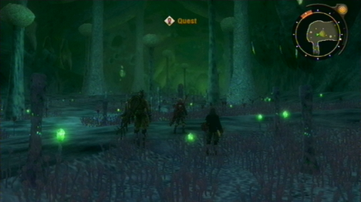
Figure 5: Xenoblade, Bionis Interior (Unknown, 2012)
Music:
Music within a video game experience is one of the core aspects in creating an atmosphere, likewise in a cityscape, though not always present, music is great manipulator of people’s behaviour. Music’s effect on people/players can be categorised into tempo, volume and genre each having unique effects on individual’s behaviour.
Using Background Music to Affect the Behavior of Supermarket Shoppers (Milliman, 2010) by Ronald E. Milliman, is a paper that researched the effects of music tempo on supermarket shoppers. The article reported that fast tempo music increased sales by 38.2%, and that slower tempo music influenced shoppers to stay longer in the shop, concluding that ‘It is possible to influence behaviour with music’. With supermarkets and shops being an integral part of the modern urban society it is fair to argue that it is possible to manipulate people’s behaviour with music tempo.
Another study was completed concerning tempo, specifically on the performance of subjects playing a video game by Daniel Lawrence, from the University of Jyväskylä, titled: The effect of musical temp on video game performance (Lawrence, 2012). The paper stated that there were no significantly different results with different tempo conditions. However, the test used 27 participants and had room for further investigation, suggesting a different test design in the papers conclusion.
It can be argued that musical tempo can encourage certain behaviours in games, such as when the tempo in Super Mario Bros (Nintendo,1985) speeds up when there are less than 100 seconds left of gameplay within the current level. This encourages the player to make more reckless decisions as they try to reach the goal with little time left, discouraging them from collecting coins and exploring and encouraging completion. This stress is in line with fast musical tempo effects in reality, as concluded in the paper Influence of Tempo and Rhythmic Unit in Musical Emotion Regulation (Fernández-Sotos, Fernández-Caballero and Latorre, 2016). This shows that the music in a game level context can influence player behaviour, though work in the academic field still needs to be continued.
The volume of music is another factor used in manipulating the behaviour of people. The Effect of Music on the Human Stress Response (Thoma et al., 2013) suggested that music at loud volumes triggers a stress response, this response is linked to the instinctive fight or flight response in people. One system found very frequently in the urban cityscape that utilises this is the fire alarm commonly found in households as a smoke detector or in large buildings as a fire prevention system, these systems emit a loud sound to warn people of the potential danger of a fire triggering the flight response encouraging people to leave the building.
Video games can replicate the alarm sounds that players may hear but ultimately have more control over how the player hears the volume at any given time. Techniques such as audio ‘ducking’ (the process of lowing all other sound volumes to hear another sound such as dialogue) cannot be accomplished in reality as each sound heard independently cannot be controlled by an external force. This dynamic control over volume allows games to accurately control how stressed a player may feel. The Silent Hill (Konami, 1999) series is known for utilising volume in its gameplay sequences, in the calmer moments of the horror game, subtle piano or rock melodies are played in a lower volume adding to the feeling of suspense controlling the player to act cautiously. During direct horror segments loud sinister music is played at a high volume to trigger the fight or flight response, when the game wants the player to fight or flee, successfully controlling the player’s attitude in the situation.
Games can lose this impact over the player as it’s very likely in any video game that volume options are available, providing the user the option to mute the intended volume, this can often be done on the hardware the game is being played on too, in this regard games lose their volume control over a player. This does follow into the urban reality however with devices such as headphones blocking external sounds rendering these methods of control ineffective.
A genre of music is arguably comprised of similar tempo and volume, as well as repeated thematic musical structures. Genres can heavily influence people’s mood triggering hormonal changes in the body according to research article The effects of different types of music on mood, tension and mental clarity (McCraty et al., 1998). The article suggested that ‘Designer music’ (a genre of music made to effect the listener on a physiologically) have great success in incurring positive feelings in the test subjects, while ‘rock music’ reduced the caring feelings of subjects more greatly in adults than teenagers. The urban cityscape uses the influence of genre in places like the London underground, where classical music if played to try and calm people in if the station is crowded or having delays (The Independent, 2008).
The genre of music played in a video game instance is a large contributor to the player’s immersion. Immersion reflects how the player acts and reacts within a simulated situation, and as such music as a contributor to this factor has an important role in controlling how the player feels. The Wonderful 101 (Platinum Games, 2013) uses the genre of its music to impact how the player feels and therefor plays in many given instances, during the games final level events the player listens to orchestrated intimidating versions of the enemy theme encouraging the player to play cautiously and tactfully against the tough foe. When the final boss is weakened in its final state the ‘Won-Stoppable Wonderful 101’ theme plays, an upbeat marching anthem that has typically played when smaller bosses have been defeated, this rushes the player with confidence encouraging aggressive play to whittle away the last of the final bosses health. The tempo and volume of the two songs remain similar, yet the change in genre drastically changes the player’s behaviour from conservation and self-preservation to take the offensive on the final boss.

Mechanic and Law:
The mechanics of a game are essentially the rules of the game enforced on the player in order to aid in the challenge or completion of the game. Mechanical influence of the player’s behaviour is vastly different across many games, though specific strategies are used to manipulate the player’s behaviour that can be found in many games.
Super Metroid (Nintendo, 1994) uses its mechanics to make the player revisit areas previously inaccessible without telling the player with dialogue where to go. The design of Super Metroid often corners the player in rooms where they cannot escape with their current equipment, these rooms will often contain new mechanic based abilities the player needs to progress in the game. When these abilities are obtained the player is only told what button input triggers their use and if left to experiment in these trapped rooms where the only way out is to use the new abilities. [Figure 6] shows the player at the start of the game trapped in a room where the only way out is a small gap at the bottom of the wall, the new mechanic lets the player shrink into a ball and move around, due to the design of the level and the introduced mechanic the player is influenced to move through the small gap to progress but never directly told too.
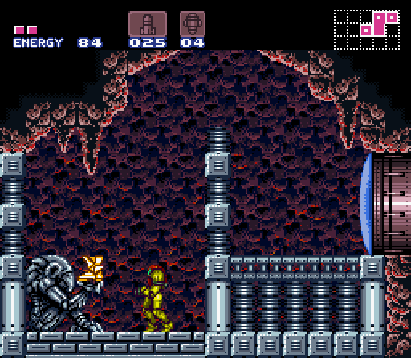
Figure 6: Super Metroid, High Jump Boots (Unknown, 2014)
This is elaborated later where a door with memorable visual design is unreachable with the player’s current mechanical abilities, when the new mechanic is obtained by the player showing that the player can jump higher, due to the memorable design of the door the player returns to the area and uses the new ability to progress. This used both the games mechanics and visual design in tandem to guide the player, Super Metroid meta-mechanic of unlocking smaller abilities a useful tool for guiding people.
Game mechanics in reality however do not exist, the closest similarities to mechanics existence are in the fundamental laws of physics and the laws set by local governance that people optionally abide by. The laws of physics are not controllable to manipulate the behaviour of people in the urban cityscape but the laws of a local governance do, yet new ‘abilities’ are not forced on people in a way that would force them to explore previously visited areas, this method of manipulation exclusive under current knowledge to game design.
A method of control over people and players behaviour that the urban city design and game design share are systems of reward for desirable behaviour and punishment for undesirable behaviour.
Sasame Credit (Ant Financial Services Group, 2015) is an experimental Chinese mobile phone application that gives its users a rewarding score for desirable behaviour, an experimental phase of the ‘Social Credit System’ proposed by the Chinese government, mandatory for citizens by 2020. A direct use of a game high score rewarding system encouraging a player’s desirable behaviour, existent since Sea Wolf (Commodor, 1976), translated and merged with social media into an urban cityscape context. The application rewards the user with a higher score “purchases the state deems valuable” and sharing links of “state-sponsored news agency’s” with a higher score (YouTube, Extra Credits 2015). The fundamental core of this application is rewarding its high scoring users with benefits such as easier loan and travel paper access. Seasame Credit is a direct use of game design logic in the urban context showing that there are core similarities in how people/players behaviour can be controlled by directly lifting one system from game design into reality as a government sponsored programme.
Game level design uses high scores to manipulate the player’s direction in level design, a notable example is the arcade game PAC-Man (Namco, 1980) that wanted players to spend money to use the cabinet. A high score was rewarding to the player and encouraged the player to play the game, fruit items were introduced as high value score items near the centre of the maze to draw the player away from their strategies risking their arcade attempt of the high scoring item in the area the ghosts could appear from. This had risk/reward relationship, the loss of the risk was a ‘game over’ and more money had to be spent to play again.
Another method shared by both urban city design and game level design is the punishment of undesirable behaviour, the opposite method of encouragement provided by rewarding the player with rewards or a high score. In this situation the law is not exclusive to city design but is encompassed in the wider modern society, though the method of punishment promoted in prisons serve as warnings to encourage acceptable behaviour by the state. In many game instances like the afore mentioned PAC-Man the mechanics encourage a desirable behaviour of avoiding the ghosts to stay alive by incurring a ‘game over’ instance punishing the players actions by making the player pay to play again. The other games mentioned also follow the method of punishment for poor gameplay, Super Mario Bros also punishes poor and undesirable behaviour by making the player the reset the level and loose a life to try again.

Conclusion:

Although the goals of people compared to players are different and that cities have to accommodate for many goals while a game is designed around its own challenges it can be summarised that most strategies of controlling a player can be applied to a person and vice versa. Fundamentally this is because players in a simulated environment still contain their experiences and human habits as both the player and people are the same. This shows that methods employed in most instances can be carried across as seen in Sesame Credit.
The layout of both cities and game levels can successfully divide people/players by a desired criterion using their physical layout, both sharing also a similar flaw in paths as desire paths/speed running ignore the inconvenient route. The colour of lighting in reality and simulated lighting in games are similar both in their capacity to evoke certain feelings through the light colour. The tempo, genre and volume of music are tools that both cities and game levels use to their advantage in manipulating the behaviour of people and players as seen in the supermarket studies and their use within the video game examples to make the player feel a certain way. Although mechanics don’t often correlate into the cityscape to control people’s behaviour, scoring systems implemented to encourage behaviour are already being directly used in China with Sesame Credit showing that both methods deployed in a game environment can influence a player.

Further Work:

Within this field of study there is still room for further work, to build a better case, studies within level design on how effective each method of the mentioned manipulation techniques are. This would gather raw data that would be very effective in further comparisons on this subject.
Wider areas in the field could also be considered, this paper focused specifically towards a comparative of game level design and the urban cityscape. Game methods of manipulation not just related to level design could be considered such as game marketing methods related to gambling such as loot box mechanics, likewise societal aspects such as cultural influences and wider societal physiological mindsets could also be compared within this field.

References:
Caro, R. (1974). The Power Broker. Knopf.
Rawinslno D. Desire Path [Online] Image available at: https://99percentinvisible.org/episode/you-should-do-a-story/ [Accessed 31 Oct. 2017].
Unknown. New York Low Bridges [Online] Image available at: https://ny.curbed.com/2017/6/21/15838436/robert-moses-jones-beach-history-new-york-city [Accessed 31 Oct. 2017].
Unknown (2013). LOL Map Sections [Online] Image available at: https://www.unrankedsmurfs.com/blog/lol-blue-side-advantage [Accessed 31 Oct. 2017]
Unknown (2012). Xenoblade, Bionis Interior [Online] Image available at: http://uk.ign.com/wikis/xenoblade-chronicles/Bionis%27_Interior [Accessed 19 Nov. 2017]
Mathias, J. (2017). Super Metroid Gameplay [Online] Image available at: http://www.loveretro.co/retro-review-super-metro-snes/ [Accessed 02 Nov. 2017]
Riot Games (2009). League of Legends.
Nintendo R&D 1 / Intelligent Systems (1994). Super Metroid.
Nintendo. (1985). Super Mario Bros.
PlatinumGames / Nintendo (2013) The Wonderful 101.
Oxford Dictionaries | English. (2017). game | Definition of game in English by Oxford Dictionaries. [Online] Available at: https://en.oxforddictionaries.com/definitio
Hattar, S. (2002). Melanopsin-Containing Retinal Ganglion Cells: Architecture, Projections, and Intrinsic Photosensitivity. [online] NCBI. Available at: https://www.ncbi.nlm.nih.gov/pmc/articles/PMC2885915/ [Accessed 7 Nov. 2017].n/game [Accessed 17 Oct. 2017].
Cajochen, C., Frey, S., Anders, D., Spati, J., Bues, M., Pross, A., Mager, R., Wirz-Justice, A. and Stefani, O. (2017). Evening exposure to a light-emitting diodes (LED)-backlit computer screen affects circadian physiology and cognitive performance. [online] Journal of Applied Physiology. Available at: http://jap.physiology.org/content/110/5/1432 [Accessed 9 Nov. 2017].
Matsubayashi (2014). Does the installation of blue Lights on train platforms shift suicide to another station?: Evidence from Japan. - PubMed - NCBI. [online] PubMed US. Available at: https://www.ncbi.nlm.nih.gov/pubmed/25151192 [Accessed 15 Nov. 2017].
El-Nasar, M., Niedenthal, S., Knez, I., Almeida, P. and Zupko, J. (2007). Game Studies - Dynamic Lighting for Tension in Games. [online] Gamestudies.org. Available at: http://gamestudies.org/0701/articles/elnasr_niedenthal_knez_almeida_zupko [Accessed 19 Nov. 2017].
Henry, D. (2016). What Are the Rules to Using Color in Stage Lighting?. [online] Learn Stage Lighting .com. Available at: https://www.learnstagelighting.com/how-do-i-use-color-effectively/ [Accessed 19 Nov. 2017].
Milliman, R. (2010). Using Background Music to Affect the Behavior of Supermarket Shoppers. [online] Freakonomics.com. Available at: http://www.jstor.org/stable/1251706?seq=1#page_scan_tab_contents [Accessed 21 Nov. 2017].
Lawrence, D. (2012). The effect of musical tempo on video game performance. Master's Thesis. University of Jyväskylä.
Fernández-Sotos, A., Fernández-Caballero, A. and Latorre, J. (2016). Influence of Tempo and Rhythmic Unit in Musical Emotion Regulation. Frontiers in Computational Neuroscience, 10.
Thoma, M., La Marca, R., Brönnimann, R., Finkel, L., Ehlert, U. and Nater, U. (2013). The Effect of Music on the Human Stress Response. PLoS ONE, 8(8), p.e70156.
McCraty, R., Barrios-Choplin, B., Atkinson, M. and Tomasino, D. (1998). The effects of music on mood, tension, and mental clarity. Alternative therapies, VOL. 4(NO. 1).
The Independent. (2008). Mind the Bach: Classical music on the underground. [online] Available at: http://www.independent.co.uk/arts-entertainment/music/features/mind-the-bach-classical-music-on-the-underground-800483.html [Accessed 29 Nov. 2017].
YouTube. (2015). Propaganda Games: Sesame Credit - The True Danger of Gamification - Extra Credits. [online] Available at: https://www.youtube.com/watch?v=lHcTKWiZ8sI [Accessed 7 Dec. 2017].
Namco, Midway. (1980). PAC-man.
Comodor. (1976). Seawolf.
Monolithsoft. (2010). Xenoblade Chronicles.
Konami. (1999). Silent Hill.
Platinum Games. (2013). The Wonderful 101.
Ant Financial Services Group. (2015). Sesame Credit.

Bibliography:

Sailer, M., Hense, J., Mayr, S. and Mandl, H. (2017). How gamification motivates: An experimental study of the effects of specific game design elements on psychological need satisfaction. Computers in Human Behavior, 69.
Lockton, D. (2017). Architectures of Control in the Built Environment. [online] Architectures.danlockton.co.uk. Available at: http://architectures.danlockton.co.uk/architectures-of-control-in-the-built-environment/ [Accessed 11 Dec. 2017].
Lockton, D. (2011). Architecture, urbanism, design and behaviour: a brief review. [online] Architectures.danlockton.co.uk. Available at: http://architectures.danlockton.co.uk/2011/09/12/architecture-urbanism-design-and-behaviour-a-brief-review/ [Accessed 11 Dec. 2017].
Kohlstedt, K. (n.d.). Least Resistance: How Desire Paths Can Lead to Better Design - 99% Invisible. [online] 99% Invisible. Available at: https://99percentinvisible.org/article/least-resistance-desire-paths-can-lead-better-design/ [Accessed 11 Dec. 2017].
Hullett, K. (2012). THE SCIENCE OF LEVEL DESIGN: DESIGN PATTERNS AND ANALYSIS OF PLAYER BEHAVIOR IN FIRST-PERSON SHOOTER LEVELS. DOCTOR OF PHILOSOPHY in COMPUTER SCIENCE. UNIVERSITY OF CALIFORNIA SANTA CRUZ.
YouTube. (2013). DNSQ: The Hidden Tutorial in Super Metroid. [online] Available at: https://www.youtube.com/watch?v=rcrdJD8whfE [Accessed 11 Dec. 2017].
Tomassoni, R., Galetta, G. and Treglia, E. (2015). Psychology of Light: How Light Influences the Health and Psyche. Psychology, 06(10), pp.1216-1222.
El-Nasr, M., Niedenthal, S., Knez, I., Almeida, P. and Zupko, J. (2007). Dynamic Lighting for Tension in Games. [online] Gamestudies.org. Available at: http://gamestudies.org/0701/articles/elnasr_niedenthal_knez_almeida_zupko [Accessed 11 Dec. 2017].
Milliman, R. (1982). Using Background Music to Affect the Behavior of Supermarket Shoppers. Journal of Marketing, 46(3), p.86.
Lawrence, D. (2012). The effect of musical tempo on video game performance. Master’s degree. University of Jyväskylä.
ICE WATER GAMES. (2012). Level Design in League of Legends. [online] Available at: http://icewatergames.tumblr.com/post/27149887061/level-design-in-league-of-legends [Accessed 11 Dec. 2017].
Atkinson, R. (2007). Ecology of Sound: The Sonic Order of Urban Space. Urban Studies, 44(10), pp.1905-1917.
Levy, L. (2015). THE EFFECTS OF BACKGROUND MUSIC ON VIDEO GAME PLAY PERFORMANCE, BEHAVIOR AND EXPERIENCE IN EXTRAVERTS AND INTROVERTS. Masters. Georgia Institute of Technology.
Sites.psu.edu. (2015). The Impact of Music in Video Games. [online] Available at: http://sites.psu.edu/passionblogrmoussa/2015/09/24/the-impact-of-music-in-video-games/ [Accessed 11 Dec. 2017].
Fabricatore, C. (2017). GAMEPLAY AND GAME MECHANICS DESIGN: A KEY TO QUALITY IN VIDEOGAMES.
Tay.kinja.com. (2016). Discussion: Are Level Skip Potions Good For MMORPGs?. [online] Available at: http://tay.kinja.com/discussion-are-level-skip-potions-good-for-mmorpgs-1790423671 [Accessed 11 Dec. 2017].
Raph's Website. (2016). The Laws of Online World Design. [online] Available at: https://www.raphkoster.com/games/laws-of-online-world-design/the-laws-of-online-world-design/ [Accessed 11 Dec. 2017].
Wheeler, B. (2017). 'LED street lights are disturbing my sleep'. [online] BBC News. Available at: http://www.bbc.co.uk/news/magazine-38526254 [Accessed 11 Dec. 2017].
Painter, K. (1996). The influence of street lighting improvements on crime, fear and pedestrian street use, after dark. Landscape and Urban Planning, 35(2-3), pp.193-201.
WhatDoTheyKnow. (2010). Crime statistics for Buchanan Street/ streets with blue street lighting in Glasgow before/after they were installed and the recent situation - a Freedom of Information request to Strathclyde Police. [online] Available at: https://www.whatdotheyknow.com/request/crime_statistics_for_buchanan_st [Accessed 11 Dec. 2017].
Cajochen, C., Frey, S., Anders, D., Spati, J., Bues, M., Pross, A., Mager, R., Wirz-Justice, A. and Stefani, O. (2011). Evening exposure to a light-emitting diodes (LED)-backlit computer screen affects circadian physiology and cognitive performance. Journal of Applied Physiology, 110(5), pp.1432-1438.
Mod DB. (2006). Lighting in game environments - the hows and whys tutorial. [online] Available at: http://www.moddb.com/tutorials/lighting-in-game-environments-the-hows-and-whys [Accessed 11 Dec. 2017].
Prall, C. (2012). Introduction to Lighting in Games. [online] Buildnewgames.com. Available at: http://buildnewgames.com/lighting/ [Accessed 11 Dec. 2017].
Omernick, M. (2004). Lighting Principles for Game Design | Color | Peachpit. [online] Peachpit.com. Available at: http://www.peachpit.com/articles/article.aspx?p=174370 [Accessed 11 Dec. 2017].
Impact of Music, Music Lyrics, and Music Videos on Children and Youth. (2009). PEDIATRICS, 124(5), pp.1488-1494.
Moormann, P. (2013). Music and game. Wiesbaden: Springer VS.
Horowitz, S. and Looney, S. (2014). The Essential Guide to Game Audio. New York: Focal Press, Taylor & Francis Group.
Collins, K. (2008). Game sound. Cambridge, Mass.: MIT Press.
Fernández-Sotos, A., Fernández-Caballero, A. and Latorre, J. (2016). Influence of Tempo and Rhythmic Unit in Musical Emotion Regulation. Frontiers in Computational Neuroscience, 10.
Neo, Y., Parie, L., Bakker, F., Snelderwaard, P., Tudorache, C., Schaaf, M. and Slabbekoorn, H. (2015). Behavioral changes in response to sound exposure and no spatial avoidance of noisy conditions in captive zebrafish. Frontiers in Behavioral Neuroscience, 9.
Lindum, J. (2016). The Effect of Sound Nudging on Customer Behavior and Vegetable Sales in a Supermarket. Masters Thesis. Aalborg University Copenhagen.
Thoma, M., La Marca, R., Brönnimann, R., Finkel, L., Ehlert, U. and Nater, U. (2013). The Effect of Music on the Human Stress Response. PLoS ONE, 8(8), p.e70156.
Quarles, Z. (2009). Game Audio Theory: Ducking. [online] Gamasutra.com. Available at: https://www.gamasutra.com/view/feature/132310/game_audio_theory_ducking.php [Accessed 11 Dec. 2017].
Nauert, R. (n.d.). Upbeat Music Helps Improve Mood. [online] Psychcentral.com. Available at: https://psychcentral.com/news/2013/05/16/upbeat-music-helps-improve-mood/54898.html [Accessed 11 Dec. 2017].
Charles S. Areni and David Kim (1993) ,"The Influence of Background Music on Shopping Behavior: Classical Versus Top-Forty Music in a Wine Store", in NA - Advances in Consumer Research Volume 20, eds. Leigh McAlister and Michael L. Rothschild, Provo, UT : Association for Consumer Research, Pages: 336-340.
Xiaoqing Fu, J. (2015). The Influence of Background Music of Video Games on Immersion. Journal of Psychology & Psychotherapy, 05(04).
Stuart, K. (n.d.). What do we mean when we call a game 'immersive'?. [online] the Guardian. Available at: https://www.theguardian.com/technology/gamesblog/2010/aug/10/games-science-of-immersion [Accessed 11 Dec. 2017].
Mentzoni, R., Laberg, J., Brunborg, G., Molde, H. and Pallesen, S. (2014). Type of musical soundtrack affects behavior in gambling. Journal of Behavioral Addictions, 3(2), pp.102-106.
Shenker, J. (2017). Revealed: the insidious creep of pseudo-public space in London. [online] the Guardian. Available at: https://www.theguardian.com/cities/2017/jul/24/revealed-pseudo-public-space-pops-london-investigation-map [Accessed 11 Dec. 2017].
Osborne, S. (2015). China has gamified obedience to the State. [online] The Independent. Available at: http://www.independent.co.uk/news/world/asia/china-has-made-obedience-to-the-state-a-game-a6783841.html [Accessed 11 Dec. 2017].

