

LEVEL/ LEFEL 4

MODULE CODE: EMPL4011
SMART TECHNOLOGY IN THE WORKPLACE
ASSESSMENT/COMPONENT: 1
STUDENT NAME: Mohammed Riktar Khan
STUDENT ID: 1605372
Table of Contents
Introduction 3
Part 1: Evaluation of the appropriate use of technology to improve workplace efficiency and employability 4
Cloud Storage: OneDrive VS iCloud 4
Smartphone VS Tablet: OnePlus 6 VS Amazon Fire HD 10 6
Part 2: Demonstrating the appropriate use of technology and its applications in the workplace 8
A. Creating own professional accounts in several social media 8
B. Evaluating the possibilities for communication and collaboration in the workplace and the measures appropriate in safeguarding personal and professional security and safety online 10
Conclusion 11
References 12

Introduction
Organisations nowadays are growing high and coping up themselves with the new generation blessings of information technology to be more specific modern technical instruments. People are working together and getting touched, connected through networking. Networking is like a spider net where every spin is connected with others. Such like people are connected with others. In this digital technologies, some has been taken remarkable place e.g. Cloud service, Web-based mail service, Social media, Web conferencing, Smartphones and tablets, online office application etc. Gmail, Yahoo, Hotmail are recommendable in mail services with attached file sharing facilitates. Google Drive, iCloud, Dropbox are very much helpful in cloud storage activities online. Social media like Facebook, Instagram, Twitter, LinkedIn are the most popular social sites in the virtual world. This is providing an opportunity for most people to get connected over any people of any corner of this world. Faceoff, Viber, Messenger, WhatsApp, Skype are some tools of web conferencing where people can live chat with video.

Part 1: Evaluation of the appropriate use of technology to improve workplace efficiency and employability
Technology is the real game changer in this digital world of information and communication. It has crossed the beneficiary limit from personal to professional. More than a common number of users are using smart devices and solutions for increasing their capability and employability. To demonstrate and evaluate this rapid changes through smart gadgets I'll be picking up a smartphone OnePlus 6 and a tablet Amazon Fire HD 10. Other side cloud storage has impacted a huge upon workstations. Bringing big size folders and information is a tough and quite timely and costly matter. But using online cloud storage it has been easier than before. Just a matter of few moments to share a file here to there sitting on a chair. In this sector, I'll take OneDrive and iCloud to demonstrate this part.

Cloud Storage: OneDrive VS iCloud
CRITERIA | OneDrive | iCloud
Memory | This cloud storage for windows users is initiative free with 5GB storage. Then one may get 50 GB starts for €1.99 monthly. Following to 1 TB for €5.99 and 5 TB paid plan for €7.99. Microsoft and Windows 10 0r later have a special facility like direct photos and file syncing. It is also available as an app for Android and iOS users. | iCloud is an online cloud storage by Apple only for its macOS and iOS users only. One may use it after having an apple id and device. Initially, iCloud gives 5 GB free storage only. It is very short if one wants to back up a simple iPhone! But the paid facilities are reasonable than any other providers. It starts from €0.99 monthly for 50 GB. Then 200 GB for €2.24, and 2 TB for €8
Operating devices | One Drive a file sharing online or cloud storage has both online and offline offers. It is capable to work in Windows and macOS computers, and iOS and Android devices. | iCloud is capable to work in all the apple technologies like macOS computers, and iOS devices. It can be synced in windows through iCloud drive official client of Microsoft.
Advertisement | One Drive has many third-party apps and pops up news and advertisement during online activation. | iCloud does not have any third party apps and pop up news and advertisement during online activation.
Capability | One Drive is very flexible to use. It does not have any complex operating function. Simple filing, easy to upload, offline saving and secure file sharing. Every uploaded file has a web link. One can just copy and share with others. | iCloud has the direct sharing facility form the folder instant. It does not require copying web link, making it public then paste the shared link with others to complete sharing a file or folder. So it is a bit easier and faster than other cloud storages.
File Sharing | Uploading files are comparatively slower than iCloud. It is highly waiting at sharing a large file. But aftermath, sharing the web link to get the file is easier. One can download to see the attachment according to broadband speed. | Uploading files or folders are comparatively less timing and smoother than One drive. It has super speed in uploading and even downloading. Fast speed is one of the reasons behind iCloud’s rapid success and trust over users.
Security | One drive has a strong security system. It has the facility to remain one's files secret until the owner or shared party does not make it public. But the good thing is it does not have any automation system for reading caches and serving ads according to users’ browsing tastes. | iCloud has tight security for its users. As it has any master engine machine who controls the whole web. But iCloud does not need any cache or cookies to follow tastes. Apple has limited customers and it works for providing the best solution to its customer every time.

Smartphone VS Tablet: OnePlus 6 VS Amazon Fire HD 10
CRITERIA | OnePlus 6 | Amazon Fire HD 10
Memory | OnePlus 6 is a signature creation of OnePlus. OnePlus 6 has one more modification called 6T. It has a total internal memory of 128 GB & 256 GB with 8 GB RAM. It does not have any external memory chip slot. | Amazon Fire HD 10 is a professional dimension by Amazon for professional user in various fields. Amazon Fire HD 10 can be a reliable name to the creative personnel. It has a total of 32 & 64 GB internal memory with 2 GB RAM for operation. It has microSD card slot up to 256 GB dedicated memory.
Battery | OnePlus 6 has a fast charging battery of 3300 mAh with fast charging built-in Li-Po. It gives 5 hours and 34 minutes display on standby backup. Which is a bit lower than iOS. | Amazon Fire HD 10 has an average non-removal battery of 3830 mAh Li-Po light charging facility. It gives 10 hours of talk time backup. And has a dual sim card slot.
Features | OnePlus 6 is a mega experience with high sensors, notification bar, best audio, video, capturing power. Base mark OS 2.0 has been used for the best experience. 16 MP front and 16 MP rare cameras with dual LED flash segment. Optic AMOLED capacitive touchscreen display and 16M colours HDR video support. Exciting face recognition feature for phone unlock. | Amazon Fire HD 10 is an average device for professional users. It has IPS LCD display with 16M colours. The rare camera of 2mp and selfie camera of VGA. WLAN, Bluetooth, Dolby Atmos audio enhancement, Accelerometer sensor, HTML5 browser and thread messaging.
Operating system | OnePlus 6 operates with Google's Android operating system. It has the latest Android 8.1 (Oreo) OS and upgradable to 9.0 (pie). | Amazon Fire HD 10 operates with Google’s built-in operating system called Android. It runs Android customised 5.1 lollipop version.
Capability | OnePlus 6 is very flexible and comfortable in using. It has a dimension of 6.13×2.97×0.31 inches which is very thin to hold. And it weighs only 177 grams. It is completely water and dust resistant. It has dual sim slot and LTE for a slot at a time. Corning gorilla glass 5 protects and provides best user quality on screen. | Amazon Fire HD 10 is an average product. It has a dimension of 10.31×6.26×0.39 inches which is quite thin. It weighs 500 grams. It does not have water and dust resistance. Play store is the main flexibility for android users. It is so easy to get apps for free and paid. And random update keeps the experience up to the mark.
Objectives | OnePlus 6 is mainly created for the ultramodern experience of a mobile phone. Which can be compared to any other smart devices and their facilities, features. OnePlus 6 is giving near about same and may be extended in some cases at a very cheap price. | Amazon Fire HD 10 has created for quality and average experience in cheap rate. It costs only 170 euro. Medium class customer in professional work and low payment buyers may get high-class satisfaction using this product.

Part 2: Demonstrating the appropriate use of technology and its applications in the workplace

A. Creating own professional accounts in several social media
According to the requirement I have created accounts in some social media platforms like Facebook, Twitter and LinkedIn. Screenshot and the profile links of those accounts are given below:
Facebook Link: https://www.facebook.com/riktar.khan.1
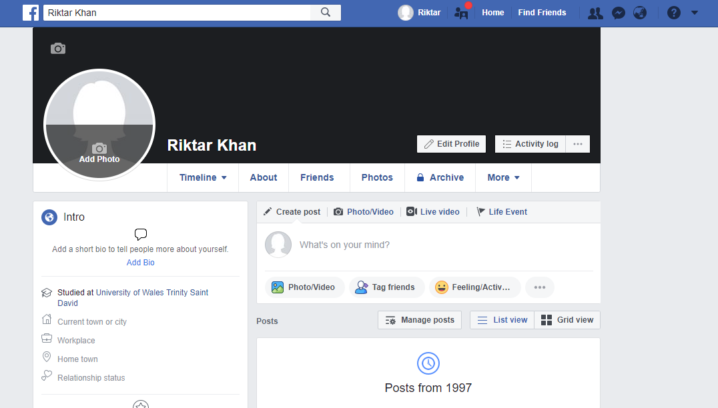

Twitter Link: https://twitter.com/riktarkhan
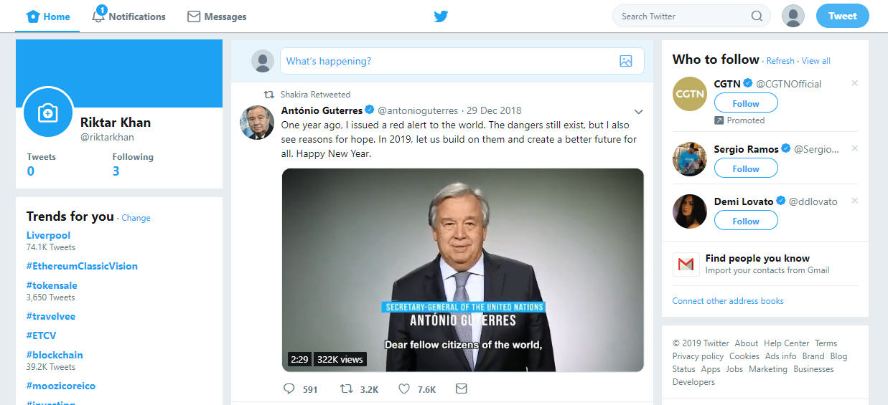

LinkedIn Link: https://www.linkedin.com/in/riktar-khan-b33594178/
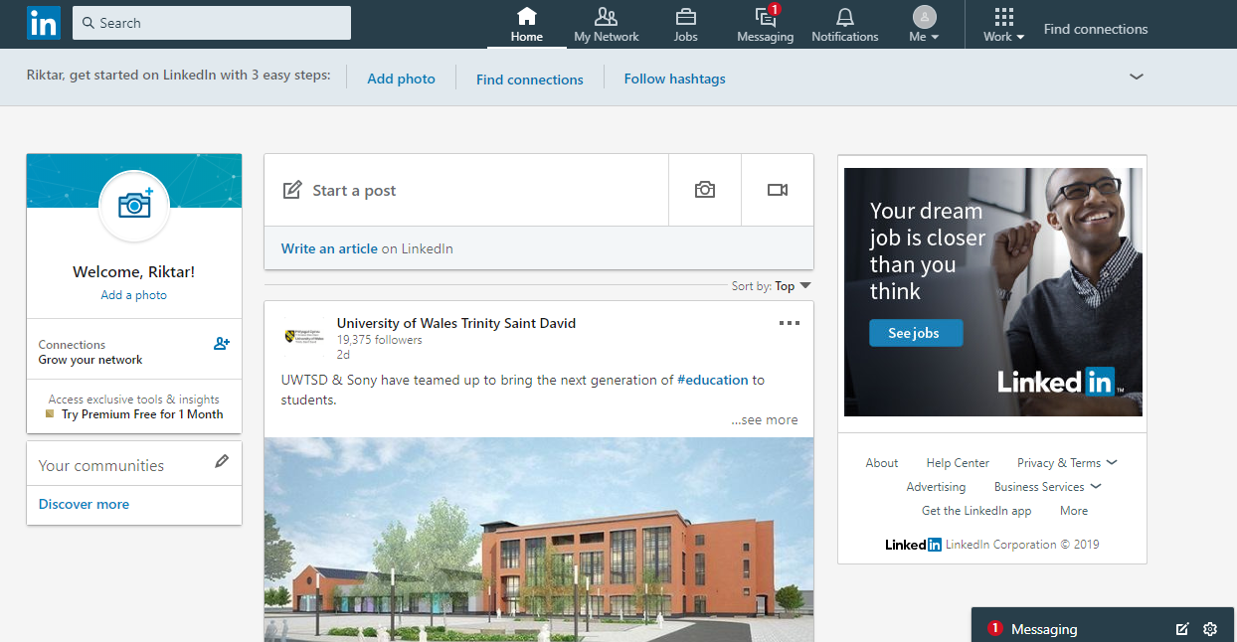

B. Evaluating the possibilities for communication and collaboration in the workplace and the measures appropriate in safeguarding personal and professional security and safety online
Communication and collaboration in the workplace through social media: Social media has made the communication and networking system vast open. Through this mediums, people from any border getting close and in touch. Recently the rapid advancement of technology has changed the total scenario then existing. It has crossed the border from personal interaction to professional. Popular social media like Facebook, Twitter, LinkedIn, and Instagram are providing easy actions and privileges to business organisations for connecting people through online marketing. Especially through the Facebook messenger, employees are keeping their communication from any border of this world. This is helping immensely for standing against any problems instantly. For example, the employees of Axiata use Facebook messenger for keeping contact and communication internally. Mail is for formal approaches but for internal relation between co-workers, even some short notices which is bothered and boring as formal notices are send through messenger texts. Using this technology employee of Axiata can solve simple or big problem discussing smart technologies through text or video conference at anywhere, anyplace. Even on vacation one can attend virtually in an emergency.
Safeguarding personal and professional security and safety online: At the working time, employee and executives share so many files internally or externally for work purpose. So, in this modern era, everyone uses cloud storage for sharing online. This cloud storage facility has brought a rapid revolution in business. It saves time and money at a time for sharing any file, folder in a few seconds from one corner to another (Benson and Morgan, 2017). But it has a risk to be hacked those social platforms to thief the information. So users need to aware of this risk and should protect their data very time while sharing or working. For this several tools and settings are available in technologies which are being used. For example, someone has shared his personal information on Twitter. Personal information includes, certificates, emails, contact numbers, check INS etc. Confidential information can be harmful to important personas. And with the general information like the background, emails, contact numbers many hackers can find out personal accounts and can blackmail for financial benefits. So one needs to be very careful all the time, for acknowledging the steps and always protect data at best possible.

Conclusion
Technology in this golden era of digitalization has brought this generation to a new dimension and space of living. It is the blessing with reducing time, energy, and money. If it comes in talking about technologies using in the workplace for increasing efficiency and employability, then it must come to the smart devices are being used nowadays. Almost everyone is using smart technologies and devices in hand for making life more flexible. In this digital era, the world is moving very fast and quick with modern technology in the information and communication system. People are working together and getting touched, connected through networking. Networking is like a spider net where every spin is connected with others. Such like people are connected with others. In this digital technologies, some has been taken remarkable place e.g. Cloud service, Web-based mail service, Social media, Web conferencing, Smartphones and tablets, online office application etc.

References
Barney, D. (2017). Communication Technology. Vancouver: UBC Press.
Davis, G. and Hamilton, S. (2017). Managing information. Burr Ridge, Ill. <<>>: Irwin.
De Moor, G. (2017). Transatlantic cooperation surrounding health-related information and communication technology. Amsterdam: IOS Press.
Derbel, F., Derbel, N. and Kanoun, O. (2016). Communication, signal processing & information technology.
Harrison, D. and Petty, D. (2016). Systems for planning and control in manufacturing. Oxford: Newnes.
Luo, J. (2015). Soft Computing in Information Communication Technology [recurso electrónico]. Alemania: Springer Healthcare Ltd.
Papazoglou, M., Spaccapietra, S. and Tari, Z. (2015). Advances in object-oriented data modelling. Cambridge, Mass: MIT Press.
Qian, Z. and Cao, L. (2017). Recent Advances in Computer Science and Information Engineering. Berlin, Heidelberg: Springer Berlin Heidelberg.
Saeed, F., Gazem, N., Patnaik, S., Saed Balaid, A. and Mohammed, F. (2018). Recent trends in information and communication technology. Cham: Springer.
Stauffacher, D. (2017). Information and communication technology for peace. New York, N.Y.: United Nations ICT Task Force.

