
DEVELOPING RELATIONSHIPS AND WORKPLACE ACHIEVEMENTS


December 4, 2020
Uniersity of wales, Trinity Saint David

Bettina Silsby
1905229

BMSW5102_SWAN

Table of Contents
Developing Relationships and Workplace Achievements 2
Introduction 2
Motivation…………………………………………………………………………………………………………………………………………………………2
Benefit to the organisation…………………………………………………………………………………………..…3
Employee engagement………………………………………………………………………………………………………………………………………5
Benefits of Employee Engagement to the Organisation…………………………………………………………….5
Benefits of Employee Engagement to Employees …………………………………………………………………..6
Performance Management 7
The Benefits of the Performance Management System to the Organisation 7
The Benefits of the Performance Management System to Employees 8
Training……………………………………………………………………………………………………………………………………………………………10
Benefits of Training to the Organisation…………………………………………………………………………….10
Benefits of Training to Employees………………………………………………………………………….10
Vodafone…………………………………………………………………………………………………………11
Cloncosion………………………………………………………………………………………………………………………………………………………11
References………………………………………………………………………………………………………………………………………………………12
Task 2 ……………………………………………………………………………………………………………………………………………………………15

Developing Relationships and Workplace Achievements

Introduction
Performance management, employee engagement, training, and motivation are four closely related constructs of organisational behaviour. Performance management can be defined as measures taken by the organisation to ensure that organisational goals are attained efficiently and effectively (Taticchi, 2010). Employee engagement can be defined as positive attitudes that employees hold to the company and its values (Robinson, Perryman, and Hayday, 2004). Motivation is defined as the process through which employees are stimulated to attain organisational goals (Ramlall, 2004). On the other hand, training is done to equip employees with the essential skills to perform their job. All these constructs are considered as development vehicles and have benefits to both the employees and the organisation.

Motivation
Motivation is a general term often used to refer to the entire class of needs, desires, drives, and similar forces that encourage an employee to complete his or her duties effectively. There is enormous data accessible about the explanation of the concept of motivation and satisfaction of employees. Motivation is defined as the progression of encouragement, correct direction and safeguarding of human behavior for the accomplishment of organizational goals, according to Locke 2007. On the other hand, he also tells that there are countless imaginary views concerning the drivers of motivation, which leads on the way to a feeling of fulfilment to the employee. Several managers believe that satisfied employees are backbone for production. ( Lock, 2007) When a person implies that managers are motivating their junior employees, it means that they take relevant steps that they believe are satisfying the workers’ desires and provoke them to act in a desired manner (Dobre, 2013). The behaviour of human beings is complex in terms of the needs-behaviour-action process. Some of the important human theories include need theories, such as Maslow’s Need Hierarchy Theory and Frederick Herzberg Two-Factor Theory; cognitive theories, such as Expectancy Theory; and behavioural theories, such as McGregor’s Theory X and Theory Y (Ramlall, 2004).

Benefits of Motivation to Organisation

Reduced labour absenteeism and turnover
Motivation makes employees satisfied with their work, as well as the working environment at large. When the employees are satisfied with their work, they are less likely to be absent from the work. Moreover, job satisfaction increases employee commitment, thus decreasing turnover (Dobre, 2013).

Increased productivity
When employees’ needs are satisfied, they also work towards satisfying the needs of the organisation. This can result in an increase in the employee’s productivity, thus prompting increased productivity.

Overcome resistance to change
Motivated employees are less likely to resist organisation changes since they comprehend the importance of change. Change is the essence of management. Therefore, a motivated workforce can facilitate organisational success by embracing newly developed strategies (Dobre, 2013).

Good industrial relations
When the needs of the employees are satisfied, they are likewise content with the job, thus promoting good relations with their employers. Further, motivated employers are willing to follow organisation guidelines, which leads to peace and discipline in the organisation. This type of organisational culture further enhances good relationships between managers and junior employees (Dobre, 2013).

Benefits of Motivation to Employees
Increased employee productivity
Motivation helps the employees to put in more effort into their work, making them more productive. It is highly beneficial for both the company and the employees in terms of output and enhanced skills, respectively.
Improved employee satisfaction
Providing motivational factors to the employees can make them be satisfied with their job, as well as their working environment, which prompts the desire to stay with this particular company (Kim, 2006).
Promotes employee development
Motivation can help the employees to attain their personal goals. Once individuals have attained some initial personal and professional goals that they long harboured, they recognise the connection between the effort and the results, which further motivates to pursue more significant goals.
Improved employee efficiency
Employees’ efficiency level is not only limited to the qualifications or abilities. It also depends on other factors, such as the willingness to perform a particular task (Kim, 2006). When employees are motivated, a good balance is created between the task performance and the willingness to perform the task (Nohria, Groysberg, and Lee, 2008).

Application of Motivation Practices to Improve the Performance of the Individual and the Organisation

Participation
Self-motivation is considered as a greater force than external motivation. The managers can enhance self-motivation of the employees by facilitating the workers’ ability and willingness to participate in managerial decision-making (Kim, 2006).

Job rotation and job enrichment
Managers can motivate employees by making jobs to be challenging and varied through various practices, such as job rotation and job enrichment. As seen in at organisation for example Tesco offering strategic career plan to each employees.

Rewarding by results
Rewarding employees based on their performance can make them result-oriented and motivated to attain the set targets.

Creating a suitable work environment
An organisation can design a suitable work environment to motivate the workers to achieve the organisational goals. A suitable environment can be created through various practices, such as pleasant working conditions, a neat and tidy workplace, and flexible working hours.

Healthy criticism
Managers should understand that no human being is perfect. Rather than criticising employees for their mistake, managers should sit with employees and discuss with them how the situations can be solved effectively to prevent similar mistakes. This can make employees work harder.

Vodafone
Reward is a broad construct that has been said to represent anything that an employee may value that an employer is willing to offer in exchange for his or her contributions. (Chiang and Birtch, 2008 as cited in Bustamam et al. 2014) Vodafone does use a rewarding system to highly motivate the employees. The organization do offer more benefit the employees are higher in the carrier ladder. The employees have access company cars such the newest model of Audi, reward gate way childcare vouchers, great pension, competitive wages, good maternity and paternity pay and one of the most success motivation the graduate scheme. This scheme gives lots of potential there for the employees, as it is a great development, on-the-job training, building expertise in the chosen area, all of which support in fulfillment and help achieve the career goals. (Vodafone, 2020)

Employee Engagement

Employee engagement can be defined as positive attitudes that employees hold towards the company and its values. It enables the workers to be aware of the business context and work together to improve performance within their jobs, thus increasing performance (Robinson, Perryman, and Hayday, 2004). The organisation should work towards developing and nurturing engagement, which necessitates a two-way relationship between the employee and the employer.
Benefits of Employee Engagement to the Organisation
Higher profits and productivity
Proper employee engagement helps the organisation to incur higher profits, thus increasing the productivity of the company.
Improved quality
The quality of services provided by an organisation can be improved when the employees are presented with proper opportunities. When an organisation commits itself to foster employee engagement, the quality levels of the organisation also rises (Patro, 2013).
Customer loyalty
Employee engagement helps the workers to have a better comprehension of the clients’ needs. Therefore, employees are able to provide excellent customer services, which, in turn, results in customer loyalty (Saks, 2006).
Employee retention
Retaining employees depends on the need of retaining them. Employee engagement increases employee job satisfaction, which promotes employee retention.

Vodafone
According to the HR Manager of Vodafone it is been concluded that if organizations engage employees with different internal competitive programs, recreational meetings, and professional creativities there will be higher rate of retention in the organization. It also can be achieved by proper and frequent communication between management and staff, regular interactions related to goals, company missions, health and safety, employee suggestions etc. The Vodafone management try to create such a relaxed environment in the office for employees providing all the opportunities for their career growth, providing different training and developmental programs. Vodafone try to retain that; the employees are think the company are the asset for the employment success and the organization value them in all manners. (Vodafone, 2020)

Benefits of Employee Engagement to Employees
Increased employee performance
Engagement is an elusive force that provides motivation to individuals to attain greater levels of performance.
Motivation and commitment
Employee engagement provides incentive plans to the employees, thus motivating them to increase their productivity (Patro, 2013).
Promotes employee development
High levels of engagement help the workers to take the initiative and pursue learning. By learning, employees can undertake career advancements, developing qualitatively (Saks, 2006).
Application of Employee Engagement to Improve the Performance of the Individual and the Organisation
Job designing
Job characteristics entailing autonomy, variety, and challenges are more likely to offer psychological meaningfulness, which is an element of employee engagement. Jobs that provide challenge and variety becomes attractive and meaningful to workers, thus impacting their levels of engagement (Patro, 2013).
Career advancement opportunities
Organisations aiming to have higher levels of employee engagement often provide their workers with opportunities to improve their abilities, acquire new knowledge and skills, to enable them to realise their potentials. These kinds of opportunities impact engagement for workers and helps the organisation to retain its best talents.
Leadership
The workers need to feel that the core values, which guide an organisation, are unambiguous. A company that wants to promote employee engagement is required to show respect to all the employees regardless of their job level. Ethical standards of an organisation can result in the engagement of an individual (Saks, 2006).
Equal and fair opportunities
Employee engagement can be fostered if the organisation provides equal opportunities for advancement and growth. A work environment with discriminating practices adversely impacts employee engagement, and it must be eliminated and replaced with conducive working conditions.

Performance Management


Performance management can be defined as measures taken by the organisation to ensure that organisational goals are attained efficiently and effectively. Performance management is a communication process by managers and employees work together to plan, monitor, and review an employee’s work objectives and overall contribution to the organization. More than just an annual performance review, performance management is the continuous process of setting objectives, assessing progress and providing ongoing coaching and feedback to ensure that employees are meeting their objectives and career goals. (OMES, 2020)

The Benefits of the Performance Management System to the Organisation
Attainment of organisational goals
Performance management system requires the employees to adhere to the laid down policies, thus increasing the chances of achieving the organisational goals (Taticchi, 2010).
Increased productivity
Performance management remunerations motivate employees to work effectively and efficiently to increase its performance, which in turn increases the increased productivity of the organisation (Armstrong and Baron, 2015).
Transparency and accountability
Performance management policies provide different responsibilities to employees, thus ensuring that operations within the organisation are conducted transparently and efficiently (Taticchi, 2010).
Staff retention
The performance management system offers appraisals as well as equitable remunerations to the employees motivates employees and results in job satisfaction. This enables the organisation to obtain employee loyalty, thus retaining its staff (Armstrong and Baron, 2015).

The Benefits of the Performance Management System to Employees
Performance management helps the workers to comprehend the importance of their contribution to the company, thus enhancing job satisfaction. It also increases the available career development opportunities, thus offering employees a high potential to climb the organisation ladder (Taticchi, 2010). Performance management offers the training and other development programmes to the employees to ensure that they are equipped with essential skills (Belcourt, Bohlander, and Snell, 2008). The performance management system has performance appraisal techniques such as a 360-feedback survey that assess employees' and give feedback that can help them to improve so that they can obtain better results.
Application of Performance Management to Improve the Performance of the Individual and the Organisation
Job description
Any organisation that intends should start by updating the job descriptions of all the employees in order to ensure their duties align with the current needs of the organisation (Taticchi, 2010). The job descriptions enable what is expected from the workers to be stipulated. When correct job descriptions are developed, they enhance efficiency operations of the company.
Evaluation scales
After correct job descriptions have been developed, it is essential to prepare a scale that will be used to evaluate workers. This scale will enable the company to determine the progress as well as performance made by its employees. The ranking scale can also be developed to provoke the employees to put in more effort, thereby helping the organisation to attain good results (Delpo and Guerin, 2007).
Progress evaluation method
After the evaluation scale has been developed, it now becomes essential to determine the technique that will be used to evaluate the progress of the performance management system. This enables the organisation to determine if the system that has been introduced is having a positive or negative impact (Delpo and Guerin, 2007).
Formulation of assessment guidelines
After performance management tool has been introduced successfully, it is essential to develop guidelines that can be utilised during the assessment of any improvements in the organisation's operation. Ways of conducting measurement need to conducted to help the organisation to determine the effectiveness of its new management system.
Determination of the reward system
Determining techniques of rewarding employees is crucial in performance management. These techniques play a crucial role in motivating workers so that they can always put in more effort to do their best for the organisation. Rewarding employees, according to their performance, enhances the effective implementation of the performance management system.
Vodafone
Vodafone does not use the performance management, the organisation like to say it is performance improvement. Vodafone prefer to improve the employment performance rather than manage that. The organisation offers wide range of training opportunities, there for the employees can contribute to the company and help

Training

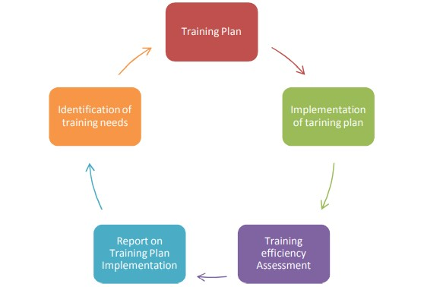
Employee training and development is among the most vital motivators that are utilised to help employees as well as organisations to achieve their long-term and short-term objectives and goals (Rodriguez and Walters, 2017). Training and developments equip the employees with essential skills to undertake certain goals. There may be different reasons for employee training, but one should make sure that it comprises of a comprehensive, consistent, and ongoing employee training program. The good training program will keep motivated the employment to learn new concept and improve profit to the organization.
(Pogue, 2007)

Benefits of Training to the Organisation
Training lowers the cost of production. When the employees are trained, they acquire more skills on how to use materials efficiently, thus resulting in lower costs of production. Training also helps the organisation to retain its best talents. Training increases the quality of staff and promotes a sense of security among the employees, which in turn results in a reduction in the turnover. Training also increases the organisation’s performance. By training employees, they acquire skills and become more productive (Bapna et al., 2013). When the productivity of employees increases, the overall productivity of the organisation also boosts. Training also instils positive attitudes among the employees, therefore enhancing employee engagement. Lastly, training helps the company to improve the quality and the availability of its staffs (Jehanzeb and Bashir, 2013).
Benefits of Training to Employees
Training increases the motivation, confidence, and morale of employees, thus, making them be more productive by offering them competencies that are essential to adjusting to challenging situations. It also serves as a gateway to the recognition promotion, and or higher in the organisation (Rodriguez and Walters, 2017). Training gives the employees the essential skills that are required in their career advancement. Taking employees through training programs can make them feel like they are a part of organisation, which appreciates them. This can boost their morale and enables them to approach their duties with more confidence (Rodriguez and Walters, 2017).
Application of Training Practices to Improve the Performance of the Individual and the Organisation
On-the-job training
This type of training can be given to the employees while performing their work at their working station. For instance, supervisors can provide mentoring and coaching to the employers while they are at their workstations.
Off-the-job training
This training involves employees being taken away from their working venues so that they can focus on training, for instance, conference training (Rodriguez and Walters, 2017).
Coaching and mentoring
This training focuses on the development of specific skills for the work as well as performance expectations in the workstations. It also enhances the mutual relationship between the manager and employees.
Vodafone

All the research pointing that way the Vodafone has offer good family policy, therefor are offer flexible working hours, good maternity, and paternity pay and very family orientated company. The company put big focus on home life balance, therefor a high number of employees enjoy working for the organisation and stay loyal. However, the organisation offers great benefit for managers and employees that have higher position. The employees who are working as sales assistant feel really left out, not appreciated and overload, according to glassdoor website.

Conclusion

This paper aimed at examining the benefits of various development vehicles. These constructs of organisational behaviour are closely related and have similar benefits to both employees and companies. Some of the benefits include increased organisation productivity, reduced employee turnover, reduced absenteeism, employee job satisfaction, and increased employee productivity. Therefore, any organisation that wants to benefit its employees should ensure that these development vehicles are adopted successfully.

References
- Armstrong, M. and Baron, A., (2005). Managing performance: performance management in action. New York, NY: CIPD Publishing.
Available at: https://omes.ok.gov/sites/g/files/gmc316/f/PMPHandbook.pdf (Accessed:30/11/20)
- Bapna, R., Langer, N., Mehra, A., Gopal, R. and Gupta, A., (2013). Human capital investments and employee performance: an analysis of the I.T. services industry. Management Science, 59(3), pp. 641-658.
- Belcourt, M., Bohlander, G. and Snell, S., (2008). Managing human resources. Toronto, ON: Nelson.
- Bustamam, F.L., Teng, S.S & Abdullah, Z. F. (2014). Reward management and job satisfaction among frontline employees in hotel industry in Malaysia. Procedia- Social and behavioural science, 144, 392-402. https://doi.org/10.1016/j.sbspro.2014.07.3
- Delpo, A. and Guerin, L., (2007). Dealing with problem employees: how to manage performance & personal issues in the workplace. Berkeley, CA: NOLO.
- Dobre, O.I., (2013). Employee motivation and organisational performance. Review of Applied Socio-Economic Research, 5(1).
- Glassdoor, (2020) Online employee review website [www.glassdoor.co.uk] https://www.glassdoor.co.uk/Reviews/Vodafone-Reviews-E5775.htm (accessed 03/12/20)
- Jehanzeb, K. and Bashir, N.A., (2013). Training and development program and its benefits to employee and organisation: a conceptual study. European Journal of Business and Management, 5(2).
- Kim, D., (2006). Employee motivation: “ask your employees”. Seoul Journal of Business, 12(1), pp. 19-35.
- Locke, E.A. (2007), The Organisational Behaviour and Human Decision Processes, Vol.5, Published by Harper CollinsPublishers,Great Britain
- Nohria, N., Groysberg, B. and Lee, L., (2008). Employee motivation: a powerful new model. Harvard Business Review, 86(7/8), pp. 78-86.
- OMES, (2020) Office of Management and Enterprise Services- Performance Management. [www.omes.ok.gov]
- Patro, C.S., 2013. The impact of employee engagement on organisation’s productivity. Mysore, India: 2nd International Conference on Managing Human Resources at the workplace.
- Pogue, G., (1997) Employee assistance programs on liberal arts campuses, University press of America, pp75-78
- Ramlall, S., (2004). A review of employee motivation theories and their implications for employee retention within organisations. Journal of American Academy of Business, 5(1/2), pp. 52-63.
- Robinson, D., Perryman, S. and Hayday, S., (2004). The drivers of employee engagement. Brighton, UK: Institute for Employment Studies.
- Rodriguez, J. and Walters, K., (2017). The importance of training and development in employee performance and evaluation. World Wide Journal of Multidisciplinary Research and Development, 3(10), pp. 206-212.
- Saks, A.M., (2006). Antecedents and consequences of employee engagement. Journal of Managerial Psychology, 21(7), pp. 600-619.
- Taticchi, P., (2010). Business performance measurement and management: new contexts, themes and challenges. New York, NY: Springer Science & Business Media.

Vodafone, (2020) Why work for Vodafone? Alex discusses why Vodafone is a great place to work [www.brightnetwork.co.uk] Available at: https://www.brightnetwork.co.uk/employer-advice/vodafone-group/why-work-vodafone/ (accessed; 03/12/2020)

Task 2
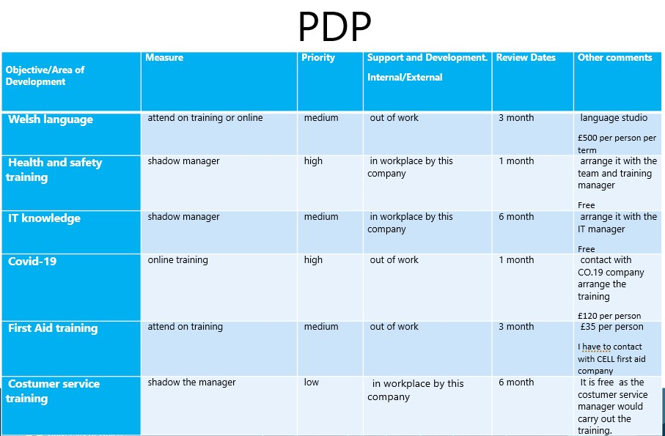

As a line manager, I can recognise it is very important to regularly reviewing each employee personal development and put in please a training where is need it. It is important for each employee feel safe and been encouraged by recognising training needs, from the company perspective we want to be work with colleagues, that have good acknowledgement and great skills to achieve our goals. The current circumstances been change due to Covid-19, so every employee must have a knowledge about the new guidelines and regulation that need to fallow to keep us and all the customers safe. I have arranged an online training with the CO-19 company to bring everyone up to date all and make sure we are fallowing all the necessary steps that is required to keep as safe. The online training will be carried out on normal working time and my employees will divided in 3 groups. The 3 groups have different date to ensure that we can covered the work, that they not fill in during the training. As the training will taking place in the actually working hours the company does not need to pay extra labouring cost. The training will cost £55 per person, that the company will pay. The training will take 8 hours same as a working shift. This training in high priority to keep our working environment safe and if any inspection will be carried out by government, we could ensure that we are doing everything to keep our customer safe. I will review each employee monthly or more frequently if any changes are made to the regulation. End of the training will all the employees have to pass a Covid-19 measure test and they will receive a certificate. The company that is undertaking the training will keep us up to date if is guideline will change. Also, I like to have a monthly one to one discussion with each employee to make sure they can adapt the new normal and feel listen if they have any concern or they need extra support in any areas.

