AI and Machine Learning
  - Module ACCA6011 Assignment
by
  - John Dunkley-Williams
1903715

Contents

- Task 1
  - The Role of AI in Supermarkets
  - Data for evaluation
  - Tools and applications
  - AI/ML Model
  - Conclusion
- References
- Appendices

Task 1

The role of AI in supermarkets

Digital technology augments and enhances most aspects of modern life, and artificial intelligence (AI) or machine learning (ML) is an evolving technology being utilised in many ways, often without acknowledgement. Unless a person rejects modern technology entirely, there’s a good chance they take advantage of AI, with examples from Apple’s FaceID, to using Social Media, to voice activated assistants like Alexa, acknowledged or not, AI is being utilised to enhance and run these and many more systems around the world. [1]
AI or Machine Learning uses available data and algorithms to “learn”, as to imitate humans in gradually improving. As the volume of data available for an application or task increases, so too can the accuracy with which an AI calculates, predicts or classifies information, and this naturally has a wealth of application across the wide-ranging business sector. [2]
Algorithms for product selection and space allocation in supermarkets are researched as early as 1979 [3] long before AI was such a well-recognised term, and perhaps even before it had become such a strong feature in science fiction as we know it today from movies like AI and I, Robot.
Supermarkets sell a very wide range of products, from perishable groceries to electronics. [4] The larger examples will need daily restocking, particularly with fresh produce. Shelves need to be kept stocked to meet customer expectation, and each individual product could make use of a unique algorithm to calculate when best to restock in response to number of items on the shelf, number of purchases within a day, to predict increased purchase of items around events or holidays or just days of the week, and all of these calculations are just one dimension of the wider business model that also needs to ensure sales targets are met, profit margins prioritised, staffing levels appropriate, and so forth. All this makes it a perfect example for AI application for augmentation. Using AI or Machine Learning to optimise stock replenishment is beneficial to both the customer, who will always find the shelves stocked, and the retailer who will have less produce expire. [4]
Other modern examples of AI being successfully utilised in supermarkets include:
- Using mobile apps to personalise offers based on shopping history
- More targeted marketing
- Improved pricing strategy
- Streamlines store management [5]
AI is being used to address challenges in the sector. In Sweden, supermarkets in rural areas are closing in increasing numbers as high maintenance costs make it less worthwhile to business owners. In an attempt to address this, LIFVS co-founder Daniel Ludh came up with a sustainable business model, using AI and unstaffed supermarkets to meet customer demands in a way that would be sustainable too for the business. [6] Customers must use a mobile application to record purchases, and from this bills are generated and payments collected. The supermarkets are open 24 hours a day, 7 days a week, and access to the stores is gained again, using the mobile application. Stores stock basic necessitous items such as meat, vegetables and dairy, and utilises data collected to monitor the stock levels of these items and automatically reorder stock as needed, and depending on the item. For example, milk would be ordered when stock is low, while longer shelf-life items do not restock until they are near exhausted. As a measure of success; a recorded 84% of people local to these stores become customers within the first month.

Data for evaluation

Based on the data currently available for Teronix a number of evaluations can take place to enhance the efficiency and success of the company.
- With Customer ID data available, an AI could look at purchase trends to look for a pattern in each customer’s purchasing habits. If a customer always buys the same products, or just buys some one occasion, targeted promotions can be created to encourage the customer to buy more. To go a step further, the invoice dates for these purchases could also show a pattern that could be used to similar advantage.
- Similarly, customer purchasing trends can be used to recommend items. If a customer commonly buys item B with item A, when a customer adds item A to the shopping basket, the website can offer the recommendation that other customers also bought item B.
- By looking at the quantity of items bought over a given time period, AI can predict how much stock should be ordered to meet consumer demand. A basic inventory management system can be used to monitor stock levels, but with AI/ML assistance, algorithms could predict stock levels, suggest sale periods to boost sales, and predict bestselling items ahead of time. [7]
- The AI can set sales and profit targets, as well as goals for other KPIs based on available data to produce achievable, but driving retail targets to improve morale and productivity.
- Location data can be used to set individual targets based on each store.
- Time periods that demonstrate high activity levels can warrant additional staff, while quieter times could suggest less.
Moving forwards, Teronix might also wish to consider collecting and using additional data.
- Including stock levels in the data would allow the AI to assist with ensuring “shelves” are appropriately stocked; products are always available when required, and items not over-stocked. In 2021 it was recorded that 66% of in store shoppers, and 51% of online customers were met with an out-of-stock product at some point, costing US supermarkets an estimated $3 billion loss of sales. [8]
- Including profit data would allow an AI to calculate profit in relation to the other data available, and where a product is in high or low demand, recommend the adjustment of price accordingly to assist with the sensitive balance of product pricing for maximum profit and business success.

1.3 Tools and applications

An Unsupervised, or semi-supervised neural network would be recommended for the task of organising Teronix data, depending on how far the company was happy to let AI make decisions. A unsupervised AI could be tasked with processing the available data and producing outputs automatically and without human assistance, set up to produce monthly reports for example, and make decisions such as the issuing of offers based on the data available.
Supervised learning is the machine learning (or AI) task of mapping inputs to outputs based on the available data. This could be anything from a simple decision tree; IF(Weather=Sunny): Go outside, to much more advanced functions such as forecasting and prediction. The supervised element means that this kind of AI will depend on human interaction to “make decisions”. It will offer a suggestion; based on the fact that this unit has sold 300 pieces on average on this day for the last 3 years, the calculation suggests you should stock 300 pieces of this unit for this year. Meanwhile, as the name might suggest, and unsupervised AI in the same position would have the autonomy to order the stock without a human decision maker. [9]
One of the simplest, and a commonly used unsupervised algorithm is K-Means Clustering. This algorithm seeks to group data point by similarity, in to as many groups as you’d like. [10] For an applied example, this could be used to group products by highest sales, middling sales and lowest sales. Once grouped, offers could be applied to boost middling sales for example, then perhaps price adjustments applied to the items with lowest number of sales.
Moving forwards, a Reinforcement Learning AI could be used. Supplied with the data currently available for years 1 and 2, the AI would learn and make increasingly informed decisions for year 3, 4 and so forth, based on the environment and the data available. The environment in this case could be seasonal sales boosts, quieter periods and so forth, and as it learns when these times occur each year, it could act by initiating a sale for example, or ordering increased stock volumes according to what it has be “taught” to expect with recurring data. [9] By combing these relevant algorithms with fairly singular tasks, a Neural Network is created. A Reinforced Neural Network combines algorithms with a defined goal; in this case, enhancing sales.
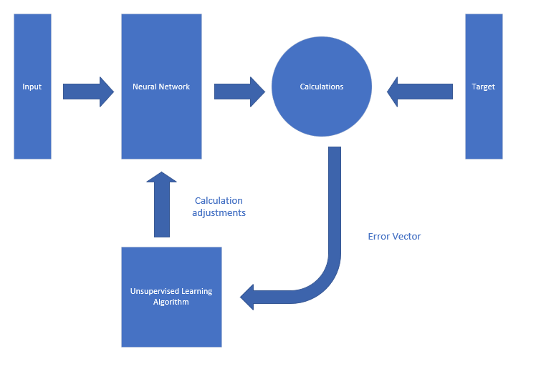

AI/ML Model

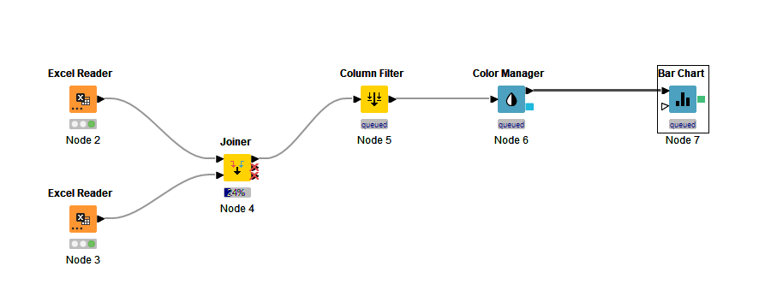
First, I attempted a join on the Excel file to count the year from both separate sheets, however the visualised data was too much to read.
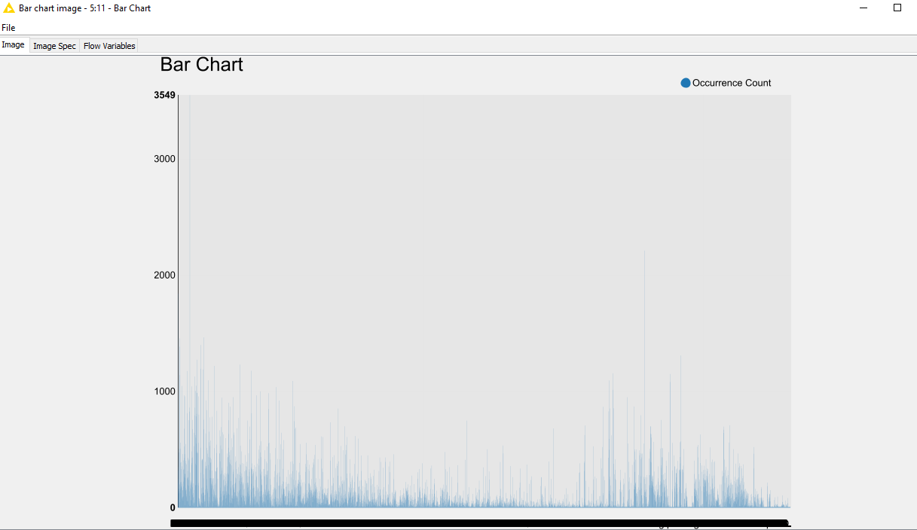
By limiting the view to a single customer with the insertion of a row filter, the data was more manageable for the human eye.

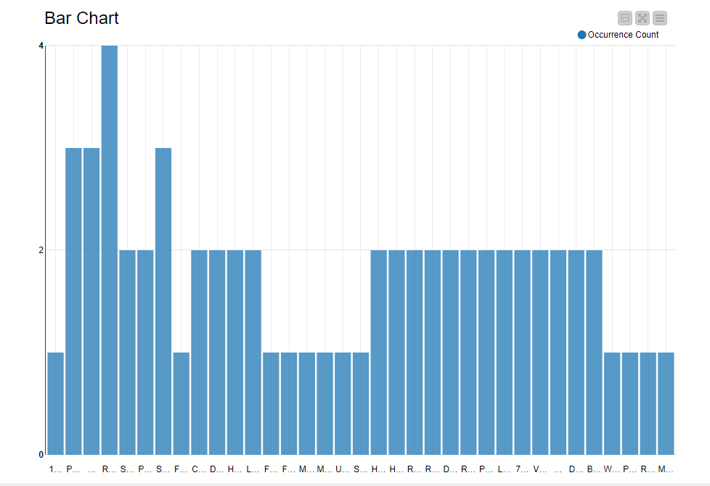
This could then be used to select the top X number of purchased items for each customer, and personalised offers created based on that data. A loop could be set to repeat the process for each unique customer ID.
To fully automate the process, the top X number could be automatically selected according to the AI programming, and produce that output on for example, a monthly basis, then this data output used to tailor offers to each customer. Else, if the AI system was fully unsupervised, select from available offers for the top rated product to automatically distribute to customers.
Using the same data, rather than for offers, when the active user ID adds an item to the basket, the website could reserve a space for recommendations, where the top purchased items not currently in the shopping basket are recommended to the customer to be added.
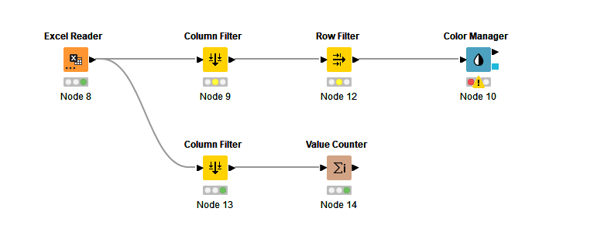
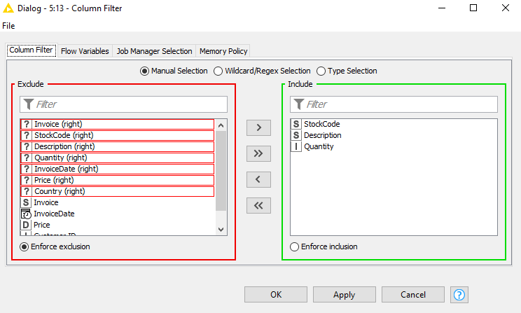
By keeping track of stock levels, an execution program can be established for each unique product (based on the properties of that product, e.g. shelf life, purchase rate) can be set to automatically restock when the quantity reaches a certain point.
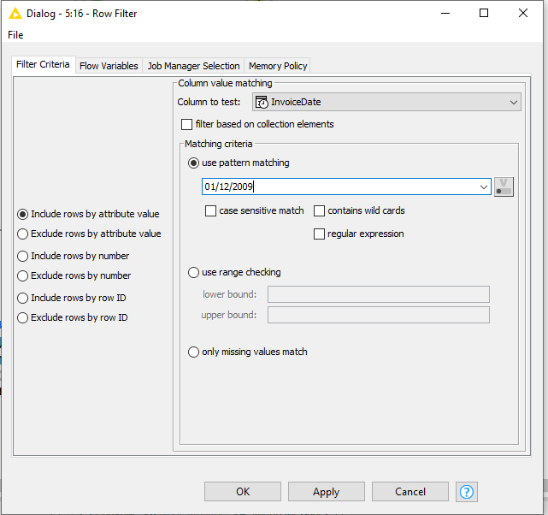
AI could be used to track number of item sales over a period of time to identify the most sold items and patterns and trends. By examining the data for example for the same day of the year, one year earlier, a sales target could be automatically set of the previous years figure plus 5% for example. AI generated target figures are a quick and simple way to establish KPIs for the store.
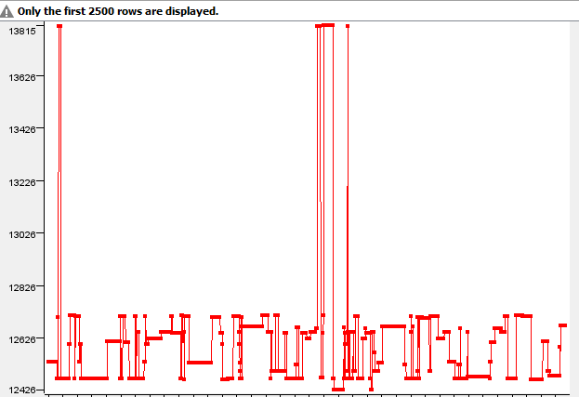
Additionally, busy time periods could trigger a notification that more staff or resources might be warranted for particular dates and times.
In addition to the processing of pre-existing data, an AI system could be utilised moving forwards, for the various aspects of running the store, such as generating a shopping basket.
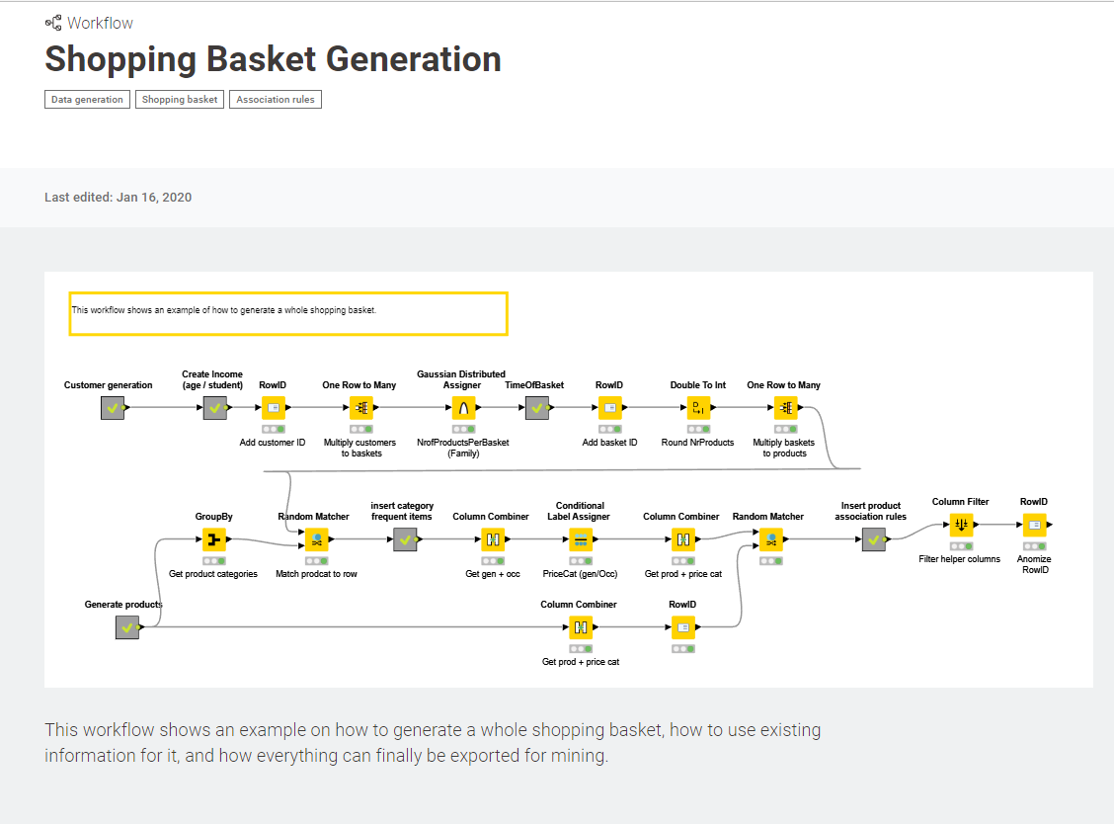
This is an example pre-made program for shopping basket generation. [11] Since to make full use of the AI/Machine Learning to enhance this shopping business, thought should be given to processes to collect and use new data as operations to continue, to further improve upon the AI established in this solution, and continue to provide further enhancement to the business with forecasting and prediction algorithms.

Conclusion

Making use of the available Teronix data, a number of trends can be observed; returning customers, high spending customers, popular products and busier time periods. With this historic data processed by Artificial Intelligence, or Machine Learning, these trends could be used to inform business decisions moving forwards. It is the predictive capabilities of AI and Machine Learning that are the most instrumental in data-driven business decision making. [12]
The primary application for AI utilisation on the existing data would be visualisation that could inform human business decisions. Graphs and other visuals could inform stakeholders as to the most successful products and the busiest times. Much of this data visualisation could be performed by a person in as much time as the implementation of an AI solution would take, however, once implemented, the tool would produce instant results moving forward.
The main benefit to the implementation of Machine Learning however would not be the review of this pre-existing data, but the application of that data and the collection of more data moving forwards. With the inclusion of additional data fields around customer, profit and so forth, moving forwards, AI could be used to calculate data for performance review of product and location to an even greater detail and benefit. The same data and system could then be set up to forecast and predict all of this data for the future, based on trends in the historic data and the data which continues to be collected. These forecasts can be used to inform, or even automatically trigger product sales, targeted to each consumer if desired. It could automatically manage stock levels for the store, as well as inform staffing levels for busier or quieter periods. It will illustrate where the company is most successful and allow the organisation to capitalise that, as well as illustrate weaknesses that can be tactically addressed and resolved. The modern world of retail is built upon such data-driven systems, and we are already at a point where the consumer expectation for them exists. To compete in the modern world of retail, AI is already an essential component. [13]

References

[1] | B. Marr, “The 10 Best Examples of How AI Is Already Used In Our Everyday Life,” Forbes, [Online]. Available: https://www.forbes.com/sites/bernardmarr/2019/12/16/the-10-best-examples-of-how-ai-is-already-used-in-our-everyday-life/?sh=27c2208c1171. [Accessed 13 December 2022].
[2] | IBM Cloud Education, “Machine Learning,” IBM, 15 July 2020. [Online]. Available: https://www.ibm.com/cloud/learn/machine-learning. [Accessed 13 December 2022].
[3] | P. Hansen, “Product selection and space allocation in supermarkets,” European Journal of Operational Research, vol. 3, no. 6, pp. 474-484, November 1979.
[4] | U. Kerzel, “Enterprise AI Canvas Intergrating Artificial Intelligence into Business,” Applied Aritifical Intelligence, vol. 35, no. 1, pp. 1-12, 4 October 2020.
[5] | R. Williamson, “Top Ways in Which AI Impacts Grocery Retail,” Data Science Central, 3 April 2022. [Online]. Available: https://www.datasciencecentral.com/top-ways-in-which-ai-impacts-grocery-retail/. [Accessed 16 December 2022].
[6] | J. Ahmed, “Innovation strategy in retail: The unstaffed digital supermarkets at LIFVS,” OnlineFirst, 20 June 2022.
[7] | H. Oza, “What Advantages AI Will Provide To Grocery Stores and Supermarkets,” HData Systems, 30 June 2022. [Online]. Available: https://www.hdatasystems.com/blog/ai-in-grocery-stores-and-supermarkets#:~:text=The%20implementation%20of%20the%20AI,the%20purchase%20of%20specific%20items.. [Accessed 16 December 2022].
[8] | insideBIGDATA, “4 Areas Where Grocery Stores Can se data Analytics to Enhance Operations,” insideBIGDATA, 4 May 2022. [Online]. Available: https://insidebigdata.com/2022/05/04/4-areas-where-grocery-stores-can-use-data-analytics-to-enhance-operations/. [Accessed 16 December 2022].
[9] | B. Mahesh, “Machine Learning Algorithm - A Review,” International Journal of Science and Research, 2018.
[10] | A. Pandey, “A Simple Explanation of K-Means Clustering,” Analytics Vidhya, 4 October 2020. [Online]. Available: https://www.analyticsvidhya.com/blog/2020/10/a-simple-explanation-of-k-means-clustering/. [Accessed 19 December 2022].
[11] | KNIME, “Shopping Basket Generation,” KNIME, 16 January 2020. [Online]. Available: https://hub.knime.com/knime/spaces/Examples/latest/01_Data_Access/03_Data_Generation/09_Generating_a_Shopping_Market_Data_Set~d_ZXDdekNcpXtQDW. [Accessed 19 December 2022].
[12] | D. Marotta, “Artificial Intelligence: How AI Is Changing Retail,” Hitachi Solutions, [Online]. Available: https://global.hitachi-solutions.com/blog/ai-in-retail/. [Accessed 19 December 2022].
[13] | Intel, “Artificial Intelligence in Retail,” Intel, [Online]. Available: https://www.intel.com/content/www/us/en/retail/solutions/ai-in-retail.html. [Accessed 19 December 2022].
[14] | A. Kumar, “Taking String input with space in C (3 Different Methods),” GeeksforGeeks, [Online]. Available: https://www.geeksforgeeks.org/taking-string-input-space-c-3-different-methods/. [Accessed 16 March 2020].
[15] | N. Kanralkar, “Scansets in C,” GeeksforGeeks, [Online]. Available: https://www.geeksforgeeks.org/scansets-in-c/. [Accessed 16 March 2020].

Appendices

