Angus Pattison-Dick.
2014719.
Design Craft.
Julia Lockheart.
Word count- 4505.

Looking at Thinking: An investigation on how walking has developed from an artistic tool for thought into a creative practice.

The connection between walking and the creative process is an area of study with no short number of discussions. The connection has been utilized in many forms of contemporary art from the 19th century to the present day. My fascination with this concept came after completing an eleven-day through hike around the Pembrokeshire coast during the summer of 2024. Armed with the essentials to survive, with a sketchbook and pen, I embarked on one of the most challenging adventures of my life. The journey was tough but has given me greater perspective of where my practice is going. While journaling and drawing along the way, this experience gave me my first truly pure feeling of inspiration, a burning desire to make work in reflection of the walk. When thinking deeper on this, I realize a common trend throughout my university existence. Nearly every project I have completed has had a connection to the coast, but this is more than just being inspired by the physical aesthetic landscape. If I find myself stuck, I will walk. Without comprehending that this was a creative tool, it was more of a coping mechanism for escaping my own mind, removing myself from a stagnant situation, and replacing it with a sense of productive procrastination. Because of this, I have set out to learn how walking inevitably made its way into its own creative practice and celebrate the ideas and works that pushed it to where it is today.
Walking and art have coexisted as shared human experiences throughout our history. Cave paintings, dating back thousands of years, depict scenes based on what early humans observed while moving through their environments (Lewis-Williams & Dowson,1988). Philosophers like Aristotle also recognized walking as a tool for critical thinking (Solnit, 2000). While these early instances are not directly tied to artistic practice, the connection between walking and creativity would emerge in the 1820s as British artist John Constable took to the outdoors.
Constable revolutionized landscape painting by moving away from studio-based work and painting on location, capturing the natural world as it truly appeared (Rees, 1982) (shown in Fig 1) This change in practice came from the revolution of being able to prepare paint prior by tubing them up and taking them out into the elements (Harley, 1971). This development and shift in artistic practice set the stage for the Impressionist movement in the 1860s, led by artists like Claude Monet, who further pushed the tradition by creating fast-paced, on-site works (Marrinan, 2021) (shown in Fig 2).
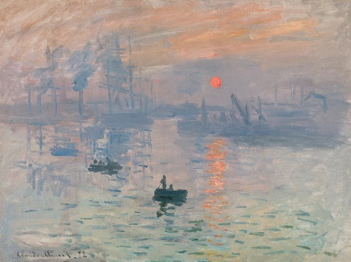
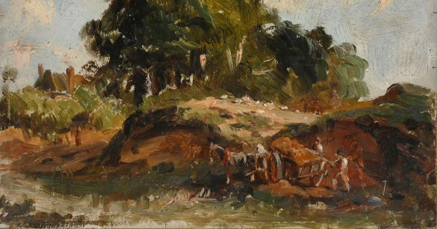

Fig 1. Fig 2.
For these artists, walking was not just a method of reaching their subject matter, but a part of their creative process. They would have walked through various landscapes before finding the scene they wished to capture, making walking an essential but often overlooked step in their artistic journey.
Growing with concepts found within the impressionists (Tate, n.d.), the first movement to hone a focus on walking would be the flâneur. Flâneur or Flânerie meaning to stroll or saunter, was a word first introduced to the French language in 1854 (etymonline, n.d.). The idea of flâneur was pushed through the works of poet Charles Baudelaire like Le Voyage, and later in Walter Benjamin’s Arcades Project. The use of this term changed to refer to someone who tends to wander around the urban environment without a specific goal or purpose. “The flâneur carried a set of rich associations: the man of leisure, the idler, the urban explorer, the connoisseur of the street” (Tate, n.d.). Through Baudelaire’s poems such as the 1861 “Le Voyage” (Supervert, 2019) and the 1869 “Le Spleen de Paris” (Supervert, 2019), the flâneur is the study of modern life, an observation of the harsh nature of the city, and the alienation of the modern existence. The flâneur’s aimless wandering is a form of personal freedom and a response to the overwhelming, fast-paced nature of the modern world.
This idea set by Baudelaire would later be picked up and elaborated on by the theorist Walter Benjamin in his work on the Arcades Project. He explored the flâneur’s practice of aimlessly walking to explore the urban environment, engaging with the city’s rapidly changing architecture and social dynamics (Benjamin, 1982). Walking is not simply a mode of transportation but a way of seeing, reflecting, and deeply engaging with the urban world. His work embodies an early representation of what would later be named psychogeography.
Nestled in the timeline between Baudelaire and Benjamin, Dada emerged as a reaction to the horrors of World War I. Founded in Zurich in 1916 by the artists Hugo Ball, Emmy Hennings, and Tristan Tzara, Dada questioned the traditional values in art, aiming to replace old norms with new, irreverent forms (Tzara, 1918). The movement pushed absurdity, humour, and change, rejecting the common aesthetic. After the war, Dada spread to cities like Berlin, Cologne, and Paris, where ideologies diverged, with the Paris group particularly branching into new artistic directions.
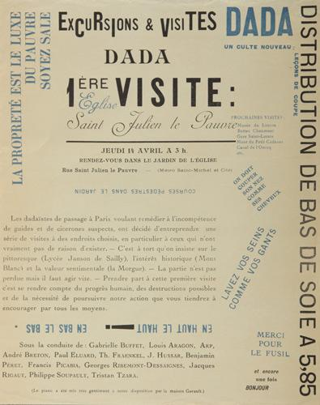
On the 14th of April 1921, these Dadaists released Excursions & Visites (displayed in Fig 3). This document outlined a planned walk around the Saint-Julien-Le-Pauvre church. This excursion was a way to oppose art’s assigned urban places, advertising it as “places that have no reason to exist” (admin, 2021), a kind of anti-tourist walk. As they moved, André Breton read the manifesto, while Georges Ribemont-Dessaignes acted as the tour guide (Breton, 1921). This initial notion of using a guided walk as the artistic focus represents an early stage of walking performance art, which is now a medium of numerous political contemporary artists. This excursion being cut short was seen by Breton as a failure (Breton, 1924), however, this simple display would birth the concept of performance-based walking art. Fig 3.
Following the infighting and demise of Dada, Breton developed his own ideologies, enticing other ex-Dada members, including Francis Picabia, Man Ray, and Max Ernst, to join him. These ideas rose in the 1924 Surrealist Manifesto (Breton, 1924). Unlike Dada's nihilism, Surrealism explored the self, focusing on the subconscious and bypassing the rational mind. This approach was influenced by Freud's (1900) The Interpretation of Dreams, which resonates heavily with surrealist thinking. As Breton explained: "Pure psychic automatism, by which one proposes to express, either verbally, in writing, or by any other manner, the real functioning of thought. Dictation of thought in the absence of all control exercised by reason, outside of all aesthetic and moral preoccupation" (Breton, 2024, p.5). This would suggest that the surrealists explored the technique of Intuitive Walking to both find inspiration in chance encounters and to tap into the unconscious mind. Rather than Breton’s earlier use of walking, this time it was to be used as a tool for further thinking, and to be applied back into their works. Breton would put this into practice in 1924 with the help of Aragon and Soupault. Together they decided to stroll from Blois, a town picked at random on a map, to Romorantin (28 miles). This 10-day meander comprised of gently walking and automatic writing while rested (admin, 2021). The experiences of this trip were included in Aragon’s Le Paysan de Paris (1926), Soupault‘s Les Dernières Nuits de Paris (1928), and Breton’s Nadja (1928). In “Nadja” Breton utilized his experience of walking to tap into the unconscious mind, highlighting the role of chance encounters and spontaneous experiences in unlocking deeper psychic truths (Breton, 1928). For Breton, walking was both a literal and metaphorical journey into the unknown, it blurred the line between the real world and the subconscious.
Drawing inspiration from the Flâneur, the Situationist International was a selection of writers, artists, and poets who formed at a gathering in Italy in 1957 (Wollen, 1989). An amalgamation of Guy Debord’s Letterist International and The International Movement for an Imaginist Bauhaus (Woolen, 1989). One of the key concepts drawn from the Letterists was the use of walking as an artistic method, which led to the development of dérive “to drift." “Dérive” means wandering through the city without a fixed purpose, to break free from the habitual patterns of everyday life and experience the city in a new, unstructured way (Debord, 1967).
Debord described dérive as an activity where the individuals would "drop all ties to their work or leisure activities"(Debord, 1967) and allow themselves to be guided by the environment, letting chance encounters and urban attractions shape their experience. This act was designed to disrupt the typical, functional uses of space and challenge the way cities were organized by capitalist and commercial interests. The goal was to reclaim a more spontaneous, subjective relationship with the city (Vaneigem, 1967).
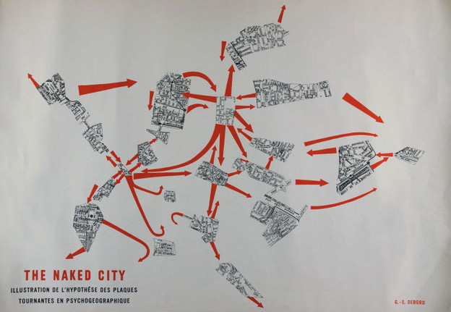
Fig 4.
In the piece titled “The Naked City” (fig. 4), Debord and Asger Jorn created a visual example of “the surreal disorientation of their drifts” (Sadler, 2001, p.2) by spreading out pieces of cut-out maps. They then drew red arrows between the images to display their route and the fractured connections of the city. This piece would become a physical representation of psychogeography, a term coined by Debord (Sidaway, 2021). Psychogeography is the study of how geographical environments influence human emotions and behaviours. It explores how physical spaces can shape our moods, thoughts, and actions (Sidaway, 2021). Despite this being recognized as a concept the situationists began, it was distinctly explored in the writings of Benjamin’s “Arcade Project.” This work did not see the light of day until it was published in 1982 but carries any parallels with the idea of psychogeography.
Alike these other Avant Guard art movements, the use of walking slotted nicely into the ideas of the Fluxus. Founded in 1960 by the Lithuanian/American artist George Maciunas, this new collective emerged internationally in the 1960s (Tate, 2017); the “Fluxus” focused on breaking the wall between art and everyday life (Oren, 1993). A melting pot of artistic mediums such as visual art, music, performance, and poetry (Oren, 1993). The outcome of this displayed experimental and playful works that would blend the lines between different practices. With a strong sense of anti-art, this collective carried an echo of Dada’s stance on breaking the conformity of the art industry.
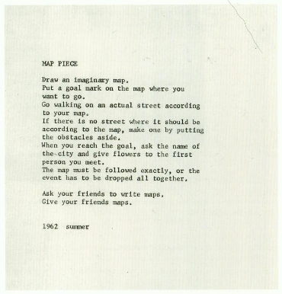
From its focus on using the normality of day-to-day existence as inspiration, it is no surprise walking would become a tool to utilize. In figure 5 below, it displays a piece titled “Map Piece” by Yoko Ono from 1962. The text gives instructions on creating an “imaginary map” and reversing the expected order of things. First, you create the map, decide upon an end goal, then follow the created map's directions, finally uncovering the place’s real name. The concept of this piece counters the expected use of such a common tool, which, much like derive, gives the participant a fresh perspective on their environment. Fig 5.

Despite the majority of these movements having distinct figureheads driving the use of walking through the groups. It would not be until past the mid-sixties that walking would transform from being a tool to use, into being the idea itself. I will next investigate the practices of Richard Long and Hamish Fulton, two artists whose practices vary, but stand as the pillars of contemporary walking art.
Starting with Richard Long, whose early ideas around walking would mould his practice of sculpture. In 1967, Long jumped on a train from London to Wiltshire, an area he often passed through while commuting from his home in Bristol to St. Martin's School of Art in London (now part of the University of the Arts). There, he found a pleasant grassy area, where he walked back and forth until a clear line had been created in the landscape (Tate, 2019) (See Fig 6). He then photographed the line with black-and-white film to “record his physical interventions within the landscape” (Tate, 2019). This simple act raised new questions about the nature of art. Was it the act of using his feet, acting as a brush that created this piece, or was it the photograph that documented the act that held artistic value? These questions led to broader debates about the boundaries of sculpture and the role of documentation in contemporary art (Bishop, 2012). Using Long as a key example, Rosalind Krauss’ 1979 book “Sculpture in the Expanded Field” would redefine the boundaries of sculpture in the context of contemporary practice (Krauss, 1979). Krauss uses a structured approach, categorizing work into four main areas based on the relationships between sculpture, architecture, and landscape (Krauss, 1979). Sculpture vs. Architecture, Sculpture vs. Landscape, Site Specific Art, and Environmental Art (Krauss, 1979). Using this method of categorization, Long’s A Line Made by Walking (see Fig 6) slots nicely under Sculpture vs. Landscape, whereas other works, such as his stone circles (see Fig 13), would be recognized as Site-Specific Art. Through the proposal of the “expanded field”, Krauss shows that sculpture is no longer confined to traditional forms. It has become an open, fluid area that includes a variety of approaches, including minimalism, land art, and installation art.
Much to Long’s dislike, A Line Made by Walking is often categorized as Land Art (Tate, 2019). Despite fighting against this notion (Judith Benhamou Reports, 2019), there are some characteristics that cannot be divided. “Land art or earth art is art that is made directly in the landscape, sculpting the land itself into earthworks or making structures in the landscape using natural materials such as rocks or twigs” (Tate, 2017). Despite this modern description, Longs opposition to land art comes from the culture it carried in the 1960s, its use of machinery and land ownership. (Judith Benhamou Reports, 2019). Through his work, Long shows that his work is about physically connecting to the land itself. He engages deeply with nature, rather than damaging the environment.

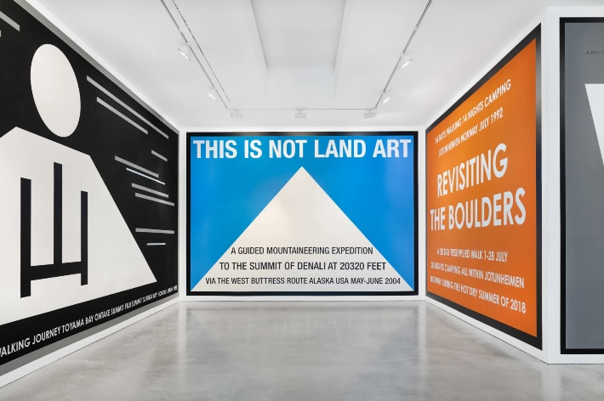
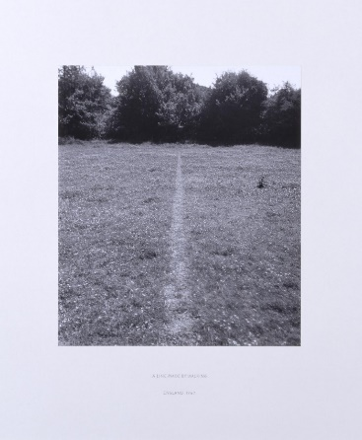

Fig 6. Fig 7.
In the same cluster of artists from St. Martins as Long, Hamish Fulton would emerge on the scene of walking art with ideas pulling him in a different direction. Opposing being categorized as a sculptor, landscape artist, or land artist, he forced the issue to be known as a walking artist (see Fig 7). For Fulton, the practice was entirely taken from his created walk text, “If I do not make a walk, I cannot materialize a walk text” (Galerie Thomas Schulte, 2021). His first group walk was completed in 1967. After refining his practice and ideas, he then walked from coast to coast in northern England in 1971, which led to his first major trek of one thousand and twenty-two miles from Duncansby Head to Lands’ End in 1973 (Tate, 2002). For Fulton, the walk is always the key attribute, pushing that his pieces are not sculptures but are experiences (Tufnell, 2002, p.16). Through his work, Fulton brings an array of subject matters that will roll into what’s seen as contemporary walking art. From having such a heavy emphasis on human respect for nature, being influenced by a range of indigenous people such as the native Americans (Admin, 2018), to fighting for artists to be categorized as walking artists (see Fig 7).

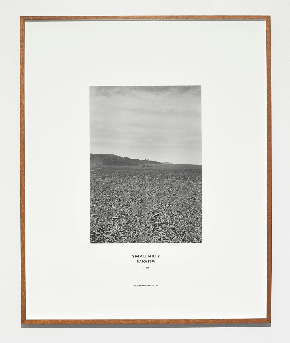
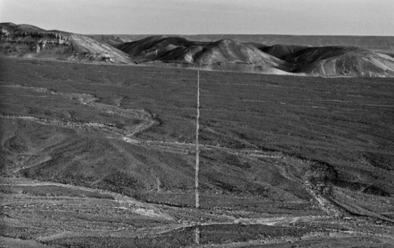
Between these two artists, whose practices vary, there are still many similarities. Both studied sculpture at St Martin's and were massively influenced by the senior lecturer Peter Atkins, who pushed his students to interpret the concept of sculpture and work differently (Arts Council Collection, 2014). The first group walk they both participated in was together alongside other students, where they walked two streets in Soho to the main entrance of St Martins. The second walk would include the idea that the final outcome is to be found in nature, so a number of them would leave from Charring Cross Road and walk until they were in the countryside (Arts Council Collection, 2014). After they both left St Martins, they made their own paths, with Long going to Europe and Fulton heading to the States. Despite both artists primarily opting for solitary walks, there are times when they’ve both included other people and even each other. Captured in both artist's 1972 works, they would travel through Bolivia, Peru, and Chile together (Printed Matter, 2016).

Fig 8. Fig 9.

Although these two pieces were displayed in separate shows, they both came from their shared time in Peru. Long’s 1972 photo titled A Line Made by Walking in Peru (see Fig 8) came with little insight. In a range of unreliable sources, the internet states that he created it by walking and it every day of the year. The truth of the image is displayed in Fulton’s piece Small Hills (see Fig 9), which labels his location as the Nazca Lines. It’s interesting how although they are different images, both artists are displaying something slightly out of character for their own work. For Long, it is unusual for him to capture and celebrate the sculptural work of others, while almost claiming it is his own by not stating otherwise. For Fulton, this image depicts more than just a footpath he is crossing, but a historical yet mythical creation of the South American past.
Through both of the early practices of Fulton and Long, their style of capturing imagery is fairly consistent. Both usually used black and white photos to capture their walk, displaying evidence of their stories. Additionally, both would include text pieces as a written representation of their works or would display text on their image. Like the two pieces below (figs 10 and 11), if they include text on their pieces, it usually displays the location and date. Both artists are skilled photographers, with a keen eye in which they wish to capture their photographic evidence. These images are also a representation of the era they were shot in. Fulton’s The Pentland Road, Isle of Lewis, Scotland was shot in 1976, and Long’s Dunkery Hill was shot in 1985. These pre-dates the boom of the digital camera, and where black and white capture the darker tones and deeper contrasts, it is also cheaper and easier to develop than colour.
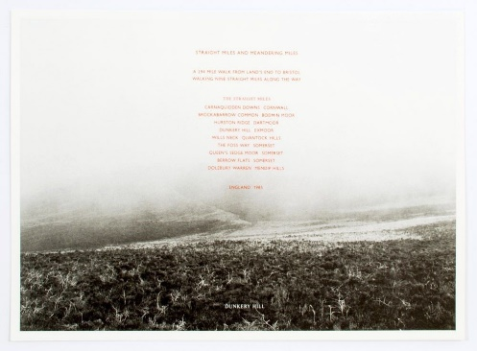
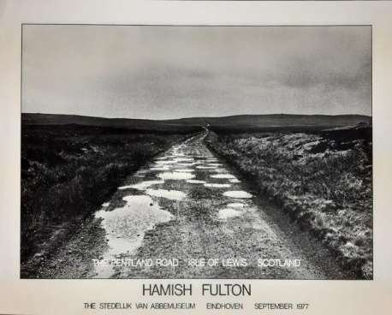

Fig 10. Fig 11.
For all the similarities between these two artists, there are still major factors that divide them. For Fulton, the walk was the entire piece and concept, whereas for Long, it was the tool to sculpt his intention. This is displayed in pieces like “A Line Made by Walking,” where he repeatedly walked back and forth on the same path, what he calls “ritualistic” walking (Thelma Hulbert Gallery, 2020). For the majority of their practices, Long’s images consisted of nature being adjusted or manipulated through means of movement (Thelma Hulbert Gallery, 2020), whereas Fulton’s work was purely imagery capturing landscape from his walk, sometimes accompanied with text (see Fig 12 below).
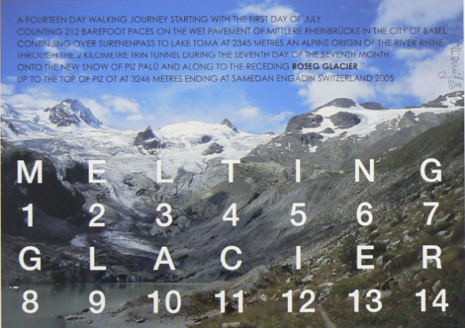
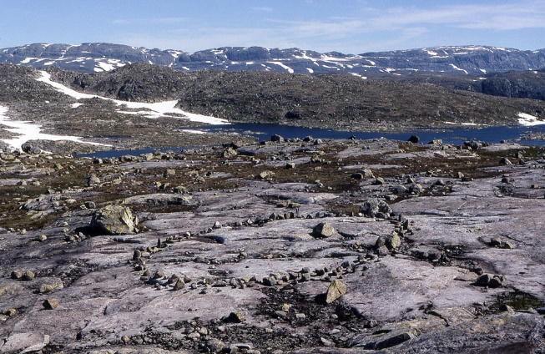

Fig 12. Fig 13.
These two images although similar, oppose each other’s different ideas. This minute difference in the two nature-based images shows how Long’s work if the physical sculptural, which the photo is only the medium of capturing and displaying it. Fulton’s image is more a reflection of the landscape, where he tries to take the audience to that location. As both artist's practices evolved, their directions spread further. For Fulton, his emphasis on the “Walk Text” (Fulton, 2019) took the highest focus, creating shows that include painted graphic art, informative posters, and pieces resembling the walk. The purpose of this is to represent the walk. Long’s sculptures too became bigger and displayed more widely as instillation pieces.
One of the largest points of division between the practices of Fulton and Long is how they comprise their works into an Exhibition. Fulton’s work, which is a combination of imagery, texts, and, in his more recent shows, hints of graphic art, is usually displayed around a space in a two-dimensional manner. This will include the walk text and show these pieces as a response to the walk (see Fig 14). Alongside his exhibitions, Fulton also leads a number of group walks. The notion of these leads to make the participants think like they would while seeing a show.
Fulton’s “Limmat Art Walk” (Fig 15) was hosted at the public art festival in Zurich in 2012 (VernissageTV, 2012). The line led by Fulton took two hours to walk around the one-and-a-half kilometres by very slowly putting one foot in front of another and keeping one meter away from the person in front of you. “Building and experience not an object, so that this artwork is made up of human beings, this is a communal walk” (VernissageTV, 2012).
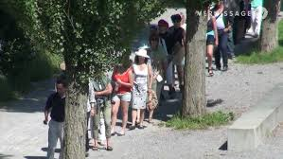
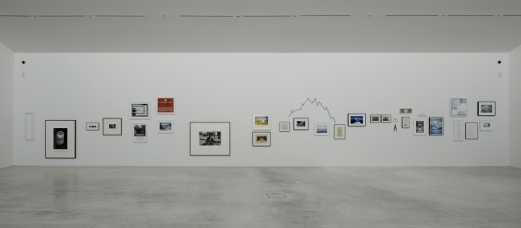
Fig 14. Fig 15.
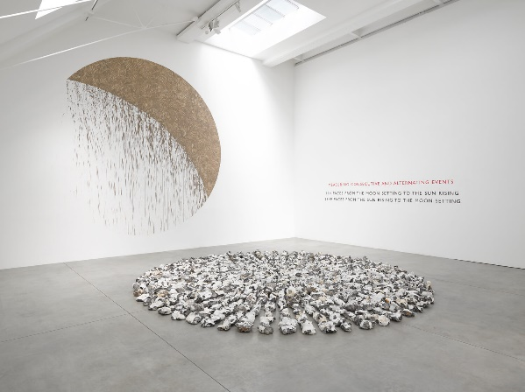
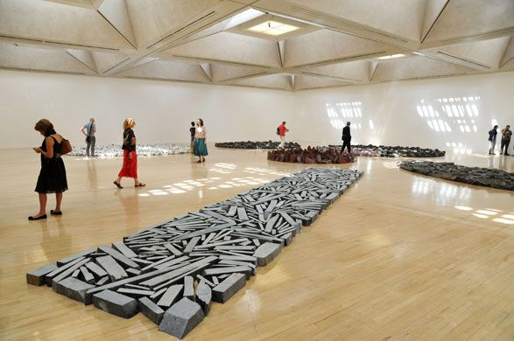
Long’s style of Exhibition captures the far more physical attributes of walking and the rugged land. His sculptural work displays hard, raw instillation-style pieces, yet they carry a very delicate feel. Alike the pieces displayed in figures 16 and 17, his sculptures remain unconnected, with nothing more than their balanced edges dancing with gravity. This shows his great care with the placement of the materials to orchestrate such pieces. Scale plays a massive role in his installations, fitting them to the space the work is displayed.

Fig 16. Fig 17.
With this new strand of art focussing on walking, both artists went through being miss labelled into a collective they did not wish to be associated with. Of these, the most obvious and dislikable to them was to be labelled as land art. Although the parallels with the modern description of land art are impossible to ignore “art that is made directly in the landscape, sculpting the land itself into earthworks” (Tate, 2017), it was a different feeling to that in the late 60’s. Back then, land art resembled something that both artists openly opposed. The rise of land art coincided with the artists buying masses of land for their sculptures. Both Long and Fulton argue against the concepts of land ownership, with this being a driving force throughout each of their practices. For Fulton, this is shown in his political work on the Chinese invasion of Tibet (Les presses du reel, 2019), and where Long discusses this openly in his Q&A at (Thelma Hulbert Gallery, 2020). As time went on, long works of natural sculptures arranged in the environment were still widely seen as land art. Although he disliked where the movement of land art had come from, his addition to this category would broaden the ideas of working alongside nature, putting the movement in a better light. For Fulton, this never stuck. His persistence and unwavering attention to the walk text would see him respected as a walking artist.

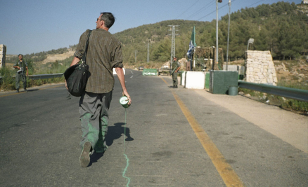
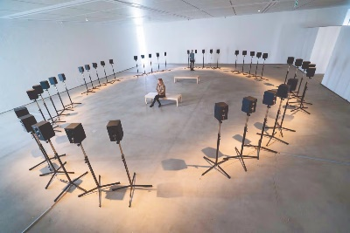
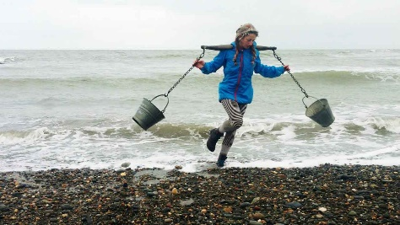
Both Long and Fulton’s careers have been extensive, still staying active to this day despite being seventy-nine and seventy-eight. From their exposure, the concept of walking art would grow and branch off into many different contemporary practices. With its use of political work like Francis Alÿs' Green Line (see Fig 18). In this, he dribbled a line of green paint as he walked along the armistice border, which was pencilled on a map at the end of the war between Israel and Jordan in 1948 (Alÿs, 2005). Contemporary walking art also sways into Eco activism, with artists like Jess Allen developing her concept of “‘tracktivism': walking along tracks with activist intent” (Allen, 2018, p.8). This practice combines “walking art in the sculptural tradition with one-to-one performance” (Allen, 2018, p.8) (see Fig 19). In a different turn, one of the most recognized modern walking artists is Jannet Cardiff, who gained popularity in 1995 with her audio walk (Tate, n.d.). Cardiff’s work is presented as sound instillation, immersing the audience in the moments she has captured (see Fig 20).
Fig 18. Fig 19. Fig 20.
Through these artists, with Fulton and Long, it shows how the only definitive certainty to walking art is that the artist has walked. The walk could be solo (Fig 18) or a group (Fig 15), it could leave no trace (fig 12) or alter the landscape (fig 13), it could be ritualistic (fig 6) or non-ritualistic (fig 11), it can be displayed through photos (fig 10), sculpture (fig 17), performance (fig 19), text (fig 7), sound (fig 20), graphic art or illustration (fig 14). The only constant through this whole movement is the simple truth of walking. When you remove all concepts and motives, you are left with presence, and the personal reflection of where you are in the tangible world. It is only through the artist's lived experience that they can create work.
Despite it not being touched on by the artists themselves, walking art carries the idea of phenomenology through its very essence. “Phenomenology” is described in the Oxford Dictionary as “the study of phenomena (things that can be observed) as distinct from that of the nature of being (ontology). [...] an approach that concentrates on the study of consciousness and the objects of direct experience” (Soanes and Hawker, 2005, p.763). Throughout the walking art displayed, this idea of “lived experience” is key to the authenticity of their work. As a study, phenomenology has a range of different outcomes, with the original concept suggested by Edmund Husserl (Moran, 2000). Husserl would describe his (pure) phenomenology as “experiences in general, has, as its exclusive concern, experiences intuitively seizable and analysable in the pure generality of their essence, not experiences empirically perceived and treated as real facts, as experiences of human or animal experiments in the phenomenal world that we posit as an empirical fact.” (Moran, 2000, p.1) He suggests that phenomenology is how the world appears to us in terms of our own subjective appearance of it. This personal view captures from experience how walking art shows such a parallel to the concept of phenomenology.
There is no surprise that walking has sculpted its own trail of concepts. There is nothing more freeing than letting your mind wander as you exercise your bipedal desire, not being stuck in a stagnant mess of thought. It brings you back to the present, engaging your brain enough to be doing something, but leaving enough space for your mind to wander. The concepts that Krauss put forward with the expanded field laid down the ideas of how the evolution of walking art has been understood. Grouping walking art firmly under the same umbrella as land art. From its initial use with the flâneur, walking has been a tool of observation and reflection of the surrounding environment. Dada’s excursion was to make a point by using walking as an experience and a performance, and in Surrealism, it was used to try to tap into the subconscious mind. Debord’s Situationists used dérive to observe the urban environment and connected it to how areas make you feel, and the Fluxus simply used it as a tool to display the close relationship between their work and modern life. Although these all leaked into their artist's respected work, it was always the “how” to obtain inspiration rather than the “why” they did work in the first place. This simple adjustment in the concept is what rose Long and Fulton into their own strand, transforming walking from method to practice.

Bibliography
Admin (2018). Hamish Fulton, Melting Glacier (2005) | Walking as Artistic Practice. Available at: https://teaching.ellenmueller.com/walking/2018/12/28/hamish-fulton/. [Accessed 23 Nov. 2024].
Admin (2021). surrealism | Walking as Artistic Practice. Available at: https://teaching.ellenmueller.com/walking/category/surrealism/ [Accessed 2 Nov. 2024].
Admin (2021). Dada Connections | Walking as Artistic Practice. Available at: https://teaching.ellenmueller.com/walking/2021/10/10/dada-connections/ [Accessed 2 Dec. 2024].
Allen, J. (2018). Tracktivism: walking & talking in rural landscapes as eco-activist performance. Manchester.
Alÿs, F. (2005). The Green Line. [video] Available at: https://www.youtube.com/watch?v=link-to-video [Accessed 1 Nov. 2024].
Arts Council Collection. (2014). Hamish Fulton In Conversation with Ben Tufnell. Available at: https://www.youtube.com/watch?v=kiQ5CSnGA9M [Accessed 14 Nov. 2024].
Bishop, C. (2012). Artificial Hells: Participatory Art and the Politics of Spectatorship. London: Verso.
Benjamin, W. (1982). The Arcades Project. Cambridge, Ma: The Belknap Pr. Of Harvard Univ. Pr.
Breton, A. (1924). Nadja. Paris: Gallimard.
Breton, A. (1924) Le Manifeste du surréalisme. Paris: Gallimard.
Debord, G. (1967). The Society of the Spectacle. Detroit, Michigan: Black & Red.
Etymonline. (n.d.). flaneur | Etymology, origin and meaning of flaneur by etymonline. Available at: https://www.etymonline.com/word/flaneur [Accessed 1 Nov. 2024].
Fulton, H. (2019). WORDS FROM WALKS. Available at: https://museo.unav.edu/documents/5318873/35720107/Words+from+Walks+final+version+6+July+2020_Hamish+Fulton+v3+(1).pdf. [Accessed 20 Nov. 2024].
Freud, S. (1900). The Interpretation of Dreams (Standard Edition, Vol. V). London: Hogarth Press.
Galerie Thomas Schulte (2021). Hamish Fulton speaks about his practice as a ‘walking artist,’ March 2021. Available at: https://www.youtube.com/watch?v=gf46UROy64c. [Accessed 21 Nov. 2024]
Judith Benhamou Reports (2019). Richard Long: 6 answers in 1 minute (4) About Land Art. YouTube. Available at: https://www.youtube.com/watch?v=rowjJ0W-WUY [Accessed 20 Dec. 2024]
Kwon, M. (2004). One Place After Another: Site-Specific Art and Locational Identity. Cambridge: MIT Press
Les presses du reel. (2019). Hamish Fulton, Michael Höpfner : From Here to Tibet - Les presses du réel (book). Available at: https://www.lespressesdureel.com/EN/ouvrage.php?id=9725&menu=0 [Accessed 23 Nov. 2024].
Lewis-Williams, J. D and Dowson, T. (1988). The Signs of All Times: Entoptic Phenomena in Upper Paleolithic Art. Current Anthropology, 29(2), 201-214.
Marrinan, M. (2021) Wiley Blackwell Companion to Impressionism, Andre Dombrowski.
Moran, D. (2000). Introduction to Phenomenology. London and New York: Routledge
Oren, M. (1993). Anti-Art as the End of Cultural History. Performing Arts Journal, 15(2), p.1. doi: https://doi.org/10.2307/3245708.
Printed Matter. (2016). Richard Long - South America - Printed Matter. Available at: https://www.printedmatter.org/catalog/32716/ [Accessed 22 Nov. 2024].
Harley, R. D. (1971) Oil colour containers: Development work by artists and colourmen in the nineteenth century, Annals of Science, 27:1, 1-12, DOI: 10.1080/00033797100203607
Rees, R. (1982). Constable, Turner, and Views of Nature in the Nineteenth Century. Geographical Review, Vol. 72, No. 3, pp. 253-269.
Rosalind, K. (1979). Sculpture in the Expanded Field. 1979, Vol. 8, pp. 30-44: The MIT Press.
Sadler, S. (2001). The situationist city. Cambridge (Mass.); London: The MIT Press.
Sidaway, J, D. (2021) Psychogeography: Walking through strategy, nature and narrative Progress in Human Geography 2022 46:2, 549-574.
Soanes, C, and Hawker, S. (2005). Compact Oxford English dictionary of current English. Oxford; New York: Oxford University Press.
Solit, R. (2000). Wanderlust: A History of Walking. London: Verso.
Supervert (2019). Charles Baudelaire’s Fleurs du Mal. Fleursdumal.org. Available at: https://fleursdumal.org/. [Accessed 1 Dec. 2024].
Tate (n.d.). Flâneur – Art Term. Available at: https://www.tate.org.uk/art/art-terms/f/flaneur [Accessed 1 Nov. 2024].
Tate (n.d.). Janet Cardiff. Available at: https://www.tate.org.uk/art/artists/janet-cardiff-4499 [Accessed 29 Nov. 2024].
Tate (2002). Hamish Fulton: Walking journey. Available at: https://www.tate.org.uk/whats-on/tate-britain/hamish-fulton-walking-journey. [Accessed 23 Nov. 2024]
Tate (2017). Fluxus – Art Term | Tate. Available at: https://www.tate.org.uk/art/art-terms/f/fluxus. [Accessed 28 Nov. 2024].
Tate (2017). Land art – Art Term | Tate. Available at: https://www.tate.org.uk/art/art-terms/l/land-art [Accessed 6 Nov. 2024].
Tate (2019). ‘A Line Made by Walking’, Richard Long, 1967 | Tate. Available at: https://www.tate.org.uk/art/artworks/long-a-line-made-by-walking-p07149. [Accessed 1 Dec. 2024].
Thelma Hulbert Gallery. (2020). Richard Long Slideshow / Q&A at Thelma Hulbert Gallery. Available at: https://www.youtube.com/watch?v=TLPnvde71p4 [Accessed 9 Nov. 2024].
Tufnell, B. (2002). Hamish Fulton: Walking Journey. London: Tate Publishing.
Tzara, T. (1965). Seven Dada Manifestos and Lampisteries. Translated by B. Wright. New York: The Viking Press.
Tzara, T. (1918). Dada manifesto 1918, Paris. Available at: https://writing.upenn.edu/library/Tzara_Dada-Manifesto_1918.pdf [Accessed 11 Nov. 2024].
Vaneigem, R. (1967). The revolution of everyday life. London: Action Books.
VernissageTV (2012). Hamish Fulton Limmat Art Walk, Zürich, 2012. Available at: https://www.youtube.com/watch?v=boMHQhj2UuA [Accessed 25 Nov. 2024].
Wollen, P. (1989). The Situationist International. New Left Review 174.1: 1.

List of Figures
Figure 1. John Constable, 1820, The Gravel Pits at Hampstead, Available at: https://www.woolleyandwallis.co.uk/departments/old-masters-british-european-art/pw040924/view-lot/867/ [Accessed 25 Nov. 2024].
Figure 2. Claud Monet, 1972, Impressionism sunrise, available at: https://www.claude-monet.com/impression-sunrise.jsp [Accessed 1 Dec. 2024].
Figure 3. Andre Breton, 1921, Excursions & Visites Dada / Premiere Visite, available at: https://www.moma.org/collection/works/184056 [Accessed 28 Nov. 2024].
Figure 4. Guy Debord and Asger Jorn, 1957, The Naked city, available at: https://medium.com/@eleenakyriacou/the-situationists-drawing-of-the-city-as-a-series-of-situations-b2a8aef3faf3 [Accessed 5 Nov. 2024]
Figure 5. Yoko Ono, 1962, Map Piece, available at: https://teaching.ellenmueller.com/walking/2021/05/30/yoko-ono-map-piece-1962-64/ [Accessed 25 Nov. 2024]
Figure 6. Richard Long, 1967, A Line Made By Walking, available at: https://www.tate.org.uk/art/artworks/long-a-line-made-by-walking-p07149 [Accessed 4 Nov. 2024]
Figure 7. Richard Long, 1972, A line made by walking in Peru, available at: https://hellogoodland.com/blogs/news/walking-in-line [Accessed 5 Nov. 2024]
Figure 8. Hamish Fulton, 1972, Small Hills, available at: https://i8.is/exhibitions/131/works/artworks9234/ [Accessed 5 Nov. 2024]
Figure 9. Hamish Fulton, 1976, The Pentland Road, Isle of Lewis, Scotland, available at: https://www.stedelijk.nl/en/collection/98147-hamish-fulton-the-pentland-road-isle-of-lewis-scotland [Accessed 8 Nov. 2024]
Figure 10. Richard Long,1985, Dunkery Hill, available at: https://www.stedelijk.nl/nl/collectie/42261-richard-long-dunkery-hill [Accessed 8 Nov. 2024]
Figure 11.Hamish Fulton, 2004, This is Not Land Art, available at: https://www.galeriethomasschulte.com/exhibitions/20/works/artworks-1294-hamish-fulton-this-is-not-land-art.-alaska-usa-2004-2004/ [Accessed 24 Nov. 2024]
Figure 12. Hamish Fulton, 2005, Roseg Glacier, available at https://teaching.ellenmueller.com/walking/2018/12/28/hamish-fulton/ [Accessed 20 Nov. 2024]
Figure 13. Richard Long, 2008, GRANITE CIRCLE, available at: http://www.richardlong.org/Sculptures/2012/granite_circle.html [accessed 2 Dec. 2024]
Figure 14. Hamish Fulton, 2012, Walk, available at: https://peterfoolen.blogspot.com/2012/01/hamish-fulton-at-turner-contemporary.html [Accessed 20 Nov. 2024]
Figure 15. Hamish Fulton, 2012, Zurich Walk, available at: https://www.youtube.com/watch?v=boMHQhj2UuA [Accessed 2 Dec. 2024]
Figure 16. Richard Long, 2018, Circle to Circle, London, available at: https://ocula.com/art-galleries/lisson-gallery/exhibitions/richard-long/ [Accessed on 1 Dec. 2024]

Figure 17. Richard Long, 2009, Heaven and Earth at Tate Britain, available at: https://www.tate.org.uk/whats-on/tate-britain/richard-long-heaven-and-earth [Accessed 23. Nov]
Figure 18. Francis Alÿs, 2004, Green Line, available at: https://www.antiatlas.net/francis-alys-the-green-line-en/ [Accessed 1 Dec. 2024]
Figure 19, Jess Allen, 2015, available at: https://art-earth.org.uk/jess-allen/ [Accessed 1 Dec. 2024]
Figure 20, Janet Cardiff, 2001, available at: https://www.theartnewspaper.com/2023/06/12/basels-got-talent-artists-invite-visitors-to-make-their-multimedia-installations-sing [Accessed on 1 Dec. 2024]

