
University of Wales Trinity Saint David
School of Engineering

Manufacturing Design & Technology

Computer Aided Manufacturing & Design for Additive Manufacturing Technologies
M5X02070

Darren J Thomas
1905425
24/06/2020

Abstract
Tasked to improve on 3-jaw gripper concept. The initial design was very basic with no attachments or stops. There were too many individual parts that were not attached to the assembly (such as the lugs). The following report details the process that was undertaken to innovate the initial design.
The original design was critically analysed to understand what improvements were required. This was carried out using a FMEA and Lucas design efficiency methods. These tools highlighted the areas to concentrate on. They also highlighted material specifications that needed to be changed.
Section two and three explains the proposal and development work undertaken to improve the design. The final section explains what improvements were made, it also shows the process required to assemble the end-effector.
The outcome from this report suggests that the initial design had all the requirements for a functioning end-effector and with investigation and development work the outcome is a flexible and adaptable end-effector that will interest buyers.
Table of Contents
1 Introduction 5
2 Appraisal of the Original System 6
2.1 Jaw 7
2.2 Joint 8
2.3 Cylinder 8
2.4 Drive plate 9
2.5 Shaft 9
2.6 Motor 10
2.7 Worm shaft 10
2.8 3-Jaw Gripper 11
3 Manufacturing Process Proposal 14
3.1 Jaw (x3) 14
3.2 Joint (x3) 15
3.3 Cylinder (Body) 15
3.4 Drive Plate 15
3.5 Motor 15
3.6 Shaft 16
4 Design & Development Work Undertaken 17
4.1 Design for manufacture (DFM) 17
4.1.1 Design changes 17
4.2 Design for Assembly (DFA) 18
5 Manufacturing Process Design 20
5.1 Parts 20
5.2 Build Process 21
6 Conclusion 22
7 References 24

Table of Figures
Figure 1 3 Jaw gripper 6
Figure 2 Concept design components 6
Figure 3 Jaw (1 shown of 3) 7
Figure 4 Advantages & Disadvantages of PVC Plasticized 7
Figure 5 Injection moulding properties 7
Figure 6 Joint (1 shown of 3) 8
Figure 7 Cylinder 8
Figure 8 1060 alloy properties 8
Figure 9 Drive Plate 9
Figure 10 Shaft 9
Figure 11 Motor 10
Figure 12 Worm Shaft 10
Figure 13 Clash condition 11
Figure 14 Prototype FMEA 12
Figure 15 End effector design efficiency 13
Figure 16 Complete proposal FMEA 14
Figure 17 Jaw re-design 15
Figure 18 Joint 15
Figure 19 End effector new design efficiency 18
Figure 20 Stainless steel advantages 19
Figure 21 New design FMEA 19
Figure 22 BoM (Bill of Materials) 20
Figure 23 Assembly process 21
Figure 24 prototype induction 22

Introduction
A 3-Jaw gripper (also known as an end-effector) is a broad definition used for a tool that can be attached to a robot arm as an accessory to carry out pre-determined functions (Bouchard, 2015).
The following report demonstrates the process used to improve the concept design. It uses FMEA’s and design efficiency tools to monitor progress and highlights areas to improve. Material changes improved the stability and increased the adaptability of the assembly. Quick release fasteners have granted the assembly to be low maintenance and increases functional adaptability. Bought in parts from external suppliers has facilitated the assembly cost to be lower as there will be less parts to manufacture.
The final product has an 18% improvement by reducing individual components and incorporating modular parts. Using stainless steel has made machining parts as one piece removing the requirement to attach extra parts (such as lugs).
The assembly of the end-effector is simple and quick thus reducing assembly costs. As the components are modular, maintenance cost is low and there are less parts to fail making this design robust, flexible and adaptable.

Appraisal of the Original System

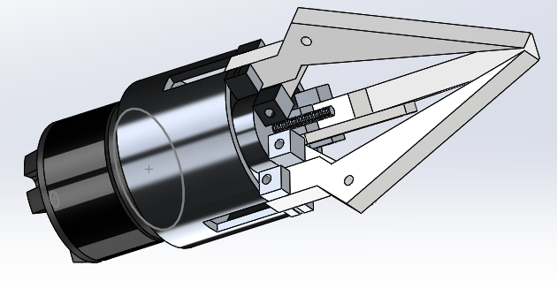
Figure 1 3 Jaw gripper

The original system is made up of:
- 3-off Jaws
- 3-off Joints
- 1-off Cylinder
- 1-off Drive plate
- 1-off Motor
- 1-off Shaft
- 1-off Worm shaft
Figure 2 Concept design components
Note there are no fasteners attaching the assembly and no strategy to prevent under and over travel of the drive plate which would result in product failure.
This design has the main components for an end-effector but due to no fasteners it would not be possible to assemble.

Jaw
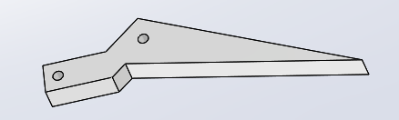
Figure 3 Jaw (1 shown of 3)
In this assembly the jaws are not connected therefore would not have the ability to function. It is manufactured from ‘PVC 0.007 plasticised’. Polyvinyl Chloride (PVC), is flexible due to the addition of a plasticizer. Common advantages and disadvantages are shown in fig 4 below.
Advantages | Disadvantages
- Low cost, flexible & high impact strength | - Properties can change with time, due to plasticizer migration
- Good resistance to UV, acids, alkalis, oils and many corrosive inorganic chemicals | - Attacked by ketones; some grades swollen or attacked by chlorinated and aromatic hydrocarbons, esters, some aromatic ethers and amines, and nitro- compounds
- Good electrical insulation properties | - Tends to degrade at high temperatures
- Non-flammable & versatile performance profile | - Non-suitable for food contact with some plasticizers
- Easier to process than rigid PVC | - Lower chemical resistance than rigid PVC
Figure 4 Advantages & Disadvantages of PVC Plasticized
The properties of PVC plactisized suggests the jaws could be manufactured by injection moulding. The figure below highlights how this is possible (Omnexus, 2020).
- Melt temperature: 170 and 210°C
- Mold temperatures: 20 to 60°C
- Mold shrinkage: 1 and 2.5%
- Material Injection Pressure: Up to 150 MPa
- Packing Pressure: Up to 100 MPa
Figure 5 Injection moulding properties

Joint
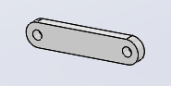
Figure 6 Joint (1 shown of 3)
The joint attaches the jaws to the drive plate. No fasteners make this component unable to operate. Made from the same material as the jaws. This material does not have the physical properties to withstand the forces that will act on it. Holes where pins should be inserted will wear over time which will cause reduced operability and failure.

Cylinder
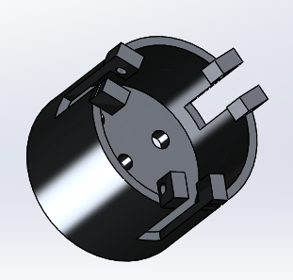
Figure 7 Cylinder

The cylinder is the ‘body of the assembly. Jaws are connected to lugs which allow the jaws to pivot. Constructed of 1060 Alloy which is recognised for its resilience to corrosion.
Elastic modulus | 70-80 GPa
Poisson's ratio | 0.33
Thermal expansion | 23.6 (10⁻⁶/ºC)
Thermal Conductivity | 234 (W/mK)
Figure 8 1060 alloy properties
Aluminium alloys are problematic at high and very low temperatures but are suitable at normal temperatures.

Drive plate
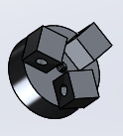
Figure 9 Drive Plate
The drive plate is connected to the shaft by threads. In this concept there are no attachment to the joints and therefore has no impact on the function. It is made from 1060 Alloy. The lugs have no strategy to attach to the plate.

Shaft

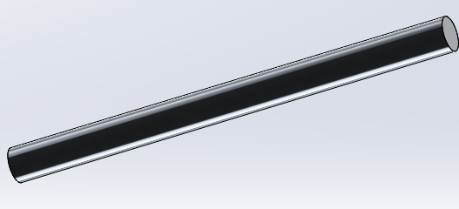
Figure 10 Shaft

The shaft rotates to operates the worm shaft. The shaft in this design has no connection to the worm shaft or from the motor so would not transfer rotary motion to the plate and has no use in this concept. It is made from 1060 alloy.

Motor

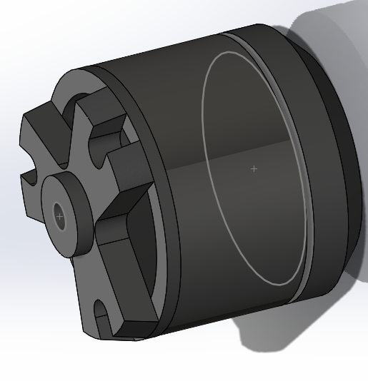
Figure 11 Motor

The motor is the power source for the gripper it can be electrical, hydraulic or pneumatic. In this concept there are no indication to determine what is. It is not attached to the shaft to transfer power. It is made from ductile iron. This material is widely used due to its ability to resist many forces such as fatigue and wear (Willman Industries, n.d.). There is no evidence of how it will attach to the cylinder or how the shaft will be attached.

Worm shaft
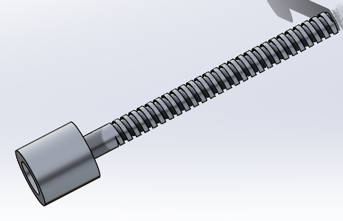
Figure 12 Worm Shaft
Made from 1060 attaches to the cylinder but has no attachment strategy so will not operate as designed. Threads are course and when turned will operate the drive plate in ’Z’ that will operate the jaws.

3-Jaw Gripper
The Figure below identifies a clash of parts. This will hinder / prevent the operation of the assembly. Over time friction will damage the components and will result in failure.
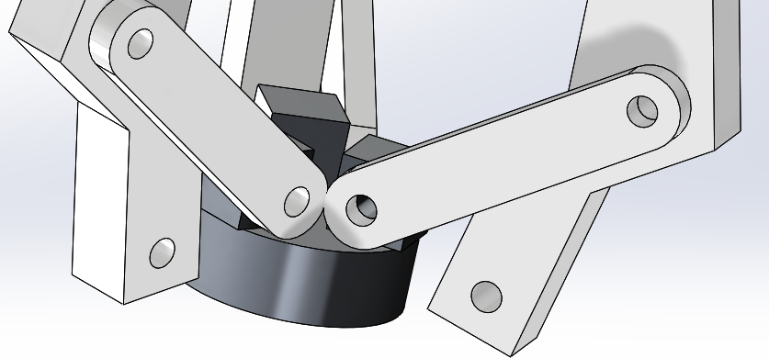
Figure 13 Clash condition
Shows the clash of the joints on each other and the base of the drive plate. The third joint has a clash on the drive plate only
The drive plate has no fixings and no stops to prevent overtravel. The shaft has threads to operate the drive plate but is not attached to the worm shaft so will be unable to rotate. The worm shaft is not attached to the shaft or the motor and will not function.
The cylinder is the housing and connects the jaws but has no fixings which will prevents them from operating. The motor is at the base of the cylinder but has no attachment. There are no power connections so there is no visual identity on what will power the motor.
In conclusion of the original design it has the individual parts but no attachments and will not function as required. It has ductile iron touching 1060 alloy which will cause dissimilar metal corrosion. Dissimilar corrosion is a bi-product of two different metals touching each other and causes an electrical field and overtime the materials will corrode and break down. Alloy joints powering PVC may cause too much force and fail.
All attaching parts have sharp edges which will concentrate stress and strain forces and will result in stress fractures and eventually fail.

Below is a Failure Mode Effects Analysis on the concept design.
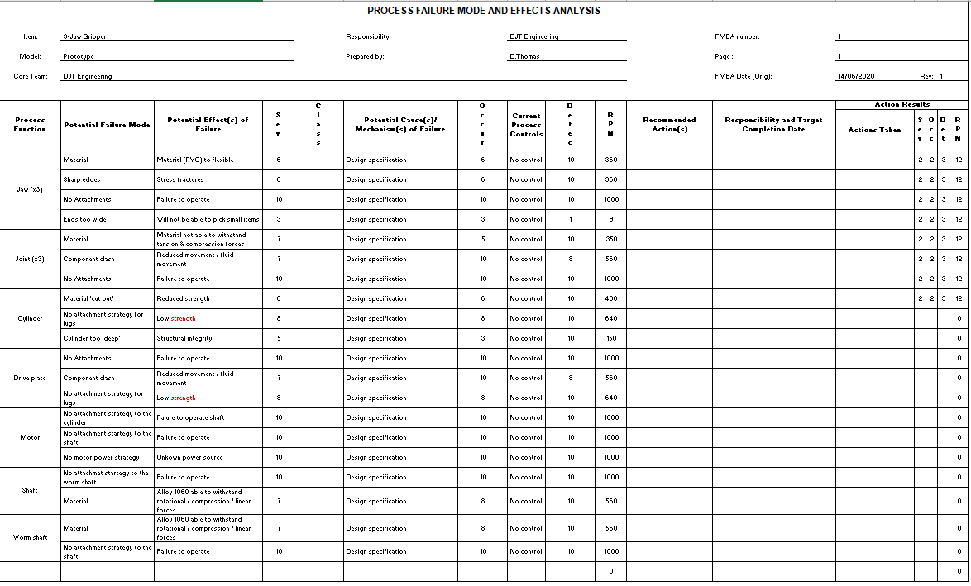
Figure 14 Prototype FMEA
This shows the failures of the concept design and potential failures resulting from them. By investigating these failures and putting recommended actions and update the effects figures will highlight the best improvements to be made.

The below figure shows the design efficiency of the concept assembly. This was carried out to investigate areas that will be concentrated on to produce a more efficient device.
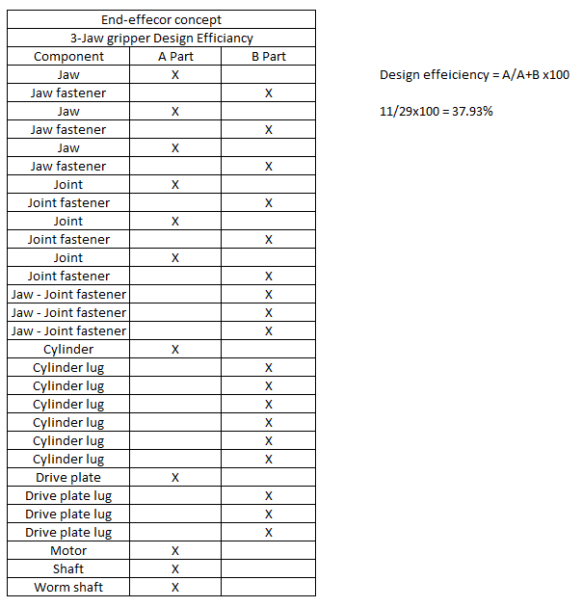
Figure 15 End effector design efficiency
38% shows it’s not an efficient design and needs improving. It has too many attaching parts. They are mainly ‘B’ parts so eliminating these will increase the product efficiency.

Manufacturing Process Proposal
To enhance the performance alterations, need to be made. Below is a FMEA of the original concept with recommended actions to enable the end-effector to operate. The final score of these actions will improve the assembly design.
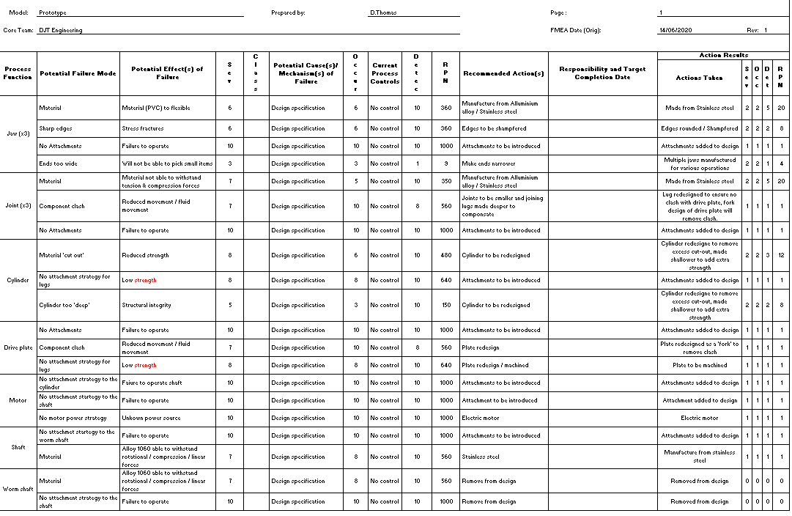
Figure 16 Complete proposal FMEA

Jaw (x3)
To ensure the jaws are flexible and adaptable it is proposed to manufacture the jaws out of a material that can withstand the forces acted upon them during operation.
The new design will be strong with curved edges to prevent stress fractures. It will be manufactured from stainless steel because of its strength and corrosion resistance (Doshi, 2018). To aid in manufacturing a flexible and adaptive device the jaws will be quick changeable. Currently the jaws will be stainless steel but can be made of different materials. These jaws could be connected to the joints via ‘pip’pins. They are quick to operate which will allow quick jaw changes. This will allow the user to change the jaws to accommodate the job they are required to carry out.
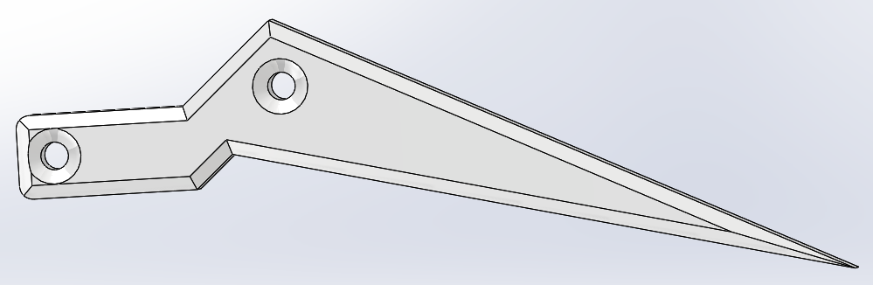
Figure 17 Jaw re-design

Joint (x3)
The current design is acceptable but will be made from stainless steel due to the properties mentioned above.
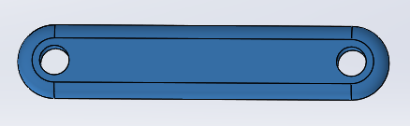
Figure 18 Joint

Cylinder (Body)
The body will be made from stainless steel. It will be shallower for added strength. It will be machined to enable the lugs to be included on the body and to allow a consistent tolerance for the jaws to be poisoned in them.

Drive Plate
The drive plate will be redesigned to include the lugs and will be machined as a single part. It will be made from stainless steel which is good at absorbing linear and centrifugal forces. The threads will be fine to aid in controlled operation. It will be machines to enable the lugs to be a part of the component.

Motor
The motor will be electrical as it will be quiet and electric is readily available where hydraulic or pneumatic would require pumps to produce compressed air or hydraulics, which would need an electrical supply. This will be bought from a supplier as these motors are common in industry.

Shaft
There will be one shaft. The threads will be fine. The material will be stainless steel for the properties mentioned above. It will be a bought finished component as it is a simple design and readily available. The shaft will attach to the motor fastened together via a flange and bolts. This form of attachment is common and therefore will be bought in from a supplier.

Design & Development Work Undertaken
To maximise the concept idea and improve it the following development work has been undertaken:

Design for manufacture (DFM)
The design and development work carried out is to simplify the design by using less parts which will reduce build time and drive cost down. To design areas into modules and use ‘off the shelf’ readily available parts where possible. The biggest design change will be to make the jaws interchangeable and quick release. This will allow the end-effector to be flexible and adaptable to the users’ requirements. Also, it will become multi-functioning due to a wide range of jaws that could be made available together with an electric motor that can accurately and easily adapt to different forces required on the types of jaws and items it is required to pick up.

Design changes
The motor will be electrically powered and attached to the cylinder housing. This will be done using male and female parts. The motor will be fastened to the cylinder with bolts through the cylinder into the motor. This will prevent angular movement when in use. The motor will be set to operate on calculated rotations to prevent overtravel and under travel, the shaft will have stops at both ends as a failsafe if the motor over or under travels. The robot arm will control the end effector with basic I / O commands. This will make the assembly attractive to buyers (Bouchard, 2014). The motor will be bought in with the shaft already installed.
The cylinder will be machined from stainless steel and will be shallower / shorter than the concept. The lugs will be incorporated in the design to remove the need for attaching the lugs. The need for it to machined is to add strength and consistent tolerance for the jaws to be installed.
The jaws will be predominantly made from stainless steel. They will be machined with rounded edges to spread the stress, ending at a point with a ‘ball’ at the end. This will allow them to close tighter with minimal gaps at the end to allow them to work with smaller items. However, the jaws will be attached to the cylinder and joints via a quick release pin allowing many different designed jaws to fit for appropriate jobs specified by the user. The jaws can be manufactured from any material to any dimension.
The joint will be made from stainless steel. This is for strength and durability. This item will be bought in as it is a standard design.
The drive plate will be machined from a block and will incorporate the lugs for the jaws to fit. This will enable limited sideways movement of the joint and enable the jaws to remain square and inline during operation. Quick release pins will be used to attach the joints.

Design for Assembly (DFA)
The below figure is the design efficiency for the new design.
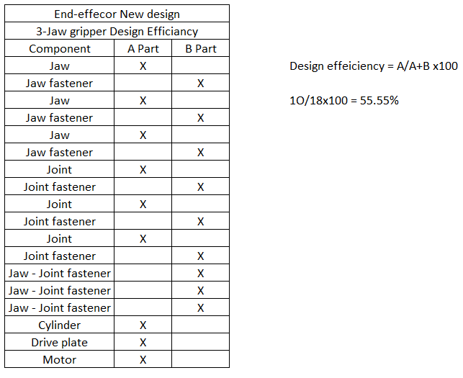
Figure 19 End effector new design efficiency

The above figure shows that there is an 18% increase in efficiency by making simple design changes of removing the shafts and lugs, more refinements can be made but fir the purpose of this report excess fasteners and lugs have been removed.

The general material that will be used for the end effector will be stainless steel. This material has been chosen because of its properties. Below are some advantages:
- High corrosion resistance
- High Cryogenic toughness
- High ductility
- High strength
- Tough
- Lower maintenance
- Pleasing finish
Figure 20 Stainless steel advantages

One disadvantage of using stainless steel is the price! It is more expensive than material such as aluminium but for this project it is the correct choice (Team, 2018).
The below figure is the FMEA of the new design. It has incorporated the new design with less parts to fail. With all mechanical designs there will always be failures but if you are aware of these then you can process a lot of them out. A standard form of prevention will be a ‘pre-use check’ use.

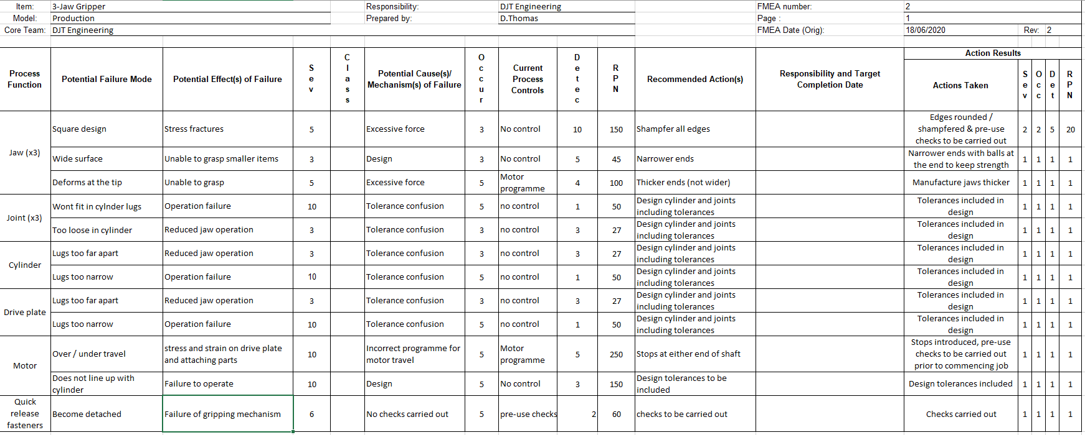
Figure 21 New design FMEA

Manufacturing Process Design
The new assembly has been designed to ensure quick and easy assembly. There will only be four bolts used in this assembly and they will be to secure the cylinder to the motor. This is to ensure there is no ‘opposite’ rotary movement on the cylinder, (if the motor turns clockwise the cylinder would move anticlockwise). The drive plate will screw on to the shaft and a locking nut will screw on to the end of the shaft as an overtravel fail safe (the stop at the bottom of the shaft will be part of the motor assembly that has been bought finished).
The jaws will attach to the cylinder via pip pin quick release fasteners. The jaws have no physical poke yoke but they are self-explanatory and this will be highlighted in the build process. The joints will attach using the same strategy, there is no requirement for poke yoke on these parts as they are symmetrical and can fit in any orientation.

Parts
The below figure is the Bill of Materials (BoM) for the complete assembly. Each part has a brief statement of how they will be supplied for assembly.
- Motor | Bought finished from supplier with shaft and lower overtravel stop installed
- Cylinder | Machined from stainless steel
- Drive plate | Machined from stainless steel
- Jaw (x3) | Initially machined from stainless steel – Stainless steel comes with assembly as standard, further materials will be available to order at extra cost, also other designs can be available from buyers’ requirements.
- Joint (x3) | Standard component bought from supplier – readily available
- Quick release fastener (x9) | Standard component bought from supplier – readily available
- Bolt (x4) | Standard component bought from supplier – readily available
Figure 22 BoM (Bill of Materials)
A BoM allows companies to understand the expense of each individual parts and how much a complete assembly costs to build (parts only). It is also a good gauge on tracking parts to ensure they are readily available for assembly (Techtarget, 2017 - 2020).

Build Process
Below is the process to assemble the end-effector. This is the process the technician will follow to assemble the end-effector with a functional test to ensure it operates correctly. There are many methods of assembly process but for this assembly it is a modular process as there are not many parts and it can be built as one process (EDITORIAL, INC. STAFF, 2020).
Operation | Process | Operation description
1 | Obtain parts | Ensure all parts are available iaw with BoM
2 | Obtain Motor | Carry out checks on motor body, shaft & lowershaft overtravel stop and ensure no damage
3 | Obtain Cylinder & x4 bolts | - Carry out checks and ensure no damage.  - Carefully insert shaft through centre hole of cylinder ensure no damage to lower overtravel stop occurs in this process.  - When cylnder is in contact with motor line up 4 holes.  - Hand start x4 bolts, tighten using socket, extension and ratchet.
4 | Obtain Drive plate & upper overtravel stop | - Hand start drive plate on shaft and wind down >10mm.  - Hand start upper stop and tighten using spanner.  - Wind drive plate up to upper stop
5 | Obtain Joint (x3) & pip pin (x3) | - Insert 1-off joint inbetween the forks on the drive plate  - Insert pip pin – ensure joint is free to operate  - Continue I & II above for remaing x2 joints
6 | Obtain Jaw (x3) & pip pin (x6) | - Inset lower jaw between fork of cylinder, ensure jaws are in correct orientation (flat part of jaw pointing inboard)  - Insert Pip pin – ensure jaw is free to operate.  - Offer jaw to the joint ensure they line up, insert pip pin  - Carry out operations I-III above for remaining 2-off jaws
7 | Pre-use checks | Carry out pre use checks on full assembly and ensure all components are assembled and no clashes are present
8 | Attach power to assembly | Connect electrical power to assembly
9 | Set motor travel | - Ensure drive plate is at the top of its travel (against uppr stop), motor the end-effector down and ensure lower stop has visible gap  - Power motor to operat the drive plate to the top and ensure there is a visible gap ot the top.  - Continue for 2 cycles (functional check complete.)
Figure 23 Assembly process

Conclusion
The concept design for the end-effector had a poor design.
- No fasteners to connect the assembly
- Clash areas
- Too many components
- Sharp edges
- Different materials
This report detailed the design activity taken to innovate and make the end-effector flexible and adaptable. It discussed the changes and described the reasons.
The final design has made the assembly functional and attractive to buyers and given the opportunity to use (or have designed) a selection of jaws appropriate to the work that needs to be undertaken.
It was decided to use stainless steel for most of the components because of its properties and resistance to corrosion and strength therefore making this assembly low maintenance. The fasteners attaching the parts are quick release so it makes the changing of jaws quick and can be done in situ.
Below is the prototype the new motor is based on with the shaft extended to enable attachment of the drive plate.
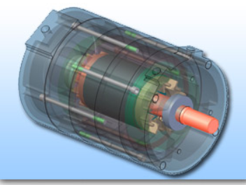
Figure 24 prototype induction
Electric motor designed on this prototype with extended shaft to attach the drive plate

By buying parts in built and ready to assemble ensures the assembly process is quick with minimal parts which drives the cost of the assembly down.
With the use of FMEA’s and design efficiency tools it enabled failures of the design to be highlighted. By investigating these allowed the final design to be more efficient.
The final design is minimal and easy to assemble, the quick release design allows effective changes of the jaws and makes general maintenance accessible and simple. The new product has been designed to make it attractive to potential buyers.

References
Bouchard, S., 2014. Robot End Effector: Definition and Examples. [Online]
Available at: https://blog.robotiq.com/bid/53266/Robot-End-Effector-Definition-and-Examples
[Accessed 17 June 2020].
Doshi, a., 2018. Quora. [Online]
Available at: https://www.quora.com/What-are-the-advantages-and-disadvantages-of-stainless-steel-2
[Accessed 16 June 2020].
EDITORIAL, INC. STAFF, 2020. Assembly Line Methods. [Online]
Available at: https://www.inc.com/encyclopedia/assembly-line-methods.html
[Accessed 20 June 2020].
Omnexus, 2020. Comprehensive Guide on Polyvinyl Chloride (PVC). [Online]
Available at: https://omnexus.specialchem.com/selection-guide/polyvinyl-chloride-pvc-plastic
[Accessed 1 June 2020].
Team, K. K., 2018. What are the Advantages and Disadvantages of Using Stainless Steel Equipment?. [Online]
Available at: https://www.kinnek.com/article/what-are-the-advantages-and-disadvantages-of-using-stainless-steel-equ/#/
[Accessed 18 June 2020].
Techtarget, 2017 - 2020. bill of materials (BOM). [Online]
Available at: https://searcherp.techtarget.com/definition/bill-of-materials-BoM
[Accessed 20 June 2020].
Willman Industries, n.d. What is Ductile Iron?. [Online]
Available at: https://www.google.com/search?rlz=1C1GCEJ_enGB877GB877&sxsrf=ALeKk03D9c5T1OxH8TPzlScuQtHK6zbqzQ%3A1591202481022&ei=sdLXXr5lroeFsg--gK7gCA&q=Ductile+iron&oq=Ductile+iron&gs_lcp=CgZwc3ktYWIQAzIECAAQQzICCAAyAggAMgIIADICCAAyAggAMgIIADICCAAyAggAMgIIADoFCAAQkQI
[Accessed 03 06 2020].

