DS 1 Template

My Screenshots/Photos

Screenshot/Photo 1
Screenshot 1: The clock app on my apple mobile phone
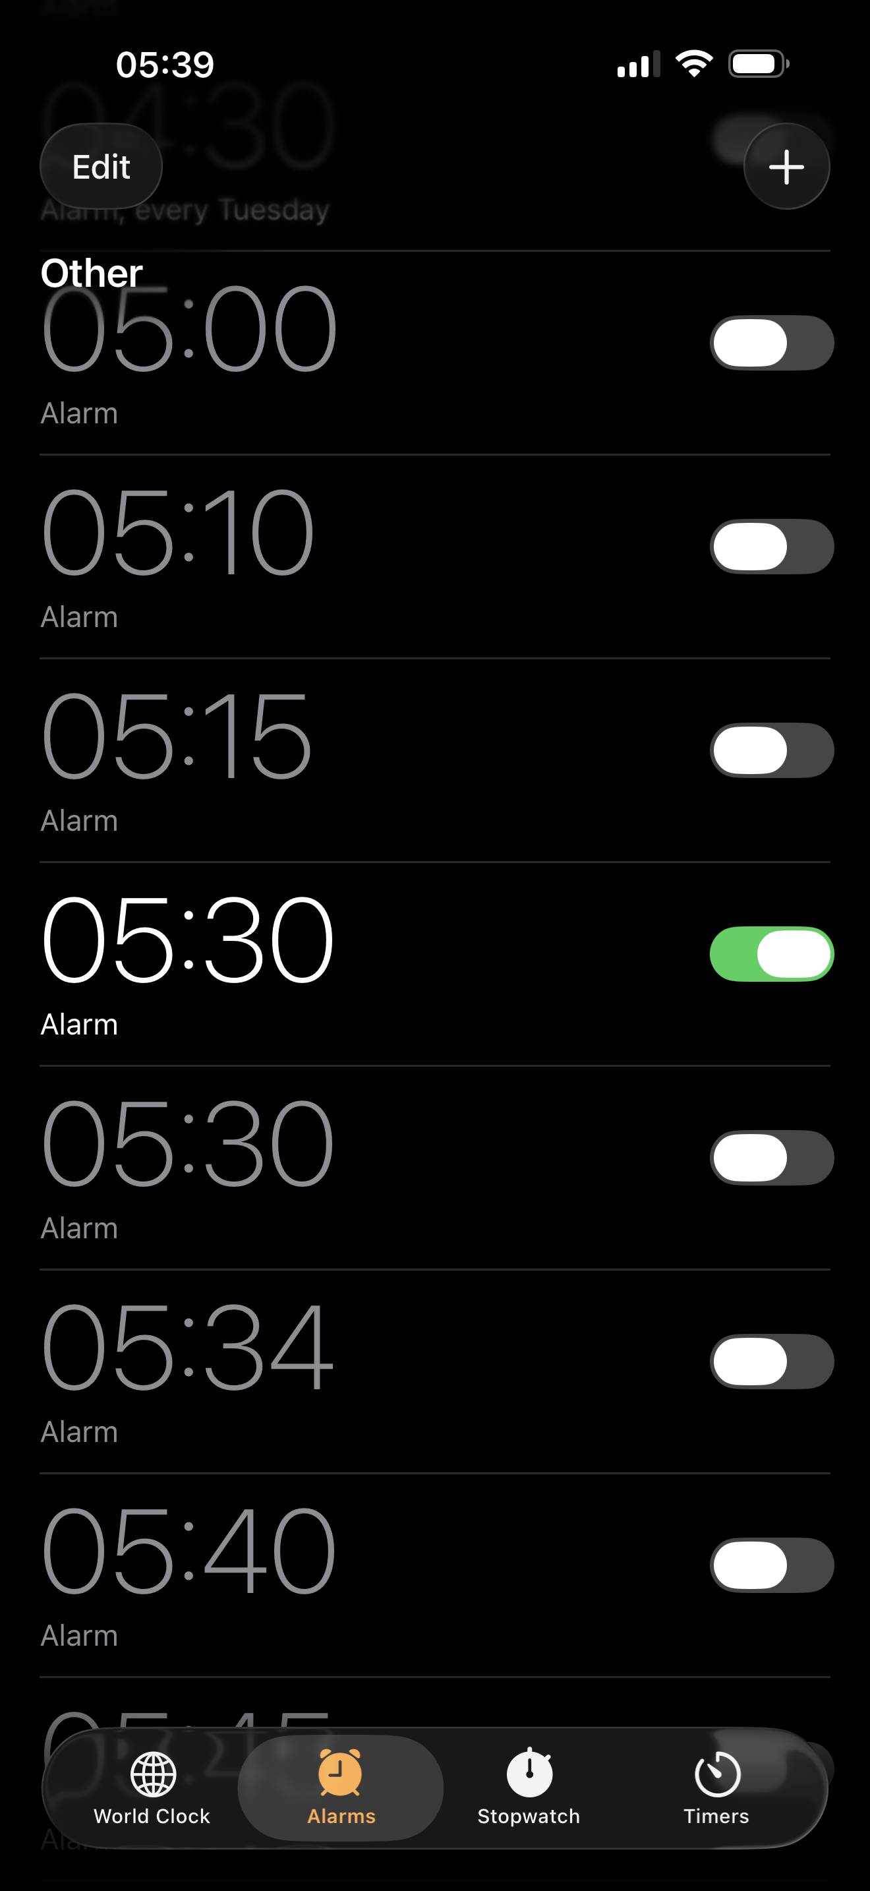
Screenshot 1shows my alarm on my phone that I use to wake me up daily.

Screenshot/Photo 2
Screenshot 2: The weather app on my phone
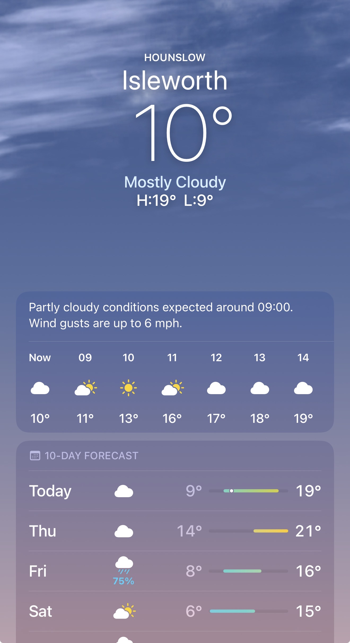
This image shows that I use the weather app daily to check what to wear on the day, all depending how the weather will be.

Screenshot/Photo 3
Screenshot 3: My wallet on my mobile phone
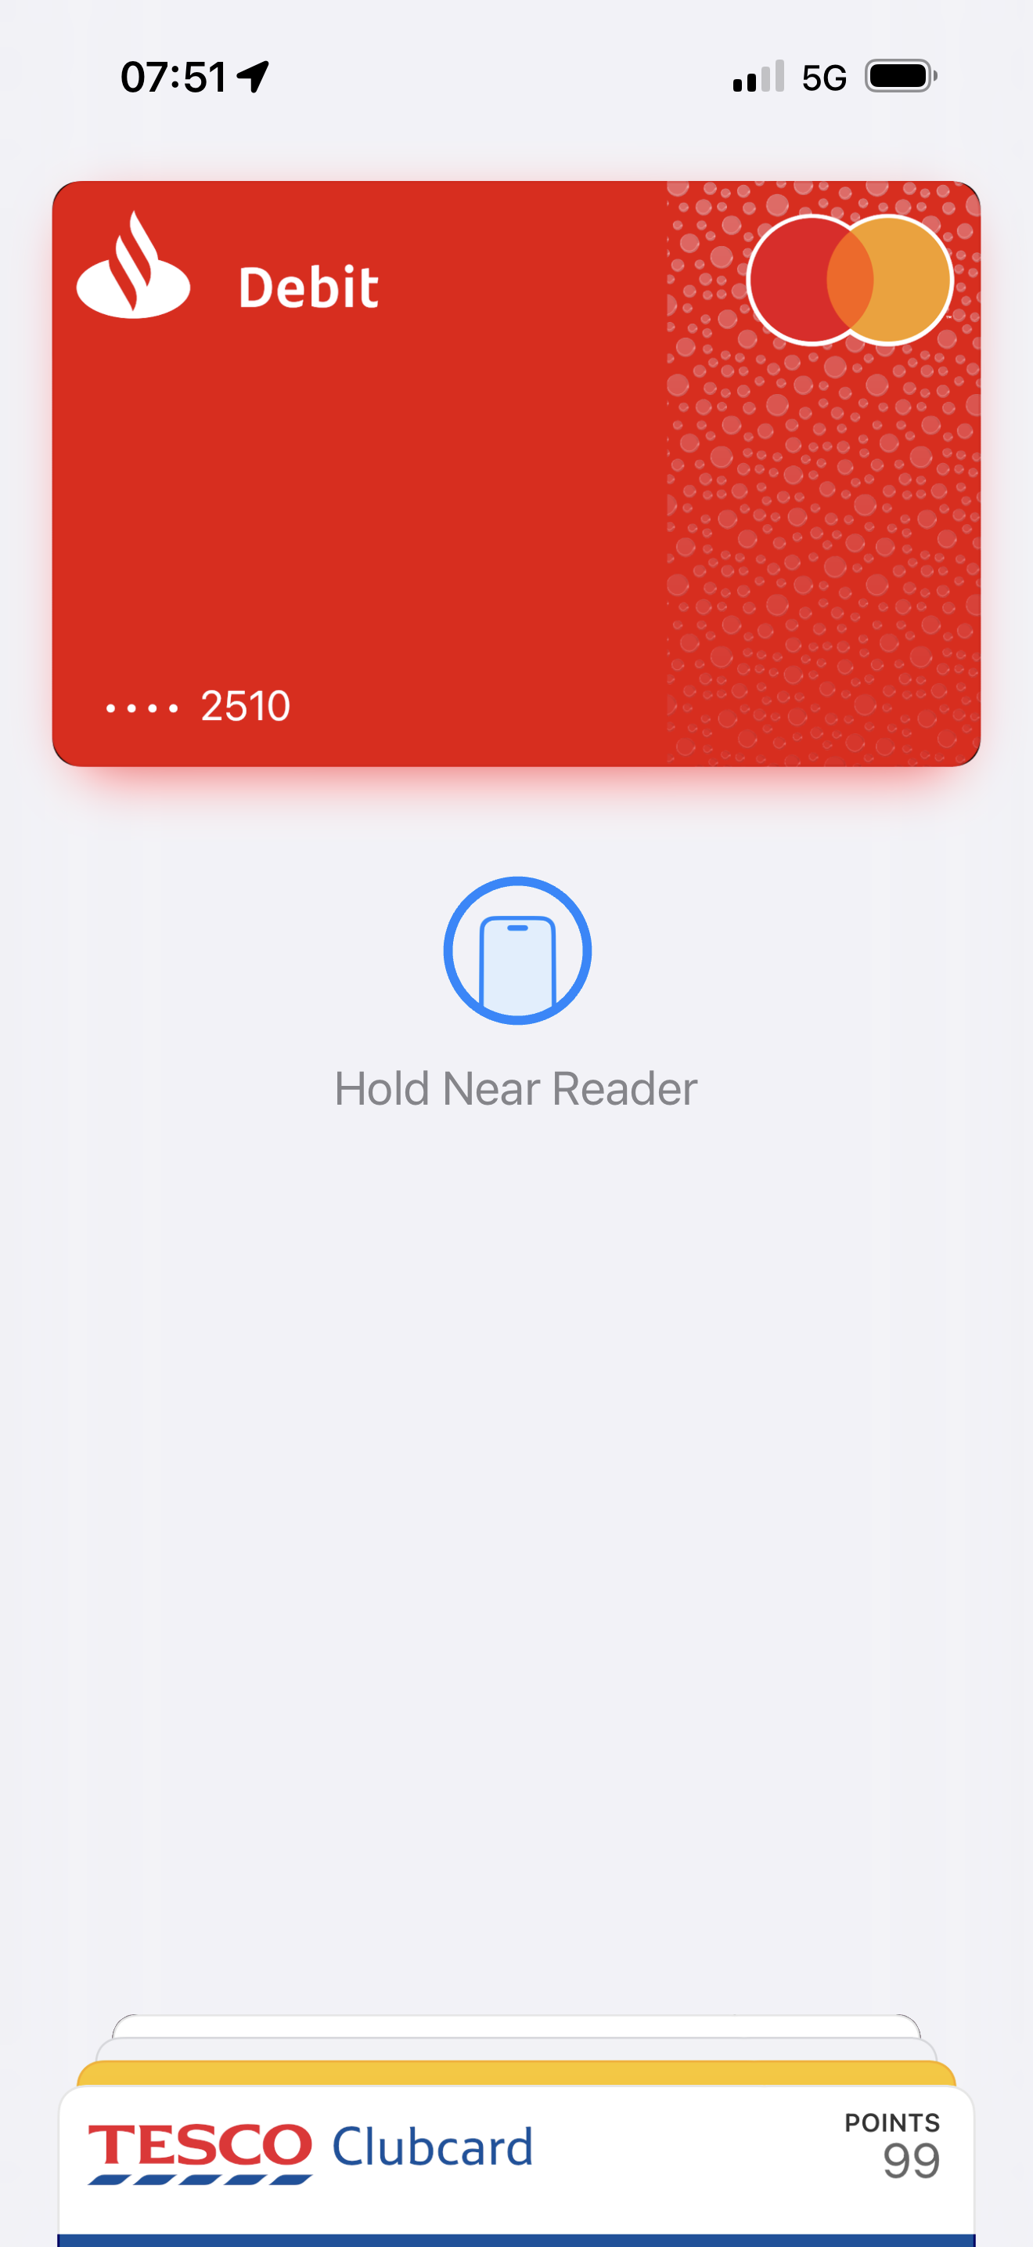
Screenshot 3 shows that I use the wallet app on my phone to store most of my cards, including my bank card that I use daily.

Screenshot/Photo 4
Screenshot 4: My university app
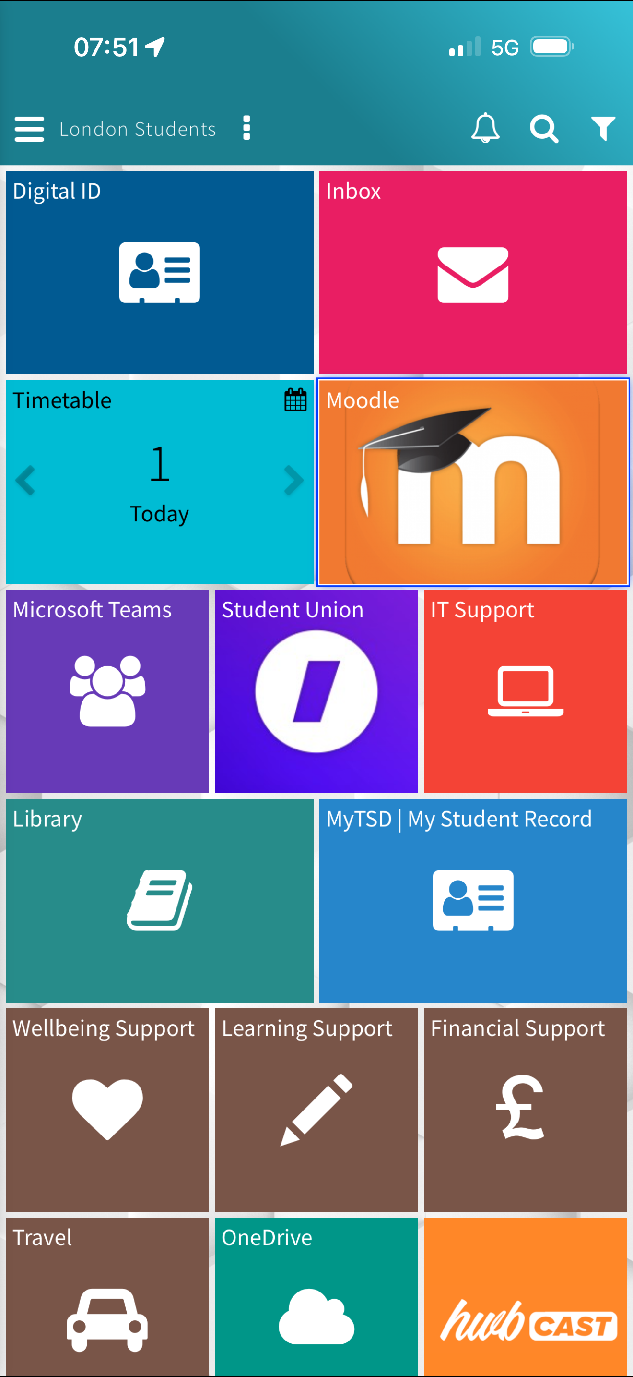
This picture shows my university app; I check this app daily for new emails and class times also class materials.

Screenshot/Photo 5
Screenshot 5: My laptop
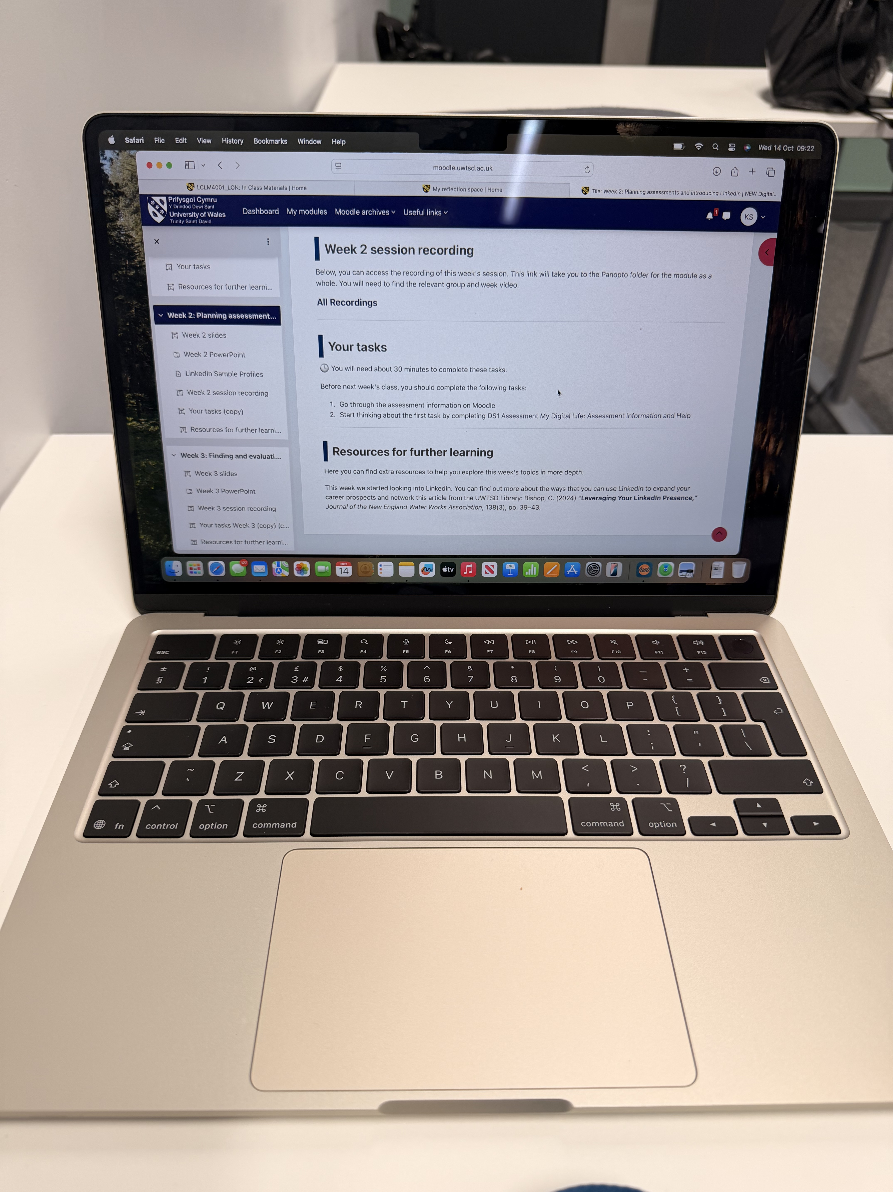
The image above shows my laptop that I use at home for personal use and at university to complete work on.

My Short Reflection
Using digital tools every day in my life is important, I would be very lost without them. I set my alarm every night and check the weather app every day, without these I would wake late and never know how the weather will be on the day.
I feel confident when using my phone for my everyday needs, at home and wherever I go, having most of my digital tools all in one place is convenient for me.
Since starting university, I want to improve using Microsoft word as I have never used this before and would like to get very comfortable knowing how to use it confidently to complete my assessments with ease.
Studying this module has and will help me build more confidence using new and different digital tools independently for my work and future studies.
When trying something new it makes me feel nervous at first until I learn more, I manage my work better when I know how to use a new digital tool.
I am happy with how I am progressing in digital skills and realising just how much our lives are digitally dependent in many ways.

