Cybersecurity Strategy for Vigilant Trust & Asset Management
Owen Stephens (2418999)

Table of Contents
Introduction 2
Threat Landscape 2
Ransomware-as-a-Service 2
AI-powered scams (phishing and vishing) 2
Attacks through suppliers 2
Fast exploitation of new flaws 3
Cloud and home-working risks 3
Security Policies & Zero Trust Approach 4
Relevant ISO Policies 4
Technical and Practical Defences 5
Watching for Attacks and Responding 7
Training and Security Culture 8
Conclusion 8
Bibliography 9

Introduction
Vigilant Trust & Asset Management is a SME asset manager, looking after billions in client assets across hundreds of investments in construction and finance industries. The threat environment facing it is not one that stops to allow the company to catch up and defend itself in advance without preparation and contingencies. This report looks to map out a Zero Trust security architecture for Vigilant Trust, with policies and controls based on NIST Cybersecurity Framework 2.0, ISO/IEC 27001:2022, and CISA’s Known Exploited Vulnerabilities (KEV) databases.

Threat Landscape

Ransomware-as-a-Service
Criminal gangs can now rent out ransomware to other cyber criminals for example renting business software. ENISA recorded 82 ransomware brands attacking EU organisations in the past year, led by Akira, SafePay and Qilin [1]. Most attackers also steal a copy of the data and threaten to publish it if no ransom is paid this can cost businesses millions of pounds if not dealt with proactively.
In 2024, Change Healthcare was hit by ransomware. Systems were down for weeks, US payments stalled across thousands of pharmacies, and around $22 million was paid [2].

AI-powered scams (phishing and vishing)
Phishing is a fake SMS or email, fooling someone into clicking a link or giving up a password for protected systems with Vishing being the telephone mirror of this attack. Generative AI available to the world, now writes convincing emails and clones voices from short audio clips. ENISA reports phishing is involved in about 60% of break-ins, with more than 80% of scam messages AI-assisted [3].
2023 was the year attackers called in to the MGM Resorts IT helpdesk pretending to be a member of staff. They exploited the system when a password was reset, attackers gained control of valuable data and MGM ran on pen and paper for days to prevent further loss of data. Costing MGM Resorts approximately $100 million [4].

Attacks through suppliers
Modern businesses depend on vast range of software companies. If cyber criminals gain unauthorised access to important third party supplier’s valuable information and data can be sold to the highest bidder on the dark net [5]. The secure file transfer program MOVEit was exploited by the Cl0p gang. More than 2,700 organisations lost personal data, with banks, universities, governmental agencies through no fault of their own finding themselves at risk [6].

Fast exploitation of new flaws
When a flaw in popular software is discovered attackers race to use it before companies send out an update that deepens security, CISA is a key source in maintaining up to date knowledge on threats [7]. Their KEV catalogue lists flaws known to be actively exploited; 245 were added during ENISA’s reporting period, at least 115 used against EU organisations[8] .

Cloud and home-working risks
Cloud-stored data and work from home landscape open businesses to the possibility that a hidden virus on one personal device can quietly hijack a login session and walk straight into company systems without setting off any firewall alerts.

Security Policies & Zero Trust Approach
Zero Trust is never assuming anything is safe just because it is inside the network. Every user, device and request is checked every time constantly and stored. The below figure demonstrates the Zero Trust architecture design as well how Vigilant Trust’s policies should cover five areas, each mapped to a NIST Cybersecurity Framework [9] function and the relevant ISO 27001:2022 controls [10].
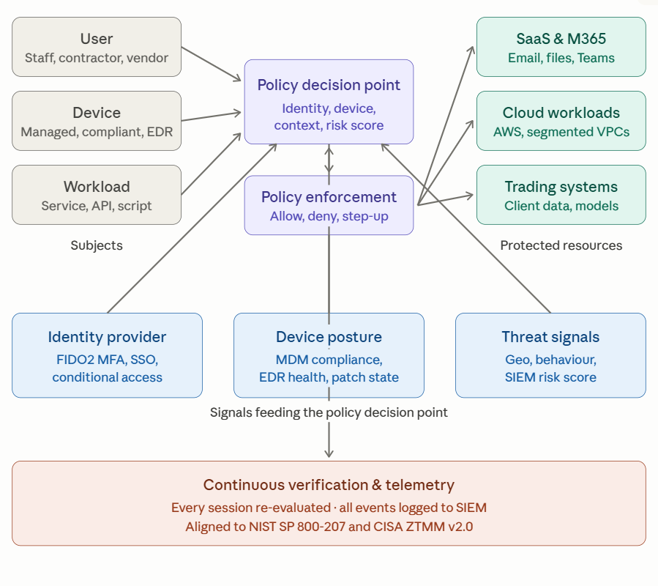
Figure 1 Zero Trust architecture

Relevant ISO Policies
Logging in (Protect; ISO A.5.15–18) [11]
Strong multi-factor authentication using physical security keys or passkeys, instead of SMS or push notifications which attackers can now intercept. Admin accounts are switched on only when needed and every session is recorded and stored.
Trusted devices (Protect; ISO A.8.1, A.8.9) [12]
Only company owned, patched and encrypted devices can reach company data. Personal devices use a safe browser window which can be monitored and control.
Network segments (Protect; ISO A.8.20–22) [13]
The internal network is divided into monitored zones and sandboxes, so attackers cannot roam freely if they get in. Trading and client data systems sit in their own locked down servers.
Protecting data (Protect; ISO A.5.12–14, A.8.10–12) [14]
Important data is labelled, monitored and encrypted. Backups include at least one copy that cannot be changed or deleted, this is essential because ransomware attacks now tend target backups first.
Managing suppliers (Govern, Identify; ISO A.5.19–23) [15]
Suppliers are checked at onboarding and yearly. Important suppliers’ contracts include audit rights, incident reporting and exit plans, as required by DORA Article 28 [16].
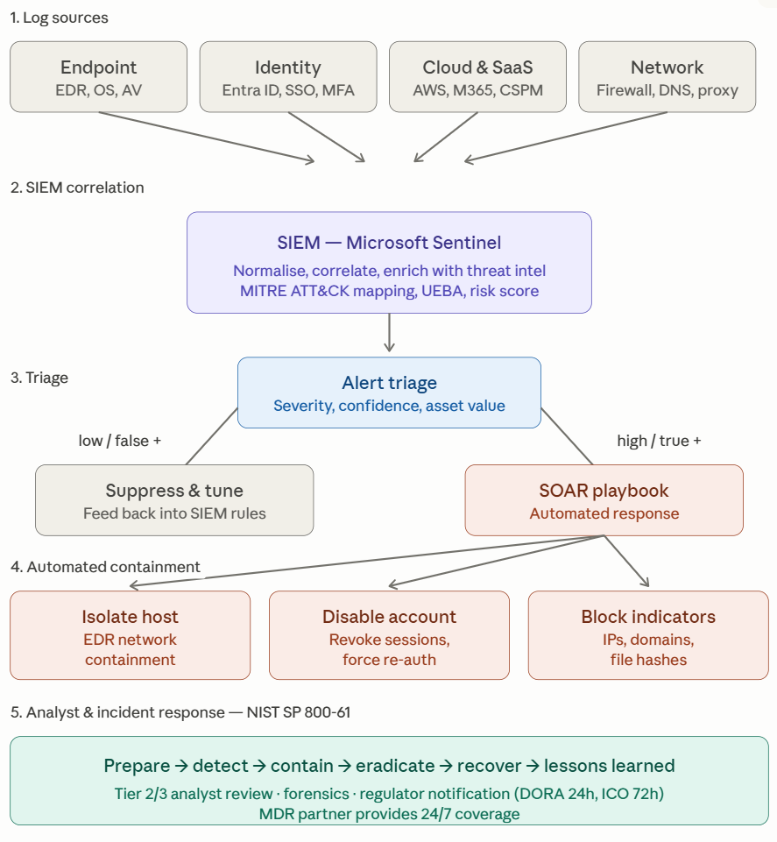
Figure 2 Zero Trust at Vigilant Trust, based on NIST SP 800-207 and CISA Zero Trust Model

Technical and Practical Defences
The defences below give the biggest real-world risk reduction for a firm of this size, mapped to NIST CSF functions and prioritised against the CISA KEV catalogue.
Strong multi-factor authentication (Protect): physical security keys or passkeys for every account, stopping the vast majority of password-stealing attacks.
Modern endpoint protection (EDR/XDR) (Detect): watches for suspicious behaviour on every laptop and server, and lets analysts isolate a compromised machine in one click.
Cloud configuration scanning (CSPM) (Identify, Protect): an automated tool that checks AWS and Microsoft 365 against best practice and fixes common mistakes such as public storage buckets.
Fast patching, guided by CISA KEV (Protect): flaws on the KEV list patched within 14 days, other criticals within 30. Internet-facing systems first.
Tested, untouchable backups (Recover): nightly backups, offline copies that cannot be deleted, monthly restore drills, four-hour recovery target for the most important systems.
Email security and anti-phishing (Protect): AI-based filtering, link sandboxing, DMARC, and protection against QR-code phishing.
Tight admin controls (PAM) (Protect): admin passwords vaulted, rotated automatically, sessions recorded.
Internet filtering for home and office (Protect, Detect): blocks staff devices from connecting to known malicious sites, wherever they are working.

Watching for Attacks and Responding
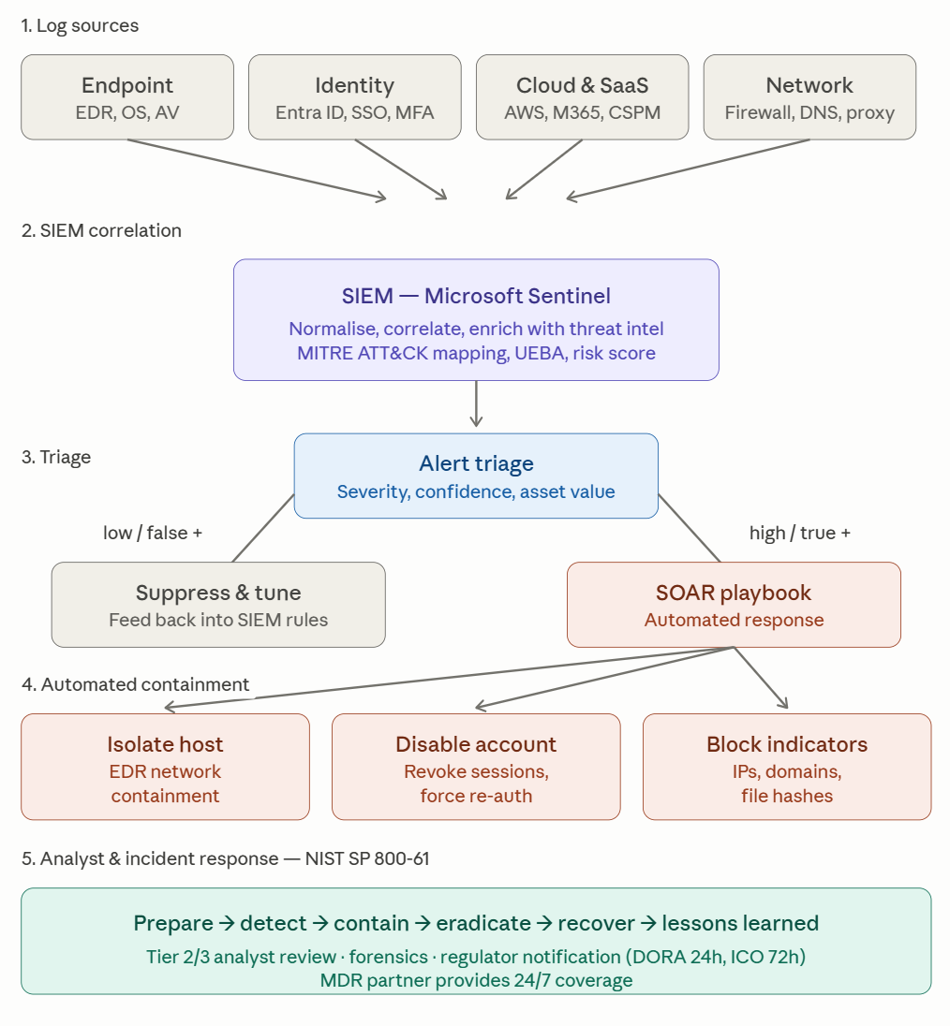
Figure 3 Detection and response. Logs from across the business feed a SIEM that raises alerts; a SOAR tool runs the first response automatically, analysts take it from there.
Vigilant Trust will run 24-hour security cover, this includes;
An in-house team during business hours, a Managed Detection and Response (MDR) on call partner for nights and weekends. Logs from laptops, identity systems, cloud and network gear feed Microsoft Sentinel (SIEM), which spots suspicious patterns mapped to MITRE ATT&CK.
When an attack is detected, a SOAR tool runs an automated playbook, isolate the laptop, disable the account, block the attacker’s addresses. Analysts then investigate, working through the six phases of NIST SP 800-61:
Prepare, Detect, Contain, Eradicate, Recover, Lessons Learned [17].
A dedicated ransomware playbook instructs the first hour, isolate infected machines, preserve evidence, check offline backups, notify senior management, and start regulatory clocks (24 hours under DORA & 72 hours under GDPR). Plans are tested by quarterly tabletop exercises and an annual external red-team test.

Training and Security Culture
Video training sessions don’t do enough to change behaviour. With phishing involved in about 60% of attacks, staff awareness is one of Vigilant Trust’s most important controls. This training program is built around regular, realistic practice.
Monthly fake-phishing emails
Realistic simulations every month, targeting getting click rate down, report rate up. The goal is for report rate to overtake click rate within twelve months.
Quarterly fake-phishing phone calls
Practice vishing for IT helpdesk, finance and HR, the exact departments that attackers target.
Role-specific training
Developers learn secure coding, executives get whaling and BEC briefings, finance covers invoice fraud, helpdesk training on social engineering techniques.
In-the-moment lessons. Clicking a simulated phish triggers a 60 second corrective video. Repeat clickers get one-to-one coaching. Each department has a “security champion” as a first contact.

Conclusion
These recommendations turn Zero Trust into practical, measurable controls suited to Vigilant Trust’s size and regulatory needs. They address the threats the business is most likely to encounter and meet ISO and DORA expectations. Cyber risk cannot be removed, but with constant monitoring, fast patching, backups and a security aware workforce, it can be made survivable.

Bibliography
[1]
“ENISA THREAT LANDSCAPE FOR RANSOMWARE ATTACKS JULY 2022 ENISA THREAT LANDSCAPE FOR RANSOMWARE ATTACKS,” 2022. Available: https://www.enisa.europa.eu/sites/default/files/publications/ENISA%20Threat%20Landscape%20for%20Ransomware%20Attacks.pdf
[2]
J. Gregory, “Change healthcare’s 22 million ransomware payment,” Ibm.com, May 24, 2024. https://www.ibm.com/think/news/change-healthcare-22-million-ransomware-payment
[3]
“EU consistently targeted by diverse yet convergent threat groups | ENISA,” Europa.eu, Oct. 2025. https://www.enisa.europa.eu/news/etl-2025-eu-consistently-targeted-by-diverse-yet-convergent-threat-groups
[4]
F. Times, “A phone call to helpdesk was likely all it took to hack MGM,” Ars Technica, Sep. 14, 2023. https://arstechnica.com/security/2023/09/a-phone-call-to-helpdesk-was-likely-all-it-took-to-hack-mgm/
[5]
Cybersecurity Insiders and Cybersecurity Insiders, “Third-Party Data Breaches: The Hidden Threat Lurking in Vendor Networks - Cybersecurity Insiders,” Cybersecurity Insiders -, Mar. 26, 2025. https://www.cybersecurity-insiders.com/third-party-data-breaches-the-hidden-threat-lurking-in-vendor-networks/
[6]
C. Page, “MOVEit, the biggest hack of the year, by the numbers,” TechCrunch, Aug. 25, 2023. https://techcrunch.com/2023/08/25/moveit-mass-hack-by-the-numbers/
[7]
Cybersecurity & Infrastructure Security Agency, “CISA,” Cisa.gov, 2020. https://www.cisa.gov/
[8]
Cybersecurity and Infrastructure Security Agency, “Known Exploited Vulnerabilities Catalog | CISA,” www.cisa.gov, 2023. https://www.cisa.gov/known-exploited-vulnerabilities-catalog
[9]
S. Quinn and B. Heiserman, “NIST Special Publication NIST SP 800-70r5 National Checklist Program for IT Products - Guidelines for Checklist Users and Developers,” 2026, doi: https://doi.org/10.6028/nist.sp.800-70r5.
[10]
International Organization for Standardization, “ISO/IEC 27001 standard – information security management systems,” ISO, 2022. https://www.iso.org/standard/27001
[11]
“ISO 27001:2022 Annex A Control 5.15 Explained - ISMS.online,” ISMS.online, 2022. https://www.isms.online/iso-27001/annex-a-2022/5-15-access-control-2022/
[12]
“ISO 27001:2013 – Annex A.8: Asset Management | ISMS.online,” ISMS.online, 2025. https://www.isms.online/iso-27001/annex-a-2013/annex-a-8-asset-management-2013/
[13]
“ISO 27001:2022 Annex A Control 8.20 Explained - ISMS.online,” ISMS.online, 2022. https://www.isms.online/iso-27001/annex-a-2022/8-20-network-security-2022/
[14]
“ISO 27001:2022 Annex A Control 8.12 Explained - ISMS.online,” ISMS.online, 2022. https://www.isms.online/iso-27001/annex-a-2022/8-12-data-leakage-prevention-2022/
[15]
“ISO 27001:2022 Annex A 5.19 Checklist | ISMS.online,” ISMS.online, 2022. https://www.isms.online/iso-27001/checklist/annex-a-5-19-checklist/
[16]
“Digital Operational Resilience Act (DORA), Article 28,” Digital-operational-resilience-act.com, 2020. https://www.digital-operational-resilience-act.com/Article_28.html (accessed May 14, 2026).
[17]
A. Nelson, S. Rekhi, M. Souppaya, and K. Scarfone, “Incident Response Recommendations and Considerations for Cybersecurity Risk Management”:, NIST, Apr. 2025, doi: https://doi.org/10.6028/nist.sp.800-61r3.

