Portfolio of written task

Employment and career Development
Certificate in Higher Education
(Business Skills for the Workplace)

Louise Jones
Student ID: 2514763

LCLM4005
Lecturer: Sujeewa Herath

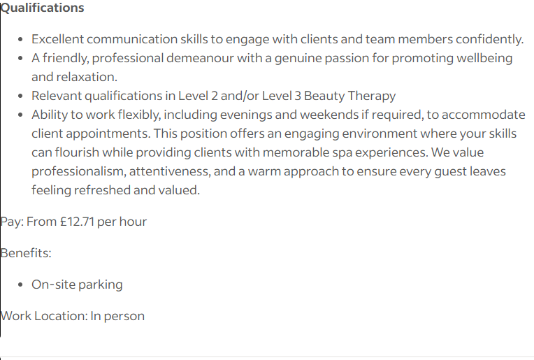
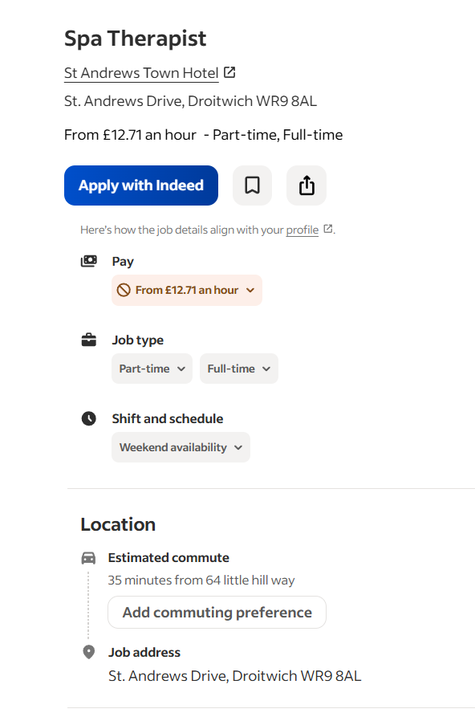

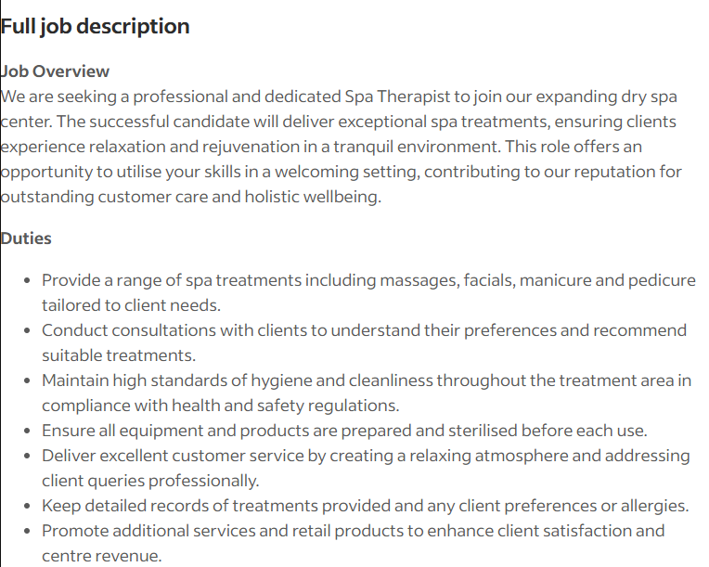

Job link:https://uk.indeed.com/viewjob?jk=137271a5f17847e8&from=shareddesktop_copy

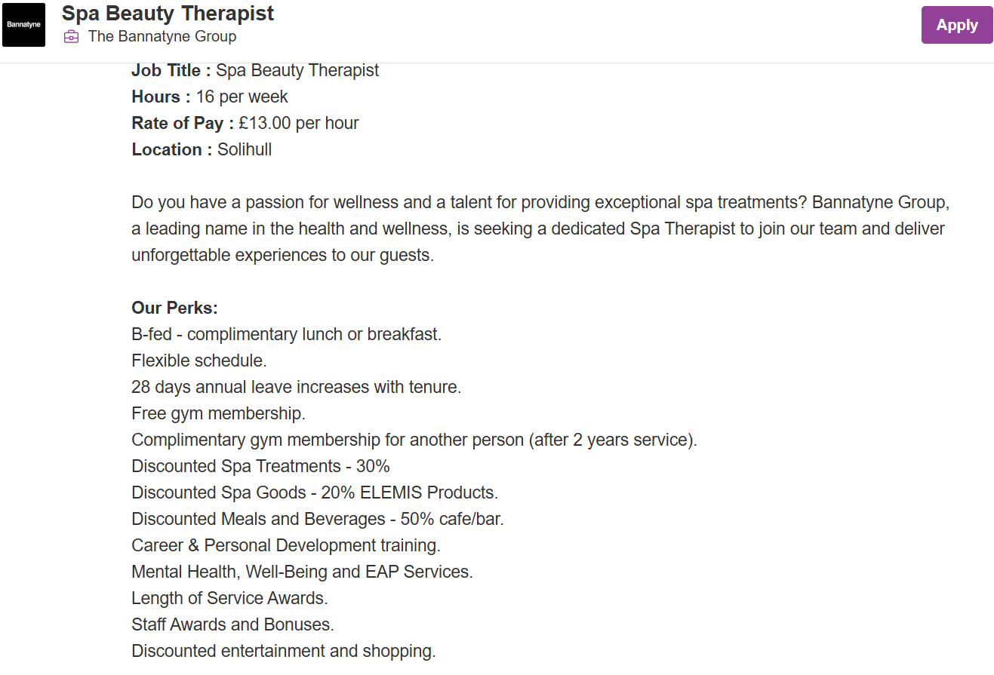

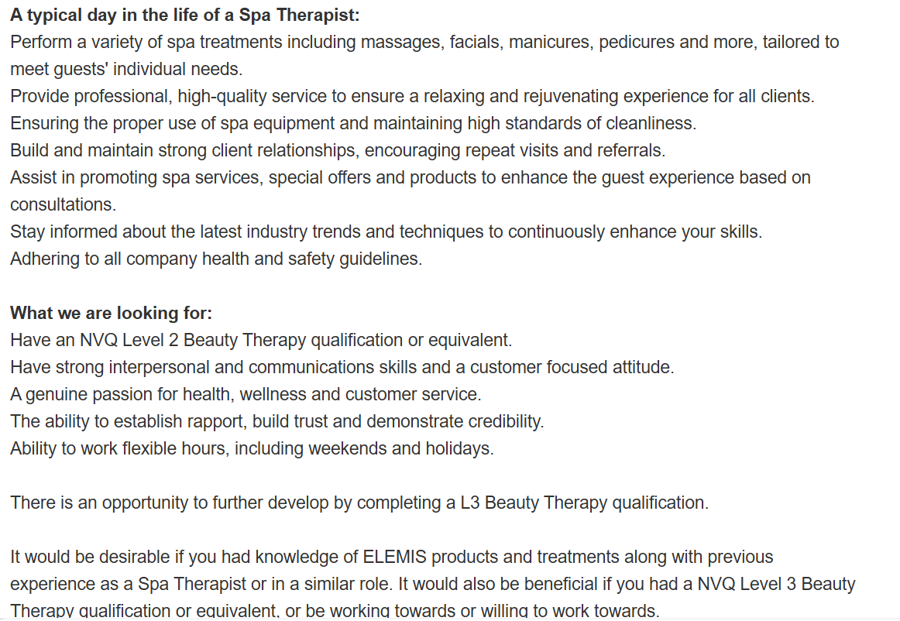

Job Link: Spa Beauty Therapist in Solihull, West Midlands | The Bannatyne Group

Key Skills
- NVQ2 Beauty Therapy
- Good communication skills
- Good customer service skills
- Interpersonal skills
- Teamwork
- Client care & Empathy
- Consultation & Advice
- Discretion & Trust
- Health and Safety
- High standard or hygiene and cleanliness
- Sales and Retailing

Both Jobs require the same key skills and qualifications.
They are both set up in the same work setting (spa) and deliver the same services and customer requirements.
They both require a professional, welcoming and relaxing approach.
The first Job advertisement
Requires you to be able to promote products and services that the spa has to offer. This position requires you to work weekends.
The second Job advertisement
Offers an opportunity to further develop by completing level 3 in Beauty Therapy. The position requires you to have or gain knowledge on ELIMIS products and offers a wide range of perks.

Key skill that will benefit future employment
I feel that building up good communication skills, customer service skill and interpersonal skills will help with employment in the future as the choice of career id like to go down requires these skills, as well as may other professions if choosing to change direction/ employment goals. Most jobs roles require interaction with other members of the public and carrying out services to meet peoples needs. It’s a good set of skills to have, improve constantly and builds a good impression for both your and the desired company you work for (or your own business if that’s the route you choose to go down). It builds comfort and trust within companies and with customers and gives a good impression for responsibility within the work environment.
Building these skills help in every aspect of employment and in normal day to day life.

SWOT Analysis
Strengths | - Customer Service/ Communication Skills: Built up and through other employment roles.  - Ability to carry out effective consultations (Allergies, required results) through training at college (also carried out on paying clients) and Aesthetics course; witch involves more technical consultations and a more detailed approach to examining, allergies, skin types and the effects that treatments can have on people. This also includes carrying out risk assessments and making sure clients sign a consent form, medical questionnaire and consultation form for treatments.  - NVQ2 Beauty Therapy: Ability to carry out Beauty treatments such as Facials, Waxing, manicure, pedicure, massage, eyelashes etc.  - Polite, Friendly and Welcoming approach: In Beauty it is essential that clients feel relaxed and comfortable whilst receiving treatments as that is part of the service provided.  - Health and Safety / Cleanliness and hygiene is another important factor to the Beauty environment as cross contamination and stop reduce the risk of infection. The correct ways to clean tools and areas of treatment was also gained through training.  - Aesthetics Trained: Ability to carry out more advanced treatments and consultations such as Botox, Filler, Microneedling, Skin peals, fat injections, B12 Injections, Dermaplaning and Skin Boosters.  - Medical Anatomy training completed: this is essential for aesthetics as you need to know the areas in the body and the things that can be effected when injecting. Precision and knowledge on the human body is needed to avoid problems or medical disasters.
Weaknesses | - No experience in employed Beauty Spa environment. Never worked in a Professional Spa, However worked in a college Spa with paying customers that came in for treatments.  - No NVQ3 in Beauty Therapy, witch other applicants may already have.
Opportunities | - Aesthetics trained: So can provide extra services to spa/ business if they chose to expand with more advanced treatments.  - Willing to learn / Complete NVQ 3 Beauty therapy.  - Extra knowledge on in depth consultations through CPD training course in Aesthetics (Skin types, anatomy etc).
Threats | - Some people already qualified or trained in NVQ3 Beauty therapy. So there able to carry out a wider range of treatments.  - Others may already have experience in this sector / working in a professional spa.  - Alot of competition when applying for these positions.

Completed NVQ2 Diploma in Beauty Therapy in 2011-2012. Qualifications gained was:
- Level 3- Ensuring responsibility for actions to reduce risks of health and safety
- Level 2- Provide facial skin care treatments
- Level 2 – Enhance the appearance of eyebrow and lashes
- Level 2- Carry out waxing services
- Level 2- Provide make-up services
- Level 2- Fulfil salon reception duties
- Level 2- Promote additional services or products
- Level 2- Develop and maintain your effectiveness at work
- Level 2- Provide manicure services
- Level 2- Provide pedicure services
During the course, the treatments provided were carried out on paying clients in a Collage Salon/ a professional setting. Consultations were carried out and the process was monitored and assessed by the tutor,
making sure everything was done to a high, professional standard. The preparation and hygiene of the working area and tools were also part of the training.

Completed CPD (certificate of continuing professional development) in Aesthetics in 2025. Certifications in:
- Foundation Botulinum Toxin
- Foundation Dermal Filler
- Skin Boosters & Polynucleotides
- Vitamin B12 Injections
- Microneedling
- Skin peels
- Dermaplaning
- Lemon Bottle Fat Dissolve
- Anatomy and Physiology
During this course, the treatments provided were also carried out on paying clients in a professional, training academy. In-depth consultations and assessments were carried out, to find out required / desired look and information provided on what to expect and the aftercare that’s needed. The relevant forms were checked and signed before services were carried out. The correct medical equipment, products and safety checks were assessed upon providing treatments.

Employment Goals
I would like to gain experience in working within a professional Beauty Spa. This will help me build my confidence in this line of work and allow me to gain experience with providing treatments on different types of people (skin tones, face/ body shapes, required looks for people preferences). I would like to build a portfolio on the treatments I carry out in a salon, as this will give me self-gratification when it comes to achieving the desired treatments and looks for satisfied customers. I believe that knowledge and providing a good service come through experience. I hope to gain a Level 3 qualification in Beauty Therapy so I can provide more services and treatments. Working in a Beauty salon and achieving a Level 3 qualification, will align with my career aspirations.
In the future I hope to set up my own Beauty Salon / Aesthetics Clinic and provide services that help people to feel confidant and good about themselves.

Personal Development Plan
I would like to work in a salon over the course of 2-3 years. This will give me the opportunity to gain experience, learn whilst carrying out treatments and help me gain more knowledge on the process and outcomes of the treatments I carry out. It will also give me the opportunity to provide services to a wide range of people, helping me to improve on customers service skills, interpersonal skills and communication skills. It will also help me improve on knowledge and advice that I can offer people, as well as improving the assessment and consultation side of things as outcomes and the effects of treatments can vary depending on each client.
Whilst working in a salon and gaining the experience, I hope to complete my NVQ3 in Beauty Therapy. This is a one year course and requires a couple of days a week at college. So I hope to be able to work this around employment.
After gaining enough experience I hope to open my own Salon / Aesthetics Clinic.
Key Performance Indicator:
Specific | Measurable | Attainable | Relevant | Time-Bound
Get a job in Salon | Within the next 2 months | Gain experience of working within a salon environment. Gain experience working on clients.  Gain experience and knowledge with carrying out treatments.  Build portfolio of treatments and results | Gain all the relevant qualities, knowledge and experience of working in a salon. | For the next 2-3 years
Start NVQ3 in Beauty therapy course | Within the next 6-12 months | Gain qualification and training for more treatments | Gaining more skills and knowledge to be able to carry out a wider variety of treatments within salon | Complete within a year
Open own salon | 3-4 years | Build own business and client base | Work for myself  Make my own income  More freedom  Employing my own staff | Future
Adapted from: https://thinkmarketingmagazine.com/how-to-create-smart-goals/

