
PG Cert tHE

MODULE CODE: UNHE 7009

ASSESSMENT COMPONENT: Professional Portfolio

STUDENT NAME: Rhiannon Akers
PRACTICE ADVISOR: Julie Thomas
TUTOR: Katie Gardner
PROGRAMME LEAD: Mark Flagg

STUDENT NUMBER: 0300943
Word count: 7841

Use of Generative AI in Assessment

RESEARCH | For this assessment, you can use Generative AI to support you in research, including searching for bibliography, using tools to summarise, compare and interrogate materials. | Yes ☒  No ☐
STRUCTURE | For this assessment, you can use Generative AI to support you in structuring your submission, including creating a draft argument structure, identifying parts and headings, etc. | Yes ☒  No ☐
PROOFREADING | For this assessment, you can use Generative AI to check your own text/creation for grammatical and syntactical mistakes, including rephrasing of your own work within specific standards. | Yes ☒  No ☐
WRITING | For this assessment, you can use Generative AI to create text for submission. | Yes ☐  No ☒
CREATIVE | For this assessment, you can use Generative AI to create creative materials, such as images. | Yes ☐  No ☒
PROGRAMING | For this assessment, you can use Generative AI to create and check code. | Yes ☐  No ☒
NONE | For this assessment, you are not allowed to use any type of Generative AI support. This includes research support, structure support, writing/proofreading support and creative support. | Yes ☒  No ☐

AI Acknowledgement
I confirm that I have not presented any AI generated materials as my own work in this portfolio.
However, I acknowledge that I used AI in the research process, namely, the UWTSD Library Research Assistant, to assist in locating appropriate, credible, academic literature.

Contents
1.0 General Statement 5
1.1 CIPD students 5
1.2 Employability Skills students 6
1.3 My approach 6
2.0 Microteach reflection 9
3.0 Teaching Intervention Cycle 11
3.1 Introduction 11
3.1.1 The background and context 11
3.1.2 Teaching pedagogy 12
3.2 Findings 13
3.2.1 Diagnosis 13
3.2.1.1 Peer support 14
3.2.1.2 Confidence in technology 15
3.2.2 Plan of action 16
3.2.2.1 Peer support 17
3.2.2.2 Confidence in technology 18
3.2.3 Action taken 20
3.2.3.1 Learner consultation 20
3.2.3.2 Peer support actions 21
3.2.3.3 Confidence in technology 22
3.2.4 Evaluating the action 22
3.2.4.1 Peer support 23
3.2.4.2 Confidence in technology 23
3.2.4.3 Learner performance 24
3.2.4.4 My performance as facilitator 25
3.3 Learning for practice 25
4.0 Teaching Observations 27
4.1 Teaching Observation 1 – Reflection – 11/02/26 27
4.2 Teaching Observation 2 – Reflection - 24/02/26 29
4.3 Teaching Observation 3 – Reflection - 26/02/26 30
5.0 Continuous Professional Development (CPD) 33
5.1 CPD 1 - 16/12/25 33
5.1.1 The learning experience 33
5.1.2 What I learnt 33
5.1.3 Changes to my approach 34
5.1.4 Wider impact 35
5.2 CPD 2 – 04/02/26 35
5.2.1 The learning experience 35
5.2.2 What I learnt 36
5.2.3 Changes to my approach 37
5.2.4 Wider impact 37
5.3 CPD 3 – 18/02/26 37
5.3.1 The learning experience 37
5.3.2 What I learnt 38
5.3.3 Changes to my approach 39
5.3.4 Wider impact 39
6.0 Teaching Log 40
7.0 Reference List 42
Appendix A – Microteach session slides 49
Appendix B – Teaching Observation 1 57
Appendix C – Teaching Observation 2 62
Appendix D – Teaching Observation 3 66

1.0 General Statement
I have been teaching at the University of Wales Trinity Saint David (UWTSD) since November 2023. I joined the teaching profession after working in the Human Resources (HR) sector for 17 years. My passion for the sector, coupled with my desire to help and support others learn (Chen, 2019) (A4), led me to apply for my current role of Human Resources Lecturer. At present, I teach across 2 programmes; Chartered Institute of Personnel Development (CIPD) at level 3 to 7 and Employability Skills at level 4-6. I also complete Programme Manager duties for CIPD level 3 and Programme Coordinator duties for Employability Skills level 5-6.
The students I teach range from those who are working full time, and those who are unemployed, many of which are returning to education after many years. Due to teaching across a variety of levels, I have a deep understanding of the importance of adapting my teaching approach to meet the needs of the learners (K1,K2,V1). For example, at level 3, I provide introductions to different concepts and theories with group activities focusing on description (V1,A1,A2,A4). At level 7, I incorporate more complex case studies to encourage critical thinking and take more of a facilitator role due to their experience and more complex learning outcomes (V2,K2,K3).

1.1 CIPD students
The majority of these students are working in HR in some capacity. They are often keen to learn about theory but also benefit from practical application. I have found the most effective approach is to incorporate practical examples from my own personal experience in industry and group activities to solidify their understanding (V4,A4,K1).

1.2 Employability Skills students
Many of the students I support on the Employability Skills programme speak English as their second language and come from a range of cultural backgrounds. I am respectful towards the diversity within these teaching groups and ensure my explanation of theories and application of group activities are appropriate (V1,V2,K1,A2). I do this by speaking clearly and allowing extra time to process information, as well as the use of mind mapping and in class research activities to aid student’s reading ability and confidence (Brandt, 2009).

1.3 My approach
I take a humanistic approach to teaching (Wilkins, 2024). I am a strong believer in creating a safe, welcoming environment within the classroom and lean towards coaching and mentoring learners to inspire (Kirylo, 2016) (K2,A4). Elements of my approach could be linked to behaviourism as I utilise positive reinforcement through real-time feedback, discuss expectations and provide direct instruction (Abramson, 2013) (A3,K1,A1). In contrast, I have found that other elements of behaviourism, such as negative reinforcement or punishment, are not conducive to a productive learning environment. This is supported by Knowles et al. (2025), who state that learning will increase if learners have a level of autonomy based on their individual goals. I am flexible yet consistent, which helps to build trust and psychological safety among students. To ensure success, learners need to feel able to ask questions when unsure and know that their opinions will be heard (Martin, 2020) (A3,V1).
Student voice is imperative to ensure the learning environment is meeting students’ needs. Recent feedback received from the 2025 PTES survey demonstrates my approach with comments such as follows: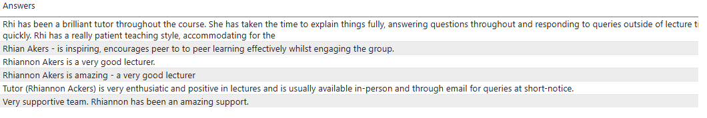
I create an inclusive environment by getting to know my students individually, making them feel valued by taking a personal interest (V1,V2). This further supports my humanist approach as it allows me to ensure that the learning content is relevant to their own interests and concerns (Goldhawk, 2023) (A1,A2).
When in the classroom environment, I consider myself a leader and ensure that I lead with passion, empathy and understanding (Coates, 2007; cited in Almulla, 2023). For example, in a recent level 3 workshop, due to behaviour displayed in the classroom, I identified that several learners were lacking in confidence following constructive feedback received for their first module (A3). To overcome this, I incorporated time at the end of the session to allow learners the opportunity to go through their feedback on an individual basis (V1,V2). We worked together within this shared environment and several learners reported feelings of higher confidence as a result (Sawyer, 2022).
I make use of the tools available to me to aid the overall teaching experience (Zhang, Peng and Jongmoo, 2024) (K4). For example, I utilise technology such as Vevox to create unique learning experiences and have attended online training with the Digital Skills team to progress my knowledge of the platform (V5,K4,A5). I find Vevox particularly useful for situations such as gaining students thoughts and feelings around a topic at the start of a lecture through a word cloud. Vevox allows students to submit their answer anonymously which is preferable for those learners who are less inclined to contribute vocally (V1,K4).

2.0 Microteach reflection
The microteach session took place on 07/01/26. My chosen topic was Evidence-Based Practice, as it is a concept I feel passionate about (V3), teach regularly and could be introduced within the designated timeframe. The session was held online. I prepared clear PowerPoint slides (see Appendix A), learning outcomes and key content which I then elaborated on during the session (A1,A2,K2). Engaging learners within a virtual environment can be a challenge for many reasons such as potential technical issues and lack of active learner engagement (Zhang, Peng and Jongmoo, 2024). To overcome this, I designed the session to include interactive activities to engage participants including a quiz to check the learning outcomes had been met (K2,K4,A2).
I was quite apprehensive at first due to being aware I was being assessed and my drive to do well. I was also a little nervous about the timeframe of 10 minutes so I made sure the session was designed with this in mind (A1). Engaging with participants led to positive emotions which in turn, enhanced my teaching (Chen, 2019) (K1).
The structure of the session was deemed appropriate for a variety of learning styles (V1,V2,K1,A1). I encouraged questions and verbal participation, but also included an activity for participants to add their answers to the chat. I received positive feedback relating to this, as well as the use of Vevox, an effective digital resource (K1,K2,K4). Participants also noted appreciation for the provision of further reading in the topic area (Lee and Ragupathi, 2025) (V3,K4).
Feedback highlighted that I gave positive praise to the participants throughout the activities, which led to them feeling encouraged and engaged (Sun, 2021). This is incredibly important to me as I pride myself on my ability to ensure students feel comfortable and valued (A1,V2,A2).
Overall, the feedback received from participants was overwhelmingly positive and I will continue to plan my teaching with this approach in mind (A1,A4,K4,V4). Specifically, I will develop my use of digital resources to improve my confidence in this area and make every effort to ensure thorough preparation for each taught session (D1,V3,K4). This will allow me to focus on learner engagement and facilitation.

3.0 Teaching Intervention Cycle

3.1 Introduction
This reflective report explores the process of a teaching intervention implemented for learners studying the part-time Postgraduate Diploma in Strategic People Management. This level 7 qualification is accredited by the Chartered Institute of Personnel Development (CIPD). Students on this course typically work full-time in the Human Resources sector.
A teaching intervention cycle can be defined as a structured process used to guide curriculum, instruction, and assessment with the aim of improving student learning outcomes (Jin, Zhan and Anderson, 2013). They can take many forms. For example, utilising digital web-based tools to support iterative assessment and reflection, allowing the facilitator to adapt to different learning contexts and the needs of the students (Cadieux Bolden, Hurt and Richardson, 2017). Findings from a study by Stromme and Furberg (2015) define facilitators as the “glue” that helps learners to link aspects of support, such as peer collaboration and digital tools. I agree with this approach and will explore this impact throughout my reflection (V5,K2,K4,A2,A4).
The importance of teaching intervention cycles is heavily linked to the encouragement of reflective practice by the facilitator, as well as the drive to improve the teaching experience and performance of students (Machost and Stains, 2023). This reflection will examine the impact on both my approach as a facilitator (A5,K2,K5) as well as the impact on learners.

3.1.1 The background and context
The module in question is Driving Change and Building a Business Case. The summative assessment criteria included a written report and a presentation at a conference-style event with their peers and members of the teaching team (K2). I took over this module in 2024, teaching first-year learners working on their chosen research project over the summer, culminating in the conference-style event.
Following completion of the module in 2024, learners reported feelings of isolation from their peers throughout the research period over the summer break and uncertainty when presenting their research recommendations. They also experienced a lack of confidence in utilising new technology offered by the immersive room team.
Specific feedback included:
“Difficulty completing the work over the summer period due to lack of regular contact with other students”
“I enjoyed presenting in a different environment but did not feel prepared to use the immersive room”

3.1.2 Teaching pedagogy
My approach was guided by constructivism theory. According to Goldhawk (2023), constructivism theory is the concept that knowledge is gained through experiences and by progressing from what you already know. This is based on Piaget’s theory of cognitive development and the importance of understanding how knowledge is constructed by individuals (Kamii and Ewing, 1996). Consideration of constructivism alone is not always sufficient for adult learners due to differing learning preferences and levels of experience (V1,V2,V3,A4).
Student engagement and collaborative learning are extremely prominent for this group of adult learners. I have identified that learning is often motivated by practical application and the ability to relate concepts to their work (K1,V4,V1). This links to adult learning theory which emphasises the importance of relatedness and growth needs being met to sustain motivation during the learning process (Diep et al., 2019). In contrast, Salter (2011) found that willingness to engage in the learning process is impacted by prior experiences and individual personality traits. Schiller et al. (2023) identified that adult learners often require instructional clarity, organisation and autonomy. Applying these ideas in the context of this module, I established the need to balance providing clear guidance with allowing autonomy to enhance the quality of my teaching delivery and meet the needs of learners (K3,K5,K1,V1,V4).
Vygotsky’s theory outlines the imperative nature of structured support for learners within their zone of proximal development (ZPD). This is the difference between what learners are able to achieve independently, compared to what they are able to achieve when receiving structured guidance (Lambright, 2024). From the outset, I was conscious of the potential differences between learners in relation to overall capabilities, experience and learning preferences (V1,V2,K1).
When reflecting on the module, I asked myself how I can improve the experience for learners the following year (A1,A4,K3,K5,V1). I utilised the action research cycle developed by Susman and Evered (1978) which highlights the need to diagnose what action is needed, planning action, taking action and evaluating action (K3).

3.2 Findings

3.2.1 Diagnosis
Initially, it was important to establish what part of the process needed to change to improve learner experience and performance. Various factors impacted learners the previous year such as timing, external pressures, confidence and workload; however key areas of improvement identified were as follows:
- Perceived isolation and lack of peer support whilst completing research throughout the summer.
- Lack of confidence in using the technology available within the immersive room.
These were established through learner feedback and performance. None of the students felt comfortable using the technology available and results dropped compared to previous modules (K3,K5).

3.2.1.1 Peer support
Feedback noted above highlights the impact of a lack of structured peer support and collaboration throughout the summer break. Linking this back to the importance of constructivist learning, this can be developed through collaboration and problem solving tasks (Goldhawk, 2023) (V5,K2,A1). Constructivism can be either cognitive or social. Cognitive constructivism focuses on learning as a personal process of constructing knowledge, social constructivism proposes that knowledge and reality are actively constructed through social interactions, language and cultural contexts. Developing differing methods to encourage peer collaboration helps to develop individual learning (Powell and Kalina, 2009) (V5,K1,V1).
As a facilitator, I felt I had nurtured and created a positive peer network for learners to be able to proactively liaise with each other away from the structured learning environment. I built relationships within the learning environment through the application of Vygotsky’s theory by encouraging social interaction and collaboration when working on group activities and case studies (Lambright, 2024) (V2,V5,K2,A2). However, to be successful outside of this environment, there was a reliance on student engagement when there was no obligation to attend lectures. For collaborative learning to be effective, there is a requirement for a number of ideal group practices and dynamics such as cooperation and mutual engagement which were lacking in the module previously (Bridges and Imafuku, 2020).
In preparation for distance learning, I had previously set up a Teams channel and optional group tutorials for a blended approach (Walker, Chong and Chong, 2021) (K2,K4,A1,A2). Blended approaches can be beneficial for adult learners to allow engagement with resources flexibly (Korr et al., 2012; Biney and Azaglo, 2024). Unfortunately, these resources were underutilised and highlighted the need for structured learning to sustain momentum for the module. This supports the earlier noted findings by Schiller et al. (2023) that although adult learners require autonomy, they also require clear organisation. This could have been overcome by effective course design, training and support to allow learners to optimise the blended learning experience (Tay, 2016), elements I would take forward when planning the intervention (V1,V2,V3,V4,A1,A2,A5).

3.2.1.2 Confidence in technology
Emerging technologies can enhance the learning experience, but this often depends on the support received and the receptiveness of learners. The anxiety experienced by previous learners highlighted a gap between available technology and their digital capability. This gap hindered their ability to fully engage with the tools and use them effectively (Wang, Hsu and Hamilton, 2011). This required me to assess whether students had the necessary skills to utilise the technology available, and if not, explore what support would be available to nurture their skills. This would involve me exploring what barriers they faced and whether these were cognitive, social, attitudinal or health-related (Xu et al., 2025) (V1,K3,A2).
I also identified that practical experience of utilising different technology methods could boost not only their confidence when studying, but also their careers. CIPD (No Date a) now classifies technology and people as core knowledge, highlighting the importance of technological capability within the profession (V3,K4,K5).
The main technology in question is the immersive room, which consists of three large video walls, creating an enclosed digital environment (UWTSD, No Date). The spaces allow learners to become immersed in the content by stimulating multiple senses (K4).
To conclude the diagnosis stage, it was important to assess the feasibility of the intervention. This included my availability to provide additional support and also my own personal capability. Throughout the process, I became aware of my own development needs and realised that I also lacked confidence in using the immersive space. I noted that I could also benefit from further training to improve my capability and to set a good example to guide my learners (A5,A4).
Overall, I established that this intervention could improve the student learning experience for the learners in 2025, through the creation of a collaborative learning community outside of the classroom and building their confidence using technology.

3.2.2 Plan of action
Malcolm Knowles’ (1970) andragogy highlights the difference between the facilitation of education for adult learners compared to child learners (Chan, 2010). While Knowles’ andragogy stresses autonomy, learner feedback suggested they still valued structured support during independent research. According to Stephens et al. (2022), learners engage based on their prior experiences, motivations, and specific needs. In response to this, I planned to consult with students and offered a variety of options to engage with different learning preferences (V1,V2,V3,K1,A1,A4).

3.2.2.1 Peer support
Based on my findings at the diagnosis stage, I established the need for a clearer focus on psychological safety in the learning environment, allowing learners to have a voice and input into their learning journey and being able to collaborate effectively with their peers. This approach is widely recognised as having a significant impact on learner engagement (Matthews and Dollinger, 2023) (V1,V2).
According to Noroozi and De Wever (2023), peer-to-peer learning can enhance self-actualisation, the highest level of Maslow’s hierarchy of needs (Figure 1). This is achieved by developing social acceptance, a positive learning environment and collaborative spaces.
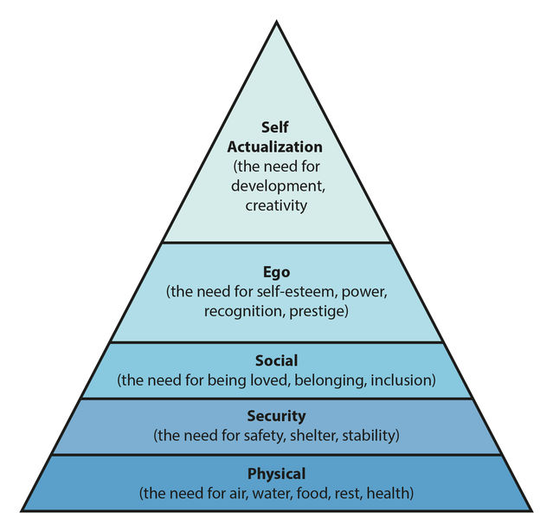
Figure 1. Maslow’s Hierarchy of Needs (Burton, 2024)
To increase the chances of students achieving high levels of psychological safety and self-actualisation, I planned the following actions:
- To conduct learner consultation through the use of online questionnaires (K4) and one to one discussions to gauge learner input for support requirements (V1,V2).
- To create smaller groups of learners based on their research topic and method to accommodate those learners who did not have the confidence to speak up in a larger group (A1,A2).
These planned actions would also assist in planning appropriate structured activities.

3.2.2.2 Confidence in technology
As part of the planning process for improving the use of technology, I utilised Mendelow’s Stakeholder Matrix. The matrix assists in assessing the level of power and influence, as well as the interests, of each stakeholder group.
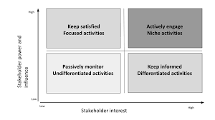
Figure 2. Mendelow’s Stakeholder Matrix (Pilt and Himma-Kadakas, 2023)
I identified the key stakeholder group as the learners studying the module (V1). I established that they would have both high power and influence and high interest. High power and influence due to their level of engagement being a major factor in the successful use of technology, and high interest due to their desire to complete the module successfully (V2).
I was aware that the impact of their power and influence could be positive or negative depending on their academic motivation. Research into Deci and Ryan’s Self-Determination Theory and the impact on education, found that student motivation is affected by range of factors including personality traits, cultural backgrounds and the students efforts to regulate their own learning behaviours (Caranfil, Badarau and Vicol, 2024). Taking this into consideration, it was imperative to determine their appetite for utilising innovative techniques (Enomoto, Warner and Nygaard, 2021).
I planned to establish the motivation and interests of the learners to ensure they were stimulated in the most appropriate way (Reece and Walker, 2009). The plan was to achieve this through the online questionnaires regarding preferences and one-to-one consultations with each learner mentioned previously, to establish the motivation for their research (V1,K1,A2,A4).
The other key stakeholders to consider were the technical support team. I deemed these to have high power and influence and medium/low interest. High power due to the impact their support could have on learner confidence and medium/low interest due to the team not being directly linked to the module. The process of building confidence through the use of technology meant I would be reliant on the immersive room team for guidance and support. Technical support services in higher education play a vital role in successful use of appropriate technological platforms (Pursan, Timothy and Joseph, 2023) (K2,K4,V5).
Hutchings (2026) highlights the benefits of the learners involvement in designing the use of the immersive room. Allowing students to make decisions can lead to a distinct sense of purpose and an improvement in confidence (Hutchings, 2026) (K2,K4,A2,V4). This supports the plan to engage learners within the planning process, however, learner input must be managed effectively with clear consequences and frameworks to avoid disengagement (Bergdahl et al., 2024).
Lastly, I identified myself as a stakeholder, due to the dedication and facilitation required throughout the process. It was essential that I liaised effectively with all other stakeholders to ensure the success of the intervention (V5), and also commit to develop my own capabilities (A5).

3.2.3 Action taken
Utilising Knowles’ andragogical principles, the process aimed to balance learner autonomy with structured facilitation, ensuring that adult learners felt supported while maintaining control of their learning experience (Reece and Walker, 2009) . My chosen actions focused on learner consultation, peer collaboration and confidence building in technological use. I attempted to strike a balance between independence and support, as too much independence may have reduced confidence, while too much structure may have reduced ownership (V1,V4,K1,K2,K3,A1,A2).

3.2.3.1 Learner consultation
Common themes from the consultation with the new learners were as follows:
- Nervousness regarding the lack of peer support over the summer.
- Enthusiasm for structured group sessions throughout the summer.
- Uncertainty over using the immersive room due to lack of confidence.
- Motivation to perform to the best of their ability and make use of the resources available to them.
This confirms the theory explored so far in relation to the perceived sense of belonging gained from peer support, but is also in contrast with the literature regarding the need for autonomy. The impact of this will be explored within the evaluation (K3,V4).

3.2.3.2 Peer support actions
In response to the findings above, I completed the following actions to improve peer support throughout the research process:
- I incorporated informal presentations in class to give learners exposure to presenting in front of each other. I encouraged learners to provide peer-to-peer feedback regarding research ideas to develop their relationships and also provided structured feedback myself (A1,A2,A3,V2).
- I set up smaller groups based on research topics and methods to allow peers to share ideas in a safe space, particularly for those who lack confidence in speaking in front of a larger group (V1,V2,V5).
- I planned group tutorials to give learners exposure to the questions and progress of their peers, which can enhance the learning experience (V5,A2). The risk of this approach is that comparison with other learners can lead to uncertainty and low self-esteem (Harvey and Keyes, 2020). To combat this, one-to-one tutorials were arranged following the group tutorials to allow me to provide tailored individual support to learners (V1,V2).
These actions created a community of learning through the research project, which can be quite an isolated process (Walker, Chong and Chong, 2021).

3.2.3.3 Confidence in technology
The following actions were completed with the aim of improving confidence in using the immersive room technology:
- I arranged a one-to-one tutorial with the immersive room team to improve my understanding and capability of using the technology available (V5,K4,A2,A4,A5).
- I organised in-person group tutorials in the immersive room in the weeks leading up to the conference-style event, utilising the support from immersive room team who were able to guide students (A1,A2,K4,V5)
- I continued to utilise praise and positive reinforcement to encourage learners to present in the same space on the day of the conference-style event (V1,V2,K2).
These actions were driven by social constructivism, which emphasises the influence of social dimensions in learning (Goldhawk, 2023).

3.2.4 Evaluating the action
Reflection is imperative and should be carried out as soon as possible to determine what went well and what could have been improved (Race and Brown, 2025) (K3).
The main pedagogical principles explored throughout this teaching intervention include andragogy, learner autonomy, structured support, psychological safety, peer-to-peer learning and co-designed learning (K1,V3). It was imperative to establish whether applying these principles delivered the expected impact and if learners engaged as theory predicted.
Feedback from learners was captured in two ways. Informal reflection was completed with peers immediately afterwards, followed by an anonymous written feedback form.

3.2.4.1 Peer support
Engagement with group tutorials was high, which demonstrated that learners valued this support (V1,V2,K1,K2). Learners were receptive to the feedback received from their peers through the learning community I had created. Learners reported high satisfaction levels through the feedback channels and stated they were encouraged by the support from their peers (V1,V2,V5,A2).
One learner did not engage with the group tutorials offered and did not attend campus outside of the timetabled classes. Many factors contributed to this, including the distance the learner had to travel to campus and also the high confidence levels of this learner. This learner also had particularly high levels of self-determination and the ability to work autonomously (Hu and Zhang, 2017). This further supports the importance of accommodating differing approaches depending on individual learning preferences (V1,K1,K2,A2).

3.2.4.2 Confidence in technology
My ability to utilise the immersive room improved meaning I was able to demonstrate this to learners, which helped to build their confidence. Facilitators leading by example through their attitudes and behaviours contributes positively to the learning environment and group cohesion (Thomas, 2008) (A5,A4).
6 out of 7 learners attended campus in their own time to utilise the support from the immersive room support team. This demonstrates the positive impact of encouragement from me as a facilitator and peer support (V2,V5,K4).
All learners utilised the immersive room for their presentations, even those who did not initially plan to. This is likely to be a result of positive influence from peers and psychological safety (Boateng et al., 2022) (V5).
Although all learners utilised the immersive room, just one learner utilised the three screens to their full potential by extending different content across the room. This can be attributed to the motivating factors driving the learner as they have a keen interest in technological advancements (V1,K1).
After identifying this through learner consultation, it could have been beneficial if I had honed in on this level of motivation to encourage other learners to do the same. However, whilst I was keen to encourage learners to utilise new technology, I was conscious not to push learners too far out of their comfort zone as this could have lowered their confidence levels (V1,V2,K2).

3.2.4.3 Learner performance
Learners reported high levels of satisfaction after completing the module and referenced an increase in their confidence presenting, attributing this to the learning environment and opportunities for practice in the immersive space (A4,V2,K2). It was also noted by our external examiner that “all students demonstrated commendable effort”. This is significant feedback as comments such as this have not been made previously. This gives the summative assessment process a high level of credibility (Bloxham and Price, 2015) (K5).
Overall, learner performance as part of the summative assessment improved significantly compared to previous years. All learners passed at their first attempt and the average increased from 55.8% to 66.85% (A2,A3,A4). This result suggests that the learning intervention was successful, however, it is also important to note that overall capability, experiences and motivating factors could have differed between the two groups of learners (Diep et al., 2019).

3.2.4.4 My performance as facilitator
I have a clearer understanding of the needs of the types of learners on this programme, particularly in relation to when they are required to work independently (V1,V2,K1,K2,A1,A2). The support requirements greatly differ and this will be something for me to continually consider whilst supporting mature learners (Schiller et al., 2023) .
Learners reported higher levels of confidence, which could enhance their performance in further modules. I have shared my approach to practice with my academic team, specifically, the learner voice activities conducted at the start of the intervention and the contacts utilised to build relationships with the immersive room team (V3,V4,V5,K4). Research by Qin et al. (2025) suggests that by doing this, it can improve overall teaching standards and help to develop new methods.

3.3 Learning for practice
My chosen pedagogical approaches relate to inclusive and collaborative methods. The original problem was not just academic performance, but also confidence and willingness to engage outside of the structured classroom environment.
I found that constructivist and adult learning principles were applied appropriately, but they were most effective when combined with clear structure and facilitation. Smaller groups, consultation and tutorials supported inclusion and psychological safety, which helped all learners to engage outside of the structured classroom environment (V1,V2,K1,K2,A1,A2).
I have learnt that I cannot assume that learners will be keen to implement technology, particularly adult learners. The tools and support may be readily available, but the effective use of these tools depends on a range of factors, including appropriate training and psychological safety (Matthews and Dollinger, 2023) (V1,K4).
This intervention has demonstrated the importance of learner voice through the assessment process. Whilst there is an assignment brief to follow with specific learning outcomes, I have established that the delivery can be led by the learner, to ensure they have the correct environment to allow them to engage and excel (V1,V2,V3,K2,K3,A2).
In my practice, I will therefore ensure that I continuously request and review learner feedback by utilising a range of methods such as one-to-one conversations and anonymous surveys (Race and Brown, 2025). This will allow me to tailor my approach to motivate learners with differing needs and increase the likelihood of continuing to create a psychologically safe environment (V1,V4,A1,A2).

4.0 Teaching Observations
Teaching observations involve colleagues reviewing and providing feedback on each other’s teaching practice and can often be more beneficial when the observation is conducted on a mutual basis (Race and Brown, 2025). The process allows teachers to learn from others through the feedback process and share best practice approaches (V5,K5,A5).

4.1 Teaching Observation 1 – Reflection – 11/02/26
This observation was completed by the Programme Manager, and my Practice Advisor, Julie Thomas. The learners are studying towards their Post Graduate Diploma in Strategic People Management. The feedback received (see Appendix B) has been utilised to write this reflection.
The learning outcome for the session was ‘How to drive an inclusive culture’. I clarified this at the start, as well as the overall structure of the session, to ensure learner’s expectations were managed (A1,A2,K1,K2,A4).
Initially, I referred back to the previous workshop to reinforce their learning (A3,K1). I asked probing questions to ensure relevant information had been retained. Following this, I utilised technology through the use of VEVOX, to engage all students and establish prior knowledge of the new learning outcome (A2,K4,V1).
According to the observer, I maintained a clear communication style and made good use of humour and praise. I used slides appropriately with suitable content included to guide learners through the session (V3,A1,A2,A4). One action recommended is to utilise the up-to-date UWTSD slide template to ensure accurate branding and a professional aesthetic.
I incorporated a range of teaching methods, including a group word cloud, questioning and a pairs exercise, to meet a variety of learning styles. This is imperative as learners will have varying ways of acquiring and processing information (Sanchez, 2022). This also demonstrated my awareness of learners benefiting from applying and trying out concepts through active learning (A2).
I was able to support and guide learners effectively through the use of questions and sharing up-to-date knowledge from the points raised by learners (K1,K2,A4). I adapted my approach accordingly due to one learner being a subject matter expert, encouraging them to contribute and share their expertise (V1,V2,K1,K2). This led to an effective level of peer learning which can lead to wider engagement among learners and ensure learners have a well-rounded experience (Sridharan, McKay and Boud, cited in Noroozi, 2023).
By asking for opinions and debating points, I was able to stimulate discussion appropriate to Post Graduate students and ensure all learners had the opportunity to contribute (K2,K3,V1).
I made adjustments for one learner to join remotely due to a specific set of individual circumstances (V1). I ensured the learner was included in the discussion and referred to them throughout.
This feedback has provided me with confidence in my approach, which in turn can improve my effectiveness as a teacher (Chadha, 2022) (K5,A5). It also reinforces the importance of engaging with learners and nurturing peer-to-peer learning, making use of existing knowledge amongst the learners. I will continue to utilise this approach to engage learners and develop my skills as a facilitator.

4.2 Teaching Observation 2 – Reflection - 24/02/26
This observation was completed by me, on the Programme Manager, and my Practice Advisor, Julie Thomas (see Appendix C). The learners are completing a module called Leading and Developing People and completing their BA Business Management. The learning outcome for the session was an ‘Introduction to Wellbeing in the Workplace’.
Julie was extremely well prepared and included a recap of the content of the previous week. She did this by asking questions to the learners to assess their understanding which was good use of formative assessment (McCallum and Milner, 2021) (K1,K2,A1,A2,A3).
Julie’s positivity and passion for the topic shone through with the enthusiasm she displayed. This is really valuable for learners as the attitude and behaviour of the teacher can have a distinct impact on the learner’s experience and improve levels of motivation (Munyengabe, 2017) (V1,K1,K2,A2).
Julie showed kindness and consideration for learners, gave relevant praise and addressed individual needs. Clear instructions were provided as well as activities for the learners to engage with. Julie also signposted to relevant sources which gave the content academic credibility (V3,K2,V1,A2).
Although there were several activities, it could have been more effective to ask learners to complete just one of the online quizzes to sustain engagement. This will ensure that the activities are appropriate for a wide range of learning preferences (Waite et al., 2021). To actively engage learners, a mix of independent and collaborative learning is most effective (Raisinghani, 2024) (V1,V2,K1,K2,A1).
Julie had prepared thoroughly for the session and incorporated up-to-date, relevant research. I have started to apply this to my practice by making use of the wellbeing resources Julie had accessed within her preparation (V3,V5,K5,A5). The De Neve and Ward (2025) source has been particularly useful as it explores up-to-date approaches to wellbeing in work within the modern workplace. This links to several modules that I teach, so it has been extremely useful.
The way Julie engaged with learners with a language barrier was enlightening. Following the observation, I have made more of an effort to speak with each of my learners one-on-one to check their understanding (V1,V2). This is especially relevant for my Employability Skills learners as many speak English as second language (Brandt, 2009).
I admire Julie’s inclusive approach and learned a large amount from the observation process (A5). Julie was professional yet engaging and comes across as extremely knowledgeable when teaching.

4.3 Teaching Observation 3 – Reflection - 26/02/26
This observation was completed by Senior Lecturer, Ffion Cumberpatch. The learners are studying towards their Masters in Automotive Engineering. This was a new experience for me, as I usually teach learners studying Human Resources or Business. The feedback received (see Appendix D) has been utilised to write this report.
The learning outcomes for the session were as follows:
- Explain principles of managing people.​
- Analyse how motivation, performance and accountability influence team effectiveness.​
- Evaluate how organisational structure affects engineering team management.​
- Identify people management challenges specific to the automotive sector and propose strategies to overcome these.​
- Understand the Equality Act 2010 and the difference between equality and equity.
These were aligned to Bloom’s Taxonomy (1956, cited in Waite et al., 2021) and were deemed to be at an appropriate level for the learners. I ensured these were explained clearly at the start of the session to manage learner expectations (K1,A2,A4).
I had not taught these learners previously, so I started the session by introducing myself and building rapport through the use of humour (K2,A2). Following this, I utilised technology through the use of VEVOX, to engage all students and establish prior knowledge of the learning outcomes (A2,A3,K4).
According to the observer, I was well prepared and structured the content logically with strong application to industry (V4,A1,K2). I was a little reliant on slides at times which could have been a result of trying to include too much information into the session. On reflection, I attempted to include too many learning outcomes within a short space of time. This was apparent in the feedback I received and also within the session as the last activity was a little rushed (A1,A2,A4,K2).
This has highlighted a need to improve my professional courage and influence, a core behaviour of the CIPD (No Date B). From the outset, I felt this would be the case, but I adhered to what the senior lecturer requested. With my knowledge of the topic, I should have suggested a reduced number of learning outcomes to ensure a more streamlined session and further opportunities for active learning (V1,V2,K1,K2,A1,A2,A5,V5). In the future, I will ensure that I raise concerns in advance of the session and contribute my opinion in a constructive manner. This will enhance my teaching practice as well as the learner experience.
Feedback from my observer also noted that I could have done more to engage quieter learners by asking them specific questions. Effective questioning can be an extremely beneficial technique to encourage learner participation (Reece and Walker, 2009) (K2,A2,V2). It is also important to consider that not all learners will feel comfortable contributing in class and vocal participation is not necessarily the only indicator of engagement (Ryder, 2025) (V1).
This observation has had a positive impact on my practice. I have become more mindful of thoroughly understanding my content and ensuring that preparation aligns with the designated teaching time (A1,A2). I strive to challenge suggestions that may impact the effectiveness of my teaching practice. The main takeaway is that I had underestimated the different approach required when teaching learners in a sector that I am less familiar with. I now recognise the importance of adjusting my practice to different contexts (Kolajo, 2025) (A1,A2,V3,V4,K3).

5.0 Continuous Professional Development (CPD)
According to Waite et al., (2021), professional development relates to lifelong learning and development, allowing individuals to take ownership of the skills and capabilities they choose to develop (A5). In turn, this can lead to an increase in both confidence and credibility.

5.1 CPD 1 - 16/12/25

5.1.1 The learning experience
Richard Beggs (Interim Head and Reader in HE Practice at Ulster University) led a session focused on Active and Interactive learning during the staff Nexus Learning conference. This session was a form of targeted CPD for lecturers to engage with relevant learning (Husband, 2014).

5.1.2 What I learnt
The session reinforced my belief that the best way for learners to learn is to discuss what they are learning and apply concepts practically (K1,K2,A1,A2). I learnt that written reflection and a focus on relating new knowledge to past experiences are also imperative to make learning part of themselves (Chickering and Gamson, 1987). The approach is supported by Bellen et al., 2017 and Theobald et al., 2020 (cited in Betts and Oprandi, 2022) who highlight how active learning can narrow the attainment gap for underrepresented groups (V1,V2,A1,A2). This is particularly applicable for the Employability Skills module I teach. It is part of a widening access programme, which provides learners from a range of backgrounds opportunities for study that they may not have otherwise have had. Creating an inclusive environment for these students in particular is imperative (V1,V2,V4).
The session explored the importance of both staff and student engagement in the active learning process, a learner-centred focus and encouragement of peer learning (V1,V2,A1,A2,A4). I learnt that active learning can be silent, for example, completing a written activity. I had previously considered active learning as only group discussions/activities so this was an important takeaway for me (V1,K1,K3,A1,A2).
I also learnt about flip learning and active learning sets. Flip learning can involve recording short videos for students to watch in advance of the session (A2) (Bergmann and Sams, cited in Galindo, 2014). Active learning sets involve putting learners in groups, making one the presenter with a real world problem and other group members ask open questions to help solve the problem (K1,K2,K3,A1,A2).
I was introduced to Dale’s cone of learning (Figure 1) which outlines the extent to which certain activities are generally remembered by learners.
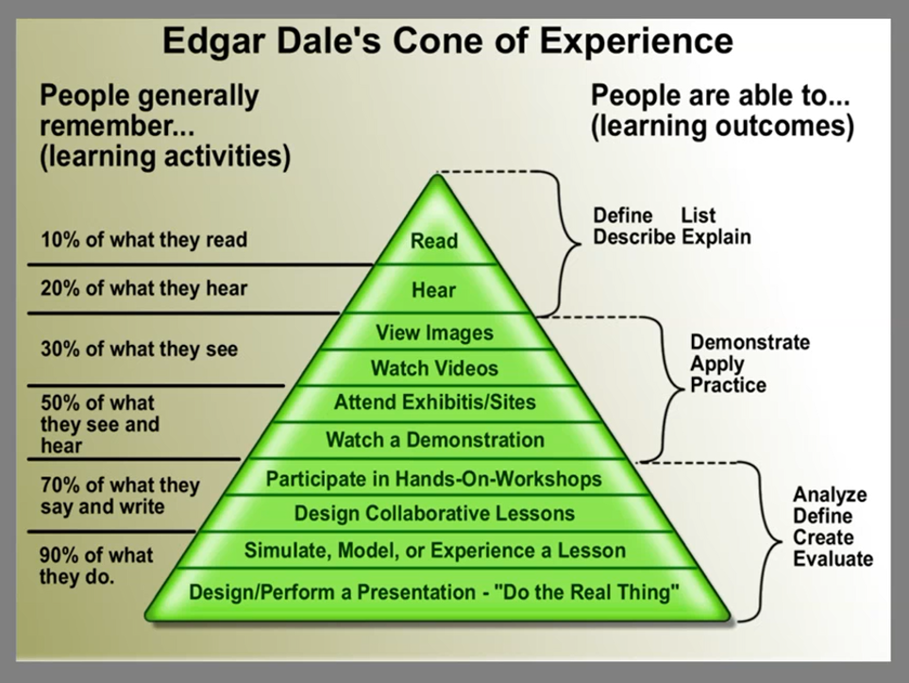
Figure 3. Cone of Experience (Beggs, 2025)

5.1.3 Changes to my approach
I have utilised more individual written activities within my teaching to encourage silent active learning. This has allowed for all learners to be included, no matter their learning preferences (D1,V1). I have also considered Dale’s cone of learning when planning for workshops to ensure a range of suitable activities are included to meet the learning outcomes (A2,A4).
I have incorporated active learning sets within my teaching for Post Graduate students when preparing for their assignments. This helped to develop their critical thinking and propose suitable recommendations for their organisations (V3,K3).
I have also trialled flip learning with my CIPD students by sharing a video for them to watch before the taught session. Unfortunately, this had a limited impact as several students did not watch the video in advance, which led to inconsistencies with the learner’s initial knowledge base for the session. If I try this again in the future, I will ensure that students are aware of the importance of the video to aid their in-class learning experience (K4,A1,A2,A4,A5).

5.1.4 Wider impact
I have utilised the book recommended to prompt ideas for effective teaching practices and made adjustments to my workshop preparation as stated above. I have also shared the book recommendation (Betts and Oprandi, 2022) with colleagues who were unable to attend the session, to encourage an active learning approach throughout the programme (V3,V5,A5).

5.2 CPD 2 – 04/02/26

5.2.1 The learning experience
Andrew Cooper conducted a guest speaker session to my Post Graduate students studying Strategic People Management. The session was based on the book ‘Under Investigation’ by Cooper and Neal (2025). The book explores the concept of transforming disciplinary practice in the workplace by adjusting the mindset of those leading workplace investigations.

5.2.2 What I learnt
The session was incredibly insightful, encouraging people managers and practitioners to view investigation processes in a different light. There was a strong focus on the concept of avoidable employee harm by introducing progressive polices as opposed to punitive measures (V3,V4).
The session highlighted the severe impact of investigations on individuals even if they result in no action. This can lead to emotional distress and lack of trust in an organisation. The use of examples from the real world enhanced the impact of the knowledge transfer throughout the session (Herrington and Herrington, 2006) (K1,K2,A1,A2).
There was a clear emphasis on the importance of communication and timely follow-ups to ensure employers are mindful of the welfare of employees throughout the disciplinary process. This is something I have always championed throughout my career in HR, and in turn, has transferred to my approach as a teacher when supporting learners (Bilz et al., 2022) (V1,A2,A4).
The session highlighted increasing demands of management’s role in the investigation process and the need for training and support for managers on an emotional level too. This is an approach I have advocated for previously due to the importance of psychological safety across all environments (V1,V2,V3,V5).
The overall message is for organisations to have less focus on risk management, and more focus on resolution, empowering employees to speak their truth and have a clear voice in an investigation process. Unfortunately, many employees end up being passive subjects as opposed to active participants in the process. Cooper and Neale (2025) have a clear purpose to change this and promote the return on investment for organisations.

5.2.3 Changes to my approach
Although the session related to how to manage employees, I have applied this mindset to learners as I feel there are many similarities. For example, ensuring my learners are active participants in their learning journey (V1,V2,K1,A4). This also has links to the findings from my teaching intervention.
I have also integrated this approach into my teaching content when discussing the impact people professionals can have within their organisations. At times, I have previously focused more on process, which, although important (ACAS, 2010), there needs to be consideration for the people within the process.

5.2.4 Wider impact
I have promoted the book to my learners as well as current and previous colleagues within the people profession (V5,A5). I am a firm believer in the concept and feel this approach can have a beneficial impact on organisations by improving trust culture and psychological safety through investigation processes (V3,V4). This is also supported by the CIPD (2024) who state that where possible, informal action is the best way to resolve an issue.

5.3 CPD 3 – 18/02/26

5.3.1 The learning experience
Data Protection and Freedom of Information training session with Paul Osborne (Data Protection Officer at UWTSD). This was held remotely via Teams.

5.3.2 What I learnt
Data protection is becoming increasingly important within higher education due to the various ways student data is now stored and different communication channels (Kumi‐Yeboah et al., 2023). All staff at UWTSD are responsible for ensuring data is kept securely and preventing confidentiality breaches (V4,A5).
Anything I do with data counts as processing (ICO), meaning I am subject to legislation. I was already aware of the Data Protection Act 2018 (GOV.UK, 2020) and GDPR, but the session was an insightful reminder of my responsibilities within UWTSD (V4,K5). The key elements linked to my day to day role is linked to learner contact details and module outcomes/feedback.
Human error does occur on occasion and the session outlined how to act if it does. For example, attaching draft feedback to an email which is sent to the wrong people. This is considered a data breach, but if you acknowledge making a mistake, report it as a data breach, the Data Protection Officer can assist. Honesty is the best policy. I pride myself on acting with integrity (CIPD, No Date C).
There has been a rise in subject access requests and formal legal proceedings in relation to alleged data breaches. The main guidance was to think before processing any written communication and be aware of expressing opinions. We always need to consider if would be comfortable for any emails/messages were to be seen by the individual they relate to or read out in court (V1,V4,K5).
I also learnt about the Freedom of Information Act 2000 (GOV.UK, No Date), which relates to the types of factual data that we hold. If we receive requests, refer it asap. We cannot ask why they are asking for information.

5.3.3 Changes to my approach
I am now more careful not to make assumptions about email requests I receive for information and feel confident in signposting (V4,K4,A5).
I make sure that I blind copy into any group emails and gain explicit consent if sharing learner data (V1,V4). For example, when requesting previous work submissions as good examples for current students, I now ensure I receive written confirmation from the student rather than just verbal agreement (V1,A1,A4). I also anonymise these, to protect both the learner and the organisation they work for, as some information could be deemed business sensitive (V4,A5).

5.3.4 Wider impact
I have set up secure One Drive folders within our shared Teams Channel for marking moderation to be stored (V4,K4,K5). I have also updated my team to encourage them to do the same by making use of the folders (V5). This helps to ensure that learner data is not shared unnecessarily and saved securely, as opposed to individual drives.

6.0 Teaching Log


PG Cert tHE--TEACHING LOG
Student name: Rhiannon Akers
Student Number: 0300943
Date | Session Details (Teaching/Tutorials/Support?) | No of Hours | Practice Advisor’s Signature
25/09/25 | Teaching – Level 3 – Business Culture and Change in Context | 5.5 | 
29/09/25 | Teaching – Level 6 – Coaching and Mentoring - Cardiff | 4
30/09/25 | Teaching – Level 6 – Coaching and Mentoring - Swansea | 4
30/09/25 | Teaching – Level 7 – Driving Change and Building a Business Case | 3.5
06/10/25 | Teaching – Level 6 – Coaching and Mentoring - Cardiff | 4
07/10/25 | Teaching – Level 6 – Coaching and Mentoring - Swansea | 4
07/10/25 | Teaching – Level 7 – Resourcing and Talent Management | 3.5
08/10/25 | Teaching – Level 5 – Organisational Performance and Culture | 7
09/10/25 | Teaching – Level 3 – Business Culture and Change in Context | 5.5
 |  | Total Hours = | 41

Student’s signature 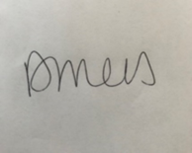

Practice Advisor’s signature ………………..

7.0 Reference List
Abramson, C. (2013) ‘Problems of Teaching the Behaviorist Perspective in the Cognitive Revolution’. Behavioral sciences, 3(1), pp. 55–71. Available at: https://doi.org/10.3390/bs3010055.
Almulla, M.A. (2023) “Constructivism learning theory: A paradigm for students’ critical thinking, creativity, and problem solving to affect academic performance in higher education,” Cogent education, 10(1). Available at: https://doi.org/10.1080/2331186X.2023.217292
Ampartzaki, M. and Kalogiannakis, M. (2023) Pedagogy, learning, and creativity. IntechOpen.
Bebane, S. M. N. T. (2021) ‘Jean Piaget as a Pioneer of Modern Psychology: Critical Review.’ ZANCO Journal of Human Sciences., 25(5), pp. 335–339. Available at: https://doi.org/10.21271/zjhs.25.5.23.
Bergdahl, N. et al. (2024) ‘Unpacking student engagement in higher education learning analytics: a systematic review.’ International Journal of Educational Technology in Higher Education, 21(1). Available at: https://doi.org/10.1186/s41239-024-00493-y.
Betts, T. and Oprandi, P. (2022) 100 Ideas for Active Learning. Open Press
Bilz, L. et al. (2022) ‘A Consequential Partnership: The Association Between Teachers’ Well-Being and Students’ Well-Being and the Role of Teacher Support as a Mediator.’ Zeitschrift für Psychologie, 230(3), pp. 264–275. Available at: https://doi.org/10.1027/2151-2604/a000497.
Biney, I. K. and Azaglo, J. (2024) ‘Experiences of Adult Learners Engaged in Blended Learning beyond COVID-19 in Ghana.’ Open education studies, 6(1), pp. 1–8. Available at: https://doi.org/10.1515/edu-2024-0037.
Bloxham, S. and Price, M. (2015) ‘External examining: fit for purpose?’ Studies in higher education (Dorchester-on-Thames), 40(2), pp. 195–211. Available at: https://doi.org/10.1080/03075079.2013.823931.
Boateng, J. K., Attiogbe, E. J. K. and Kunbour, V. M. (2022) ‘Influence of adult learners’ self-direction on group learning.’ Cogent social sciences, 8(1). Available at: https://doi.org/10.1080/23311886.2022.2064592.
Brandt, C. (2009) Read, research and write : academic skills for ESL students in higher education. SAGE
Bridges, S. M. and Imafuku, R. (eds.) (2020) Interactional research : into problem-based learning. Purdue University Press.
Burton, N. (2024) ‘Our Hierarchy of Needs’. Psychology Today (23 June). Available at: https://www.psychologytoday.com/gb/blog/hide-and-seek/201205/our-hierarchy-of-needs (Accessed: 20 March 2026)
Cadieux Bolden, D., Hurt, J. W. and Richardson, M. K. (2017) ‘Implementing Digital Tools to Support Student Questioning Abilities: A Collaborative Action Research Report.’ I.e. (Wheeling, Ill.), 9(1). DOI: 10.1080/20004508.2017.1305754.
Caranfil, N.G., Badarau, O.L. and Vicol, M. I. (2024) ‘A Brief Overview of Self-Determination Theory: Implications for Educational Psychology.’ Journal of innovation in psychology, education and didactics, 28(2), pp. 253–264. Available at: https://doi.org/10.29081/JIPED.2024.28.2.10.
Carvalho, L.C. (2020) Learning styles and strategies for management students. IGI Global.
Chadha, D. (2022) ‘How Do We Prepare to Teach? Exploring Science Lecturers’ Authentic Approaches to Teaching in Higher Education’. Research in science education (Australasian Science Education Research Association), 52(2), pp. 635–653. Available at: https://doi.org/10.1007/s11165-020-09972-4.
Chan, S. (2010) ‘Applications of in Multi-Disciplined Teaching and Learning’. Journal of adult education, 39(2), p. 25-35. Available at: https://www.scirp.org/reference/referencespapers?referenceid=1211160 (Accessed: 5 April 2026).
Chen, J. (2019) ‘Exploring the impact of teacher emotions on their approaches to teaching: A structural equation modelling approach’ British journal of educational psychology, 89(1), pp. 57–74. Available at: https://doi.org/10.1111/bjep.12220.
Cheng, J. et al. (eds.) (2024) Handbook of Teaching Competency Development in Higher Education. 1st ed. 2024. Singapore: Springer Nature Singapore. Available at: https://doi.org/10.1007/978-981-99-6273-0 .
Chickering, A. W. and Gamson, Z. F. (1987) ‘Seven principles for good practice in undergraduate education’. AAHE Bulletin, 3 (7). Available at: https://doi.org/10.1016/j.iheduc.2004.06.003.
CIPD (No Date a) Technology, the workplace and people management. Available at: https://www.cipd.org/uk/views-and-insights/thought-leadership/insight/workplace-people-management/ (Accessed: 21 March 2026)
CIPD (No Date b) Professional courage and influence. Available at: https://www.cipd.org/uk/the-people-profession/the-profession-map/explore-the-profession-map/core-behaviours/professional-courage-influence/ (Accessed: 25 April 2026)
CIPD (No Date C) Code of Conduct and Ethics. Available at: https://www.cipd.org/en/membership/professional-standards/code-of-conduct/#:~:text=Role%2Dmodel%20high%20standards%20of,the%20CIPD%20or%20other%20members. (Accessed: 28 April 2026)
CIPD (2024) Disciplinary and grievance procedures: Guide for people professionals. Available at: https://www.cipd.org/uk/knowledge/guides/discipline-and-grievance/ (Accessed: 25 April 2026)
Cooper, A. and Neal, A. (2025) Under Investigation. Bristol University Press.
De Neve, J.-E. and Ward, G. (2025) Why workplace wellbeing matters : the science behind employee happiness and organizational performance. Harvard Business Review Press.
Diep, A.N. et al. (2019) “Adult learners’ needs in online and blended learning,” Australian journal of adult learning, 59(2), pp. 223–253.
Enomoto, K., Warner, R. and Nygaard, C. (2021) Teaching and learning innovations in higher education. Libri Publishing.
Galindo, I. (2014) ‘Flip Your Classroom: Reach Every Student in Every Class Every Day - By Jonathan Bergmann and Aaron Sams’ Teaching theology & religion, 17(1), p. 82. Available at: https://doi.org/10.1111/teth.12165
Goldhawk, A. (2023) The Super Quick Guide to Learning Theories and Teaching Approaches. Learning Matters.
Goldhawk, A. (2023) The super quick guide to learning theories & teaching approaches. Learning Matters.
Goodman, G.S. (2008) Educational psychology : an application of critical constructivism. New York: P. Lang.
GOV.UK (2020) Data Protection Act 2018. Available at: https://www.gov.uk/government/collections/data-protection-act-2018 (Accessed: 18 April 2026).
GOV.UK (No Date) How to make a freedom of information (FOI) request. Available at: https://www.cipd.org/en/membership/professional-standards/code-of-conduct/#:~:text=Role%2Dmodel%20high%20standards%20of,the%20CIPD%20or%20other%20members. (Accessed: 28 April 2026)
Harvey, A. J. and Keyes, H. (2020) ‘How do I compare thee? An evidence-based approach to the presentation of class comparison information to students using Dashboard’. Innovations in education and teaching international, 57(2), pp. 163–174. Available at: https://doi.org/10.1080/14703297.2019.1593213.
Herrington, A. and Herrington, J. (2006) Authentic learning environments in higher education. Information Science Pub.
Hu, P. and Zhang, J. (2017) ‘A pathway to learner autonomy: a self-determination theory perspective.’ Asia Pacific education review, 18(1), pp. 147–157. Available at: https://doi.org/10.1007/s12564-016-9468-z.
Husband, G. (2015) ‘The impact of lecturers’ initial teacher training on continuing professional development needs for teaching and learning in post-compulsory education’. Research in post-compulsory education, 20(2), pp. 227–244. Available at: https://doi.org/10.1080/13596748.2015.1030262.
Hutchings, L. (2026) ‘Co-Creating Immersive Learning: A Strategic Shift from Delivery to Partnership’. LinkedIn (28 February). Available at: https://www.linkedin.com/pulse/co-creating-immersive-learning-strategic-shift-from-laura-hutchings-anfpe (Accessed: 28 February 2026)
Jefferson, M. and Anderson, M. (2022) Transforming education : reimagining learning, pedagogy and curriculum. : Bloomsbury Academic.
Jin, H., Zhan, L. and Anderson, C.W. (2013) ‘Developing a Fine-Grained Learning Progression Framework for Carbon-Transforming Processes’. International journal of science education, 35(10), pp. 1663–1697. Available at: https://doi.org/10.1080/09500693.2013.782453.
Kamii, C. and Ewing, J. K. (1996) ‘Basing Teaching on Piaget’s Constructivism.’ Childhood education, 72(5), pp. 260–264. Available at: https://doi.org/10.1080/00094056.1996.10521862.
Kirylo, J.D. (2016) Teaching with purpose : an inquiry into the who, why and how we teach. Rowman & Littlefield
Kolajo, Y. (2025) ‘Advancing pedagogical excellence through reflective teaching practice and adaptation.’ Reflective practice, 26(6), pp. 832–847. Available at: https://doi.org/10.1080/14623943.2025.2504143.
Knowles, M.S. et al. (2025) The adult learner : the definitive classic in adult education and human resource development. Tenth edition. Routledge.
Korr, J. et al. (2012) ‘Transitioning an Adult-Serving University to a Blended Learning Model.’ The Journal of continuing higher education, 60(1), pp. 2–11. Available at: https://doi.org/10.1080/07377363.2012.649123.
Kumi‐Yeboah, A. et al. (2023) ‘Diverse students’ perspectives on privacy and technology integration in higher education’, British journal of educational technology, 54(6), pp. 1671–1692. Available at: https://doi.org/10.1111/bjet.13386.
Lambright, K. (2024) ‘The Effect of a Teacher’s Mindset on the Cascading Zones of Proximal Development: A Systematic Review.’ Technology, knowledge and learning, 29(3), pp. 1313–1329. Available at: https://doi.org/10.1007/s10758-023-09696-0.
Larochelle, M., Bednarz, N. and Garrison, J.W. (eds.) (1998) Constructivism and education. Cambridge: Cambridge University Press.
Lee, A.M. and Ragupathi, K. (2025) ‘Trust and ethos in academic development: credibility, identity, and value’. The international journal for academic development, 30(1), pp. 68–81. Available at: https://doi.org/10.1080/1360144X.2024.2417942.
Machost, H. and Stains, M. (2023) ‘Reflective Practices in Education: A Primer for Practitioners’. CBE life sciences education, 22(2), p. es2. Available at: https://doi.org/10.1187/cbe.22-07-0148.
Martin, J.G. (2020) “Teaching without Fear: Psychological Safety Can Alter the Professional Learning Landscape,” The learning professional, 41(2), p. 36. Available at: https://research-ebsco-com.uwtsd.idm.oclc.org/c/onvpsy/viewer/pdf/ud55vdke6b?route=details (Accessed: 5 April 2026)
Marzano, R.J. (2021) Improving teacher development & evaluation : a guide for leaders, coaches, & teachers. Marzano Resources.
Matthews, K. E. and Dollinger, M. (2023) ‘Student voice in higher education: The importance of distinguishing student representation and student partnership.’ Higher education, 85(3), pp. 555–570. Available at: https://doi.org/10.1007/s10734-022-00851-7.
McCallum, S. and Milner, M. M. (2021) ‘The effectiveness of formative assessment: student views and staff reflections.’ Assessment and evaluation in higher education, 46(1), pp. 1–16. Available at: https://doi.org/10.1080/02602938.2020.1754761.
Munyengabe, S. et al. (2017) ‘Factors and Levels Associated with Lecturers’ Motivation and Job Satisfaction in a Chinese University.’ Eurasia Journal of Mathematics, Science and Technology Education, 13(10), p. 6415. Available at: https://doi.org/10.12973/ejmste/77946.
Noroozi, O. (2023) The Power of Peer Learning : Fostering Students’ Learning Processes and Outcomes. Edited by Omid. Noroozi and B. De Wever. Cham: Springer International Publishing. Available at: https://doi.org/10.1007/978-3-031-29411-2.
Noroozi, O. and De Wever, B. (2023) The Power of Peer Learning: Fostering Students’ Learning Processes and Outcomes. Springer Nature.
People Management (2025) Essential HR skills: technology and AI. Available at: https://www.peoplemanagement.co.uk/article/1931154/essential-hr-skills-technology-ai (Accessed: 21 March 2026)
Pilt, E. and Himma-Kadakas, M. (2023) ‘Training researchers and planning science communication and dissemination activities: testing the QUEST model in practice and theory’. Journal of Science and Communication. 22(6). Available at: https://doi.org/10.22323/2.22060204
Powell, K.C. and Kalina, C.J. (2009) ‘Cognitive and Social Constructivism: Developing Tools for an Effective Classroom’. Education (Chula Vista), 130(2), p. 241-250. Available at: https://go.gale.com/ps/i.do?id=GALE%7CA216181184&v=2.1&it=r&u=walamp&p=AONE&aty=shibboleth (Accessed: 5 April 2026)
Pursan, G., Adeliyi, Timothy.T. and Joseph, S. (2023) ‘Information Technology Technical Support Success Factors in Higher Education: Principal Component Analysis’. International journal of advanced computer science & applications, 14(6). Available at: https://doi.org/10.14569/IJACSA.2023.0140630.
Qin, S., Jia, S. and Su, S. (2025) ‘How does teacher collaboration impact teachers’ innovation ability? The chain mediation of teaching motivation and teaching efficacy’. Humanities & social sciences communications, 12(1). Available at: https://doi.org/10.1057/s41599-025-04965-y.
Race, P. and Brown, S. (2025) The Lecturer’s Toolkit. 6th edition. Routledge.
Raisinghani, M. S. et al. (2024) ‘Learner-Centric Education in Heterogeneous Learning Environments: Key Insights for Optimal Learning.’ International journal of online pedagogy and course design, 14(1), pp. 1–13. Available at: https://doi.org/10.4018/IJOPCD.335950.
Reece, I. and Walker, S. (2009) Teaching, training and learning. 6th edition revised. Business Education Publishers.
Ryder, M. (2025) ‘The Quiet Learner of the UK Art Classroom.’The international journal of art & design education, 44(2), pp. 447–461. Available at: https://doi.org/10.1111/jade.12549.
Salter, L. (2011) ‘Preconditions for Post-Employment Learning: Preliminary Results from Ongoing Research.’ International review of research in open and distance learning, 12(1), pp. 24–41. Available at: https://doi.org/10.19173/irrodl.v12i1.888.
Sánchez, D.O. (ed.) (2022) Active learning : research and practice for STEAM and social sciences education. IntechOpen.
Sawyer, R.K. (ed.) (2022) The Cambridge handbook of the learning sciences. Third edition. Cambridge University Press.
Schiller, E. and Dorner, H. (2023) ‘Preparing adult educators for counselling older adult learners: Lessons learned from a professional development programme in Hungary.’ International journal of lifelong education, 42(6), pp. 550–569. Available at: https://doi.org/10.1080/02601370.2023.2266141.
Schluer, J. and Arndt, M. (2024) Digital feedback in higher education : teaching practices, student voices, and research findings. Bielefeld: transcript Verlag. Available at: https://doi.org/10.1515/9783839475713.
Stephens, M. L. et al. (2022) ‘Adult Learning Facilitators in any Setting, Instructional Designers’ Roles as the Adult Learner and Educator, and their Perceived Knowledge Construction when Preparing Graduate Faculty for Teaching Online: An Interpretive Study.’ New horizons in adult education & human resource development, 34(1), pp. 3–15. Available at: https://doi.org/10.1002/nha3.20319.
Stromme, T. A. and Furberg, A. (2015) ‘Exploring Teacher Intervention in the Intersection of Digital Resources, Peer Collaboration, and Instructional Design’. Science education (Salem, Mass.), 99(5), pp. 837–862. Available at: https://doi.org/10.1002/sce.21181.
Tay, H. Y. (2016) ‘Investigating engagement in a blended learning course.’ Cogent education, 3(1), p. 1135772. Available at: https://doi.org/10.1080/2331186X.2015.1135772.
Thomas, G. (2008) ‘Facilitate First Thyself: The Person-Centered Dimension of Facilitator Education.’ The Journal of experiential education, 31(2), pp. 168–188. Available at: https://doi.org/10.1177/105382590803100205.
UWTSD (No Date) Immersive Rooms. Available at: https://digitalservices.uwtsd.ac.uk/dee/immersive-rooms/ (Accessed: 22 March 2026).
Waite, K., Beevers, K., Small, N., Tomlinson, K and Hussain, S. (2021) People Practice: A Complete Guide. Kogan Page
Walker, R., Chong, S. and Chong, J. (2021) ‘Facilitating peer-led group research through virtual collaboration spaces: an exploratory research study.’ Research in learning technology, 29, pp. 1–21. Available at: https://doi.org/10.25304/rlt.v29.2520.
Wang, Z., Hsu, J. and Hamilton, K. (2011) ‘Developing and Managing Digital/Technology Literacy and Effective Learning Skills in Adult Learners’. International journal of digital literacy and digital competence, 2(1), pp. 52–70. Available at: https://doi.org/10.4018/jdldc.2011010105.
Wilkins, E.M. (2024) ‘The Ongoing Learning Cycle: Understanding a Teacher’s Role in Humanistic Teaching’. Schools (Chicago, Ill.), 21(1), pp. 189–199. Available at: https://doi.org/10.1086/729553.
Wood, M. and Su, F. (2021) Pursuing teaching excellence in higher education : towards an inclusive perspective. Bloomsbury Academic. Available at: https://doi.org/10.5040/9781350055315.
Xu, L. et al. (2025) ‘A systematic review of digital literacy in lifelong learning for older adults: challenges, strategies, and learning outcomes.’ Educational technology research and development, 73(6), pp. 3627–3674. Available at: https://doi.org/10.1007/s11423-025-10530-w.
Zann, A., Harwayne-Gidansky, I. and Maa, T. (2021) ‘Incorporating Simulation Into Your Plan-Do-Study-Act Cycle’. Pediatric Annals, 50(1), pp. e25–e31. Available at: https://doi.org/10.3928/19382359-20201213-01.
Zhang, P., Zhao, P. and Kim, J. (2024) ‘Assessing the Learner’s Engagement Through Virtual Classroom and Teaching Pedagogy: The Mediating Role of Technology Usage’. Comunicar (Huelva, Spain), (78), pp. 16–28. Available at: https://doi.org/10.58262/V32I78.2.

Appendix A – Microteach session slides
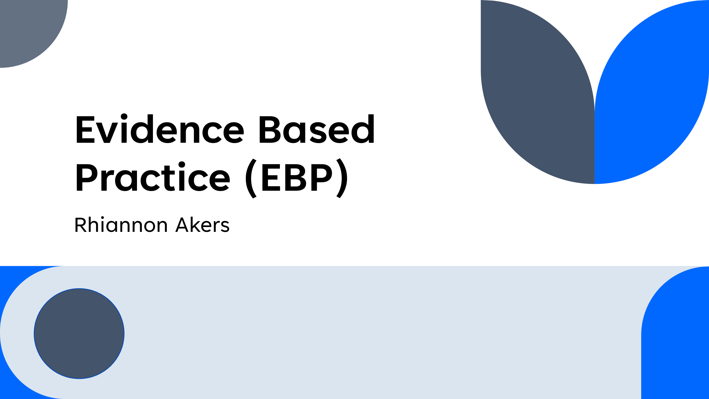
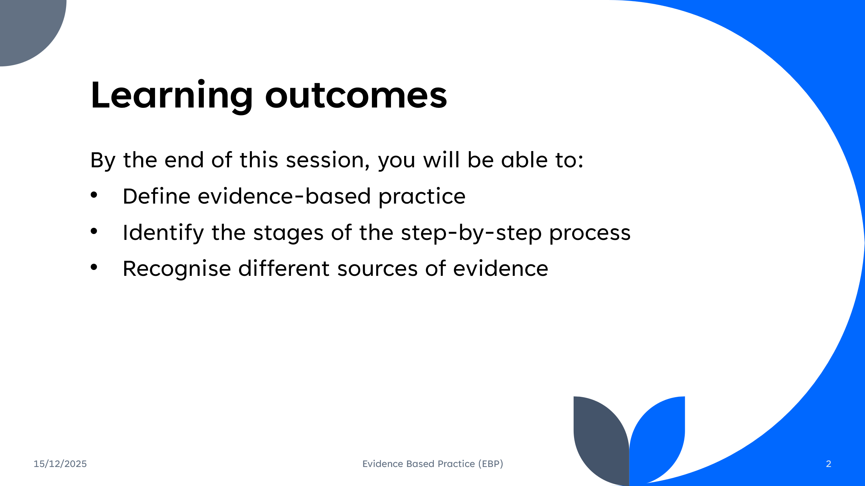
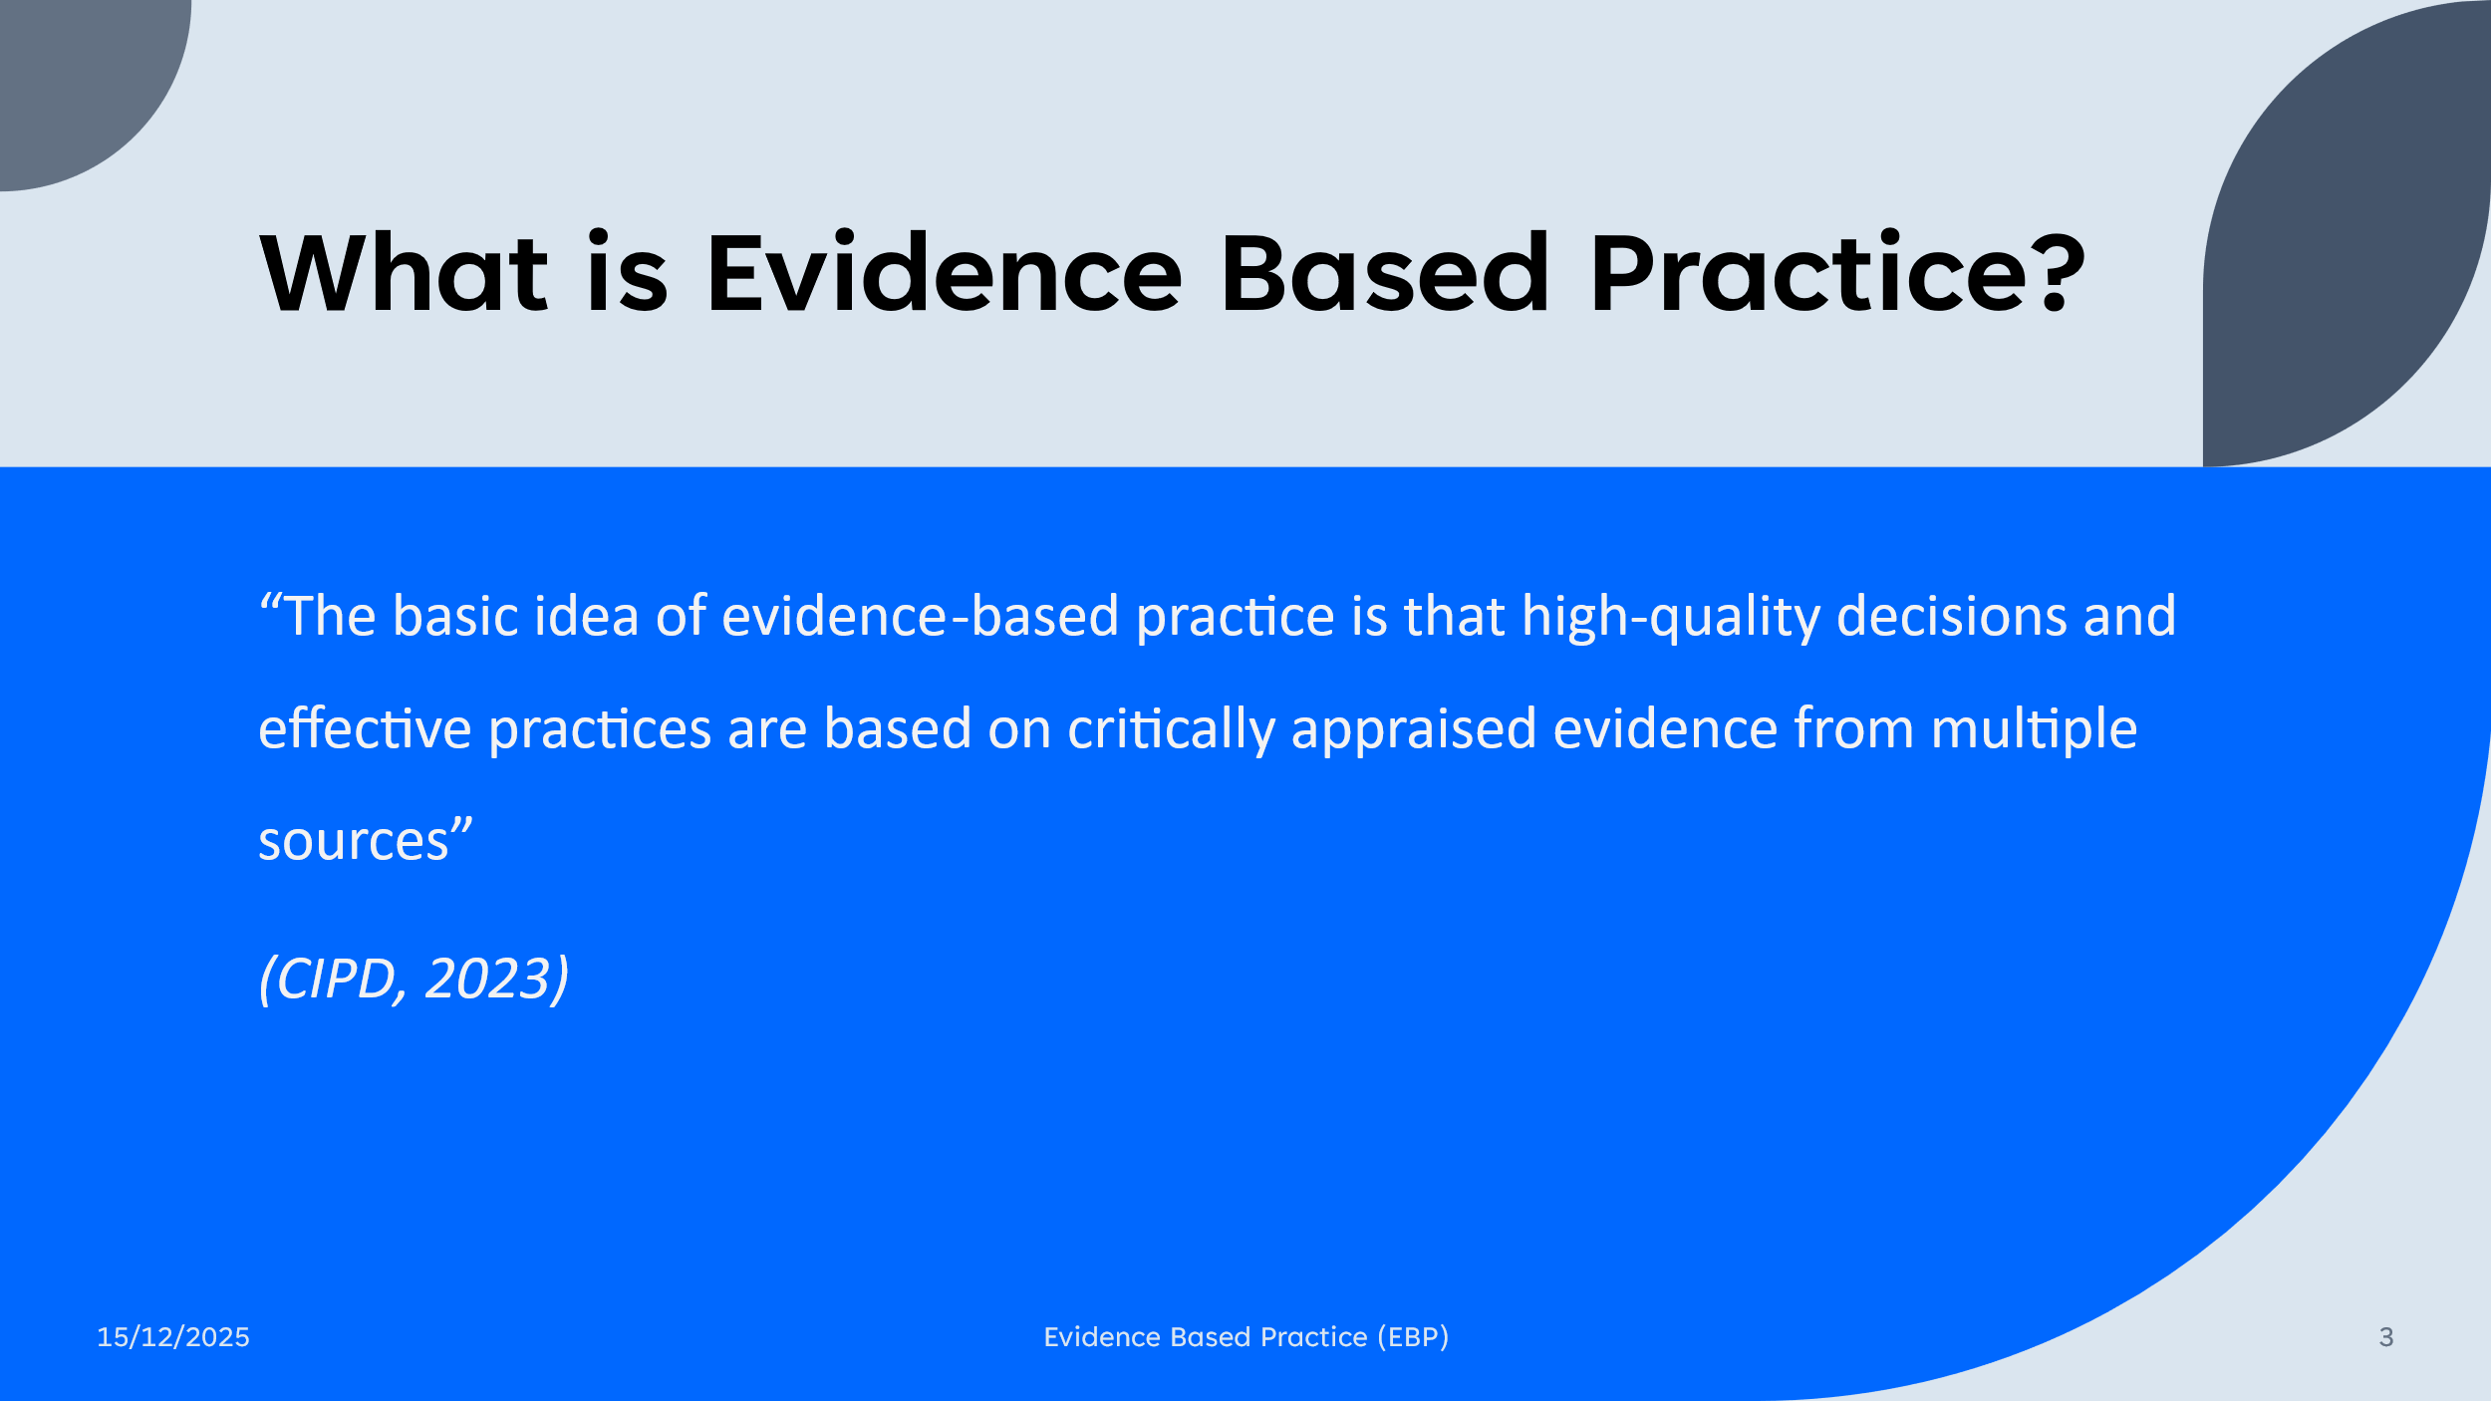
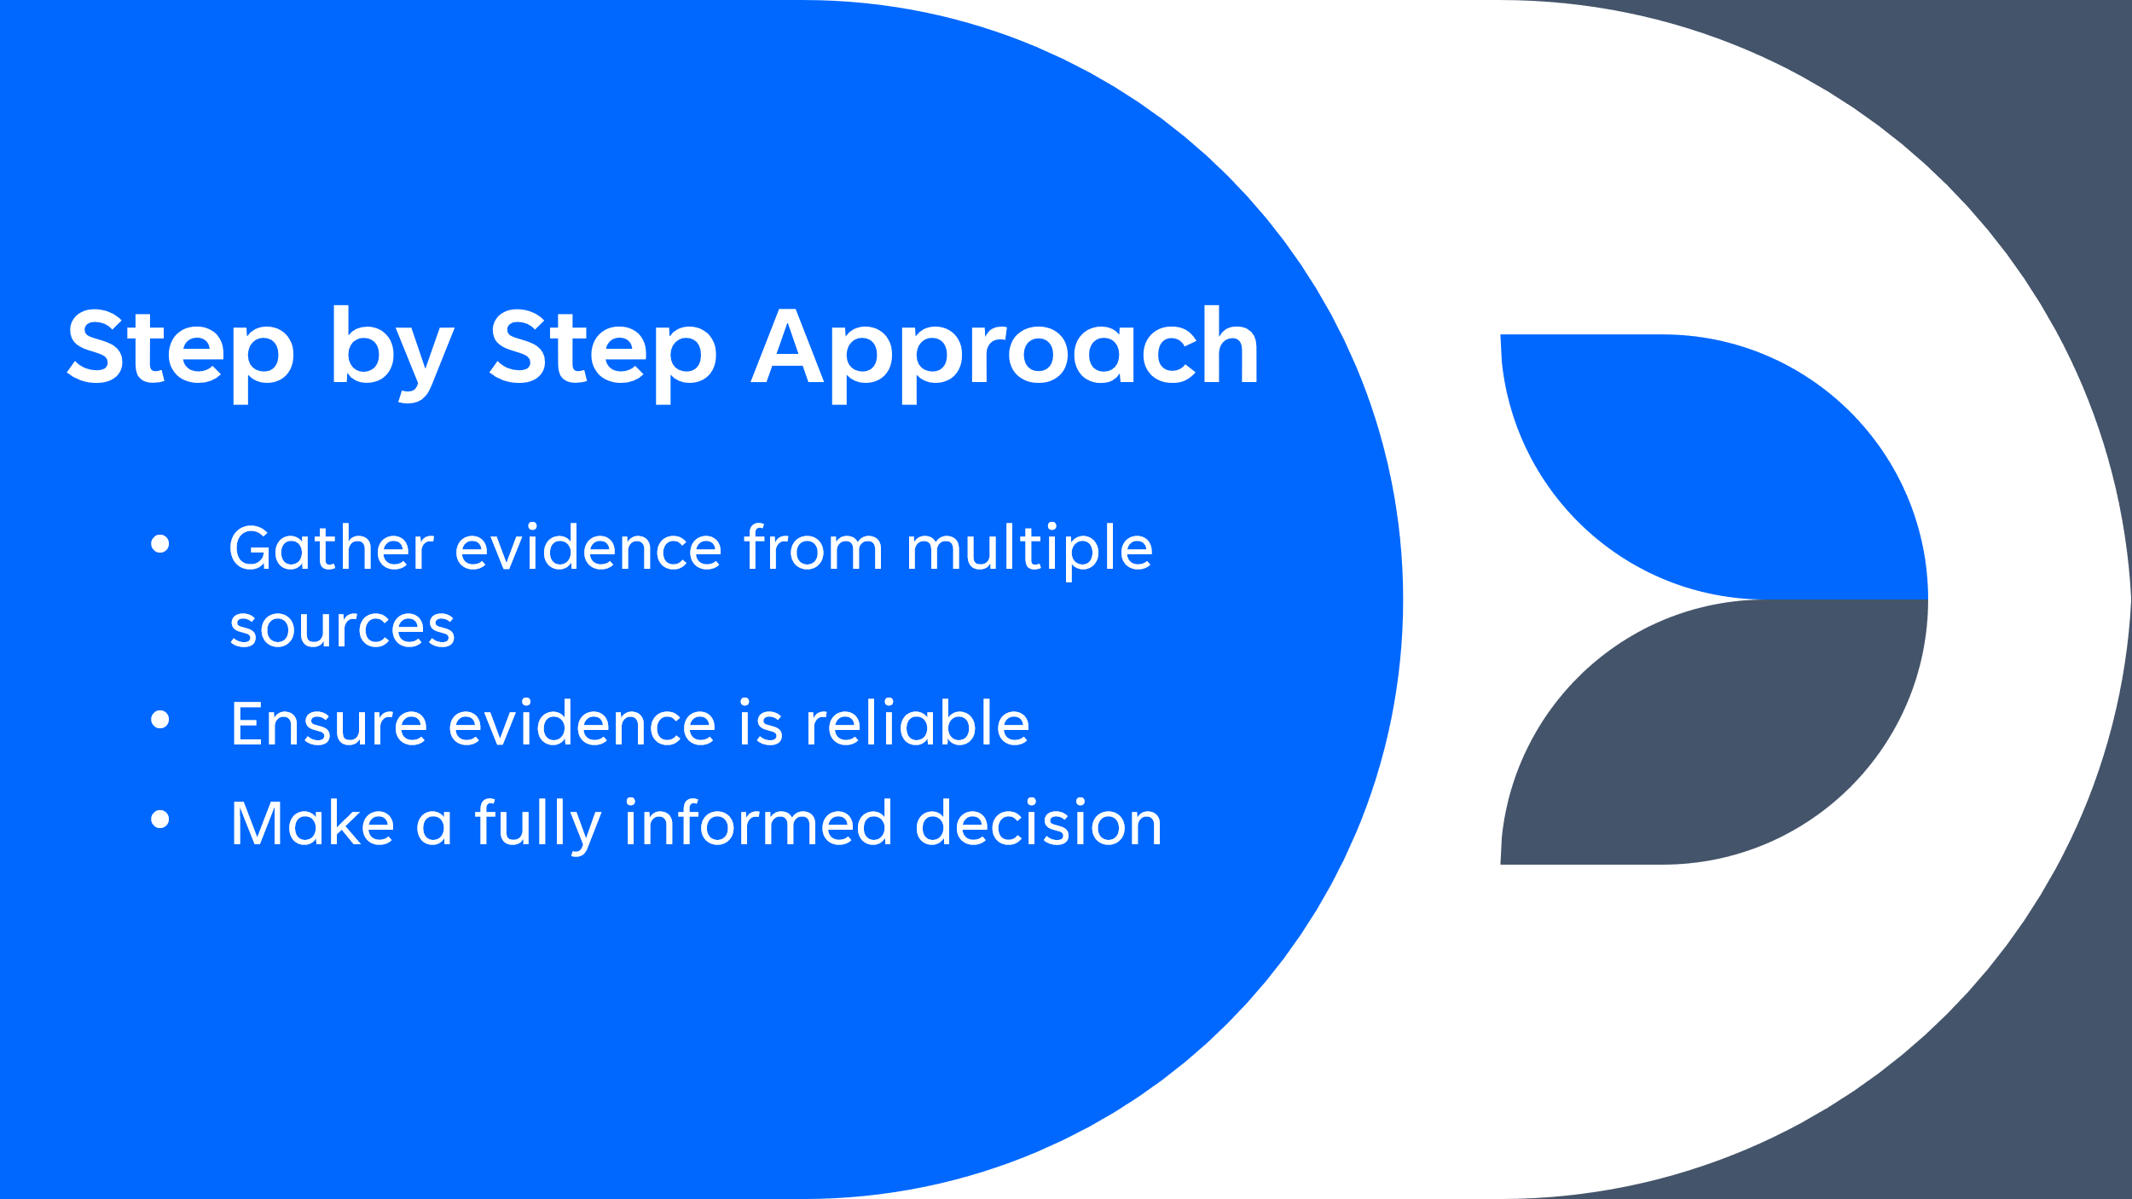
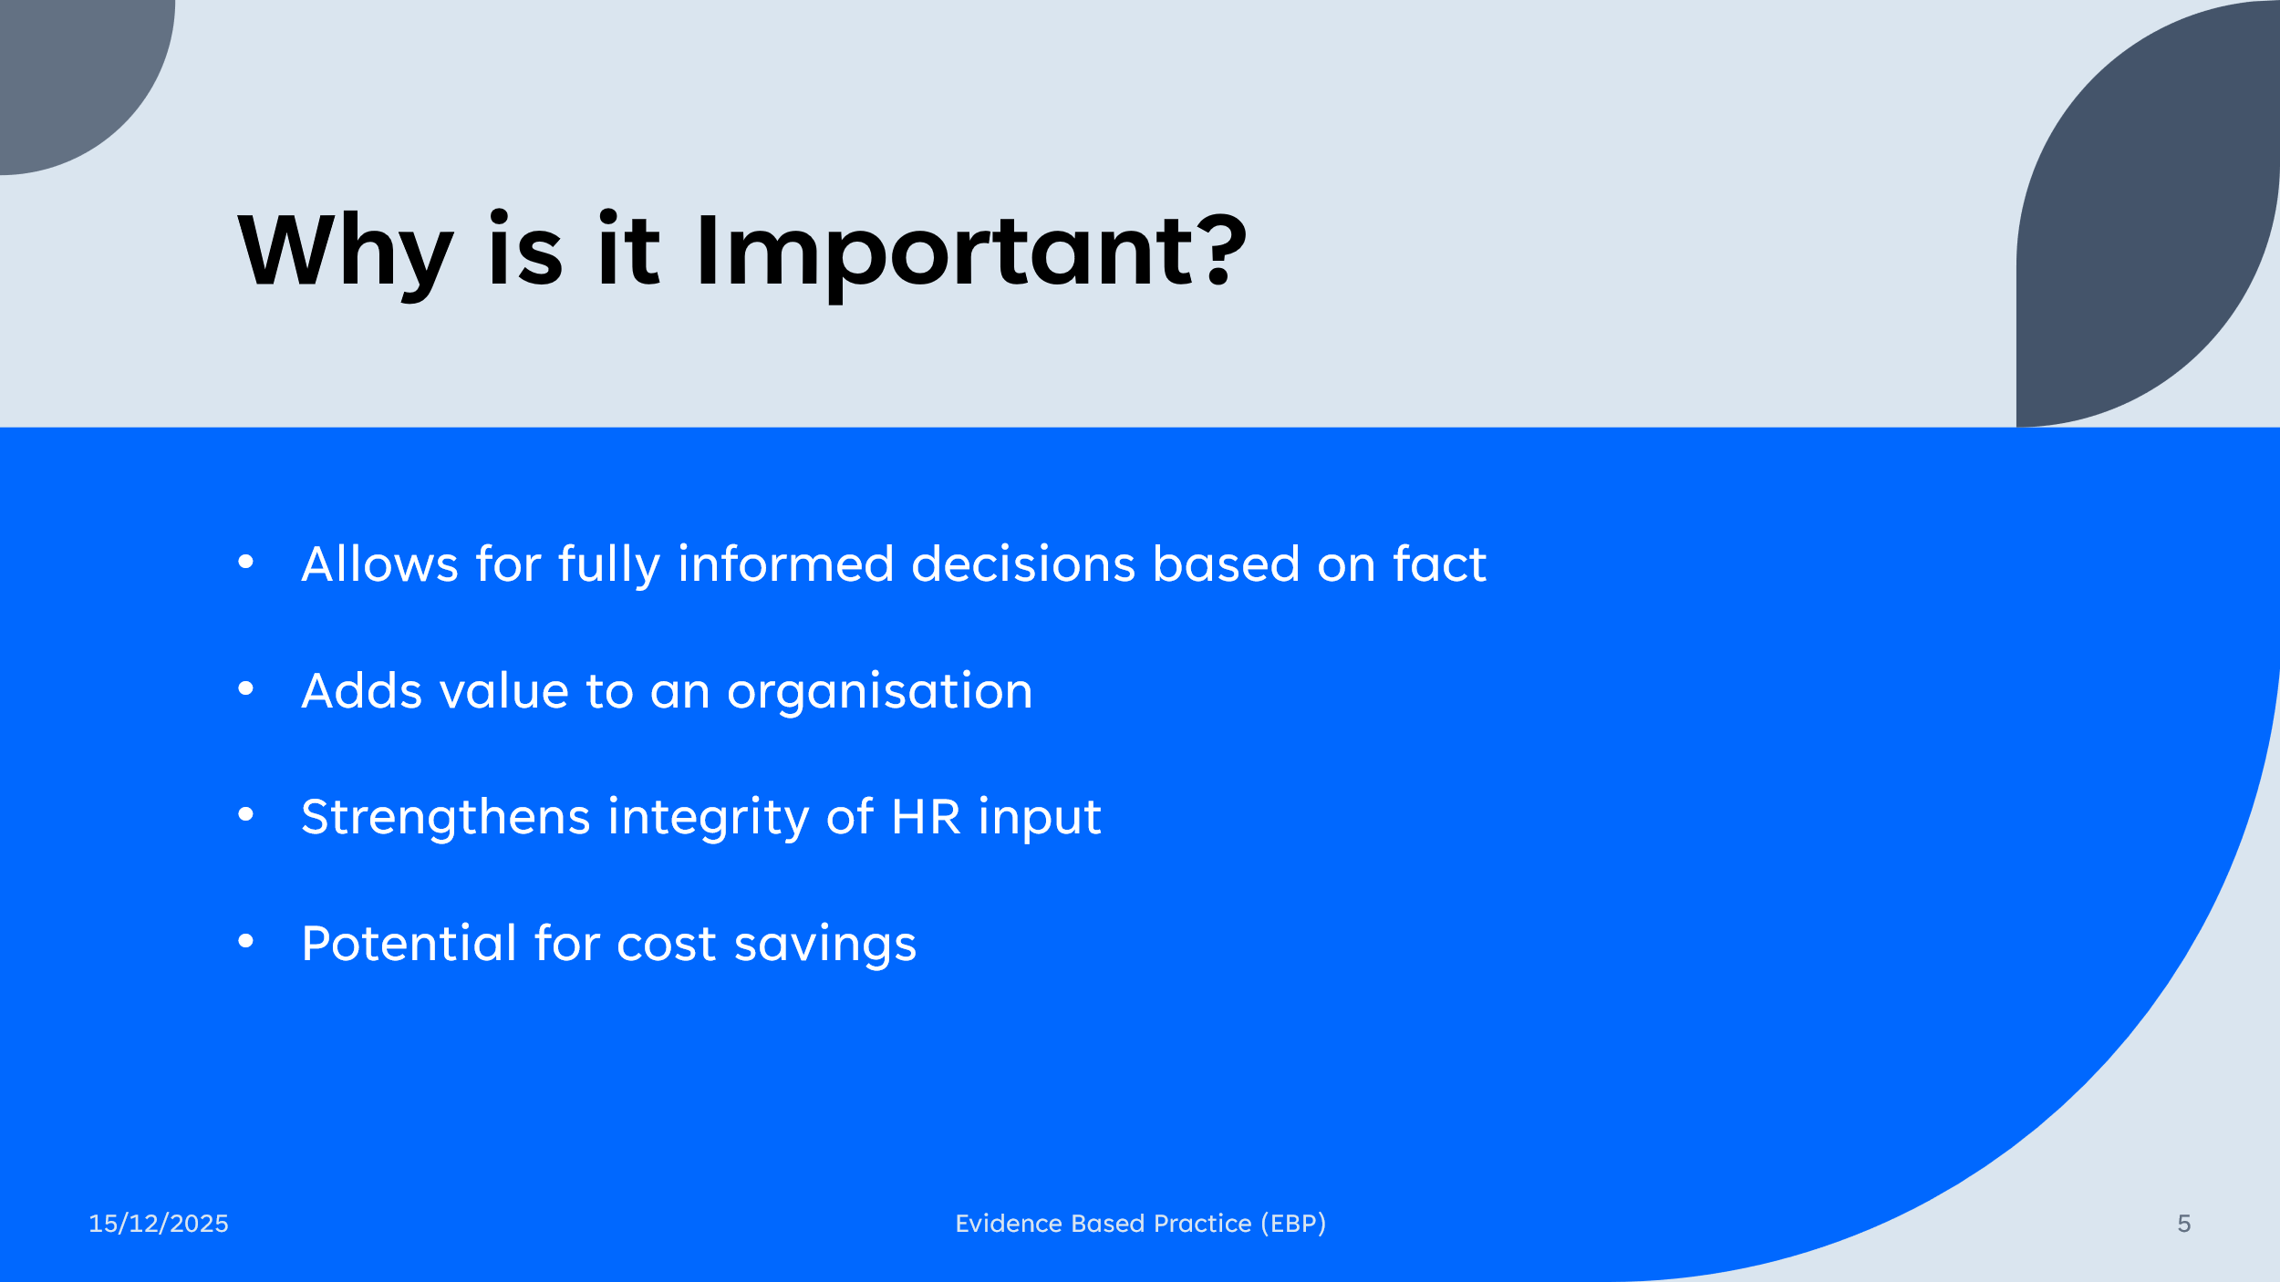
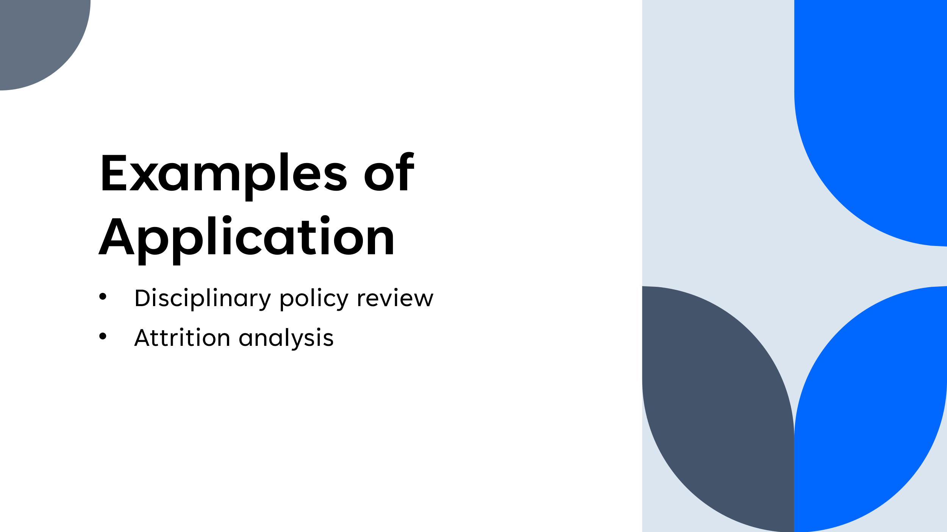
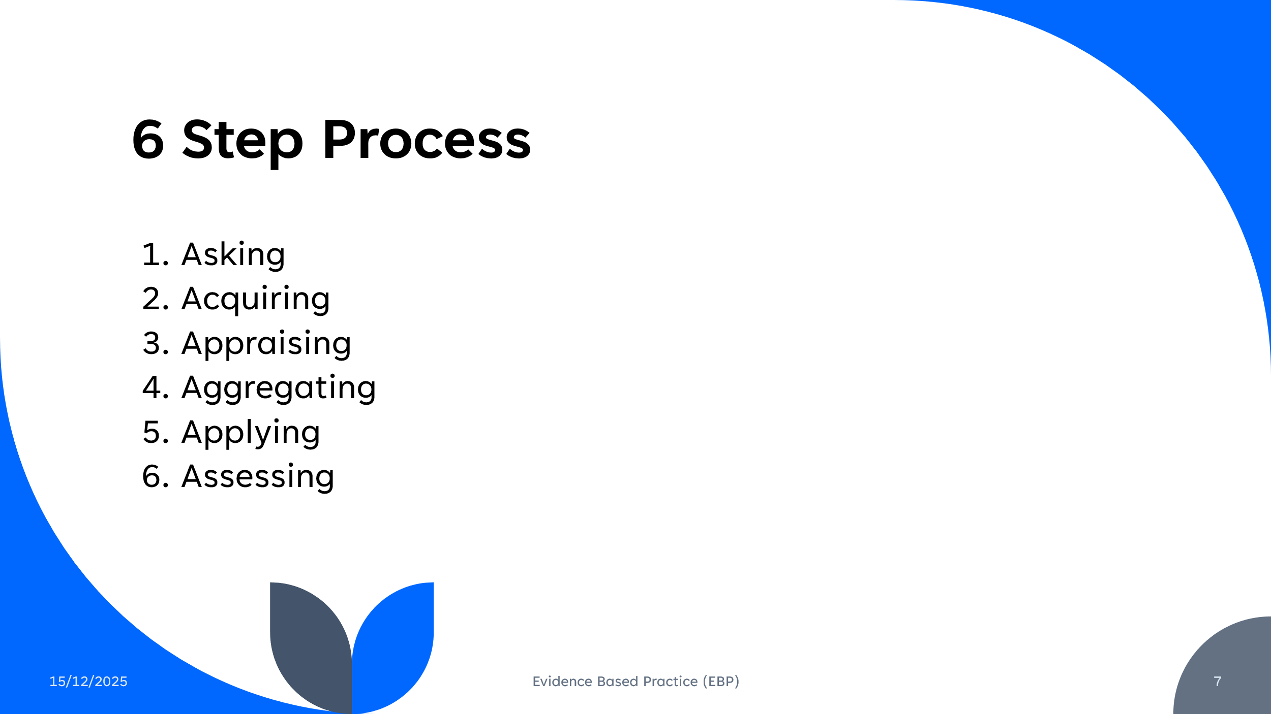
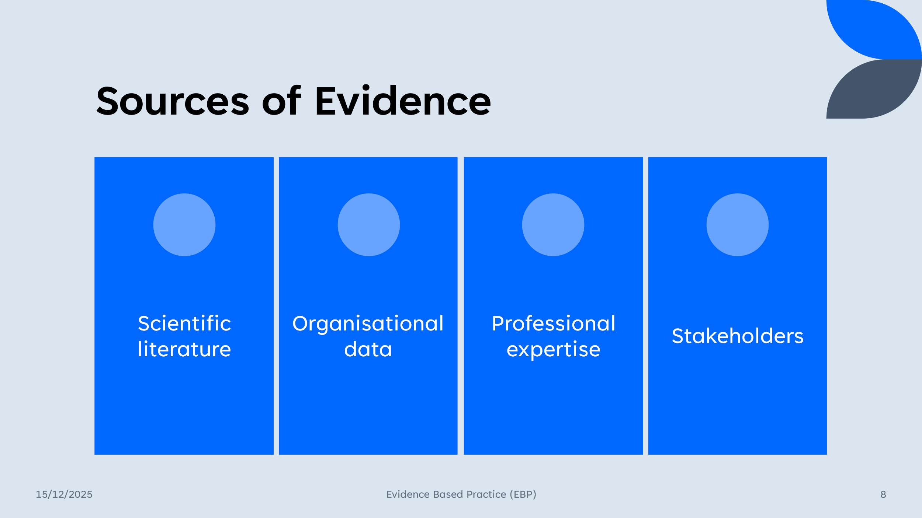
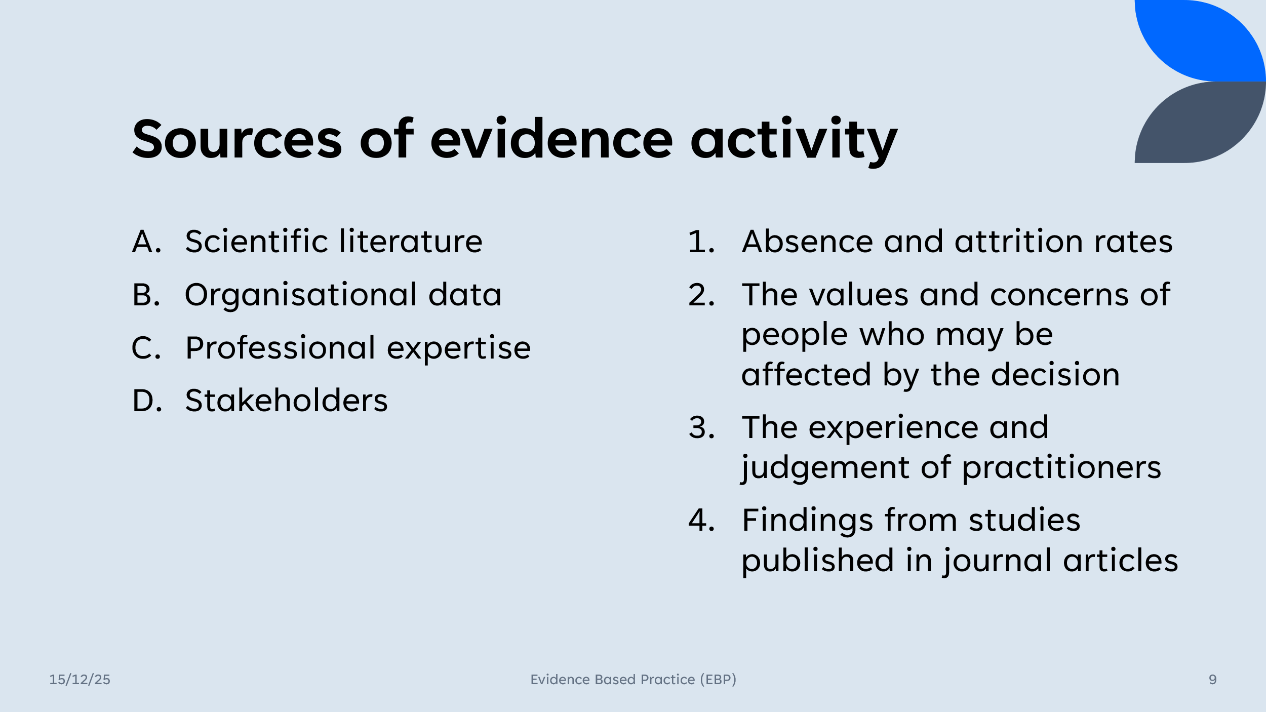
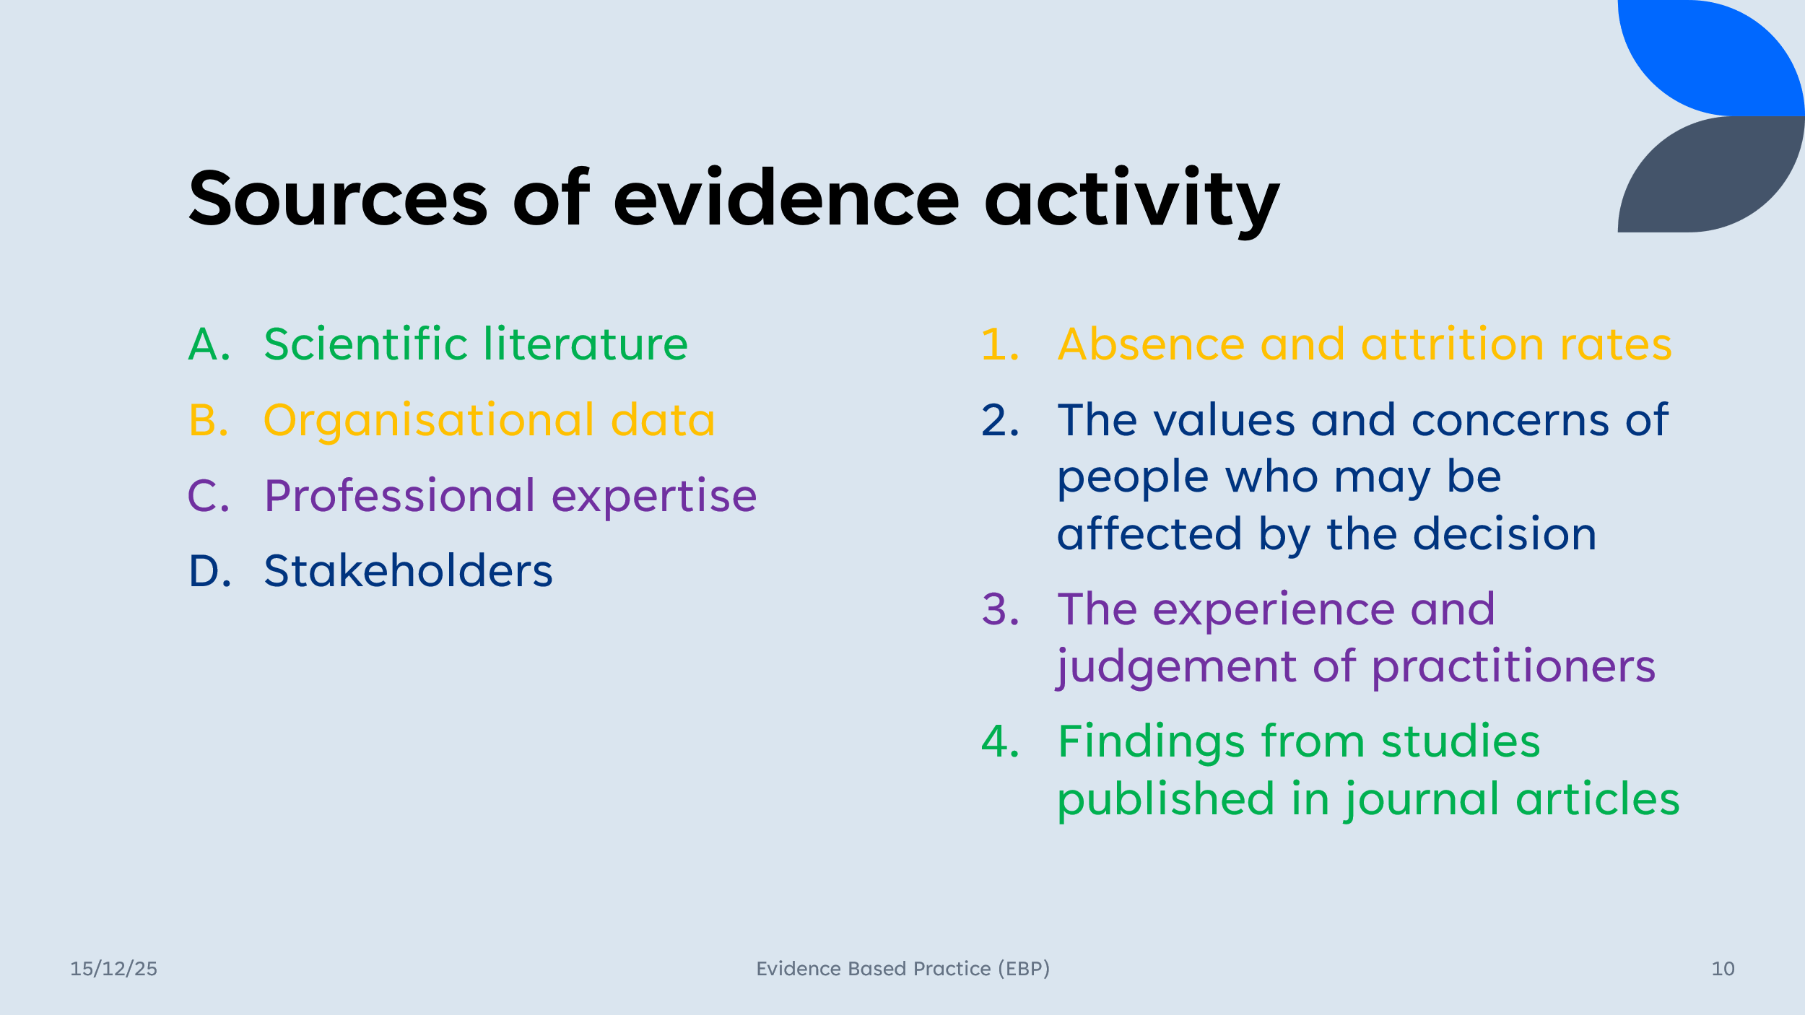
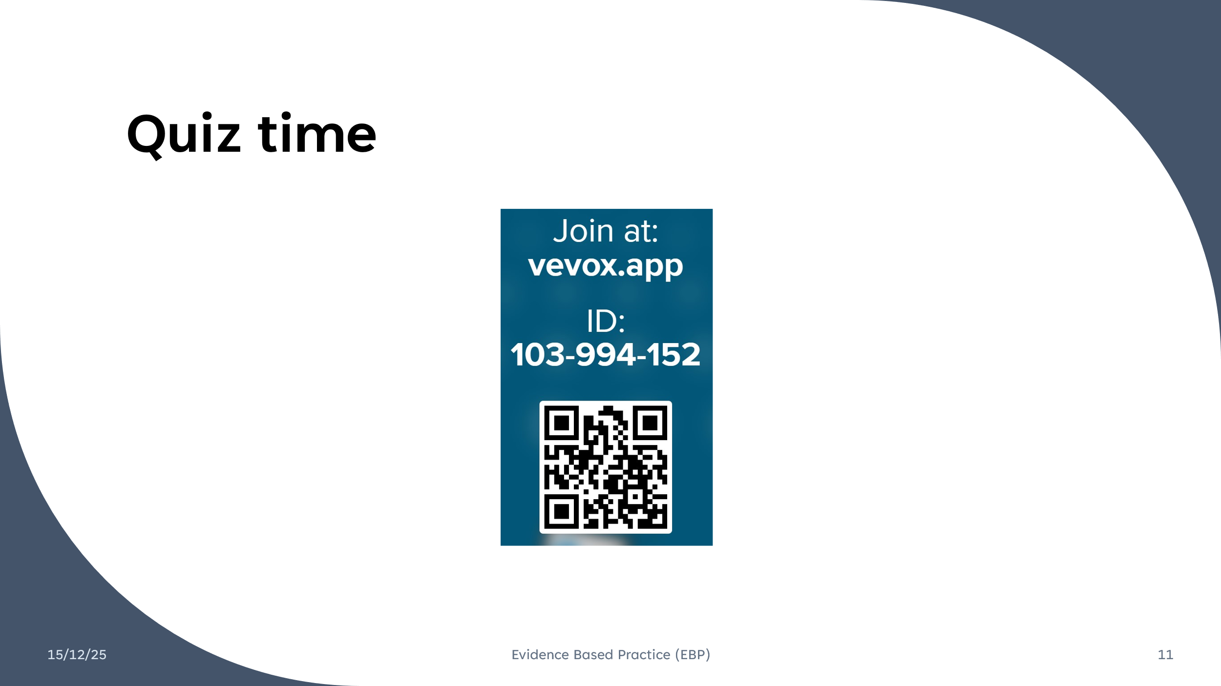
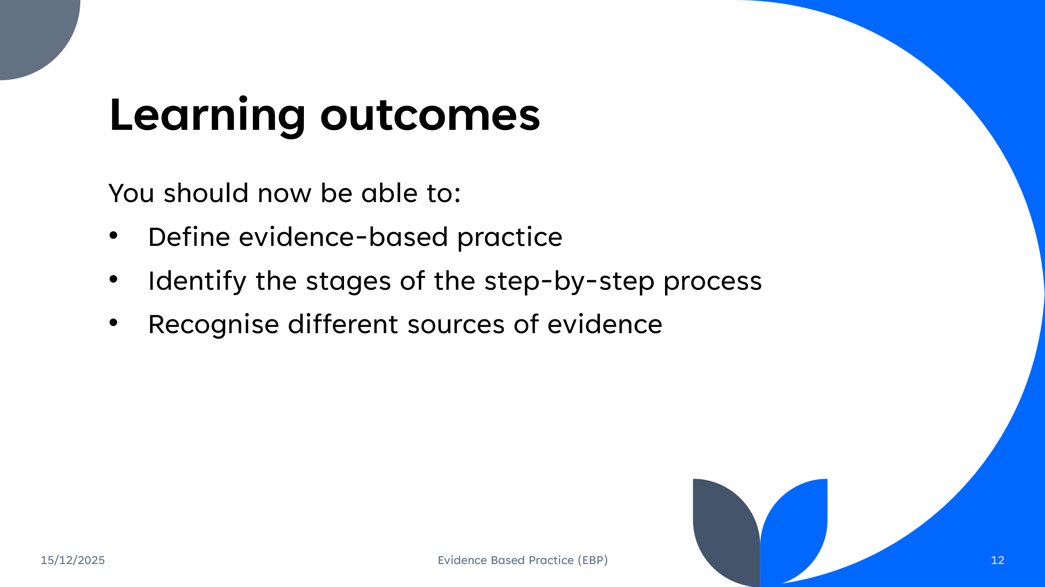
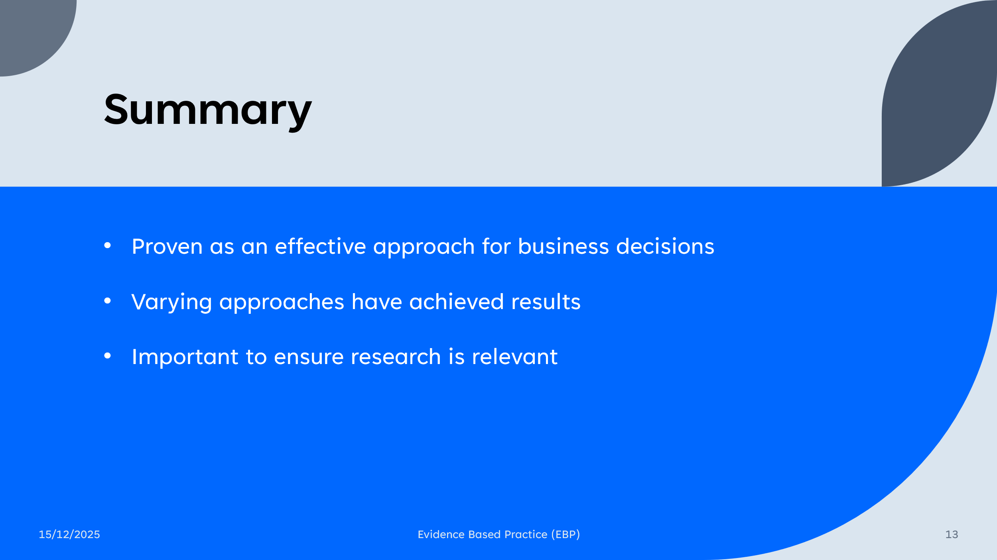
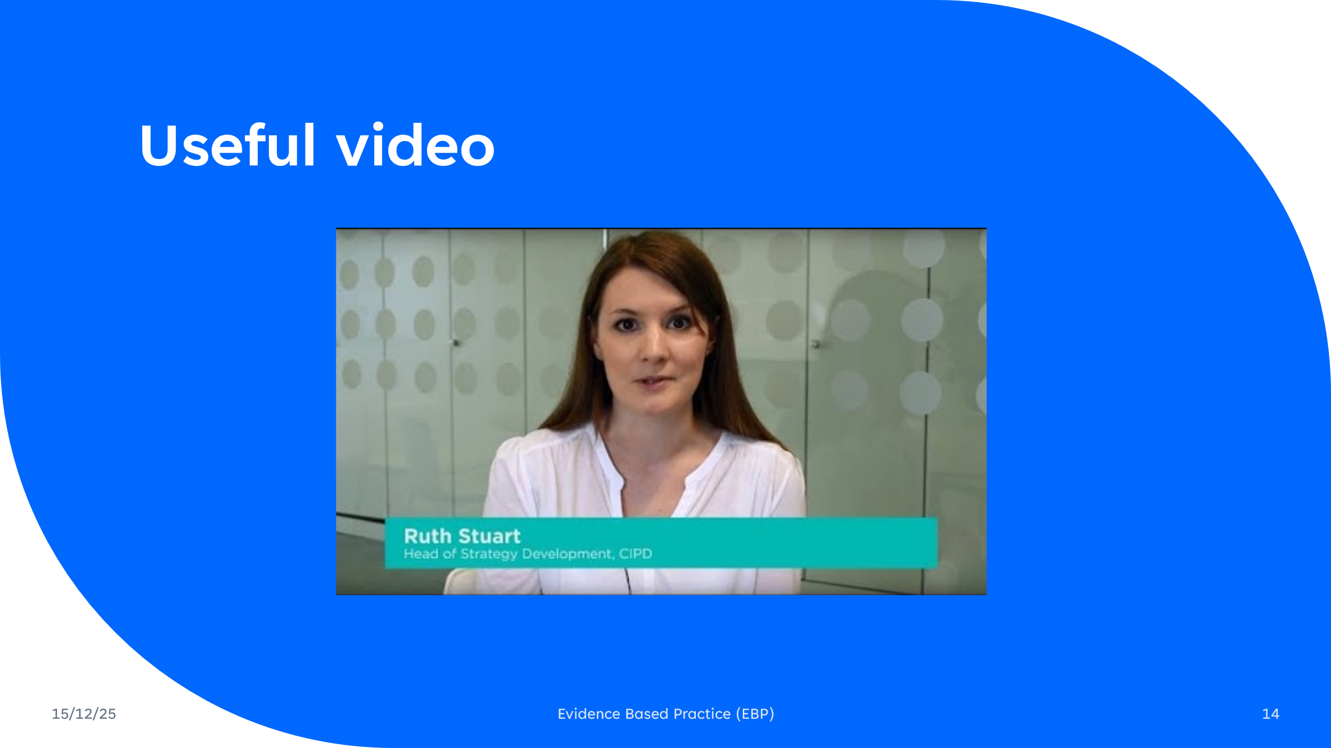

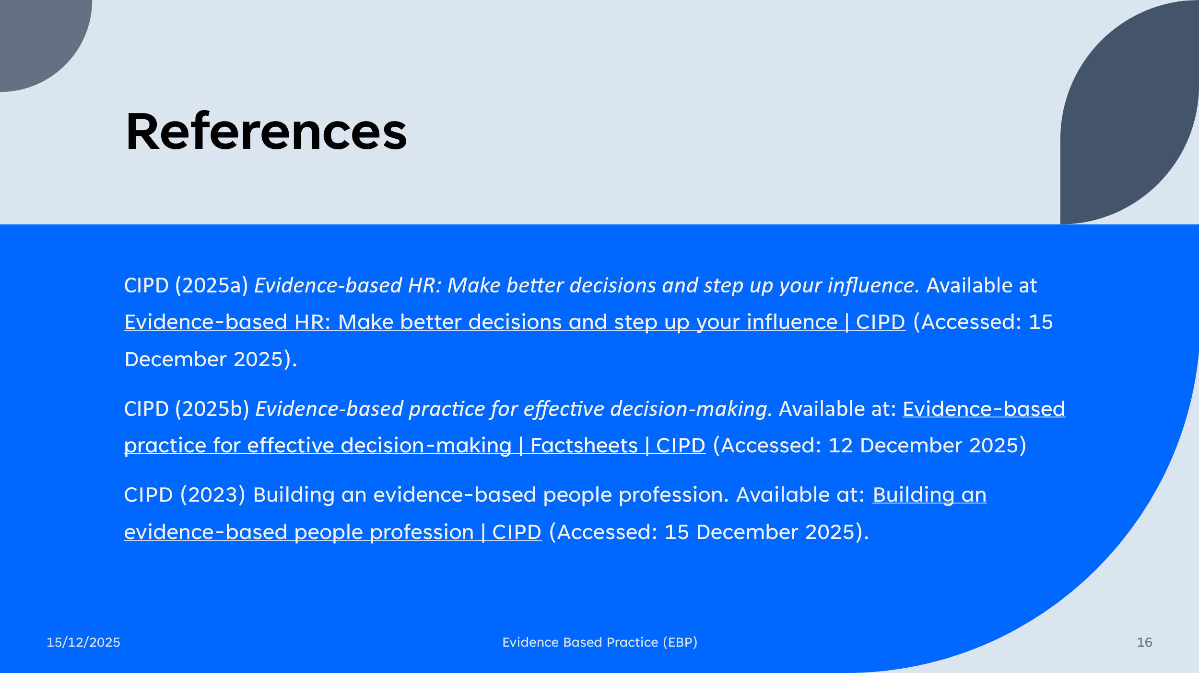

Appendix B – Teaching Observation 1
PGCert tHE- OBSERVATION FORM -PSF 2023
Details of the Observation
Observee | Rhiannon Akers
Practice Advisor / Expert peer observer | Julie Thomas SFHEA  Senior Lecturer
Date of the Observation | 11.2.26
Campus / Location | IM Swansea
Date, Time, Duration | 11.2.26, 2pm-3:15pm, 1.25 hours.
Subject Speciality | Strategic People Management
Type of activity | Workshop
This observation will contribute to the participant’s portfolio of evidence to satisfy the assessment of the PGCert tHE and should be undertaken by an experienced academic colleague. Observation by a fellow participant on the programme is not permissible as a means of authenticating practice.

Teaching/Support preparation [A1: Design and plan learning activities/programmes]
i.e. Preparation, selection and organisation of content. Choice of teaching/learning methods.

Comments
Rhi had clearly planned well for the session. She arrived early and the slides were on the screen ready for the students. She had spent time making sure that the room was arranged appropriately and that students would be comfortable. She had found out beforehand when the coffee shop would close so that she timed the break to maximise student comfort.
There was evidence of good planning and preparation such as appropriate slides, clear learning outcomes and a mixture of activities to involve and engage students. Rhi’s choice of learning methods were excellent – the Vevox word cloud allowed quieter members to participate and prompted a good discussion. The pairs exercise allowed students time to have thorough discussions with fellow students.
The level of discussions was strategic, as well as operational, which was highly appropriate for level 7.

Teaching [A2: Teach and/or support learning.]
i.e. Beginning class, introduction, continuity with other sessions, students’ prior knowledge. Clarity of presentation. Pace. Attitude to the subject matter. Use of appropriate reinforcement. Ending the session – summary, future work etc. Technique and Aids: General apparatus – board, data projector, use of handouts. Was effective communication achieved? Was there good student–teacher rapport? Were the aims/outcomes achieved? Appropriateness of teaching/learning methods.
Comments
Rhi started the session by asking the group their thoughts on the previous week’s workshop, which was important to reinforce learning and encourage discussion. She clarified the learning outcomes for the session and gave the group important reminders regarding upcoming events (CIPD Student Conference) and the PTES survey. She used technology to effectively engage students and establish their prior knowledge.
Rhi communicated the main points of the session clearly and confidently. Her slides were visually appealing and contained an appropriate amount of information.
Rhi responded well to student comments, using humour and praise to establish and maintain rapport.
The teaching methods were varied – she used a group word cloud, questioning and a pairs exercise, which were very effective in generating debate and encouraging analysis and deep learning.

Effective Learning Environments [A4:Support and guide learners/V1 Respect individual learners/diverse groups of learners]
i.e General class atmosphere, level of participation, attention, and interest. Student attitude and ability to carry out classwork. Were learning problems identified and overcome? Awareness of individual needs. Attitude to students.

Comments
The group atmosphere was positive, with all students participating in discussions. Rhi asked certain students questions to ensure that everyone had a chance to contribute. Students willingly contributed and appeared to enjoy all the activities.
One student was online – Rhi regularly checked in with her and ensured that she felt part of the group. Another student was a subject matter expert – she acknowledged this and encouraged her to contribute.
Rhi was positive and friendly towards the group, responding well to their contributions.

Assessment [A3: Assess and give learners feedback for learning]
i.e Formative/summative assessment examples , Question and answer technique. Other evaluation procedures, class management, instructions to students.
Comments
Rhi assessed the students’ prior knowledge using a word cloud exercise. She effectively used questioning to test and explore their knowledge throughout the session. She used a variety of formative assessments including a pairs exercise.
Rhi gave clear instructions regarding the activities and was able to manage the class well, ensuring that everyone had the opportunity to contribute. She explained what a word cloud was and what larger words represented, so that students not only learnt about the subject matter, but also fully understood the purpose of various teaching methods.
Core Knowledge
- K1 - how learners learn, generally and within specific subjects
- K2 - approaches to teaching and/or supporting learning, appropriate for subjects and level of study
- K3 - critical evaluation as a basis for effective practice
- K4 - appropriate use of digital and/or other technologies, and resources for learning
- K5 - requirements for quality assurance and enhancement, and their implications for practice
Comments
Rhi demonstrated excellent core knowledge. For example:
K1 – by utilising activities, she demonstrated that she was aware that students learn from applying and trying out concepts.
K2 – by asking for opinions and debating points, Rhi was able to stimulate discussion that was appropriate for level 7 students.
K4 – Rhi used technology (Vevox word cloud) to engage students.

Professional values
- V1 Respect for individual learners/ Diverse groups of learners.
- V2 Promote engagement and learning and equity of opportunity for all to reach their potential.
- V3 Use scholarship, Research or professional learning? All other evidence informed approaches as a basis of effective practice.
- V4 Respond to the wider context in which higher education operates, recognising implications for practice.
- V5 Collaborate with others to enhance practice.
Comments
Rhi also demonstrated professional values. For example:
V1 and V2 – she adapted the session so that one student could attend online.
V3 – Rhi demonstrated an awareness of best practice in teaching by incorporating learning outcomes and using a variety of teaching methods.
V4 – Rhi used practical real-life examples to illustrate points. She also embraced technology which is used in organisational learning settings.
V5 – Rhi welcomed suggestions from the observer such as potential guest speakers, case studies and podcasts.

Examples of good practice:
Overall, Rhi delivered a high-quality teaching session, which students engaged with willingly. She used a variety of teaching methods, plus a good range of formative assessments. She was organised and had planned the session well, using learning outcomes and a variety of ways to engage students and stimulate debate. Content and activities were appropriate for level 7. Rhi demonstrated excellent subject matter knowledge by including up to date concepts (e.g. hybrid working and the CIPD inclusion calendar) and recent case examples, as well as being able to build upon student comments and answers. Her slides contained appropriate amounts of information, plus images, so were visually appealing and added to the learning experience. Her friendly, positive demeanour was appreciated by students who were also upbeat and positive, ensuring that the environment was conducive to learning. Rhi’s pace and tone of voice were appropriate for the group. She was highly inclusive, ensuring that everyone had an opportunity to contribute.
Action points:
A minor point – Rhi could have used the up to date UWTSD templates for Powerpoint presentations.
For Observee
Write a short statement to address area of activity [A5]. Describe how this observation will enhance your practice
I am pleased that this feedback confirms that my teaching practice aligns with level 7 expectations, particularly in areas such as session planning, learner engagement, inclusivity and use of formative assessment. Moving forward, I will continue to maintain this focus on up to date concepts and varied to delivery methods to ensure my teaching is relevant and engaging.
I will adopt the latest UWTSD PowerPoint template for future sessions and will continue to experiment with the use of technology such as Vevox to consolidate learning.

Observer ...................................................... Date 11.2.26

Observee Date 11/02/26

Appendix C – Teaching Observation 2
PGCert tHE- OBSERVATION FORM -PSF 2023
Details of the Observation
Observee | Julie Thomas
Practice Advisor / Expert peer observer | Rhiannon Akers
Date of the Observation | 24/02/26
Campus / Location | IQ Building, Swansea Waterfront
Date, Time, Duration | 1pm-2pm
Subject Speciality | Wellbeing at work
Type of activity | Taught lecture
This observation will contribute to the participant’s portfolio of evidence to satisfy the assessment of the PGCert tHE and should be undertaken by an experienced academic colleague. Observation by a fellow participant on the programme is not permissible as a means of authenticating practice.

Teaching/Support preparation [A1: Design and plan learning activities/programmes]
i.e. Preparation, selection and organisation of content. Choice of teaching/learning methods.

Comments
Julie was clearly well prepared for the session. The PowerPoint slides followed a logical structure and a clear agenda was provided.
Julie utilised a variety of teaching methods throughout the session to ensure all learners were engaged. She asked questions to the class to stimulate discussion, incorporated a group activity at an appropriate time to encourage all students to get involved and included individual online activities.

Teaching [A2: Teach and/or support learning.]
i.e. Beginning class, introduction, continuity with other sessions, students’ prior knowledge. Clarity of presentation. Pace. Attitude to the subject matter. Use of appropriate reinforcement. Ending the session – summary, future work etc. Technique and Aids: General apparatus – board, data projector, use of handouts. Was effective communication achieved? Was there good student–teacher rapport? Were the aims/outcomes achieved? Appropriateness of teaching/learning methods.
Comments
Julie introduced the session appropriately by checking that the learners were all ok. She included a recap of the previous session to establish the learners understanding and provided useful links to the assignments.
Julie came across as positive and passionate about the topic and gave relevant praise to learners.

Effective Learning Environments [A4:Support and guide learners/V1 Respect individual learners/diverse groups of learners]
i.e General class atmosphere, level of participation, attention, and interest. Student attitude and ability to carry out classwork. Were learning problems identified and overcome? Awareness of individual needs. Attitude to students.

Comments
Julie provided excellent support to the group and ensured she spoke with all students to address their individual needs.

Assessment [A3: Assess and give learners feedback for learning]
i.e Formative/summative assessment examples , Question and answer technique. Other evaluation procedures, class management, instructions to students.
Comments
Clear instructions were provided for each activity and Julie had good management of the group. Julie responded well to input from the learners, clarified points and linked it back to the theory. She probed into responses to gain clarity to challenge students appropriately.

Core Knowledge
- K1 - how learners learn, generally and within specific subjects
- K2 - approaches to teaching and/or supporting learning, appropriate for subjects and level of study
- K3 - critical evaluation as a basis for effective practice
- K4 - appropriate use of digital and/or other technologies, and resources for learning
- K5 - requirements for quality assurance and enhancement, and their implications for practice
Comments
Julie demonstrated excellent awareness of how learners learn by structuring the session with a range of activities to complement the theory and ideas being presented. Julie explored a range of view points throughout her slides and signposted to relevant sources.

Professional values
- V1 Respect for individual learners/ Diverse groups of learners.
- V2 Promote engagement and learning and equity of opportunity for all to reach their potential.
- V3 Use scholarship, Research or professional learning? All other evidence informed approaches as a basis of effective practice.
- V4 Respond to the wider context in which higher education operates, recognising implications for practice.
- V5 Collaborate with others to enhance practice.
Comments
Julie displayed kindness and consideration for learners throughout the session. She addressed individual needs. For example, one student arrived late so she spoke with him, checked he was ok and made sure he understood the activity.
Julie also made an effort to check in with all students as some did not appear to be taking part in the activity initially due to a language barrier. Her explanations were clear and she took account of those with differing needs by addressing these on an individual basis.

Examples of good practice:
As above, Julie has a clear passion for the subject and engaged learners appropriately through various activities and discussion.
Action points:
It might have been more effective to ask learners to complete just one of the online quizzes, or to include a more structured discussion focused on the results of their quizzes.
Overall, I really enjoyed the session and it was clear the learners were engaged with the content and your teaching style.
For Observee
Write a short statement to address area of activity [A5]. Describe how this observation will enhance your practice
Observer Date 24/02/26

Observee ... Date 25/02/26

Appendix D – Teaching Observation 3
PGCert tHE- OBSERVATION FORM -PSF 2023
Details of the Observation
Observee | Rhiannon Akers
Practice Advisor / Expert peer observer | Ffion Cumberpatch
Date of the Observation | 26/02/2026
Campus / Location | Swansea, IQ
Date, Time, Duration | 26/02/2026  1.30PM – 3PM
Subject Speciality | People Management
Type of activity | Lecture
This observation will contribute to the participant’s portfolio of evidence to satisfy the assessment of the PGCert tHE and should be undertaken by an experienced academic colleague. Observation by a fellow participant on the programme is not permissible as a means of authenticating practice.

Teaching/Support preparation [A1: Design and plan learning activities/programmes]
i.e. Preparation, selection and organisation of content. Choice of teaching/learning methods.

Comments
Rhiannon was well prepared for the session. The content was logically structured, relevant to the subject area and clearly aligned to learner level. There was strong application to industry, particularly tailored to the automotive engineering cohort, which enhanced contextual understanding.
Slides were accessible and clearly presented. The sequencing of material supported progressive knowledge development.
Learning outcomes were aligned to Bloom’s Taxonomy and appropriately ambitious for the level of study.
There may have been a high volume of slides and learning outcomes for a two-hour session. Streamlining may allow greater depth of exploration and consolidation.

Teaching [A2: Teach and/or support learning.]
i.e. Beginning class, introduction, continuity with other sessions, students’ prior knowledge. Clarity of presentation. Pace. Attitude to the subject matter. Use of appropriate reinforcement. Ending the session – summary, future work etc. Technique and Aids: General apparatus – board, data projector, use of handouts. Was effective communication achieved? Was there good student–teacher rapport? Were the aims/outcomes achieved? Appropriateness of teaching/learning methods.
Comments
Rhiannon began the session clearly, maintaining continuity and demonstrating awareness of the learner group despite not having taught them previously. She built rapport quickly and established credibility.
Presentation was clear, structured and appropriately paced overall. There was effective use of reinforcement through questioning, quizzes and interactive tools such as VVOX, with sufficient time allocated for completion.
The aims and learning outcomes were addressed throughout the session. Teaching methods were appropriate for the subject and level, with good integration of industry examples.
There was some reliance on slides in certain areas; diversifying delivery techniques further may enhance engagement.

Effective Learning Environments [A4:Support and guide learners/V1 Respect individual learners/diverse groups of learners]
i.e General class atmosphere, level of participation, attention, and interest. Student attitude and ability to carry out classwork. Were learning problems identified and overcome? Awareness of individual needs. Attitude to students.

Comments
Rhiannon created a calm, inclusive and positive learning atmosphere. Participation levels were strong, and students were encouraged to share viewpoints, including opposing opinions, fostering critical discussion.
Her attitude was encouraging and respectful, and this was reflected in learner engagement. She thanked students for contributions, reinforcing participation positively.
There were opportunities to further engage quieter learners through targeted questioning strategies to ensure equitable participation.

Assessment [A3: Assess and give learners feedback for learning]
i.e Formative/summative assessment examples , Question and answer technique. Other evaluation procedures, class management, instructions to students.
Comments
Formative assessment was embedded effectively throughout the session via quizzes, discussion and questioning.
Question and answer techniques were strong, with good reinforcement and acknowledgement of contributions.
To further enhance inclusive assessment practice, probing quieter learners could support broader engagement and evidence of learning.

Core Knowledge
- K1 - how learners learn, generally and within specific subjects
- K2 - approaches to teaching and/or supporting learning, appropriate for subjects and level of study
- K3 - critical evaluation as a basis for effective practice
- K4 - appropriate use of digital and/or other technologies, and resources for learning
- K5 - requirements for quality assurance and enhancement, and their implications for practice
Comments
Rhiannon demonstrated secure subject knowledge and an understanding of how learners engage within the discipline (K1).
Teaching approaches were appropriate to subject and level (K2), with clear alignment to intended learning outcomes.
There was evidence of reflective and evaluative practice within session structure (K3).
Digital tools (e.g. VVOX, presentation technology) were used appropriately to enhance learning (K4).
Practice reflected an awareness of quality standards and structured session planning (K5).
All Core Knowledge criteria were met.

Professional values
- V1 Respect for individual learners/ Diverse groups of learners.
- V2 Promote engagement and learning and equity of opportunity for all to reach their potential.
- V3 Use scholarship, Research or professional learning? All other evidence informed approaches as a basis of effective practice.
- V4 Respond to the wider context in which higher education operates, recognising implications for practice.
- V5 Collaborate with others to enhance practice.
Comments
Rhiannon demonstrated respect for individual learners and fostered an inclusive environment (V1).
She promoted engagement and equitable opportunity through interactive tools and open discussion (V2), though further inclusion of quieter learners would strengthen this area.
Her industry application reflected scholarship-informed and professionally informed practice (V3).
The session acknowledged the wider professional context of higher education and industry alignment (V4).
Strong facilitation and relationship-building indicated collaborative engagement with learners (V5).
All Professional Values were met, with minor development identified under V2.

Examples of good practice:
- High-quality, accessible teaching materials
- Strong industry contextualisation for automotive engineering students
- Effective use of digital engagement tools
- Positive reinforcement and respectful facilitation of discussion
- Good pacing despite adjusted session timing
- Rapid rapport-building with a new cohort
Action points:
- Review slide volume and learning outcome quantity to optimise depth within time constraints
- Further develop questioning strategies to actively include quieter learners
For Observee
Write a short statement to address area of activity [A5]. Describe how this observation will enhance your practice
This feedback highlights several areas of effective practice that I will consciously maintain and build upon, particularly the creation of accessible, high-quality learning materials and strong contextualisation for automotive engineering students. I’m pleased that my use of digital engagement tools and my ability to quickly establish rapport with new learners were recognised, as these contribute directly to participation, confidence, and a positive classroom environment.
To further enhance my sessions, I will review the number of slides and learning outcomes to ensure each session allows sufficient depth of discussion within available time. This could involve focusing on fewer but more complex topics, allowing for a more in depth exploration and critical thinking.
In addition, I will refine my questioning techniques to encourage wider participation, especially from quieter learners.

Observer Ffion Cumberpatch Date 26/02/2026

Observee Date 26/02/26

